**Muhammad Nadeem**

**201980050**

**Data Visualization**

**CP-02**

* **Build dataset on your own & plot the following distribution shapes:**

**1st way:**

# Load required library

library(ggplot2)

# Set seed for reproducibility

set.seed(123)

# Create datasets for each distribution shape

# Bimodal distribution

bimodal_data <- c(rnorm(1000, mean = -2, sd = 1), rnorm(1000, mean = 2, sd = 1))

# Comb distribution

comb_data <- c(runif(1000, min = -3, max = -2), runif(1000, min = 1, max = 2))

# Edge peak distribution

edge_peak_data <- c(rexp(1000, rate = 1), rexp(1000, rate = 2))

# Normal distribution

normal_data <- rnorm(2000)

# Skewed distribution

skewed_data <- c(rnorm(1000), rnorm(1000, mean = 4, sd = 1))

# Uniform distribution

uniform_data <- runif(2000)

# Plot distributions

# Bimodal distribution

ggplot(data.frame(x = bimodal_data), aes(x)) +

geom_histogram(bins = 30, fill = "skyblue", color = "black", alpha = 0.7) +

labs(title = "Histogram - Bimodal") +

theme_minimal()

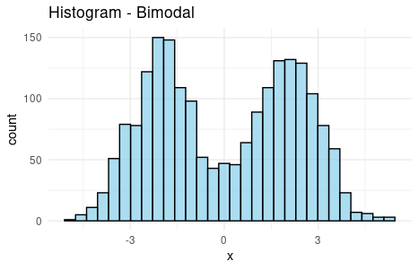

ggplot(data.frame(x = bimodal_data), aes(x)) +

geom_density(fill = "skyblue", color = "black") +

labs(title = "Density Plot - Bimodal") +

theme_minimal()

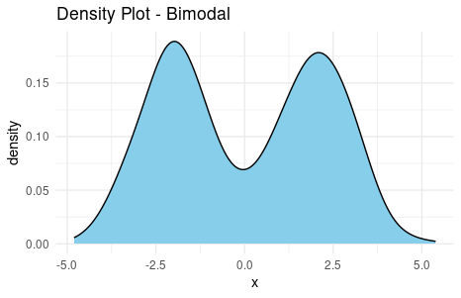

# Edge peak distribution

ggplot(data.frame(x = edge_peak_data), aes(x)) +

geom_histogram(bins = 30, fill = "skyblue", color = "black", alpha = 0.7) +

labs(title = "Histogram Skewed") +

theme_minimal()

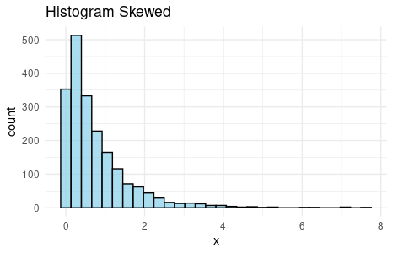

ggplot(data.frame(x = edge_peak_data), aes(x)) +

geom_density(fill = "skyblue", color = "black") +

labs(title = "Density Plot - Skewed") +

theme_minimal()

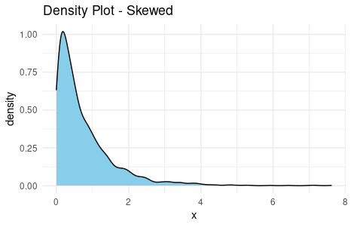

# Normal distribution

ggplot(data.frame(x = normal_data), aes(x)) +

geom_histogram(bins = 30, fill = "skyblue", color = "black", alpha = 0.7) +

labs(title = "Histogram - Normal") +

theme_minimal()

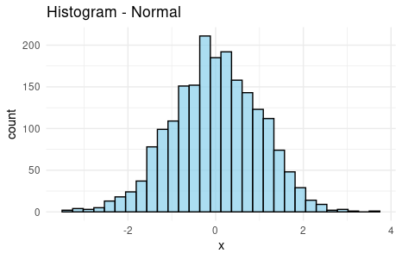

ggplot(data.frame(x = normal_data), aes(x)) +

geom_density(fill = "skyblue", color = "black") +

labs(title = "Density Plot - Normal") +

theme_minimal()

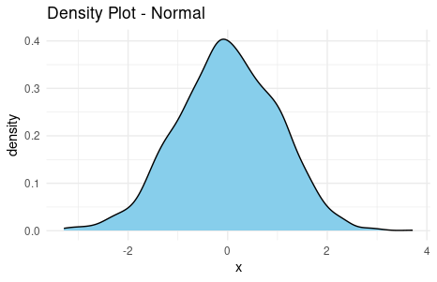

# Uniform distribution

ggplot(data.frame(x = uniform_data), aes(x)) +

geom_histogram(bins = 30, fill = "skyblue", color = "black", alpha = 0.7) +

labs(title = "Histogram - Uniform") +

theme_minimal()

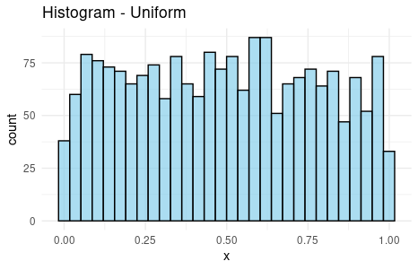

ggplot(data.frame(x = uniform_data), aes(x)) +

geom_density(fill = "skyblue", color = "black") +

labs(title = "Density Plot - Uniform") +

theme_minimal()

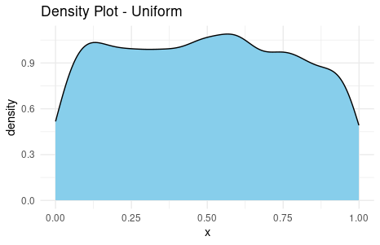

**2nd Way:**

# Build dataset with different distributions

data <- data.frame(

type = c( rep("edge peak", 1000), rep("comb", 1000), rep("normal", 1000), rep("uniform", 1000), rep("bimodal", 1000), rep("skewed", 1000) ),

value = c( rnorm(900), rep(3, 100), rnorm(360, sd=0.5), rep(c(-1,-0.75,-0.5,-0.25,0,0.25,0.5,0.75), 80), rnorm(1000), runif(1000), rnorm(500, mean=-2), rnorm(500, mean=2), abs(log(rnorm(1000))) )

)

# Represent it

data %>%

ggplot( aes(x=value)) +

geom_density(fill="#69b3a2", color="#e9ecef", alpha=0.9, adjust = 0.5) +

facet_wrap(~type, scale="free") +

theme_ipsum() +

theme(

panel.spacing = unit(0.1, "lines"),

axis.title.x=element_blank(),

axis.text.x=element_blank(),

axis.ticks.x=element_blank()

)

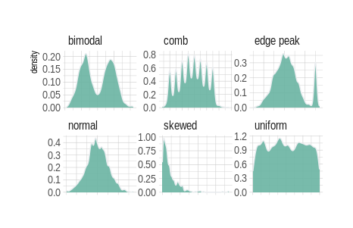

* **Plot histogram or density plot with your own choice of data and play with its bin-width to See the difference.**

# Task 2

# Generate random data

set.seed(123)

data <- rnorm(1000)

# Load required library

library(ggplot2)

# Plot histogram with default bin width

ggplot(data.frame(x = data), aes(x)) +

geom_histogram(bins = 30, fill = "skyblue", color = "black", alpha = 0.7) +

labs(title = "Histogram with Default Bin Width") +

theme_minimal()

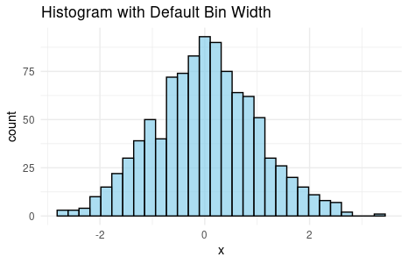

# Plot histogram with smaller bin width

ggplot(data.frame(x = data), aes(x)) +

geom_histogram(bins = 50, fill = "lightgreen", color = "black", alpha = 0.7) +

labs(title = "Histogram with Smaller Bin Width") +

theme_minimal()

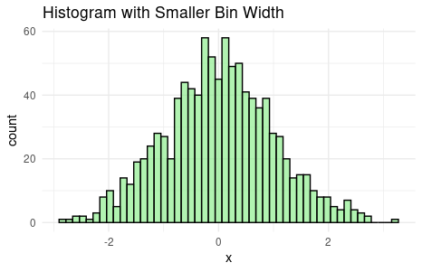

# Plot histogram with larger bin width

ggplot(data.frame(x = data), aes(x)) +

geom_histogram(bins = 20, fill = "salmon", color = "black", alpha = 0.7) +

labs(title = "Histogram with Larger Bin Width") +

theme_minimal()

