### Assignment\_01

**Blue Sky Online Consumer Electronics Retailer**

## 

## IMG_256

## Submitted by

Mehar Hamid Ishfaq

201980038

Muhammad Nadeem

201980050

Muhammad Bilal Butt

191980015

**Submitted to**

Sir Hamza Ali

**Department of Data Science,**

GIFT University, Gujranwala

Due : 27-12-2023

**ERD Diagram:**

**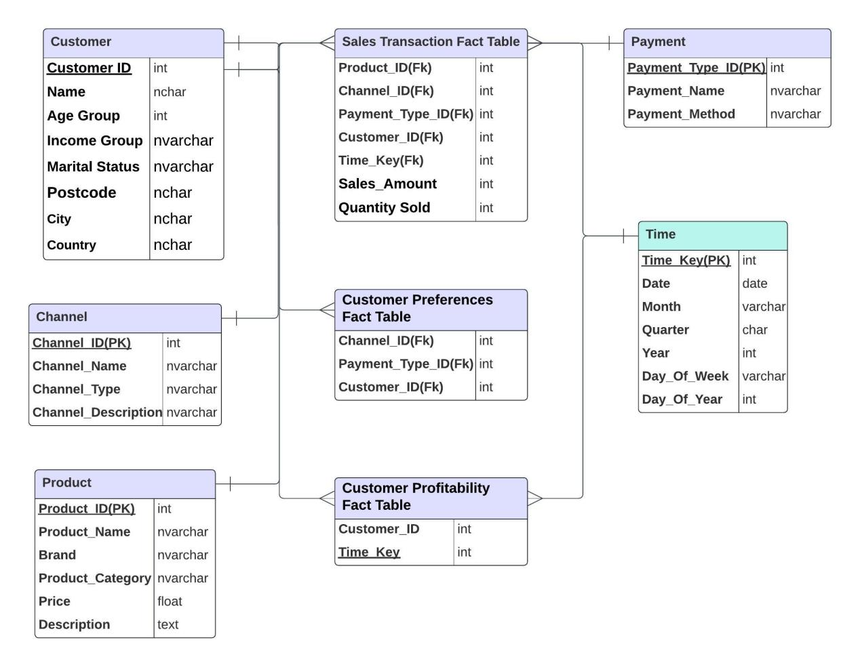**

**Dummy Data Entry Queries:**

**Customer\_Dimension:**

-- Create Customer table

CREATE TABLE Customer (

Customer\_ID INT PRIMARY KEY,

Name VARCHAR(100),

Age\_Group VARCHAR(20),

Income\_Group VARCHAR(20),

Marital\_Status VARCHAR(20),

Postcode VARCHAR(20),

City VARCHAR(100),

Country VARCHAR(100),

Email VARCHAR(100),

Phone\_Number VARCHAR(20)

);

-- Insert data into Customer table

INSERT INTO Customer (Customer\_ID, Name, Age\_Group, Income\_Group, Marital\_Status, Postcode, City, Country, Email, Phone\_Number)

VALUES

(1, 'John Doe', '25-34', 'High', 'Married', '12345', 'New York', 'USA', 'john@example.com', '123-456-7890'),

(2, 'Alice Smith', '18-24', 'Medium', 'Single', '67890', 'Los Angeles', 'USA', 'alice@example.com', '987-654-3210'),

(3, 'Bob Johnson', '35-44', 'Low', 'Divorced', '54321', 'Chicago', 'USA', 'bob@example.com', '111-222-3333'),

(4, 'Emily Davis', '25-34', 'High', 'Married', '13579', 'London', 'UK', 'emily@example.com', '444-555-6666'),

(5, 'Michael Brown', '35-44', 'Medium', 'Single', '24680', 'Sydney', 'Australia', 'michael@example.com', '777-888-9999'),

(6, 'Sophia Johnson', '18-24', 'Low', 'Single', '97531', 'Houston', 'USA', 'sophia@example.com', '222-333-4444'),

(7, 'Oliver Williams', '25-34', 'Medium', 'Married', '88888', 'San Francisco', 'USA', 'oliver@example.com', '555-666-7777'),

(8, 'Emma Brown', '35-44', 'High', 'Divorced', '44444', 'Miami', 'USA', 'emma@example.com', '999-000-1111'),

(9, 'William Wilson', '45-54', 'High', 'Single', '66666', 'Austin', 'USA', 'william@example.com', '123-456-7890'),

(10, 'Mia Taylor', '18-24', 'Low', 'Married', '11111', 'Seattle', 'USA', 'mia@example.com', '987-654-3210');

**Product:**

CREATE TABLE Product (

Product\_ID INT PRIMARY KEY,

Product\_Name VARCHAR(100),

Product\_Category VARCHAR(50),

Brand VARCHAR(50),

Description VARCHAR(255)

);

-- Insert dummy data into the existing 'Products' table

INSERT INTO Product (Product\_ID, Product\_Name, Product\_Category, Brand, Description)

VALUES

(1, 'Smartphone\_XYZ', 'Smartphones', 'ABC Electronics', 'This is a smartphone description.'),

(2, 'Laptop ABC', 'Laptops', 'XYZ Computers', 'This is a laptop description.'),

(3, 'Headphones HD', 'Headphones', 'AudioTech', 'This is a headphone description.'),

(4, 'Tablet QWERTY', 'Tablets', 'TechCo', 'This is a tablet description.'),

(5, 'Smartwatch 123', 'Wearable Tech', 'TechGadgets', 'This is a smartwatch description.'),

(6, 'Camera SuperShot', 'Cameras', 'SnapTech', 'This is a camera description.'),

(7, 'Gaming Console X', 'Gaming Consoles', 'GameMaster', 'This is a gaming console description.'),

(8, 'TV UltraView', 'Televisions', 'ViewTech', 'This is a TV description.'),

(9, 'Printer FastPrint', 'Printers', 'PrintPro', 'This is a printer description.'),

(10, 'Router SpeedNet', 'Networking', 'NetTech', 'This is a router description.');

**Time Dimension:**

-- Create TimeTable

CREATE TABLE TimeTable (

Time\_Key INT PRIMARY KEY,

Date DATE,

Month VARCHAR(10),

Quarter VARCHAR(10),

Year INT

);

-- Insert data into TimeTable

INSERT INTO TimeTable (Time\_Key, Date, Month, Quarter, Year)

VALUES

(1, '2024-01-01', 'January', 'Q1', 2024),

(2, '2024-02-15', 'February', 'Q1', 2024),

(3, '2024-03-20', 'March', 'Q1', 2024),

(4, '2024-04-05', 'April', 'Q2', 2024),

(5, '2024-05-10', 'May', 'Q2', 2024),

(6, '2024-06-15', 'June', 'Q2', 2024),

(7, '2024-07-01', 'July', 'Q3', 2024),

(8, '2024-08-10', 'August', 'Q3', 2024),

(9, '2024-09-15', 'September', 'Q3', 2024),

(10, '2024-10-05', 'October', 'Q4', 2024);

**Channel:**

-- Create Channel table

CREATE TABLE Channel\_Dim (

Channel\_ID INT PRIMARY KEY,

Channel\_Name VARCHAR(100),

Channel\_Type VARCHAR(50),

Channel\_Description VARCHAR(255)

);

-- Insert data into Channel table

INSERT INTO Channel\_Dim (Channel\_ID, Channel\_Name, Channel\_Type, Channel\_Description)

VALUES

(1, 'News Channel', 'News', '24/7 news coverage with breaking news and analysis.'),

(2, 'Sports Channel', 'Sports', 'Live sports events, highlights, and expert commentary.'),

(3, 'Entertainment Channel', 'Entertainment', 'Movies, TV shows, and celebrity interviews.'),

(4, 'Music Channel', 'Music', 'Latest music videos, artist interviews, and music news.'),

(5, 'Tech Channel', 'Technology', 'In-depth coverage of the latest technology trends and innovations.'),

(6, 'Cooking Channel', 'Food', 'Cooking shows, recipes, and culinary tips.'),

(7, 'Travel Channel', 'Travel', 'Explore the world with travel documentaries and destination guides.'),

(8, 'Fashion Channel', 'Fashion', 'Fashion shows, trends, and style tips from industry experts.'),

(9, 'Documentary Channel', 'Documentary', 'Informative documentaries on various topics.'),

(10, 'Health Channel', 'Health', 'Wellness tips, fitness routines, and medical advice.');

**Payment:**

-- Create PaymentType table

CREATE TABLE PaymentType (

Payment\_Type\_ID INT PRIMARY KEY,

Payment\_Name VARCHAR(100),

Payment\_Method VARCHAR(50)

);

-- Insert data into PaymentType table

INSERT INTO PaymentType (Payment\_Type\_ID, Payment\_Name, Payment\_Method)

VALUES

(1, 'Credit Card', 'Online Payment'),

(2, 'Debit Card', 'Online Payment'),

(3, 'PayPal', 'Online Payment'),

(4, 'Cash', 'In-Person Payment'),

(5, 'Bank Transfer', 'Online Payment'),

(6, 'Cryptocurrency', 'Digital Payment'),

(7, 'Cheque', 'In-Person Payment'),

(8, 'Mobile Wallet', 'Digital Payment'),

(9, 'Gift Card', 'Online Payment'),

(10, 'Wire Transfer', 'Online Payment');

**Country Sub Dimension table For Constellation Schema:**

**CREATE TABLE Country ( Country\_ID INT PRIMARY KEY, Country\_Name NVARCHAR(50) -- Other country-related columns );**

**INSERT INTO Country (Country\_ID, Country\_Name) VALUES (1, 'USA'), (2, 'Canada'), (3, 'United Kingdom'), (4, 'Germany'), (5, 'France'), (6, 'Australia'), (7, 'Japan'), (8, 'Brazil'), (9, 'India'), (10, 'South Africa');**

**Sales Transaction Fact Table:**

-- Create SalesTransactionFact table

CREATE TABLE SalesTransactionFact (

Product\_ID INT,

Channel\_ID INT,

Payment\_Type\_ID INT,

Customer\_ID INT,

Time\_Key INT,

Sales\_Amount DECIMAL(10, 2), -- Assuming a decimal data type for sales amount

Quantity\_Sold INT,

FOREIGN KEY (Product\_ID) REFERENCES Product(Product\_ID),

FOREIGN KEY (Channel\_ID) REFERENCES Channel(Channel\_ID),

FOREIGN KEY (Payment\_Type\_ID) REFERENCES PaymentType(Payment\_Type\_ID),

FOREIGN KEY (Customer\_ID) REFERENCES Customer(Customer\_ID),

FOREIGN KEY (Time\_Key) REFERENCES TimeTable(Time\_Key)

);

**Customer Preferences Fact Table**

-- Create CustomerPreferencesFact table

CREATE TABLE CustomerPreferencesFact (

Customer\_ID INT,

Channel\_ID INT,

Payment\_Type\_ID INT,

FOREIGN KEY (Customer\_ID) REFERENCES Customer(Customer\_ID),

FOREIGN KEY (Channel\_ID) REFERENCES Channel(Channel\_ID),

FOREIGN KEY (Payment\_Type\_ID) REFERENCES PaymentType(Payment\_Type\_ID)

);

**Customer Profitability Fact Table**

-- Create CustomerProfitabilityFact table

CREATE TABLE CustomerProfitabilityFact (

Customer\_ID INT,

Time\_Key INT,

FOREIGN KEY (Customer\_ID) REFERENCES Customer(Customer\_ID),

FOREIGN KEY (Time\_Key) REFERENCES TimeTable(Time\_Key)

);

**Normalization:**

**1NF:**

Normalizing the tables from 1st Normal Form (1NF) to Boyce-Codd Normal Form (BCNF) involves analyzing the data and dependencies between columns in each table. Based on the data, let's structure the tables and normalize them accordingly.

1. **Customer\_Dimension(1NF) :**

CREATE TABLE Customer\_Dimension (

Customer\_ID INT PRIMARY KEY,

Name VARCHAR(50),

Age\_Group VARCHAR(10),

Income\_Group VARCHAR(50),

Marital\_Status VARCHAR(20),

Postcode VARCHAR(10),

City VARCHAR(50),

Country VARCHAR(50),

Email VARCHAR(100),

Phone\_Number VARCHAR(20)

);

**2. Product Table (1NF):**

CREATE TABLE Product (

Product\_ID INT PRIMARY KEY,

Product\_Name VARCHAR(50),

Product\_Category VARCHAR(50),

Brand VARCHAR(50),

Description TEXT

);

**3. Time Dimension Table (1NF):**

CREATE TABLE Time\_Dimension (

Time\_Key INT PRIMARY KEY,

Date DATE,

Month VARCHAR(20),

Quarter VARCHAR(5),

Year INT

);

**4. Channel Table (1NF):**

CREATE TABLE Channel (

Channel\_ID INT PRIMARY KEY,

Channel\_Name VARCHAR(50),

Channel\_Type VARCHAR(50),

Channel\_Description TEXT

);

**5. Payment Table (1NF):**

CREATE TABLE Payment (

Payment\_Type\_ID INT PRIMARY KEY,

Payment\_Name VARCHAR(50),

Payment\_Method VARCHAR(20)

);

**6. Sales Transaction Fact Table (1NF):**

CREATE TABLE Sales\_Transaction\_Fact (

Sales\_Transaction\_ID INT PRIMARY KEY,

Product\_ID INT,

Channel\_ID INT,

Payment\_Type\_ID INT,

Customer\_ID INT,

Time\_Key INT,

FOREIGN KEY (Product\_ID) REFERENCES Product(Product\_ID),

FOREIGN KEY (Channel\_ID) REFERENCES Channel(Channel\_ID),

FOREIGN KEY (Payment\_Type\_ID) REFERENCES Payment(Payment\_Type\_ID),

FOREIGN KEY (Customer\_ID) REFERENCES Customer(Customer\_ID),

FOREIGN KEY (Time\_Key) REFERENCES Time\_Dimension(Time\_Key)

);

**7. Customer Preferences Fact Table (1NF):**

CREATE TABLE Customer\_Preferences\_Fact (

Customer\_Preferences\_ID INT PRIMARY KEY,

Customer\_ID INT,

Channel\_ID INT,

Payment\_Type\_ID INT,

FOREIGN KEY (Customer\_ID) REFERENCES Customer(Customer\_ID),

FOREIGN KEY (Channel\_ID) REFERENCES Channel(Channel\_ID),

FOREIGN KEY (Payment\_Type\_ID) REFERENCES Payment(Payment\_Type\_ID)

);

**8. Customer Profitability Fact Table (1NF):**

CREATE TABLE Customer\_Profitability\_Fact (

Customer\_Profitability\_ID INT PRIMARY KEY,

Customer\_ID INT,

Time\_Key INT,

FOREIGN KEY (Customer\_ID) REFERENCES Customer(Customer\_ID),

FOREIGN KEY (Time\_Key) REFERENCES Time\_Dimension(Time\_Key)

);

**2nd Normal Form (2NF):**

**Customer(2NF):**

The table appears to be in 2NF as all attributes seem to depend on the whole primary key (Customer\_ID).

**Product Table (2NF):**

The Product table doesn't seem to have composite keys, and all non-prime attributes appear to depend on the whole primary key (Product\_ID). Thus, it's already in 2NF.

**Time Dimension Table (2NF):**

The Time\_Dimension table appears to be in 2NF as all attributes seem to depend on the primary key (Time\_Key).

**Channel Table (2NF):**

The Channel table appears to be in 2NF as all attributes seem to depend on the primary key (Channel\_ID).

**Payment Table (2NF):**

The Payment table appears to be in 2NF as all attributes seem to depend on the primary key (Payment\_Type\_ID).

**Sales Transaction Fact Table (2NF):**

The Sales\_Transaction\_Fact table might already be in 2NF as all attributes seem to depend on the composite primary key or foreign keys.

**Customer Preferences Fact Table (2NF):**

The Customer\_Preferences\_Fact table might be in 2NF as all attributes appear to depend on the composite primary key or foreign keys.

**Customer Profitability Fact Table (2NF):**

The Customer\_Profitability\_Fact table might be in 2NF as all attributes seem to depend on the composite primary key or foreign keys.

**3rd Normal Forms:**

**3rd Normal Form (3NF):** Based on the assumption that Postcode, City, and Country are dependent on each other:

CREATE TABLE Customer\_Location (

Postcode VARCHAR(10) PRIMARY KEY,

City VARCHAR(50),

Country VARCHAR(50)

);

ALTER TABLE Customer\_Dimension

ADD FOREIGN KEY (Postcode) REFERENCES Customer\_Location(Postcode);

**3rd Normal Form (3NF):**

To fully determine 3NF, we need to identify transitive dependencies between non-prime attributes. Unfortunately, the table structures don't explicitly reveal these dependencies.

**Boyce-Codd Normal Form (BCNF):**

Similarly, for BCNF, we need to ensure that there are no non-trivial functional dependencies where the determinant is not a superkey. A thorough understanding of the dependencies and constraints is required, which is not explicitly provided in the given data.