### Assignment\_03

**Blue Sky Online Consumer Electronics Retailer**

## 

## IMG_256

## Submitted by

Mehar Hamid Ishfaq

201980038

Muhammad Nadeem

201980050

Muhammad Bilal Butt

191980015

**Submitted to**

Sir Hamza Ali

**Department of Data Science,**

GIFT University, Gujranwala

Due : 23-02-2024

**Star Schema’s**

**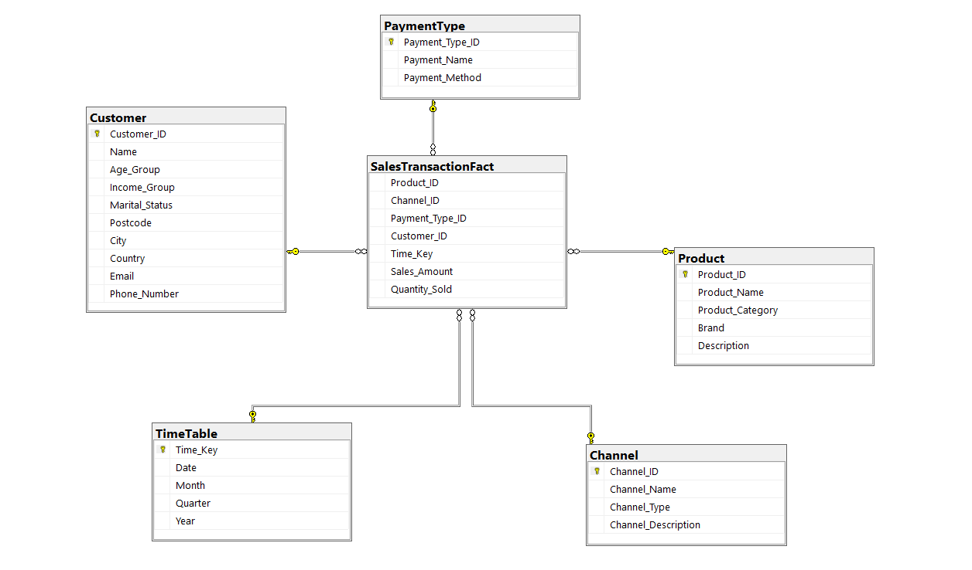**

**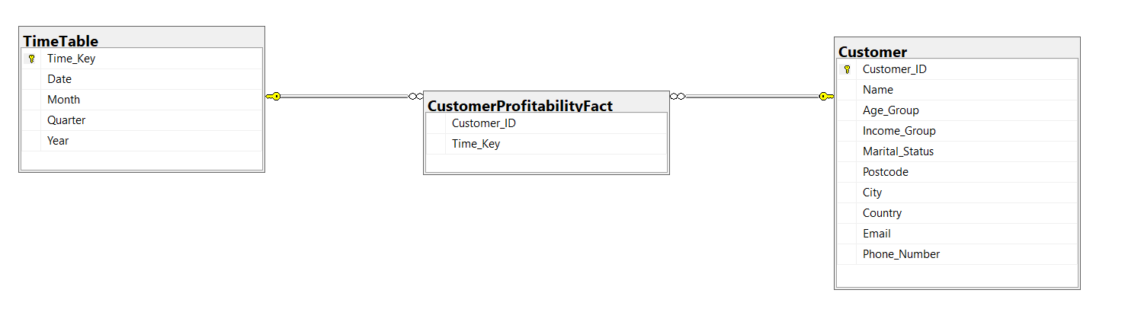**

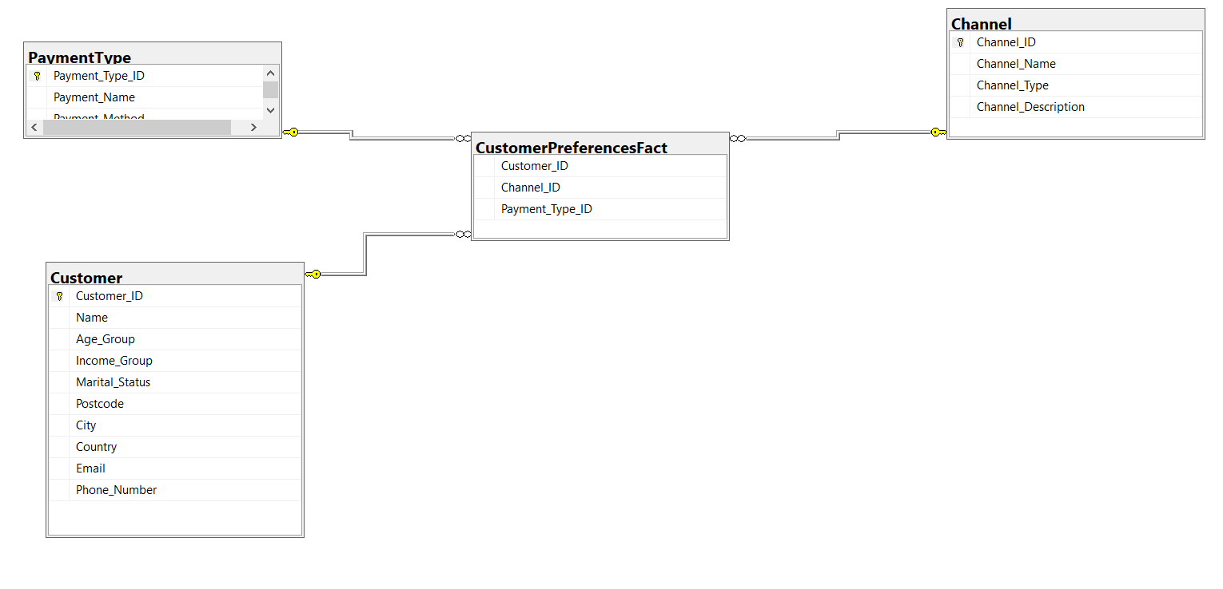

**Snow Flake Schema**

**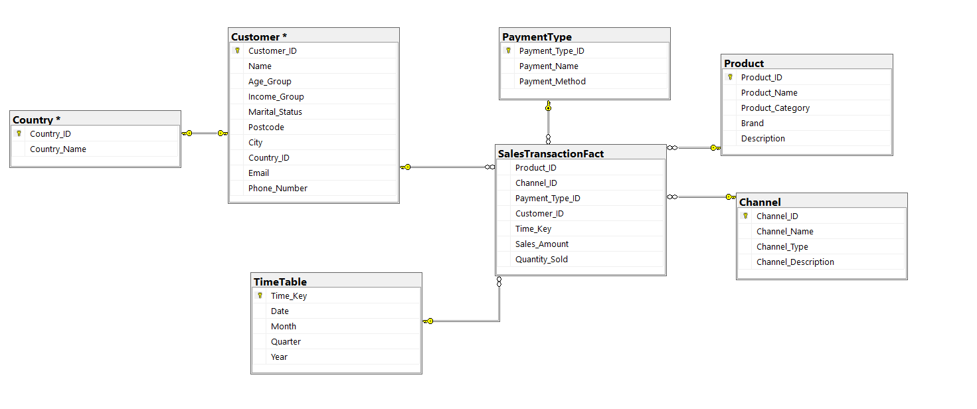**

**Constellation Schema**

