**Muhammad Nadeem 201980050**

**Data Warehouse**

**Lab_Task_3**

**Question:**

1. Create a Job with Title SimpleMsg and Display any Random

message using tMsgBox Component.

2. Create a new job in Talend and Import movies.csv file and use

tLogRow component to show the content of csv file.

We created First job:

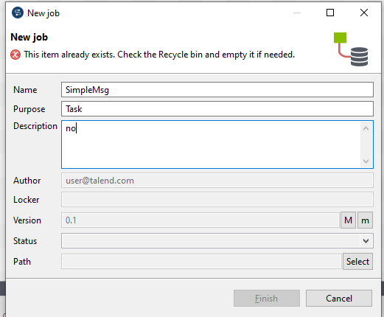

See that it makes properly:

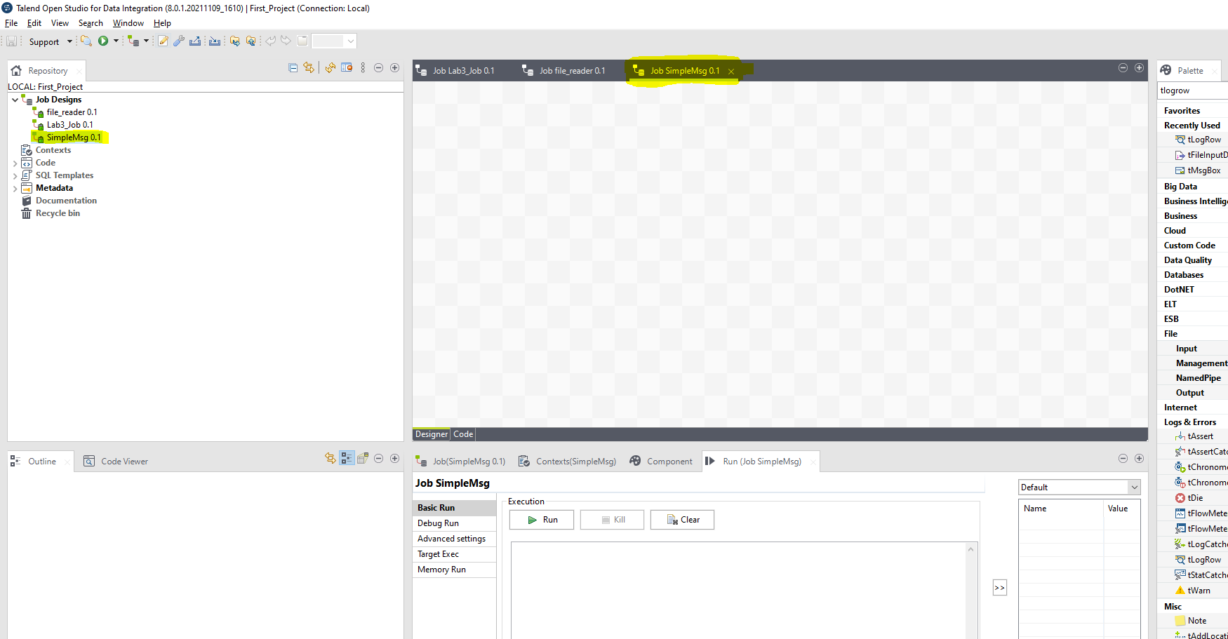

Now show Message :

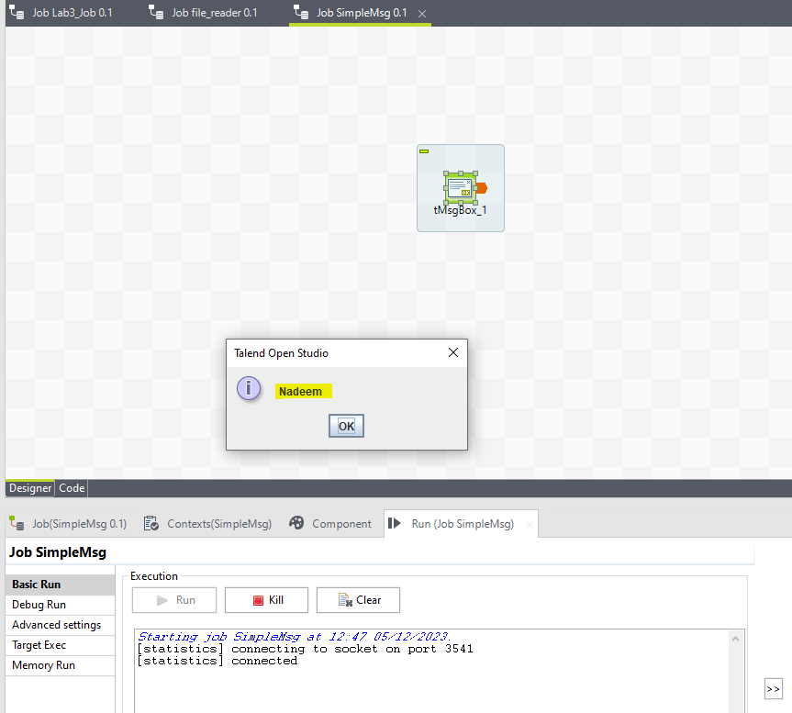

Task Question 1 Done.

Now make 2nd job

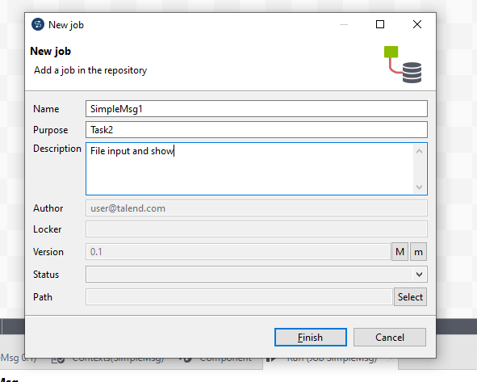

Now configure File Schema etc:

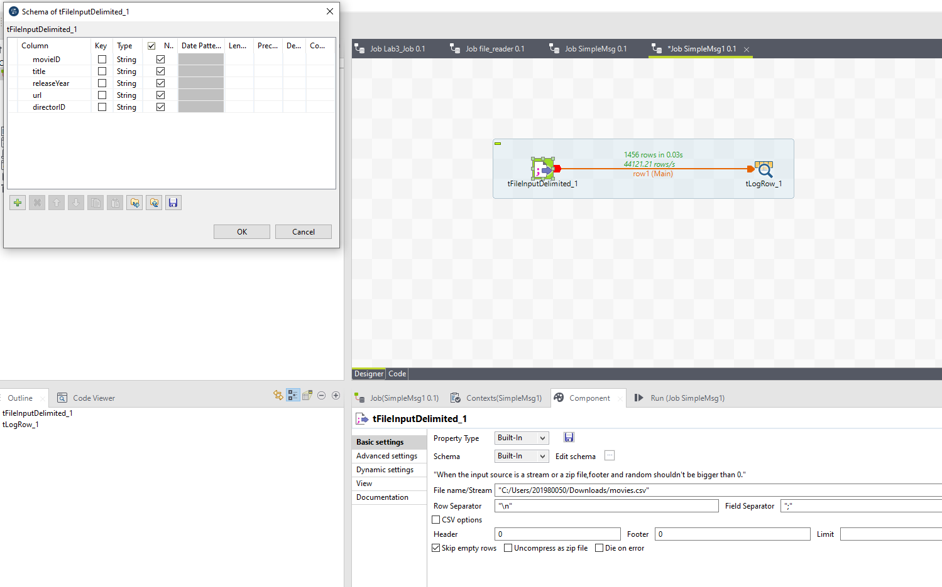

See that gathered successfully:

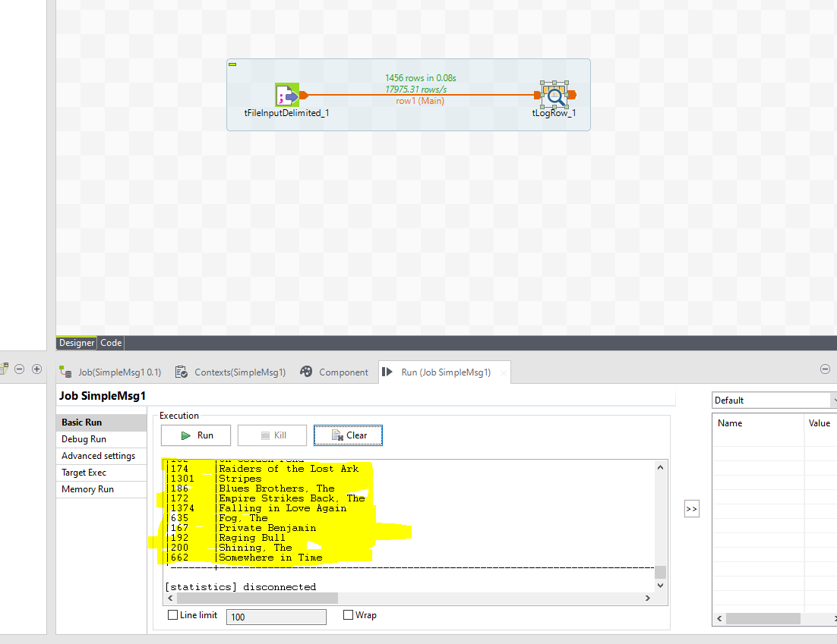

See that proper message show by tMsgRow:

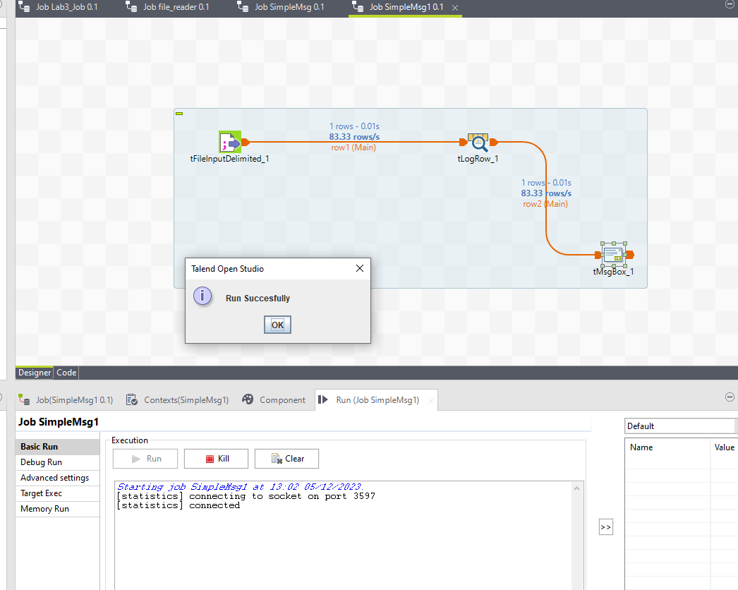

See that filter is properly show Filtered Data.

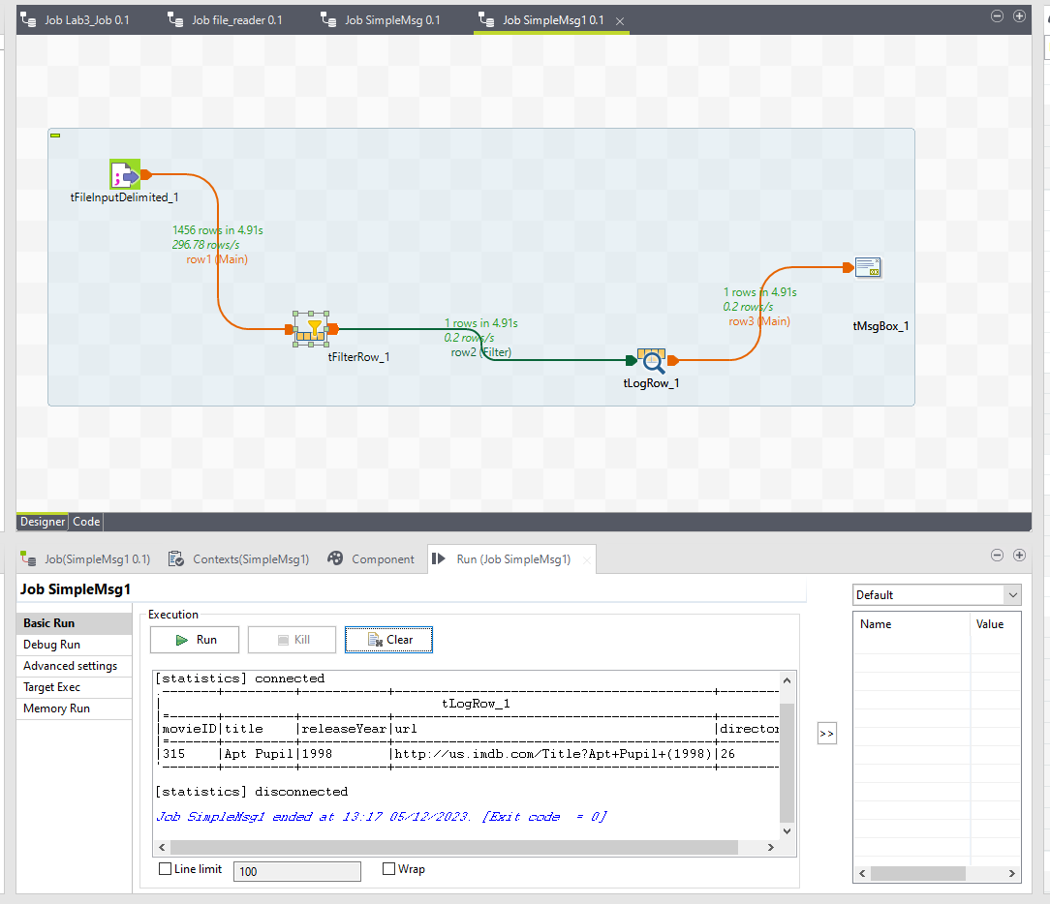

Task 2 also Done.