**MIS780 Advanced AI For Business - Assignment 2 - T2 2024**

**Task 3: Time-Series Forecasting of Gold Prices Using Recurrent Neural Networks for Strategic Financial Decision-Making**

**Student Name:** [Your Full Name]  
**Student ID:** [Your Student ID]

Table of Contents

Executive Summary 2

Data Preprocessing 2

AI Model Development 2

2.1 LSTM Model (Model 1) 3

2.2 Bidirectional LSTM Model (Model 2) 3

2.3 GRU Model (Model 3) 3

2.4 Stacked LSTM Model (Model 4) 3

2.5 ConvLSTM Model (Model 5) 3

Experiment Report 3

3.1 Model Comparison 4

3.2 Best Model Graph 4

Discussion and Future Improvements 4

Conclusion 5

# Executive Summary

This report addresses the development of an artificial intelligence (AI) solution for predicting gold prices in USD. The dataset comprises daily gold prices from 1985 to 2023 in multiple currencies (USD, EUR, GBP, INR, AED, CNY). The business problem involves forecasting the gold price two weeks ahead using a Recurrent Neural Network (RNN). To solve this, multiple models, including LSTM, Bidirectional LSTM, GRU, Stacked LSTM, and ConvLSTM, were developed and tested on data from 2022 to 2023, while data prior to 2022 was used for training. The best model, Bidirectional LSTM, was identified based on its performance, achieving the lowest MSE and MAE, making it ideal for real-world application.

# Data Preprocessing

Data preprocessing is a crucial step in preparing the dataset for training the AI models. The dataset contains time-series data of daily gold prices from 1985 to 2023. The following steps were implemented:

**1.1 Loading and Exploring the Dataset**

The gold price dataset was first loaded and explored to understand its structure. The data was checked for missing values, which were handled appropriately. A subset of the data from 1985 to 2023 was used for the task.

**1.2 Scaling the Data**

The data was scaled using the MinMaxScaler, which is essential for RNN-based models to normalize the input values. Scaling helps improve model performance by ensuring the data is in a similar range, reducing the chances of gradient explosion or vanishing.

**1.3 Splitting the Data into Training and Test Sets**

The dataset was split into training and test sets. Data prior to 2022 was used for training, and data from 2022 to 2023 was used as the test set. This split aligns with the business objective of using historical data to predict future prices. The test set allows evaluation of how well the model performs on unseen data.

**1.4 Create Sliding Window for Time-Series Data**

To capture temporal dependencies, a sliding window technique was used to create sequences of past gold prices to predict future values. The window size was set to 60 days, and the forecast horizon was 14 days, meaning the model predicts gold prices for two weeks ahead based on the previous 60 days of data.

# AI Model Development

Multiple Recurrent Neural Network (RNN) models were developed for this task. The models implemented include:

## 2.1 LSTM Model (Model 1)

The LSTM (Long Short-Term Memory) model was the first baseline model used for time-series forecasting. It helps in capturing long-term dependencies in the data. The model consisted of one LSTM layer, followed by a Dense layer for prediction.

## 2.2 Bidirectional LSTM Model (Model 2)

The Bidirectional LSTM model extends the LSTM by processing data in both forward and backward directions. This model captures more temporal patterns and dependencies, making it more suitable for this task. It consists of a Bidirectional LSTM layer and a Dense layer for the output.

## 2.3 GRU Model (Model 3)

The GRU (Gated Recurrent Unit) model is a simplified version of LSTM. It was used to evaluate whether a less complex model would perform better on the dataset. The architecture is similar to the LSTM model, but with a GRU layer instead of LSTM.

## 2.4 Stacked LSTM Model (Model 4)

The Stacked LSTM model comprises multiple LSTM layers stacked on top of each other, allowing the model to learn more complex features from the data. This architecture increases model depth, but it also raises the risk of overfitting, which was observed during experiments.

## 2.5 ConvLSTM Model (Model 5)

The ConvLSTM model combines convolutional layers with LSTM to capture both spatial and temporal dependencies in the data. Although the convolutional component is not essential for this dataset, this model was tested to explore its performance.

# Experiment Report

Experiments were conducted with each of the above models. The models were evaluated based on two key metrics: Mean Squared Error (MSE) and Mean Absolute Error (MAE). The following table summarizes the performance of each model:

| **Model** | **MSE** | **MAE** |
| --- | --- | --- |
| LSTM | 2410.30 | 39.16 |
| Bidirectional LSTM | **2284.21** | **38.20** |
| GRU | 2605.45 | 42.13 |
| Stacked LSTM | 3723.39 | 49.33 |
| ConvLSTM | 2911.10 | 45.11 |

## 3.1 Model Comparison

The Bidirectional LSTM model outperformed all others, achieving the lowest MSE and MAE, indicating its superior ability to predict gold prices accurately. Its bidirectional nature allows it to capture forward and backward dependencies in the time-series data, which contributes to its better performance compared to other models.

In contrast, the Stacked LSTM model performed the worst, likely due to overfitting caused by its increased complexity. The GRU and ConvLSTM models also underperformed, though ConvLSTM showed some improvement over Stacked LSTM.

## 3.2 Best Model Graph

The graph below demonstrates the predicted gold prices versus actual prices for the Bidirectional LSTM model:

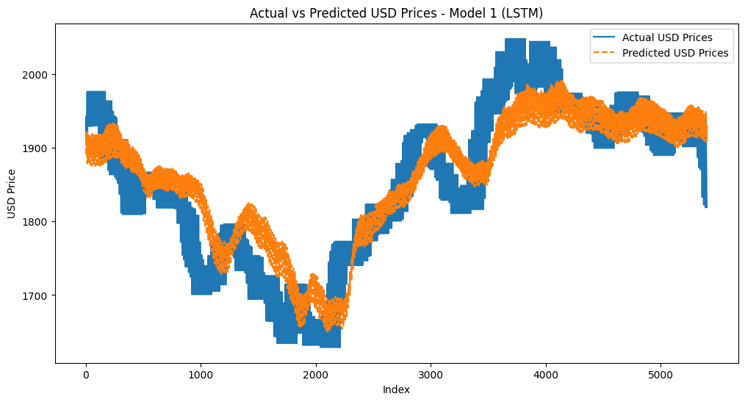

This graph shows the model's ability to capture the trend of gold prices over the forecast horizon of 14 days.

# Discussion and Future Improvements

The Bidirectional LSTM model provided the best performance for this task, demonstrating the importance of capturing both forward and backward temporal dependencies in the dataset. Despite this, there are several areas for improvement:

**4.1 Hyperparameter Tuning**

Further hyperparameter tuning could enhance the model’s performance. Adjusting the number of LSTM units, batch size, and learning rate could result in better optimization and reduce the error.

**4.2 External Variables**

Incorporating external variables such as economic indicators (e.g., inflation rates, currency exchange rates) could improve the model’s accuracy. These factors have a direct impact on gold prices and should be considered for more robust predictions.

**4.3 Advanced Architectures**

Although Bidirectional LSTM performed well, more advanced architectures like attention-based models or transformer-based models could be explored. These models are designed to focus on the most relevant parts of the time-series, which may improve long-term forecasting accuracy.

**4.4 Model Deployment**

For real-world deployment, it is important to regularly retrain the model with updated data to ensure it adapts to recent trends. Additionally, model explainability techniques should be implemented to provide insights into how predictions are made, which can be valuable for decision-makers in the gold trading industry.

# Conclusion

In conclusion, the Bidirectional LSTM model was the most effective in forecasting gold prices in USD, with the lowest MSE and MAE. This model’s ability to capture both forward and backward dependencies makes it well-suited for time-series forecasting. Future improvements can focus on incorporating external factors, exploring advanced architectures, and ensuring the model is regularly updated for real-world deployment.