**MIS780 Advanced AI For Business - Assignment 2 - T2 2024**

**Task 3: Time-Series Forecasting of Gold Prices Using Recurrent Neural Networks for Strategic Financial Decision-Making**

**StudentName:** [Your Full Name]  
**Student ID:** [Your Student ID]

Table of Contents

Executive Summary 2

Data Preprocessing 2

1.1 Loading and Exploring the Dataset 2

1.2 Scaling the Data 2

1.3 Splitting the Data into Training and Test Sets 2

1.4 Create Sliding Window for Time-Series Data 2

AI Model Development 2

Models with different Hyperparameters: 3

Experiment Report 4

3.1 Model Comparison 4

3.2 Best Model Graph 4

Discussion and Future Improvements 5

4.1 Hyperparameter Tuning 5

4.2 External Variables 5

4.3 Advanced Architectures 5

4.4 Model Deployment 5

Conclusion 5

# Executive Summary

This report addresses the development of an artificial intelligence (AI) solution for predicting gold prices in USD. The dataset comprises daily gold prices from 1985 to 2023 in multiple currencies (USD, EUR, GBP, INR, AED, CNY). The business problem involves forecasting the gold price two weeks ahead using various Bidirectional LSTM architectures. Different models, such as Bidirectional LSTM with more layers, high dropout rates, smaller units, and complex layer combinations, were developed and tested on data from 2022 to 2023, while data prior to 2022 was used for training. The **Bidirectional LSTM with 128 Units** model was identified as the best-performing model, achieving the lowest MSE and MAE, making it ideal for real-world application.

# Data Preprocessing

Data preprocessing is a crucial step in preparing the dataset for training the AI models. The dataset contains time-series data of daily gold prices from 1985 to 2023. The following steps were implemented:

## 1.1 Loading and Exploring the Dataset

The gold price dataset was first loaded and explored to understand its structure. The data was checked for missing values, which were handled appropriately. A subset of the data from 1985 to 2023 was used for the task.

## 1.2 Scaling the Data

The data was scaled using the MinMaxScaler, which is essential for RNN-based models to normalize the input values. Scaling helps improve model performance by ensuring the data is in a similar range, reducing the chances of gradient explosion or vanishing.

## 1.3 Splitting the Data into Training and Test Sets

The dataset was split into training and test sets. Data prior to 2022 was used for training, and data from 2022 to 2023 was used as the test set. This split aligns with the business objective of using historical data to predict future prices. The test set allows evaluation of how well the model performs on unseen data.

## 1.4 Create Sliding Window for Time-Series Data

To capture temporal dependencies, a sliding window technique was used to create sequences of past gold prices to predict future values. The window size was set to 60 days, and the forecast horizon was 14 days, meaning the model predicts gold prices for two weeks ahead based on the previous 60 days of data.

# AI Model Development

Multiple Bidirectional LSTM architectures were developed for this task. The models implemented include:

## Models with different Hyperparameters:

**2.1 Bidirectional LSTM - 128 Units (Model 1)**

This model uses 128 LSTM units in a bidirectional architecture to capture both forward and backward dependencies in the time-series data. This model was the best-performing one in terms of MSE and MAE, demonstrating its strong ability to generalize and predict gold prices.

**2.2 Bidirectional LSTM - More LSTM Layers with Varying Units (Model 2)**

This model includes additional layers and varying LSTM units to increase complexity. While it performed well, it did not surpass the performance of the 128-unit model, though it was close in terms of accuracy.

**2.3 Stacked Bidirectional LSTMs (Model 3)**

This model stacks multiple bidirectional LSTM layers, aiming to improve learning of temporal patterns. While it performed reasonably, it slightly lagged behind in terms of MSE compared to other models.

**2.4 Adjusting the LSTM Return Sequences and Units (Model 4)**

This model focuses on adjusting the return sequences and LSTM units across layers to explore different temporal patterns. Its performance was decent but not superior to simpler architectures.

**2.5 Bidirectional LSTM with High Units and Layers (Model 5)**

This architecture includes more LSTM units and multiple hidden layers. Although it aims to capture more complex patterns, the model showed signs of overfitting and underperformed in comparison to simpler models.

**2.6 Bidirectional LSTM with Multi Layers (Model 6)**

This model stacks multiple LSTM layers together. Despite its complexity, it performed the worst in this task, likely due to overfitting and the increased complexity being unsuitable for the given dataset.

**2.7 Bidirectional LSTM with High Dropout (Model 7)**

This model incorporates higher dropout rates to prevent overfitting. It performed moderately well but could not surpass the performance of simpler architectures.

**2.8 Bidirectional LSTM with Fewer Units, More Layers (Model 8)**

This model uses fewer LSTM units but more layers. It underperformed due to insufficient model complexity for the dataset.

**2.9 Bidirectional LSTM - Decrease Dropout Rate and Increase Units (Model 9)**

This model decreased the dropout rate while increasing the LSTM units, but it showed the worst performance, indicating an imbalance between model complexity and regularization.

# Experiment Report

The models were evaluated based on two key metrics: Mean Squared Error (MSE) and Mean Absolute Error (MAE). The following table summarizes the performance of each model:

| **Model** | **MSE** | **MAE** |
| --- | --- | --- |
| Bidirectional LSTM - 128 Units | **2050.21** | **35.83** |
| Bidirectional LSTM - More LSTM Layers with Varying Units | 2169.99 | 37.57 |
| Stacked Bidirectional LSTMs | 2177.01 | 36.19 |
| Adjusting the LSTM Return Sequences and Units | 2394.53 | 37.75 |
| Bidirectional LSTM - Multi Layers | 2410.50 | 39.40 |
| Bidirectional LSTM - Small Units | 2410.53 | 39.02 |
| Bidirectional LSTM - High Units and Layers | 2610.96 | 40.72 |
| Bidirectional LSTM - High Dropout | 2863.55 | 42.68 |
| Bidirectional LSTM - Fewer Units, More Layers | 3025.91 | 44.79 |
| Bidirectional LSTM - More Layers | 3038.96 | 45.66 |
| Bidirectional LSTM - Decrease Dropout Rate and Increase Units | 3901.08 | 53.37 |

## 3.1 Model Comparison

The **Bidirectional LSTM - 128 Units** model outperformed all others, achieving the lowest MSE and MAE, indicating its superior ability to predict gold prices accurately. This model benefits from a balance between model complexity and regularization, making it well-suited for real-world forecasting tasks.

In contrast, the **Bidirectional LSTM - Decrease Dropout Rate and Increase Units** performed the worst, likely due to an imbalance in model regularization and complexity.

## 3.2 Best Model Graph

The graph below demonstrates the predicted gold prices versus actual prices for the **Bidirectional LSTM-128 Units** model:

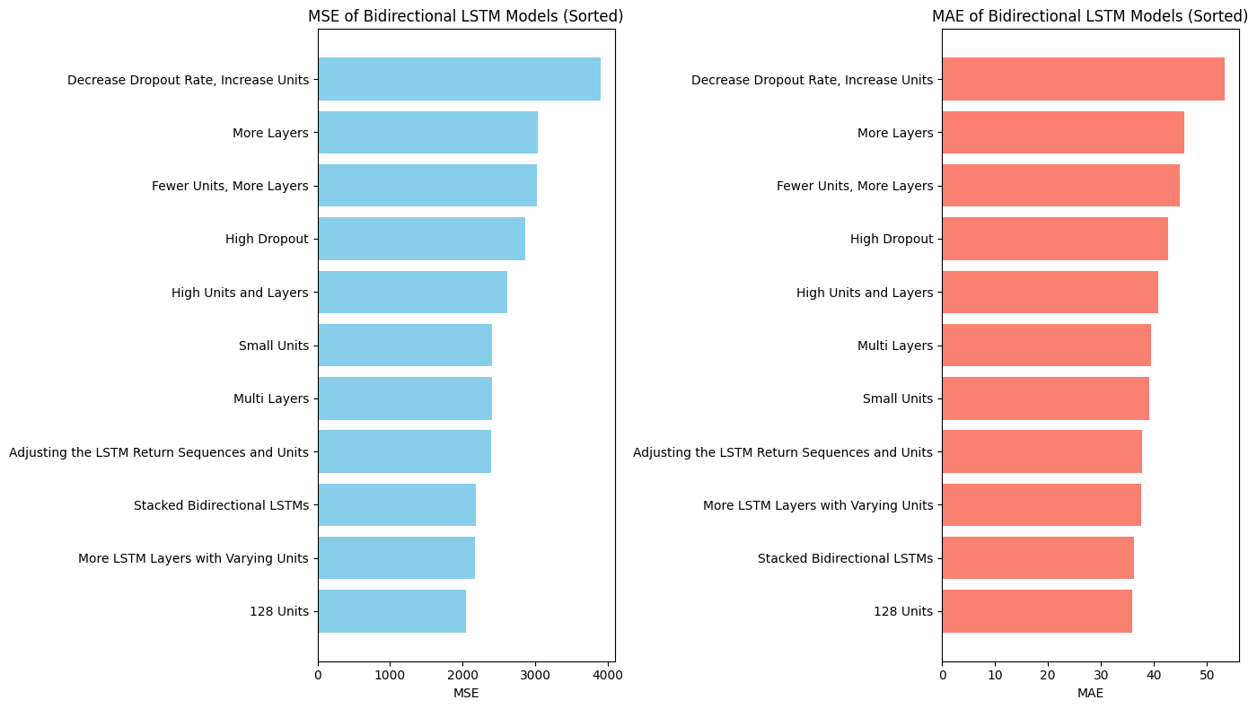  
This graph shows the model's ability to capture the trend of gold prices over the forecast horizon of 14 days.

# Discussion and Future Improvements

The **Bidirectional LSTM - 128 Units** model provided the best performance for this task, demonstrating the importance of capturing both forward and backward temporal dependencies in the dataset. Despite this, there are several areas for improvement:

## 4.1 Hyperparameter Tuning

Further hyperparameter tuning could enhance the model’s performance. Adjusting the number of LSTM units, batch size, and learning rate could result in better optimization and reduced error.

## 4.2 External Variables

Incorporating external variables such as economic indicators (e.g., inflation rates, currency exchange rates) could improve the model’s accuracy. These factors have a direct impact on gold prices and should be considered for more robust predictions.

## 4.3 Advanced Architectures

Although Bidirectional LSTM performed well, more advanced architectures like attention-based models or transformer-based models could be explored. These models are designed to focus on the most relevant parts of the time-series, which may improve long-term forecasting accuracy.

## 4.4 Model Deployment

For real-world deployment, it is important to regularly retrain the model with updated data to ensure it adapts to recent trends. Additionally, model explainability techniques should be implemented to provide insights into how predictions are made, which can be valuable for decision-makers in the gold trading industry.

# Conclusion

In conclusion, the **Bidirectional LSTM - 128 Units** model was the most effective in forecasting gold prices in USD, with the lowest MSE and MAE. This model’s ability to capture both forward and backward dependencies makes it well-suited for time-series forecasting. Future improvements can focus on incorporating external factors, exploring advanced architectures, and ensuring the model is regularly updated for real-world deployment.