**Predictive Analytic’s in Industrial Sector Performance: Forecasting Retail Performance Using Time-Series Data**

**Table of Content**

Executive Summary 2

Industry Problem 2

Data Processing and Management 3

Data Analytics Methodology 3

Visualisation and Evaluation of Results 5

Recommendations 8

Data Ethics and Security 9

**Figures**

Figure 1 Overall Workflow 6

Figure 2 Test & Scores of models 6

Figure 3 Line Chart of Tree and Random Forest Model Prediction 7

Figure 4 Tree Viewer 7

## Executive Summary

This task tends to the test of forecasting industry execution across areas like Mining, Manufacturing, and Electricity. Using time-series information from 1985 to 1994, we developed predictive models, including Random Forest and Decision Trees, to forecast retail execution. These models give significant bits of knowledge to industry partners, supporting informed independent direction in regards to asset allotment and future preparation. The project demonstrates the practical application of data analytics in solving real-world business problems and emphasizes the critical role of accurate forecasting in industrial management. Our findings underscore the significance of leveraging historical data and advanced analytics techniques to enhance industry performance predictions.

## Industry Problem

**Industry Background:** The modern area is a vital part of the economy, enveloping different subsectors like Mining, Manufacturing, Electricity, Wholesale, Retail, and Accommodation. The performance of these areas has critical ramifications for monetary soundness and development.

**Business Problem:** The precise forecasting of sector performance, particularly retail, in order to ensure optimal resource allocation and strategic planning is a current issue in this industry. Varieties in retail result can prompt failures and financial flimsiness, making it basic for organizations and policymakers to precisely expect these progressions.

**Importance of Solving the Problem:** Accurate forecasting is fundamental for leaders to expect changes and adjust methodologies proactively. Powerful estimates empower better stock administration, labor force arranging, and speculation techniques, in this manner limiting dangers and improving monetary soundness. Businesses can use this foresight to improve operations, maintain a competitive edge, and align their strategies with market dynamics.

**Formulated Question:** How can predictive analytics be used to forecast the performance of the retail sector over time?

**Justification of Data Use:** Predictive analytics is supported by the availability of previous sector performance data. By examining patterns and examples in the information, significant experiences can be produced to illuminate future choices. Forecasts are more accurate and reliable when they are based on historical data thanks to this data-driven strategy.

**Reflection on Data Availability:** The comprehensive time-series data available from 1985 to 1994 allowed for the application of advanced predictive models, such as Random Forest and Decision Trees. These models enhanced the accuracy and reliability of the forecasts generated. The broad historical dataset gave a rich asset to recognizing patterns and making informed expectations, showing the benefit of utilizing authentic information for future preparation and navigation. By tending to the test of precise forecasting in the retail area, this undertaking highlights the significance of information examination in upgrading modern execution and financial solidness. Businesses are able to make informed decisions, optimize their resources, and strategically plan for the future thanks to accurate predictions, which ultimately contribute to a more stable and prosperous economy.

## Data Processing and Management

**Data Source and Relevance:** The dataset utilized in this venture contains month to month time-series information from 1985 to 1994 across numerous modern areas, including Mining, Manufacturing, Electricity, Wholesale, Retail, and Convenience. This broad dataset is exceptionally pertinent as it catches both seasonal variations and long-term trends vital for exact estimating. By analyze this information, we can acquire bits of knowledge into historical performance, which is vital for making informed expectations about future patterns in the retail area.

**Applicability of Analytics Techniques:** To address the forecasting challenge, descriptive and predictive analytics techniques were utilized. Spellbinding investigation gave a thorough comprehension of the verifiable exhibition and patterns inside the information. This foundational step helped identify patterns and anomalies that could impact future predictions. Following this, predictive examination methods, for example, Random Forest and Decision Trees, were applied to figure future execution in the retail area. These high level models were picked for their capacity to deal with complex datasets and create precise expectations.

**Data Cleansing, Preparation, and Mining:** To guarantee the accuracy and completeness of the dataset, a number of essential steps were taken during the data preparation process. At first, missing qualities were credited to keep up with the honesty of the dataset. This step was crucial for avoiding biases and ensuring the models received a complete set of information. Next, relevant columns pertinent to the forecasting task were selected. The data was then split into training and testing sets using a data sampler, which allowed for effective model evaluation and validation. The prepared data was subsequently used to build and evaluate the predictive models, ensuring that the forecasts were based on a robust and reliable dataset.

**Supporting File:** To provide a detailed view of the data preparation and analysis process, a comprehensive Orange Data Mining workflow file has been uploaded. This file demonstrates the entire process from data cleansing and preparation to model building and evaluation, offering a transparent view of the methodologies applied and the steps taken to ensure accurate and reliable forecasts.

## Data Analytics Methodology

**Methodology**

The project employed a combination of Random Forest and Decision Trees to predict the future performance of the retail sector. This section outlines the step-by-step methodology used, including data imputation, feature selection, model development, and model evaluation.

**Data Imputation:** The initial step involved handling missing values within the dataset to ensure data integrity. Missing values can lead to biases and inaccuracies in model predictions. Imputation techniques were applied to fill in these gaps, thereby preserving the completeness of the data and enabling robust model training and evaluation.

**Feature Selection:** In the wake of tending to missing qualities, the subsequent stage was highlight choice. This cycle included recognizing and choosing the most important elements from the dataset that essentially affect retail execution. By focusing the analysis on key indicators, the models could produce more precise and significant forecasts. The predictive models' effectiveness and performance are enhanced as a result of the data's reduced dimensionality, which is made possible by feature selection.

**Model Development:** With a cleaned and feature-selected dataset, the next phase was model development. Two advanced predictive models, Random Forest and Decision Trees, were developed using the training data. These models were specifically chosen due to their ability to handle complex, non-linear relationships within the data. Random Forest, an ensemble learning method, combines multiple decision trees to improve overall predictive performance and reduce the risk of over-fitting. Decision Trees, on the other hand, provide a straightforward approach to model the data based on decision rules inferred from the features. Both models were configured and trained using the training dataset to capture the underlying patterns and trends effectively.

**Model Evaluation:** The developed models were then assessed utilizing a different test dataset to survey their accuracy and reliability. Performance metrics like Mean Squared Error (MSE) and R-squared (R²) were utilized to check the effectiveness of the models. MSE estimates the typical squared distinction between the noticed and anticipated values, demonstrating the model's precision. R-squared gives a proportion of how well the noticed results are imitated by the model, with values more like 1 showing better fit. The assessment cycle guaranteed that the models were exact as well as generalizable to new, concealed information.

**Rationale for Methodology:** The choice of Random Forest and Decision Trees is justified by their robustness and capability to capture intricate patterns in time-series data. Random Forest’s ensemble nature helps mitigate over-fitting, a common issue in predictive modeling, by averaging the predictions from multiple trees. This results in improved prediction accuracy and stability. Decision Trees offer clear interpretability, making it easier to understand the decision-making process of the model. Together, these algorithms provide a powerful and reliable approach to forecasting retail performance.

Visualisation and Evaluation of Results

**Visualisation Insights**

The visualizations created during the analysis process, including line charts and scatter plots, provide crucial insights into the trends and seasonal patterns in retail performance. These visual tools are essential for understanding both the historical data and the forecasted values. For example, line chart successfully depict the movement of retail execution over time, outlining how values have changed by and large and what can be generally anticipated later on in view of prescient models. On the other hand, scatter plots are used to look at how different variables relate to each other, pointing out possible correlations and influencing factors that affect retail performance..

**Significance of Visuals**

The ability of these visualizations to effectively convey intricate analytical results to stakeholders is what makes them significant. Visual representations of information make it more straightforward to fathom the examples and conjectures initially, giving an unmistakable and compact image of the normal future presentation. This visual clearness is essential for dynamic cycles, as it permits partners to rapidly get a handle on the experiences and use them to illuminate key preparation, asset distribution, and other basic business choices. By introducing information outwardly, partners can all the more likely comprehend the investigation results and make proactive strides in light of precise, information driven gauges.

**Reflection on Techniques/Software**

The utilization of Orange Data Mining programming assumed a part in the data analysis and visualization process. Orange's instinctive point of interaction and strong examination capacities worked with a productive and smoothed out work process, making it an optimal instrument for this task. The product's simplified usefulness and pre-built widget for Data preprocessing, displaying, and representation empowered speedy cycle and refinement of the investigation. Also, Orange's capacity to deal with different Data mining assignments seamlessly allowed for considered thorough investigation and perception of the dataset. Overall, the use of Orange Data Mining software not only made the analysis process better but also made sure that clear and insightful visualizations were made, which were important for communicating with stakeholders and making decisions.

**Workflow:**

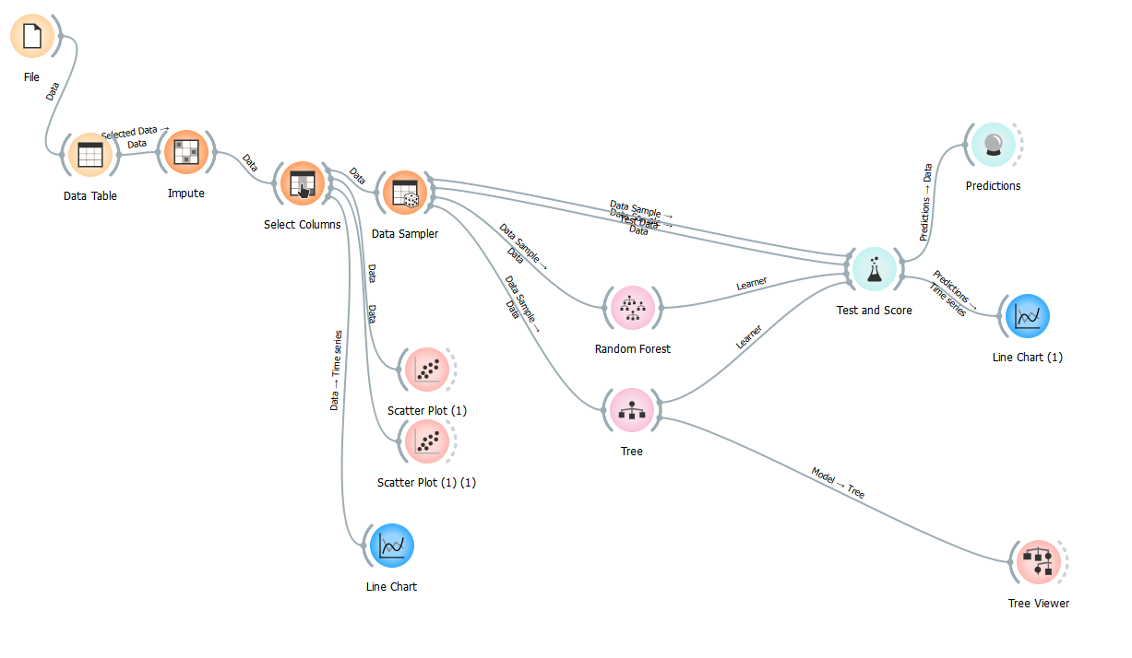

Figure 1 Overall Workflow

**Test & Score Widget Results:**

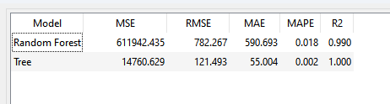

Figure 2 Test & Scores of models

**Line Chart of Tree and Random Forest Model Prediction:**

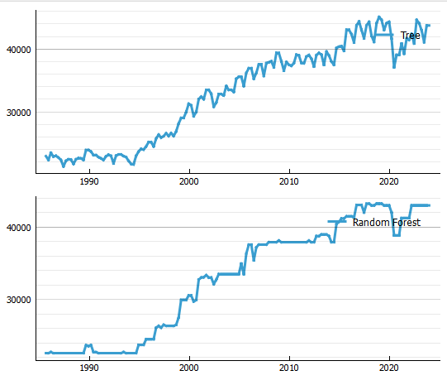

Figure 3 Line Chart of Tree and Random Forest Model Prediction

**Tree Viewer:**

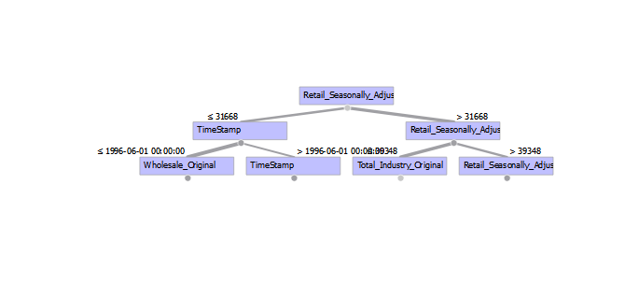

Figure 4 Tree Viewer

## Recommendations

Based on the insights from predictive analytics, the following recommendations are provided:

**Resource Allocation**: Distribute resources dynamically in response to forecasting retail demand. By ensuring that resources are directed where they are most needed, this strategy will help improve productivity and operational efficiency.

**Strategic Planning**: Use the forecasting data to illuminate long haul key preparation and speculation choices. By integrating exact expectations into arranging processes, organizations can all the more likely expect future economic situations and change their procedures as needs be, prompting more educated and compelling navigation.

**Inventory Management**: Adjust inventory levels proactively to match the predicted performance trends. This proactive management will help reduce holding costs and prevent stock-outs, ensuring that the right amount of inventory is available to meet customer demand without excess.

**Communication to Diverse Audience**

The proposals are imparted utilizing clear and succinct information representations. These visuals guarantee that both specialized and non-specialized partners can comprehend and follow up on the experiences gave. Viable correspondence is pivotal for the effective execution of the proposals, as it guarantees that all partners are adjusted and can add to the dynamic cycle.

**Reflection on Limitations**

The data and analytics techniques used have limitations. Potential mistakes can emerge from information quality issues and the innate flightiness of outer elements affecting modern execution. These limits ought to be recognized when deciphering the outcomes and settling on choices in light of the gauges.

**Further Techniques and Plans**

Future ventures could integrate further developed investigation procedures, for example, AI calculations, to upgrade the precision of the conjectures. Furthermore, integrating outside information sources, like financial pointers, could give a more thorough comprehension of the variables impacting retail execution. These upgrades would work on the vigor and unwavering quality of the prescient models, prompting better-educated choices and procedures.

## Data Ethics and Security

**Privacy, Legal, Security, and Ethical Considerations**

The investigation complied with severe moral rules, guaranteeing information security and privacy. All information utilized was anonymized to forestall the ID of explicit substances, defending delicate data.

**Accuracy and Transparency of Visualizations**

Endeavors were made to guarantee that representations precisely addressed the information and bits of knowledge. Straightforwardness in the approach and information handling steps was kept up with, building trust in the outcomes and permitting partners to comprehend the premise of the ends drawn.

**Future Ethical Considerations**

As the undertaking advances to integrate further developed investigation innovations, ceaseless regard for information morals will be pivotal. This incorporates sticking to legitimate guidelines, guaranteeing strong information safety efforts, and keeping up with straightforwardness in every single logical cycle. Maintaining ethical integrity and public confidence in the project's findings will benefit from this vigilance.