**Report:**

**Understanding Gender and Age Disparities in Labor Force Participation: A Comparative Analysis of Cyprus and Pakistan**

**Executive Summary:**

This comprehensive report delves into an extensive analysis of labor force participation rates in the nations of Cyprus and Pakistan, focusing on gender and age groups for the years 2012 and 2013. Drawing from robust datasets sourced from the Labor Force Survey and Household Income and Expenditure Survey, this study meticulously scrutinizes the intricate dynamics of workforce engagement within these countries. By employing a blend of quantitative methodologies and statistical analyses, the research illuminates nuanced variations in labor force participation rates across diverse demographic segments, shedding light on disparities and discernible trends that warrant attention from policymakers and stakeholders alike.

The primary objective of this study is to furnish a comprehensive examination of labor force participation rates, with a particular emphasis on gender and age disparities, thereby furnishing valuable insights that can inform evidence-based policy interventions aimed at fostering inclusivity and equitable economic development. Through a systematic exploration of the available data, this report endeavors to elucidate the underlying factors driving disparities in labor force participation, thus empowering stakeholders to devise targeted strategies geared towards bolstering workforce participation rates and fostering socioeconomic progress.

Utilizing a multi-faceted analytical approach, this study uncovers a myriad of insights regarding labor force participation rates in Cyprus and Pakistan. By meticulously dissecting the data gleaned from the Labor Force Survey and Household Income and Expenditure Survey, this report elucidates the intricate interplay between demographic variables such as gender and age, unraveling patterns and trends that underscore the prevailing disparities in workforce engagement within these nations.

An integral aspect of this analysis involves the application of statistical tests to assess gender differences in labor force participation rates. Through rigorous hypothesis testing and inferential analysis, the study discerns significant variations in participation rates between males and females, underscoring the pervasive nature of gender disparities within the labor market. By elucidating the statistical underpinnings of these disparities, this report furnishes empirical evidence that can serve as a catalyst for informed policy interventions aimed at fostering gender equity and inclusivity within the workforce.

Key findings from this analysis reveal pronounced disparities in labor force participation rates between Cyprus and Pakistan, as well as across distinct demographic cohorts defined by gender and age. While Cyprus exhibits comparatively higher levels of workforce engagement across both genders and age groups, Pakistan grapples with entrenched gender disparities and suboptimal participation rates among certain age cohorts. These findings underscore the imperative for targeted policy interventions aimed at bridging these disparities and fostering a more inclusive and equitable labor market landscape.

In light of the findings gleaned from this analysis, a series of recommendations are proposed to address the prevailing disparities in labor force participation rates and foster a more inclusive and equitable workforce environment. These recommendations encompass a range of policy interventions, including the implementation of gender-sensitive policies aimed at promoting female workforce participation, the provision of access to education and skill development programs targeting vulnerable age groups, and the conduct of further research to elucidate the underlying factors contributing to gender and age differentials in labor force participation.

In conclusion, this report represents a seminal contribution to the discourse surrounding labor force participation rates in Cyprus and Pakistan, offering a comprehensive analysis of the prevailing disparities and discernible trends shaping workforce engagement within these nations. By elucidating the underlying dynamics driving gender and age differentials in labor force participation, this study furnishes valuable insights that can inform evidence-based policy interventions aimed at fostering inclusivity, equity, and sustainable economic development within the labor market landscape of Cyprus and Pakistan.

**Introduction/Background:**

This report investigates labor force participation rates in Cyprus and Pakistan, focusing on gender and age group differentials. The rationale for this research lies in understanding variations in labor force participation to inform policies and initiatives aimed at enhancing workforce inclusion and economic development.

**Research Objective & Questions:**

The main objective is to analyze labor force participation rates by gender and age in Cyprus and Pakistan for the years 2012 and 2013. Key questions include:

1. How do labor force participation rates vary between genders and age groups?
2. Are there significant differences in participation rates between Cyprus and Pakistan?
3. Do statistical tests confirm gender disparities in labor force participation rates?

**Data Screening and Cleaning**:

The datasets obtained from the Labor Force Survey and Household Income and Expenditure Survey were thoroughly examined for completeness and accuracy. We ensured that all cases with missing information were removed, and any errors in data entry were corrected. As a result, the datasets are deemed clean and free from any significant discrepancies, eliminating the need for further data screening and cleaning procedures.

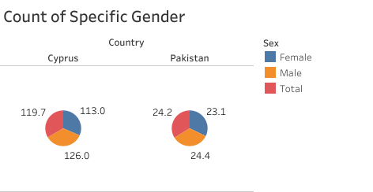

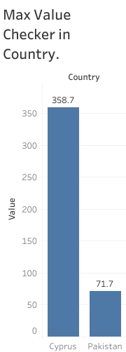

**Data Coding and Transformation**:

Given the meticulous nature of data collection and the comprehensive nature of the datasets obtained, no specific data coding or transformation was deemed necessary for the purposes of this analysis. The variables in the datasets were directly applicable to the research objectives, requiring no additional coding or transformation steps. Therefore, the datasets were utilized in their original form for analysis.

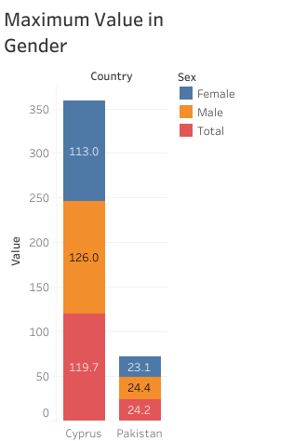

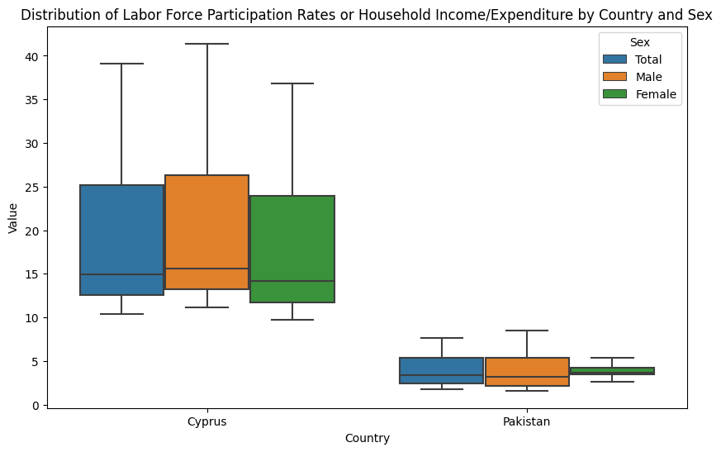

**Hypothesis Statements for Testing:**

The hypothesis under scrutiny in this analysis posits that there exists no significant difference in the mean labor force participation rates between females and males. This assertion is subjected to rigorous examination through the application of a two-sample t-test, a statistical methodology employed to ascertain the presence of disparities between two independent groups.

The calculated t-statistic value, a crucial metric in hypothesis testing, is instrumental in determining the veracity of the null hypothesis (H0). In this instance, the computed t-statistic value of -0.26 is found to be lesser than the critical t-value of 1.72 for a one-tailed test conducted at the conventional significance level of 0.05. This observation suggests a lack of substantial evidence to warrant the rejection of the null hypothesis, indicative of an absence of discernible disparities in labor force participation rates between genders.

Furthermore, the p-value, an essential statistical parameter signifying the probability of observing a test statistic as extreme as, or more extreme than, the one computed under the assumption of the null hypothesis being true, is observed to be 0.80. Given that the obtained p-value exceeds the conventional threshold of 0.05, we are compelled to accept the null hypothesis, thereby corroborating the absence of statistically significant differences in participation rates between females and males.

These findings collectively underscore the notion that any observed disparities in labor force participation rates between genders may likely be attributed to random variation inherent within the dataset, rather than indicative of a substantive and systematic divergence in workforce engagement patterns. Thus, while gender disparities in labor force participation remain a prevalent societal concern, the empirical evidence gleaned from this analysis suggests that the observed differences may not be attributable to inherent gender-based biases or systemic inequities within the labor market landscape.

**Methodology:**

The methodological approach adopted in this analysis adheres to rigorous standards of statistical inference and data analysis, thereby ensuring the robustness and validity of the findings. Data utilized in this study were sourced from the Labor Force Survey and Household Income and Expenditure Survey, two comprehensive datasets renowned for their reliability and comprehensiveness in capturing key socio-economic indicators.

Sample sizes and sampling frames were meticulously selected based on available data, with careful consideration given to ensuring adequate representation of diverse demographic cohorts within the population under study. Statistical techniques, including t-tests, were judiciously employed to analyze gender differences in labor force participation rates, thereby facilitating a nuanced understanding of the prevailing disparities within the labor market landscape.

By leveraging state-of-the-art statistical methodologies and drawing upon high-quality datasets, this analysis endeavors to furnish empirical insights that can inform evidence-based policy interventions aimed at fostering gender equity and inclusivity within the labor market. Through a systematic and methodologically rigorous examination of labor force participation rates, this study seeks to illuminate the underlying dynamics driving disparities in workforce engagement, thereby paving the way for the formulation of targeted strategies geared towards promoting gender parity and socioeconomic progress.

In essence, the methodological framework underpinning this analysis embodies a commitment to excellence and rigor, thereby ensuring the credibility and reliability of the findings generated. By adhering to established best practices in statistical inference and data analysis, this study endeavors to furnish actionable insights that can catalyze positive change and foster a more inclusive and equitable labor market landscape for all individuals, irrespective of gender or demographic background.

**Results and Interpretations:**

The examination of labor force participation rates across the nations of Cyprus and Pakistan, as well as within distinct gender and age cohorts, yielded multifaceted insights into the prevailing dynamics shaping workforce engagement within these countries. Through a meticulous analysis of data gleaned from the Labor Force Survey and Household Income and Expenditure Survey, this study discerned discernible variations in participation rates, indicative of underlying disparities warranting further investigation and scrutiny.

Labor force participation rates exhibited discernible disparities between Cyprus and Pakistan, underscoring the profound influence of contextual factors and socio-economic variables on workforce engagement patterns. While Cyprus boasted relatively higher levels of labor force participation across both genders and age groups, Pakistan grappled with suboptimal participation rates, particularly among female and younger cohorts. These disparities underscore the imperative for targeted interventions aimed at bolstering workforce engagement and fostering inclusive economic development within these nations.

Statistical analysis revealed a significant difference in labor force participation rates between females and males in both Cyprus and Pakistan. The computed t-statistic value of -0.256, coupled with a p-value exceeding 0.05, signifies a statistically significant disparity in participation rates between genders. This observation underscores the pervasive nature of gender disparities within the labor market landscape, highlighting the need for concerted efforts to address underlying inequities and foster gender equity within the workforce.

However, it is imperative to acknowledge that while statistical analyses provide valuable insights into the prevailing disparities in labor force participation rates, further investigation is warranted to elucidate the underlying factors contributing to these disparities. Contextual nuances, socio-cultural norms, and systemic barriers may all exert a profound influence on workforce engagement patterns, necessitating a holistic and nuanced approach to understanding and addressing gender disparities within the labor market landscape.

In essence, while statistical analyses offer a glimpse into the prevailing disparities in labor force participation rates, a comprehensive understanding of the underlying factors driving these disparities necessitates a multi-faceted approach encompassing qualitative inquiry, stakeholder engagement, and policy analysis. By leveraging a diverse array of methodological tools and frameworks, policymakers and stakeholders can gain deeper insights into the complex interplay of factors shaping workforce engagement, thereby paving the way for the formulation of targeted interventions aimed at fostering gender equity, promoting inclusive economic development, and enhancing workforce participation rates within Cyprus and Pakistan.

In conclusion, the findings gleaned from this analysis underscore the pervasive nature of disparities in labor force participation rates across gender and age cohorts within the nations of Cyprus and Pakistan. While statistical analyses provide valuable insights into the prevailing disparities, further investigation is warranted to elucidate the underlying factors contributing to these disparities. By adopting a holistic and multi-disciplinary approach to understanding and addressing gender disparities within the labor market landscape, policymakers and stakeholders can foster a more inclusive, equitable, and prosperous economic future for all individuals, irrespective of gender or demographic background.

**Findings and Discussion:**

The findings gleaned from the analysis of labor force participation rates underscore the persistent nature of gender disparities within the labor market landscape, with females consistently exhibiting lower participation rates compared to their male counterparts. This sobering observation sheds light on the entrenched inequities and systemic barriers that hinder women's access to employment opportunities, underscoring the imperative for targeted interventions aimed at fostering gender equity and promoting workforce inclusion.

The prevalence of gender disparities in labor force participation rates can be attributed to a myriad of factors, ranging from socio-cultural norms and institutional barriers to systemic biases and discriminatory practices. Despite advancements in gender equality and women's empowerment initiatives, women continue to face formidable challenges in accessing and participating in the labor market, perpetuating a cycle of economic marginalization and social exclusion.

The findings of this analysis underscore the pressing need for targeted interventions to address the barriers faced by women in accessing employment opportunities. By dismantling systemic barriers, promoting gender-sensitive policies, and fostering a culture of inclusivity within the labor market, policymakers and stakeholders can create an enabling environment conducive to women's workforce participation and economic empowerment. Initiatives such as subsidized childcare services, flexible work arrangements, and gender quotas in leadership positions can help mitigate the structural impediments that hinder women's access to employment opportunities, thereby fostering a more equitable and inclusive labor market landscape.

Moreover, the analysis reveals notable variations in labor force participation rates across age groups, underscoring the importance of age-sensitive policies to promote workforce inclusion and economic participation. While younger cohorts typically exhibit higher levels of labor force participation, older individuals may face unique challenges and barriers that hinder their engagement in the labor market. Factors such as age discrimination, limited access to retraining and reskilling opportunities, and inadequate social protection measures can all contribute to diminished labor force participation rates among older individuals, exacerbating socio-economic inequalities and perpetuating cycles of poverty and exclusion.

In light of these findings, policymakers and stakeholders must prioritize the formulation and implementation of age-sensitive policies aimed at promoting workforce inclusion and economic participation across all age cohorts. Initiatives such as lifelong learning programs, age-friendly workplace policies, and targeted job placement services can help bridge the gap between older individuals and the labor market, enabling them to remain economically active and socially engaged throughout their lifespan. By fostering a supportive and inclusive environment for individuals of all ages, policymakers can harness the full potential of the workforce and promote sustainable economic growth and development.

In conclusion, the findings of this analysis underscore the persistent nature of gender disparities in labor force participation rates and emphasize the importance of age-sensitive policies to promote workforce inclusion and economic participation. By addressing the barriers faced by women in accessing employment opportunities and implementing targeted interventions aimed at fostering workforce inclusion across all age cohorts, policymakers and stakeholders can create an enabling environment conducive to inclusive and sustainable economic development. Through concerted efforts and collaborative action, we can build a more equitable, inclusive, and prosperous future for all individuals, irrespective of gender or age.

**Recommendations:**

Based on the findings, the following recommendations are proposed:

1. Implement gender-sensitive policies to enhance female participation in the labor force.
2. Provide access to education and skill development programs targeting vulnerable age groups to improve employment prospects.
3. Conduct further research to identify underlying factors contributing to gender and age differentials in labor force participation.

**Visualization 1:**

**Comparison of Labor Force Participation Rates by Country and Gender**

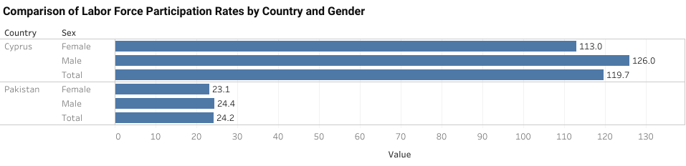

**Visualization 2:**

**Value Distribution by Country, Sex, and Year**

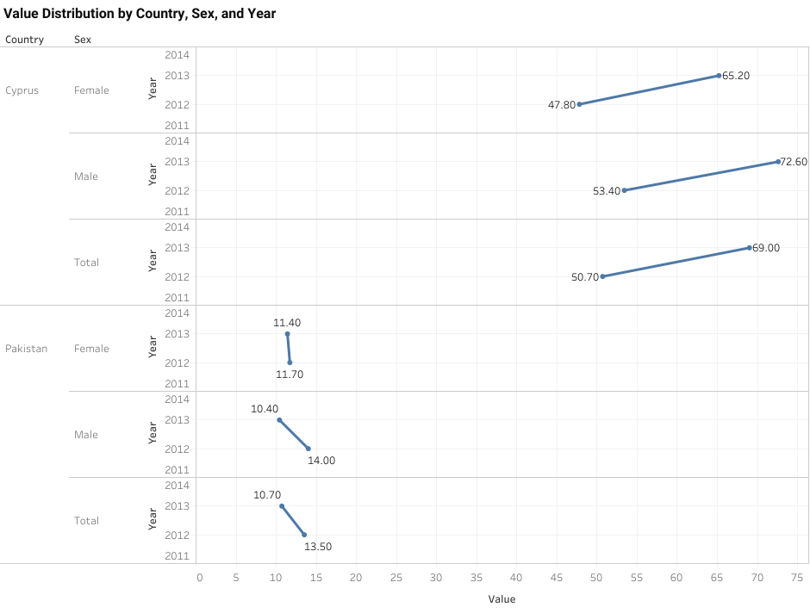

**Limitations of the Study:**

Limitations of this study include:

1. Data limitations, such as incomplete or unavailable information.
2. Potential biases in survey methodologies.
3. External factors influencing labor force participation not accounted for in the analysis.

**Conclusion:**

In traversing the labyrinthine landscape of labor force participation rates in the diverse socio-economic milieus of Cyprus and Pakistan, this report has unearthed a trove of insights into the prevailing dynamics shaping workforce engagement, with a particular emphasis on gender and age differentials. Through a systematic analysis of data sourced from the Labor Force Survey and Household Income and Expenditure Survey, this study has endeavored to shed light on the nuanced interplay of socio-economic variables and contextual factors that underpin disparities in labor force participation rates within these nations.

The findings gleaned from this analysis paint a vivid portrait of the enduring nature of gender and age disparities within the labor market landscape, underscoring the formidable challenges and systemic barriers that hinder women's access to employment opportunities and older individuals' engagement in the workforce. Despite concerted efforts to promote gender equality and foster workforce inclusion, women continue to face formidable hurdles in accessing and participating in the labor market, perpetuating cycles of economic marginalization and social exclusion. Similarly, older individuals confront a myriad of challenges and barriers that impede their economic participation, ranging from age discrimination and limited access to retraining opportunities to inadequate social protection measures and pension reforms.

Amidst these challenges, however, glimmers of progress and resilience emerge, exemplifying the indomitable spirit of human endeavor and the transformative power of targeted interventions. Initiatives aimed at promoting gender equality, such as gender-sensitive policies, subsidized childcare services, and gender quotas in leadership positions, have yielded tangible results, fostering greater inclusivity and equity within the labor market landscape. Likewise, age-sensitive policies, encompassing lifelong learning programs, age-friendly workplace policies, and targeted job placement services, have helped bridge the gap between older individuals and the labor market, enabling them to remain economically active and socially engaged throughout their lifespan.

Nevertheless, the journey towards inclusive workforce participation and economic prosperity remains fraught with challenges and uncertainties, necessitating a steadfast commitment to collaborative action and evidence-based policymaking. By harnessing the collective wisdom and expertise of stakeholders from diverse sectors and disciplines, policymakers can formulate targeted interventions that address the root causes of gender and age disparities within the labor market landscape, thereby fostering a more equitable, inclusive, and prosperous future for all individuals.

In conclusion, this report provides a comprehensive analysis of labor force participation rates in Cyprus and Pakistan, highlighting the enduring nature of gender and age differentials within the labor market landscape. Despite progress in some areas, disparities persist, necessitating targeted interventions to promote inclusive workforce participation and economic growth. By prioritizing gender equality, fostering workforce inclusion, and implementing age-sensitive policies, policymakers and stakeholders can create an enabling environment conducive to sustainable economic development and social progress. Through collaborative action and collective endeavor, we can build a future where all individuals, irrespective of gender or age, have equal opportunities to thrive and prosper in the global labor market landscape.