Name: Muhammad Nadeem

Roll no: 201980050

Section: B

Course: Information Security

Submitted to: Sir Aleem Awan

Targeted Website:

<https://www.uo.edu.pk>

Tool Name:

Zenmap

Find Ip address through cmd.

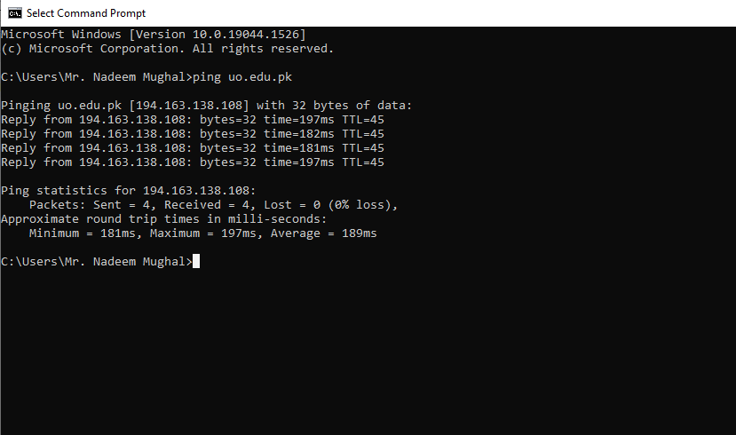

Ip address paste in Zenmap and scan it.

