Design Document (Phase 3)
Project Name: EasePharma
Course: CSAI 203 - Software Engineering
Date: November 22, 2025

1. Introduction
1.1 Purpose of the Document
The purpose of this Design Document is to describe the architectural and detailed design of the EasePharma Online Pharmacy system. It translates the requirements identified in the previous phase into a concrete software structure, defining the system architecture, user interfaces, and file storage models. This document serves as the primary blueprint for developers during the implementation phase.
1.2 Scope of the Design Phase
This document covers the design of the entire EasePharma Monolithic Web Application.
- Architecture: Implementation of the MVC pattern using Python Flask.
- Module Design: Detailed design of the User, Product, and Order modules.
- Data Storage: The File Structure design for the CSV-based storage system.
- User Interface: Wireframes for the Customer Storefront, Shopping Cart, Login, and Admin Dashboard.
- External Interfaces: Simulation logic for the POS (Point of Sale) synchronization.
1.3 Intended Audience
This document is intended for:
- Developers: To understand the class structures and coding requirements.
- Project Manager: To track progress against design goals.
- Course Instructors: To evaluate the application of Software Engineering principles, specifically the MVC pattern.
1.4 Overview of the Contents
Section 2 provides a high-level overview of the system. Section 3 details the System Architecture and technology stack. Section 4 contains the detailed design, including MVC mapping, UML diagrams (Class and Sequence), and UI Wireframes. Section 5 concludes the design decisions.

2. System Overview
2.1 Brief Description of the System
EasePharma is a web-based e-commerce platform designed to allow customers to browse and purchase Over-the-Counter (OTC) medicines. It features a public storefront for customers and a secure dashboard for pharmacists (admins) to manage inventory. The system's unique feature is a POS Synchronization Service, which simulates real-time stock updates from a physical store using simulated input data.
2.2 Key Design Goals and Constraints
- Modularity (MVC): The system is strictly divided into Model, View, and Controller layers to ensure code maintainability and separation of concerns.
- Portability (CSV Storage): To avoid complex database server setups, the system uses CSV files and the Pandas library for data persistence, allowing the system to run in any standard Python environment.
- Simplicity (Monolithic): Given the scope, a monolithic architecture was chosen to reduce deployment complexity while maintaining clear internal structure.

3. Architectural Design
3.1 System Architecture Diagram
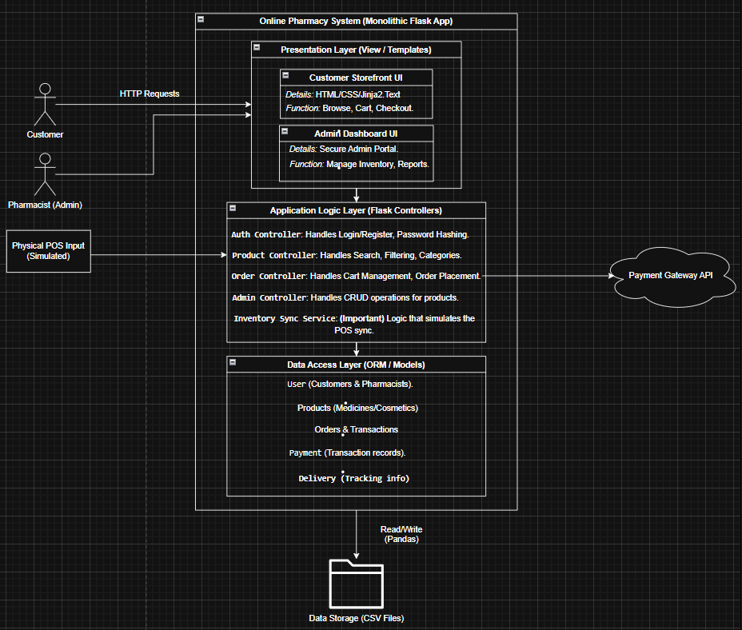
Figure 1: System Architecture Diagram
3.2 Discussion of Architectural Style and Components
The system utilizes a Layered Monolithic Architecture.
- Presentation Layer (View): Handles user interaction via HTML/Jinja2 templates.
- Application Logic Layer (Controller): Contains the Flask route handlers and business logic. It creates the bridge between the UI and the Data.
- Data Access Layer (Model): Manages reading and writing to the CSV files using the Pandas library.
- External Systems: The system integrates with a simulated Physical POS (for stock sync) and a Payment Gateway (for checkout).
3.3 Technology Stack and Tools
- Programming Language: Python 3.x
- Web Framework: Flask
- Data Manipulation: Pandas Library
- Data Storage: CSV Files (Comma Separated Values)
- Frontend: HTML5, CSS3, Bootstrap
- Design Tools: Draw.io (Diagrams & Wireframes)

4. Detailed Design
4.1 Model–View–Controller (MVC) Design Pattern
4.1.1 Description of MVC Pattern
The Model-View-Controller (MVC) pattern is mandated for this project to enforce a clean separation of concerns.
- Model: Manages the system data (CSV files) and the associated business logic/operations.
- View: Defines and manages how the data is presented to the user (HTML Templates).
- Controller: Manages user interaction (requests) and acts as the intermediary between the View and the Model.
Why It Was Chosen:
- Separation of Concerns: Ensures that data handling is kept separate from the user interface.
- Maintainability: Changes to the UI (e.g., redesigning the Admin Dashboard) do not require changes to the underlying business logic.
- Reusability: The backend logic could theoretically serve data to a mobile app in the future without modification.
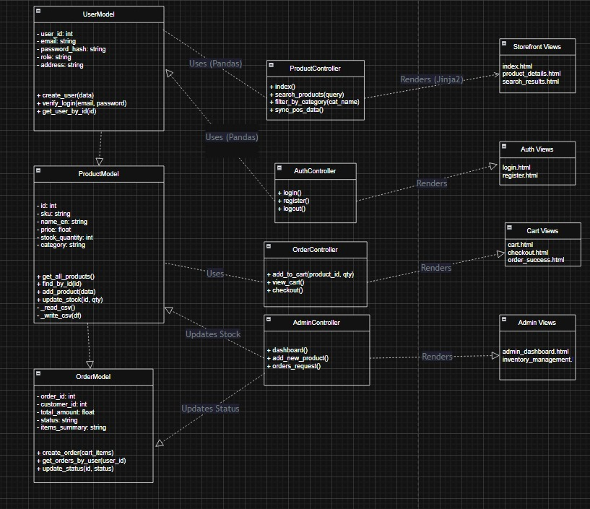
4.1.2 Mapping of Project Components to MVC
MVC Layer | Project Components (from your SRS)
Model Layer | Database Classes (User, Order, Payment, Medicine, ….)  Business Logic:  - Validating password complexity (FR-001),  - Hashing and salting passwords (NFR-001),  - Calculating the shopping cart subtotal (FR-005)  - Automatically decrementing stock when an order is placed (FR-010)  - Simulating the POS inventory sync (FR-012)
View | HTML Templates:  All the html files created  …  …  ..  Customer Storefront Pages:  - Home Page  - Product Browsing/Category Page (from FR-003)  - Product Search Results Page (from FR-004)  - Shopping Cart Page (from FR-005)  - Checkout Pages (from FR-006)  - User Registration Page (from FR-001)  - Login Page (from FR-002)  - Order History Page (from FR-007)  Admin Dashboard Pages:  - Admin Login Portal (FR-008)  - Product Management (CRUD) forms (FR-009)  - Inventory Management view (FR-010)  - Order Management list (FR-011)
Controller | - @app.route('/login', methods=['GET', 'POST'])  This function handles the User Authentication (FR-002).  - @app.route('/register', methods=['GET', 'POST'])  This function handles User Registration (FR-001).  - @app.route('/add_to_cart/<product_id>')  This function handles adding an item to the cart (FR-005).  - @app.route('/admin/products/new')  This function handles showing the form to create a new product (FR-009).  - @app.route('/admin/orders/update/<order_id>')  This function handles updating an order's status (FR-011).

4.1.3 Responsibilities of Model, View, and Controller
- Model: Responsible for data integrity. It reads/writes CSV files via Pandas, validates data types (e.g., ensuring price is positive), and handles logic like password hashing.
- View: Responsible for display. It receives data from the Controller and renders it into HTML pages. It captures user inputs (clicks, form data) and sends them to the Controller.
- Controller: Responsible for orchestration. It receives HTTP requests, decides which Model to call, processes the data, and determines which View to render next.
4.1.4 Interaction Between Components
Data flows linearly: View Controller Model Controller View. (Refer to the Sequence Diagrams below for detailed interaction flows)

4.2 UML Diagrams
4.2.2 Detailed Class Diagram
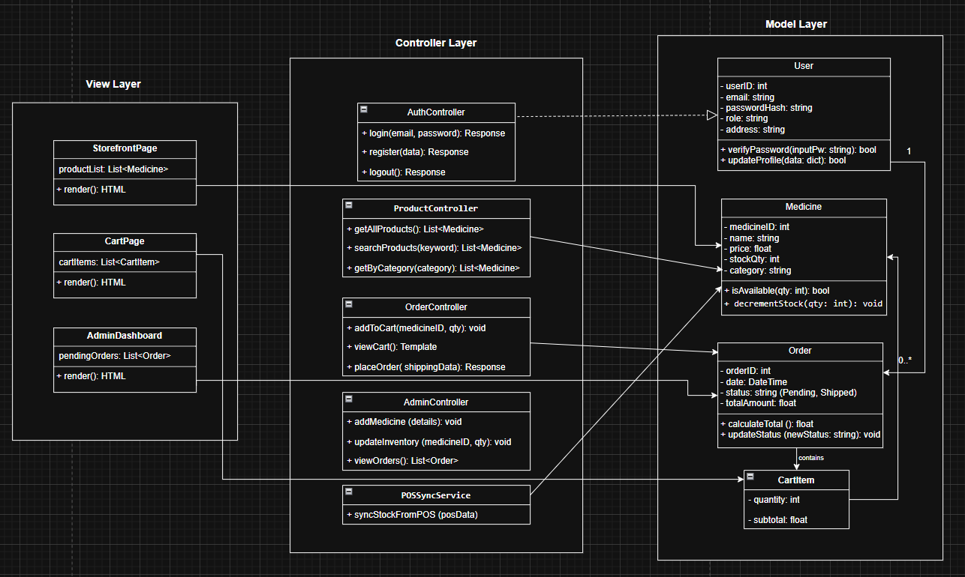
Figure 2: Detailed MVC Class Diagram
This diagram illustrates the classes within the MVC packages. It defines the dependencies (dashed lines) where Controllers use Models, and associations (solid lines) between Models (e.g., User 1---0..* Order).
4.2.3 Sequence Diagrams
Figure 3: User Registration Sequence
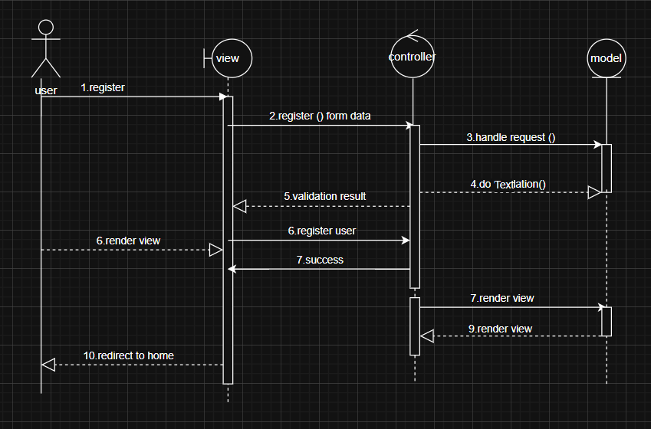
This diagram illustrates the process of a new user creating an account.
- The User submits the registration form with their email and password.
- The Controller validates the input format (e.g., checking for a valid email address).
- The Model checks for duplicate emails in the CSV data and saves the new user record.
- The system redirects the user to the Login page upon successful creation.
Figure 4: User Login Sequence 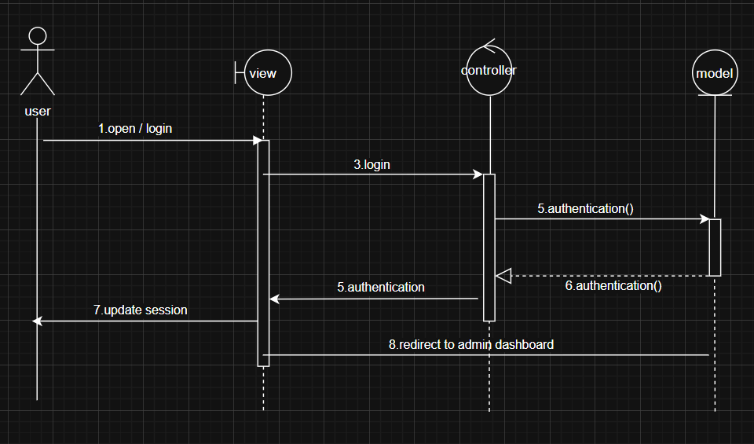
This diagram depicts the authentication flow for a registered user.
- The User enters their email and password into the Login View.
- The Controller receives the credentials and requests authentication from the Model.
- The Model verifies the provided password against the stored user data in the CSV file.
- Upon successful verification, the Controller creates a user session.
Figure 5: Add to Cart Sequence 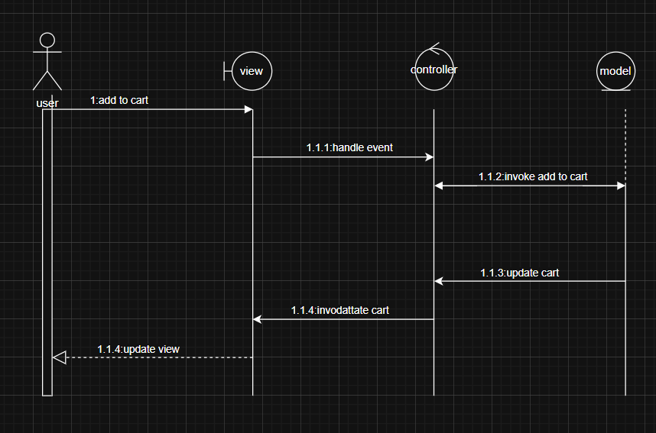
This diagram illustrates how a customer adds a product to their shopping session.
- The User clicks the 'Add to Cart' button on the storefront interface.
- The View triggers an event that is handled by the Controller.
- The Controller invokes the logic to add the specific item to the cart, interacting with the Model to ensure the item exists and is available.
- The Model updates the cart state and confirms the update.
- The Controller instructs the View to update, showing the user the new cart total.
Figure 6: Place Order Sequence 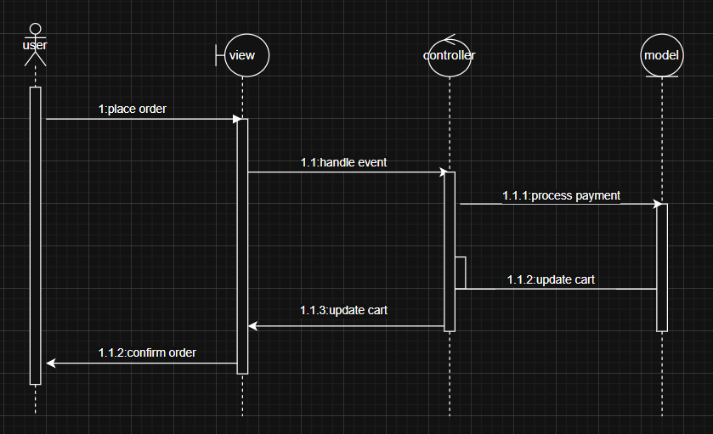
This diagram details the final checkout process.
- The User confirms the order details.
- The Controller processes the payment (simulated).
- Upon success, the Controller communicates with the Model to create the permanent order record in orders.csv.
- The Model decrements the stock quantity in products.csv.
Figure 7: Admin Product Management Sequence 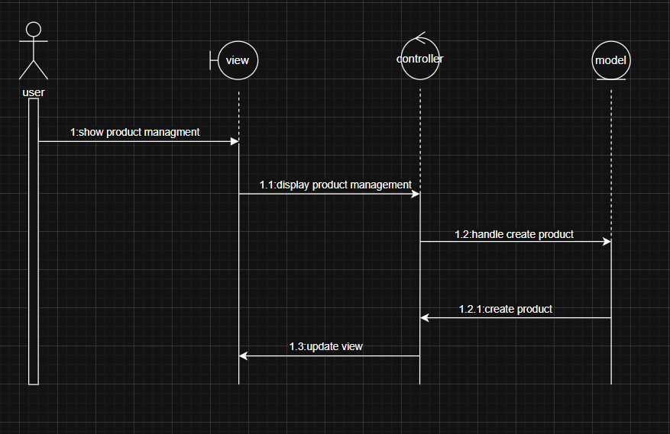
This diagram demonstrates how an Admin adds a new medicine.
- The Admin submits the "Add Medicine" form.
- The Controller communicates with the Model to handle the product creation logic.
- The Model appends the new product to the CSV file.
- The Controller triggers an 'Update View' to refresh the dashboard.

4.3 UI/UX Design
4.3.1 Wireframes / Mockups
Figure 8: Customer Storefront (Home) 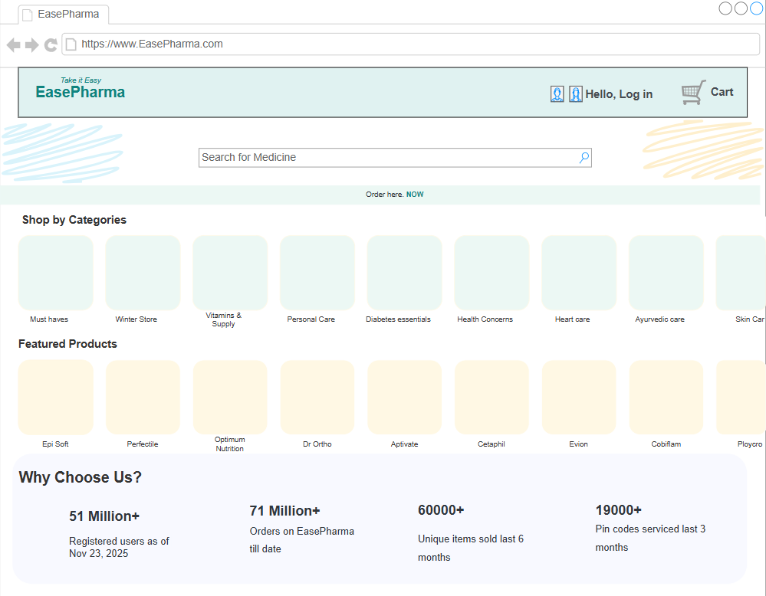
The main landing page featuring category navigation, search functionality, and featured products.
Figure 9: Login Page 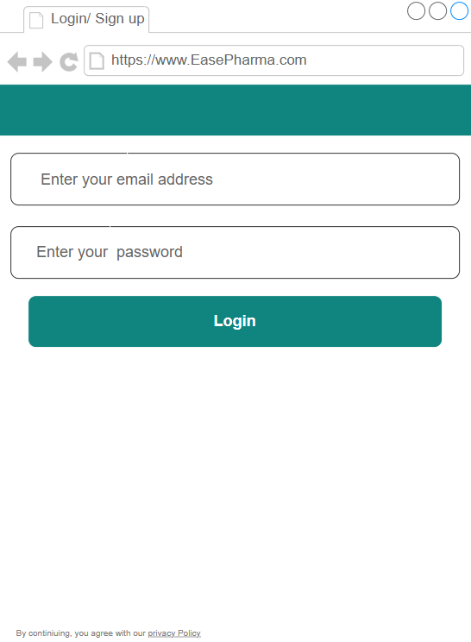
The secure authentication screen for both Customers and Admins.
Figure 10: Admin Dashboard 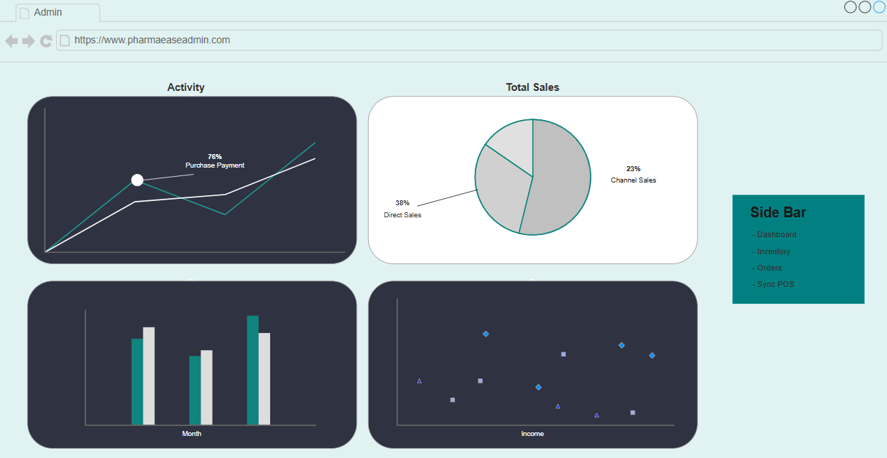
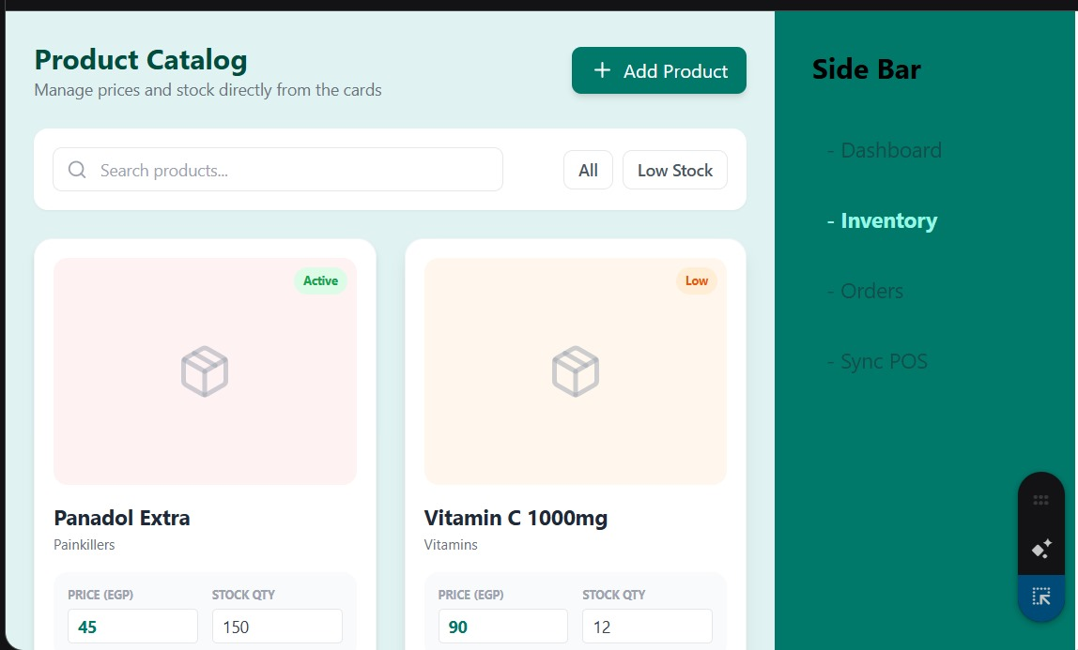
The management interface showing inventory levels, low-stock alerts, and sales data.
Figure 11: Shopping Cart 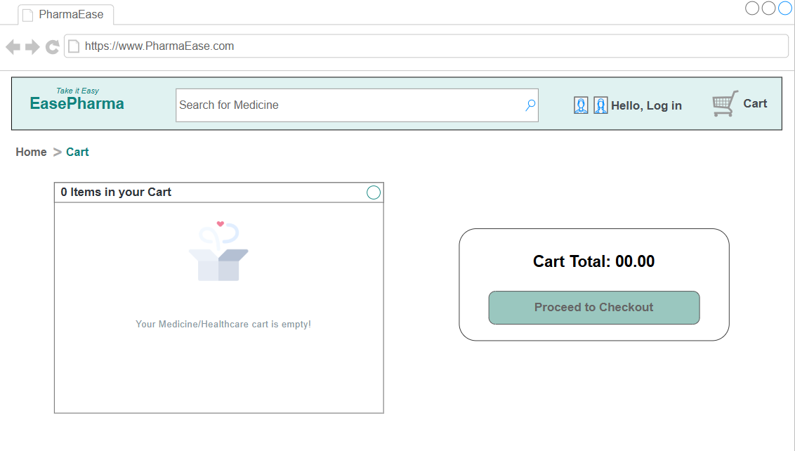
The cart summary page allowing users to review items, adjust quantities, and proceed to checkout.

4.4 Data Design
4.4.1 Entity Relationship Diagram (ERD)
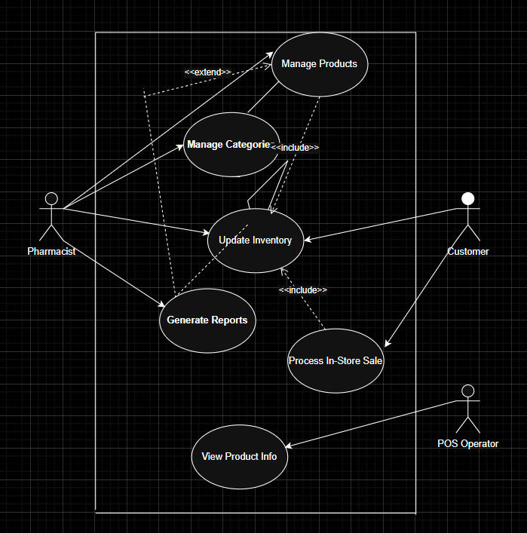
Figure 12: Entity Relationship Diagram
This diagram conceptualizes the logical relationships between the system's data entities. Even though the system uses CSV files for storage, these relationships are enforced by the application logic:
- User to Order: A One-to-Many relationship (One User can place multiple Orders).
- Order to CartItem: A One-to-Many relationship (One Order contains multiple items).
- CartItem to Medicine: Each item in the cart references a specific product from the inventory.

4.4.2 File Structure / Data Storage Model
The system uses a flat-file database structure stored in the server's local file system, managed via Pandas DataFrames.
- data/users.csv: Stores user credentials and profiles.
- data/products.csv: Stores inventory details (Medicines, Cosmetics).
- data/orders.csv: Stores transaction history and order status.
4.4.3 Data Dictionary
This section details the columns within each CSV file used by the application.
Table 1: Users File (users.csv) | Column | Data Type | Description | | :--- | :--- | :--- | | user_id | Integer | Unique ID (Primary Key). | | email | String | User email (Used for Login). Unique. | | password_hash | String | Encrypted password string (Bcrypt). | | role | String | 'Customer' or 'Admin'. | | full_name | String | User's display name. | | phone | String | Contact number. | | address | String | Shipping address. |
Table 2: Products File (products.csv) | Column | Data Type | Description | | :--- | :--- | :--- | | id | Integer | Unique ID (Primary Key). | | sku | String | Stock Keeping Unit code. | | name_en | String | Product Name (English). | | price | Float | Unit price. | | stock_quantity | Integer | Current stock level. Decremented by Orders or Sync. | | category | String | Product category (e.g., Vitamin). | | is_active | Integer | 1 = Active, 0 = Discontinued. |
Table 3: Orders File (orders.csv) | Column | Data Type | Description | | :--- | :--- | :--- | | order_id | Integer | Unique ID. | | customer_id | Integer | Foreign Key linking to users.csv. | | total_amount | Float | Final transaction value. | | status | String | 'Pending', 'Shipped', or 'Delivered'. | | items_summary | String | Serialized string of items purchased. |

5. Conclusion
5.1 Summary of Design Phase
The design phase for EasePharma has successfully defined a robust, modular architecture based on the MVC pattern. By utilizing CSV files and Pandas for data management, the design meets the constraint of portability while maintaining data integrity. The detailed class and sequence diagrams provide a clear path for the development team to begin implementation, ensuring that critical features like the POS Synchronization and Order Processing are built according to requirements. The UI wireframes ensure a user-friendly experience for both customers and pharmacists.

