
Sri Lanka Institute of Information Technology

SOFTWARE ENGINEERING PROJECT REPORT

METADATA

Project Title: Smart Event Management System
Project Domain: Web-Based Event Planning & Booking Platform
Group ID: SE-Y2-GROUP-05
Course Code: SE2030
Semester: Year 2 – Semester 1
Submission Date: 2026-03-15

Group Members:
1. Nadeesha Shalom | IT24100001
2. Tharindu Perera | IT24100002
3. Kavindu Silva | IT24100003
4. Isuri Fernando | IT24100004
5. Chamod Weerasinghe | IT24100005
6. Sanduni Jayawardana | IT24100006
1. INTRODUCTION

1.1 System Overview
The Smart Event Management System is a web-based platform designed to automate event planning, booking, vendor management, and financial tracking. The system connects event organizers, clients, vendors, and administrators through a centralized digital platform. It eliminates manual scheduling, reduces booking conflicts, and ensures efficient coordination between stakeholders.

1.2 Objectives

OBJ-01: Automate event booking and scheduling.
OBJ-02: Enable secure online payments.
OBJ-03: Provide role-based access control.
OBJ-04: Ensure real-time availability management.
OBJ-05: Provide centralized reporting dashboard.

1.3 Stakeholders and Assigned Members

Member 1 → Stakeholder: Client (Customer)
Member 2 → Stakeholder: Event Manager
Member 3 → Stakeholder: Vendor Manager
Member 4 → Stakeholder: Finance Officer
Member 5 → Stakeholder: System Administrator
Member 6 → Stakeholder: Support & Service Coordinator

2. MEMBER-WISE MODULE STRUCTURE
MEMBER 1 – CLIENT MANAGEMENT MODULE
Stakeholder: Client
CRUD Entities:
- Client Profile
- Event Booking
- Payment Record

Functional Requirements:
FR-01: Client can register and login.
FR-02: Client can create event booking.
FR-03: Client can update booking details.
FR-04: Client can cancel booking.
FR-05: Client can view booking history.

Non-Functional Requirements:
NFR-01: Page load time under 3 seconds.
NFR-02: Password encryption using BCrypt.
NFR-03: Session timeout after 15 minutes.

UI Screens (Minimum 4):
1. Client Registration Page
2. Client Dashboard
3. Booking Form Page
4. Payment Page

MEMBER 2 – EVENT MANAGER MODULE
Stakeholder: Event Manager
CRUD Entities:
- Event Schedule
- Venue Allocation
- Staff Assignment

Functional Requirements:
FR-06: Manager can create event schedule.
FR-07: Manager can update venue availability.
FR-08: Manager can assign staff.
FR-09: Manager can delete cancelled events.

Non-Functional Requirements:
NFR-04: Real-time schedule validation.
NFR-05: Prevent double booking conflicts.

UI Screens:
1. Event Dashboard
2. Schedule Creation Page
3. Venue Management Page
4. Staff Allocation Page

MEMBER 3 – VENDOR MANAGEMENT MODULE
Stakeholder: Vendor Manager
CRUD Entities:
- Vendor Profile
- Service Packages
- Vendor Contracts

Functional Requirements:
FR-10: Add vendor.
FR-11: Update service package.
FR-12: Remove vendor.
FR-13: Assign vendor to event.

Non-Functional Requirements:
NFR-06: Vendor data consistency.
NFR-07: Secure file upload for contracts.

UI Screens:
1. Vendor Dashboard
2. Add Vendor Page
3. Package Management Page
4. Contract Upload Page

MEMBER 4 – FINANCE MODULE
Stakeholder: Finance Officer
CRUD Entities:
- Invoices
- Transactions
- Refund Records

Functional Requirements:
FR-14: Generate invoice.
FR-15: Record payment.
FR-16: Process refund.
FR-17: View financial report.

Non-Functional Requirements:
NFR-08: Transaction validation.
NFR-09: Audit log tracking.

UI Screens:
1. Finance Dashboard
2. Invoice Generation Page
3. Transaction History Page
4. Refund Processing Page

MEMBER 5 – SYSTEM ADMIN MODULE
Stakeholder: Administrator
CRUD Entities:
- User Accounts
- Roles
- System Announcements

Functional Requirements:
FR-18: Create user.
FR-19: Assign roles.
FR-20: Deactivate user.
FR-21: Post announcement.

Non-Functional Requirements:
NFR-10: Role-based access control.
NFR-11: Prevent unauthorized access.

UI Screens:
1. Admin Dashboard
2. User Management Page
3. Role Assignment Page
4. Announcement Page

MEMBER 6 – SUPPORT & SERVICE MODULE
Stakeholder: Support Coordinator
CRUD Entities:
- Support Tickets
- Feedback Records
- Service Logs

Functional Requirements:
FR-22: Create support ticket.
FR-23: Update ticket status.
FR-24: Close resolved ticket.
FR-25: View customer feedback.

Non-Functional Requirements:
NFR-12: Response time under 24 hours.
NFR-13: Data backup every 24 hours.

UI Screens:
1. Support Dashboard
2. Ticket Creation Page
3. Ticket Tracking Page
4. Feedback Management Page

3. SYSTEM DESIGN

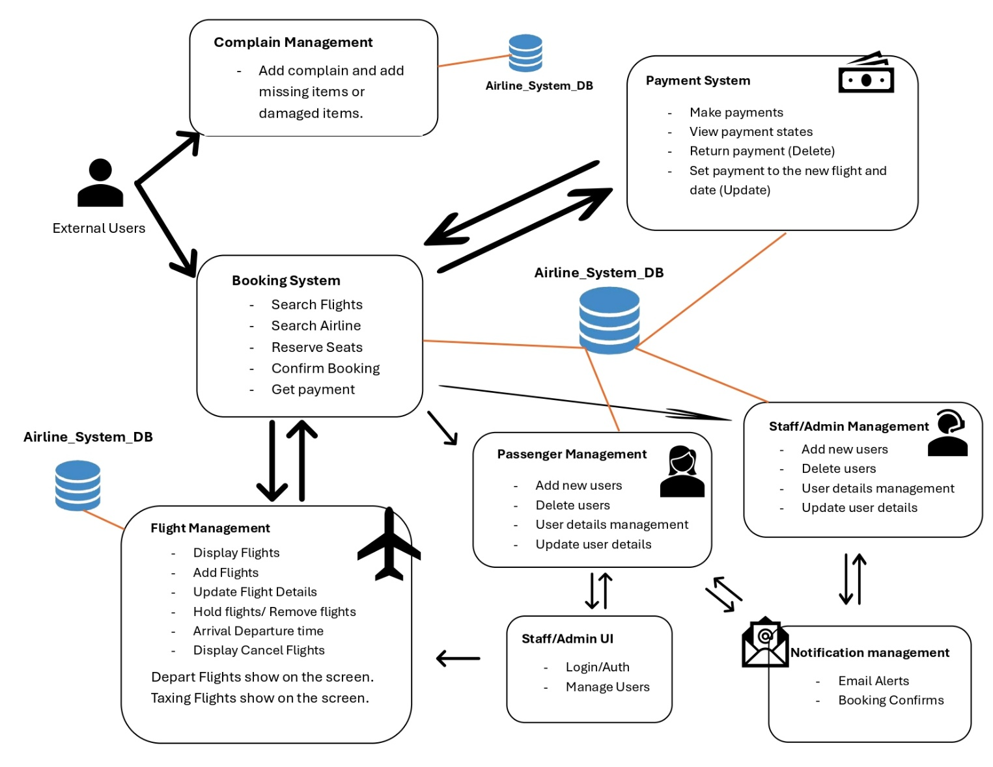
3.1 System Architecture Diagram

Description:
The Smart Event Management System follows a 3-Tier Architecture consisting of:
1. Presentation Layer (React Frontend)
- Handles user interface rendering.
- Communicates with backend via REST APIs.
2. Business Logic Layer (Spring Boot Backend)
- Handles authentication and authorization (JWT).
- Processes business logic for each module.
- Validates input data and enforces access control.
3. Data Access Layer (MySQL Database)
- Stores user data, bookings, vendors, transactions, and support tickets.
- Enforces referential integrity using foreign key constraints.

All communication between frontend and backend occurs through secured HTTPS APIs.
JWT tokens are used to authenticate and authorize users based on roles.

3.2 Use Case Diagram
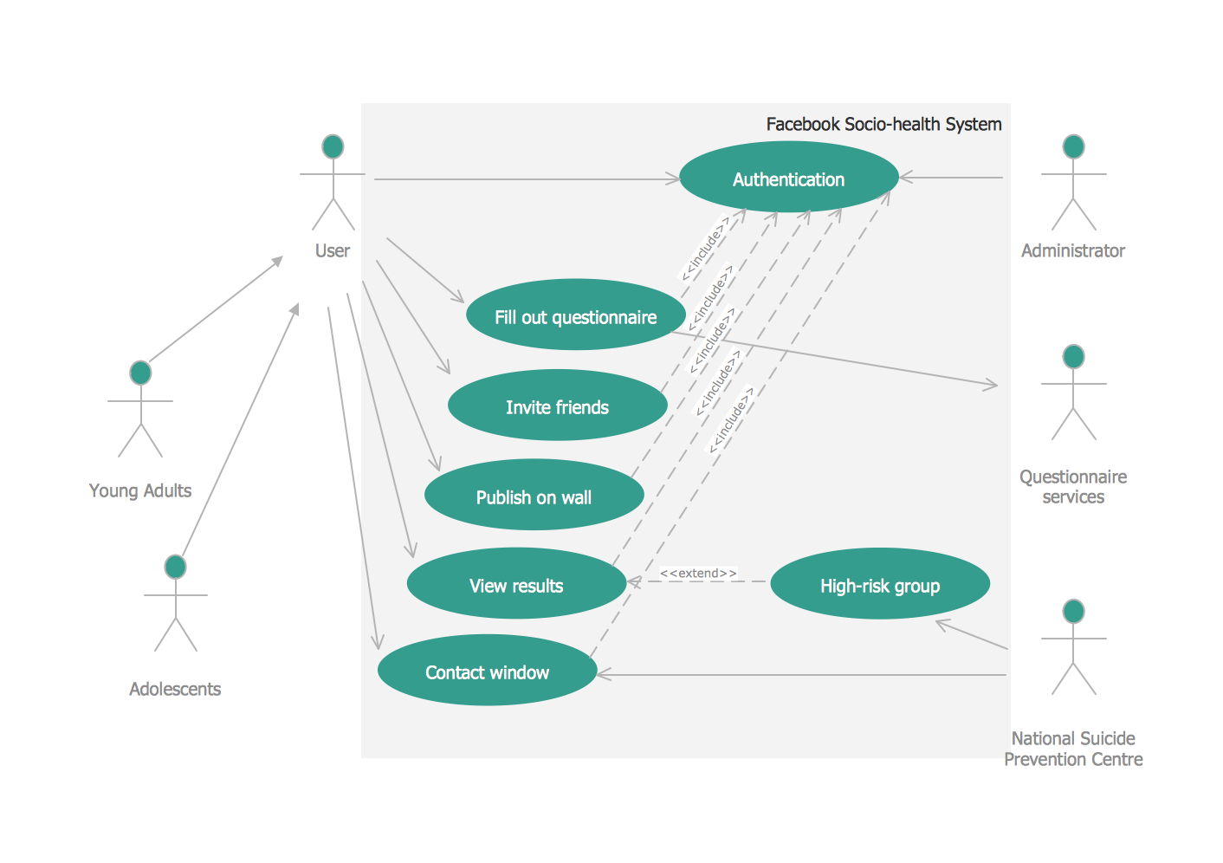

Description:
The system consists of 6 primary actors:
1. Client
2. Event Manager
3. Vendor Manager
4. Finance Officer
5. Administrator
6. Support Coordinator

Each actor interacts with specific use cases based on assigned responsibilities.

Major use cases include:
- Register / Login
- Create Booking
- Manage Vendors
- Generate Invoice
- Manage Users
- Create Support Ticket

The diagram shows role-based interaction with the system and separation of concerns.

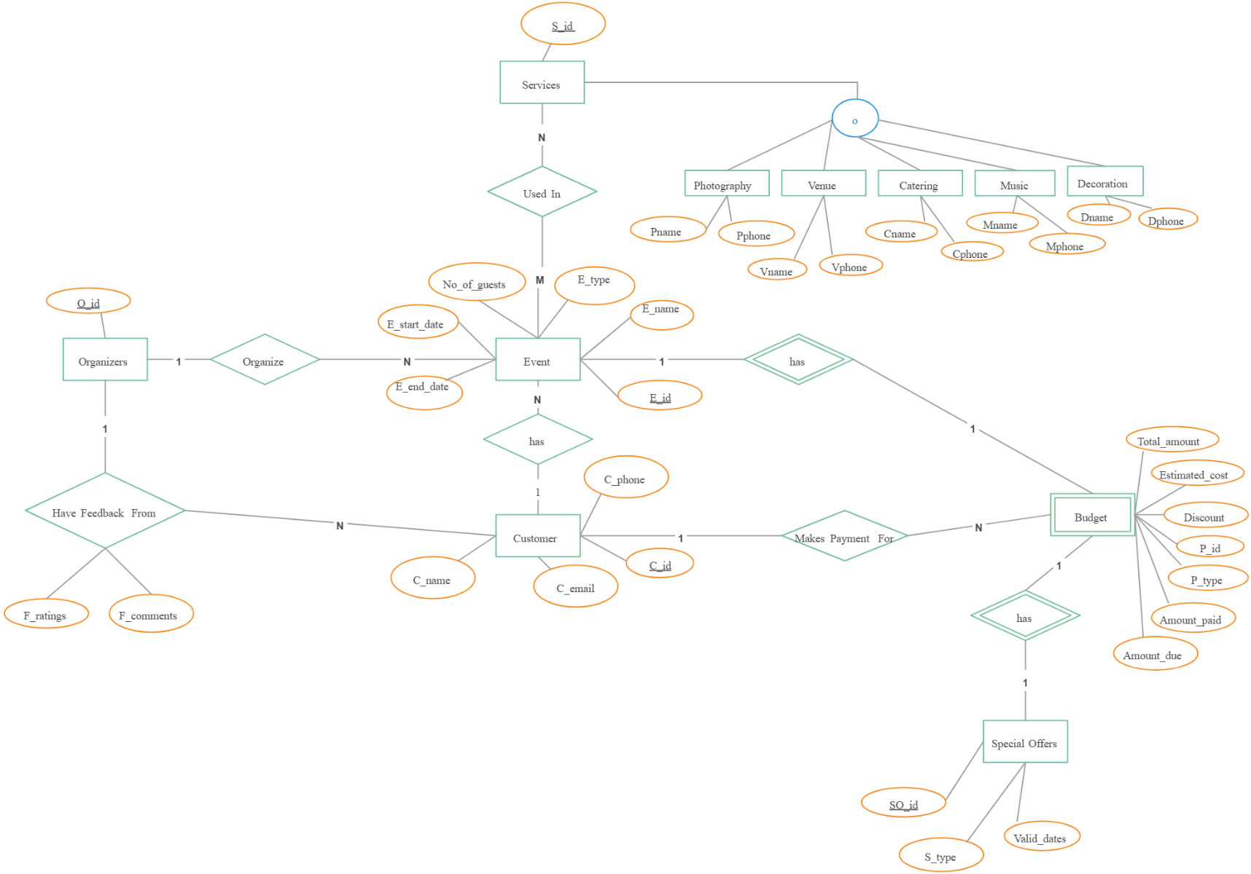
3.3 ER / EER Diagram

Entities and Key Attributes:

Client (client_id PK, name, email, password_hash, phone, created_at)
Booking (booking_id PK, client_id FK, event_date, venue_id FK, status, created_at)
Payment (payment_id PK, booking_id FK, amount, payment_method, status, paid_at)
EventSchedule (schedule_id PK, event_date, venue_id FK, manager_id FK, status)
Venue (venue_id PK, venue_name, location, capacity)
Staff (staff_id PK, name, role, contact_no)
Vendor (vendor_id PK, name, service_type, contact_info)
ServicePackage (package_id PK, vendor_id FK, package_name, price)
Contract (contract_id PK, vendor_id FK, start_date, end_date, document_path)
Invoice (invoice_id PK, booking_id FK, amount, status, issued_date)
Transaction (transaction_id PK, invoice_id FK, amount, payment_status, transaction_date)
Refund (refund_id PK, transaction_id FK, amount, reason, processed_date)
User (user_id PK, username, password_hash, role_id FK, status)
Role (role_id PK, role_name, description)
Announcement (announcement_id PK, title, content, created_by FK, created_at)
SupportTicket (ticket_id PK, client_id FK, subject, status, created_at)
Feedback (feedback_id PK, client_id FK, message, rating, created_at)
ServiceLog (log_id PK, ticket_id FK, action_taken, updated_at)

Relationships:

Client → Booking (1:N)
Booking → Payment (1:1)
Booking → Invoice (1:1)
Invoice → Transaction (1:N)
Transaction → Refund (1:N)
Vendor → ServicePackage (1:N)
Vendor → Contract (1:N)
Client → SupportTicket (1:N)
SupportTicket → ServiceLog (1:N)
User → Role (N:1)

3.4 Module-Level Diagrams
3.4.1 Client Module Use Case
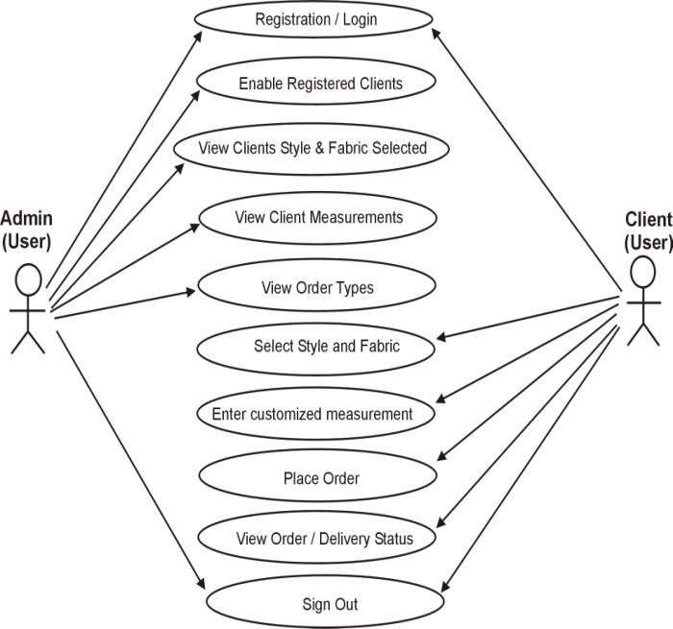

The Client Module Use Case Diagram illustrates how the Client interacts with the system to manage personal information and event bookings. The client can register, log in, create and update bookings, process payments, and view booking history. All operations follow secure authentication and authorization rules to ensure data privacy. CRUD functionality is applied to Client Profile, Booking, and Payment entities.

3.4.2 Event Manager Module Use Case
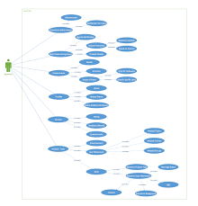

The Event Manager Module Use Case Diagram shows how the Event Manager schedules events, allocates venues, and assigns staff members. The manager can create, update, and delete event schedules while ensuring no booking conflicts occur. The module enforces real-time validation rules and maintains schedule integrity. CRUD operations apply to Event Schedule, Venue Allocation, and Staff Assignment entities.

3.4.3 Vendor Module Use Case


The Vendor Management Module Use Case Diagram represents how the Vendor Manager maintains vendor information and service packages. The manager can add, update, and remove vendors, as well as assign vendors to specific events. Secure document handling is applied for contract uploads. CRUD operations are implemented for Vendor Profile, Service Package, and Vendor Contract entities.

3.4.4 Finance Module Use Case


The Finance Module Use Case Diagram illustrates how the Finance Officer manages invoices, transactions, and refunds. The officer can generate invoices, record payments, process refunds, and view financial reports. The system ensures transaction validation and maintains audit logs for accountability. CRUD functionality applies to Invoice, Transaction, and Refund entities.

3.4.5 Admin Module Use Case


The System Admin Module Use Case Diagram shows how the Administrator manages user accounts and system roles. The administrator can create users, assign roles, deactivate accounts, and publish system announcements. Role-based access control ensures that each user only accesses authorized system functions. CRUD operations apply to User Account, Role, and Announcement entities.

3.4.6 Support Module Use Case



The Support & Service Module Use Case Diagram demonstrates how the Support Coordinator manages customer assistance operations. The coordinator can create and update support tickets, track ticket status, close resolved cases, and review customer feedback. The system maintains service logs and enforces response time constraints. CRUD operations apply to Support Ticket, Feedback, and Service Log entities.

4. DESIGN SUMMARY

Total Entities: 18
Total Relationships: 10
Total CRUD Modules: 6
Total Actors: 6
Total Use Cases: 25
Total UI Screens: 24
Architecture: 3-Tier Web Architecture
Database: MySQL (Normalized to 3NF)
Backend: Spring Boot
Frontend: React
Security: JWT Authentication

5. CONCLUSION

The Smart Event Management System successfully implements six independent CRUD modules aligned with six stakeholders. Each member developed full-stack components including frontend, backend, database design, and testing.

============================================================

END OF REPORT

