1.

* What is the relationship between age of a house & its market value?
* What is the relationship between the square feet of house and its market value?
* Is there any relationship between age of house & square feet of a house?
* Does the independent variables in the data set indicates causation?

2.

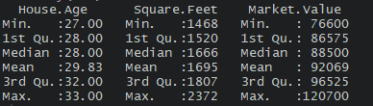

According to the above summary of the data set, minimum age of the house is 27 & maximum age of the house is 33. The average of the age of a house would be 29.83. Square feet of a house range from 1468 to 2372. And the average square feet of a house would be 1695.Market value of a house range from $76600 to $120700.And the average market value of a house would be $92069.

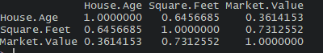

We can see a higher positive correlation between square feet of a house and the market value. And also a positive correlation between the age of a house & the market value of the house.

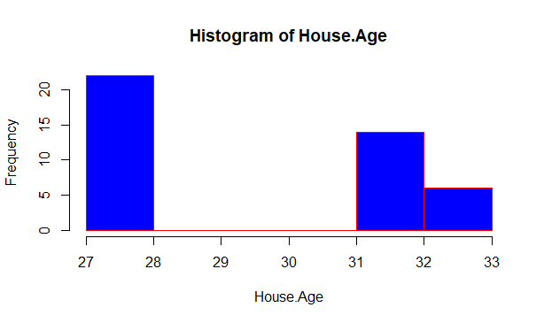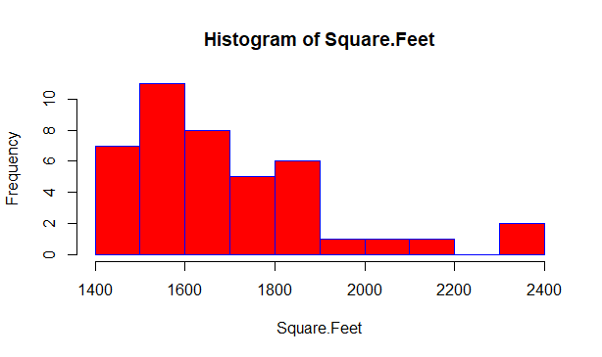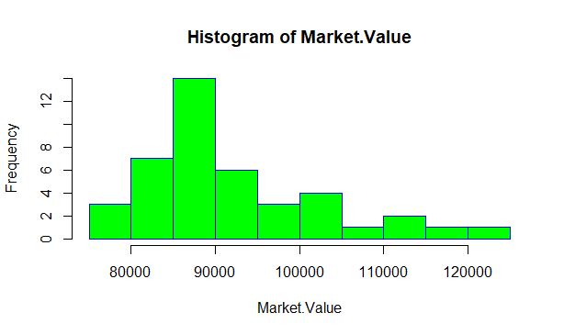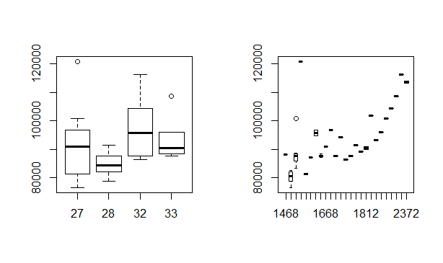

According to the above box plots first one depicts the distribution of market value based on the age of a house. And the second box plot depicts the distribution of the market value based on the square feet of a house. According to the second box plot we can see that when increasing the square feet of a house, the market value increases.

3.

According to the correlation matrix, we can see a higher positive correlation between square feet of a house and the market value. And also a positive correlation between the age of a house & the market value of the house. Ultimately once the square feet increase the market value increases. Apart from that, independent variables have more than 0.3 correlation with the dependent variable and less than 0.7 with other independent variables. So the age of a house & the square feet of a house could be considered as possible predictors. As we have two attributes we can build a **multiple linear regression** model to predict the market value of a house based on age & square feet.

$$y=β_{0}+β_{1 }x_{1}+β_{2}x_{2}+ϵ$$

4.

Predicted values

