C L O U D - N A T I V E E N G I N E E R I N G M E N T O R I N G T R A C K
TaskFlow Containerization Challenge
Phase 1 — Docker Fundamentals
Submission Report
Submission details
Mentee | Nadeesha Medagama
Mentor | Mr. Kanishka Maduranga
Date | 18 September 2026
Application | TaskFlow — four services: web, api, db, cache
Published images | hub.docker.com/r/nadeeshamedagama/taskflow-api  hub.docker.com/r/nadeeshamedagama/taskflow-web
Project archive | Download the full project (.zip)
Verified on | Docker Engine 29.7.2 · Compose v5.5.0 · macOS 26.6 · Apple M4 (arm64)
Status | All deliverables complete · stack verified end-to-end
Answers the brief in TaskFlow_Docker_Mentoring_Task.pdf. All figures in Section 4 were measured, not estimated.

Contents
If the entries appear blank, press Ctrl+A then F9 in Word to refresh.
1. Summary 2
1.1 Deliverables 2
2. Architecture 3
3. What Was Built (Parts 1–3) 3
3.1 Build evidence 4
3.2 Two decisions worth explaining 5
4. Image Optimization (Part 4) 6
4.1 Before / after 6
4.2 Build cache — what layer ordering actually buys 7
4.3 The .dockerignore — an honest finding 7
5. Debugging Challenge (Part 5) 9
5.1 Identified on inspection 9
5.2 Found while making the stack work 10
6. Bonus (Part 6) 11
6.1 Resource limits on every service 11
6.2 Semantic version tags, published 11
6.3 Base + override split, and the smoke test 12
7. Verification 13
7.1 Data survives a full teardown 14
7.2 Non-root and service discovery 14
8. Reflection Questions 15
8.1 What carries over to Kubernetes, and what changes? 15
8.2 Why isn't depends_on + health the same as a readiness probe? 15
8.3 What happens to the data if the database crashes? 15
8.4 Trade-offs between image size, build time and complexity 16
Appendix — Test Environment 17
Method 17
Reproducing it 17

1. Summary
TaskFlow previously needed a hand-installed PostgreSQL, a hand-installed Redis and node server.js on every developer machine. The whole stack now starts with one command:
$ cp .env.example .env
$ docker compose up --build
Four services — taskflow-web, taskflow-api, taskflow-db, taskflow-cache — come up on one named bridge network, gated by health checks, with task data in a named volume that survives a full teardown. The front end is on http://localhost:8080.
Result
API image | 246 MB, down from 1.63 GB single-stage on the full Node base (−85%)
Rebuild after a code edit | ~1.3 s vs ~3.4 s — the npm ci layer stays cached
Security | Non-root uid 1000; no credential in any committed file; datastores not published to the host
Debugging exercise | 17 defects found and fixed (brief asks for at least six)
Verification | Smoke test: 13 checks passed, 0 failed
Bonus | All four done — resource limits, semantic tags pushed to Docker Hub, base/override split, smoke test

1.1 Deliverables
Deliverable (brief §7) | Status | Artifact
Multi-stage, non-root Dockerfile with healthcheck | Done | api/Dockerfile
Frontend Dockerfile | Done | web/Dockerfile
.dockerignore | Done | api/.dockerignore
Working, fixed compose file | Done | docker-compose.yml
.env.example filled in; real .env not committed | Done | .env.example · .gitignore
Written report — sizes, Part 5 bugs, end-to-end output | Done | This document
Reflection answers | Done | Section 7
Bonus — nginx reverse proxy for /api/ | Done | web/nginx.conf
Bonus — resource limits on every service | Done | docker-compose.yml
Bonus — semantic tags pushed to a registry | Done | Docker Hub — see §6.2
Bonus — base + override split | Done | docker-compose.override.yml
Bonus — smoke-test script | Done | scripts/smoke-test.sh
Source. The complete project — Dockerfiles, compose files, application source, scripts and this report — is available as a single archive: drive.google.com/file/d/1UkdTDh3m0H98AuwMR9BJtMzuyOfq36vX. It ships without node_modules and without the real .env, so it is built from the lockfile on first run: cp .env.example .env && docker compose up --build.

2. Architecture
Four services on one user-defined bridge network, taskflow-net. Only the web tier is published to the host — the API, database and cache are reachable only from inside the network.
HOST docker network: taskflow-net
+---------------------------------------------+
Browser --> localhost:8080 --> taskflow-web nginx:1.27-alpine |
| (nginx, :80) |
| | proxy_pass /api/ and /health |
| v |
| taskflow-api node:22-alpine |
| (node, :4000, non-root uid 1000) |
| | | |
| SQL | | RESP (30s TTL) |
| v v |
| taskflow-db taskflow-cache |
| postgres:16-alpine redis:7-alpine |
+-------|-------------------------------------+
|
named volume: taskflow-db-data
Figure 1 — Request flow. Only port 8080 crosses the host boundary.
Service | Image | Published | Role
taskflow-web | nginx:1.27-alpine | 8080 → 80 | Serves index.html; reverse-proxies /api/ and /health
taskflow-api | node:22-alpine | no | Express REST API; reads/writes Postgres, caches reads in Redis
taskflow-db | postgres:16-alpine | no | Persistent store; schema seeded from init.sql on first boot
taskflow-cache | redis:7-alpine | no | Caches the task list for 30 s; invalidated on every write
The broken file published PostgreSQL on 5432:5432, exposing it to the host and LAN. The base file publishes nothing; developers use "docker compose exec taskflow-db psql".

3. What Was Built (Parts 1–3)
Requirement | How it is met
Part 1 — API image
Multi-stage build | A deps stage installs; a runtime stage carries only node_modules, package.json, server.js
Small base image | node:22-alpine for both stages
Non-root user | USER node — the built-in uid/gid 1000, verified at runtime
Production dependencies only | npm ci --omit=dev — reproducible from the lockfile and fails loudly on drift, unlike npm install
Layer-cache ordering | Manifests copied before source, so editing server.js does not re-run the install (measured in §4.2)
EXPOSE + HEALTHCHECK | EXPOSE 4000; the probe uses the node binary already in the image rather than installing curl
Part 2 — Frontend image
Official nginx base, index.html, EXPOSE 80 | nginx:1.27-alpine, pinned to a minor version, not latest
Bonus — reverse-proxy /api/ | proxy_pass http://taskflow-api:4000 with no trailing slash, so /api/tasks is forwarded intact. /health gets an exact-match rule of its own. The browser talks to one origin, so no CORS and no rebuild when the API moves.
Part 3 — Compose orchestration
Explicitly-named shared network | taskflow-net (bridge)
Named volume + init.sql auto-loaded | taskflow-db-data; init.sql bind-mounted read-only into /docker-entrypoint-initdb.d/
Config from .env, no secrets in compose | env_file: .env for the API; ${DB_USER}/${DB_PASSWORD}/${DB_NAME} interpolated into Postgres, so the two halves cannot drift
Health checks on every service | pg_isready · redis-cli ping · node fetch /health · wget
depends_on + service_healthy | API waits on the database and the cache; web waits on the API
Frontend on host port 8080 | "8080:80"

3.1 Build evidence
Both images build cleanly from a cold cache and are tagged with a semantic version at build time.
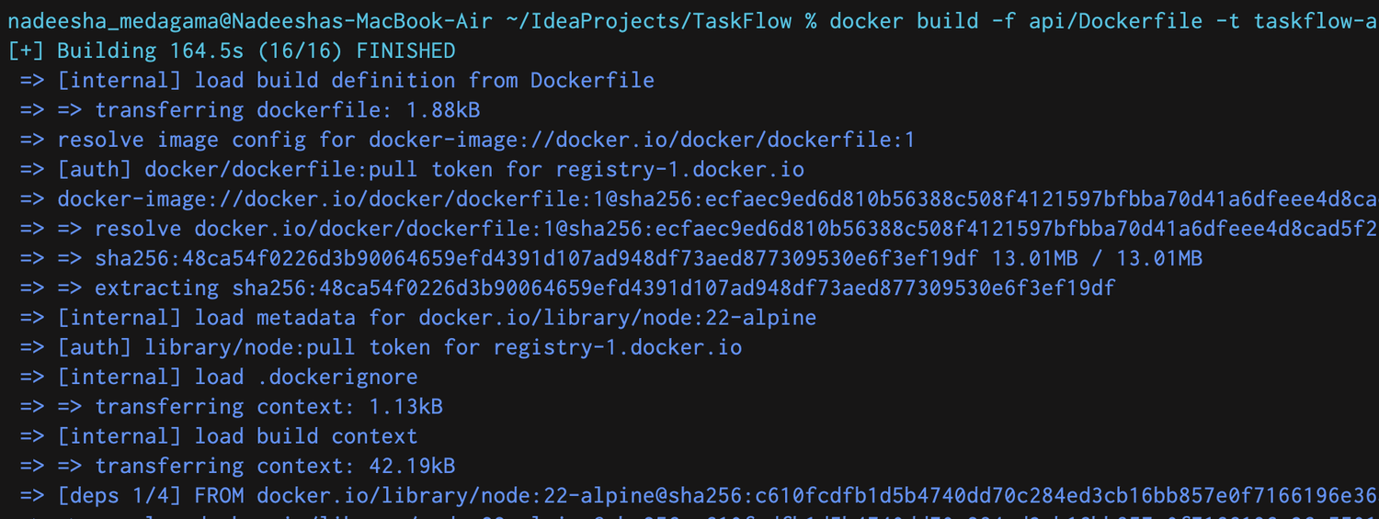
Figure 2 — The API image build. BuildKit loads the .dockerignore, transfers a 42.19 kB context, then runs the deps stage: COPY of the manifests alone, followed by npm ci --omit=dev.
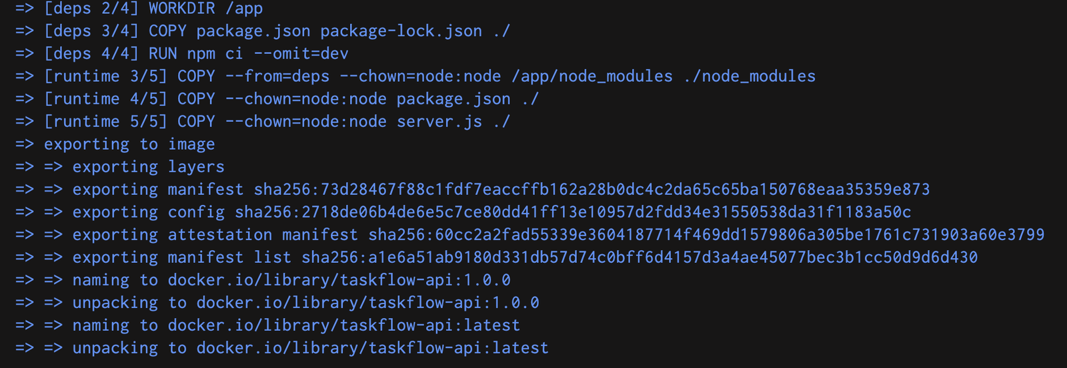
Figure 3 — The same build completing. The runtime stage copies only node_modules, package.json and server.js — each with --chown=node:node — and the result is tagged 1.0.0 and latest.
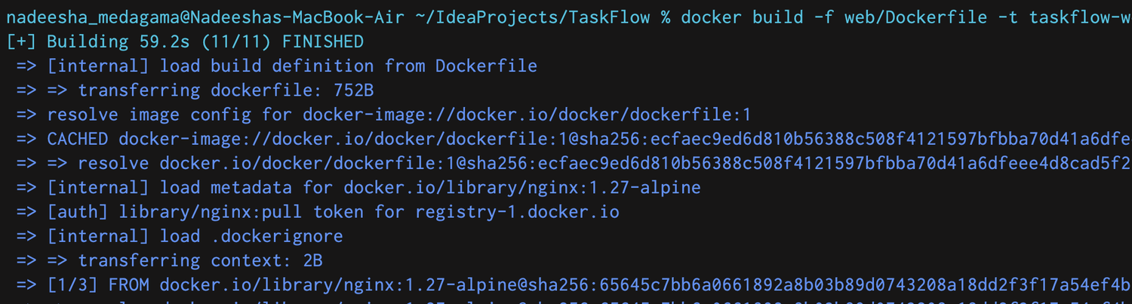
Figure 4 — The frontend image build on nginx:1.27-alpine, pinned to a minor version rather than latest.
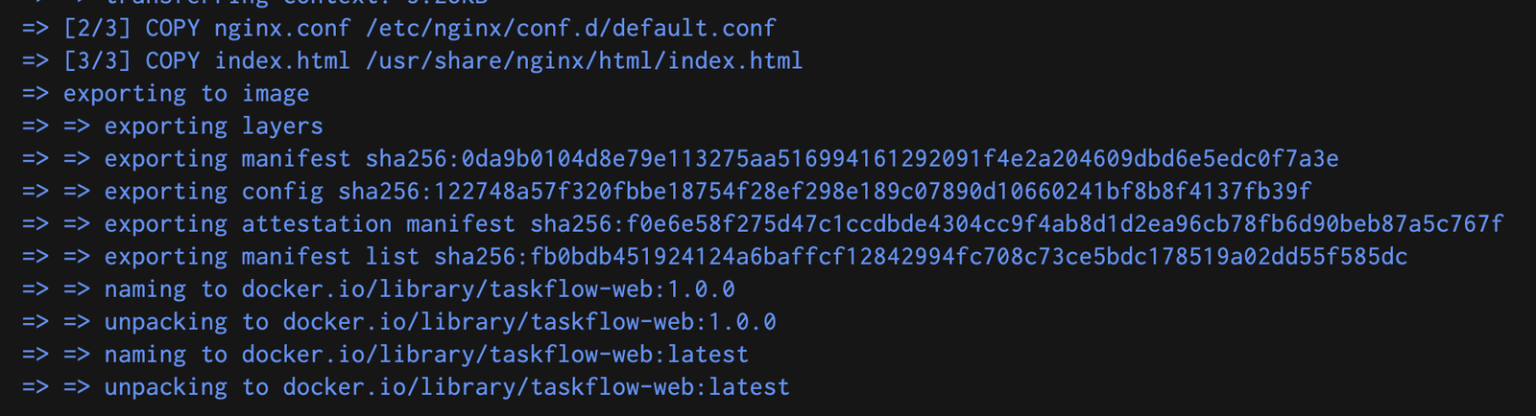
Figure 5 — The frontend build completing: nginx.conf replaces the stock default.conf and index.html lands in the Nginx web root, tagged 1.0.0 and latest.

3.2 Two decisions worth explaining
- Postgres health is checked over TCP. While init.sql runs, the official entrypoint starts a temporary server with listen_addresses empty — reachable on the Unix socket but not over TCP. pg_isready -h 127.0.0.1 therefore refuses to go healthy mid-initialisation, which a default socket check would not.
- init: true on the API. Otherwise node is PID 1 with no SIGTERM handler and every docker compose down stalls for the full ten-second grace period before a SIGKILL.

4. Image Optimization (Part 4)
Measured on the machine in the Appendix, with base images pre-pulled so no timing includes a download.

4.1 Before / after
# | Variant | Image size | Cold build | Rebuild after code edit
A | Single-stage, node:22 (full Debian) | 1.63 GB | 3.5 – 4.6 s | —
B | Single-stage, node:22-alpine | 254 MB | 5.0 – 6.9 s | 3.1 – 3.8 s
C | Multi-stage, alpine, no .dockerignore | 246 MB | 4.1 – 5.0 s | —
D | Multi-stage, alpine, with .dockerignore (final) | 246 MB | 4.3 – 7.8 s | ~1.3 s
Table 1 — Each variant measured three to four times; ranges are the observed spread.
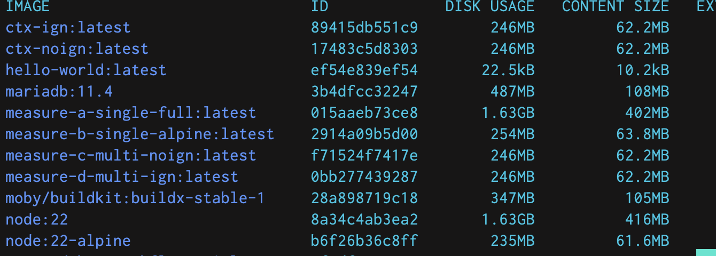
Figure 6 — The four variants on disk, corroborating Table 1: measure-a 1.63 GB, measure-b 254 MB, measure-c and measure-d 246 MB.
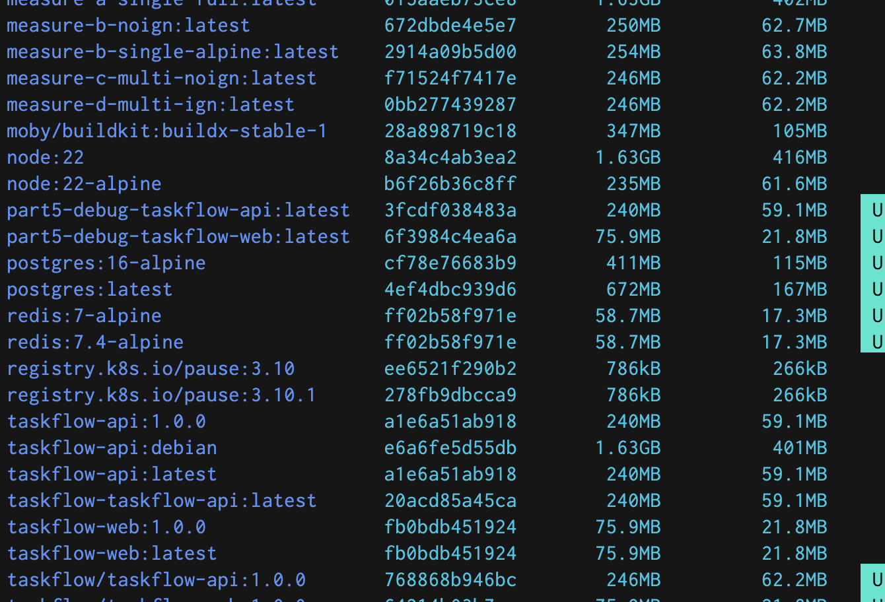
Figure 7 — The same comparison from a second angle. taskflow-api:debian — a single-stage build on the full Node base — is 1.63 GB against the shipped taskflow/taskflow-api:1.0.0 at 246 MB, a 6.6x difference. measure-b-noign (250 MB) is the single-stage alpine variant built without a .dockerignore, discussed in §4.3.
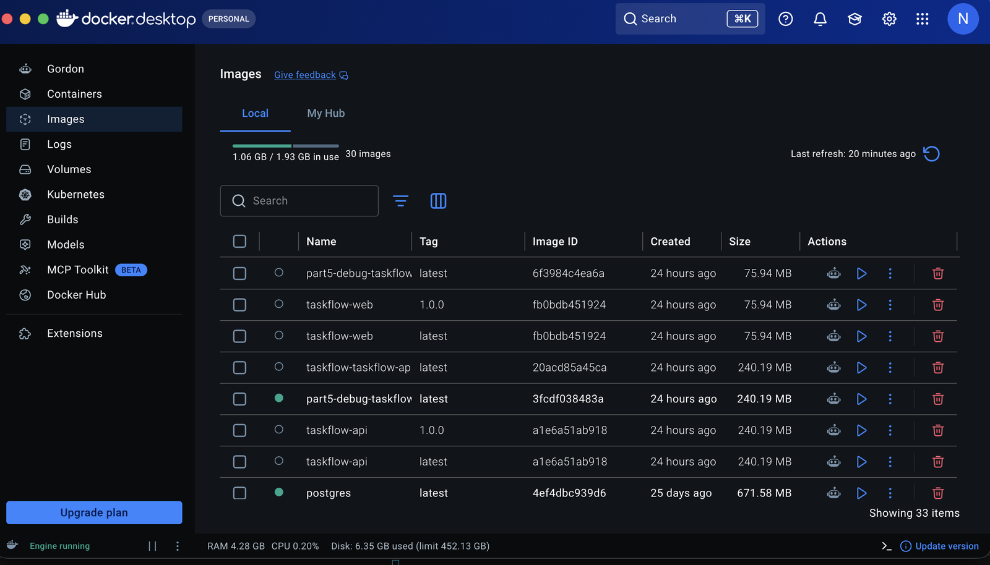
Figure 8 — Docker Desktop's local image inventory during the same work. The 17 September build of taskflow-api reads 240 MB here; the 246 MB in Table 1 is an 18 September rebuild after an upstream node:22-alpine refresh. Both figures are genuine — the comparison in Table 1 was measured in a single session, so every row is like for like.
The base image is the whole story. Moving from Debian-based node:22 to node:22-alpine cuts 1.63 GB to 254 MB — an 84% reduction for a one-word change, because the Debian variant carries a full distribution userland and toolchain a running Node process never touches. Multi-stage removes a further 8 MB, and the honest reason it is only 8 MB is that this application has no build step: no compiler, no devDependencies, no dist/ to leave behind, so the final stage only discards npm's cache and install metadata. On a TypeScript service the gap between rows B and D would be the interesting one.
Where the 246 MB goes. docker history shows the application is 10.7 MB of the 246 MB image — 10.7 MB of dependencies plus about 25 kB of source. The remaining ~235 MB is the Node 22 runtime (159 MB), Yarn (5.5 MB) and the Alpine root filesystem (9.3 MB). That is the floor for anything running Node, and it sets the priority: further optimisation belongs on the runtime base, not on the application layers.

4.2 Build cache — what layer ordering actually buys
Dockerfile shape | Rebuild after editing server.js | npm step
Single-stage: COPY . . then npm install | 3775 / 3263 / 3079 / 3133 ms | re-runs every time
Multi-stage: manifests before source | 1385 / 1291 / 1286 / 1334 ms | CACHED
Table 2 — Four runs each. Roughly a 2.4× difference, confirmed by BuildKit reporting the npm ci layer as CACHED.
A layer invalidates everything beneath it. COPY . . means any source edit busts the npm install layer; copying package.json and package-lock.json first keys the install layer to the dependency set alone. With four dependencies that is worth two seconds, and the ratio holds as the dependency count grows.

4.3 The .dockerignore — an honest finding
Under BuildKit, the default builder since Docker 23, the .dockerignore made no difference to the final image size for this multi-stage build (rows C and D are both 246 MB), and context transfer measured 42.19 kB either way — BuildKit sends only the files a COPY instruction names. Its value here is correctness, not size: building the single-stage variant without it copied the host's 10.2 MB node_modules straight into the image, and native modules compiled for macOS/arm64 do not run on Alpine/musl. It also keeps .env out of any layer, stops incidental files busting the cache, and still matters on the classic builder, which ships the whole 9.5 MB context.
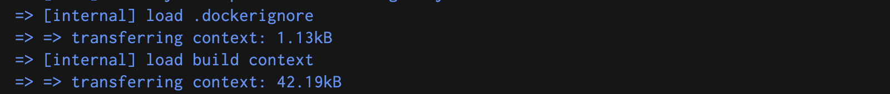
Figure 9 — BuildKit reporting the context it actually transferred: 1.13 kB for the .dockerignore itself and 42.19 kB for the build context — the manifests and source only, not the 9.4 MB node_modules sitting beside them on disk.

5. Debugging Challenge (Part 5)
The brief supplies a broken docker-compose.yml with "at least six" issues. Seventeen were found. §5.1 lists those identified on inspection; §5.2 lists the rest, which had to be fixed before the stack would run. The original is kept as docker-compose.broken.yml.

5.1 Identified on inspection
# | Defect | Why it matters | Fix
1 | Duplicate environment key | The two environment: blocks are at lines 5 and 15; inconsistent indentation folds the second into the first service's mapping and YAML rejects the duplicate, so the file does not parse. | Re-indent so each service owns its own block.
2 | Inconsistent indentation | YAML is whitespace-significant — taskflow-cache's image: uses three spaces where everything else uses four, so keys attach to the wrong service. | Two spaces per service, four per property.
3 | version: "3.9" obsolete | Compose v2 ignores it and warns; the Compose Specification is versionless. | Removed.
4 | DB config hard-coded in compose | User, password and database name sit in a file that is committed, disclosing them to anyone with repository access. | Moved to .env and referenced by interpolation.
5 | DB_PASSWORD in the compose file | Listed separately because it is the one genuinely secret value; a secret in a tracked file leaks on clone and rotating it needs a commit. | .env holds it, .env.example ships a placeholder, .env is gitignored.
6 | DB_PASSWROD misspelled | The API reads DB_PASSWORD, so the password never arrives, pg connects with undefined and Postgres rejects the auth — it looks like a database fault, not a typo. | Corrected, and sourced from .env so it cannot drift from POSTGRES_PASSWORD.
7 | ports: - "4000" | A single-port entry publishes on a random ephemeral host port, so the API's address changes on every up. | Made explicit as "4000:4000"; in the final base file the API is not published at all since nginx proxies it, and that mapping lives in the dev override.
8 | DB_HOST: postgres | Compose DNS resolves service names and no service is called postgres, so the API cannot resolve its database. | DB_HOST=taskflow-db, from .env.

5.2 Found while making the stack work
# | Defect | Why it matters | Fix
9 | No volume on the database | Data goes to the container's writable layer, so docker compose down destroys every task — exactly what the brief's checkpoint tests. | Named volume taskflow-db-data.
10 | init.sql never mounted | The tasks table is never created, so GET /api/tasks returns 500 even when every container is "up". | Bind-mounted read-only into the init directory.
11 | No health checks | Nothing can express readiness, which makes correct ordering impossible to write. | A healthcheck on all four services.
12 | depends_on without a condition | Plain depends_on waits for the container to start, not to be ready, so the API hammers a Postgres that is still initialising. | condition: service_healthy on every dependency.
13 | ports: "80:8080" reversed | nginx listens on 80 inside the container, so the mapping points at a dead port, and it binds privileged host port 80. | "8080:80", as the brief requires.
14 | postgres:latest | An unpinned tag can jump a major version and then refuse to start on an existing data directory. | postgres:16-alpine.
15 | Database published on 5432:5432 | Exposes PostgreSQL to the host and LAN for no reason. | Removed; use docker compose exec.
16 | No explicitly-named network | Services land on the implicit default network, not the named one the brief asks for. | taskflow-net declared explicitly.
17 | API does not depend on the cache | Redis may be absent when the API connects; reads then silently fall through to the database. | Both dependencies declared.

6. Bonus (Part 6)
All four bonus items are done and working.

6.1 Resource limits on every service
deploy.resources was chosen over the older mem_limit: / cpus: keys because it maps 1:1 onto Kubernetes limits/requests, which is the point of the exercise.
Service | CPU limit | Memory limit | CPU req. | Memory req. | Why
taskflow-db | 0.75 | 512M | 0.10 | 256M | Heaviest — shared_buffers, page cache, work_mem
taskflow-api | 0.75 | 512M | 0.10 | 128M | Node sizes its heap from visible memory, so the limit caps the heap too
taskflow-cache | 0.25 | 256M | 0.05 | 32M | Paired with --maxmemory 192mb
taskflow-web | 0.25 | 128M | 0.05 | 16M | nginx serving one file and proxying is nearly free
Redis does not read its cgroup limit: left unlimited it would grow into the 256 MB ceiling and be OOM-killed, so capping it below the container limit makes it evict instead — which is what a cache should do.

6.2 Semantic version tags, published
Both images are built, semver-tagged by scripts/build-images.sh, and pushed to Docker Hub. These are the tags a Phase 2 Pod spec will pull from.
Image | Pull reference | Public registry page
API | nadeeshamedagama/taskflow-api:1.0.0 | https://hub.docker.com/r/nadeeshamedagama/taskflow-api
Frontend | nadeeshamedagama/taskflow-web:1.0.0 | https://hub.docker.com/r/nadeeshamedagama/taskflow-web
Table 3 — Both repositories are public; the links open the Docker Hub page for each image. A taskflow-api:debian tag was also pushed — the single-stage Debian build from Table 1, kept for comparison.
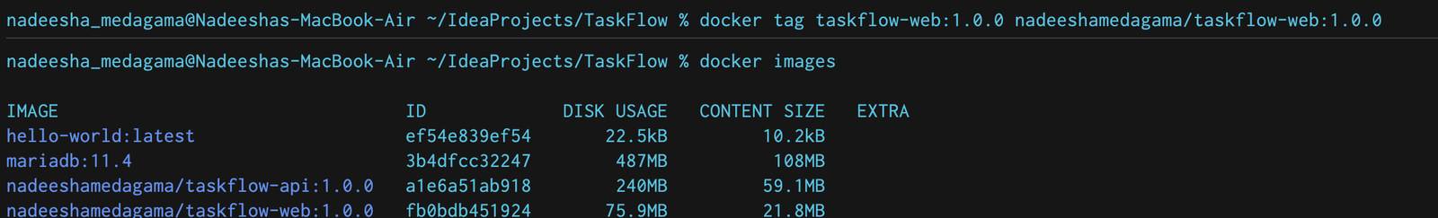
Figure 10 — Re-tagging the locally built image into the Docker Hub namespace before publishing, then listing it: nadeeshamedagama/taskflow-api:1.0.0 and nadeeshamedagama/taskflow-web:1.0.0.
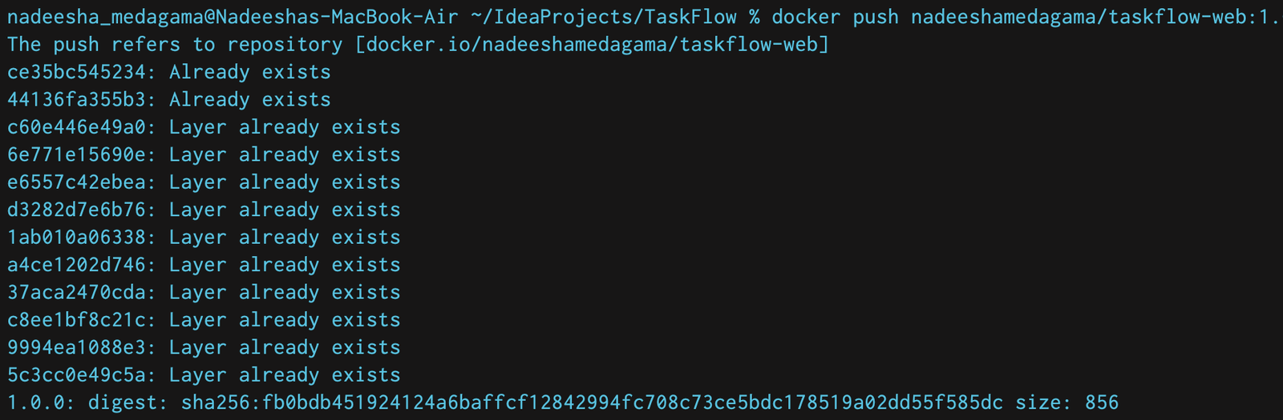
Figure 11 — Publishing the frontend image. The digest line confirms the push completed.

6.3 Base + override split, and the smoke test
The stack splits into a base docker-compose.yml describing how it really runs, and docker-compose.override.yml holding development conveniences — live reload via node --watch, a source bind mount, published datastore ports and restart: "no". Compose loads the override automatically, so exercising the real thing means being explicit:
$ docker compose up -d # base + override (development)
$ docker compose -f docker-compose.yml up -d # base only (production-like)
One detail in the override is load-bearing: the bind mount replaces all of /app, so an anonymous volume at /app/node_modules is needed to preserve the image's dependencies — the host copy may not exist, and if it does it is built for the wrong platform.
scripts/smoke-test.sh brings the stack up, waits for health, exercises the API and exits non-zero on any failure, so it works unchanged as a CI gate. It also checks the cache contract both ways: that a write invalidates the cache and that the next read is served from Redis.

7. Verification
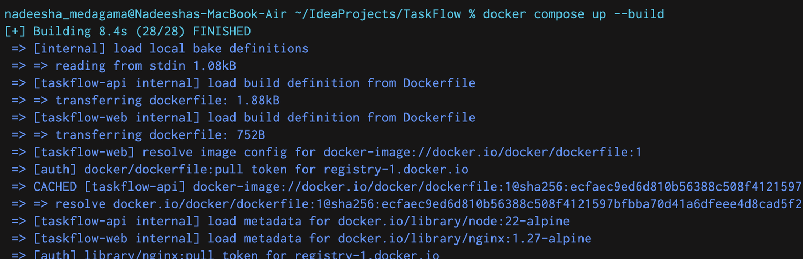
Figure 12 — The single command from the brief. docker compose up --build builds both first-party images and starts all four services in one step.
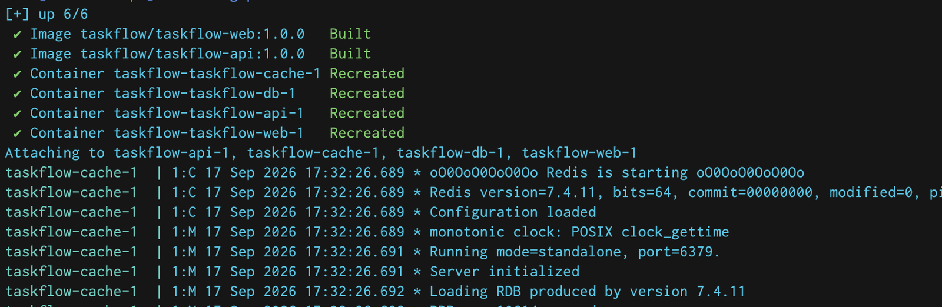
Figure 13 — The same run completing: both images built, all four containers created, and the service logs streaming — Redis ready to accept connections and PostgreSQL 16.15 starting and listening on 5432.
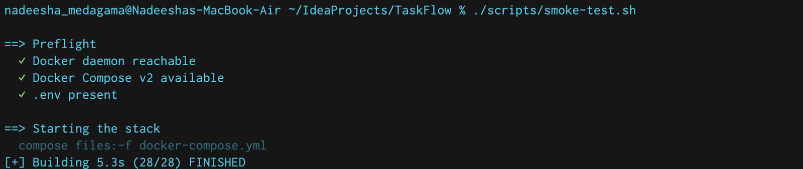
Figure 14 — scripts/smoke-test.sh begins with a preflight check that Docker, Compose v2 and the .env file are all present, then brings the stack up from the base compose file only.
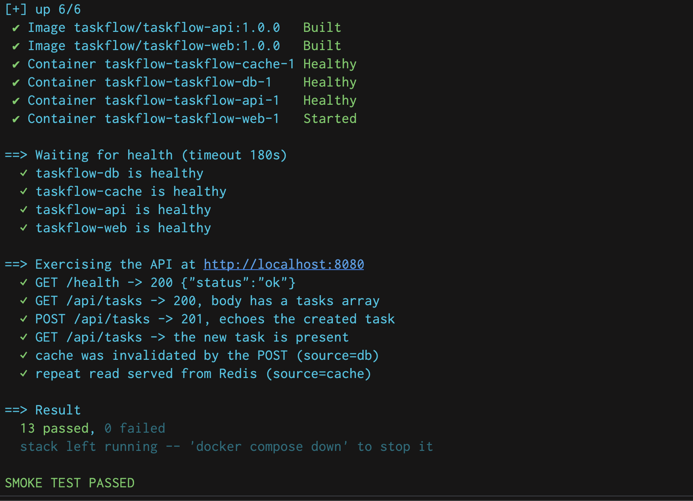
Figure 15 — The result. Compose reports each container Healthy before the next starts — depends_on: service_healthy doing its job — and all 13 checks pass, including a successful GET and POST to /api/tasks and the cache-invalidation contract in both directions.
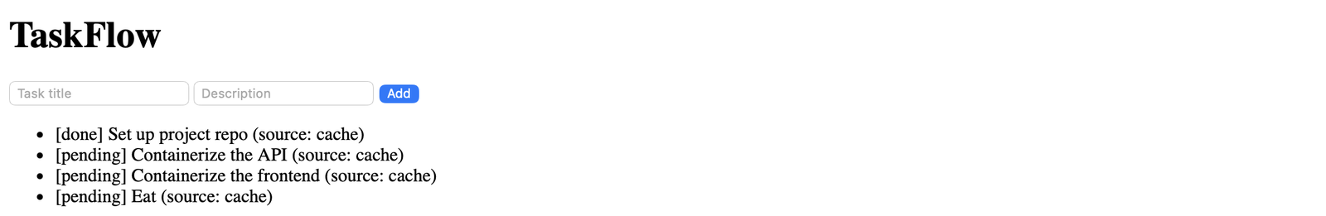
Figure 16 — TaskFlow served by the nginx container through the reverse proxy. "source: cache" shows the reads being served by Redis rather than PostgreSQL.

7.1 Data survives a full teardown
The brief's persistence checkpoint. A task created before docker compose down was still present after up, because the data lives in a named volume rather than the container's writable layer:
$ docker compose down # containers removed; the NAMED VOLUME is kept
$ docker volume ls --filter name=taskflow
local taskflow-db-data

$ docker compose up -d && curl -s http://localhost:8080/api/tasks
source: db | task count: 6
id=6 [pending] Write the Phase 1 report <- created before the teardown

7.2 Non-root and service discovery
$ docker compose exec taskflow-api id
uid=1000(node) gid=1000(node) groups=1000(node) <- not root

$ docker compose exec taskflow-api node -e 'dns.lookup("taskflow-db", ...)'
taskflow-db -> 172.18.0.3 <- service name resolves, exactly as in Kubernetes
taskflow-cache -> 172.18.0.2

8. Reflection Questions

8.1 What carries over to Kubernetes, and what changes?
Carries over unchanged. Service names are already DNS names — a Kubernetes Service called taskflow-db gives the identical hostname, so DB_HOST=taskflow-db needs no edit at all; the broken file's DB_HOST: postgres would have had to be fixed twice. The environment-variable contract is the same: server.js reads eight variables and no files, so it splits cleanly into a ConfigMap plus a Secret for DB_PASSWORD, consumed with envFrom, with no code change. The images are already tagged name:1.0.0 and pushed, which is exactly what a Pod spec's image: field wants. And deploy.resources translates literally to resources.limits/requests.
Needs to change. .env has no cluster equivalent — it becomes a ConfigMap and a Secret, and the secret must come from a sealed secret or an external store rather than a file on a laptop. depends_on: condition: service_healthy has no equivalent at all: Kubernetes has no ordering primitive between Deployments, so the API Pod will start before Postgres is ready and must tolerate it, via an init container that blocks on pg_isready or by crash-looping until it succeeds. The named volume becomes a PersistentVolumeClaim and Postgres should become a StatefulSet so the volume identity follows the Pod; the init.sql bind mount becomes a ConfigMap; and ports: "8080:80" disappears in favour of a ClusterIP Service plus an Ingress.

8.2 Why isn't depends_on + health the same as a readiness probe?
Because it is a one-shot start gate, not a continuous signal, and it governs the wrong thing.
- Evaluated once. After the API has started, Compose never re-checks the database. If Postgres goes unhealthy an hour later nothing reacts — the API keeps running and keeps failing. A readiness probe re-runs for the lifetime of the Pod.
- It gates container start, not traffic. Readiness in Kubernetes is a statement about traffic eligibility: a failing probe removes the Pod from the Service's endpoints while it stays alive and keeps trying. Compose has no load balancer to be removed from, so "not ready" has nowhere to be expressed.
- A check only proves what it tests. My probe calls GET /health, which returns {"status":"ok"} unconditionally — it proves the port is bound, not that the database pool can serve a query. The stack can report fully healthy while every /api/tasks request returns 500. A meaningful readiness probe would have to run something like SELECT 1.
- Even pg_isready is narrower than it looks. It reports that the postmaster accepts connections, not that init.sql has finished and the tasks table exists.
So depends_on removes a startup race on a laptop and nothing more. The application still has to survive its dependencies being absent — which this one partly does: redisReady stays false if Redis is unreachable and reads fall through to PostgreSQL. The database path has no such tolerance, and that is the gap Phase 2 has to close.

8.3 What happens to the data if the database crashes?
Today, nothing is lost. The data lives in the named volume taskflow-db-data, which is independent of the container lifecycle — a crash, a restart or a full down/up all leave it intact, as verified in §7.1, and PostgreSQL replays its write-ahead log on start to recover to the last committed transaction. Three honest caveats: docker compose down -v does delete the volume and nothing guards against typing it; it is one disk on one laptop with no backup and no replica; and inside Docker Desktop's VM there is an extra layer between a commit and the physical disk.
Across a cluster durability needs storage that is not tied to a node — a PersistentVolumeClaim on networked storage through a StorageClass, so the volume re-attaches when the Pod is rescheduled, where a hostPath volume would pin the database to one machine and lose the data with it. Postgres should run as a StatefulSet for stable identity, with streaming replication or an operator such as CloudNativePG so a node loss is a failover rather than an outage. A PVC protects against Pod loss, not against the disk or availability zone failing. Replication is also not a backup — it copies an accidental DROP TABLE to every replica in milliseconds — so WAL archiving plus base backups to object storage, with a restore that has actually been tested, is the other half. Access mode stays ReadWriteOnce: two PostgreSQL instances must never mount the same data directory.

8.4 Trade-offs between image size, build time and complexity
Size. Single-stage on the full node:22 base gave 1.63 GB; one word — node:22-alpine — brought it to 254 MB, an 84% cut for no added complexity. Multi-stage removed a further 8 MB, small here only because this application has no build step to discard. Build time. Cold builds were effectively identical across all four variants (3.5–7.8 s, run-to-run noise); I had expected multi-stage to be measurably slower cold, and at this scale it simply is not. The real difference is the warm path, and it comes from layer ordering rather than multi-stage as such — ~1.3 s against ~3.4 s, because npm ci stays CACHED. Complexity. Two stages, an explicit COPY --from, and a genuine footgun: --chown on the copy is load-bearing, since copying as root and running chown -R in a later layer would write a second full copy of the 10.7 MB node_modules that no later instruction can remove.
The conclusion I would defend. Roughly 99% of the size win came from the base image and essentially all of the build-time win from layer ordering — neither of which needs multi-stage. Its payoff on this application is genuinely small, but it costs about six lines and is the structure that starts paying the moment a build step appears. The deeper lesson is where effort belongs: the application is 10.7 MB of a 246 MB image, and the rest is the Node runtime.

Appendix — Test Environment
Component | Version
Host | macOS 26.6 (25G72) · Apple M4, 10 cores, 16 GB RAM · arm64
Docker Engine / Compose | 29.7.2 / v5.5.0
Builder | BuildKit via buildx v0.36.1
Images | node:22-alpine · postgres:16-alpine · redis:7-alpine · nginx:1.27-alpine

Method
- Base images were pulled before timing began, so no build timing includes a registry download.
- Cold builds used docker build --no-cache, three runs per variant; warm rebuilds appended a comment to server.js and rebuilt with the cache intact, four runs per variant.
- Sizes are as reported by docker images (uncompressed, on disk). Ranges are the observed spread across runs, not averages.
- Variant builds ran against a scratch copy of api/, so nothing in the repository was modified to produce these figures.

Reproducing it
$ cp .env.example .env
$ docker compose -f docker-compose.yml up -d --build # production-like
$ scripts/smoke-test.sh # 13 checks, non-zero on failure
$ docker history taskflow/taskflow-api:1.0.0 # layer breakdown

