
Autonomous Traffic Intersection Management for Cross-Traffic Control


Authors

Name | Matriculation
Nader Yahia | 2210026


2026

Chapter 1 – Introduction

1.1 Background
The continuous growth of urban traffic demand has increased congestion, travel delays, fuel consumption, and accident risks at road intersections. Traditional intersection control methods, particularly traffic light systems, rely on predefined signaling strategies that are often unable to adapt efficiently to dynamic traffic conditions. As cities move toward intelligent transportation infrastructures, more advanced traffic management approaches are required to improve traffic flow, safety, and resource utilization.

Intelligent Transportation Systems
Intelligent Transportation Systems (ITS) integrate sensing, communication, computation, and control technologies to improve the efficiency and safety of transportation networks. Modern ITS solutions use real-time data from roadside infrastructure, connected vehicles, and communication networks to support adaptive traffic management and automated decision-making.

Autonomous Vehicles
Autonomous vehicles are equipped with sensing, localization, planning, and communication capabilities that enable them to operate with minimal or no human intervention. The increasing adoption of autonomous and connected vehicles introduces new opportunities for cooperative traffic management, where vehicles can exchange information with infrastructure and other vehicles through Vehicle-to-Everything (V2X) communication.

Smart Intersections
Smart intersections extend traditional traffic management by replacing fixed signal-based control with intelligent coordination mechanisms. Instead of relying on traffic lights, vehicles communicate their states and intentions to an intersection controller, which computes safe crossing schedules while preventing collisions and minimizing delays. Such systems represent an important cyber-physical systems application that combines real-time sensing, scheduling, communication, and safety verification.

1.2 Problem Statement
Conventional traffic light systems allocate intersection access using static or semi-adaptive timing strategies. These approaches often cause unnecessary waiting times, reduced throughput, and inefficient utilization of intersection space, particularly under varying traffic conditions. For autonomous and connected vehicles, traffic-light-based control may no longer be the most efficient solution. A more advanced approach is required in which vehicles coordinate their movements through a centralized intersection controller capable of dynamically assigning safe intersection reservations. However, implementing such a system introduces significant challenges related to real-time scheduling, conflict resolution, safety guarantees, communication delays, and embedded-system constraints.

1.3 Motivation
Recent advances in autonomous driving, V2X communication, and embedded computing enable the development of intelligent intersection management systems that operate without traditional traffic signals. By replacing stop-and-go traffic control with reservation-based scheduling, vehicles can traverse intersections more efficiently while maintaining safety requirements. The motivation for this project is to investigate how cyber-physical system principles, real-time scheduling algorithms, and embedded-system implementation techniques can be combined to create a safe, efficient, and verifiable smart intersection controller. Furthermore, the project provides an opportunity to evaluate the feasibility of implementing such a system on resource-constrained embedded platforms while preserving deterministic real-time behaviour.

1.4 Project Objectives
The primary objective of this project is to design and model an intelligent reservation-based intersection management system for autonomous and connected vehicles.
The specific objectives are:
- Develop a formal traffic model for a four-way urban intersection with two lanes per approach.
- Design a conflict-aware vehicle coordination mechanism.
- Develop a reservation-based scheduling strategy for safe intersection access.
- Minimize vehicle waiting times and improve traffic throughput.
- Ensure collision-free operation through conflict detection and arbitration mechanisms.
- Model the system as a cyber-physical system suitable for real-time execution.
- Prepare the architecture for FreeRTOS-based embedded implementation.
- Establish a foundation for formal verification using UPPAAL.

1.5 Research Questions

RQ1 – Traffic Modelling: How can vehicle arrivals, lane occupancy, and intersection conflicts be modelled accurately to represent traffic behaviour at a smart intersection?

RQ2 – Traffic Optimization: How can reservation-based scheduling improve traffic flow efficiency, reduce waiting times, and maintain collision-free operation compared to conventional control approaches?

RQ3 – Embedded Real-Time Implementation: How can the proposed smart intersection controller be structured and implemented as a deterministic real-time embedded system while satisfying timing, safety, and resource constraints?

1.6 Scope and Assumptions
This project focuses on a single four-way urban intersection consisting of two lanes per approach. The intersection is controlled by a centralized reservation-based controller and does not use conventional traffic lights.
The following assumptions are adopted:
- Vehicles are autonomous and capable of V2X communication.
- Reliable sensor information is available to the controller.
- Vehicle intentions are known before entering the intersection control zone.
- The intersection controller possesses a global view of the intersection state.
- Communication delays remain within acceptable operational limits.
- Pedestrian traffic and non-autonomous vehicle behaviour are outside the scope of this project.
- The work emphasizes system modelling, scheduling, architecture design, and verification rather than deployment on physical vehicles.

1.7 Report Structure
The remainder of this report is organized as follows:
- Chapter 2 presents the requirements engineering process, stakeholder analysis, operational scenarios, and system requirements.
- Chapter 3 introduces the system architecture and modelling activities, including component decomposition, activity diagrams, state machines, and sequence diagrams.
- Chapter 4 discusses traffic modelling, scheduling concepts, and conflict-resolution mechanisms.
- Chapter 5 presents the embedded-system design considerations and real-time implementation strategy.
- Chapter 6 describes verification and validation approaches, including formal modelling considerations.
- Chapter 7 summarizes the results, discusses limitations, and outlines future work.

Chapter 2 – System Requirements Engineering

2.1 Stakeholder Analysis
Layer | Main stakeholders | Role in the system
Layer 1  Vehicle Agents | Autonomous vehicles; human-driven or partially connected vehicles | Send intent/state data; receive movement permission or guidance; introduce deterministic and stochastic behaviour inputs.
Layer 2:  Sensing & Perception | V2X communication module; roadside sensors; state fusion unit | Convert raw sensor/V2X information into one global lane-level intersection state.
Layer 3:  Control Layer | Intersection Control Unit (ICU) | Decision core: conflict detection, conflict graph construction, time-space reservation, and lane-level arbitration.
Layer 4:  Supervisory Layer | Traffic authority; emergency override system; system operator | Inject policy rules, priority constraints, emergency pre-emption, configuration, and maintenance actions.
Layer 5:  Environment Constraints | Intersection geometry; multi-lane approaches; kinematic limits; V2X latency | Define physical and communication bounds that restrict all scheduling decisions.

Entity | Role in the system
Autonomous vehicles | Provide trajectory intent and vehicle state; cooperate with ICU scheduling.
Human-driven / partially connected vehicles | Represent uncertain behavior; may require conservative safety margins and inferred state estimation.
Emergency vehicles | Require highest-priority preemption through the intersection when active.
Intersection Control Unit / Edge Server | Central scheduler that calculates safe crossing order, reservations, and permissions.
Roadside Units (RSUs) | Host communication devices and may support local edge processing near the intersection.
Roadside sensors | Cameras, radar, or loop detectors used to observe lane occupancy and detect obstacles.
V2X communication network | Transfers vehicle state, intent, scheduling messages, and priority requests.
Traffic authority / city operator | Defines rules, legal constraints, priority policies, and deployment requirements.
System operator / maintenance team | Maintains sensors, communication modules, and computing infrastructure.
Environment constraints | Geometry, multi-lane structure, vehicle dynamics, and communication latency limits.

2.2 Operational Scenarios
Scenario | Idea | Operation
S1 Normal Operation | Normal vehicles are handled using FCFS and reservation scheduling. | Vehicle request -> FCFS queue -> conflict check -> reservation -> permission
S2 Non-Conflicting Movement | Safe vehicles can cross together when their paths do not conflict. | No conflict detected -> same/overlapping slot -> allow crossing
S3 Conflicting Movement | Conflicting vehicles must be separated by time to avoid collision. | Conflict detected -> arbitration -> separate time slots -> safe crossing
S4 Emergency Vehicle | Emergency vehicles get highest priority while safety is still checked. | Emergency request -> override FCFS -> normal vehicles stop/wait -> priority permission
S5 Sensor/V2X Failure | If sensor or V2X data is unreliable, the system switches to safe mode. | Missing/delayed data -> uncertain state -> stop/wait command -> safe mode

2.3 Functional Requirements
ID | Requirement | Description | Input | Output
FR-1 | Vehicle State Acquisition | System shall collect real-time vehicle state data | V2X, sensors | Structured lane-wise vehicle state
FR-2 | Lane Monitoring | System shall maintain lane occupancy and queue state | Vehicle arrivals | Lane state model
FR-3 | Trajectory Interpretation | System shall map vehicle intent to intersection paths | Vehicle intent | Conflict zone path mapping
FR-4 | Conflict Detection | System shall detect spatial-temporal conflicts | Trajectories | Conflict graph
FR-5 | Time-Space Reservation | System shall assign non-overlapping intersection slots | Conflict graph | Schedule plan
FR-6 | Movement Authorization | System shall issue movement permissions | Schedule | Vehicle commands
FR-7 | Scheduling Update | System shall update schedule in real time | New arrivals | Updated schedule
FR-8 | State Maintenance | System shall maintain global intersection state | All inputs | System state model
FR-9 | Deadlock Prevention (Functional) | System shall avoid full intersection blocking | Lane states | Safe schedule
FR-10 | Emergency Override Handling | System shall prioritize emergency vehicles | Emergency input | Preempted schedule
FR-11 | Fault Tolerance | System must degrade safely under failures | Safe fallback mode

2.4 Non-Functional Requirements
ID | Requirement | Description | Constraint
NFR-1 | Real-Time Responsiveness | System must respond to events within bounded time | ≤ 50 ms latency
NFR-2 | Determinism | Same input must produce identical output | 100% deterministic
NFR-3 | Scalability | System must handle all lanes under peak load | 8 lanes active
NFR-4 | Availability | System must operate continuously | ≥ 99.9% uptime
NFR-5 | Fault Tolerance | System must degrade safely under failures | Safe fallback mode
NFR-6 | Communication Delay Tolerance | System must tolerate V2X delays | ≤ 100 ms delay
NFR-7 | Computational Efficiency | Scheduling must remain bounded | O(n²) or better
NFR-8 | Embedded Feasibility | Must run on embedded hardware | CPU + memory bounded
NFR-9 | Collision Avoidance | No two vehicles shall occupy the same conflict area or collision block simultaneously. | Strict mutual exclusion of conflict zones
NFR-10 | Cross-Collision Point Safety | Vehicles from conflicting directions shall not reach the same collision point at the same time. | Conflict-free scheduling
NFR-11 | Permission Before Entry | Vehicles shall only enter the intersection after receiving crossing permission from the intersection coordination unit. | Entry only with valid authorization
NFR-12 | Minimum Vehicle Separation | Vehicles traveling in the same lane shall maintain a safe separation distance. | Separation distance ≥ safety threshold
NFR-13 | Safe Turning Speed | Vehicles performing left or right turns shall reduce speed to safe turning limits. | Turning speed ≤ configured safety limit
NFR-14 | Communication Failure Safety | A disconnected vehicle without valid permission shall stop before the stop line. | Fail-safe stop on communication loss
NFR-15 | Sensor Failure Safe Mode | If roadside or vehicle sensors become unreliable, the system shall switch to a safe operational mode. | Mandatory safe-mode activation
NFR-16 | Emergency Vehicle Priority Safety | Emergency vehicles shall receive priority crossing while maintaining safety for all other road users. | Emergency traffic receives highest priority
NFR-17 | Controller Response Time | The intersection coordination unit shall compute and send crossing permission within 2 seconds after receiving vehicle data. | Response time ≤ 2 s
NFR-18 | Maximum Vehicle Waiting Time | No vehicle shall wait indefinitely for crossing permission during normal operation. | Bounded waiting time
NFR-19 | Safe Intersection Clearance Time | Vehicles shall clear reserved conflict areas within the assigned crossing time window. | Clearance within allocated time slot
NFR-20 | Communication Timeout Detection | The system shall detect V2I or V2X communication failure within 3 seconds. | Failure detection ≤ 3 s
NFR-21 | Emergency Reaction Time | The controller shall cancel unsafe permissions immediately after detecting an obstacle, accident, or emergency vehicle. | Immediate emergency response
NFR-22 | Sensor Update Timing | Vehicle sensors, roadside cameras, and radars shall provide periodic environment updates in real time. | Continuous real-time updates
NFR-23 | Safe Switching Delay | The controller shall maintain a safe temporal separation between conflicting vehicle movements. | Minimum switching delay enforced
NFR-24 | Congestion Scheduling Time | The controller shall continuously recompute crossing schedules during high traffic density conditions. | Dynamic schedule recomputation within operational deadline

2.7.1 Requirement Traceability Matrix
ID | Requirement | Description | Mapped Block(s) | Verification
FR-1 | Vehicle State Acquisition | Collect real-time vehicle data | Sensor Subsystem | V2X + sensor fusion validation
FR-2 | Lane Monitoring | Maintain lane occupancy and queue state | Lane State Builder | LaneState consistency checks
FR-3 | Trajectory Interpretation | Map intent to intersection paths | Lane State Builder | State model validation
FR-4 | Conflict Detection | Detect spatial-temporal conflicts | Conflict Detection Engine | ConflictGraph correctness checks
FR-5 | Time-Space Reservation | Assign non-overlapping slots | Arbitration Manager, Scheduling Engine | Schedule feasibility + constraint checks
FR-6 | Movement Authorization | Issue movement commands | Reservation Manager, Vehicle Interface | Command execution validation
FR-7 | Scheduling Update | Update schedule in real time | Scheduling Engine | Replanning + update cycle validation
FR-8 | State Maintenance | Maintain global intersection state | Lane State Builder, Global State Manager | State consistency + snapshot checks
FR-9 | Deadlock Prevention | Avoid full intersection blocking | Arbitration Manager, Scheduling Engine | Deadlock freedom analysis
FR-10 | Emergency Override Handling | Prioritize emergency vehicles | Arbitration Manager | Priority override verification

2.7.2 Non-Functional Requirements (NFR)
ID | Requirement | Description | Mapped Block(s) | Verification
NFR-1 | Real-Time Responsiveness | ≤ 50 ms response | Scheduling Engine, Vehicle Interface | WCET + latency profiling
NFR-2 | Determinism | Same input → same output | Global State Manager, Verification Module | Replay-based validation
NFR-3 | Scalability | Support 8 lanes | Lane State Builder, Scheduler | Load testing
NFR-4 | Availability | ≥ 99.9% uptime | Entire system | Fault injection testing
NFR-5 | Fault Tolerance | Safe degradation | Global State Manager, Verification Module | Failure mode analysis
NFR-6 | Communication Delay Tolerance | ≤ 100 ms delay tolerance | Vehicle Interface | Network latency simulation
NFR-7 | Computational Efficiency | O(n²) or better | Scheduling Engine | Complexity analysis
NFR-8 | Embedded Feasibility | Run on embedded hardware | Entire control core | Resource profiling
NFR-9 | Collision Freedom | No conflicting vehicles simultaneously | Conflict Detection, Verification | Model checking (UPPAAL-ready)
NFR-10 | Safe Separation | Maintain safe distance | Conflict Detection, Scheduling | Constraint validation
NFR-11 | Deadlock Freedom | No circular wait | Arbitration, Scheduling, Verification | Graph-based + formal analysis
NFR-12 | Bounded Decision Time | ≤ 10–50 ms scheduling WCET | Scheduling Engine | Worst-case execution analysis
NFR-13 | Maximum Waiting Time | Bounded delay per lane | Scheduling, Reservation Manager | Queue analysis
NFR-14 | Atomic Scheduling | No partial commits | Reservation Manager | Transaction-like commit validation
NFR-15 | Emergency Preemption | Emergency vehicle priority | Arbitration Manager | Priority override test
NFR-16 | Temporal Consistency | No stale execution | Global State Manager, Vehicle Interface | Time synchronization validation
The system ensures full requirement traceability by mapping each functional, non-functional, and safety requirement to one or more dedicated subsystems. Safety requirements are intentionally distributed across detection, decision, and verification layers to ensure multi-stage enforcement and formal verifiability.

2.8 Concept Selection and Evaluation
Before selecting the final smart intersection architecture, several alternative intersection management approaches were evaluated.

Pugh Matrix Reference Concept: Traditional Traffic Lights (Solution A)
Scoring: "+" = Better than reference, "0" = Same as reference, "-" = Worse than reference
Criteria | Weight | Traffic Lights (Ref) | Roundabout | Reservation-Based | Distributed Negotiation
Safety | 5 | 0 | + | + | -
Traffic Throughput | 5 | 0 | + | + | +
Waiting Time Reduction | 5 | 0 | + | + | +
Real-Time Suitability | 4 | 0 | 0 | + | -
Embedded Implementation | 4 | 0 | + | + | -
Formal Verification | 5 | 0 | - | + | -
Scalability | 3 | 0 | 0 | + | +
Complexity | 3 | 0 | + | - | -
V2X Integration | 4 | 0 | - | + | +
Autonomous Vehicle Compatibility | 5 | 0 | 0 | + | +

Weighted Evaluation Matrix
Using numerical scores:
Criteria | Weight | Roundabout | Reservation-Based | Distributed
Safety | 5 | 5 | 5 | -5
Throughput | 5 | 5 | 5 | 5
Waiting Time | 5 | 5 | 5 | 5
Real-Time Suitability | 4 | 0 | 4 | -4
Embedded Feasibility | 4 | 4 | 4 | -4
Formal Verification | 5 | -5 | 5 | -5
Scalability | 3 | 0 | 3 | 3
Complexity | 3 | 3 | -3 | -3
V2X Integration | 4 | -4 | 4 | 4
AV Compatibility | 5 | 0 | 5 | 5
Total | — | 13 | 37 | 1

Selected Solution
The Reservation-Based Intersection Management System achieved the highest overall score (37 points) and was therefore selected as the preferred system concept.
The approach offers:
- Collision-free scheduling
- Real-time decision making
- High traffic throughput
- Compatibility with autonomous vehicles
- Suitability for FreeRTOS implementation
- Strong support for formal verification using UPPAAL
This makes it the most appropriate solution for the objectives and requirements defined in this project.

Chapter 3 – System Modelling and Architecture

3.1 High-Level Architecture
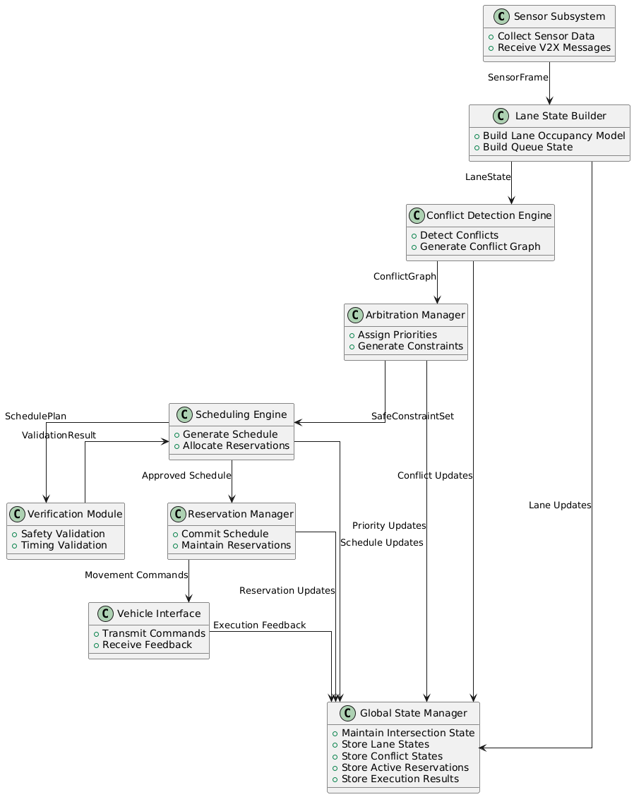
The Block Definition Diagram (BDD) for the smart intersection system defines the structural decomposition of the controller into well-scoped functional blocks rather than a single monolithic unit. At the highest level, the system is partitioned into perception, decision, execution, and state management layers. The perception layer includes the Sensor Subsystem and Lane State Builder, which convert raw V2X and sensor data into a structured traffic representation. The decision layer is further decomposed into Conflict Detection, Arbitration, Scheduling, and Verification, each responsible for a distinct transformation of system knowledge from safety analysis to time-space planning. The execution layer contains the Reservation Manager and Vehicle Interface, which ensure that validated schedules are safely committed and physically executed. The Global State Manager acts as a shared system memory, maintaining a consistent and synchronized view of all critical system states across these layers.
This BDD structure also explicitly captures the relationships and dependencies between blocks, showing how outputs of one subsystem become inputs or shared state updates for others. Instead of embedding all logic inside a single controller, each block has a clearly defined responsibility and interface. This makes the system behaviour traceable from requirements to implementation, since each block can be directly mapped to specific FR, NFR, and STR requirements. It also enables hierarchical reasoning, where complex behaviour emerges from the interaction of simpler, verifiable components rather than from an opaque centralized algorithm.
Compared to a monolithic controller design, this decomposition provides significantly better modularity and maintainability. In a monolithic system, perception, safety reasoning, scheduling, and execution logic are tightly coupled, making it difficult to isolate faults, update individual functions, or formally verify correctness. Any modification to one part of the controller risks unintended side effects elsewhere, which becomes critical in safety-sensitive systems like autonomous intersections. In contrast, the BDD-based architecture isolates concern into independent blocks with well-defined interfaces, reducing coupling and improving system robustness under changes or extensions.
Furthermore, the distributed architecture is better suited for real-time and safety-critical verification. Each subsystem can be individually analysed for timing constraints, correctness, and resource usage, enabling formal methods such as UPPAAL to be applied more effectively. It also allows direct mapping to RTOS task structures, improving schedulability analysis and implementation feasibility on embedded platforms. Overall, while monolithic controllers may be simpler initially, the BDD-based modular architecture provides stronger guarantees in terms of safety, scalability, verifiability, and requirement traceability, which are essential for intelligent intersection systems.

3.2 Activity Modelling

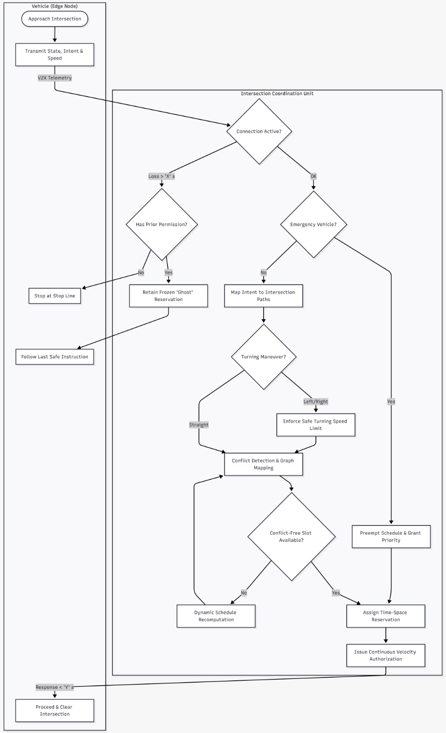
Activity Diagram

Behavioural Analysis

3.3 State Machine Modelling

The State Machine Diagram represents the behaviour of the Reservation-Based Intersection Management Controller. The controller begins in the Idle state and waits for vehicle requests. When a vehicle arrives, its position, speed, and intended movement are collected and validated using sensor and V2X data.

Controller States

Based on the received information, the controller classifies the request according to the operational scenarios. During normal operation (S1), vehicles are processed using First-Come-First-Served (FCFS) reservation scheduling. For non-conflicting movements (S2), compatible vehicles may receive overlapping reservation slots and cross simultaneously. For conflicting movements (S3), an arbitration process assigns separate time slots to ensure collision-free crossing. Emergency vehicle requests (S4) activate the Emergency Override state, which temporarily prioritizes emergency traffic over normal traffic. If sensor or V2X data becomes unreliable (S5), the controller enters Safe Mode and issues stop or wait commands until reliable information is restored.

Transition Analysis

Before granting permission, all reservations are verified to ensure that no collision or conflict can occur. Once permission is granted, the controller monitors the vehicle while it crosses the intersection. After the vehicle exits the reserved conflict zone, the reservation is released and the controller returns to the Idle state, ready to process new requests.

3.7 Sequence Modelling

Vehicle Processing Sequence
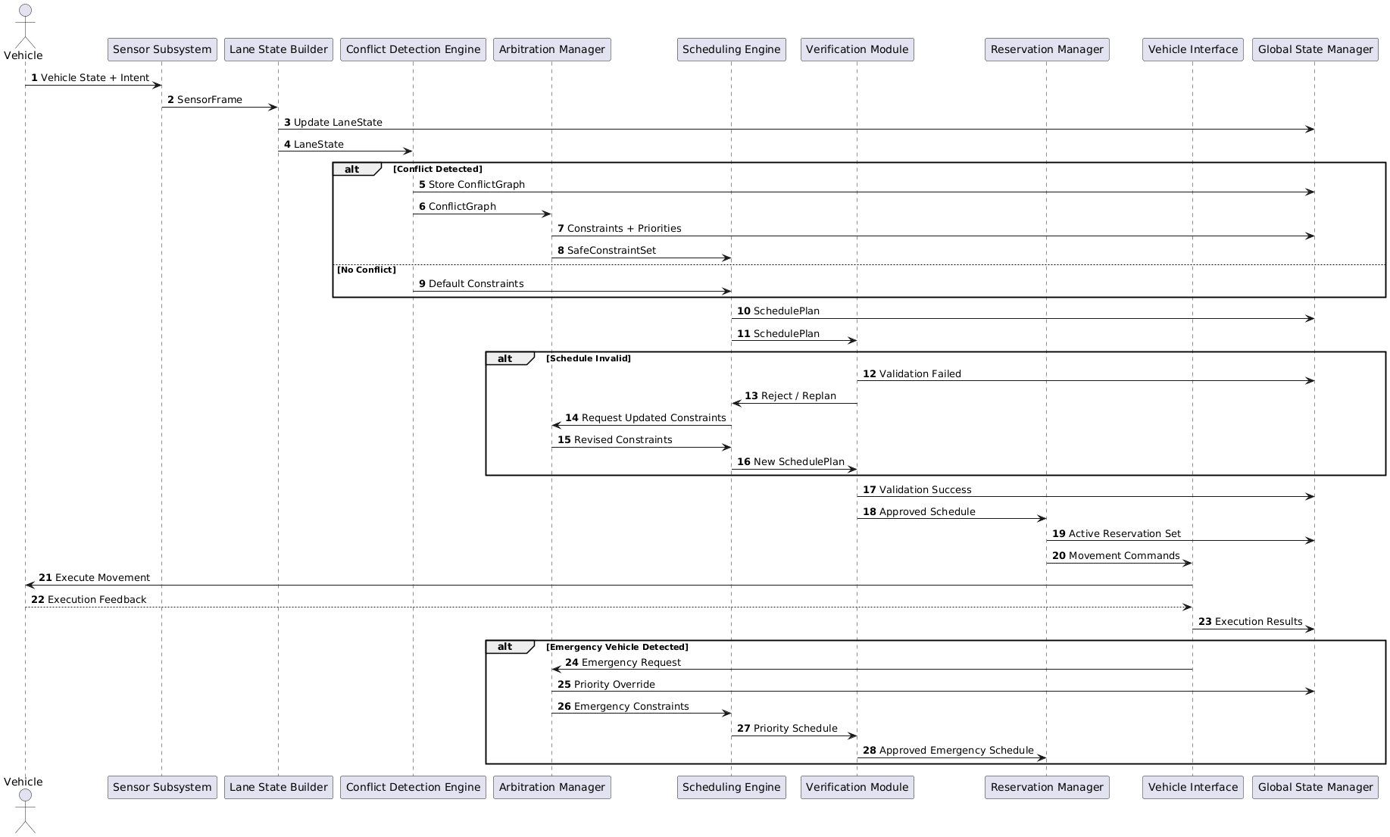
The Vehicle Processing Sequence describes the normal operation of the smart intersection controller from vehicle arrival to movement execution. The sequence begins when vehicle state and intent information are received through sensors and V2X communication. The Sensor Subsystem collects the raw data and forwards it to the Lane State Builder, which constructs a structured LaneState representing the current traffic situation. This information is stored in the Global State Manager and passed to the Conflict Detection Engine, where potential conflicts between vehicle trajectories are identified. If conflicts exist, the Arbitration Manager applies priority and safety rules to generate a SafeConstraintSet; otherwise, default constraints are used.
Using the available constraints, the Scheduling Engine generates a SchedulePlan that defines the temporal order and reservation of intersection resources. The Verification Module then validates the generated schedule against safety, timing, and consistency requirements. If the schedule is invalid, a replanning process is triggered until a valid schedule is produced. Once approved, the Reservation Manager commits the schedule and creates active reservations. The Vehicle Interface subsequently issues movement commands to the vehicles and receives execution feedback. Finally, the execution results are stored in the Global State Manager, completing the control cycle and providing an updated system state for the next scheduling iteration.

Emergency Handling Sequence
The Emergency Handling Sequence is activated whenever an emergency vehicle is detected within the intersection environment. During normal operation, emergency vehicle information may be received through V2X messages or dedicated priority signals. When such a request is detected, the Vehicle Interface forwards the emergency event to the Arbitration Manager. The Arbitration Manager immediately applies priority override rules, ensuring that emergency traffic receives precedence over regular vehicles while maintaining safety constraints.
Following the priority update, a new set of scheduling constraints is generated and forwarded to the Scheduling Engine. The scheduler computes an updated priority schedule that incorporates the emergency vehicle's route and timing requirements. This schedule is then validated by the Verification Module to ensure that collision freedom, safe separation, and timing constraints remain satisfied despite the priority override. After successful verification, the Reservation Manager commits the emergency schedule and the Vehicle Interface transmits the corresponding movement commands. The resulting execution feedback and updated priority state are recorded in the Global State Manager, ensuring that subsequent control cycles operate using the latest emergency-aware system state. This process allows emergency vehicles to receive immediate priority while preserving safe and deterministic intersection operation.

Chapter 4 – Queueing Theory Modelling

4.1 Traffic Flow Modelling

4.2 Queueing System Representation

4.3 M/M/1 Model

Assumptions

Mathematical Formulation

Results

4.4 M/D/1 Model

4.5 Priority Queue Model

4.6 Multi-Queue Model

4.7 Comparative Analysis

4.8 Selected Traffic Model

Chapter 5 – Traffic Optimization Strategies

5.1 Fixed-Time Scheduling

5.2 Adaptive Scheduling

5.3 Priority-Based Scheduling

5.4 Reservation-Based Scheduling

5.5 Emergency Vehicle Prioritization

5.6 Comparative Evaluation

5.7 Selected Control Strategy

Chapter 6 – Formal Verification Using UPPAAL

6.1 Verification Objectives

6.2 System Abstraction

6.3 Timed Automata Design

6.4 Safety Verification

Collision Freedom

Mutual Exclusion

6.5 Liveness Verification

Eventual Access

Fairness

6.6 Timing Verification

Waiting Time Bounds

Response Time Constraints

6.7 Deadlock Analysis

6.8 Verification Results

Chapter 7 – Real-Time Embedded System Design

7.1 Real-Time Requirements

7.2 FreeRTOS Architecture

7.3 Task Design

Sensor Task

Scheduler Task

Arbitration Task

Emergency Task

Monitoring Task

7.4 Scheduling Strategy

Fixed Priority

RMS

EDF

Selected Scheduler

7.5 Inter-Task Communication

7.6 Synchronization Design

Queues

Semaphores

Mutexes

7.7 WCET Analysis

7.8 Latency Analysis

7.9 Jitter Analysis

Chapter 8 – HW/SW Co-Design

8.1 Co-Design Objectives

8.2 Hardware–Software Partitioning

8.3 Candidate Hardware Accelerators

Traffic Arbitration

Sensor Preprocessing

Timing Logic

8.4 FPGA-Based Architecture

8.5 ModelSim Validation

8.6 Trade-Off Analysis

Chapter 9 – System Implementation

9.1 Software Structure

9.2 Implemented Modules

9.3 Controller Logic

9.4 Communication Mechanisms

9.5 Integration Process

9.6 Implementation Challenges

Chapter 10 – Testing and Validation

10.1 Validation Strategy

10.2 Functional Testing

10.3 Congestion Testing

10.4 Emergency Vehicle Testing

10.5 Stress Testing

10.6 Real-Time Performance Testing

10.7 Verification Matrix

10.8 Test Results

Chapter 11 – Results and Evaluation

11.1 Throughput Analysis

11.2 Waiting Time Analysis

11.3 Queue Length Analysis

11.4 CPU Utilization Analysis

11.5 Deadline Miss Analysis

11.6 Jitter Analysis

11.7 Fairness Evaluation

11.8 Discussion of Results

Chapter 12 – Project Management and Team Contributions

12.1 Project Planning

12.2 Milestones

12.3 Risk Management

12.4 Team Responsibilities

12.5 Lessons Learned

Chapter 13 – Conclusion and Future Work

13.1 Summary of Achievements

13.2 Research Question Answers

RQ1 Answer

RQ2 Answer

RQ3 Answer

13.3 Limitations

13.4 Future Enhancements

References
(IEEE format)

Appendices

Appendix A – Complete Requirements Specification

Appendix B – SysML Diagrams

Appendix C – UPPAAL Models

Appendix D – FreeRTOS Configuration

Appendix E – Additional Simulation Results

Appendix F – Source Code Excerpts

