**Inertial measurement unit (IMU)**

**What is an Inertial measurement unit?**

An Inertial Measurement Unit (IMU) is a sensor system that measures acceleration, angular velocity, and often magnetic fields to determine an object’s orientation and movement in space. It typically includes accelerometers, gyroscopes, and sometimes magnetometers. These components work together to provide crucial data for navigation, stabilization, and control in a wide range of applications, from aerospace and robotics to smartphones and autonomous vehicles. IMUs are essential in systems where precise movement and orientation data are required.

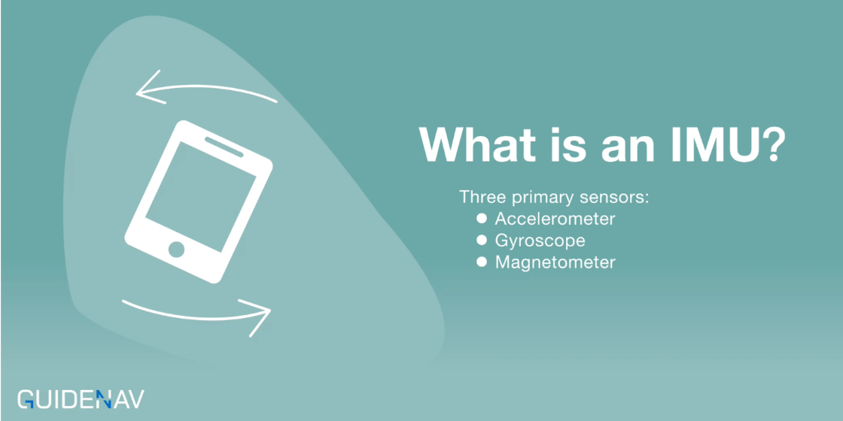

**What is IMU Sensor Data?**

The IMU sensor data consists of signals from three primary sensors:

1. Accelerometers: Measure linear acceleration along the X, Y, and Z axes.
2. Gyroscopes: Measure rotational velocity or angular velocity around the same axes.
3. Magnetometers (optional): Measure the magnetic field to help with orientation in space, offering a compass-like functionality.

Each of these IMU sensors provides a stream of IMU data that, when combined and processed, gives a complete picture of an object’s movement and orientation. Typically, this data is used to derive important metrics like:

* Acceleration: Linear change in velocity.
* Angular Velocity: Rate of rotation around an axis.
* Orientation: The rotational position of an object in 3D space.

The precision and accuracy of IMU sensor data play a pivotal role in systems that require real-time tracking and navigation. When used in aerospace, defense, or industrial applications, the data can guide a spacecraft, aircraft, or robotic system with pinpoint accuracy.

******Basic Components of an IMU:**



**Common Relative Applications of IMU:**

In consumer electronics, IMUs have a more subtle but equally significant presence. They are in your smartphone, ensuring smooth screen rotation or powering motion-based games. In fitness trackers and smartwatches, IMUs track movement, monitor activity, and calculate steps or calories burned.

In several projects involving wearable technology, I’ve seen firsthand how much an IMU contributes to the user experience. The sensors inside fitness devices use accelerometers and gyroscopes to capture movements accurately, be it walking, running, or even swimming. IMUs ensure that these devices work seamlessly, providing users with accurate data they rely on daily.

**2. Application Needs (Based on Your Project)**

|  |  |
| --- | --- |
| **Parameter** | **Relevance to Your Project** |
| **Update Rate** | Needed for real-time orientation tracking — ideally ≥100Hz |
| **Accuracy / Drift** | High accuracy is needed to reduce drift over time |
| **Low Noise** | Essential to avoid noisy or jittery rotation estimates |
| **Stability / Bias** | Important for long sessions with minimal recalibration |
| **Size** | Compact form for your lightweight tracking device |
| **I2C/SPI Interface** | For MCU compatibility (STM32F401) |
| **Power Consumption** | Relevant if battery-powered |
| **Sensor Fusion** | Either done on-chip or by STM32 via software |

**3. Minimum Specs**

For a good tracking system, aim for:

* **Gyro range**: ±2000 °/s
* **Gyro noise**: < 0.01 °/s/√Hz
* **Accelerometer range**: ±16g
* **Sampling rate**: ≥100Hz (ideally 200–500Hz)
* **Communication**: SPI preferred over I2C for lower latency
* **Temperature stability**: Low drift with temperature changes

**4. Popular IMU Choices (Compared)**

|  |  |  |  |
| --- | --- | --- | --- |
| **IMU** | **Pros** | **Cons** | **Typical Price** |
| **MPU-9250** | Widely used, 9-DOF, low cost | Not very accurate, discontinued | $3–5 |
| **MPU-6050** | Cheap, reliable, 6-DOF | No magnetometer, more drift | $2–4 |
| **ICM-20948** | 9-DOF, lower power, better fusion | Needs external fusion software | $7–10 |
| **BNO055** | Onboard fusion, simple interface | More expensive, less flexible | $10–15 |
| **ISM330DHCX** | High performance, industrial-grade | Requires external fusion | $6–8 |
| **LSM6DSOX** | Built-in machine learning core | Somewhat newer, needs tuning | $4–6 |

**Recommended**:

* **ICM-20948** or **ISM330DHCX** for best balance of cost and performance.
* Use **BNO055** if you want an easier setup with onboard fusion and lower MCU processing.

**5. Sensor Fusion**

As STM32F401 has been selected:

* If IMU has no fusion (e.g., MPU-9250), needed to run a **Kalman filter** or **Madgwick/Mahony** filter in software.
* If it has **onboard fusion** (e.g., BNO055), MCU just reads angles (pitch, yaw, roll)= plug and play. Others = more control + better tuning, but more work.