Browser testing report

SS for home page from

1-google chrome latest ver.

2-safari last version
Both on macos tahoe 26.3

On chrome:-
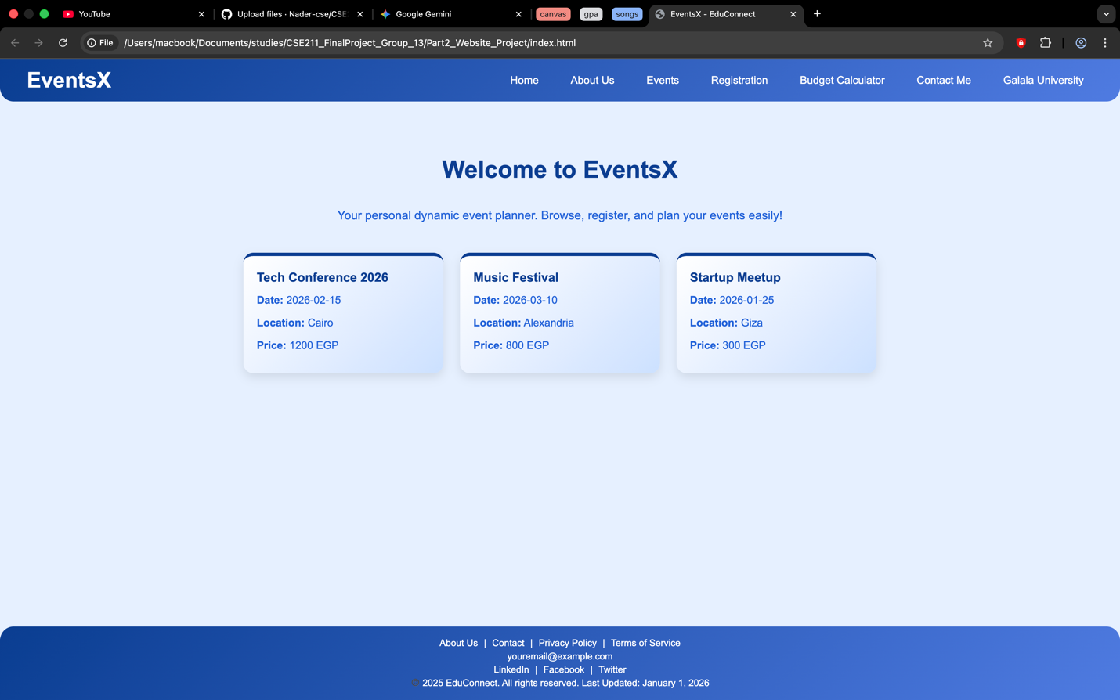

On safari:-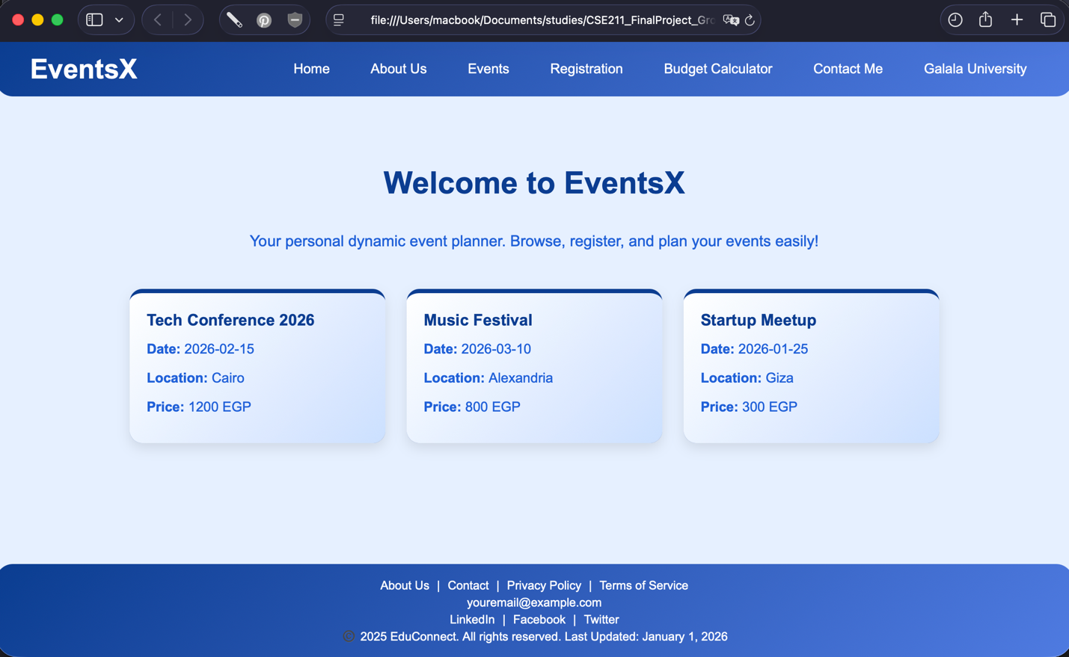

Check list of each browser
google chrome
Browser | Chrome | safari
version | Version 143.0.7499.170 (Official Build) (arm64) | Version 26.3 (21623.2.2.11.1)
Page loads correctly | Yes | Yes
Images | Displayed properly | Displayed properly
Links,mailto | Works as expected | Works as expected
Forms | Works as expected | Works as expected
Submission and navigation | Works as expected | Works as expected
Tables and texts | Display properly | Display properly
Developer tools | No errors/warnings | No errors/warnings

Conclusion:-
All pages have been tested on the latest version of macOS on both chrome and safari and all pages is working flawlessly

