ErpLite — Pages Reference
Screenshot and description of every page in the system. Captured from the running application; screens reflect sample/test data.
Total pages: 69

General

Home (Dashboard)
Route: /home2
Default landing page. Voucher-activity dashboard with date-range / currency / posted-status filters (auto-applied and remembered), per-type KPIs, data grids and switchable charts (column/line/area/pie/donut) for Journal, Cash Payment, Cheque Payment and Receipt vouchers, plus quick shortcuts to every system page.
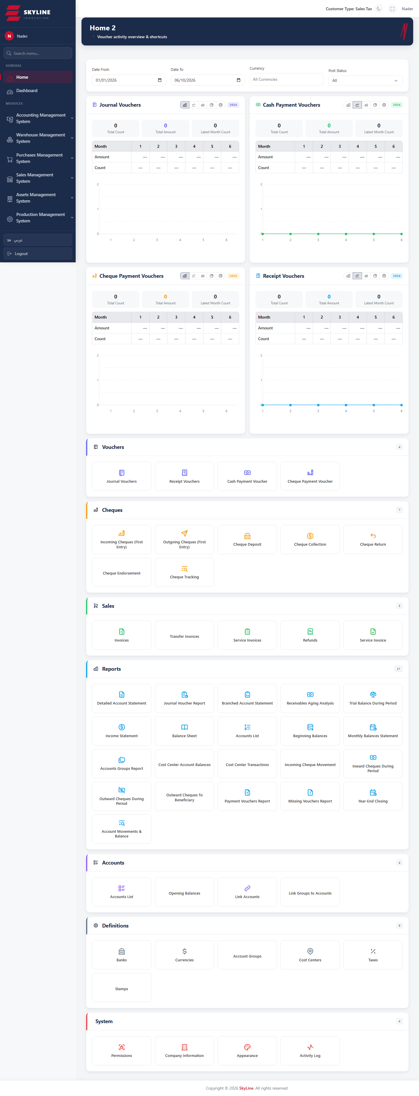

Control Panel
Route: /dashboard
Primary control-panel dashboard with high-level operational widgets and summaries.
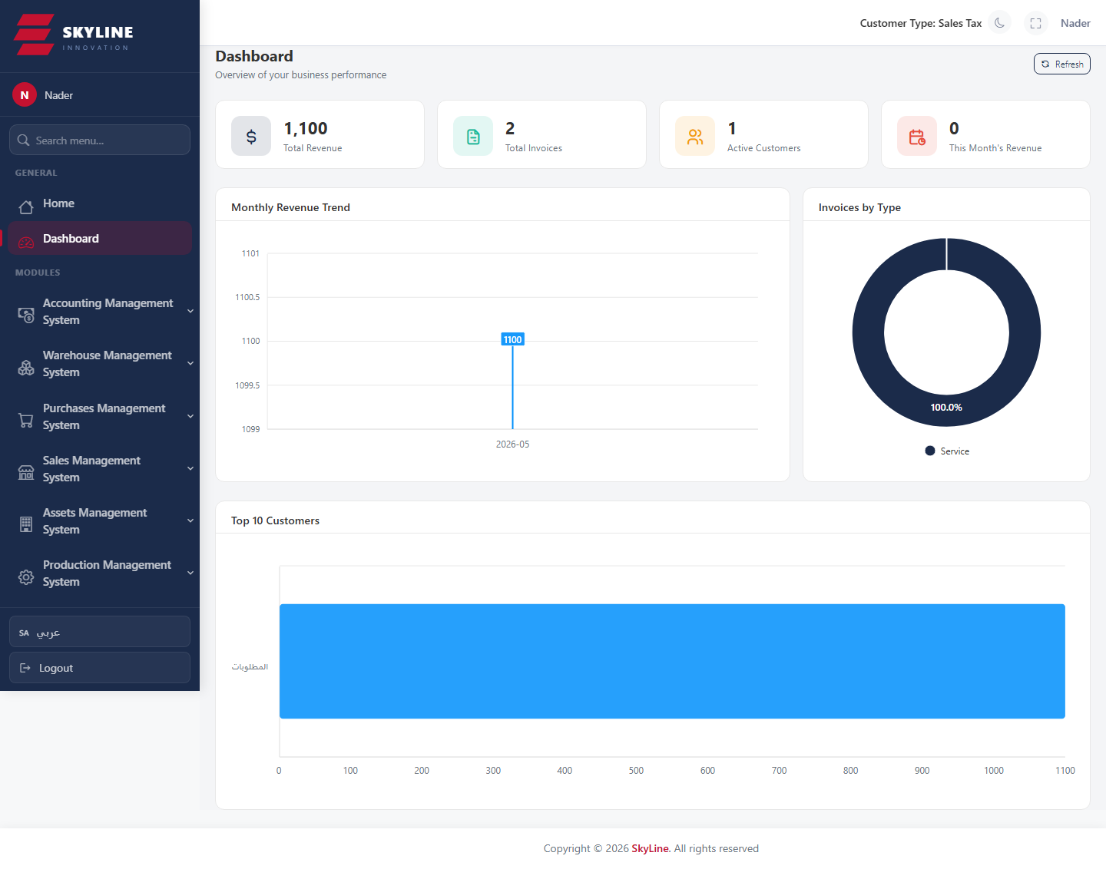

Activity Log
Route: /activity-log
Audit trail of user actions across the system, filterable for review.
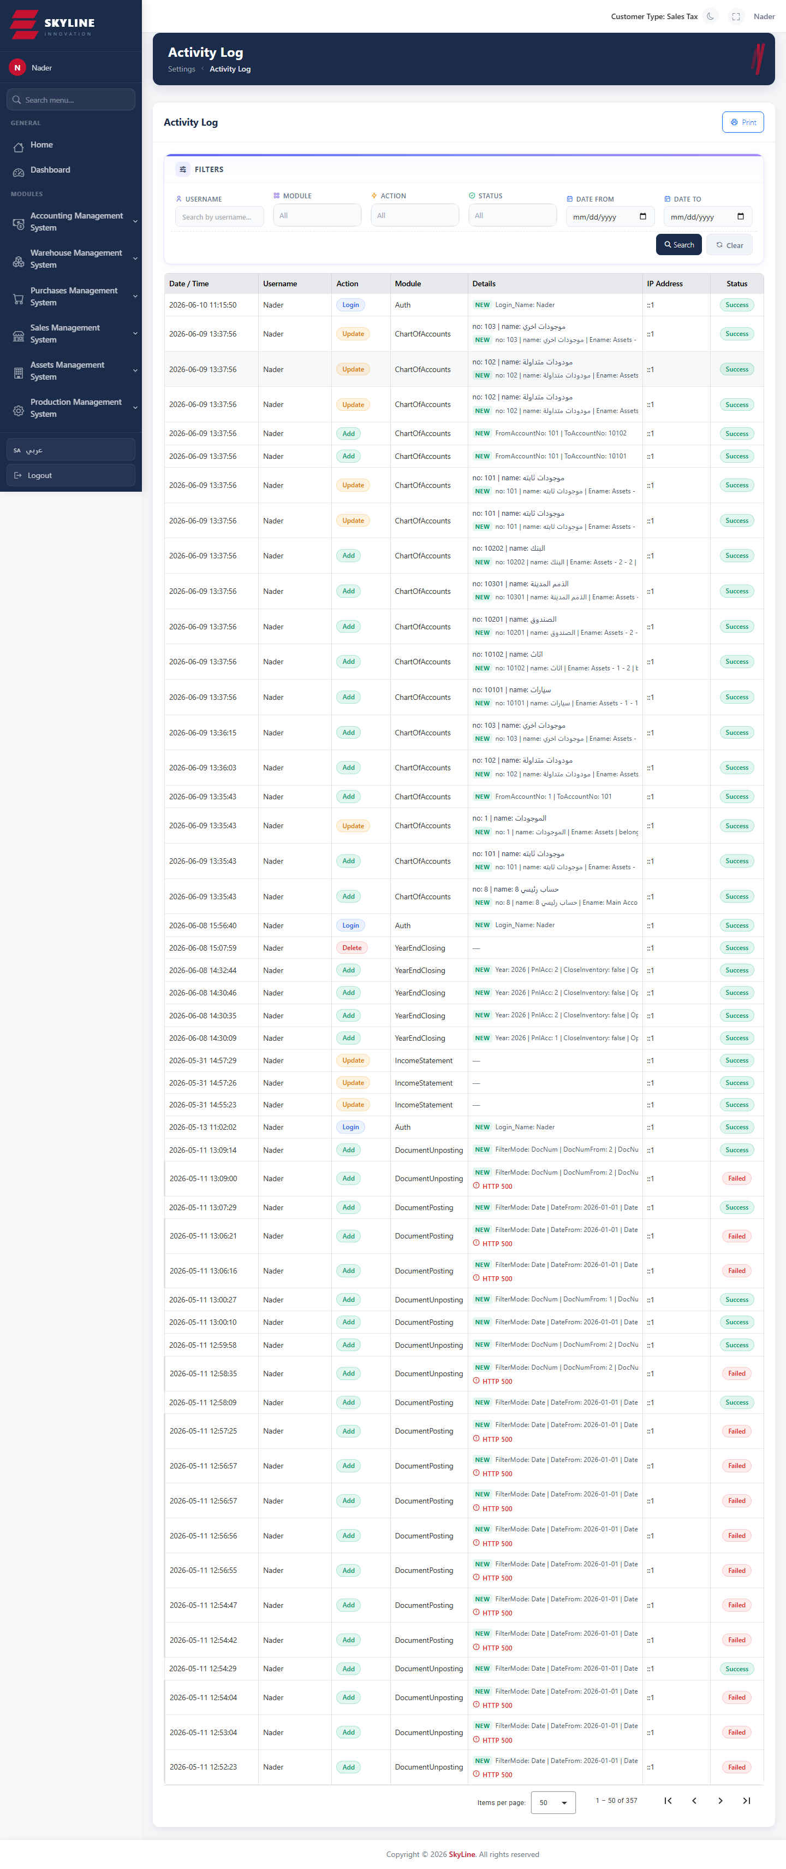

Accounting · General Ledger

Chart of Accounts
Route: /accounting/gl/accounts-list
Tree-based chart of accounts with inline add / edit / delete, branch and cost-center flags, search, and Excel import/export. Posting to parent (non-leaf) accounts is blocked.
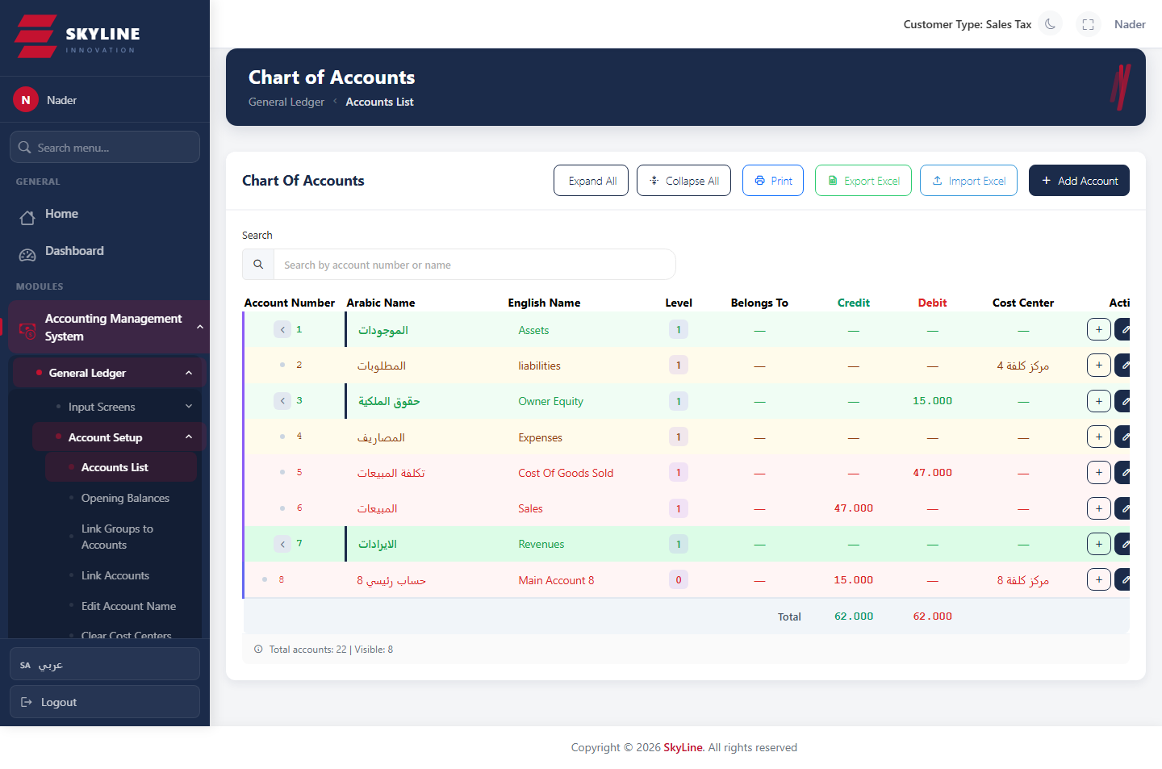

Opening Balances
Route: /accounting/gl/opening-balances
Enter and import the opening debit/credit balances for accounts at the start of the fiscal year.
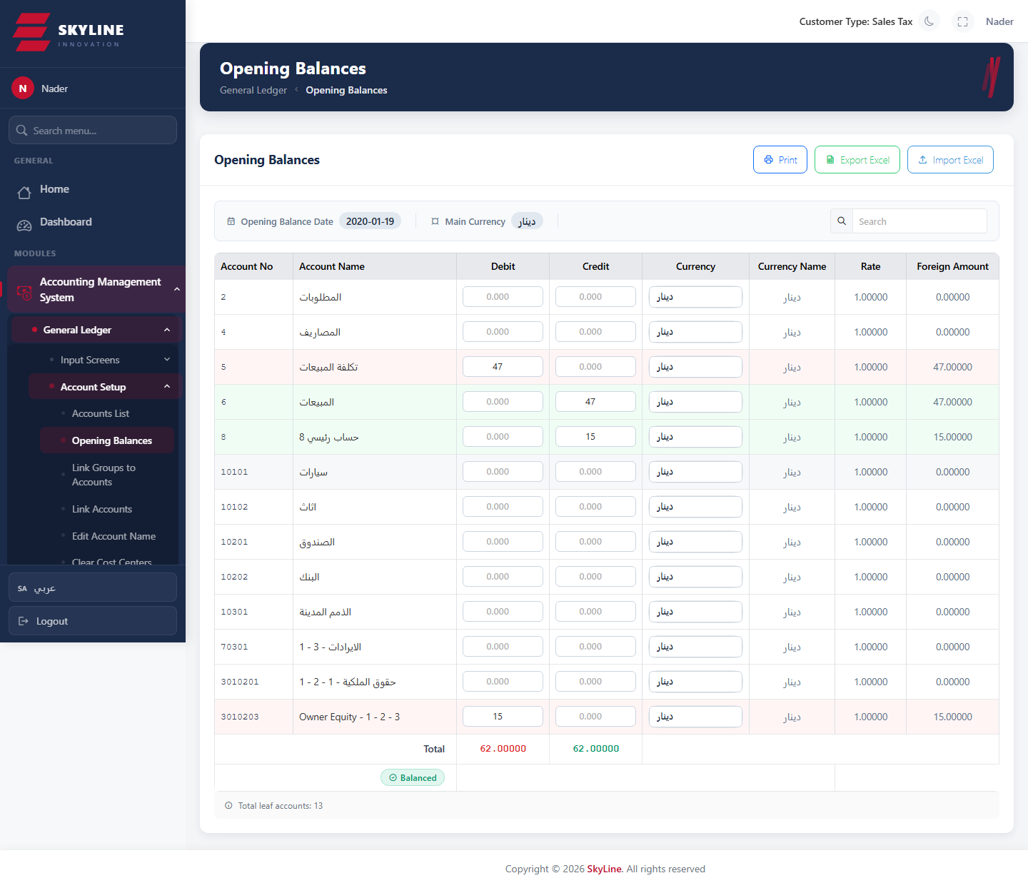

Link Groups to Accounts
Route: /accounting/gl/link-groups-accounts
Associate account groups with their member accounts for grouped reporting.
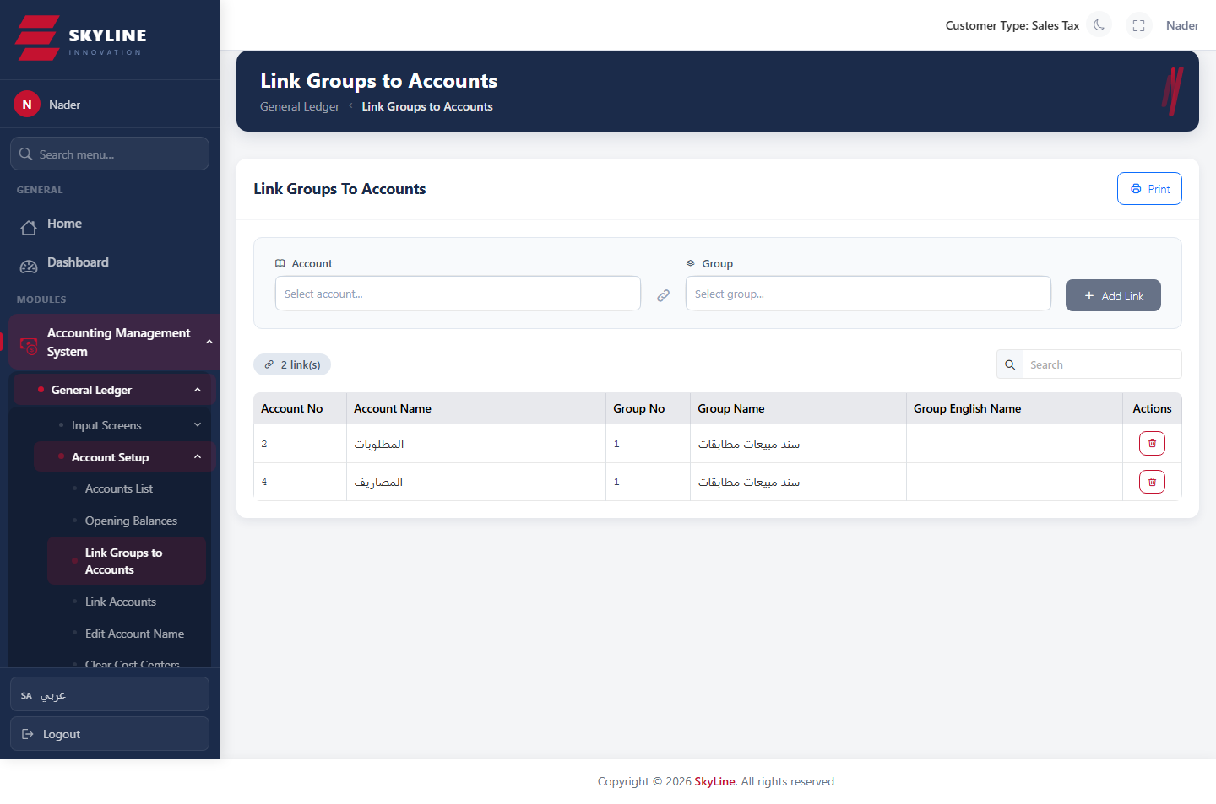

Link Accounts
Route: /accounting/gl/link-accounts
Map/link accounts to system roles (e.g. cash, bank, customers, suppliers) used by automated postings.
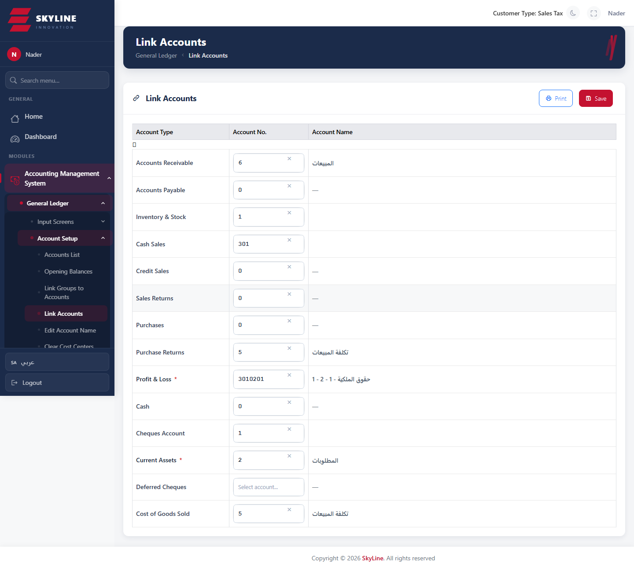

Edit Account Name
Route: /accounting/gl/edit-account-name
Bulk rename of account names (Arabic/English) with print support.
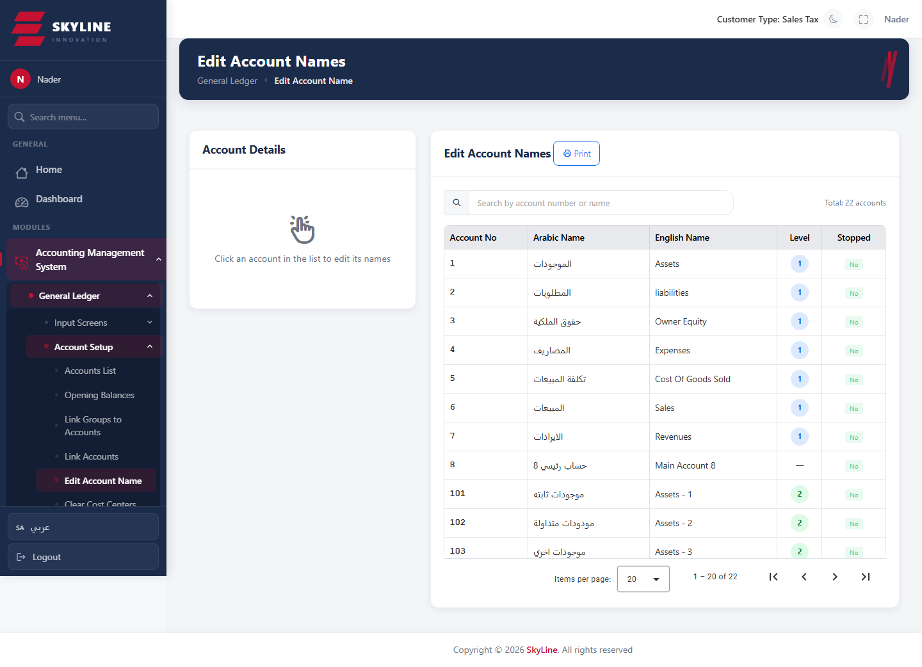

Clear Cost Centers
Route: /accounting/gl/clear-cost-centers
Utility to clear/reset cost-center assignments on account movements.
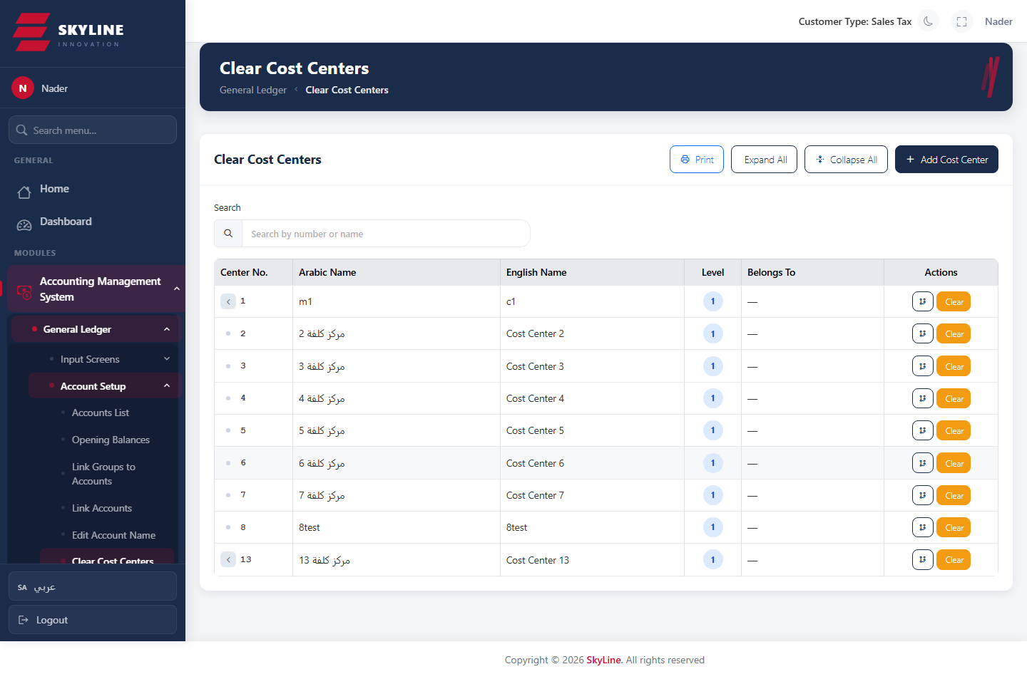

Transfer Account Movements
Route: /accounting/gl/transfer-account-movements
Move posted movements from one account to another.
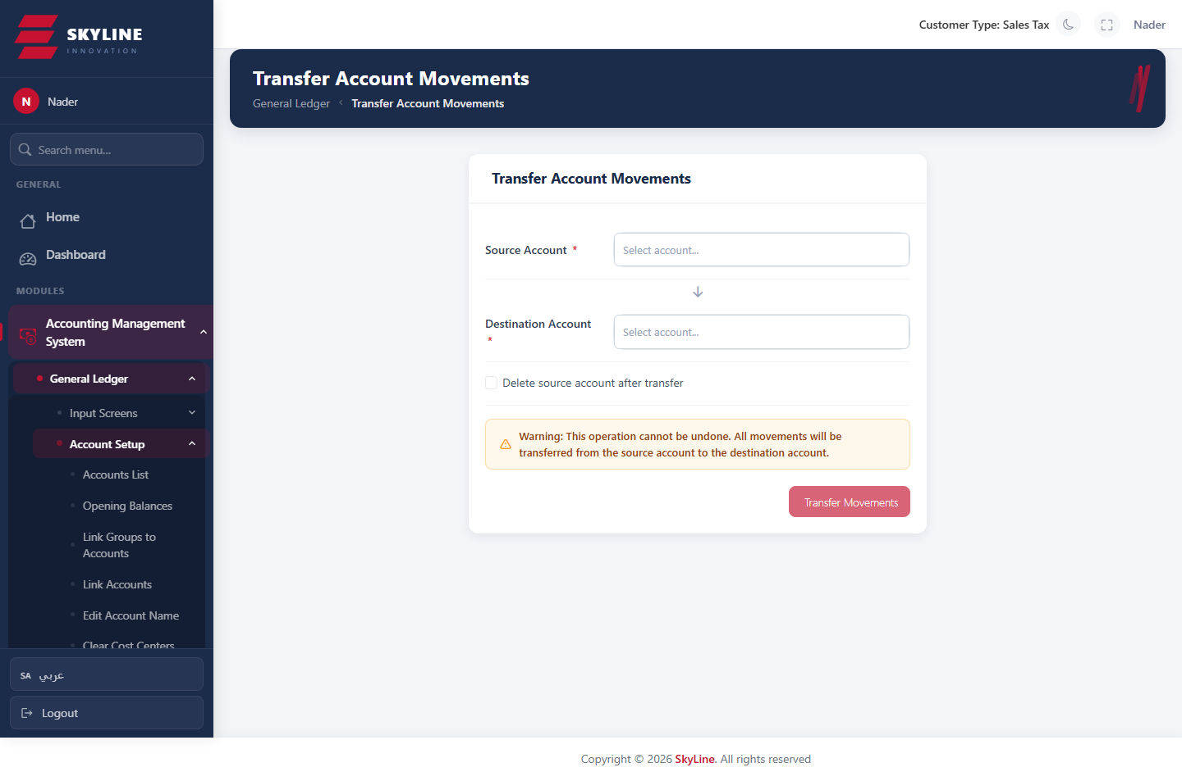

Cost-Center Opening Balances
Route: /accounting/gl/cc-opening-balances
Enter the opening balances per cost center.
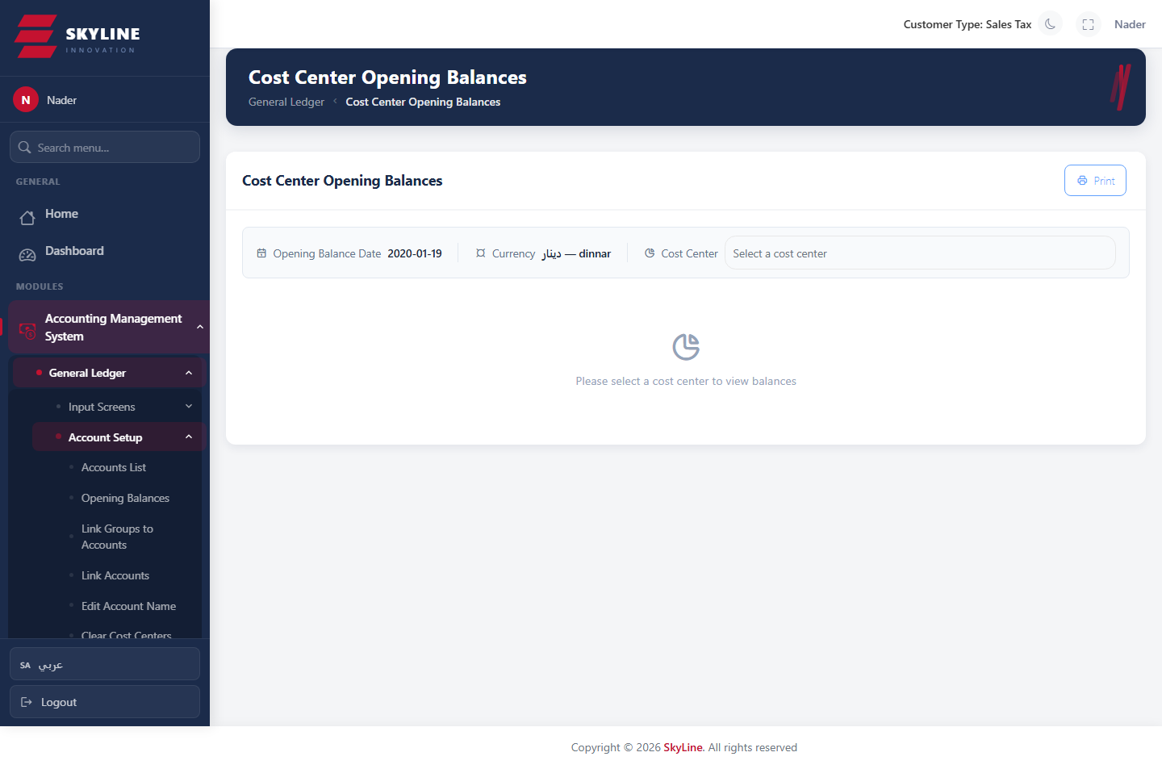

Accounting · Vouchers

Journal Vouchers (القيود اليومية)
Route: /accounting/vouchers/journal
Create/edit general-ledger journal entries: date, serial type, currency, and balanced debit/credit lines with cost centers. Cannot save unless the entry balances (difference = 0).
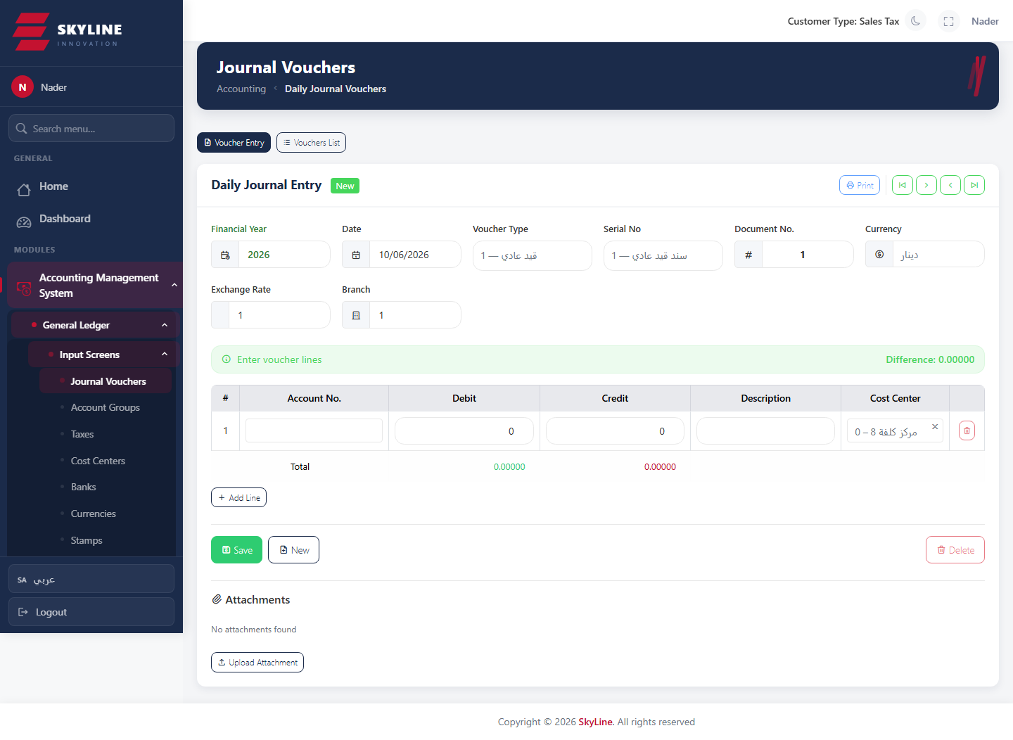

Receipt Vouchers (سند قبض)
Route: /accounting/receipt-vouchers
Record cash/bank receipts from customers, debiting the cash/bank account and crediting the party.
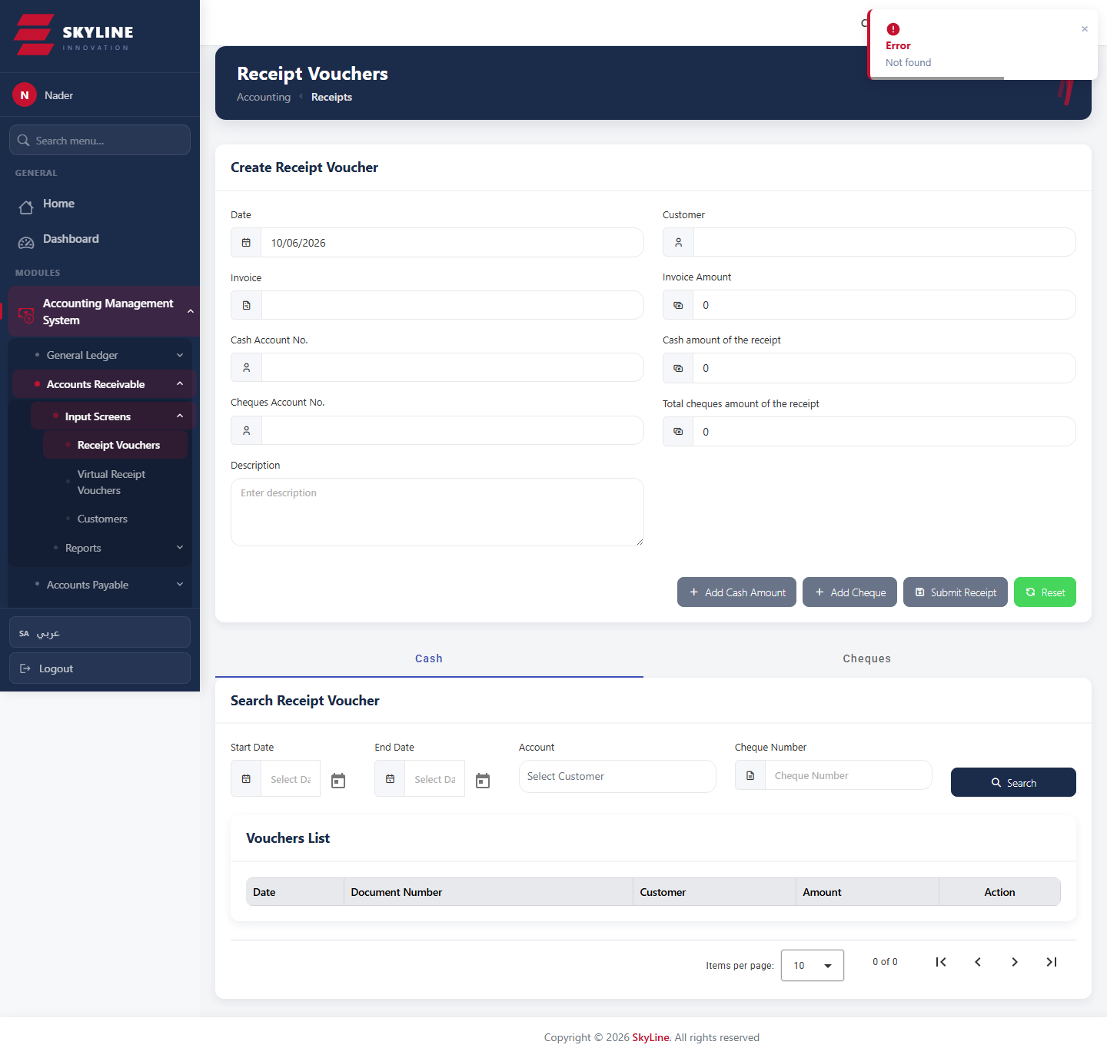

Cash Payment Voucher (سند صرف نقدي)
Route: /accounting/vouchers/cash-payment
Record cash payments to suppliers/expenses.
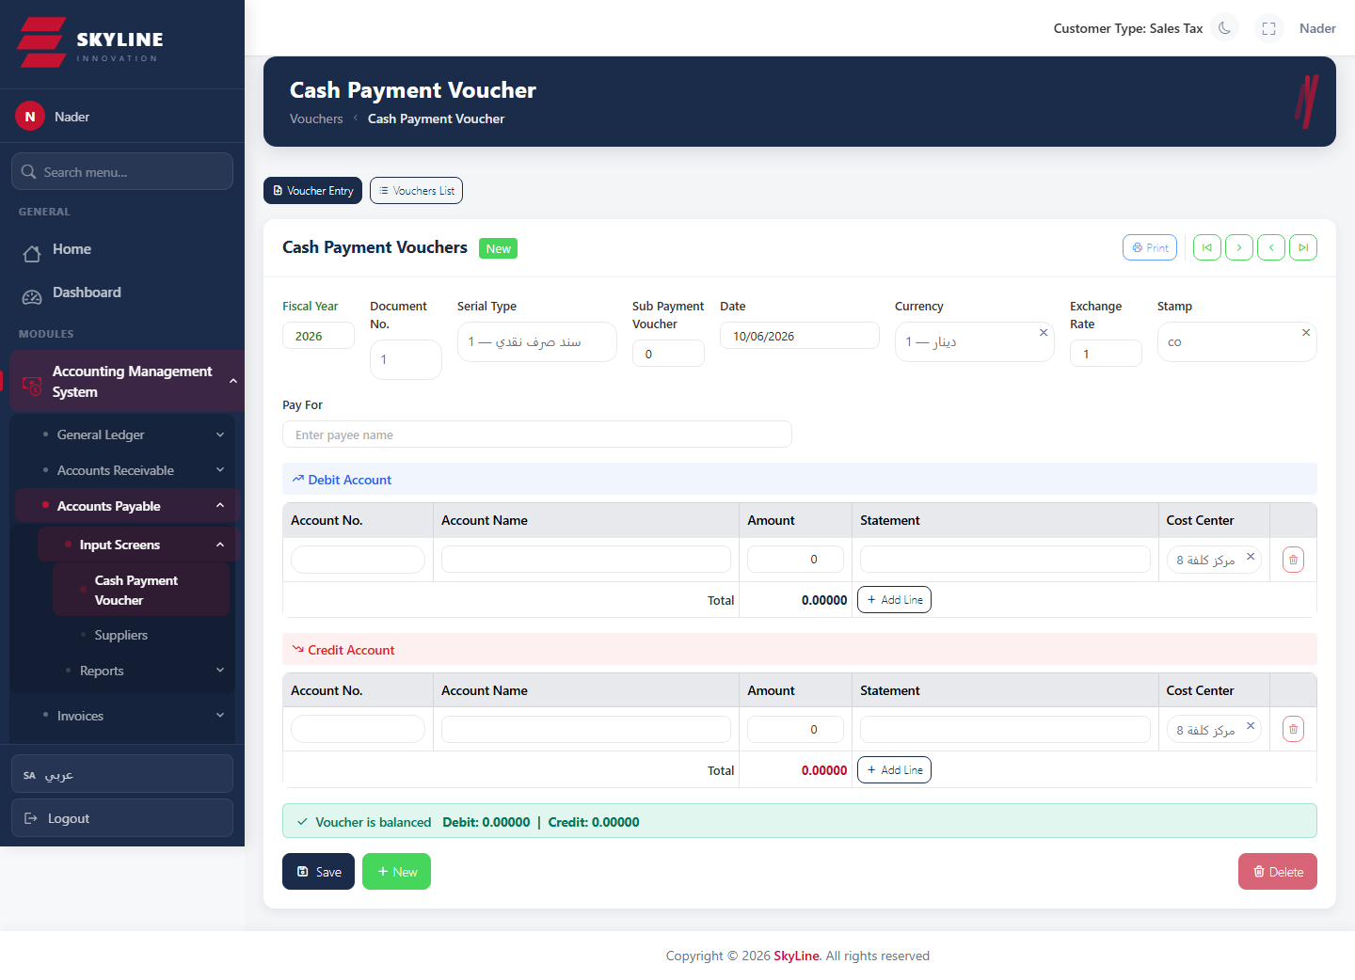

Cheque Payment Voucher (سند صرف شيكات)
Route: /accounting/cheques/payment-voucher
Issue payment by cheque, generating the corresponding GL voucher and outgoing cheque.
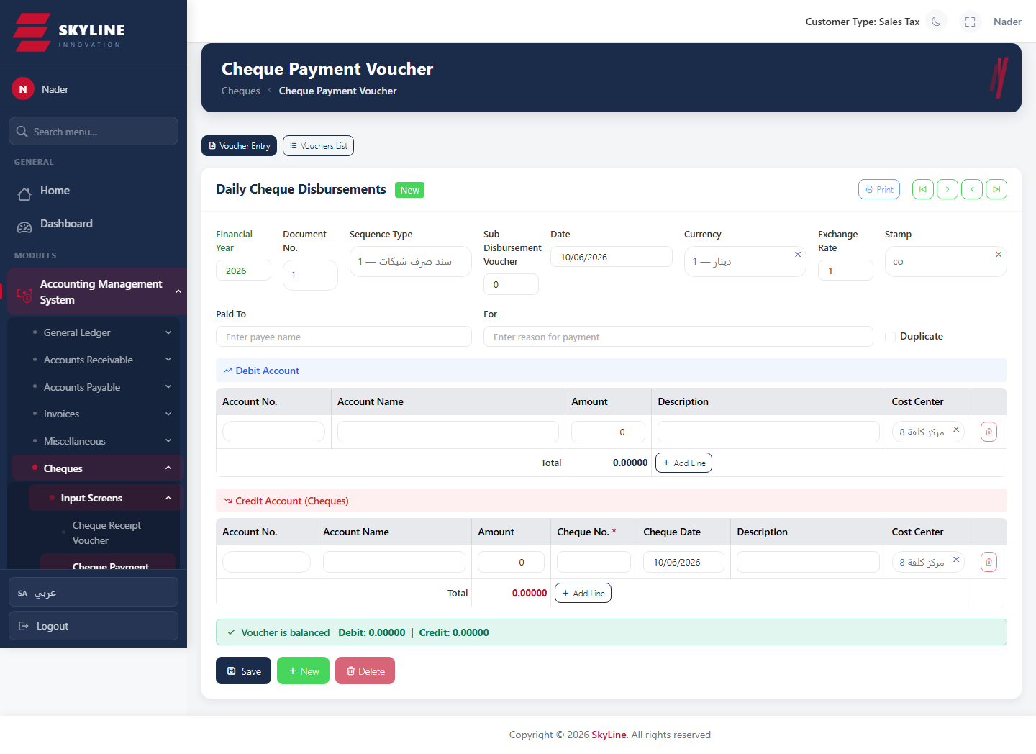

Cheque Receipt Voucher (سند قبض شيكات)
Route: /accounting/ar/cheque-receipt-vouchers
Receive payment by cheque, recording the incoming cheque and its GL voucher.
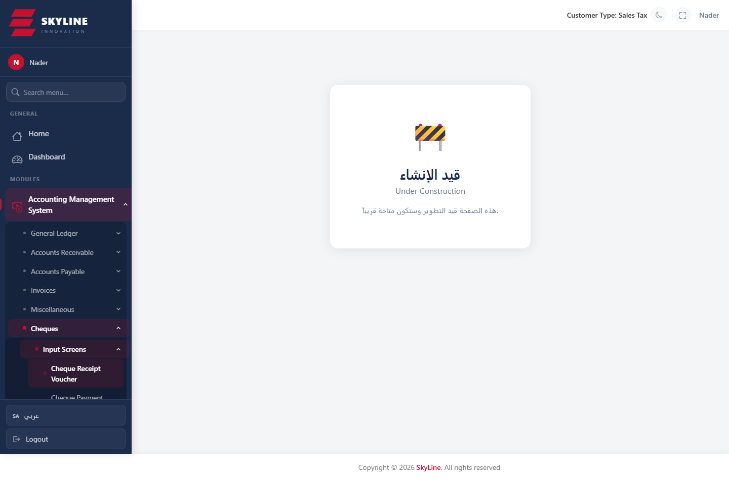

Journal Voucher Report
Route: /accounting/vouchers/journal-report
List/print journal vouchers within a period with filters; clears results when filters change.
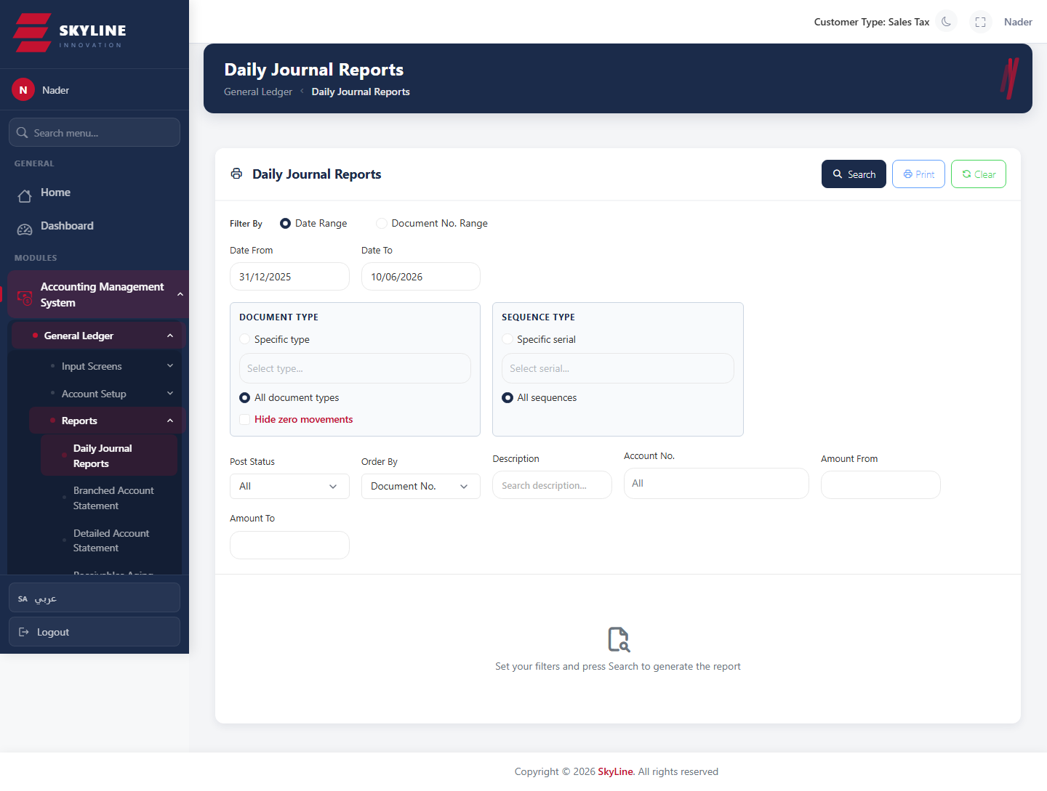

Account Belong Report
Route: /accounting/vouchers/acc-belong-report
Statement of an account and the accounts that belong to it (branched view).
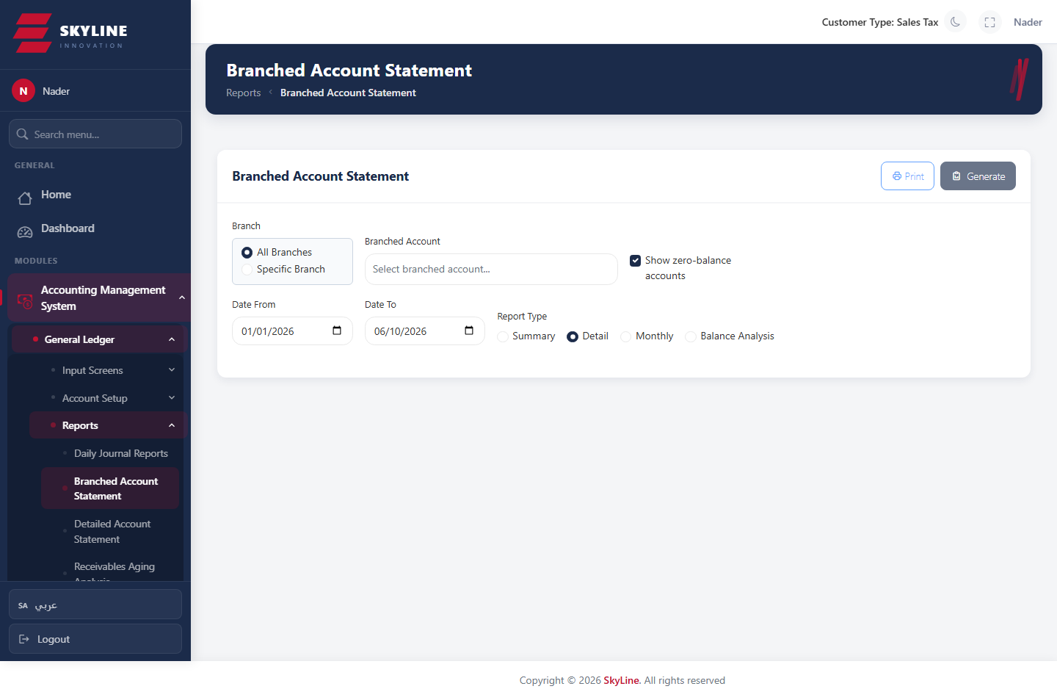

Accounting · Cheques

Incoming Cheques (first entry)
Route: /accounting/cheques/incoming-first
Register beginning/incoming cheques (number, bank, drawer, dates, amount, currency).
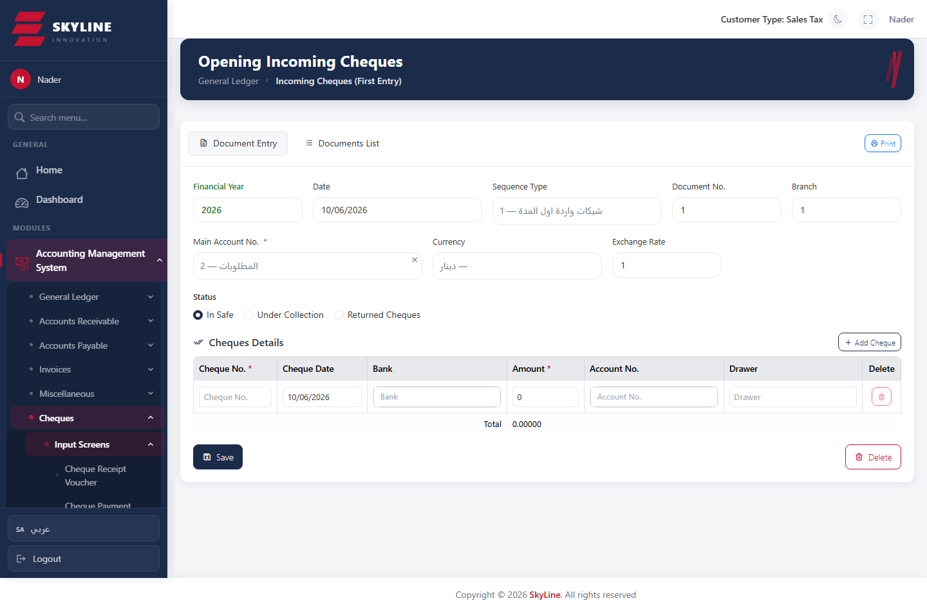

Outgoing Cheques (first entry)
Route: /accounting/cheques/outgoing-first
Register beginning/outgoing cheques.
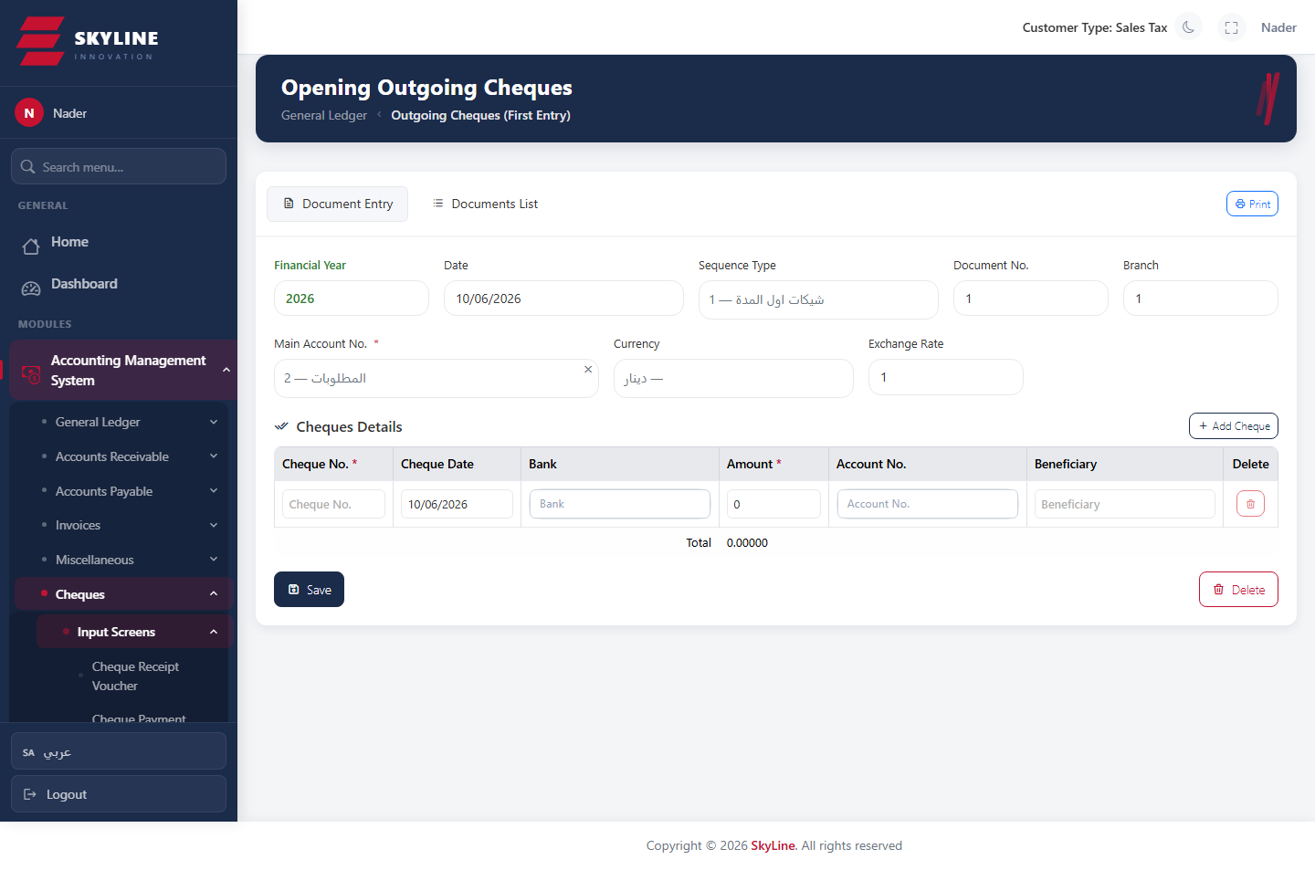

Cheque Deposit
Route: /accounting/cheques/deposit
Deposit incoming cheques to a bank account.
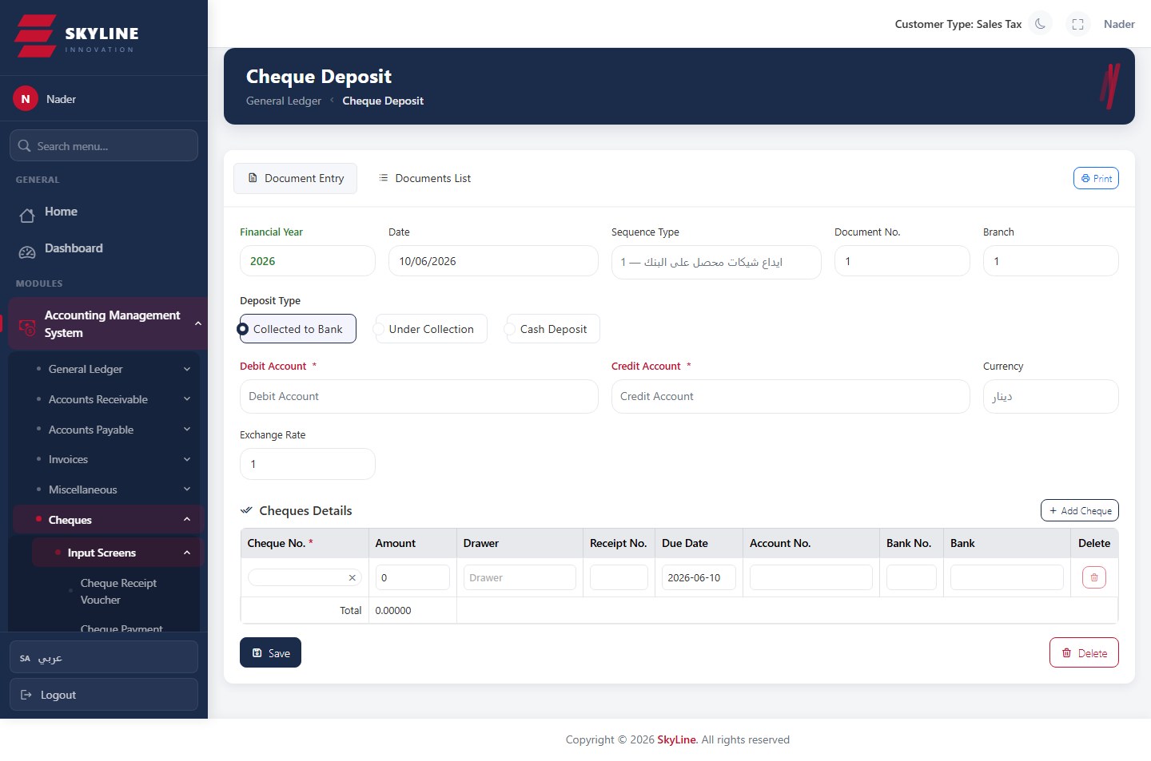

Cheque Collection
Route: /accounting/cheques/collection
Mark deposited cheques as collected/cleared.
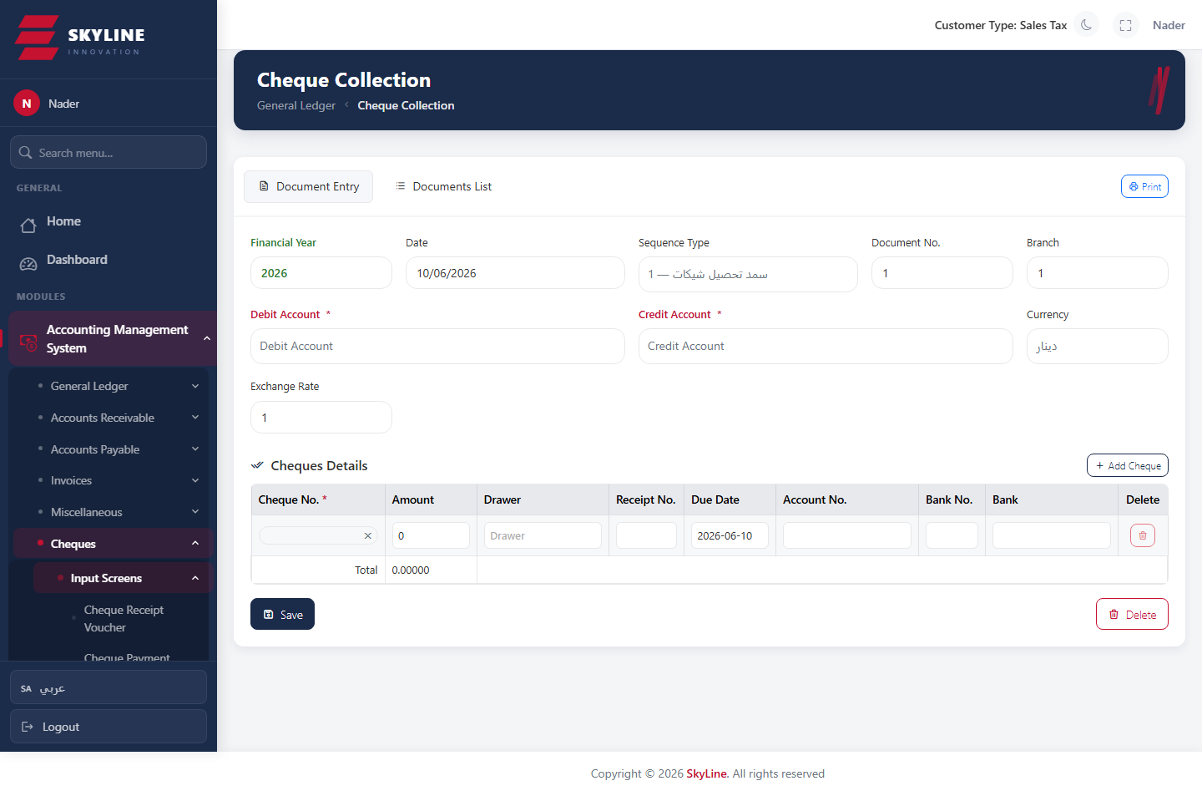

Cheque Return
Route: /accounting/cheques/return
Record returned (bounced) cheques.
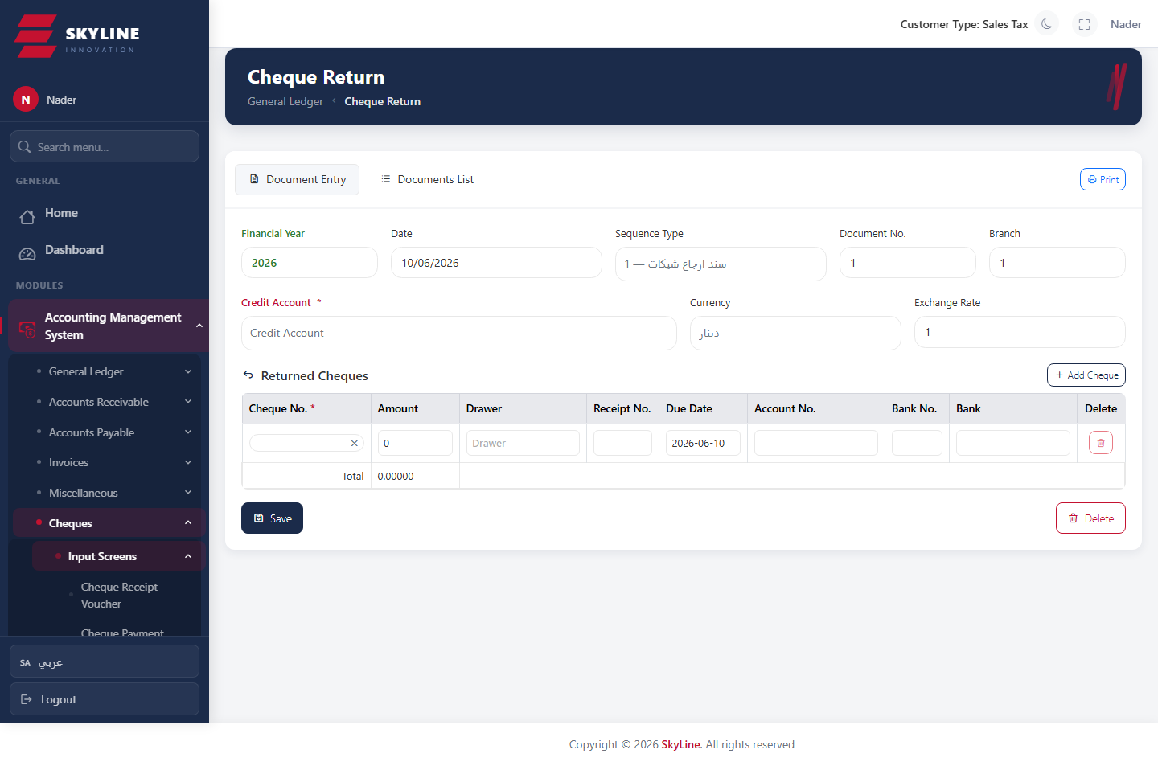

Re-deposit Returned Cheques
Route: /accounting/cheques/re-return
Re-deposit previously returned cheques.
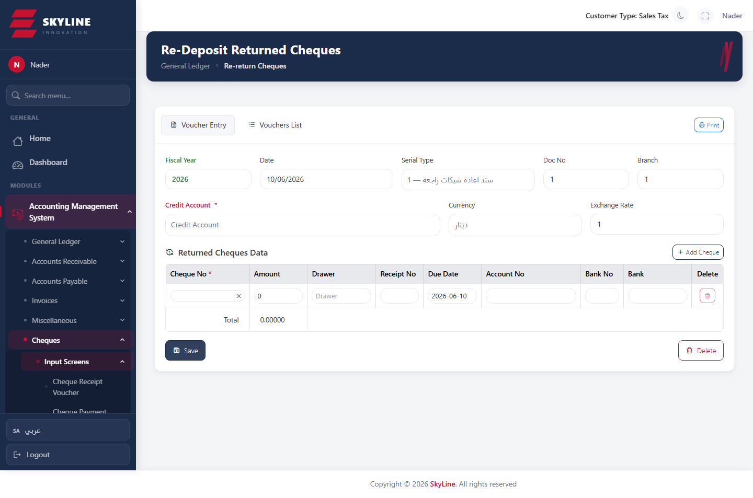

Cheque Withdrawal
Route: /accounting/cheques/withdrawal
Withdraw/cancel incoming cheques.
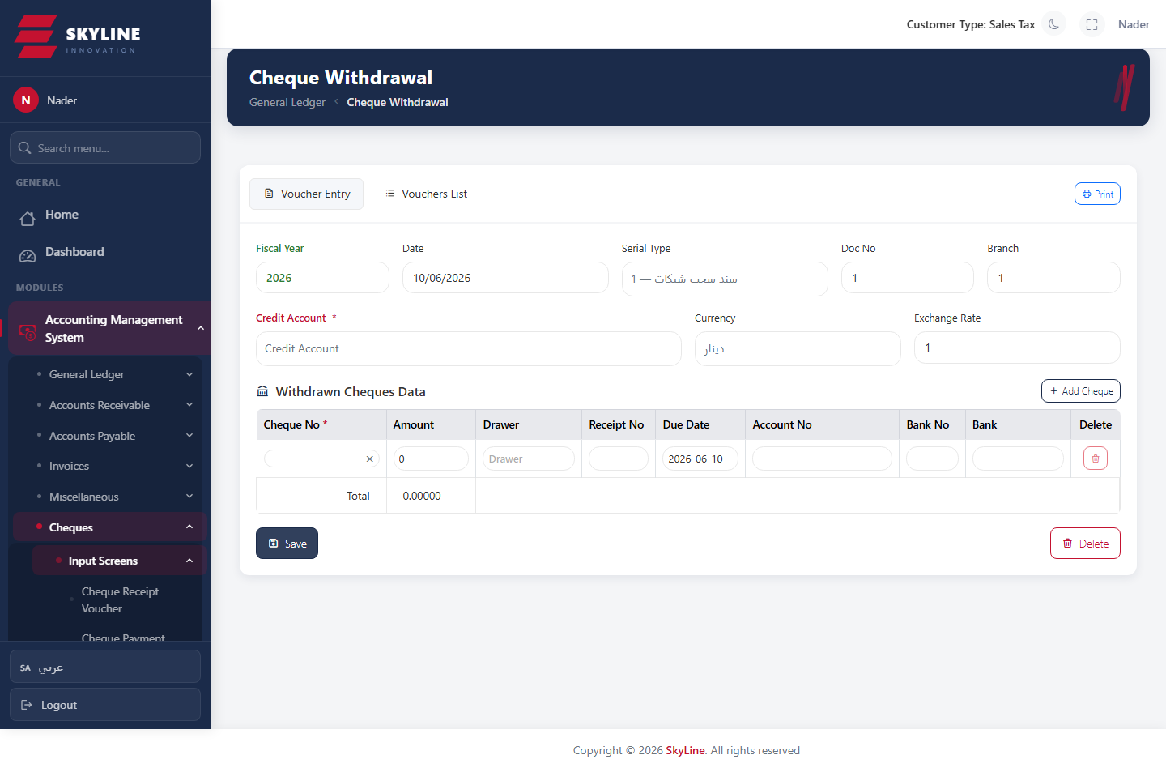

Cheque Endorsement
Route: /accounting/cheques/endorse
Endorse incoming cheques to a third party.
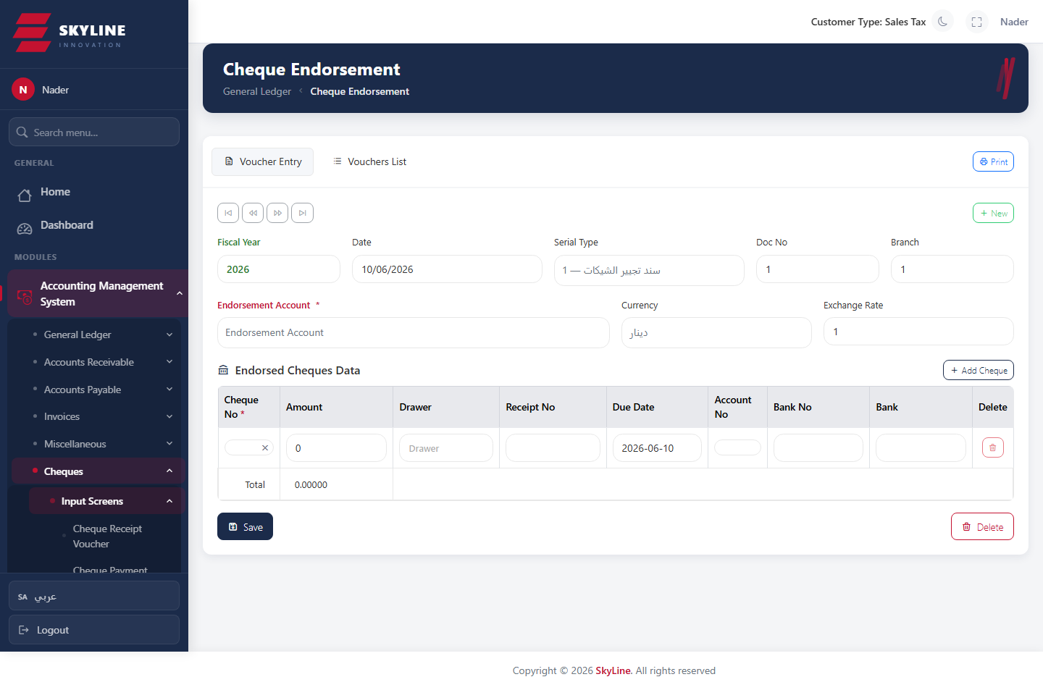

Cheque Tracking
Route: /accounting/cheques/tracking
Track the full movement history of a cheque by serial/number/value/date.
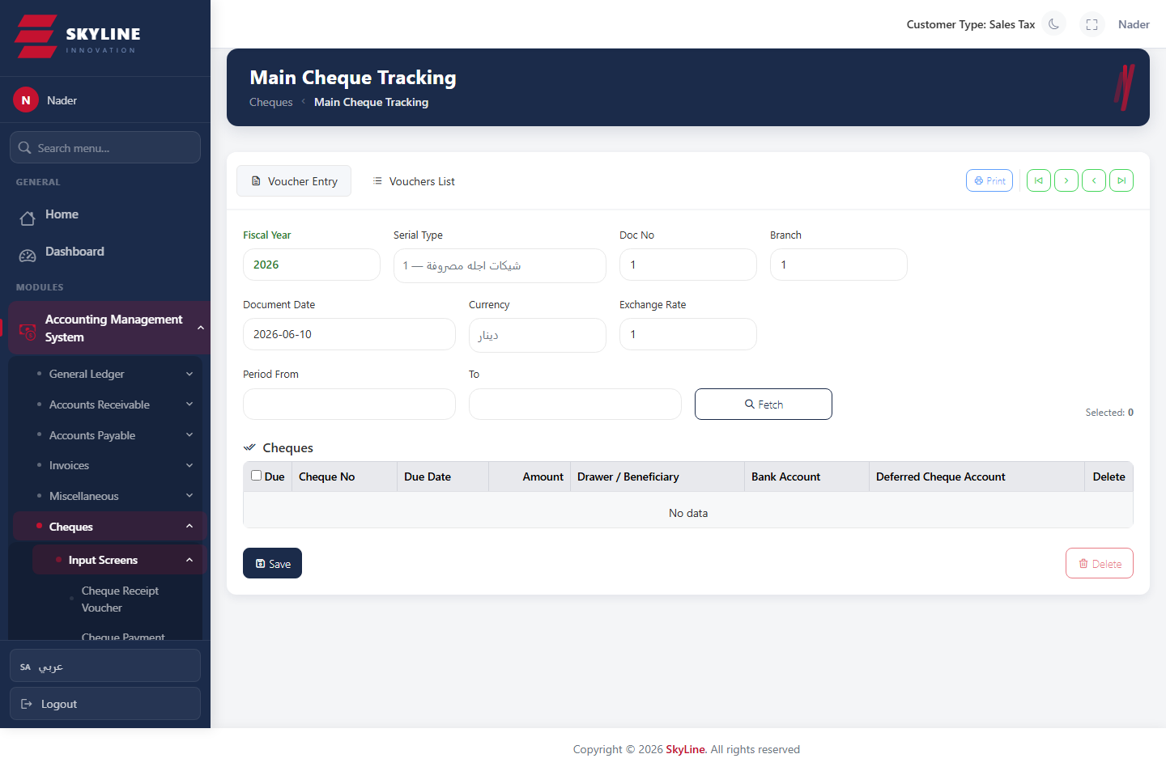

Accounting · Reports

Detailed Account Statement
Route: /accounting/reports/detailed-statement
Detailed ledger statement per account with opening balance, movements, cheques, aging and balance in words; deep-links to source vouchers.
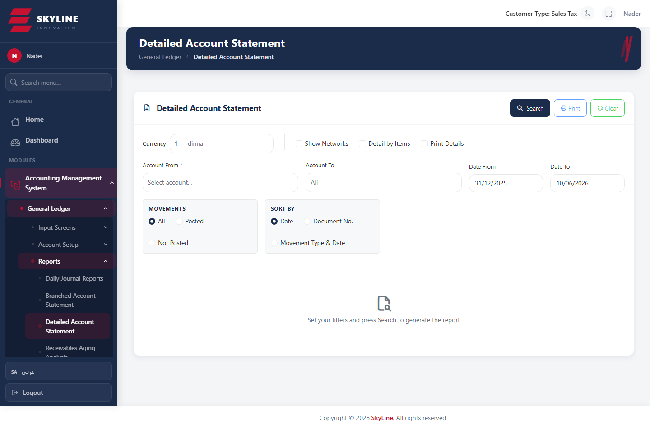

Aging Analysis
Route: /accounting/reports/aging-analysis
Receivables/payables aging buckets (0-30, 31-60, 61-90, 91-120, >120 days).
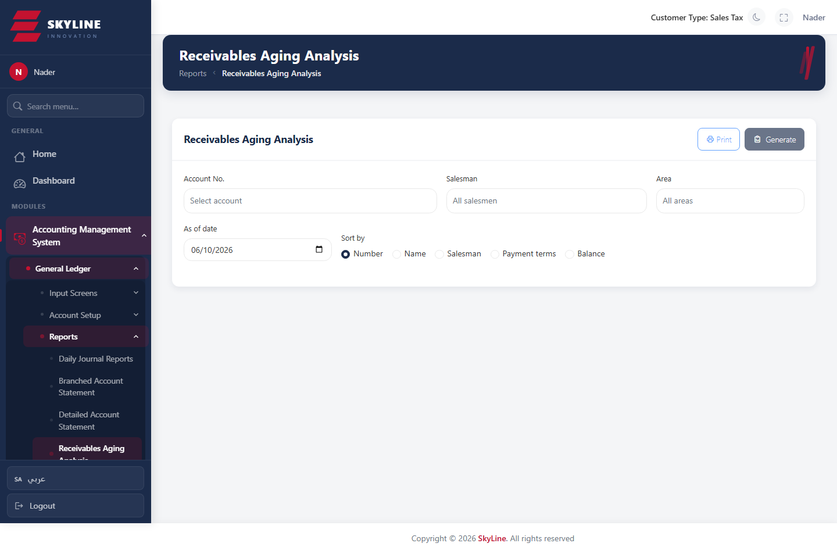

Trial Balance
Route: /accounting/reports/trial-balance
Trial balance for a period with debit/credit and balance columns.
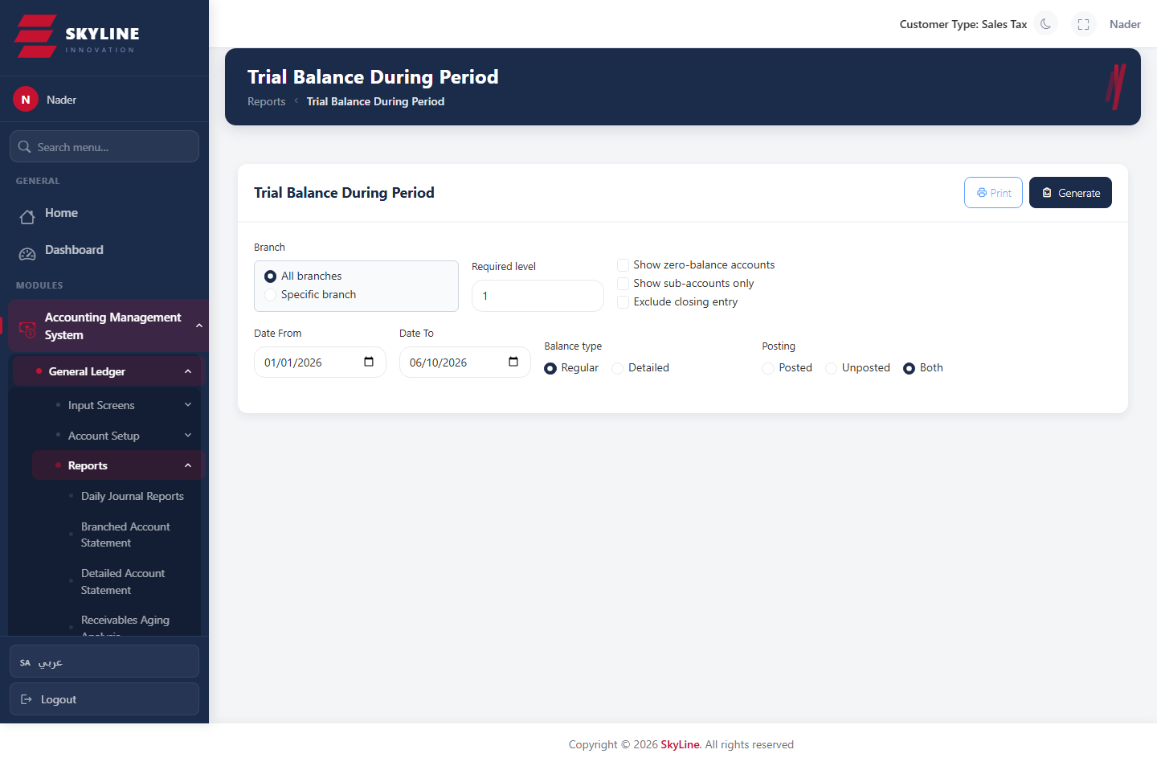

Income Statement
Route: /accounting/reports/income-statement
Profit & loss statement for the selected period.
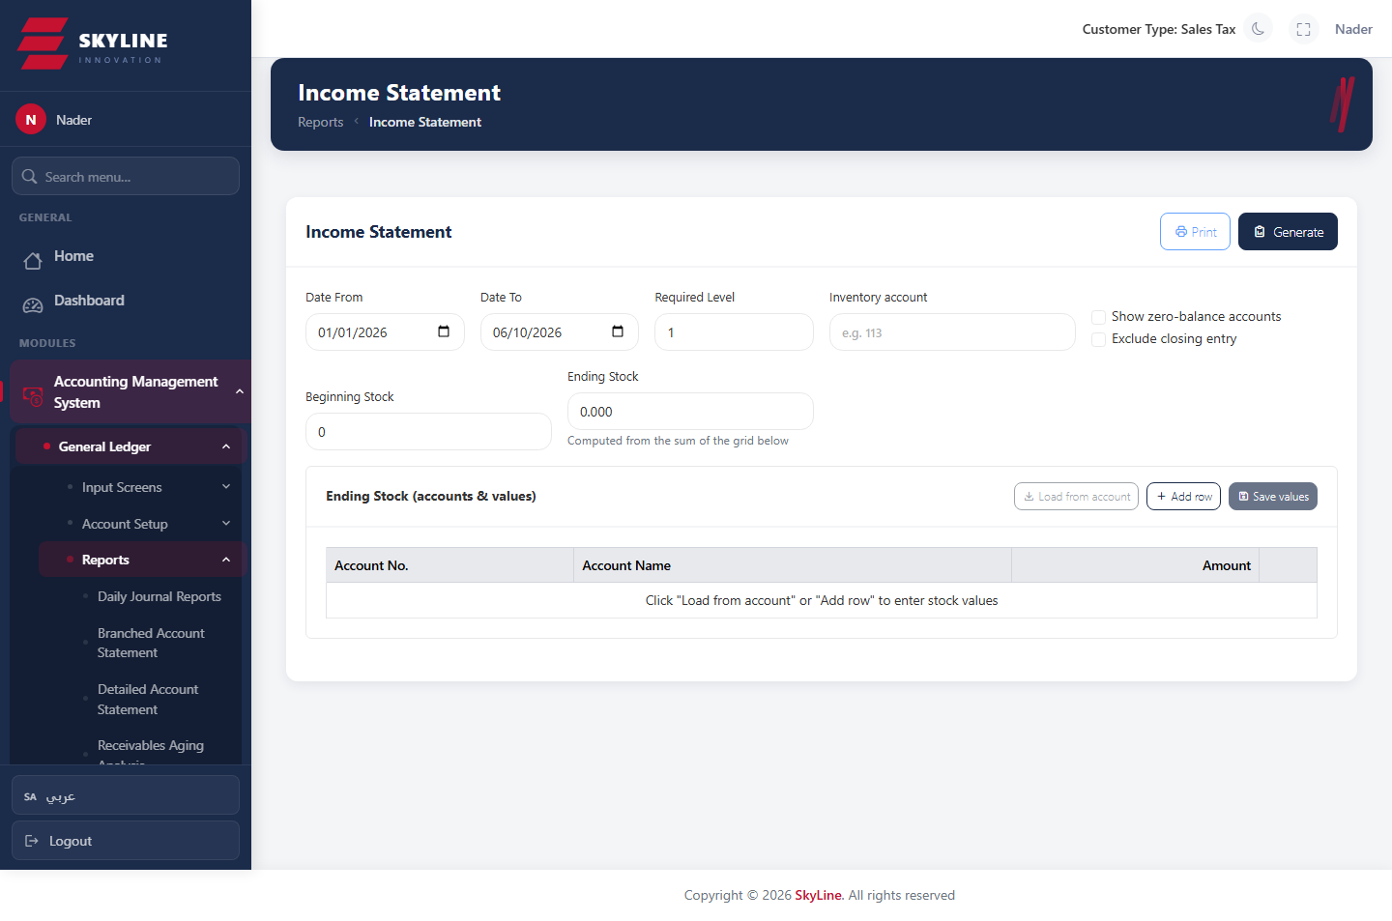

Balance Sheet
Route: /accounting/reports/balance-sheet
Statement of financial position (assets, liabilities, equity).
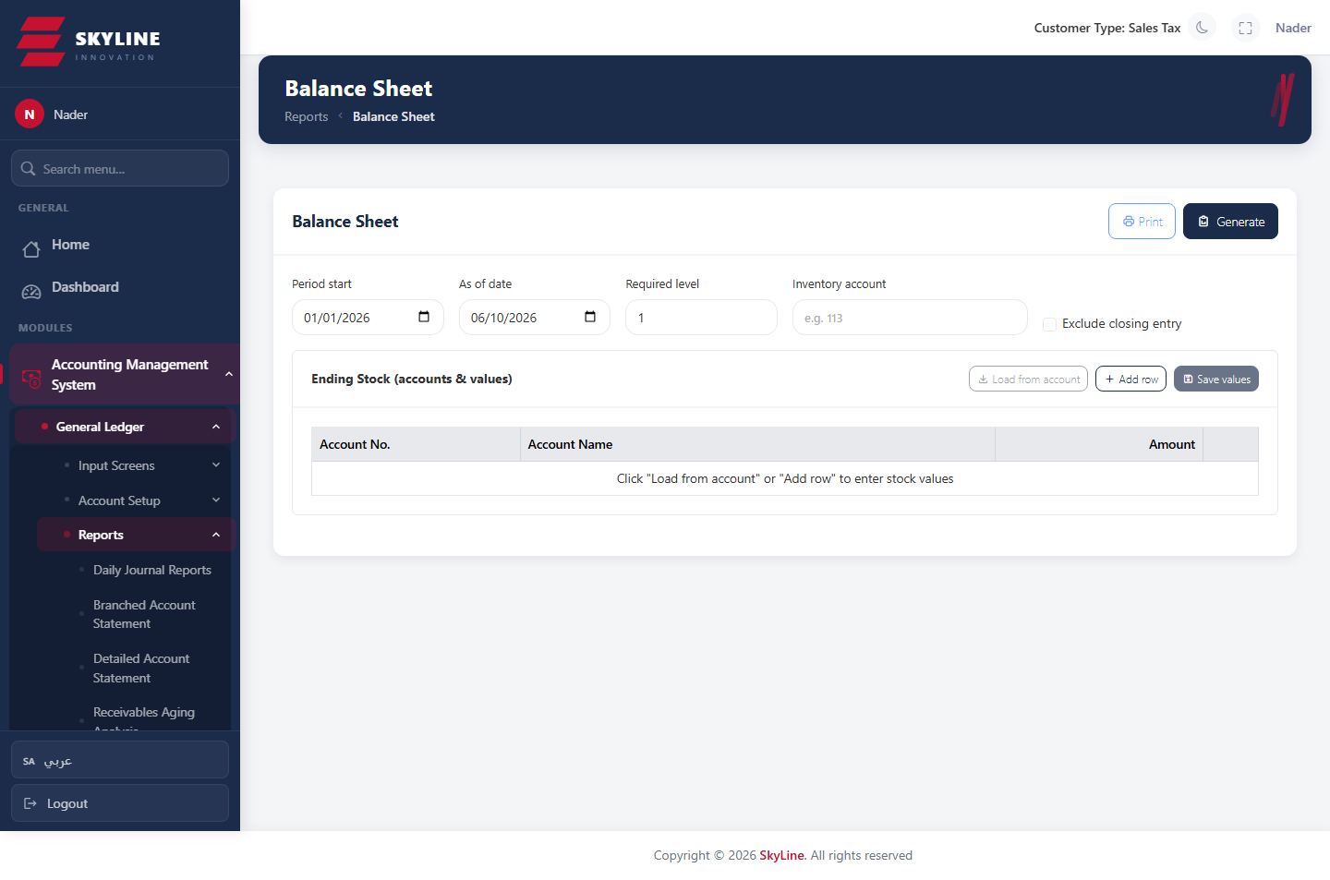

Accounts List Report
Route: /accounting/reports/accounts-list
Printable list of accounts up to a level, with clickable links to the chart of accounts.
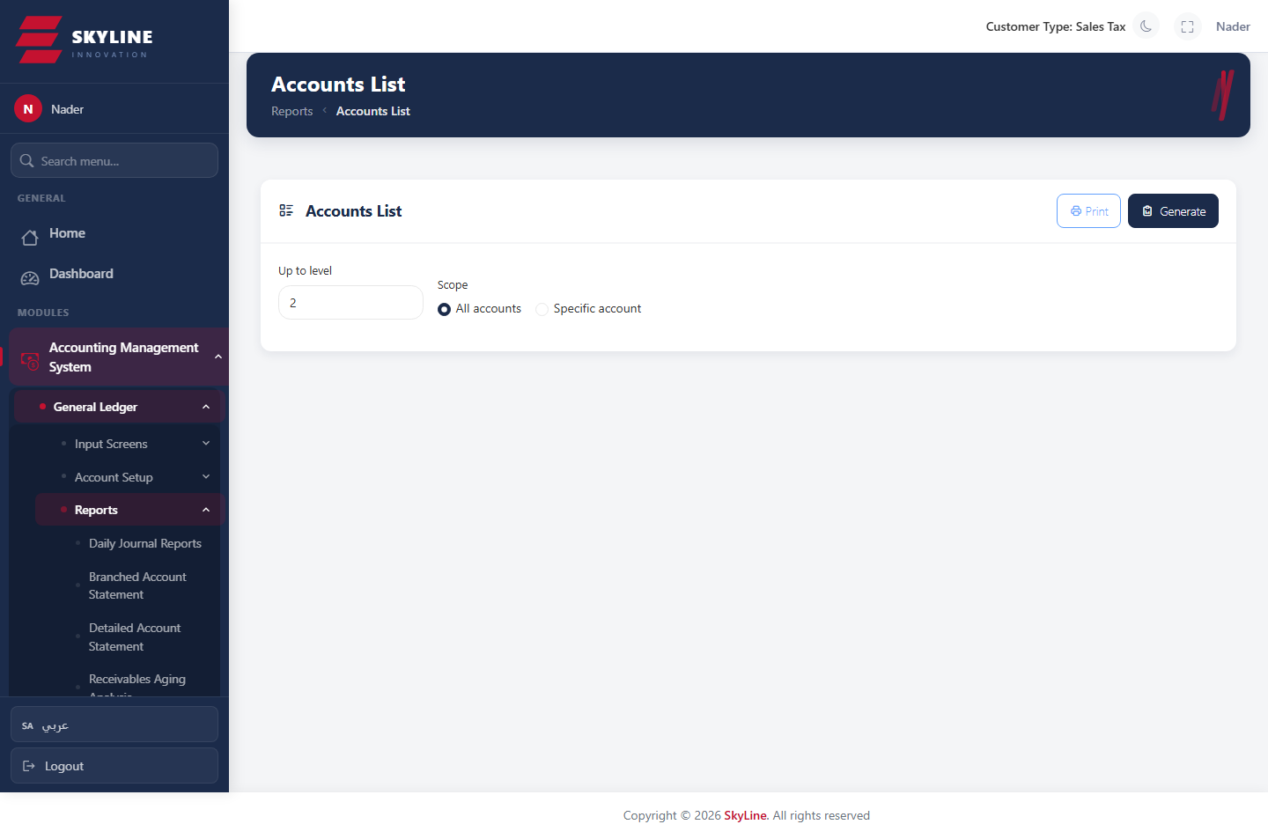

Beginning Balances Report
Route: /accounting/reports/beginning-balances
Report of opening balances per account.
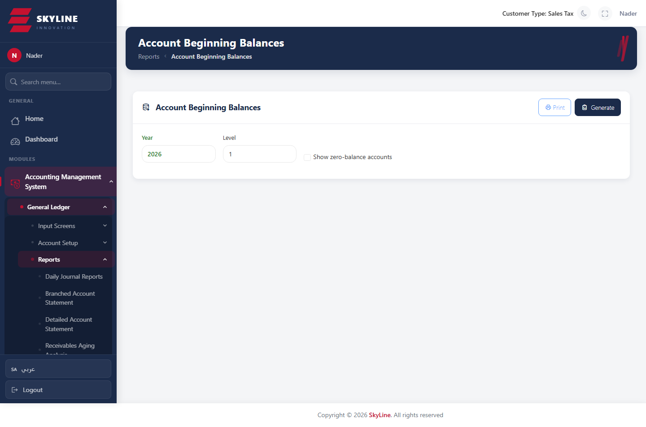

Monthly Balances
Route: /accounting/reports/monthly-balances
Account balances broken down by month.
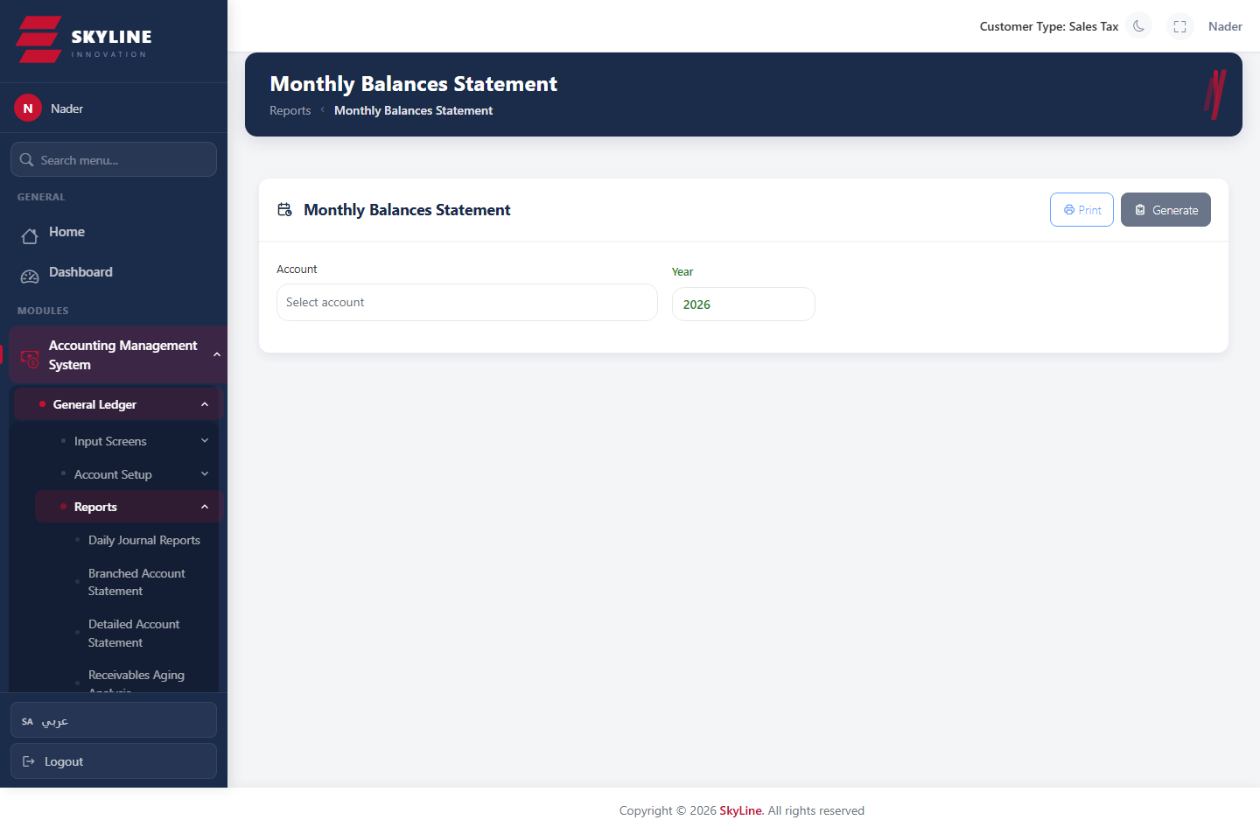

Account Groups Report
Route: /accounting/reports/accounts-groups
Balances aggregated by account group.
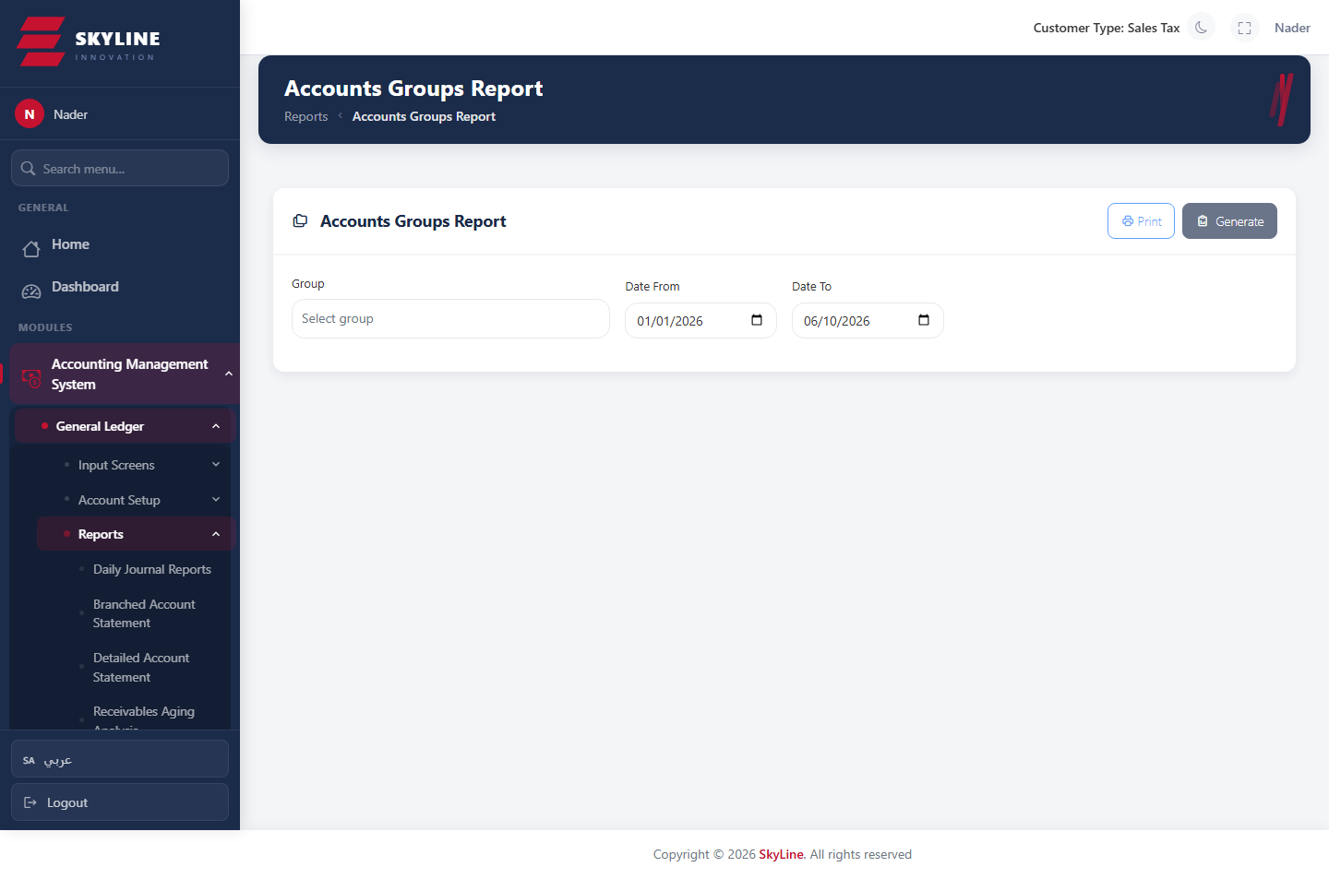

Cost-Center Account Balances
Route: /accounting/reports/cost-center-account-balances
Account balances per cost center, with optional estimated-balance columns and clickable cost-center links.
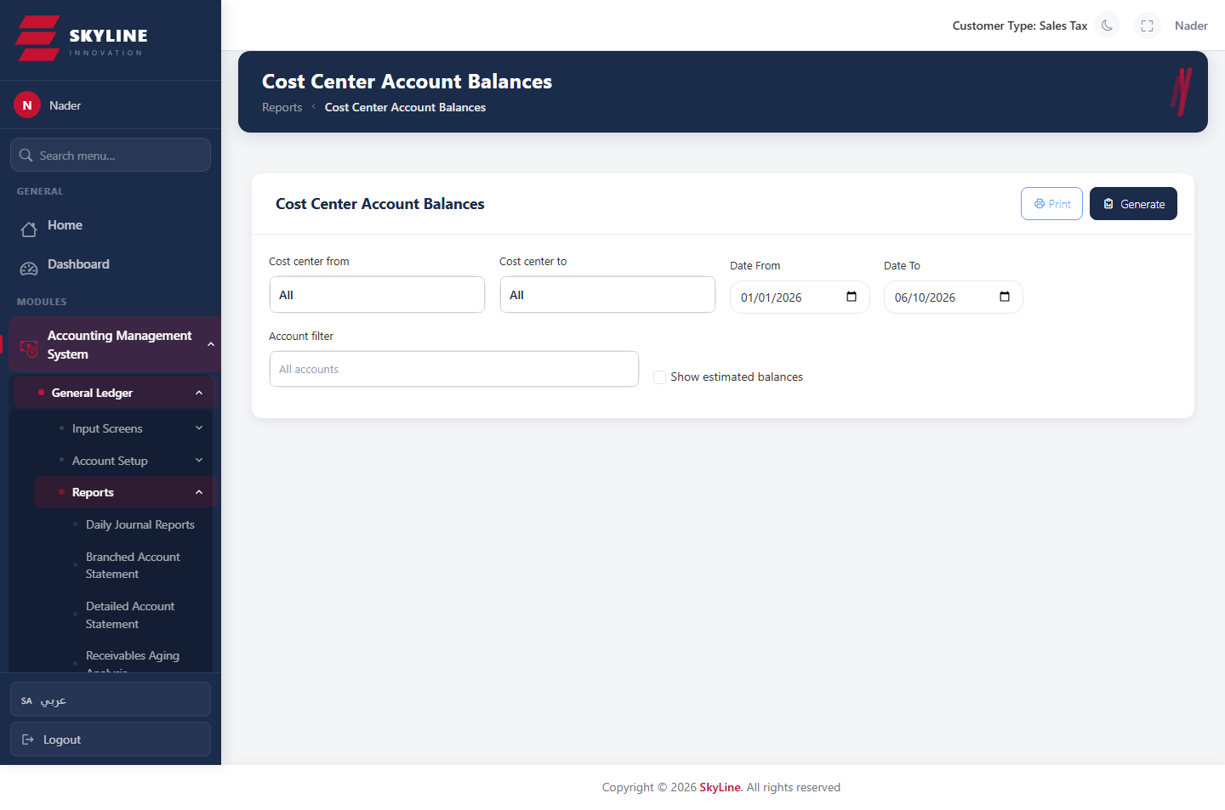

Cost-Center Transactions
Route: /accounting/reports/cost-center-transactions
Detailed transactions per cost center, including the cost-center column.
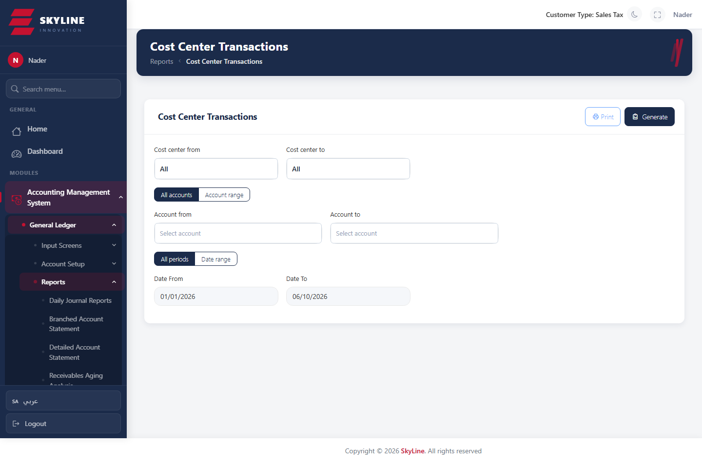

Incoming Cheque Movement
Route: /accounting/reports/incoming-cheque-movement
Movement statement for a selected incoming cheque, by serial type.
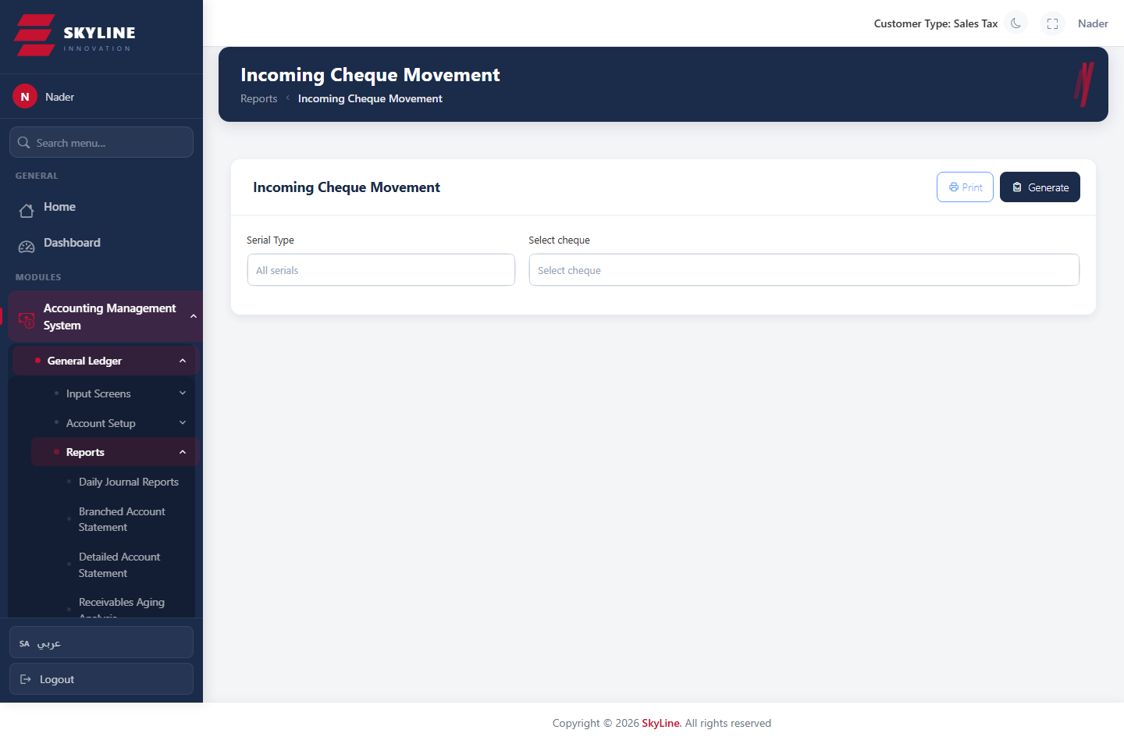

Inward Cheques (period)
Route: /accounting/reports/inward-cheques
Incoming cheques received within a period.
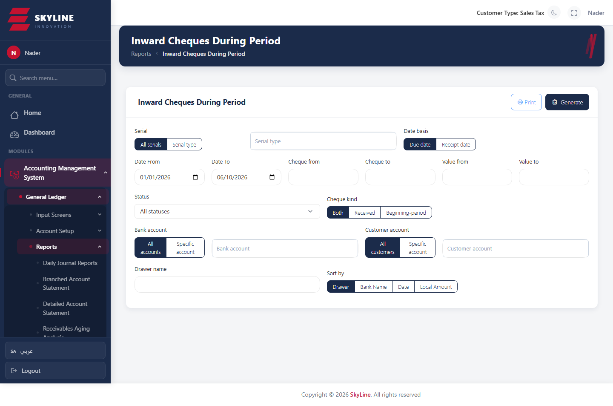

Outward Cheques (period)
Route: /accounting/reports/outward-cheques
Outgoing cheques issued within a period.
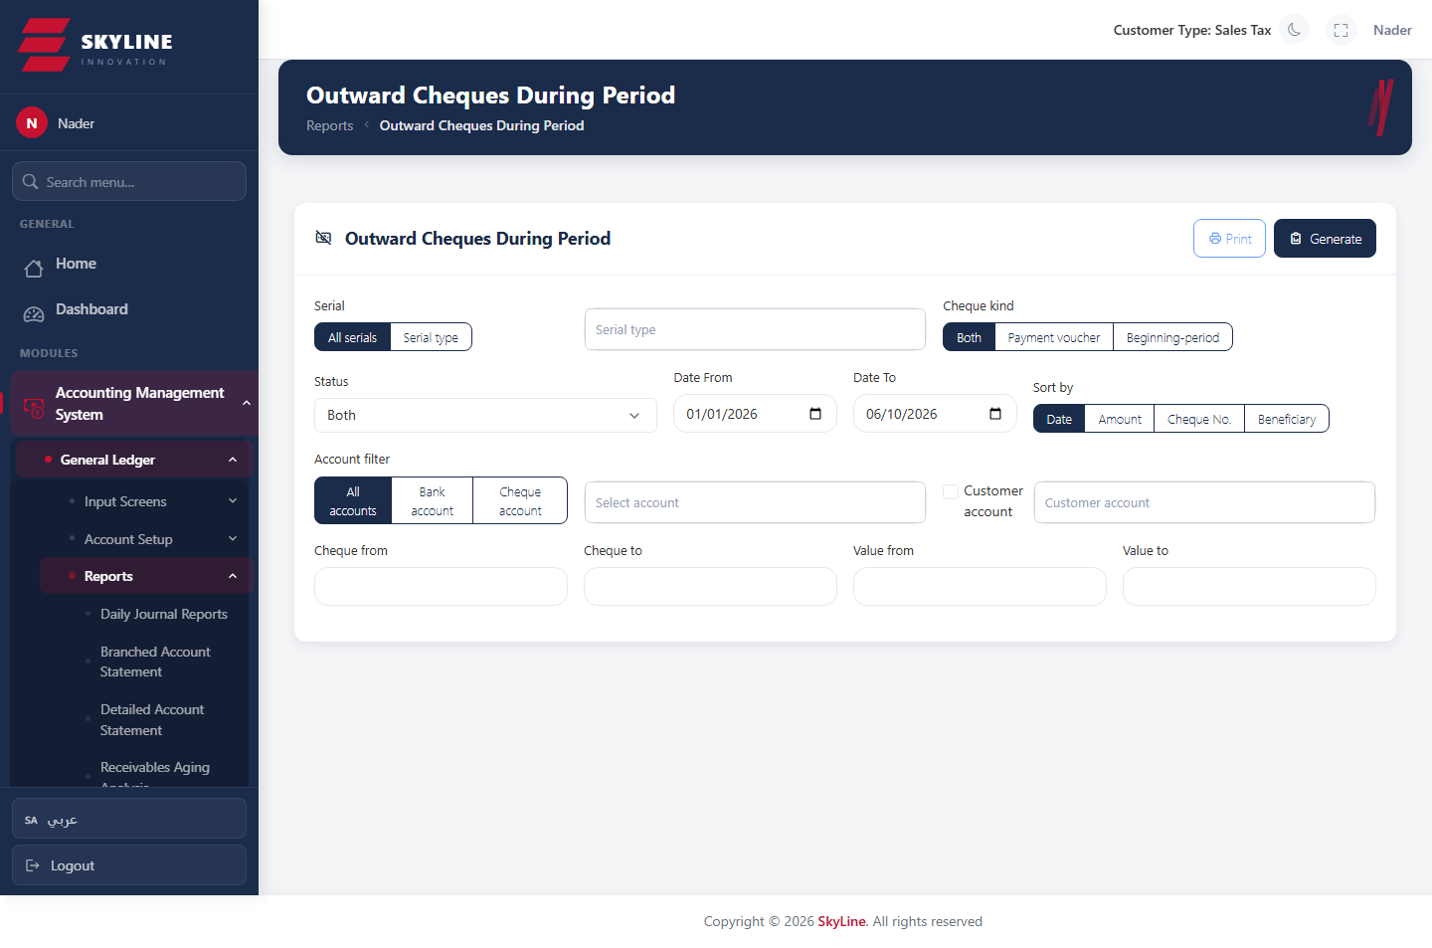

Cheques to Beneficiary
Route: /accounting/reports/cheques-to-beneficiary
Outgoing cheques issued to a specific beneficiary.
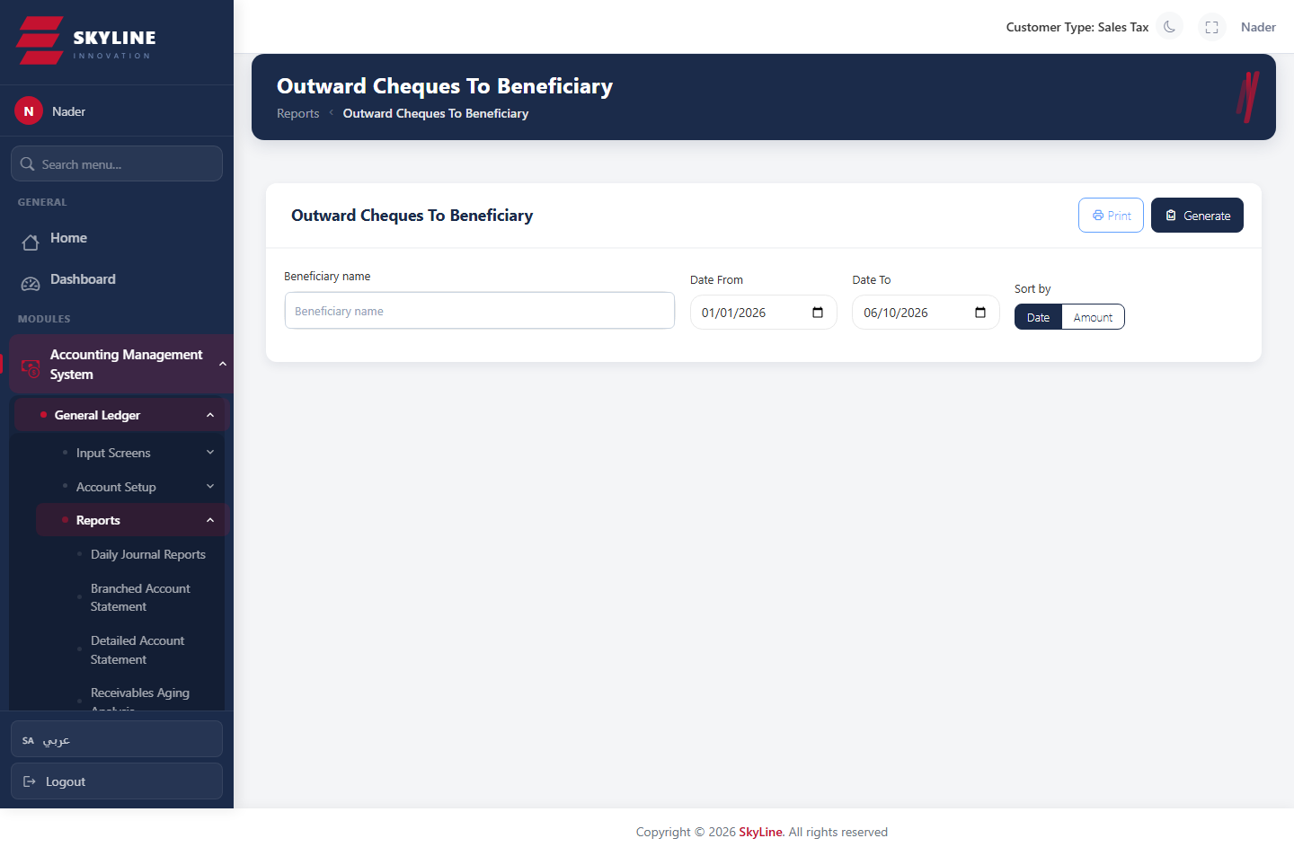

Payment Vouchers Report
Route: /accounting/reports/payment-vouchers
List of cheque payment vouchers (سندات الصرف) within a period.
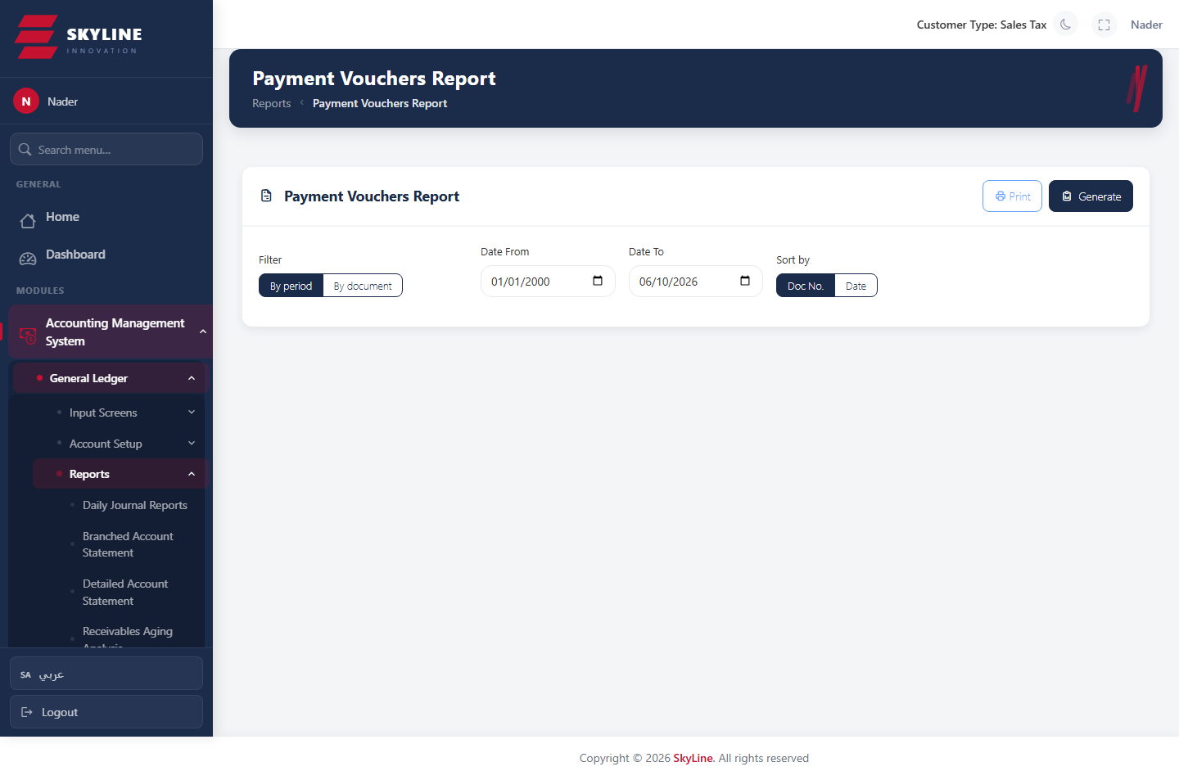

Accounting · Misc

Account Ledger (كشف حركات ورصيد حساب)
Route: /accounting/misc/account-ledger
Ledger for one account over a period: opening balance, movements with running balance, final balance; rows deep-link to vouchers and to the detailed statement (in a popup).
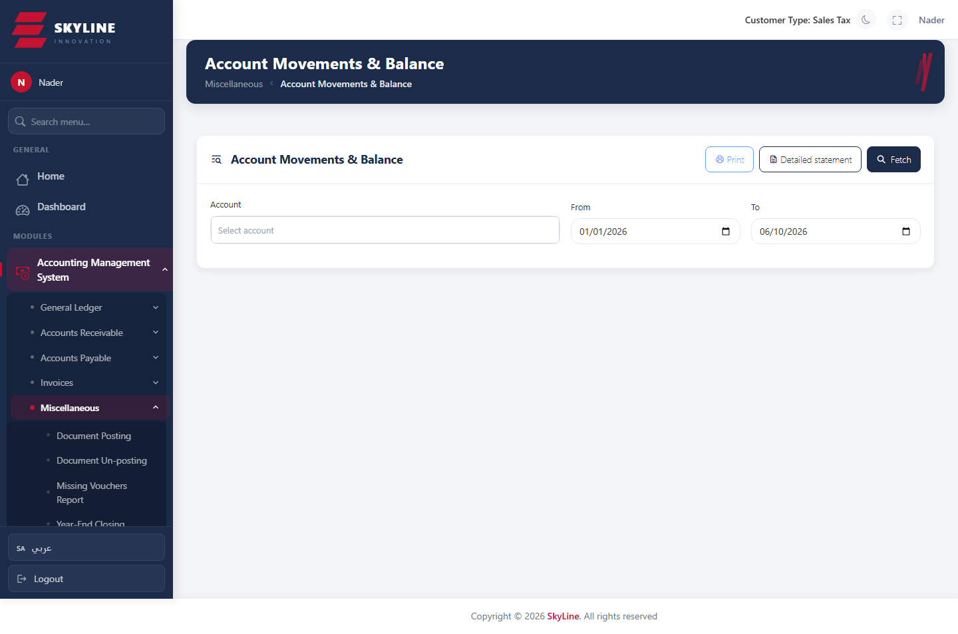

Missing / Unbalanced Vouchers
Route: /accounting/misc/missing-vouchers
Finds gaps in voucher numbering for a type (auto-fills min/max), and an unbalanced-transactions view for vouchers that don't net to zero.
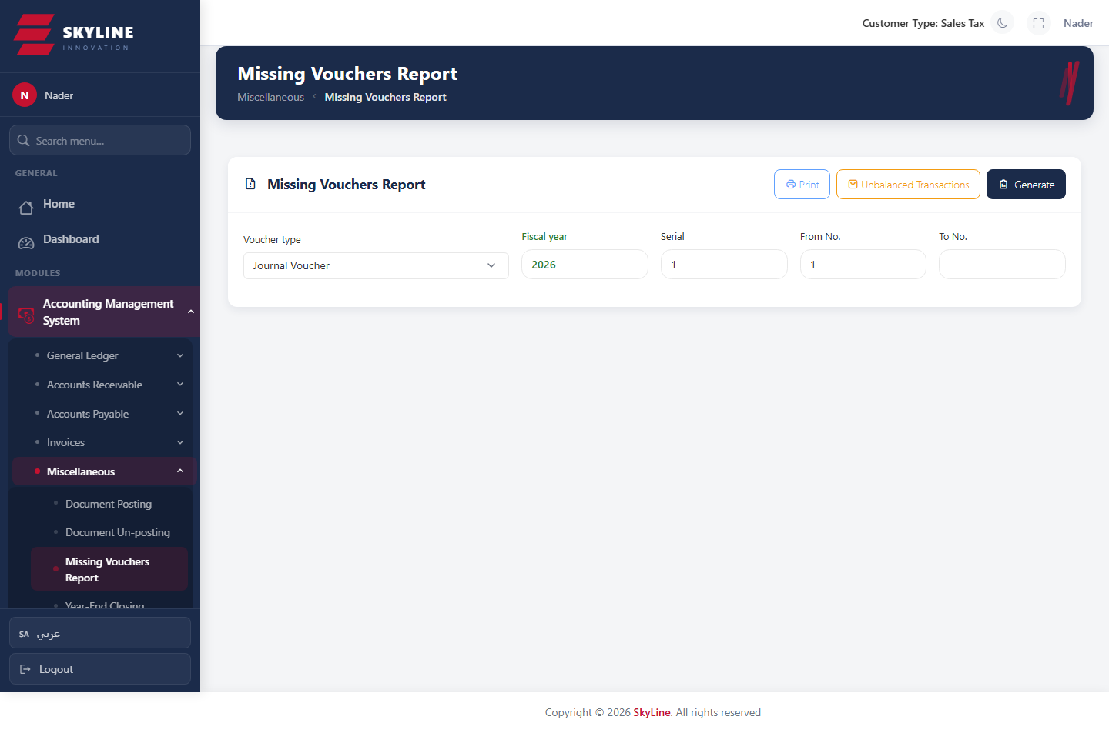

Year-End Closing (الاقفال السنوي)
Route: /accounting/misc/year-end-closing
Generates the year-end closing voucher that nets income-statement accounts into the P&L account, with a progress bar; supports deleting the closing entry.
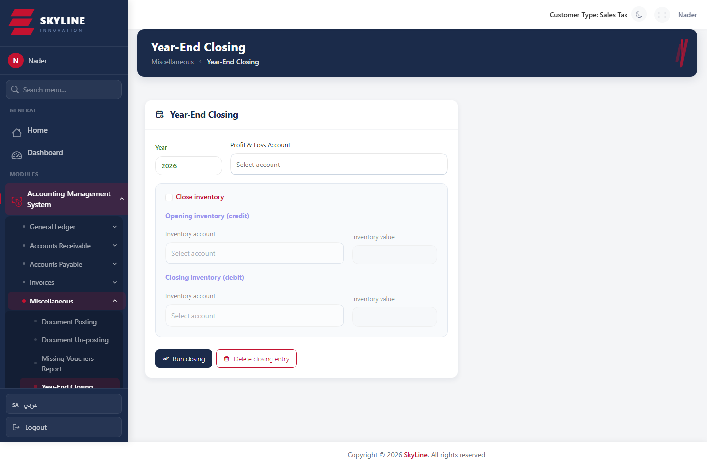

Document Posting
Route: /accounting/misc/document-posting
Post selected documents/ranges to the ledger.
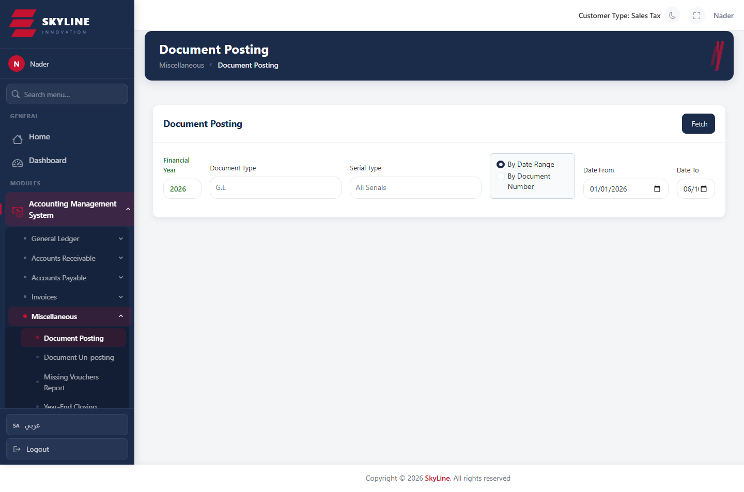

Document Un-posting
Route: /accounting/misc/document-unposting
Reverse posting on selected documents.
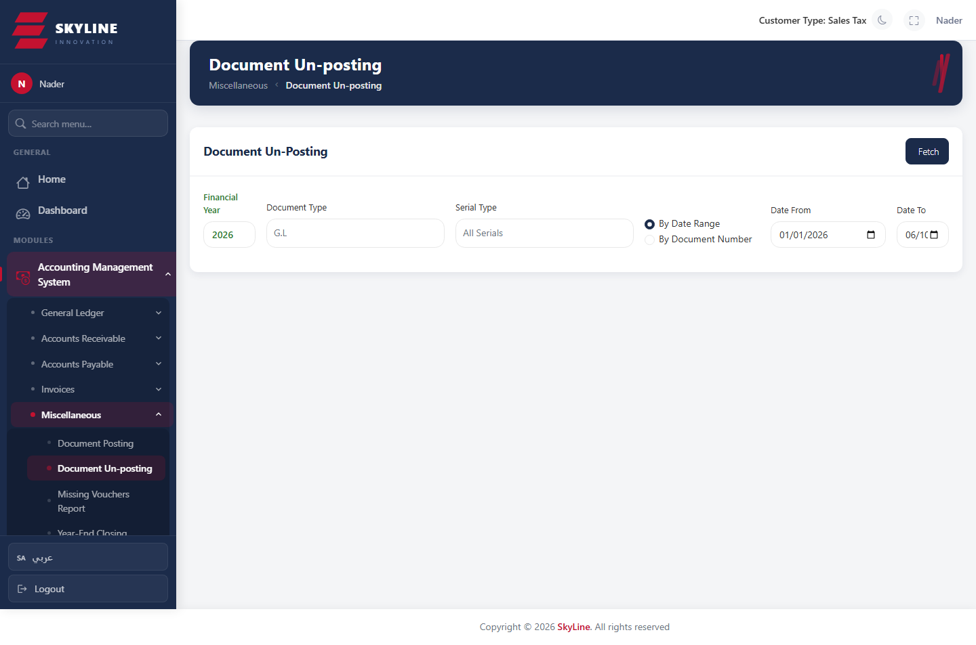

Accounting · Definitions

Banks
Route: /accounting/definitions/banks
Define bank accounts used in cheque and payment operations.
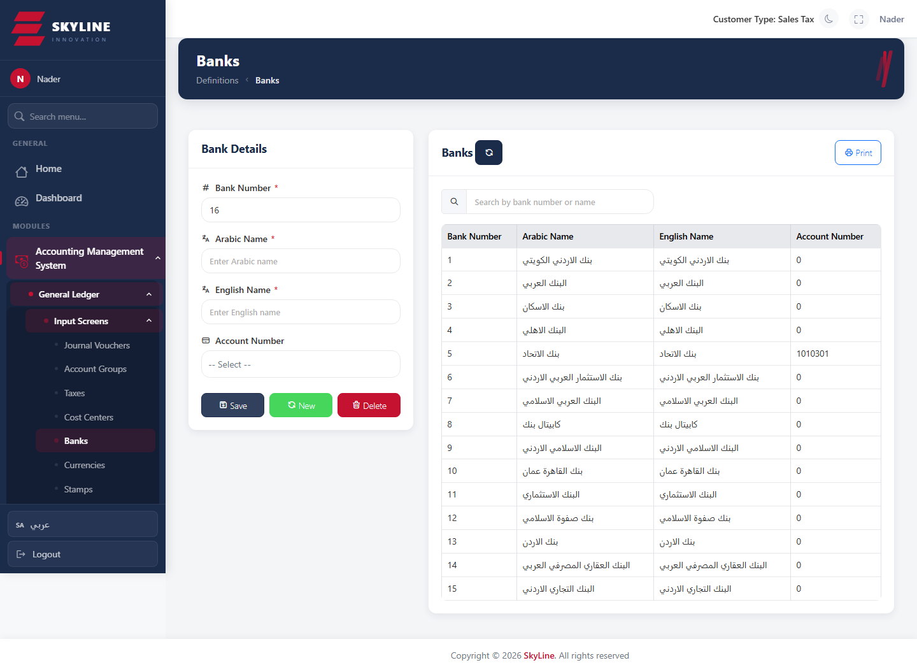

Currencies
Route: /accounting/definitions/currencies
Define currencies: number, Arabic/English name, exchange rate, decimal places and symbols.
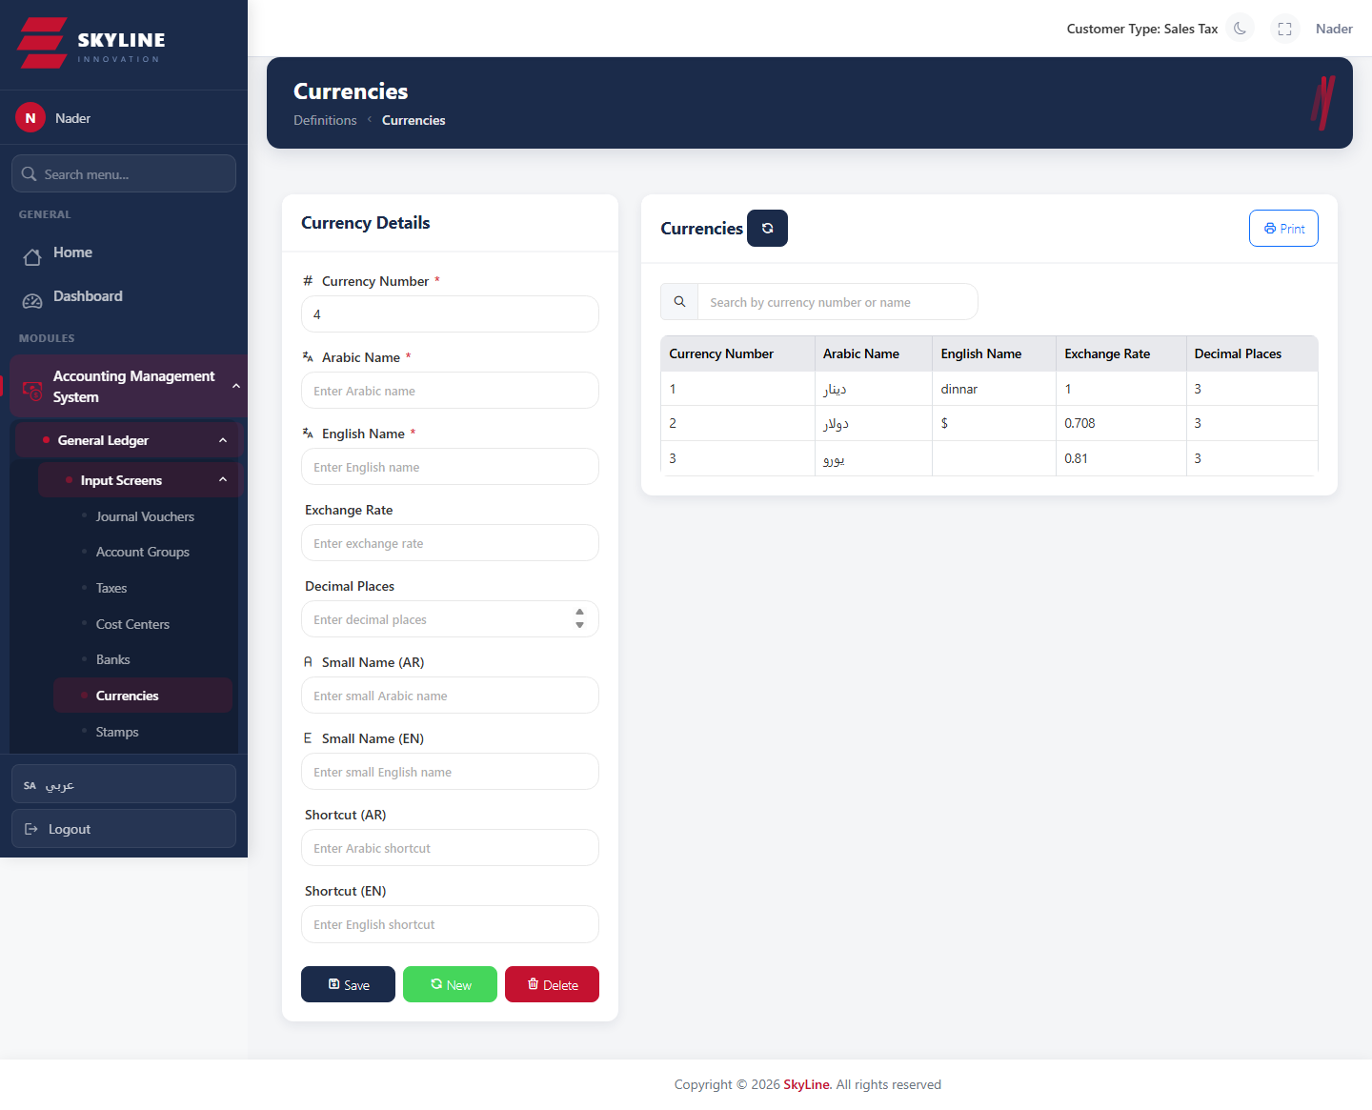

Account Groups
Route: /accounting/definitions/account-groups
Define account groups for grouped reporting.
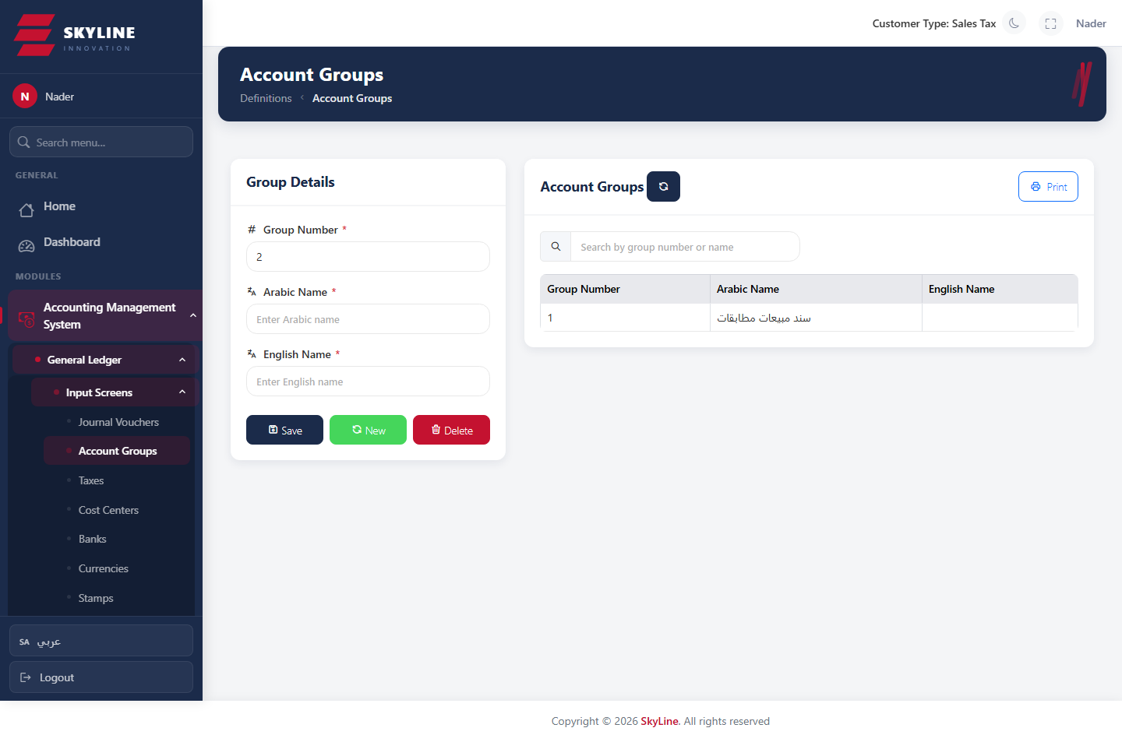

Cost Centers
Route: /accounting/definitions/cost-centers
Define cost centers used to tag and analyze transactions.
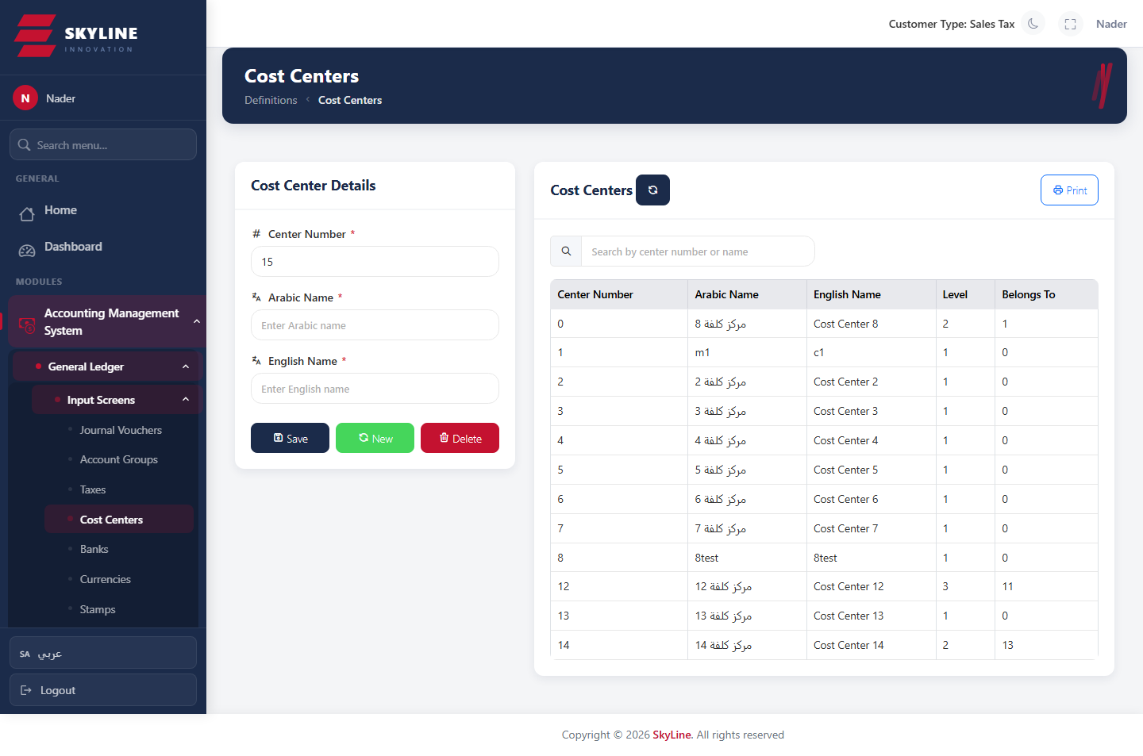

Taxes
Route: /accounting/definitions/taxes
Define tax types and rates.
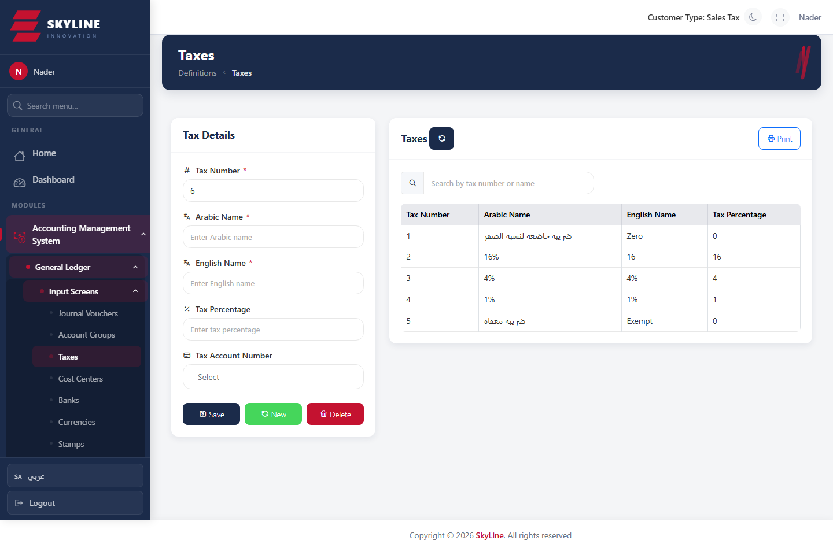

Stamps
Route: /accounting/definitions/stamps
Define stamp duties/fees.
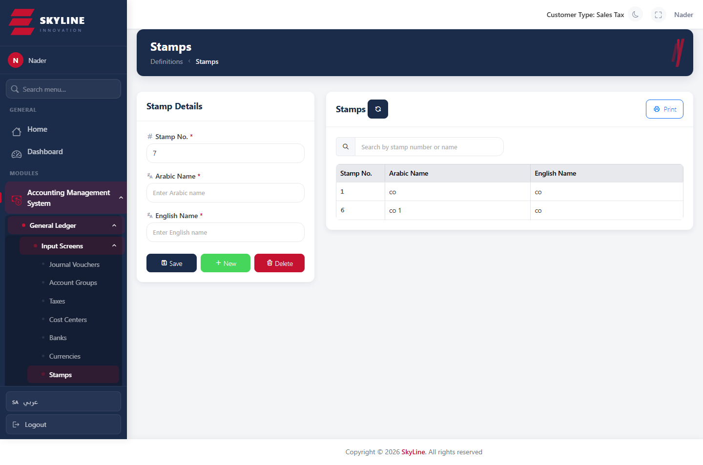

Accounting · Parties & Invoices

Customers
Route: /accounting/ar/customers
Customer master data for receivables.
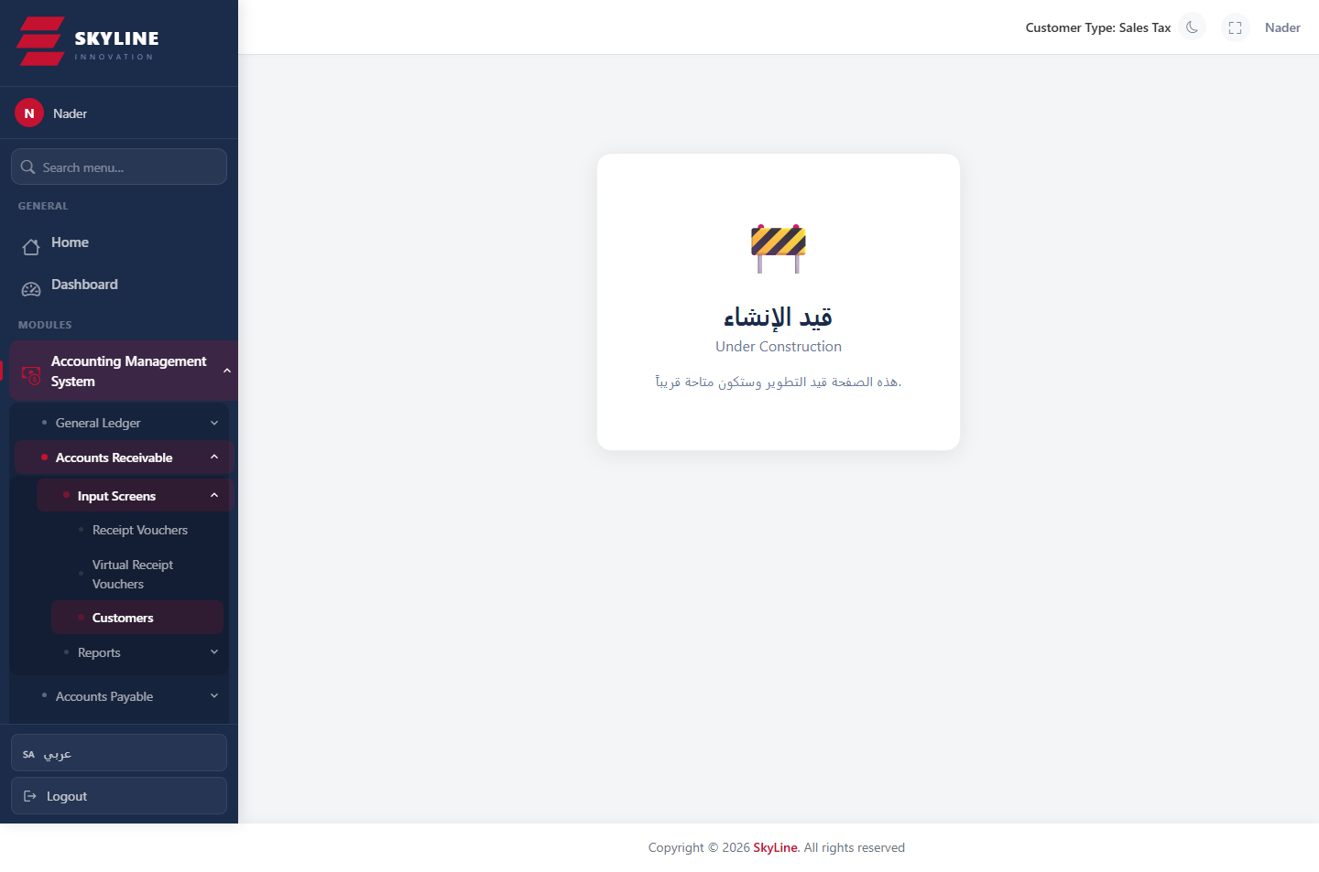

Suppliers
Route: /accounting/ap/suppliers
Supplier/vendor master data for payables.
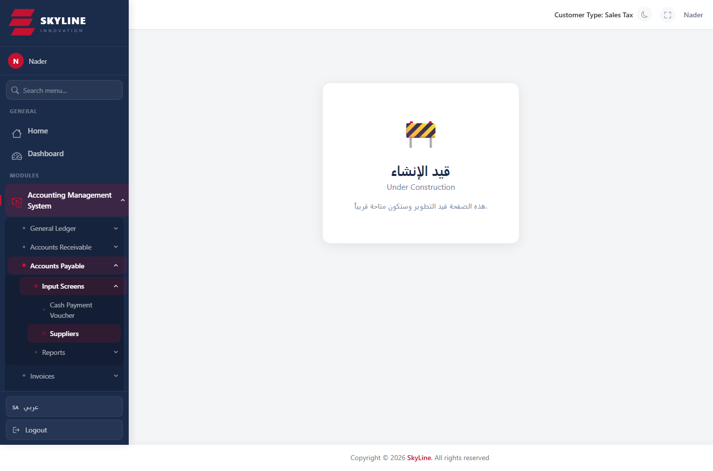

Service Invoice (فاتورة خدمات)
Route: /accounting/invoices/service
Create service-type invoices that auto-post to the general ledger.
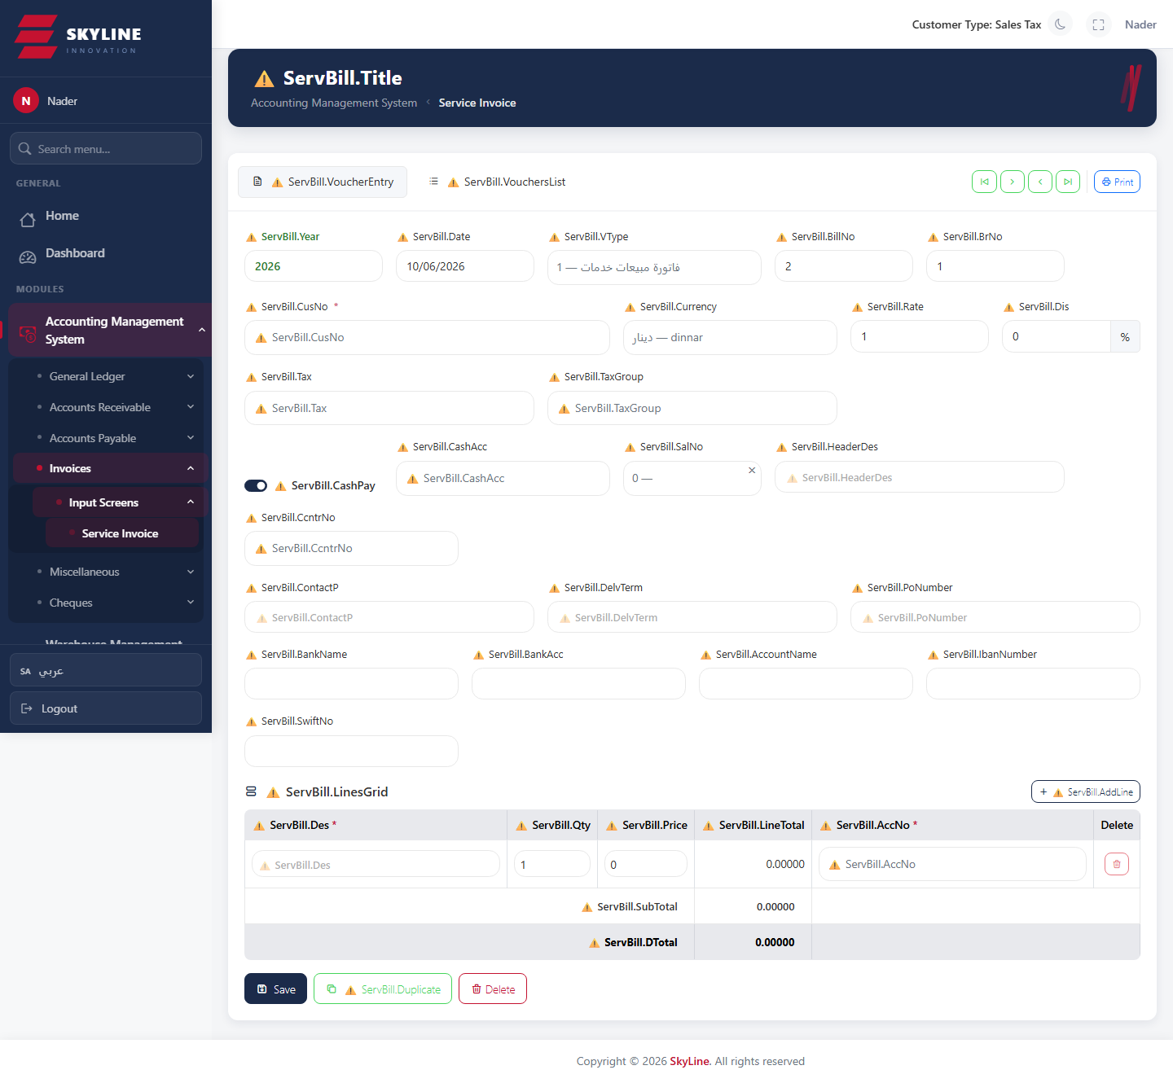

Accounting · Administration

Permissions
Route: /accounting/admin/permissions
User × permission matrix grouped by module. Grant/revoke fine-grained permissions; gated by Admin.ManagePermissions.
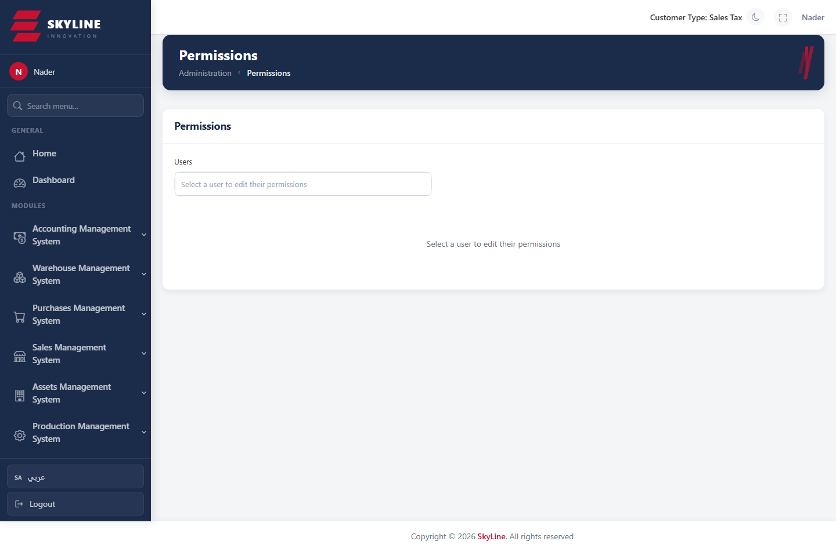

Company Info
Route: /accounting/system/company-info
Company profile, decimals and branding used across the app.
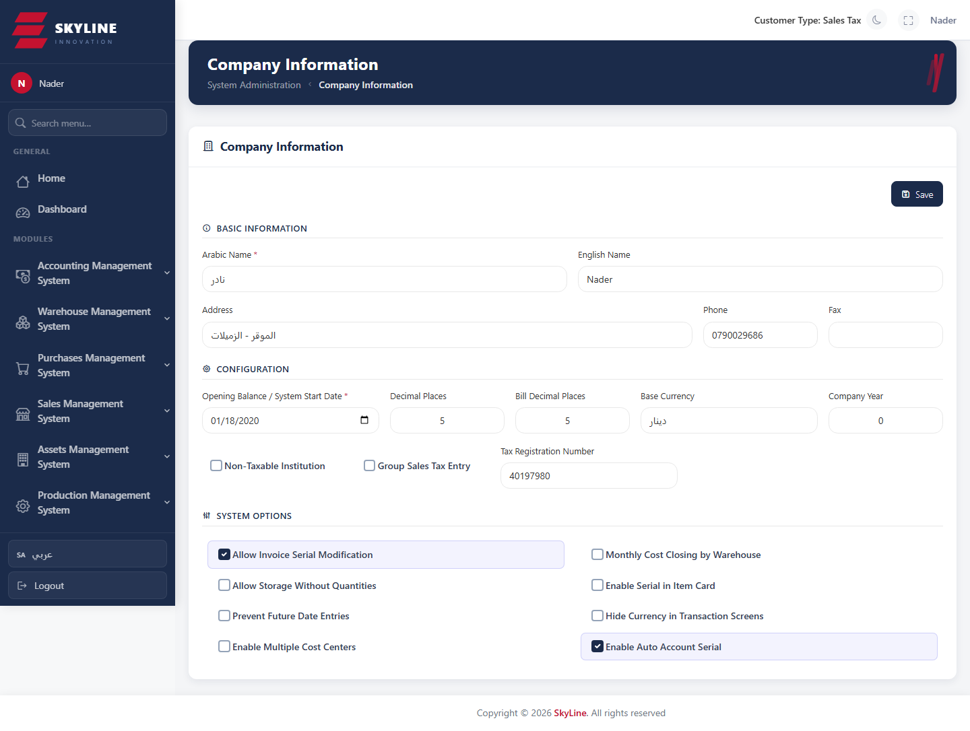

Appearance
Route: /accounting/settings/appearance
Theme (light/dark), app theme and layout/direction settings.
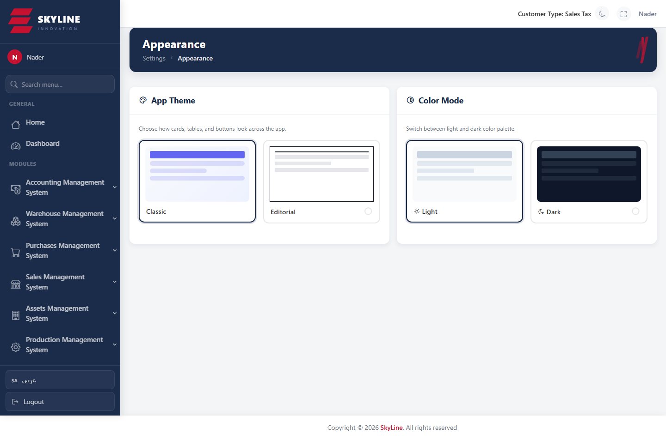

Voucher Serials
Route: /accounting/service-misc/voucher-serials
Define voucher serial/numbering types per voucher category.
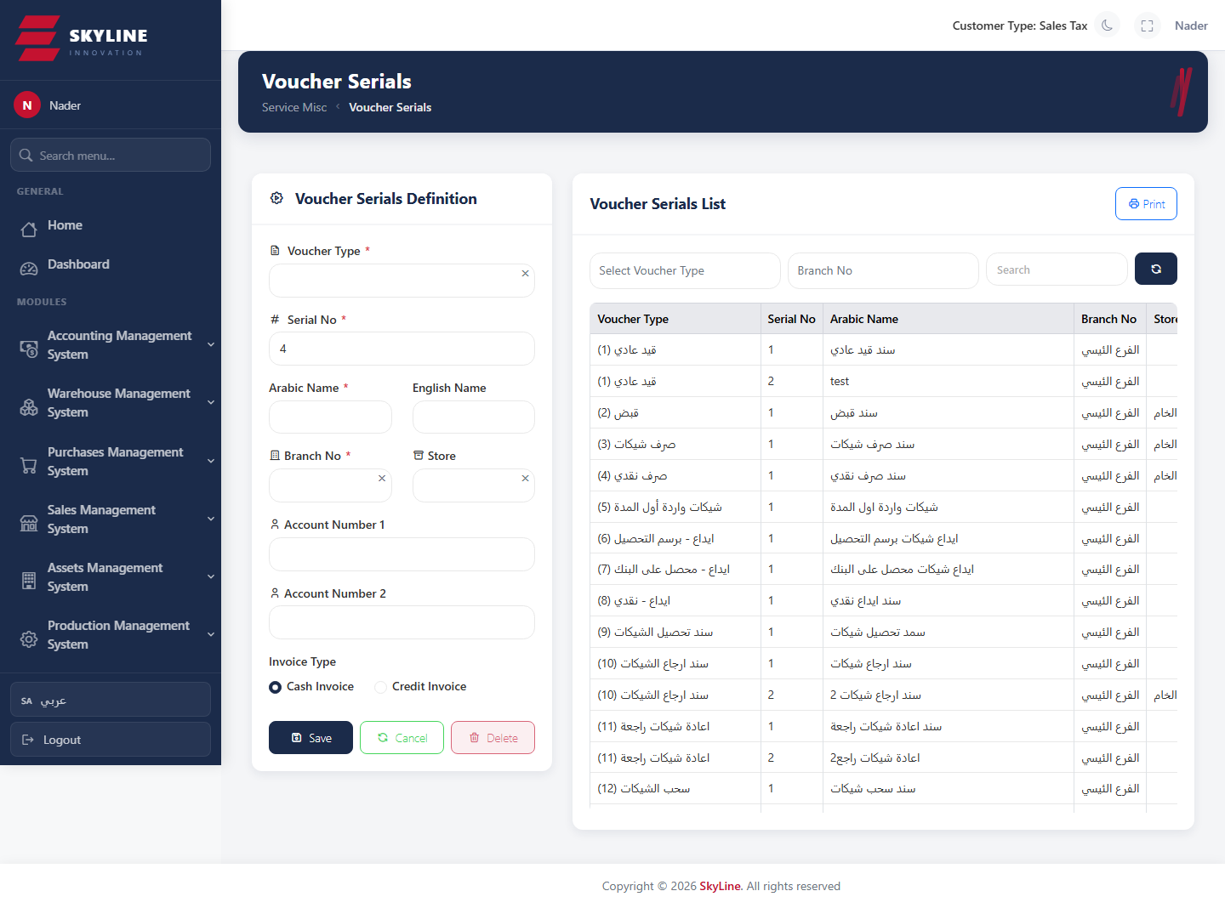

Branches
Route: /accounting/service-misc/branches
Define company branches.
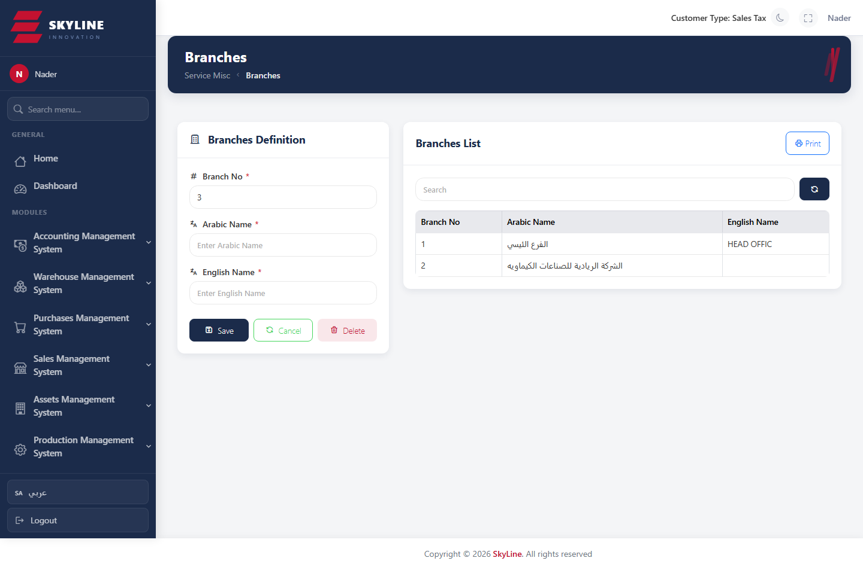

Sales

Sales Invoices
Route: /sales/invoice
List of sales invoices with sorting, paging, view/print and (where allowed) delete and e-invoice transfer.
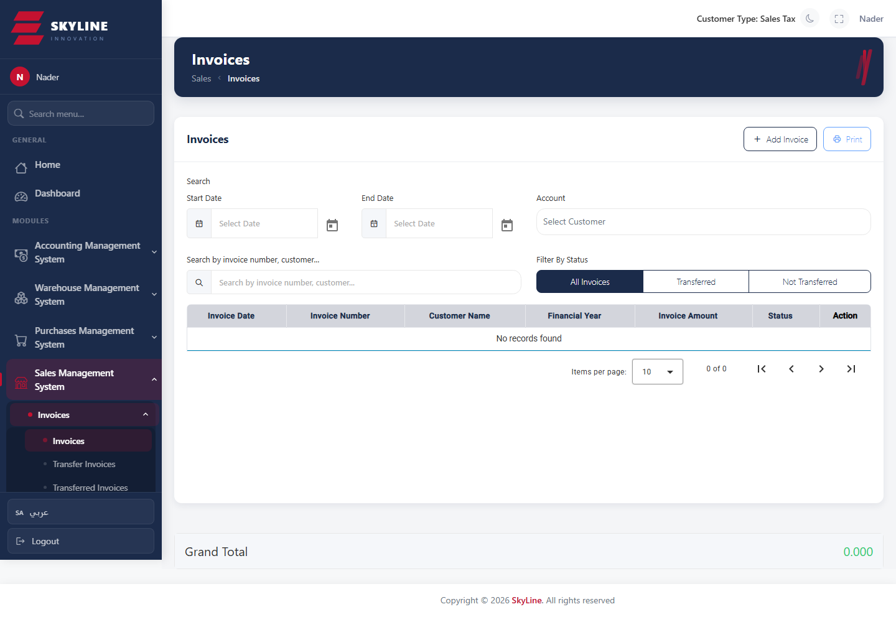

Add Sales Invoice
Route: /sales/add-invoice
Create a new sales invoice: customer, line items (qty, price, discount, tax).
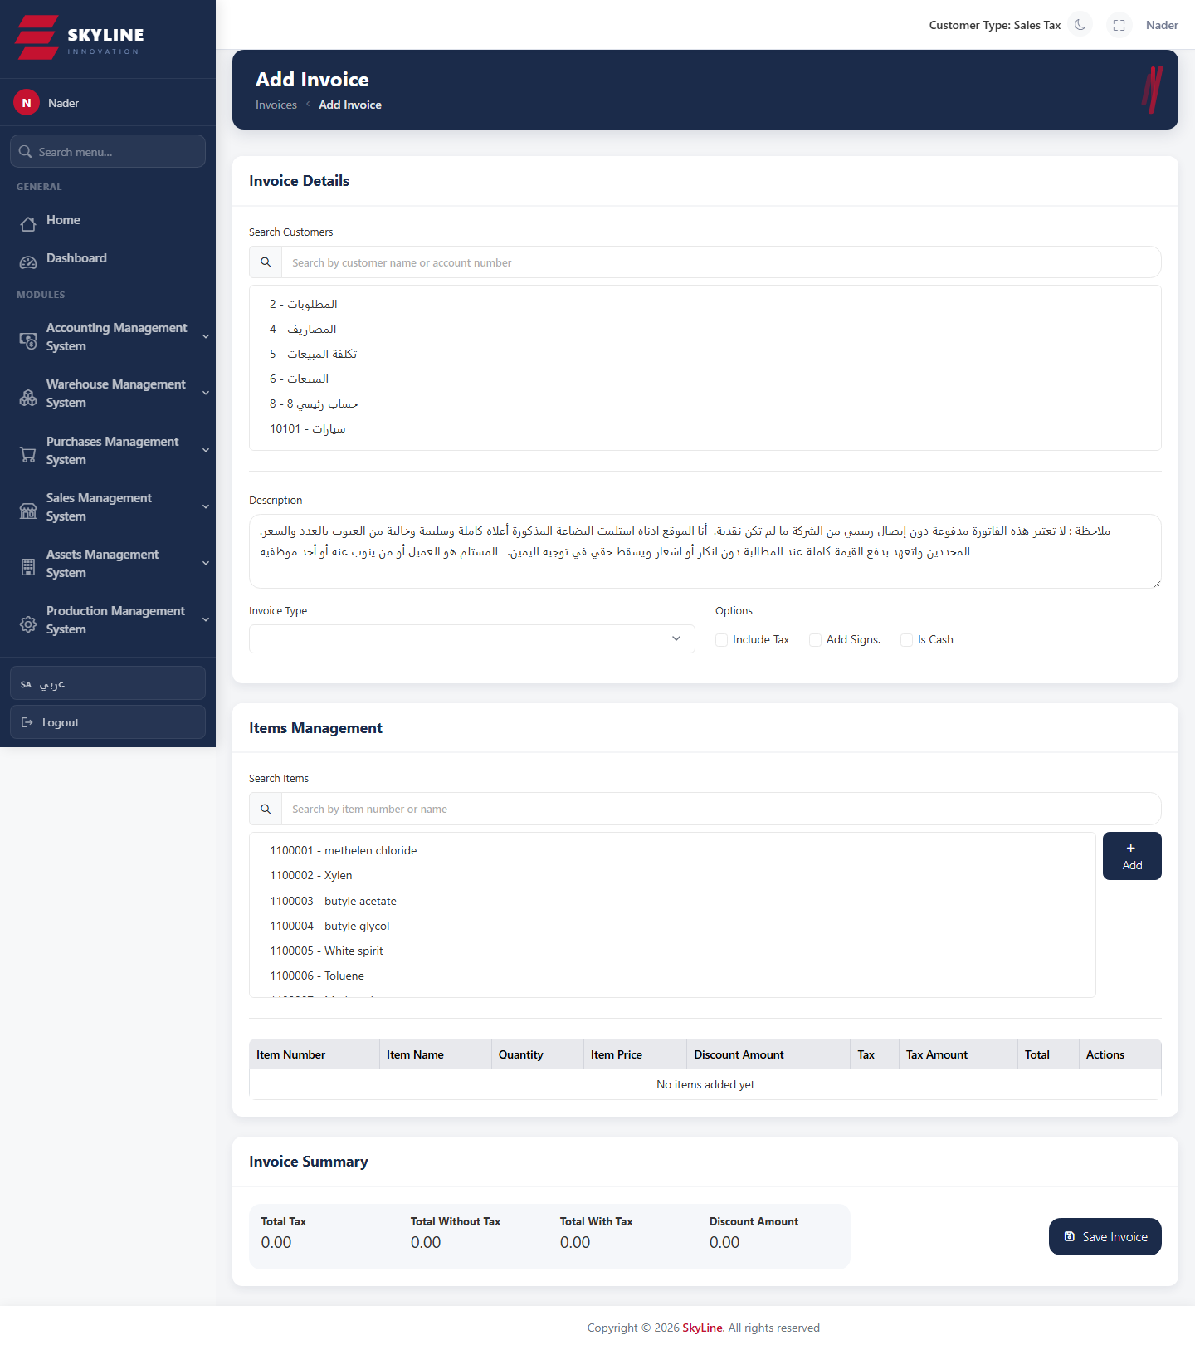

Transfer Invoices
Route: /sales/transfer-invoices
Invoices pending transfer to e-invoicing (JoFawtara/Fotara) with QR generation.
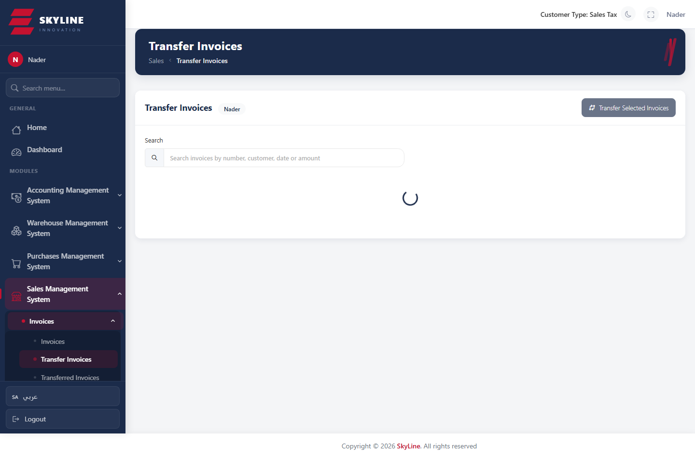

Transferred Invoices
Route: /sales/transfered-invoices
Invoices already transferred to e-invoicing, with their QR codes.
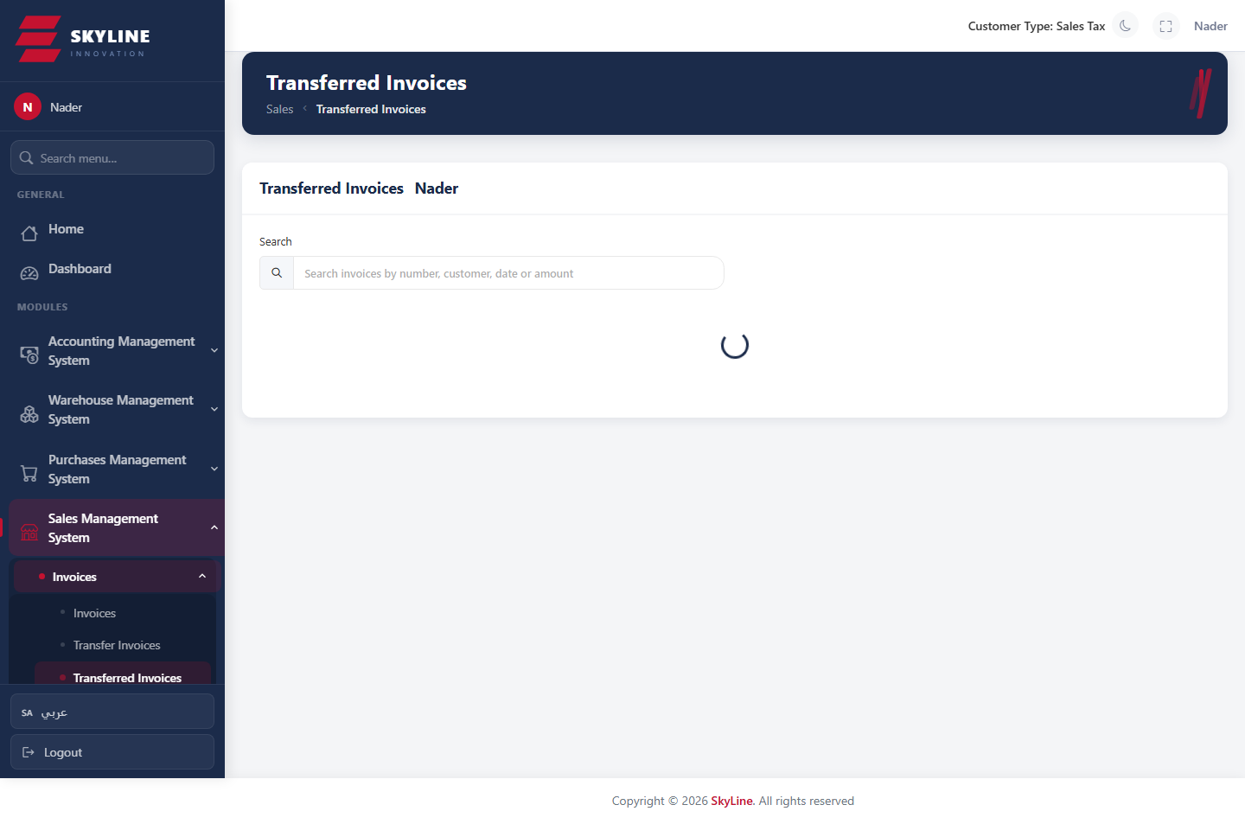

Refunds
Route: /sales/refunds
Sales refund/credit documents.
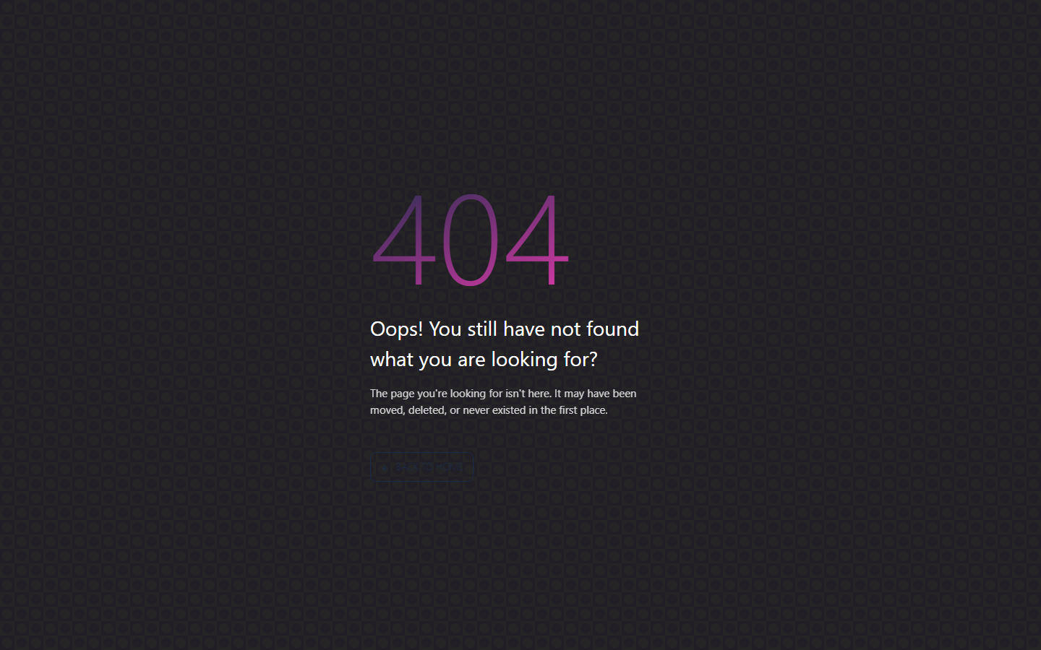

Service Invoices
Route: /sales/service/invoice
List of service invoices.
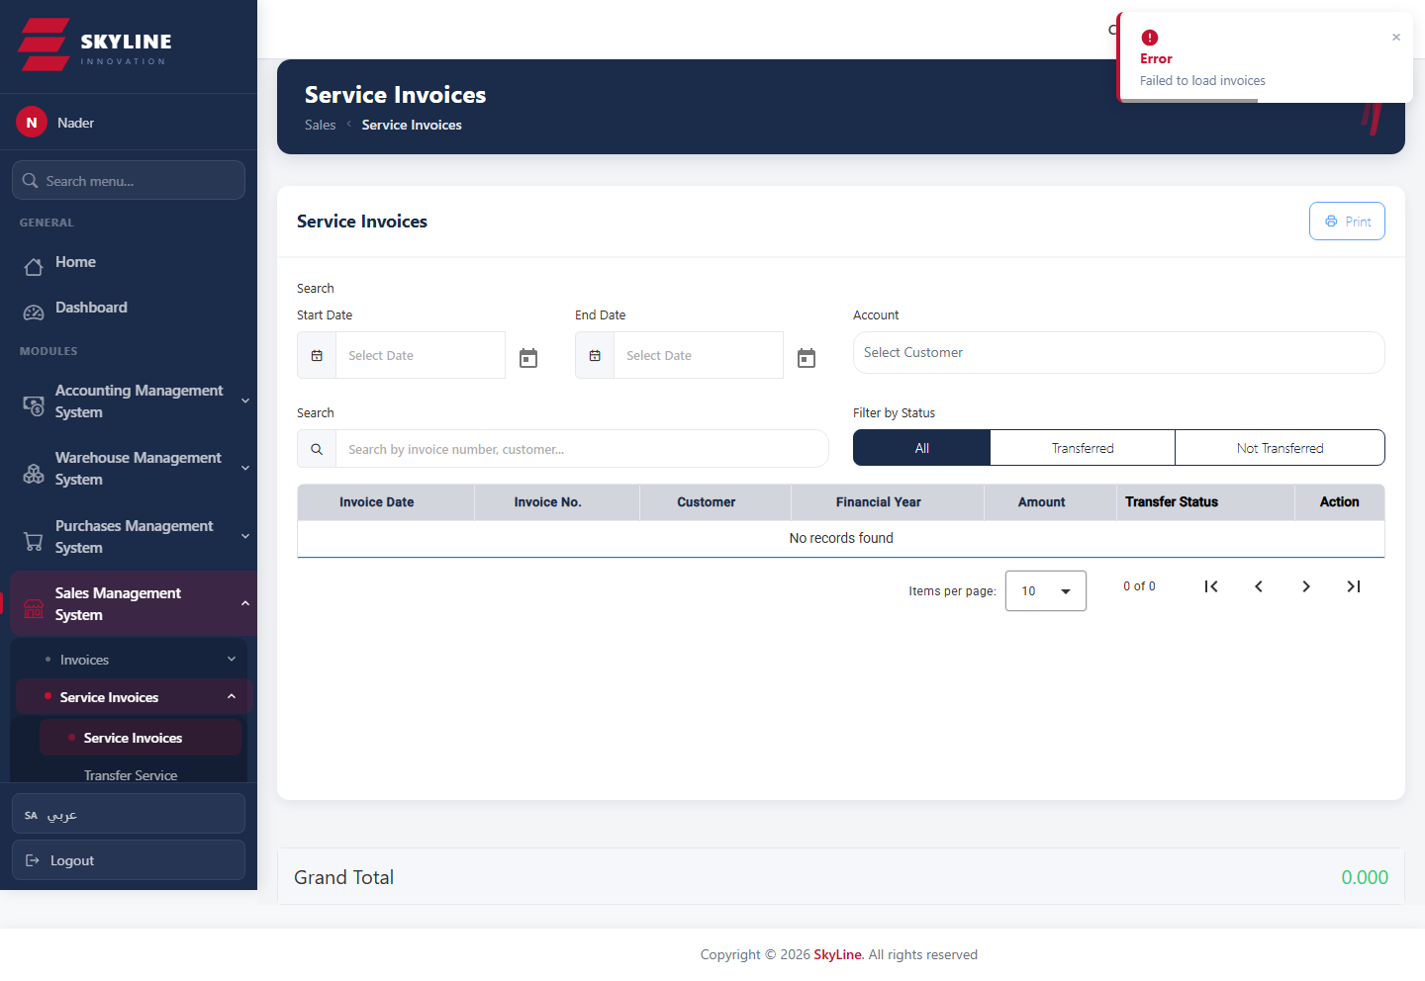

Virtual Invoices
Route: /sales/virtual/invoices
List of virtual invoices.
