Skyline Maintenance System — Use Cases
Integrated Maintenance Management System (نظام إدارة الصيانة المتكامل)
Angular SPA (hash-routed, JWT in localStorage) + ASP.NET (.NET 8) API + SQL Server.
This document captures the system's actors and use cases. It is derived from the
implemented roles (Tbl_User_level), Angular routes/guards, and the API service layer.

1. Actors
Actor | Role (`User_level`) | Description
System Administrator (مدير النظام) | 9 | Full access. Manages master data, users, inventory, billing config, and views logs.
Maintenance Manager (مدير الصيانة) | 1 | Creates/edits maintenance requests, assigns work, oversees the maintenance lifecycle.
Maintenance Technician (فني) | 3 | Executes assigned maintenance jobs and records results/parts used.
Accountant (محاسب) | 6 | Issues receipts/bills (سندات القبض) and handles financial documents.
Follow-up Officer (مسؤول المتابعة) | 7 | Performs after-maintenance follow-up and customer satisfaction tracking.
Enquiry Officer (الاستعلام) | 8 | Read-oriented lookups and status enquiries.
Public Demo Visitor | 1 (demo acct) | Auto-signed-in, sandboxed preview embedded in the marketing site (?demo=1).
Scheduler / System (time-based) | — | Non-human actor that triggers periodic/scheduled maintenance due-dates.

Generalization: the System Administrator can perform every use case available to the
functional roles; each functional role is a specialization with a restricted subset.

2. Use Case Diagram (PlantUML)
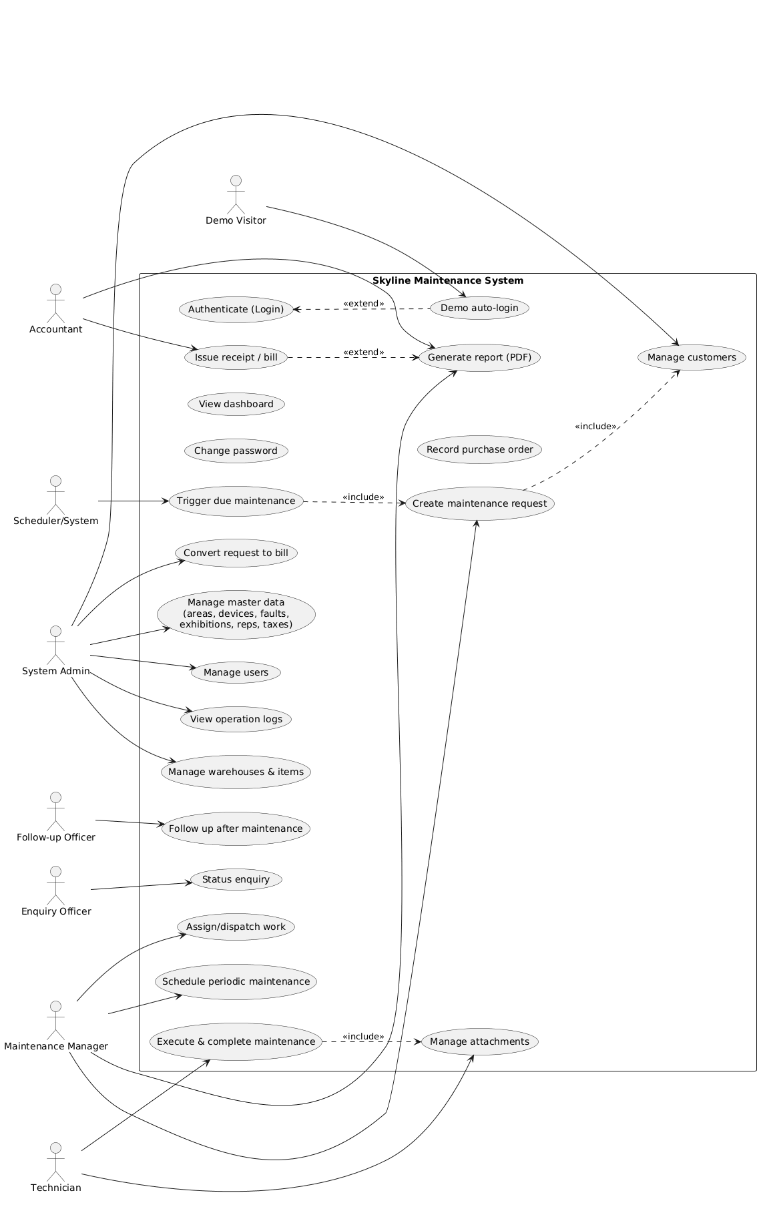
Rendered diagram: use-cases-diagram.png (also available as use-cases-diagram.svg).
Regenerate from the PlantUML source below after edits.

3. Use Case Catalog (by subsystem)

3.1 Access & Account
ID | Use Case | Primary Actor
UC-01 | Authenticate (Login) | All staff roles
UC-02 | Demo auto-login (public preview) | Demo Visitor
UC-03 | Change password | All staff roles
UC-04 | Role-based navigation / access control | System
UC-05 | View dashboard | All staff roles

3.2 Master Data (Definitions — admin)
ID | Use Case | Primary Actor
UC-10 | Manage customers (العملاء) | Admin
UC-11 | Manage exhibitions/showrooms (المعارض) | Admin
UC-12 | Manage areas (المناطق) | Admin
UC-13 | Manage representatives (المندوبين) | Admin
UC-14 | Manage technicians (تعريف الفنيين) | Admin
UC-15 | Define devices (تعريف الأجهزة) | Admin
UC-16 | Define faults (تعريف الأعطال) | Admin
UC-17 | Define taxes (تعريف الضرائب) | Admin
UC-18 | Manage users (المستخدمين) | Admin
UC-19 | View operation logs (سجل العمليات) | Admin

3.3 Maintenance Lifecycle
ID | Use Case | Primary Actor
UC-20 | Create maintenance request (طلب صيانة) | Manager
UC-21 | Edit / view maintenance request | Manager
UC-22 | Assign / dispatch work to technician | Manager
UC-23 | Execute & complete maintenance | Technician
UC-24 | Upload / view attachments (images, docs) | Technician / Manager
UC-25 | After-maintenance follow-up (متابعة) | Follow-up Officer
UC-26 | Status enquiry (استعلام) | Enquiry Officer
UC-27 | Schedule periodic maintenance (الصيانة الدورية) | Manager
UC-28 | Trigger due scheduled maintenance | Scheduler/System

3.4 Inventory & Procurement
ID | Use Case | Primary Actor
UC-30 | Manage warehouses (المستودعات) | Admin
UC-31 | Manage items / materials (المواد) | Admin
UC-32 | Record purchase order (warehouse purchase) | Admin
UC-33 | Convert warehouse transactions | Admin

3.5 Billing & Reporting
ID | Use Case | Primary Actor
UC-40 | Issue receipt / bill (سندات القبض) | Accountant
UC-41 | View bill for a maintenance job | Accountant / Admin
UC-42 | Convert maintenance request to bill | Admin
UC-43 | Generate report / export PDF | Manager / Accountant

4. Detailed Use Case Specifications

UC-01 — Authenticate (Login)
- Actor: Any staff role.
- Goal: Obtain an authenticated session to use the system.
- Preconditions: User has an active account (Tbl_Users, not soft-deleted).
- Main flow:
- User opens the app; the login screen is shown.
- User enters username (UserNmAr) and password.
- System calls POST /api/TblUsers/Login; the API verifies the HMAC-SHA512 password hash.
- API returns a signed JWT (claims: nameid, unique_name, role_id, role name, email).
- SPA stores the token in localStorage and routes to the dashboard (or role landing page).
- Alternate / Exception:
- 3a. Invalid credentials → API returns Unauthorized; SPA shows an error toast, stays on login.
- 4a. Token expired on later requests → guards redirect back to login.
- Postcondition: Valid JWT present; role-based menu rendered.

UC-02 — Demo auto-login (public preview)
- Actor: Public Demo Visitor (via marketing-site iframe).
- Goal: Let a visitor preview the system without credentials.
- Preconditions: App opened with ?demo=1 before the hash; backend demo endpoint enabled
with a configured demo user.
- Main flow:
- App boots; an APP_INITIALIZER reads window.location.search and detects demo=1.
- With no valid session, SPA calls POST /api/TblUsers/DemoLogin (no credentials sent).
- API mints a short-lived demo JWT for the dedicated demo account and returns { token }.
- SPA stores the token and lands on the dashboard; a "Demo — sample data" badge is shown.
- Alternate / Exception:
- 2a. Endpoint unavailable / not configured → fail open to the normal login screen.
- Postcondition: Read-oriented demo session active; normal login path unaffected when demo=1 absent.

UC-20 — Create maintenance request
- Actor: Maintenance Manager (also Admin).
- Goal: Register a new maintenance job for a customer/device.
- Preconditions: Authenticated as role 1 or 9; relevant customer/device master data exists.
- Main flow:
- Manager opens Maintenance Requests → Add.
- Selects the customer (and exhibition/area), device, and reported fault.
- Enters description, priority, and contact/scheduling details.
- Optionally attaches images/documents.
- System persists the request and assigns it an identifier and an initial status.
- Alternate / Exception:
- 2a. Customer not found → Manager triggers Manage customers (UC-10) to add one, then returns.
- 5a. Validation error (missing required field) → inline error; record not saved.
- Postcondition: New maintenance request stored and visible in the requests list.

UC-22 — Assign / dispatch work to technician
- Actor: Maintenance Manager.
- Goal: Route an open request to the right technician.
- Preconditions: An open maintenance request exists; technicians are defined.
- Main flow:
- Manager opens the request and selects a technician (and schedule slot).
- System records the assignment and updates the request status to assigned/in-progress.
- Alternate: 1a. Reassign to a different technician → previous assignment superseded.
- Postcondition: Request appears in the assigned technician's queue.

UC-23 — Execute & complete maintenance
- Actor: Maintenance Technician (role 3).
- Goal: Carry out the job and record the outcome.
- Preconditions: A request is assigned to the technician.
- Main flow:
- Technician opens Technician Maintenance and selects an assigned job.
- Records work performed, fault diagnosis, and parts/items consumed (from inventory).
- Attaches before/after photos (UC-24).
- Marks the job complete (or pending parts / re-visit).
- Alternate / Exception:
- 2a. Required part out of stock → flag for procurement (UC-32); job set to pending parts.
- 4a. Customer not available → job set to follow-up required (feeds UC-25).
- Postcondition: Job status updated; consumption recorded; ready for follow-up/billing.

UC-25 — After-maintenance follow-up
- Actor: Follow-up Officer (role 7).
- Goal: Confirm completion quality and customer satisfaction.
- Preconditions: Job marked complete or flagged for follow-up.
- Main flow:
- Officer opens After-maintenance / Follow.
- Contacts customer, records outcome (satisfied / re-open / escalate).
- Updates the record; re-opens a request if needed (loops to UC-20/UC-22).
- Postcondition: Follow-up outcome logged; lifecycle closed or re-opened.

UC-27 — Schedule periodic maintenance
- Actor: Maintenance Manager.
- Goal: Define recurring maintenance for a customer/device.
- Preconditions: Customer/device exist.
- Main flow:
- Manager opens Scheduled Maintenance → Add.
- Selects customer/device, interval, and start date.
- System stores the schedule with its next due date.
- Postcondition: Schedule persisted; eligible for UC-28.

UC-28 — Trigger due scheduled maintenance
- Actor: Scheduler / System (time-based).
- Goal: Surface schedules whose due date has arrived as actionable requests.
- Main flow:
- On/after the due date, the schedule becomes due.
- The Manager is presented the due item and generates a maintenance request (includes UC-20).
- Postcondition: Periodic job enters the normal maintenance lifecycle.

UC-40 — Issue receipt / bill
- Actor: Accountant (role 6; also Admin role 9).
- Goal: Produce a financial receipt for completed work/services.
- Preconditions: Authenticated as role 6 or 9; relevant job/customer exists; taxes defined (UC-17).
- Main flow:
- Accountant opens Bills / Receipts (سندات القبض).
- Selects customer/job, adds line items and amounts; taxes applied per configuration.
- System computes totals and persists the bill.
- Optionally generates a printable PDF (UC-43).
- Alternate: 2a. Convert an existing maintenance job to a bill (UC-42) to pre-fill line items.
- Postcondition: Bill recorded; PDF available for print/share.

UC-43 — Generate report / export PDF
- Actor: Manager / Accountant / Admin.
- Goal: Produce a printable document (bill, contract, maintenance report).
- Preconditions: Source record exists.
- Main flow:
- User selects a record and chooses Print/Export.
- API renders a PDF (server-side, wkhtmltopdf/DinkToPdf) with Arabic-capable fonts.
- The document is returned for download/print.
- Postcondition: PDF delivered to the user.

UC-18 — Manage users
- Actor: System Administrator (role 9).
- Goal: Create, edit, view, or deactivate system users and their roles.
- Preconditions: Authenticated as role 9.
- Main flow:
- Admin opens Add/Manage User.
- Enters name, email, role (User_level), and initial password (hashed server-side).
- System creates the user (AddNewUser) and returns the new id.
- Alternate / Exception:
- Edit existing user (EditeUsers); soft-delete (softDeleteUsers) to deactivate.
- Postcondition: User account created/updated; can authenticate per its role.

5. Cross-cutting notes & assumptions
- Authorization: roles are enforced in the SPA via route guards (AuthGuard, RoleGuard).
Several API endpoints currently have authorization attributes commented out — server-side
enforcement should be hardened for production (especially for the public demo).
- Auth transport: JWT stored in localStorage; works inside the cross-origin marketing
iframe (no cookies).
- Localization: UI is bilingual (Arabic default, RTL; English supported).
- Statuses named above (assigned / in-progress / pending parts / follow-up / complete) are
the logical lifecycle; exact status codes live in the maintenance tables/stored procedures.
- This catalog reflects implemented modules; extend it as new screens/endpoints are added.

