Real-Time Ecommerce Data Engineering Pipeline

Student Name:
Nader Saeed
Project Type:
Data Engineering Project
Technologies:
Apache NiFi, Apache Kafka, Hadoop HDFS, Docker, Python

1. Introduction
This project implements a real-time ecommerce data engineering pipeline using Apache NiFi, Apache Kafka, Hadoop HDFS, Docker, and Python. The system generates streaming ecommerce order data, validates and cleans the data, transforms CSV records into JSON format, publishes the records to Kafka, and finally stores them in Hadoop HDFS for scalable storage and analytics.

2. Project Objectives
- Build a real-time streaming data pipeline
- Generate ecommerce order data continuously
- Validate incoming data records
- Detect corrupted and invalid records
- Transform CSV records into JSON format
- Clean and standardize data
- Stream data using Apache Kafka
- Store processed data inside Hadoop HDFS
- Implement scalable enterprise-style architecture

3. Technologies Used
Technology | Purpose
Apache NiFi | Real-time data flow management
Apache Kafka | Real-time streaming platform
Apache Hadoop HDFS | Distributed storage system
Docker | Containerization environment
Python | Streaming data generation

4. System Architecture
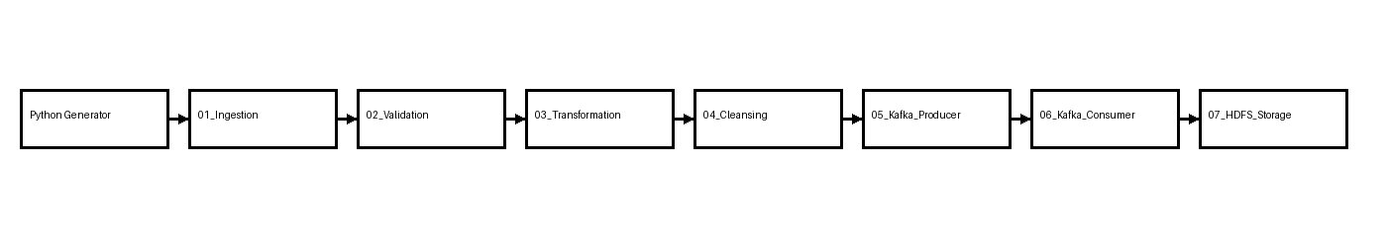

5. Process Groups Explanation

01_Ingestion
Reads generated CSV files using GetFile and splits records using SplitRecord.

02_Validation
Validates records and detects corrupted values using ValidateRecord and QueryRecord.

03_Transformation
Transforms validated records into JSON format using ConvertRecord.

04_Cleansing
Cleans and standardizes fields using UpdateRecord.

05_Kafka_Producer
Publishes processed JSON records into Apache Kafka topics.

06_Kafka_Consumer
Consumes streaming records from Kafka topics.

07_HDFS_Storage
Stores streaming records into Hadoop HDFS using partitioned directories.

6. Data Validation Rules
- Missing customer_id values
- Corrupted values such as %%%%CORRUPTED%%%%
- Invalid amount values
- Incorrect timestamps
- Duplicate records

7. Kafka Integration
Apache Kafka is used as the streaming layer between producers and consumers. The Kafka Producer process group publishes processed records into the ecommerce_orders topic, while the Kafka Consumer process group continuously consumes the records for storage into HDFS.

8. HDFS Storage
Processed records are stored inside Hadoop HDFS using date-based partitioning. This structure improves scalability and enables faster future analytics queries.

9. Challenges Faced
- Kafka broker connectivity configuration
- CSV splitting issues using SplitContent
- Handling corrupted records
- Docker networking configuration
- NiFi Controller Services configuration

10. Conclusion
This project successfully demonstrates a complete real-time data engineering pipeline using Apache NiFi, Apache Kafka, and Hadoop HDFS. The architecture supports scalable streaming ingestion, validation, transformation, cleansing, Kafka streaming, and distributed storage.

