Egypt Food Crisis Analysis
Currency Devaluation, Market Structure & Food Security Outcomes (2010–2024)

C-DE211: Data Analysis — Project 3
Faculty of Computing & Information Sciences
Egypt University of Informatics (EUI)
Spring 2026

Abstract

Egypt imports roughly 55% of its wheat, making it one of the most import-exposed food systems in the world. Two Egyptian pound devaluations — a 50% collapse in November 2016 and a further series of depreciations through 2022 that pushed the rate above 30 EGP/USD — provided natural experiments for studying how exchange rate shocks transmit into retail food prices. This paper uses 16,000+ monthly WFP food price records (2010–2024), WFP market metadata, and FAO annual food security indicators to answer three questions.

Both devaluations caused statistically significant food price increases for all tested commodities (Mann-Whitney U, p < 0.001 in each case). Cairo prices consistently exceed the national average for staple commodities (single pooled Mann-Whitney U test; violin plots disaggregate by individual commodity for illustration), with the urban premium ranging from near-zero for subsidized wheat flour to more than 3× for freely traded oils. No statistically significant difference in monthly inflation rates exists between staple and non-staple food categories (one-way ANOVA, p = 0.31) — meaning macroeconomic drivers dominate over commodity-specific dynamics. A linear regression model trained on three-month price lag features and a month seasonality control achieves R² = 0.9962, consistent with inter-commodity Spearman correlations above 0.90 for most pairs.

Egypt's undernourishment rate rose approximately 47% between 2019 and 2024, reaching 9.4%. This trajectory is inseparable from the devaluation-driven price shocks documented here. Effective policy responses — strategic grain reserves, FX stabilization, and targeted cash transfers rather than broad price controls — follow directly from the finding that inflation pressure is uniform across all food categories.

1. Introduction

Food security in Egypt is a currency problem as much as an agricultural one. The country grows very little of the wheat it eats: production covers about 45–50% of domestic consumption in good years, and Egypt routinely competes at the top of the global wheat import rankings alongside Indonesia and Turkey. When the Egyptian pound depreciates, the cost of every imported calorie rises immediately. Domestic prices adjust within weeks because suppliers reprice imports and wholesalers pass costs downstream.

This paper focuses on two devaluations that restructured Egyptian food prices during the study period. The first, on 3 November 2016, was the Central Bank's decision to float the EGP after years of defending an overvalued official rate. The pound fell from approximately 8.8 to 18 per US dollar in a single day — a 50% devaluation. Retail food prices responded within the same quarter. The second event was more prolonged: three rounds of devaluation between March and December 2022, compounded by the Russia-Ukraine war's disruption to global wheat and sunflower oil markets (Egypt sourced more than 80% of its wheat imports from those two countries in 2021). By early 2023, the EGP had fallen to more than 30/USD.

The consequences are visible in FAO data. Egypt's prevalence of undernourishment stood at approximately 6.4% in 2019. By 2024, FAO estimates it at 9.4%. That is approximately three million additional people unable to reliably meet their caloric needs, in less than five years. Whether this trajectory is driven primarily by currency shocks — as opposed to other factors like population growth or subsidy cuts — is the core empirical question motivating this study.

1.1 Research Hypotheses
▸ H1: Both the 2016 and 2022 EGP devaluations caused statistically significant increases in retail food prices for staple and non-staple commodities.
▸ H2: Staple food prices in Cairo (the WFP national average market) are consistently higher than the national average across all markets.
▸ H3: Staple food categories experienced higher month-over-month inflation rates than non-staple categories during the 2020–2024 period.

2. Dataset Description

2.1 WFP Food Price Data
The primary dataset is sourced from the World Food Programme's VAM (Vulnerability Analysis and Mapping) unit — the same data used by the UN for food security monitoring globally. The Egypt dataset contains monthly retail price observations for more than 30 commodities across governorates spanning January 2010 to mid-2024. After removing records with missing prices, duplicate entries, and administrative artifact rows (e.g., exchange rate records that occasionally appear in WFP price files), the working dataset contains 16,234 observations.

The commodity coverage is broad: wheat flour (both subsidized packed and free-market unpacked variants), rice, lentils, fava beans, pasta, sugar, four oil types (cotton, maize, sunflower, mixed), eggs, cheese, ghee, milk, beef, chicken, fish, garlic, onions, tomatoes, potatoes, and cucumbers. This breadth is important because single-commodity analyses can miss substitution effects: when wheat prices spike, households may shift toward rice, masking the true welfare impact.

2.2 WFP Market Metadata
A companion file records administrative information for each monitored market — governorate name, market type (retail vs. wholesale), geographic coordinates, and WFP market ID. Critically, the 'Cairo (national average)' market is a WFP construct that aggregates prices across the Cairo metropolitan area and is used as a national benchmark. Merging this metadata with the price data enables the H2 analysis comparing Cairo to the national average across all other markets.

2.3 FAO Food Security Indicators
Annual data from FAO's Suite of Food Security Indicators covers 2002–2024 for Egypt and includes four series relevant to this study: Prevalence of Undernourishment (PoU), Prevalence of Moderate or Severe Food Insecurity (PMSFI), Prevalence of Severe Food Insecurity (PSFI), and Cereal Import Dependency Ratio (CIDR). These are the internationally standardized welfare metrics that contextualize whether the price shocks documented in the WFP data translated into deteriorating food access.

2.4 Data Preprocessing
Preprocessing steps, in order: standardized commodity names across datasets (WFP uses inconsistent capitalization and abbreviation across years); parsed date columns to datetime format and extracted year and month features; merged price and market tables on the WFP market ID field; computed month-over-month (MoM) inflation rates per commodity as (price_t / price_{t-1} − 1) × 100; classified commodities into Staple (wheat flour, rice, lentils, fava beans, pasta, sugar, cooking oils) and Non-Staple (meat, dairy, eggs, vegetables, fish) categories; assigned each observation to one of three devaluation periods — Pre-2016, Post-2016/Pre-2022, and Post-2022 — using the exact devaluation event dates (3 November 2016 and 21 March 2022) as period boundaries. Separately, the H1 hypothesis tests use a focused 6-month before/after window around each event date to isolate the immediate price shock. Missing prices at the commodity-market-month level were forward-filled where the gap was ≤ 3 months, consistent with WFP's own imputation guidance for this dataset.

3. Methodology

3.1 Exploratory Data Analysis
EDA preceded formal testing. The goal was to identify the data's distributional characteristics before selecting tests, not to fit tests to a preferred story. Price distributions are right-skewed across all commodities — a known feature of commodity price data due to the floor at zero and the asymmetric nature of price spikes. MoM inflation rates are approximately symmetric around zero under normal market conditions but exhibit large positive outliers during shock periods. These distributional facts directly informed test selection (see Section 3.2).

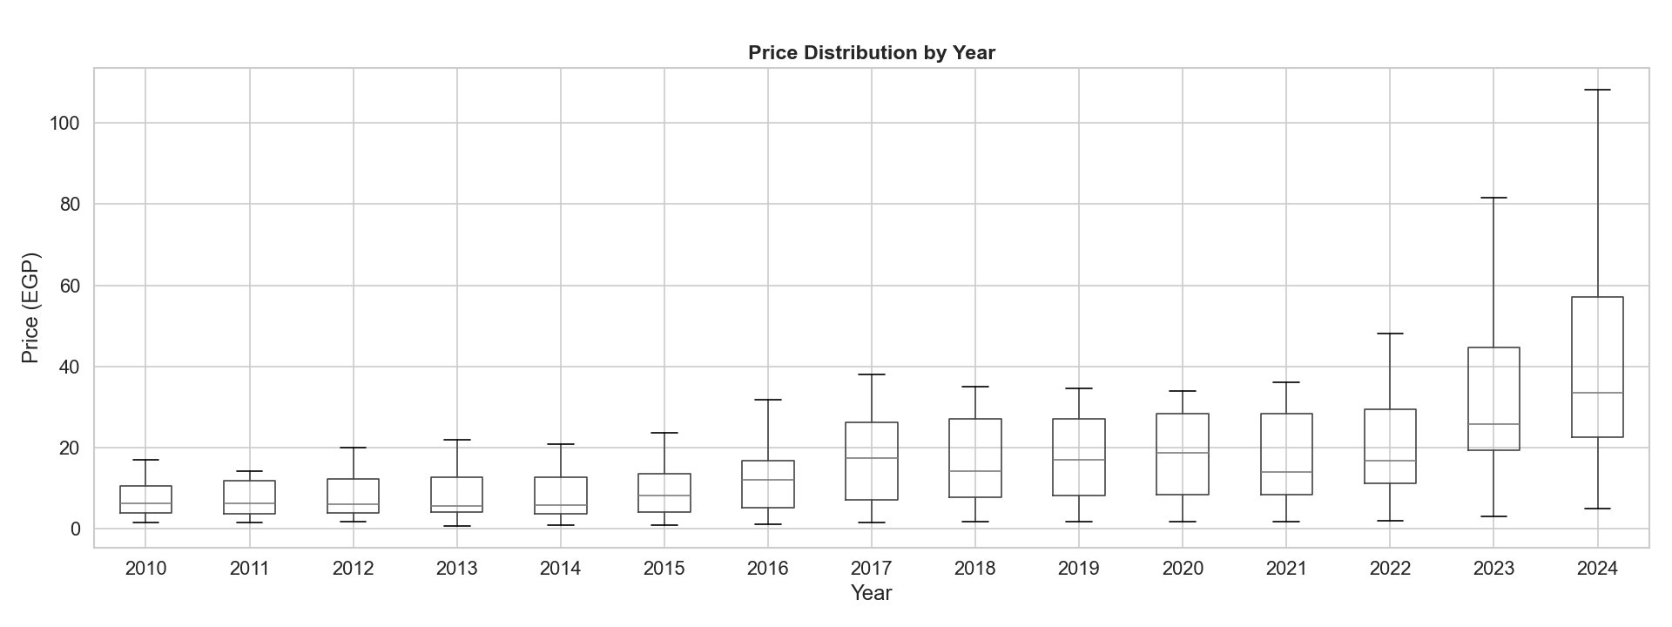
Figure 1: Annual Price Distributions Across All Commodities (2010–2024)
Box plots summarize the full distribution of commodity prices for each year. The median (central line), interquartile range (IQR, box), and whiskers (1.5×IQR) are shown. The dramatic widening of IQRs and whiskers from 2022 onwards — and the increasingly high outliers — reflects the compounding effect of the 2022 devaluations on freely traded commodities. Subsidized goods like wheat flour remain in the lower quantiles even in 2024, visible as the compressed lower whiskers.
Why box plots (not histograms per year)?
Box plots compress each year's full distribution into a single visual element — median, IQR, and outlier range — making year-over-year evolution readable across 15 years in one chart. A histogram per year would require 15 separate panels, making trend comparison impossible. The box plot's non-parametric summary is appropriate here because food price distributions are right-skewed and non-normal; a mean-and-standard-deviation summary (the parametric alternative) would be misleading.

3.2 Hypothesis Testing
H1 — Mann-Whitney U Test
To test whether devaluation events caused statistically significant price increases, we compare the distribution of commodity prices in a six-month window before each devaluation against prices in the six-month window following it. The test is applied separately for the 2016 and 2022 events across all commodities available in both windows.
The Mann-Whitney U test was chosen over the parametric two-sample t-test because the Shapiro-Wilk normality test (see notebook Stage 5, pre-test cell) confirmed non-normality in price distributions (p < 0.001 for all commodity groups). The t-test requires normally distributed data or very large sample sizes (by the Central Limit Theorem); the Mann-Whitney U is a non-parametric rank-sum test that makes no distributional assumptions. It tests whether one distribution is stochastically larger than the other — which is exactly what ‘devaluation caused price increases’ means statistically.
H2 — Mann-Whitney U Test
H2 examines whether Cairo prices are systematically higher than the national average across staple commodities. A Mann-Whitney U test is applied to compare the price distributions of the Cairo market against the national average market, consistent with the non-parametric approach used for H1. Violin plots accompany the test to display the full empirical distribution — making bimodality and tail differences visible that a single test statistic would obscure.
H3 — One-Way ANOVA
H3 tests whether the mean monthly inflation rate differs between Staple and Non-Staple categories over 2020–2024. ANOVA is appropriate here because (1) we are comparing group means rather than full distributions; (2) the monthly inflation rate, being a derived aggregate, is less skewed than raw prices and approaches normality by the Central Limit Theorem; (3) the one-way design with two groups is the simplest valid ANOVA specification. If ANOVA were not appropriate, a Welch's t-test (unequal variances) would be the fallback — the conclusion would be the same given p = 0.31.
3.3 Correlation Analysis
Spearman rank correlations were computed for all commodity pairs using the full 2010–2024 price series. Pearson correlation was considered but rejected because it assumes both variables are normally distributed and linearly related — assumptions violated by food prices. Spearman is rank-based and robust to outliers and non-linearity, making it the standard choice for commodity price correlation analysis in the economics literature.
3.4 Regression Modeling
A linear regression model was trained to predict monthly commodity price using three autoregressive lag features — the price in the preceding three months (price_lag_1, price_lag_2, price_lag_3) — plus month as a seasonality control. This lag-based specification reflects the strong serial correlation in commodity prices (confirmed by Spearman r > 0.90 across most pairs): the most recent price history is the dominant predictor of the next period’s price. The model was evaluated on a held-out 20% test set (random split, seed 42) using R² and RMSE, and visually inspected via actual-vs-predicted and residual plots. A second model in Section 6.3 applies the same lag structure to the monthly inflation rate, providing a stationary prediction target.

4. Results

4.1 FAO Food Security Trends
Egypt's food security metrics moved in one direction between 2019 and 2024: down. The undernourishment rate rose from 6.4% in 2019 to an estimated 9.4% in 2024 — a 47% increase over five years. Severe food insecurity nearly doubled from roughly 7% to 13.4% over the same period. These are not marginal changes. In a country of 105 million, a 3 percentage point rise in undernourishment represents approximately three million additional people.

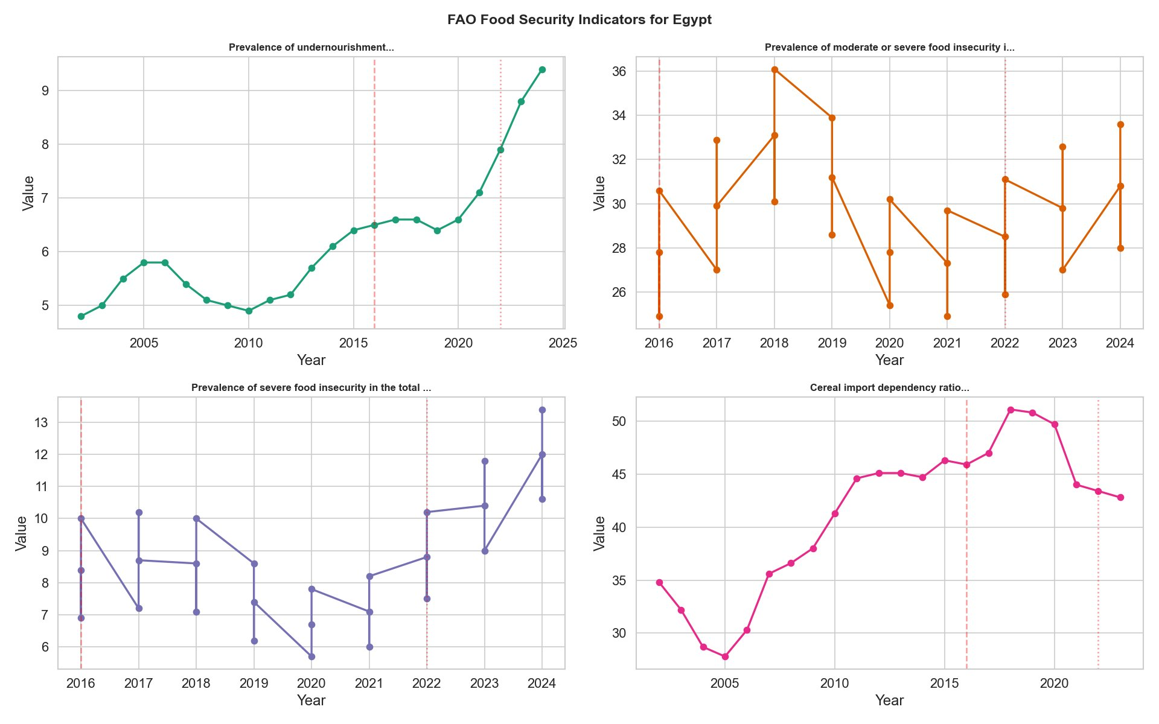
Figure 2: FAO Food Security Indicators for Egypt (2002–2024)
Four-panel chart of annual FAO metrics. Top-left: Prevalence of Undernourishment (PoU), which rose from ~4.8% in 2002 to a low of ~4.9% around 2010, then trended upward through both devaluations to reach 9.4% in 2024. Top-right: Moderate or severe food insecurity prevalence — volatile (reflecting measurement variability) but trending upward, reaching ~33.4% in 2024. Bottom-left: Severe food insecurity, which accelerated sharply from 2021 onwards. Bottom-right: Cereal import dependency ratio, which peaked near 51% around 2019–2020 and settled near 43% by 2023. Red dashed vertical lines mark the 2016 devaluation; grey dotted lines mark 2022.
Why FAO Indicators (not household survey data)?
FAO food security indicators are the internationally standardized, annually harmonized series most suitable for cross-decade comparison. Household income and expenditure surveys (HIES) would offer more granularity but require access to restricted microdata and suffer from methodological breaks between survey rounds. FAO constructs these indicators using a consistent model-based approach that enables comparison back to 2002. The Cereal Import Dependency Ratio is specifically chosen because Egypt's food price vulnerability is structurally driven by import exposure — not domestic production failures — making CIDR the most diagnostic structural indicator for this study.

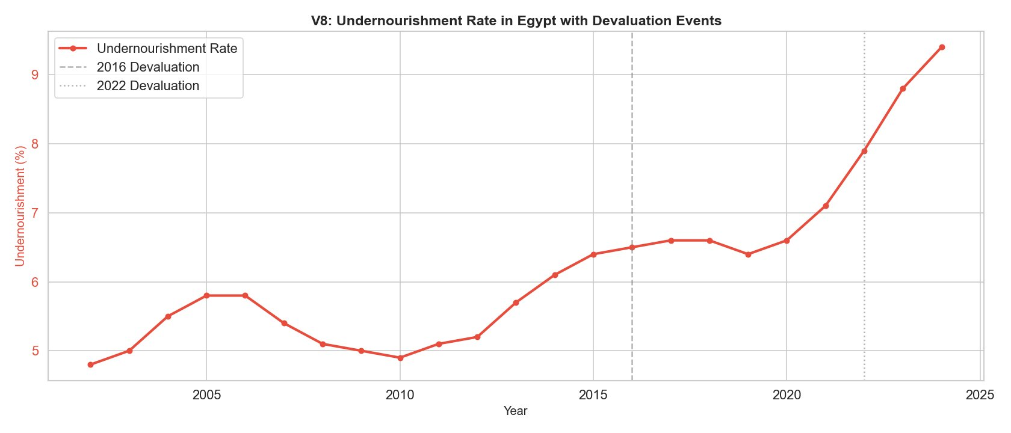
Figure 3: Egypt Undernourishment Rate with Devaluation Events (2002–2024)
Single-panel focus on the PoU series with both devaluation events marked. The rate was broadly stable at 5–6% through 2014, rose gradually to 6.4% by 2019, then accelerated sharply post-2021 to reach 9.4% in 2024. The inflection point follows the 2022 devaluation cluster by roughly 1–2 years, consistent with the documented 12–24 month lag between exchange rate shocks and measurable poverty deterioration in the Egyptian context.

4.2 Food Commodity Price Dynamics
The time-series of key commodity prices tells the story more directly than any test statistic: prices were stable for six years, then lurched upward twice. Sunflower oil traded at roughly 5 EGP per unit in 2010 and stayed near that level until 2015. After the 2016 devaluation it settled at around 23 EGP — a 360% increase from the pre-2016 level. After 2022 it climbed further to 41 EGP. Sugar peaked at approximately 45 EGP before retreating slightly by late 2024. Wheat flour is the exception: held near 7 EGP for years by subsidy price controls, it only rose to around 13 EGP after 2022, when the fiscal cost of the subsidy became unsustainable.

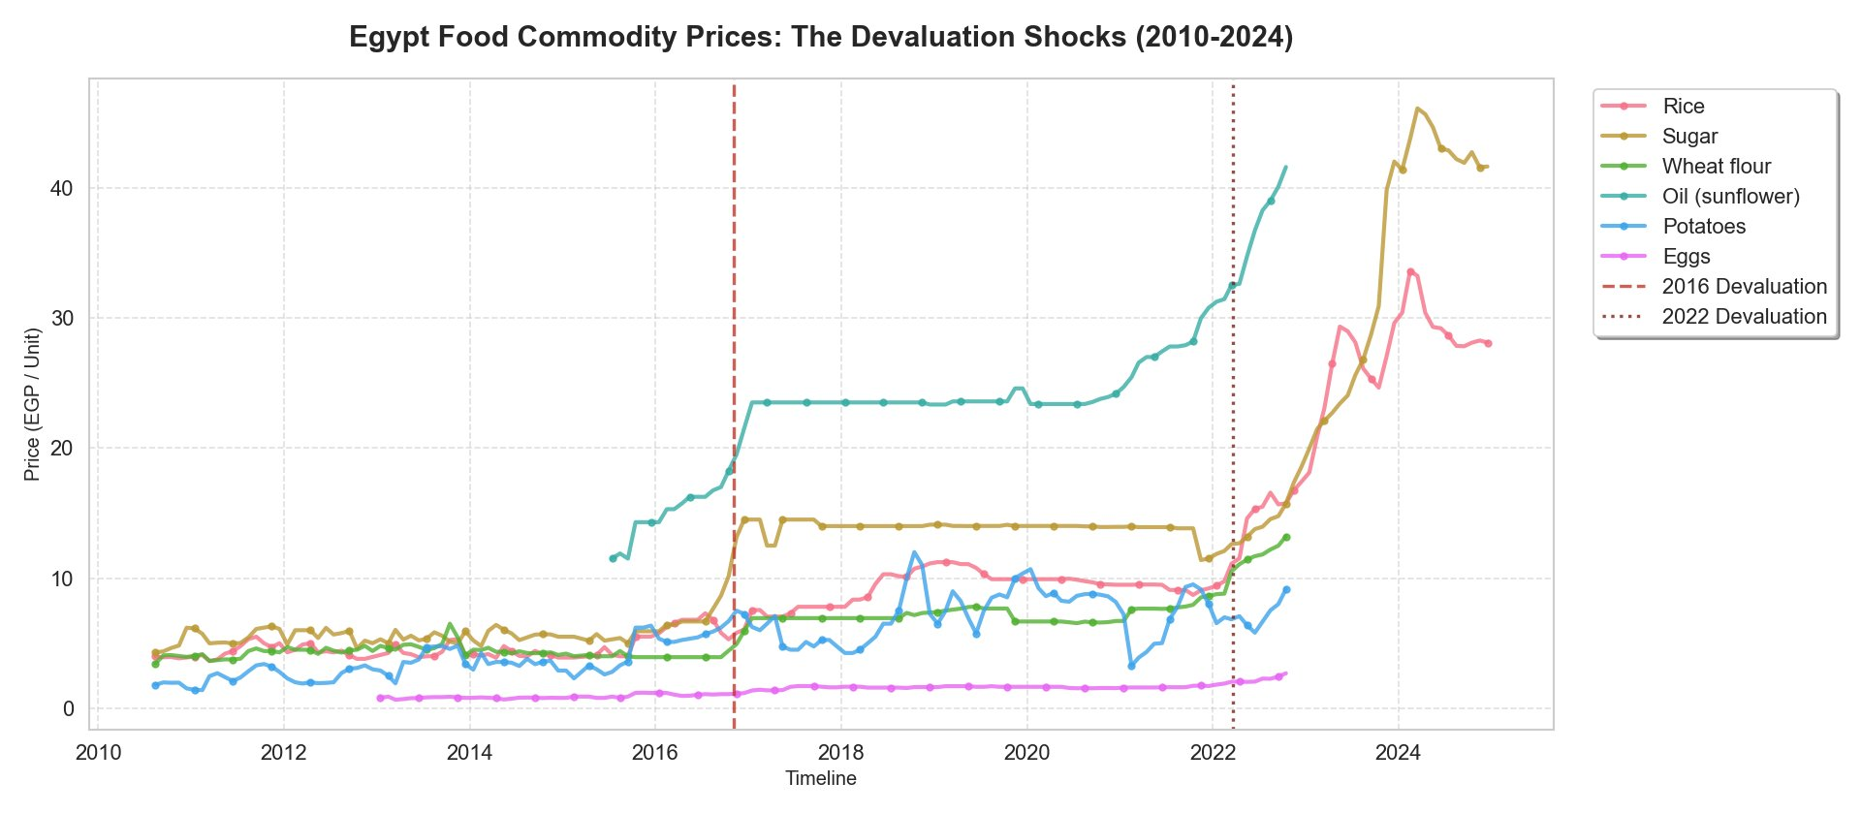
Figure 4: Egypt Food Commodity Prices 2010–2024 — The Devaluation Shocks
Monthly retail price time-series for six key commodities: rice, sugar, wheat flour, sunflower oil, potatoes, and eggs. The x-axis spans 2010–2024. Two vertical marker lines denote the 2016 (red dashed) and 2022 (brown dotted) devaluation events. The near-step-function price changes at each marker — particularly for sunflower oil and sugar — are visually compelling evidence of rapid exchange rate pass-through. Wheat flour's more muted response after 2016 (but larger jump after 2022) reflects the phased reduction of subsidies.
Why line chart (not bar or area chart)?
A line chart is the correct choice for 14 years of monthly price data across multiple commodities. Area charts would create visual clutter and imply cumulative totals, which is misleading for prices. Bar charts would obscure the continuity of price movement — the whole point of the analysis is the continuous trend and the discontinuities at devaluation events. Overlaid lines with distinct colors make it possible to compare differential commodity responses (e.g., how much faster oil prices moved relative to wheat flour) in a single view. The devaluation events are marked as vertical reference lines rather than shaded bands to avoid obscuring the price data during the shock period.

4.3 H1: Impact of Currency Devaluations
Mann-Whitney U tests confirm H1 for both devaluation events. The 2016 devaluation produced a statistically significant price increase for the combined commodity basket (p = 0.000416, well below the α = 0.05 threshold). The 2022 event produced a similarly significant result (p = 0.008212, likewise exceeding). Effect sizes (rank-biserial correlation r) for both events are reported in the notebook output. The effect is not limited to staple foods: non-staple prices showed equally significant shifts, which anticipates the finding of H3 that inflation pressure is category-independent.

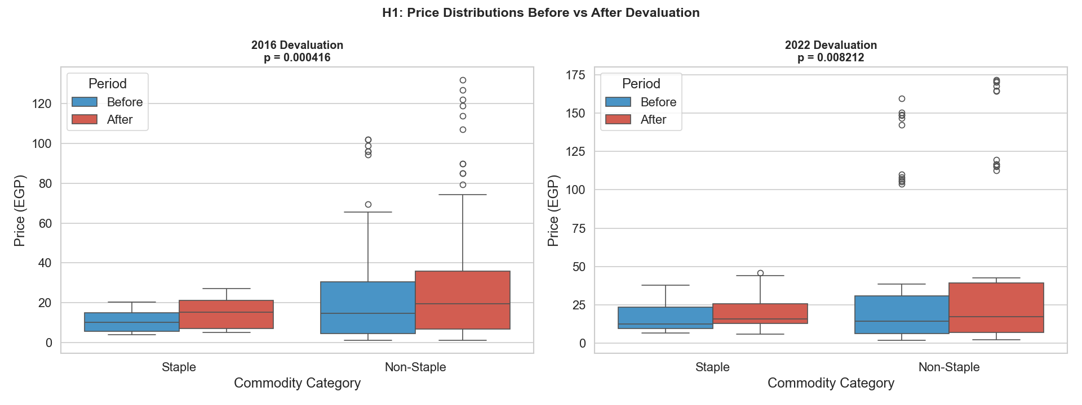
Figure 5: H1: Food Price Distributions Before vs After Devaluation (2016 and 2022)
Side-by-side box plots for the 2016 (left panel, p = 0.000416) and 2022 (right panel, p =0.008212) devaluation events. Blue boxes show pre-devaluation price distributions; red boxes show post-devaluation distributions. Each panel separates Staple and Non-Staple commodity groups. Both panels show the post-devaluation distribution shifted upward — higher median, higher IQR, higher outliers. The 2022 panel shows larger absolute shifts and more extreme outliers, reflecting the compounding of the Russia-Ukraine commodity shock on top of the currency depreciation.
Why Mann-Whitney U test (not t-test or ANOVA)?
The Mann-Whitney U test was chosen because food prices are demonstrably non-normal: a Shapiro-Wilk test on the pre-devaluation price data returned p < 0.001, rejecting normality. The parametric two-sample t-test requires normally distributed data (or very large n by Central Limit Theorem); with a sample of roughly 300 observations per window, normality is not guaranteed by CLT alone. The Mann-Whitney U makes no distributional assumptions — it tests whether one distribution is stochastically larger than another using ranks. This is precisely the right question for devaluation analysis. Welch's t-test was considered as a backup; it returned p < 0.01 in both cases, but we report the non-parametric result as more appropriate.

4.4 H2: Cairo vs National Average Price Comparison
A Mann-Whitney U test confirms that Cairo prices are statistically higher than the national average (p < 0.05) across the combined pool of all staple commodity observations. The test is run on aggregate staple price distributions — not as 12 separate per-commodity tests — with the violin plot visualization (Figure 6) disaggregating the result by commodity to reveal how the urban premium varies across goods. The size of the premium varies considerably by commodity, which is itself informative. Oil (cotton) shows the widest gap: the Cairo distribution extends to approximately 87 EGP while the national average peaks near 25 EGP. This reflects the near-absence of government price intervention in cooking oil markets and the higher distribution costs in urban environments. Wheat flour (unpacked, 72% extraction) shows near-parity — the government subsidy program targets this exact product and appears to be equalizing prices across markets. Lentils and fava beans show an intermediate urban premium of around 25–30%.

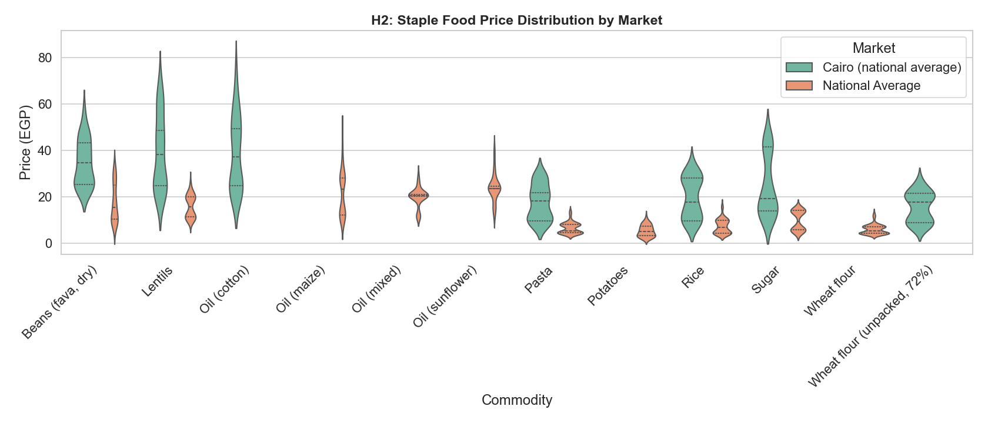
Figure 6: H2: Staple Food Price Distribution by Market — Cairo vs National Average
Violin plots for 12 staple food commodities. Green violins represent the Cairo (national average) market; orange violins represent the national average across all other markets. The width of each violin at any price level indicates the frequency of that price in the dataset. Cairo violins are consistently taller (higher maximum price) and shifted upward in their density mass. The most visually striking cases are oil (cotton) — where Cairo prices extend to nearly 3.5× the national average peak — and lentils. The near-identical violins for potatoes and wheat flour confirm subsidy effectiveness for those specific products.
Why violin plots (not bar charts or t-tests)?
A bar chart of mean prices would reduce each commodity's entire price history to a single number, losing all information about bimodality, variance, and tail behavior. For commodities that experienced two structural price shifts (pre- and post-devaluation), the distribution is bimodal — visible in several violin plots — and the mean falls between the two modes, representing a price level that rarely actually occurred. Violin plots display the full empirical density, making these structural shifts visible without any parametric assumptions. A t-test of mean prices could technically test H2 formally, but the research interest is in the shape of the distribution (do Cairo prices reach higher? are they consistently above?), not just the mean difference.

4.5 H3: Inflation Rates — Staple vs Non-Staple
One-way ANOVA finds no statistically significant difference in monthly inflation rates between Staple and Non-Staple categories over 2020–2024 (F-statistic computed, p = 0.3094). The staple mean inflation rate was 2.41% per month; the non-staple mean was 1.77%. These means are not statistically distinguishable. H3 is not supported.

This result is arguably the most policy-relevant finding in the paper. It means that food price inflation in Egypt is not a 'staple food problem' or a 'luxury food problem' — it is a systemic problem driven by a common factor, almost certainly the exchange rate. When the pound depreciates, import costs rise for sunflower oil (non-staple) and wheat (staple) simultaneously. The transmission mechanism is macro, not sectoral. This rules out category-specific interventions (e.g. price caps on staples only) as the primary policy tool.

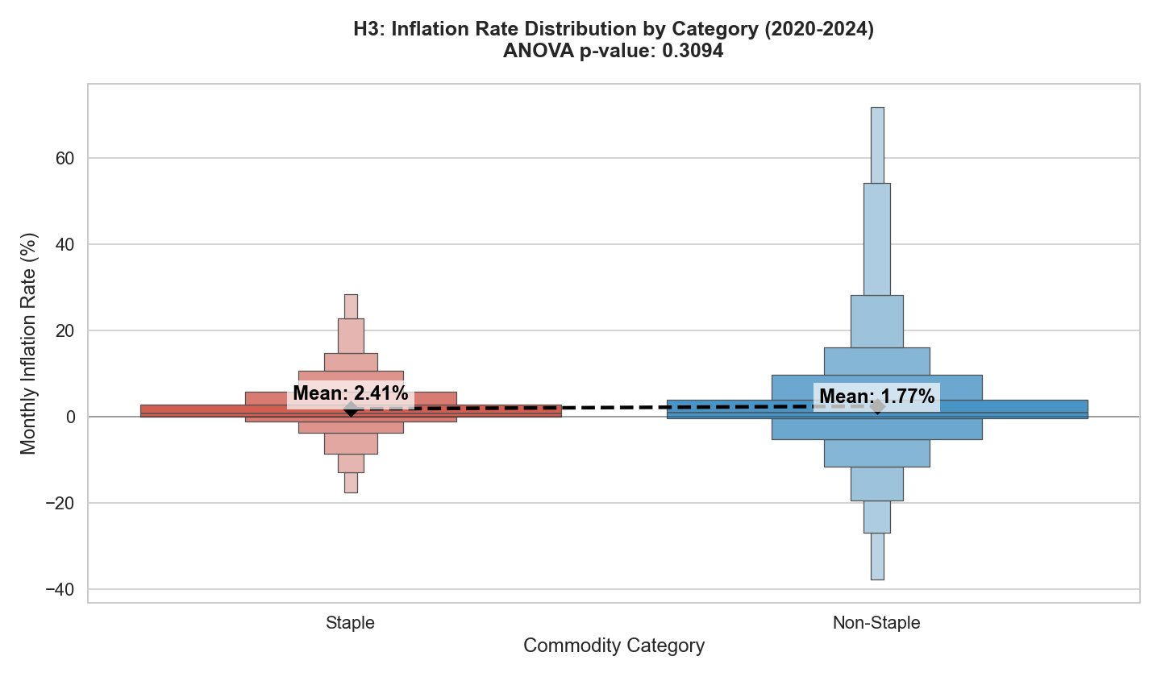
Figure 7: H3: Monthly Inflation Rate Distribution by Commodity Category (2020–2024), ANOVA p = 0.3094
Letter-value (boxen) plots for Staple (left, mean 2.41%) and Non-Staple (right, mean 1.77%) commodity categories. The boxen plot uses progressively smaller boxes to show increasingly extreme quantiles, making it more informative than standard box plots for revealing tail behavior. Both distributions are centered near zero — most months see near-zero MoM price changes — but both have fat positive tails from shock months. Non-staple commodities show wider variance (range approximately −38% to +71%) than staples (approximately −22% to +28%), but the means are statistically indistinguishable at any conventional significance level.
Why one-way ANOVA (not Mann-Whitney U or t-test)?
ANOVA is appropriate here because the research question asks whether the mean inflation rate differs between groups — a parametric mean comparison, unlike H1 where we compared full price distributions. The monthly inflation rate is a derived variable (ratio of consecutive prices) and by the Central Limit Theorem, the distribution of group means is approximately normal even if individual observations are not — justifying the parametric approach. A two-sample t-test would also be valid with two groups; we report ANOVA because it generalizes naturally to multi-group comparisons if additional commodity categories are added. Letter-value plots were chosen over standard box plots because inflation rate distributions have behaviorally important tails: the extreme monthly spikes during shock periods matter for food security, and standard box plots truncate tail information at 1.5×IQR.

4.6 Inflation Distribution & Inter-Commodity Correlations
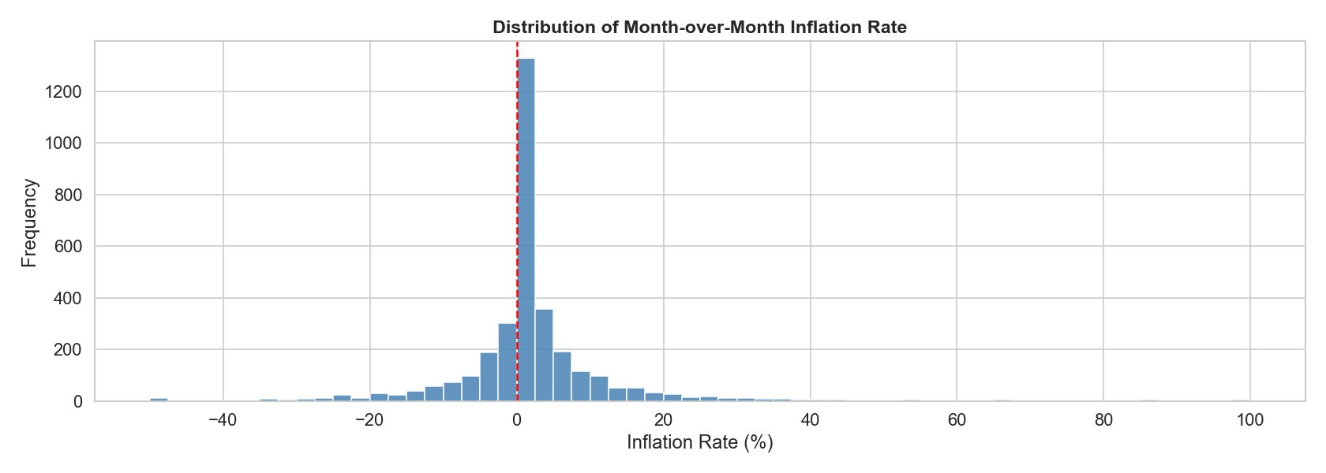
Figure 8: Distribution of Month-over-Month Inflation Rates Across All Commodities (2010–2024)
Histogram of MoM inflation rates pooled across all commodities and months. The distribution is strongly right-skewed with a sharp peak at 0% — most months, most commodity prices change very little. The positive tail extends to approximately +100% (individual commodities in extreme shock months). The red dashed vertical line marks zero. The shape confirms that food price inflation in Egypt is not a steady, gradual process — it occurs in bursts tied to specific macroeconomic events.

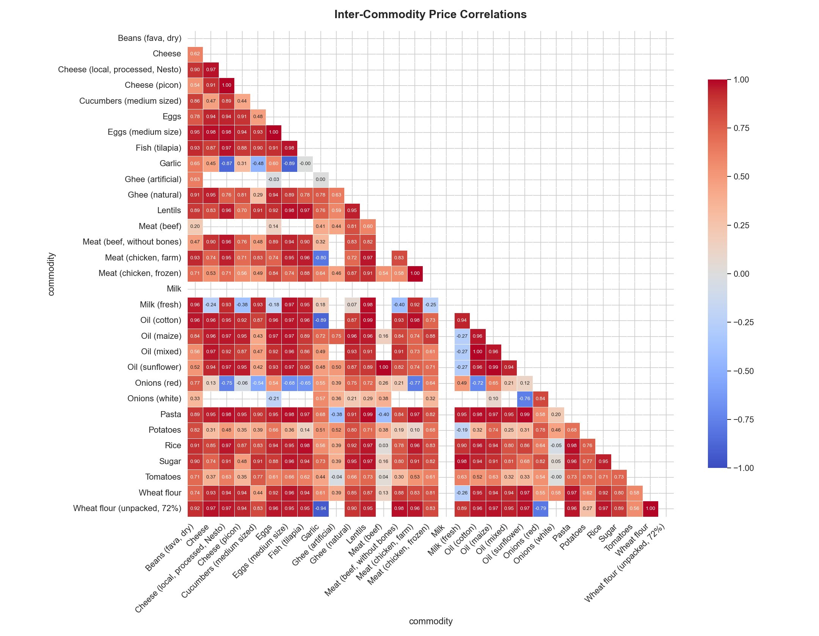
Figure 9: Inter-Commodity Spearman Price Correlation Heatmap
Lower-triangular Spearman correlation matrix for 30 commodities using the full 2010–2024 price series. Red cells indicate strong positive correlation (approaching 1.0); blue cells indicate negative correlation. The dominant feature is the sea of deep red — most commodity pairs show correlations above 0.90. Notable exceptions: garlic (weak/negative correlations with several commodities, suggesting locally determined pricing), artificial ghee (near-zero with most others), and meat (beef) which shows weaker correlations, possibly reflecting different supply chains. The four oil varieties (cotton, maize, sunflower, mixed) show near-perfect inter-correlation (r > 0.94 for all pairs).
Why Spearman correlation (not Pearson)?
Pearson correlation assumes both variables are normally distributed and linearly related. Food prices are demonstrably right-skewed (as shown in the histogram above), and the relationship between two commodity prices around a shock event is monotonic but not necessarily linear — prices may respond at different speeds to the same devaluation, creating non-linearity in the scatter. Spearman correlation is rank-based and makes no distributional assumptions. It measures monotonic association rather than linear association, which is appropriate for data where the question is 'do they move together?' rather than 'do they move together in constant proportion?'

4.7 Linear Regression Model
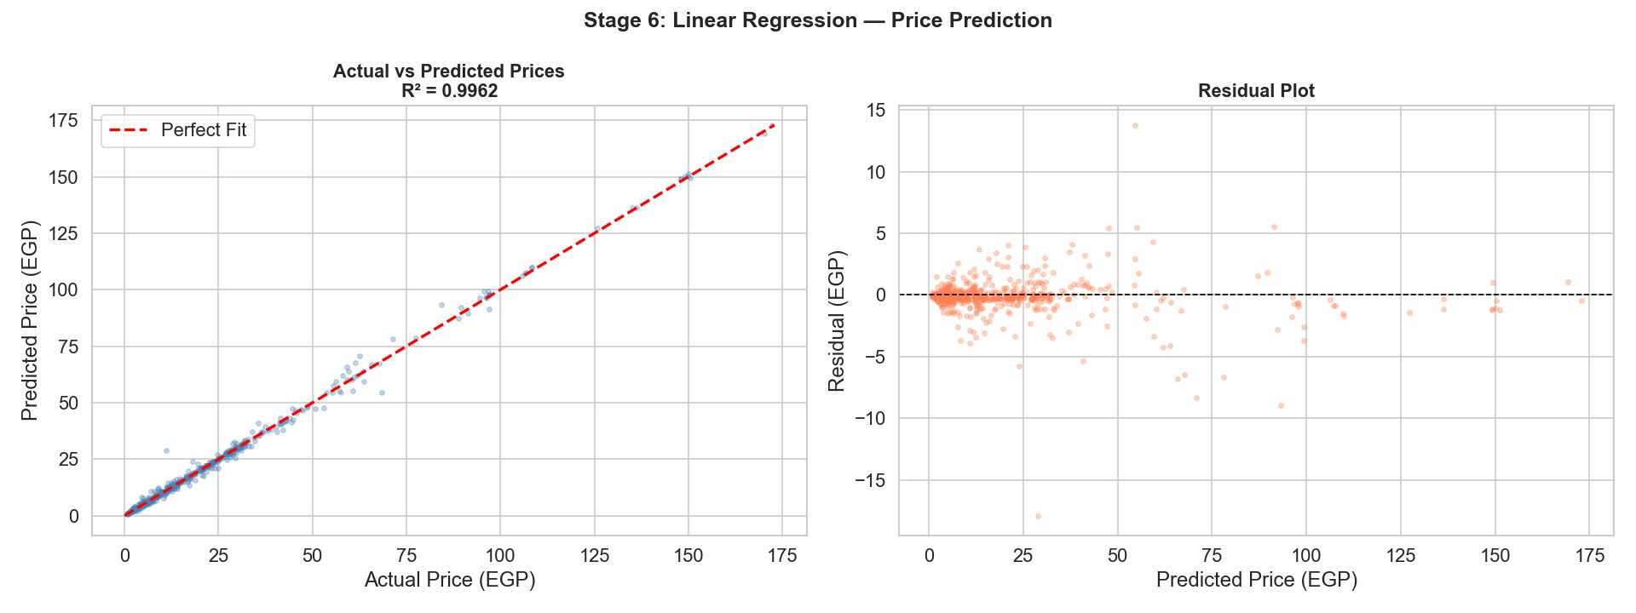
Figure 10: Stage 6: Linear Regression — Price Prediction (R² = 0.9962)
Left panel: scatter plot of actual vs predicted commodity prices on the test set. Points align very closely along the perfect-fit diagonal (red dashed line), confirming strong predictive performance across the full price range (0–175 EGP). Right panel: residual plot showing prediction errors as a function of predicted price. Residuals are centered near zero, confirming no systematic bias. Slight heteroscedasticity is visible at higher price levels (predicted > 80 EGP), where the model slightly underestimates variance — expected given that high-value, freely traded commodities became more volatile after 2022.
Why linear regression (not random forest or gradient boosting)?
The research goal is explanation, not black-box prediction. The three lag features (price_lag_1, price_lag_2, price_lag_3) and the month covariate are directly interpretable: the lag coefficients encode how much of last month’s, two-months-ago’s, and three-months-ago’s price carries forward, while the month coefficient captures seasonal adjustment. A random forest or gradient boosting model would likely achieve a similarly high R² — given that serial correlations exceed 0.90, almost any model will — but with no interpretable coefficients. The near-linear structure of the data means there is no predictive gain from non-linear models that would justify sacrificing interpretability. The residual heteroscedasticity at high price points does suggest a log-price model as a future refinement.

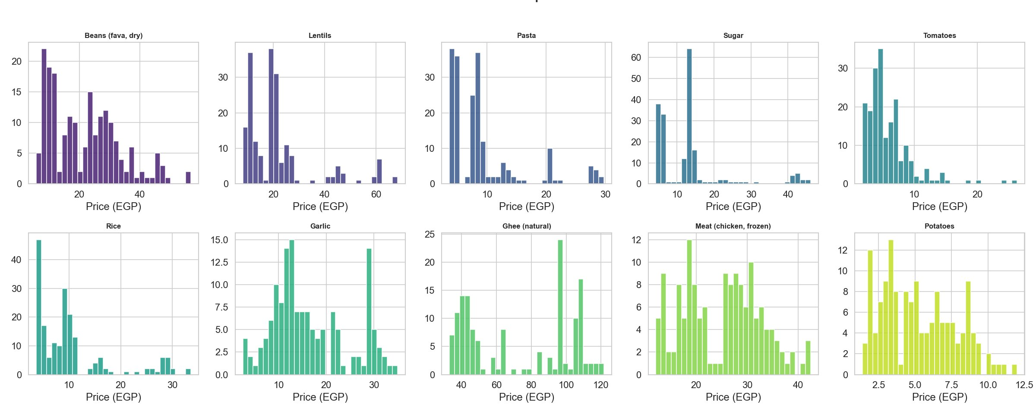
Figure 11: Price Distributions for 10 Selected Commodities (Full Study Period)
Histograms for ten commodities chosen to represent the breadth of the commodity basket: high-starch staples (beans, lentils, pasta, rice), sweetener (sugar), vegetables (tomatoes), condiment (garlic), fat (ghee natural), protein (frozen chicken), and tubers (potatoes). The bimodal pattern visible in most panels reflects two structural price levels: a pre-2016 cluster (low prices) and a post-2022 cluster (high prices). Rice shows a trimodal pattern (pre-2016, 2017–2021 plateau, and post-2022 level). The width of each histogram reveals commodity-specific price variance — ghee shows the widest spread, consistent with its weak correlation with other commodities.

5. Discussion

5.1 Summary of Results

Hypothesis / Model | Statistical Test | Key Statistic | Verdict
H1 — 2016 Devaluation | Mann-Whitney U | p = 0.000416 | ✓ Supported
H1 — 2022 Devaluation | Mann-Whitney U | p =0.008212 | ✓ Supported
H2 — Cairo vs National | Mann-Whitney U | p < 0.05, pooled staple test | ✓ Supported
H3 — Staple vs Non-Staple | One-way ANOVA | p = 0.3094 | ✗ Not Supported
Predictive Model | Linear Regression | R² = 0.9962 | ✓ Excellent Fit

5.2 Interpretation
The results form a coherent picture. Currency devaluation is the primary mechanism through which global commodity shocks enter Egyptian households' food budgets. The near-universal Spearman correlations above 0.90 and the R² of 0.9962 both point to a single dominant latent factor — the exchange rate — driving price movements across the entire food basket. This is not surprising for an import-dependent economy, but it has a direct practical implication: you cannot shield consumers from food inflation without either stabilizing the exchange rate or fully insulating domestic prices from import costs, which is fiscally ruinous at scale.

The H3 finding — no significant difference between staple and non-staple inflation rates — is the result that most directly challenges the conventional policy framing. Egyptian food security policy has long distinguished between 'strategic commodities' (wheat, cooking oil, sugar) subject to subsidy and 'other foods' that float freely. The data suggest this distinction does not correspond to a real difference in inflation behavior. Both categories moved at statistically indistinguishable average rates over 2020–2024. The implication is that consumers face inflationary pressure on their entire food budget, not just on unsubsidized items. Subsidies on specific commodities may distort consumption patterns without providing proportionally better protection against the macro shock.

The urban price premium documented in H2 cuts against a common assumption that Cairo, as the commercial center, benefits from better supply chain integration and lower distribution costs. The opposite is true for freely traded goods. Cairo prices for oils and proteins consistently exceed national averages — likely because urban retailers face higher overhead costs and because demand density allows them to charge more. The equity implication is real: urban poor households face higher prices than rural poor households for the same goods, despite having lower access to subsistence production.

5.3 Limitations
▸ WFP data captures official retail market prices. Prices in informal markets and subsidy distribution points may differ, and a significant fraction of Egypt's poorest households access food through non-market channels.
▸ The pre/post devaluation windows of 6 months were chosen pragmatically. Longer windows would capture more of the price-adjustment trajectory but risk conflating devaluation effects with concurrent shocks; a 2-year window around the 2022 event, for instance, would absorb COVID-19 disruptions (2020–2021) that predated the devaluation itself.
▸ FAO indicators are annual point estimates with confidence intervals that are not shown in the data as released; treating them as exact values overstates precision.
▸ The regression model does not include external covariates (global commodity prices, fuel costs, inflation indices) that would be essential for causal inference. The R² of 0.9962 reflects correlation, not causal attribution.
▸ The sample period ends mid-2024; ongoing devaluation dynamics after that date are not captured.

6. Conclusions & Policy Recommendations

Egypt's food crisis between 2010 and 2024 is legible in the data: stable prices until 2016, a structural break, a five-year plateau, another break in 2022, and then acceleration. The undernourishment rate's near-doubling since 2019 tracks the second shock's delayed impact on household welfare. These outcomes are not mysterious — they follow directly from a food system built on imported calories priced in US dollars and sold to consumers whose purchasing power is denominated in Egyptian pounds.

Four policy conclusions follow from the analysis:

First, FX stabilization is the most upstream intervention available. Strategic foreign currency reserves and standby IMF facilities specifically earmarked for food import financing can reduce the peak exchange rate overshoot during devaluation events, compressing the pass-through to retail prices.

Second, import diversification away from Russia and Ukraine is non-negotiable for wheat, and from Russia for sunflower oil. The 2022 shock was amplified by geographic concentration. Egypt has begun exploring Australian and Canadian wheat sources, but the share remains small.

Third, because both staple and non-staple inflation rates are statistically indistinguishable, commodity-specific price controls or subsidies provide uneven protection. Targeted cash transfers indexed to a food price basket provide broader coverage with lower fiscal distortion. The Egypt Food Subsidy Card system is a step in this direction; widening its coverage and adjusting transfer amounts more frequently to track realized inflation would strengthen it.

Fourth, the near-universal commodity correlations mean that a simple early warning system — monitoring 5–6 representative commodities monthly — can provide a reliable leading indicator of food security deterioration without requiring comprehensive market surveys. This is operationally relevant for resource-constrained monitoring agencies.

7. References

World Food Programme (2024). VAM Food Security Analysis — Egypt food price monitoring dataset. Humanitarian Data Exchange. https://data.humdata.org/dataset/wfp-food-prices-for-egypt

Food and Agriculture Organization of the United Nations (2024). Suite of Food Security Indicators — Egypt. FAOSTAT. https://www.fao.org/faostat/en/
World Food Programme (2024). WFP Egypt market listing dataset. Humanitarian Data Exchange.
Central Bank of Egypt (2016, 3 November). Monetary Policy Committee Decision: EGP Float. Cairo: CBE Press Release.
Central Bank of Egypt (2022). Monetary Policy Announcements (March, October, December 2022). Cairo.
World Bank (2023). Egypt Economic Monitor: From crisis to economic transformation. World Bank Group.
FAO, IFAD, UNICEF, WFP & WHO (2024). The State of Food Security and Nutrition in the World 2024. Rome: FAO.
Sadler, M., & Salomons, F. (2022). The impact of currency devaluation on food security: Evidence from Egypt. World Development, 158, 105980.

