Supplementary Material
TUDOR, an ascertainment-aware model for LDLR genetic-testing triage in specialist lipid clinics: development, validation, and UK Biobank transport
Manuscript JCLINLIPID-D-25-01142R2 — Journal of Clinical Lipidology. Supplementary figure legends.
Note on numbering and status. These figures were part of an earlier reviewer-seen version and were condensed from the main text during revision; they are reinstated here as online Supplementary figures. Renumber (S1, S2, …) to continue the sequence of the existing Supplement. Each figure below carries a status flag: READY = consistent with the accepted analyses; REGENERATE = the current image must be re-rendered on the locked cohorts before upload. Aggregate outputs only; no participant-level UK Biobank or NHS Wales data are shown.

Supplementary Figure S1. Effect of the LDL-C estimating equation on threshold-based recognition of treated carriers
Effect of the LDL-C estimating equation on threshold-based recognition of treated LDLR carriers (UK Biobank LDLR carriers, n = 3,093). (a) Lin concordance correlation coefficients for Friedewald, Sampson-NIH and Martin-Hopkins LDL-C against the directly measured assay. (b) Mean bias (calculated minus direct LDL-C) by triglyceride band, showing progressively greater Friedewald under-estimation as triglycerides rise. (c) Sensitivity for a true LDL-C ≥ 4.9 mmol/L at the referral threshold, by triglyceride band and equation. (d) Discordance direction by dyslipidaemia pattern, and TUDOR AUC by equation (range 0.004 across equations). Because TUDOR reconstructs untreated LDL-C and includes triglycerides as an explicit feature, the equation choice contributes one of eleven inputs rather than determining the decision.
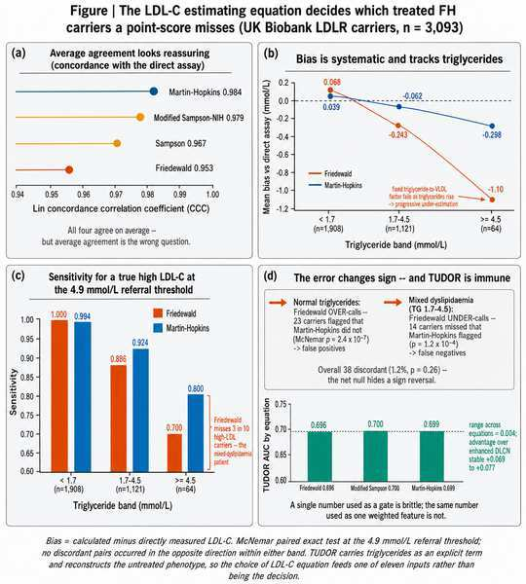
LOW-RESOLUTION PREVIEW — replace with your 300+ dpi original (Figure_S3_LDL_equation_impact.png) before upload.
Status: READY. The uploaded file was named “Figure_S3” — confirm whether this is already your existing Supplementary Figure S3; if so, no action is needed.

Supplementary Figure S2. Receptor-selective lipoprotein signature of LDLR carriers on NMR metabolomics
Receptor-selective lipoprotein signature of LDLR carriers on NMR metabolomics (UK Biobank, n = 486,866). At matched LDL-C, LDLR carriers show lower triglycerides with unchanged VLDL-C and HDL-C, consistent with a selective LDL-receptor-clearance lesion; standardised mean differences are shown across matched comparisons and across LDL-C bands. This analysis is reported in full in the companion manuscript [insert companion citation] and is reproduced here to document the biological basis of TUDOR’s triglyceride-based (“Triglyceride Shield”) feature.
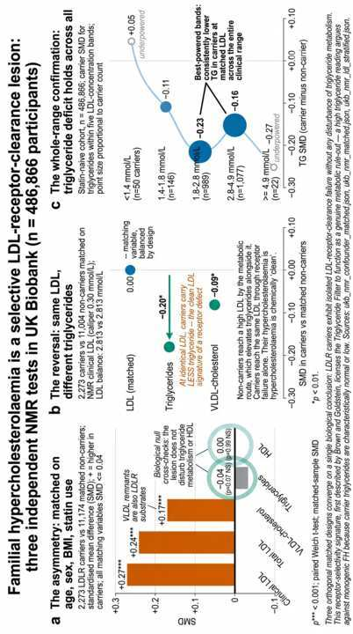
LOW-RESOLUTION PREVIEW — replace with your 300+ dpi original (NMR.png) before upload.
Status: READY, overlap-managed. Cross-cite the companion manuscript in this legend and reciprocally in that paper; submit only one NMR file (NMR.png or fig7_nmr_smd.png are duplicates).

Supplementary Figure S3. Subgroup discrimination across prespecified clinical subgroups
Subgroup discrimination (AUC, DeLong 95% CI) for TUDOR versus comparators (eDLCN, FAMCAT, Simon Broome, MEDPED) across prespecified subgroups — sex, age band, statin status, LDL-C band, triglyceride band and type 2 diabetes — in the All-Wales registry [insert n; carriers] and the UK Biobank lipid-clinic-eligible cohort [insert n; carriers]. TUDOR coefficients frozen (locked model scored, not re-estimated); dashed line = chance.
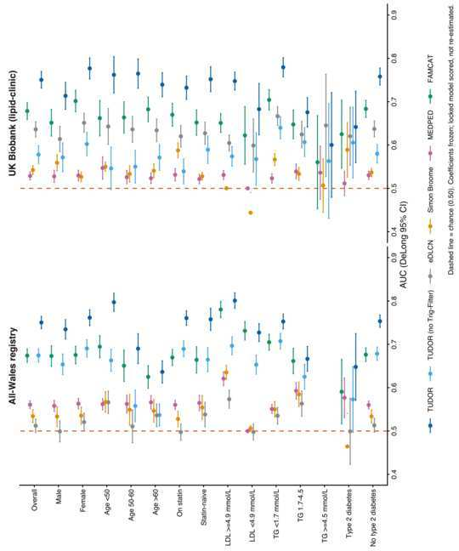
LOW-RESOLUTION PREVIEW — replace with your 300+ dpi original (Figure9_subgroup_forest.png) before upload.
Status: REGENERATE before upload. The current image shows All-Wales N=5,613 and UK Biobank N=58,021, which do not match the accepted paper’s cohorts (n = 1,274 / 4,570 / 49,427 / 501,936). Re-render on the locked cohorts.

Supplementary Figure S4. Receiver-operating-characteristic curves across models and cohorts
Receiver-operating-characteristic curves for discrimination of LDLR variant carriers by TUDOR and comparators (eDLCN, FAMCAT, Simon Broome, MEDPED) in the All-Wales registry [insert n; carriers] and the UK Biobank lipid-clinic-eligible cohort [insert n; carriers], with DeLong 95% confidence intervals. TUDOR (bold) scored with frozen coefficients; FAMCAT input-limited per cohort.
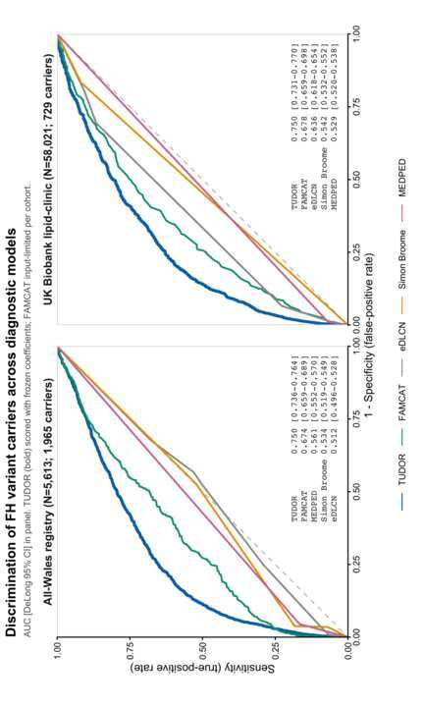
LOW-RESOLUTION PREVIEW — replace with your 300+ dpi original (Figure_ROC_5models_2cohorts.png) before upload.
Status: REGENERATE before upload (same cohort mismatch as S3).

Supplementary Figure S5. Distribution of model scores by carrier status (optional)
Distribution of standardised model scores among LDLR variant carriers versus non-carriers, by model and cohort (All-Wales registry; UK Biobank lipid-clinic-eligible). Vertical lines mark group medians; d = Cohen’s d separation. TUDOR shows the largest carrier/non-carrier separation.
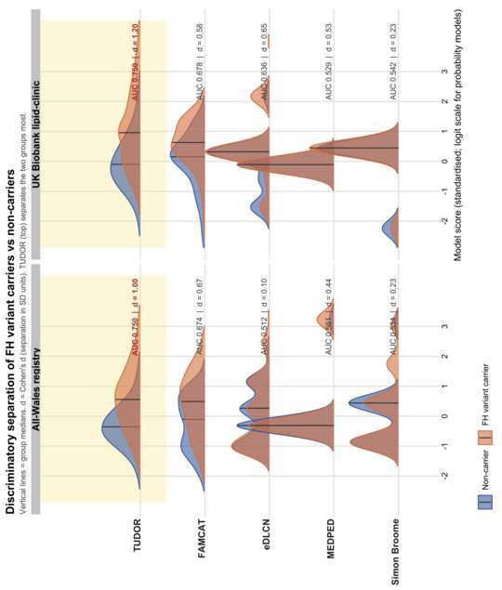
LOW-RESOLUTION PREVIEW — replace with your 300+ dpi original (Figure10_separation_density.png) before upload.
Status: OPTIONAL (partly redundant with S4) and REGENERATE on the locked cohorts if retained.

Graphical Abstract (recommended) — Molecular basis of LDLR-mediated FH and treatment masking
Recommended as the manuscript’s Graphical Abstract rather than a Supplementary figure. If retained as a Supplementary figure instead, use: “Supplementary Figure S6. Molecular basis of LDLR-mediated familial hypercholesterolaemia and treatment masking. Pathogenic LDLR variants impair hepatic LDL-particle clearance through class-specific mechanisms (Classes 2–5); lipid-lowering therapy amplifies residual receptor activity and lowers measured LDL-C, obscuring the untreated phenotype assumed by conventional criteria. TUDOR reconstructs the pre-treatment phenotype from routine variables. Conceptual illustration; no participant-level data.”
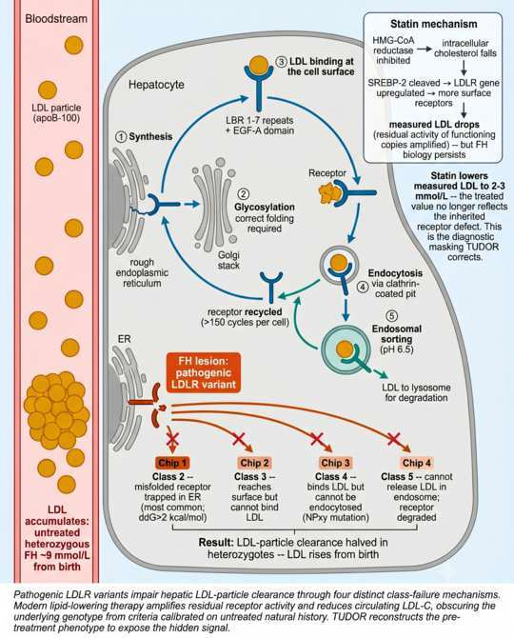
LOW-RESOLUTION PREVIEW — replace with your 300+ dpi original (FH_PATHOGENESIS.png) before upload.
Status: READY (conceptual, no data).

Appendix A — Main-text callouts to insert (each Supplementary figure must be cited once)
The accepted main text currently contains no numbered Supplementary-figure callouts; insert one sentence per figure (clear with the editor, as this lightly edits the accepted text):
- Methods (untreated-LDL reconstruction): “The choice of LDL-C estimating equation had minimal influence on TUDOR (Supplementary Figure S1).”
- Discussion (Triglyceride Shield): “TUDOR’s triglyceride-based feature reflects a receptor-selective lipoprotein signature demonstrated in our companion analysis [cite] and summarised in Supplementary Figure S2.”
- Results (subgroups): “Discrimination across prespecified subgroups is shown in Supplementary Figure S3.”
- Results (head-to-head): “Receiver-operating-characteristic curves for all models in both cohorts are provided in Supplementary Figure S4 (score distributions, Supplementary Figure S5).”

Appendix B — Before upload
- Renumber S1–S5 to continue the existing Supplement; confirm S1 is not already your current S3.
- Regenerate Supplementary Figures S3–S5 on the locked cohorts (or state the alternative cohort definitions explicitly).
- Submit one NMR file only; add reciprocal cross-citation between this paper and the companion manuscript.
- Decide FH-pathogenesis = Graphical Abstract (preferred) vs Supplementary Figure S6.
- Replace every low-resolution preview with the 300+ dpi original.

