|  |  |  |  |  |
| --- | --- | --- | --- | --- |
| رقم المجموعة على البلاكبورد | رقم المقعد | الفصل | رقم الجلوس | اسم الطالب |
| **69** | **32** | **4** | **32198** | **نادر عاطف لبيب** |
| **39** | **4** | **32205** | **نور الدين محمد عبدالطيف** |

# System Design

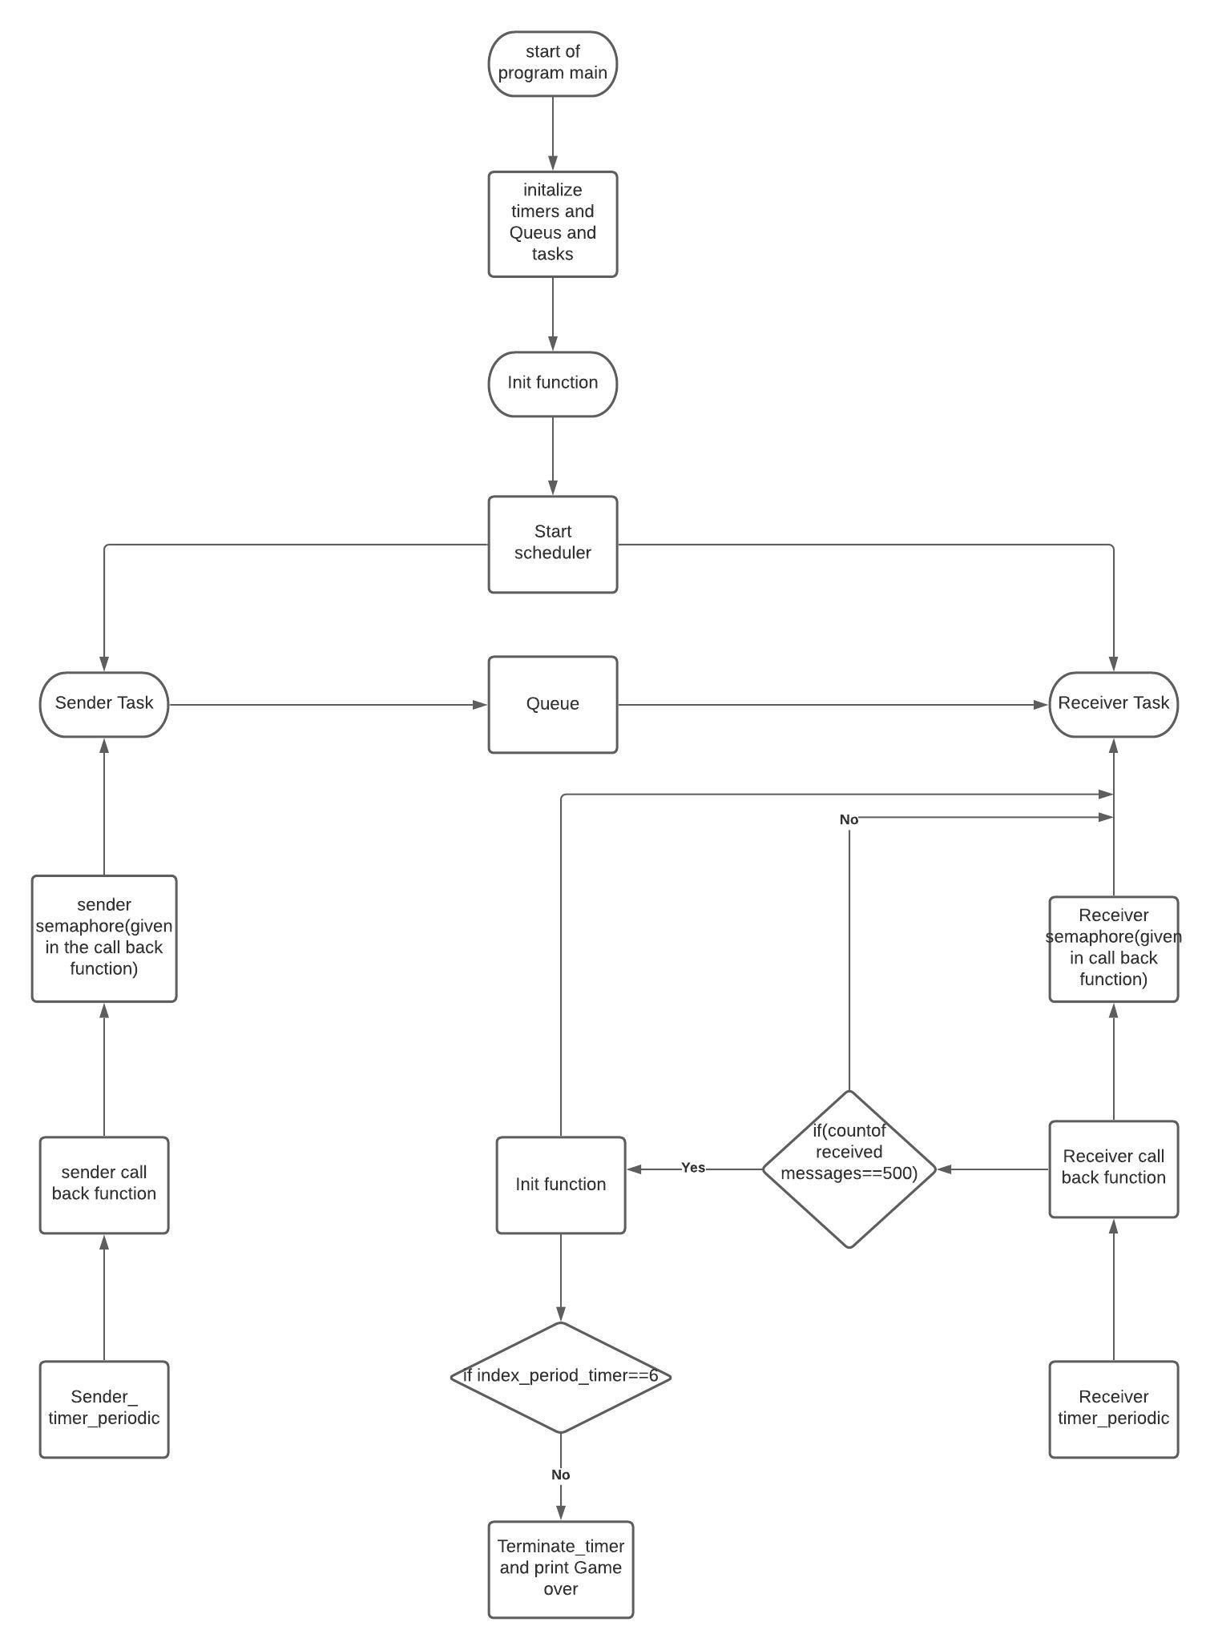

Figure ‎1‑1

## Code description

The code starts from the main function. Firstly, we initialized the queue, timers, semaphores, tasks and started both timers, then we started scheduler. The 2 tasks sender and receiver communicate via a queue, both the sender task and receiver task start sleeping for a period and remain blocked until 2 periodic timers fire and release a dedicated semaphore so that the 2 tasks start working.

# Results and Discussion

## Queue of size 2

Table ‎2‑1

|  |  |  |  |
| --- | --- | --- | --- |
| Period | Successfully sent messages | Received messages | Blocked messages |
| 100 | 502 | 500 | 499 |
| 140 | 502 | 500 | 213 |
| 180 | 502 | 500 | 54 |
| 220 | 500 | 500 | 0 |
| 260 | 500 | 500 | 0 |
| 300 | 500 | 500 | 0 |

### Total number of successfully sent messages.

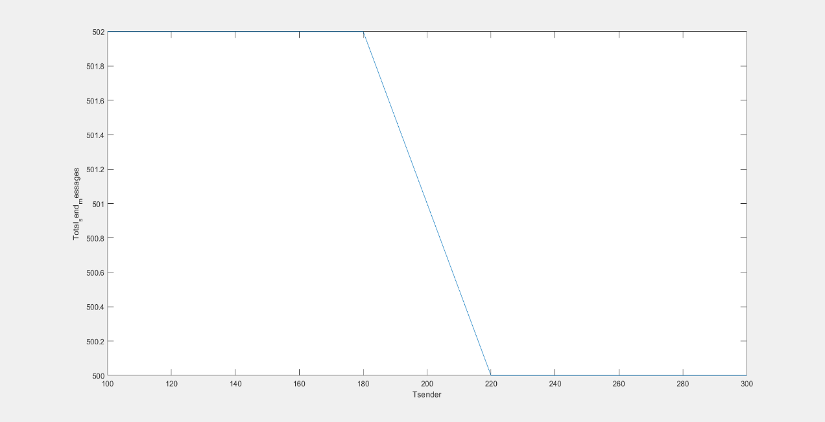

Figure ‎2‑1

### Total number of sent messages(failed+sent)

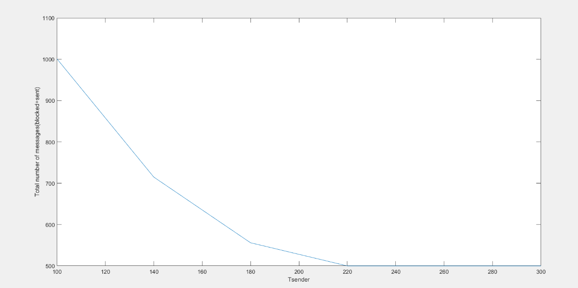

Figure ‎2‑2

### Total number of blocked messages

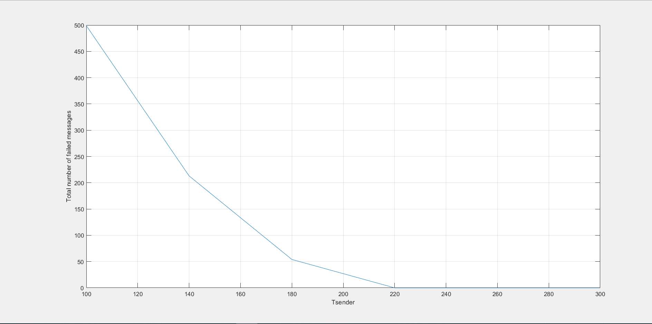

Figure ‎2‑3

## Queue of size 20

Table ‎2‑2

|  |  |  |  |
| --- | --- | --- | --- |
| Period | Successfully sent messages | Received messages | Blocked messages |
| 100 | 520 | 500 | 481 |
| 140 | 520 | 500 | 195 |
| 180 | 520 | 500 | 36 |
| 220 | 500 | 500 | 0 |
| 260 | 500 | 500 | 0 |
| 300 | 500 | 500 | 0 |

We can conclude from the table above that when we increase the size of the queue the number of successfully sent messages increase and the number of blocked messages decrease, also the gap between the successfully sent messages and the blocked messages is due to the difference in period of the timers, the receiver task waits for the receiver timer call back function every 200ms, while the sender task sends every 100ms so that is where the gap happens.

### Total number of successfully sent messages.

### 

Figure ‎2‑4

### Total number of sent messages(failed+sent)

### 

Figure ‎2‑5

### Total number of blocked messages

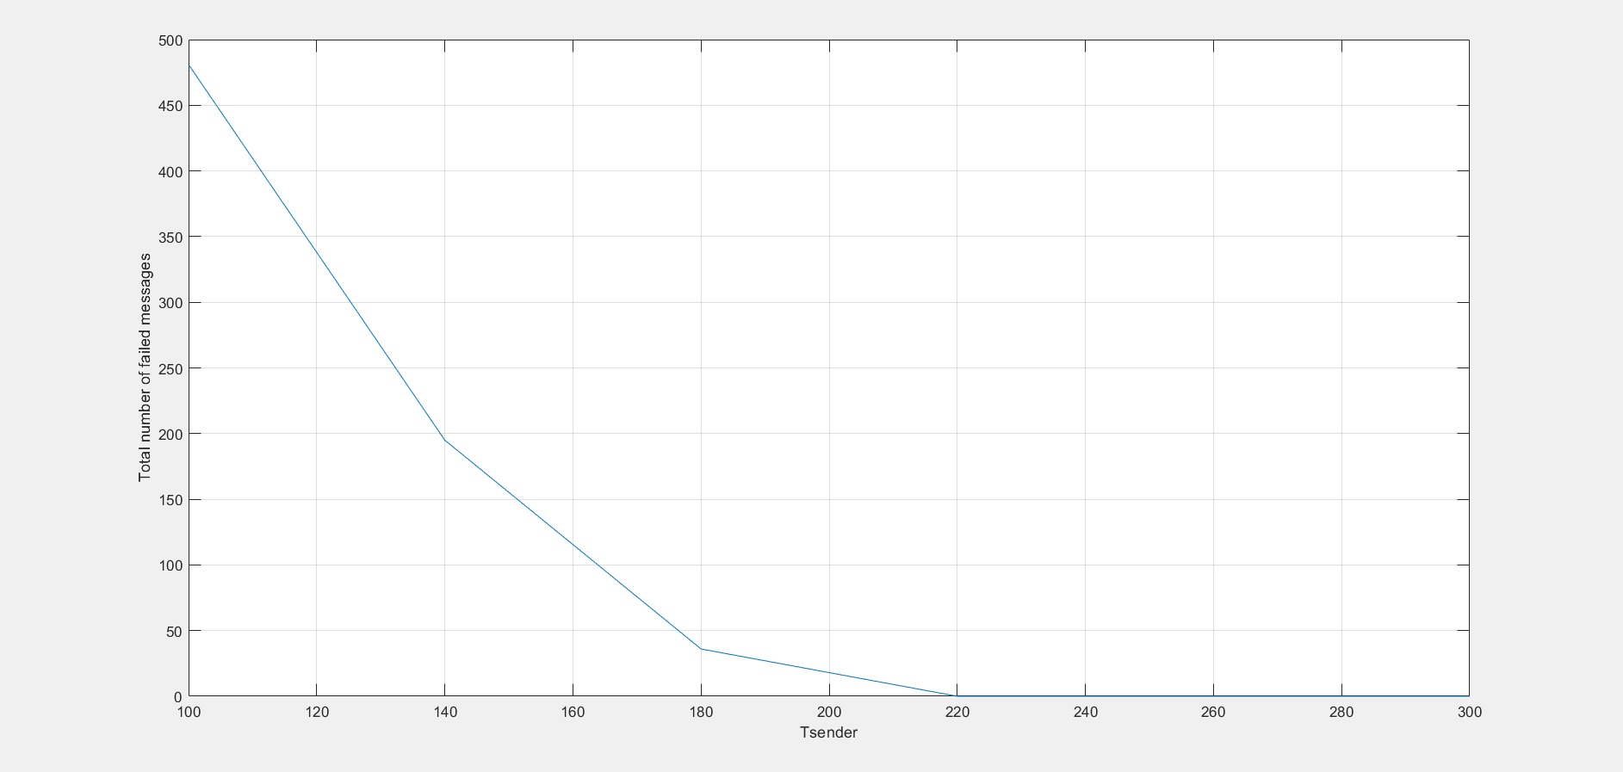

Figure ‎2‑6