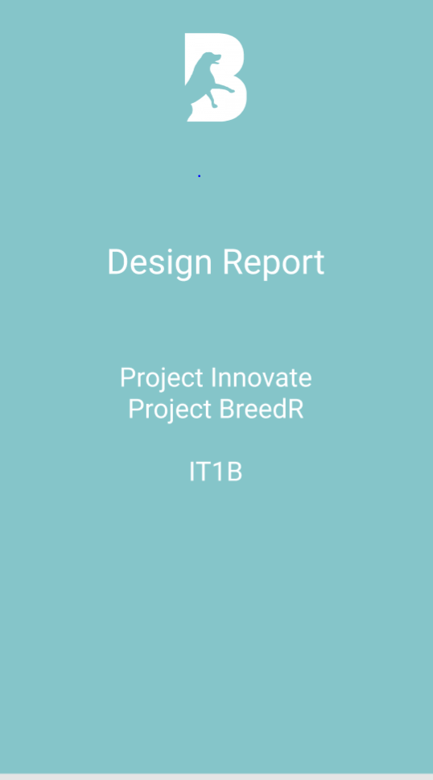

Contents

Chat Page 3

GetStarted Page 3

Profile Page 3

Registration Page 3

Settings Page 3

Swipe Page 3

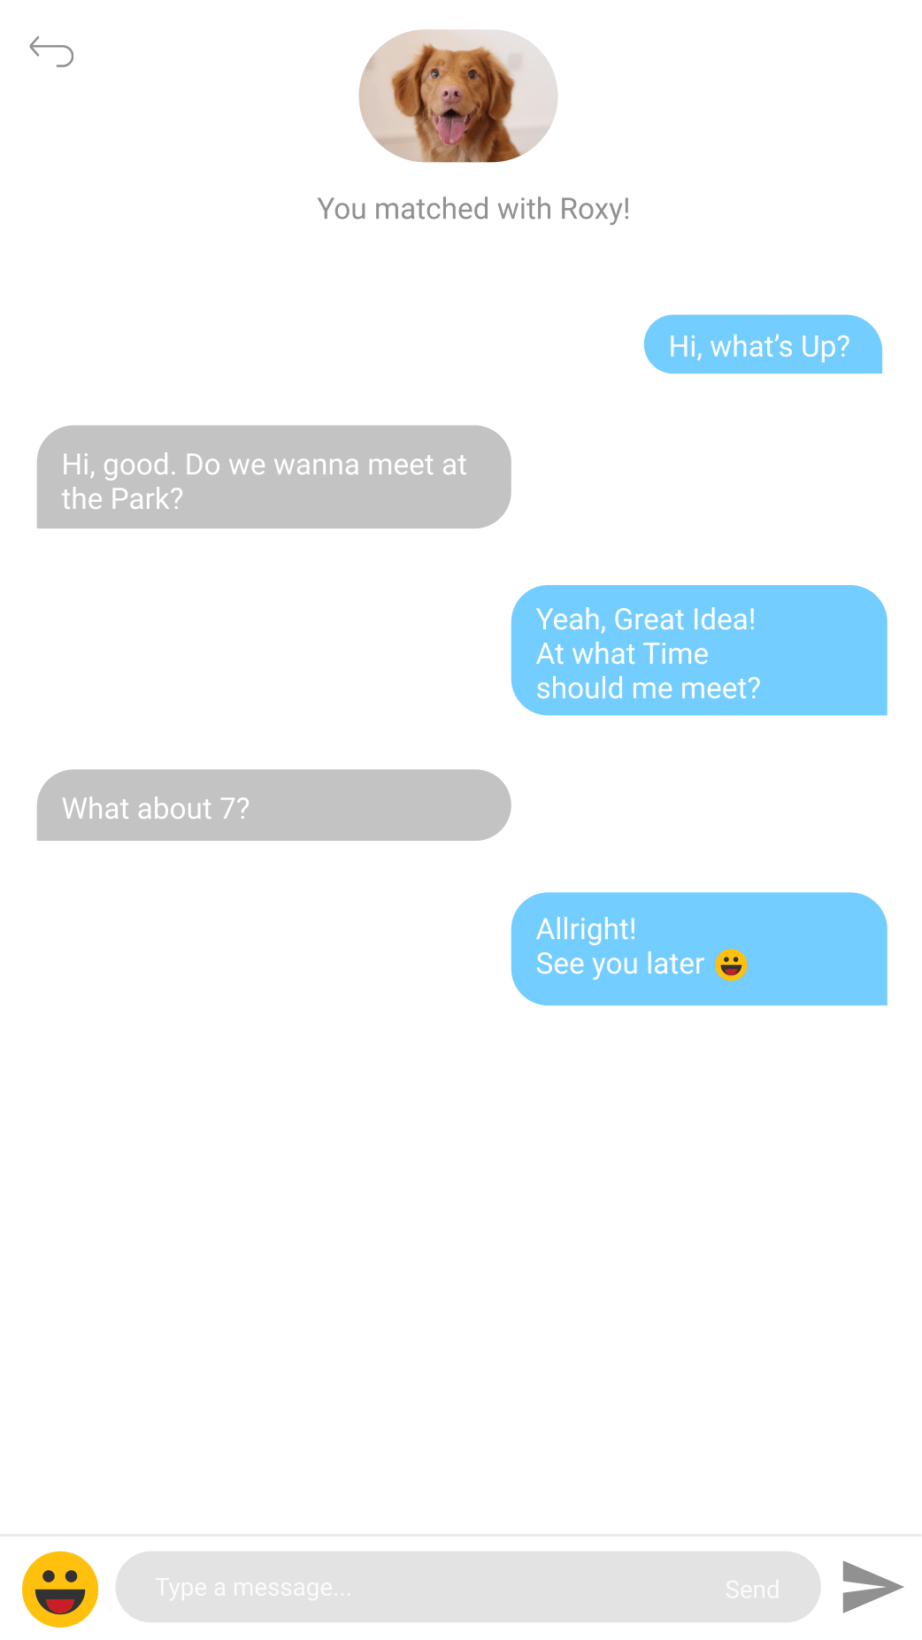Chat Page

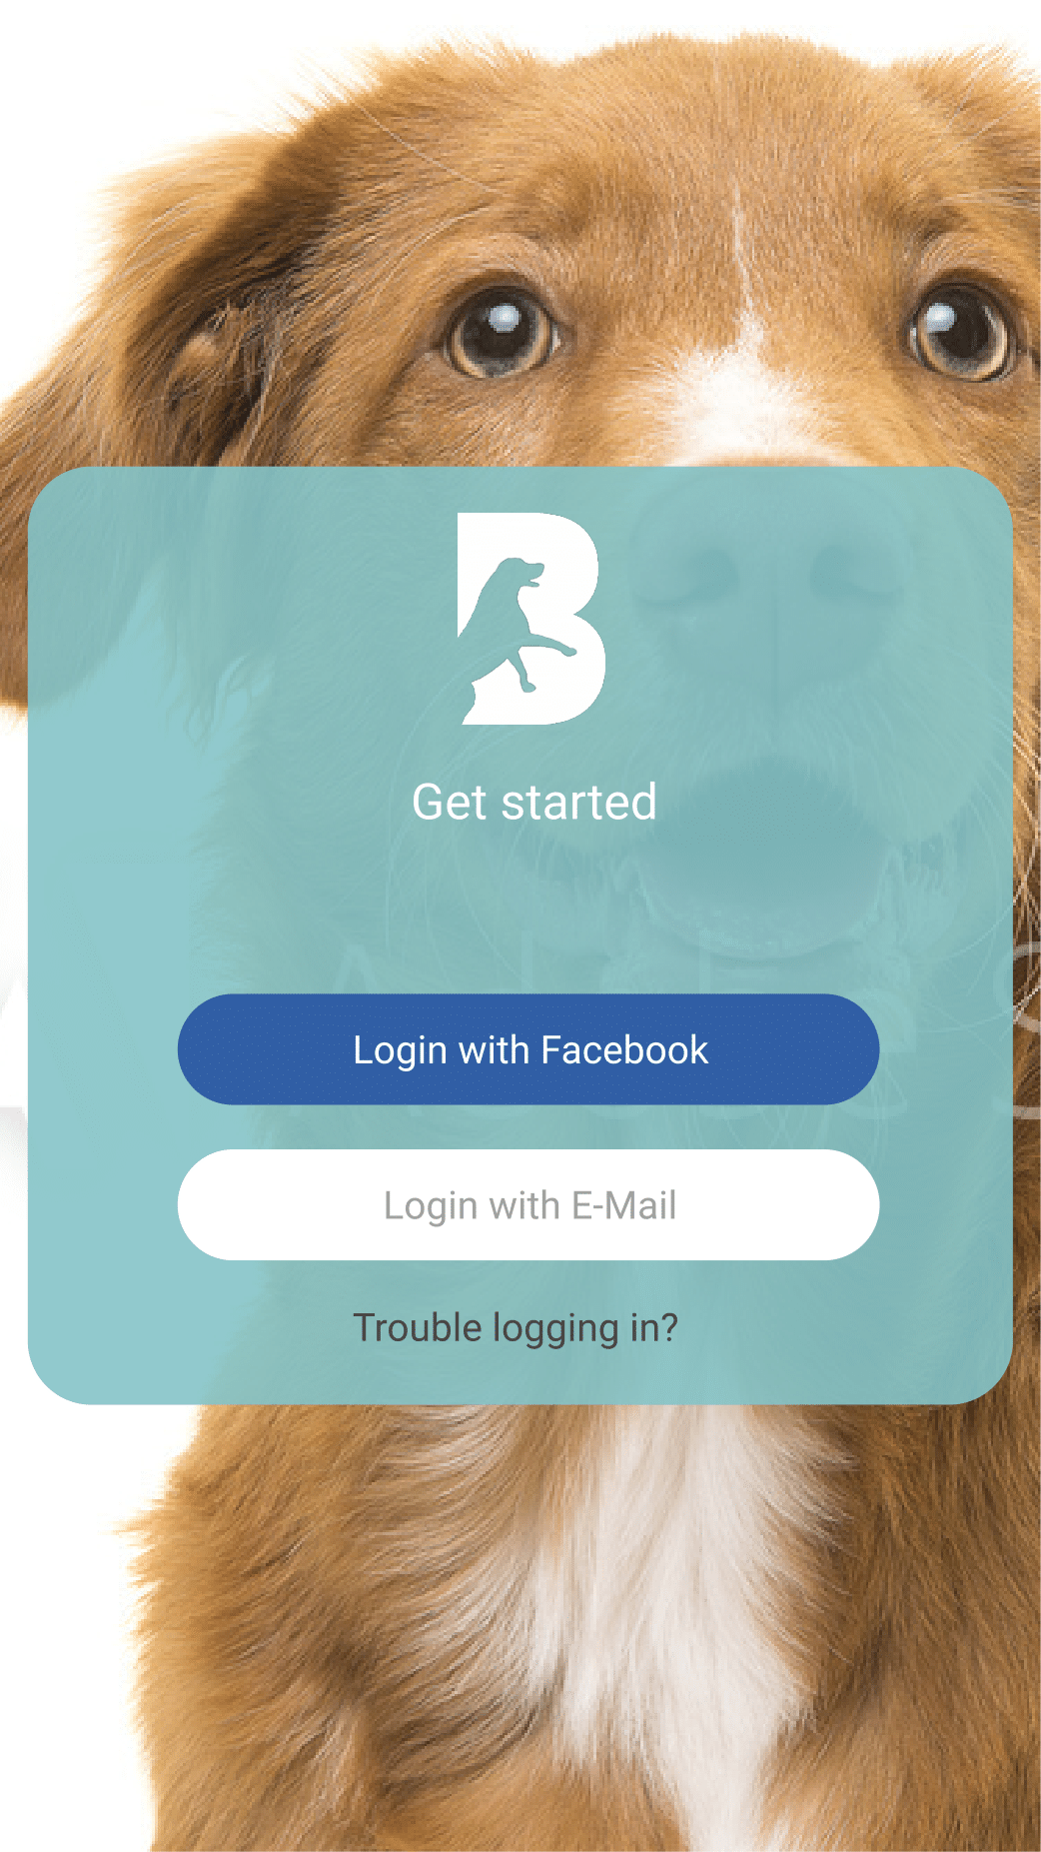Get Started Page

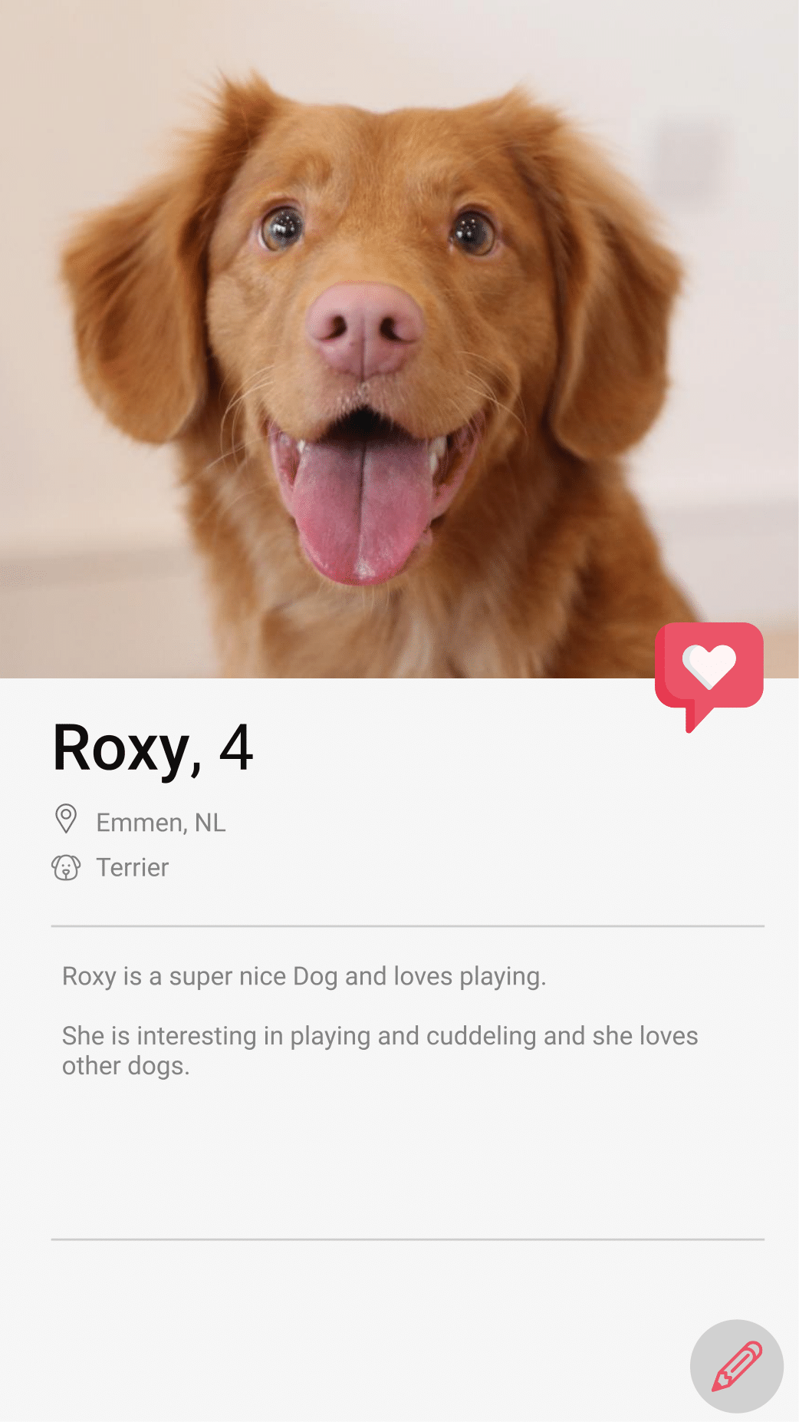Profile Page

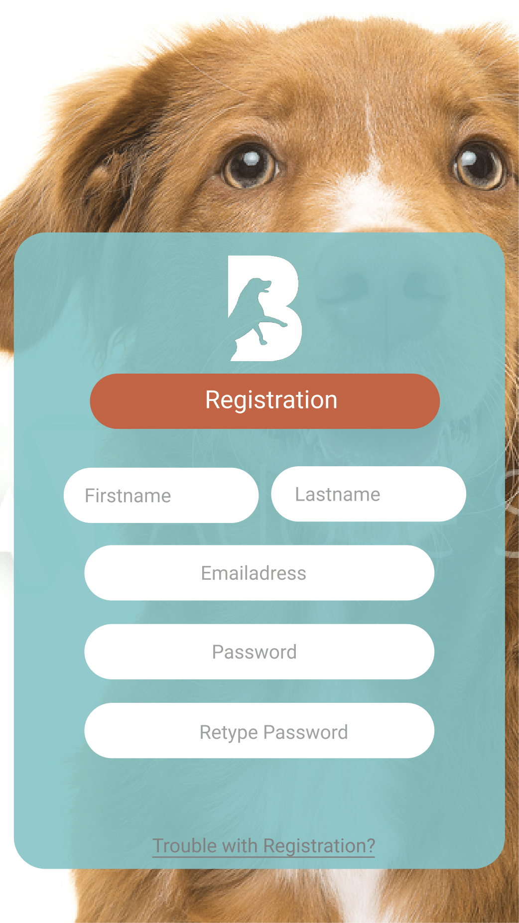Registration Page

Settings Page

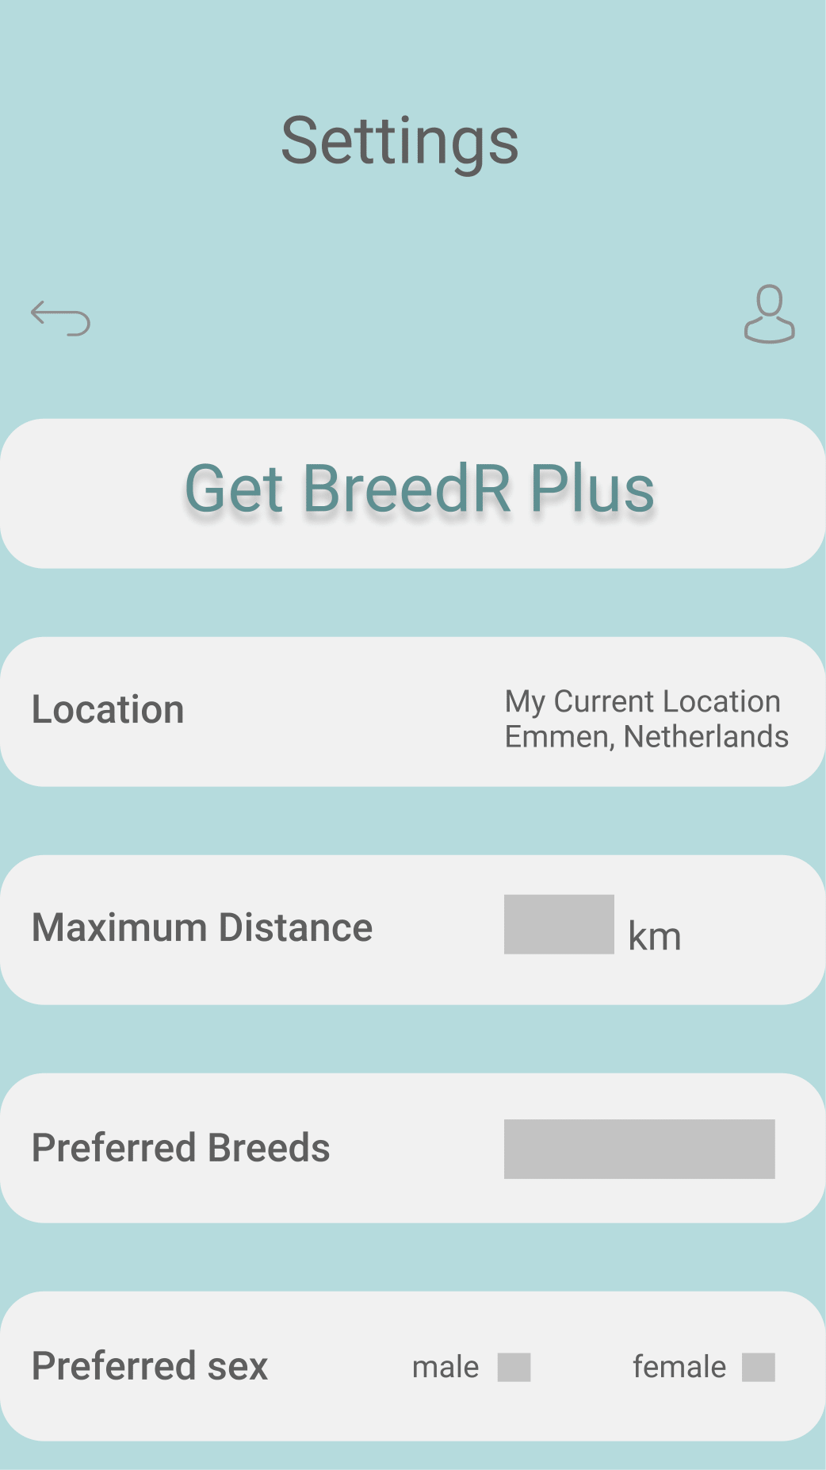

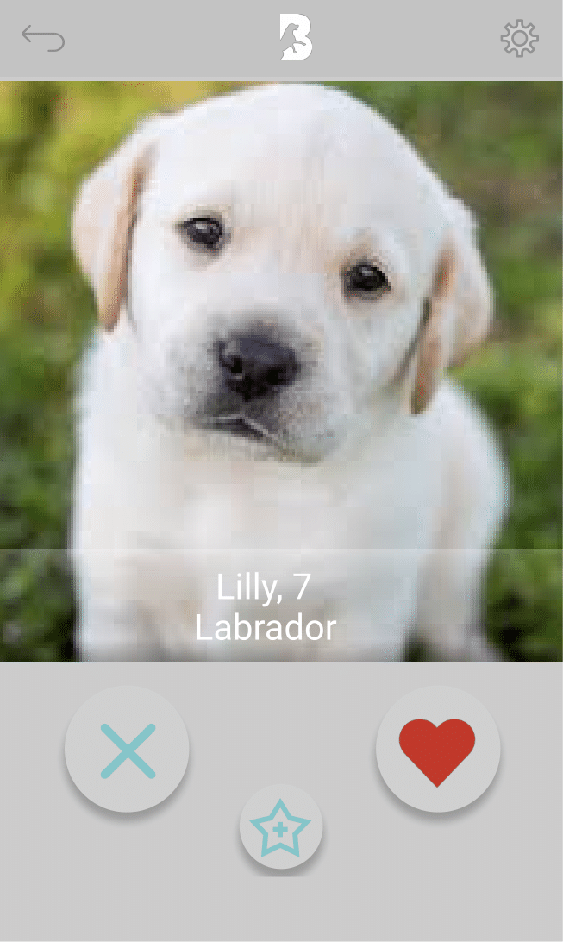Swipe Page