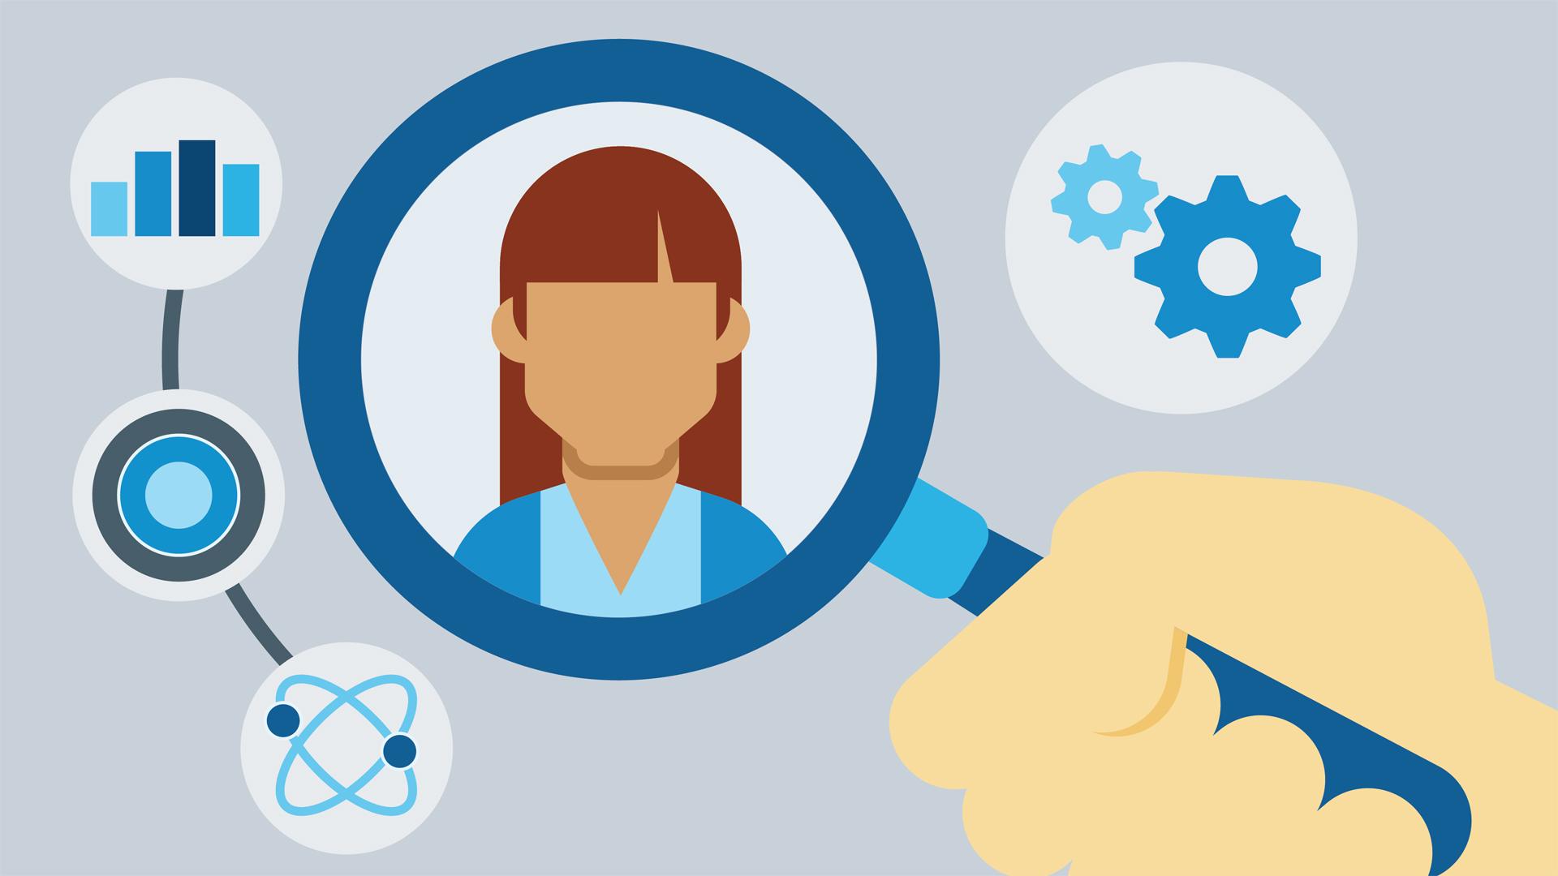

Research Paper  
Technical Research Report

Table of Contents

App Development: 3

Possible Platforms for Developing an Application in Android 4

Deep Learning 6

How does Deep-learning work? 7

Examples of deep learning applications 7

Limitations of deep learning 8

AI – Artificial Intelligence 9

Definition: 9

Examples for an AI: 9

Machine learning models: 11

Implementing AI into an App 12

Sources 15

App Development:  
  
  
Real time chat (C++ Socket Programming, XMPP Server Integration, a third party chat hosted through WeChat for example, an option better for those restrained budget).  
  
**Frontend:**(Android, IOS, Windows, etc) or web. As the Platform maybe Xaramin and it can reduce up to 70% the total time to develop Android and IOS apps. For web development: Ruby / Rails and Python / Django as fast and reliable programming languages.  
  
  
  
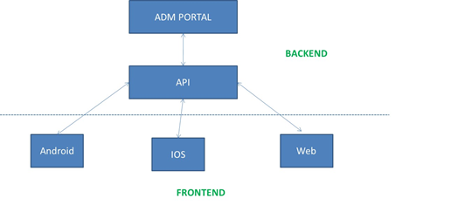  
  
  
****Programming languages for **Android**

* + Java
  + C#

Possible Candidates for a **Database**

* + MS
  + MySQL
  + FireBase

Candidates for **Backend / API**

* + Scala
  + SQS
  + Kinesis
  + Kubernetes
  + Rundeck
  + EMR
  + Node.js

Possible Platforms for Developing an Application in Android





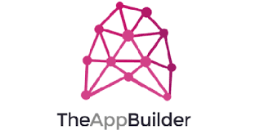

# 



**Login:**

Facebook open authorization protocol

Or phone number.

**Databases:**

Profiles (breed, gender, date of birth, photos, etc.)

Users can connect their Tinder profiles with Instagram so that the recent Instagram photos to be available on Tinder as well. Tinder content does not go to Instagram, though.

**Push notifications:**

To enable push notifications in your Android app use **FCM (Firebase Cloud Messaging)**.

**Geolocation:**

classes of android.location package and the MapView class.

**Other:**

In Tinder users can chat with each other only when they have mutual likes. Otherwise, the chat is disabled. As a rule, this function is implemented via the RESTful API or through HTTP. Permanent socket connections are not involved in order not to overload the server. The polling interval is set up depending on the frequency of the messages being sent.

**Breakdown of features to be implemented:**

* Authorization
* GPS location
* Settings
* User profile
* Matching functionality
* Notifications
* Communication
* 3rd party services integration

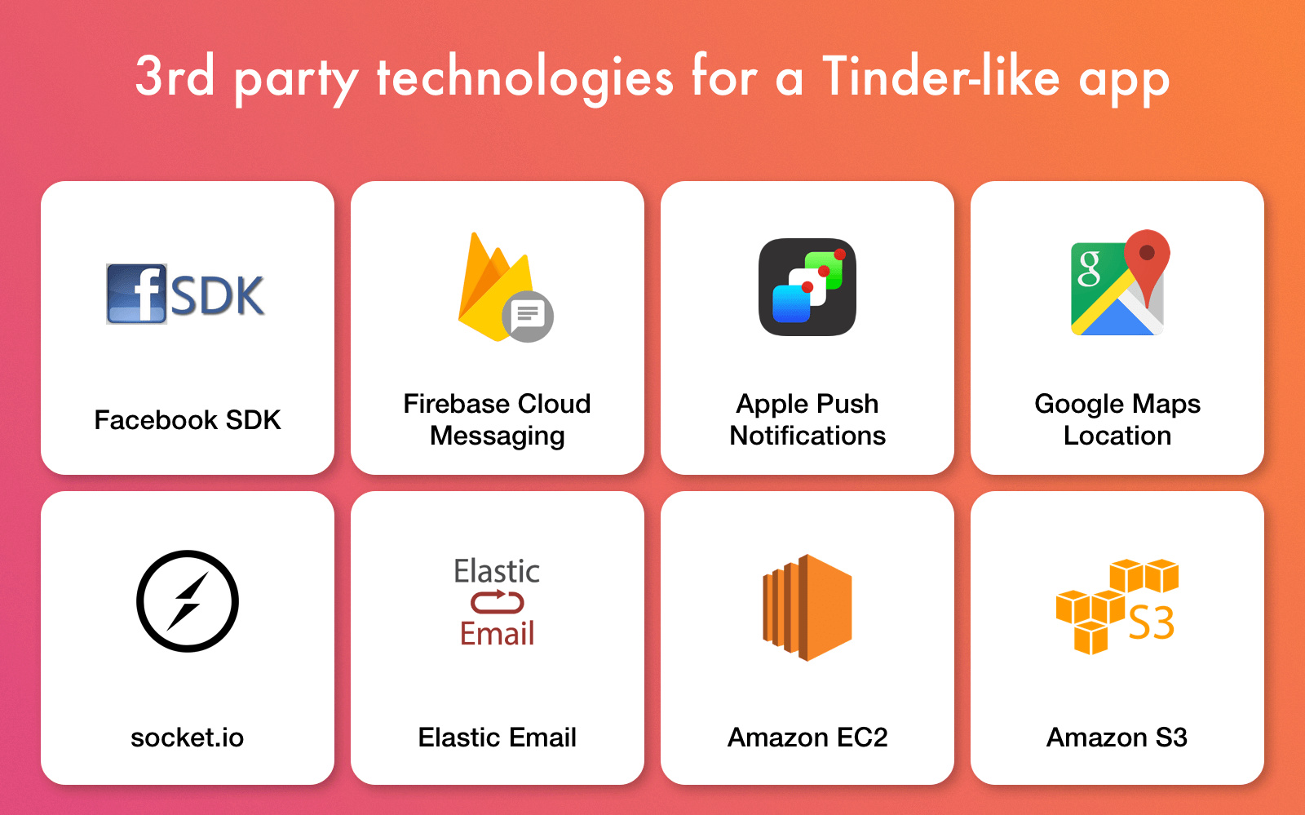

Deep Learning   
  
Deep learning is an aspect of artificial intelligence ([AI](https://searchenterpriseai.techtarget.com/definition/AI-Artificial-Intelligence)) that is concerned with emulating the learning approach that human beings use to gain certain types of knowledge.   
It allows us to train an AI to predict outputs, given a set of inputs.

Training the AI is the hardest part of Deep Learning because:

1. We need a large data set.
2. We need a large amount of computational power.

This is the way a learning machine works:

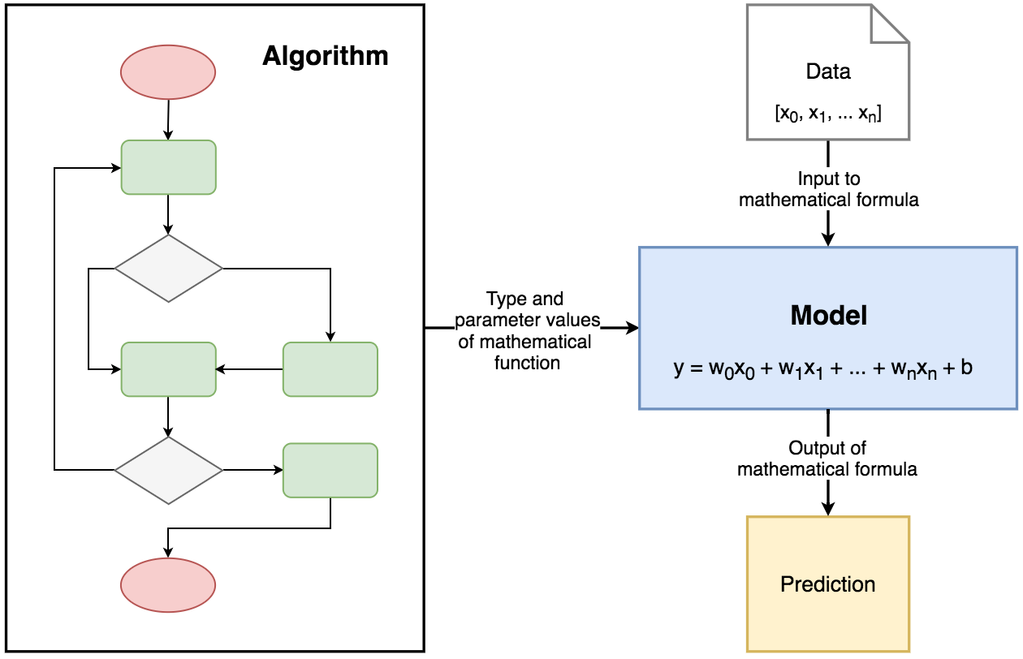

Supervised Learning models are trying to find parameter values that will allow them to perform well on historical data. Then they are used for making predictions on unknown data, that was not a part of training dataset. This is a model of how supervised learning is working:

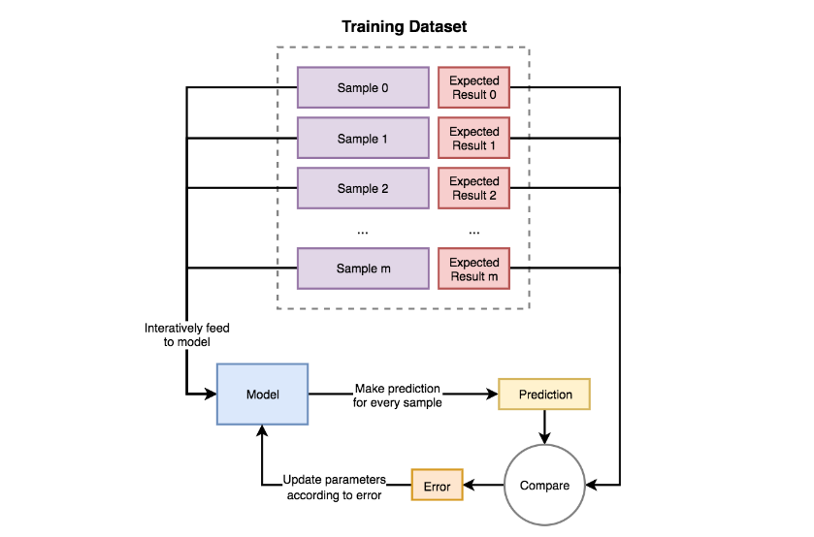

## How does Deep-learning work?

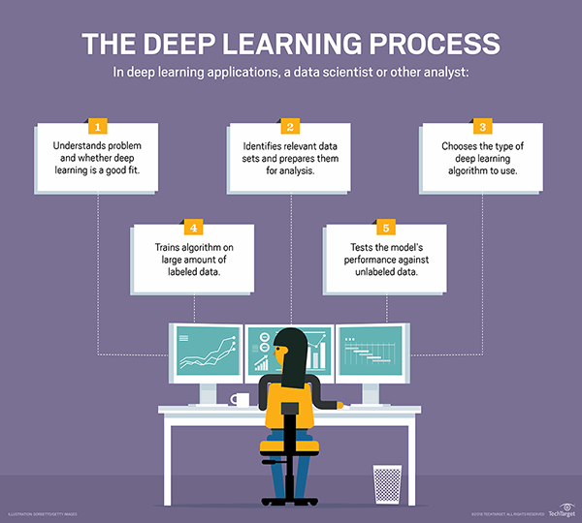

Initially, the computer program might be provided with training data, a set of images for which a human has labeled each image "dog" or "not dog" with [meta tags](https://whatis.techtarget.com/definition/meta-tag). The program uses the information it receives from the training data to create a feature set for dog and build a [predictive model](https://searchenterpriseai.techtarget.com/definition/predictive-modeling). In this case, the model the computer first creates might predict that anything in an image that has four legs and a tail should be labeled "dog." Of course, the program is not aware of the labels "four legs" or "tail;" it will simply look for patterns of pixels in the digital data. With each iteration, the predictive model the computer creates becomes more complex and more accurate.

### Examples of deep learning applications

* Natural language processing (NLP) is the ability of a computer program to understand human language as it is spoken. NLP is a component of artificial intelligence ([AI](https://searchenterpriseai.techtarget.com/definition/AI-Artificial-Intelligence)).

Because deep learning models process information in ways similar to the human brain, models can be applied to many tasks people do. Deep learning is currently used in most common [image recognition](https://searchenterpriseai.techtarget.com/definition/image-recognition) tools, NLP processing and speech recognition software. These tools are starting to appear in applications as diverse as self-driving cars and language translation services.

## Limitations of deep learning

The biggest limitation of deep learning models is that they learn through observations. This means they only know what was in the data they trained on. If a user has a small amount of data or it comes from one specific source that is not necessarily representative of the broader functional area, the models will not learn in a way that is generalizable.

To work with Deep learning, we can use the following examples:

**TensorFlow Mobile**

To use TensorFlow Mobile, you need to have a TensorFlow model that’s successfully working in a desktop environment. Actually, there are two options: [TensorFlow for Mobile](https://www.tensorflow.org/mobile/mobile_intro) and [TensorFlow Lite](https://heartbeat.fritz.ai/how-tensorflow-lite-optimizes-neural-networks-for-mobile-machine-learning-e6ffa7f8ee12). TensorFlow Lite is an evolution of TensorFlow Mobile, where models will have a smaller binary size, fewer dependencies, and better performance.

It works with both [Android](https://www.tensorflow.org/mobile/android_build) and [iOS](https://www.tensorflow.org/mobile/ios_build) devices.

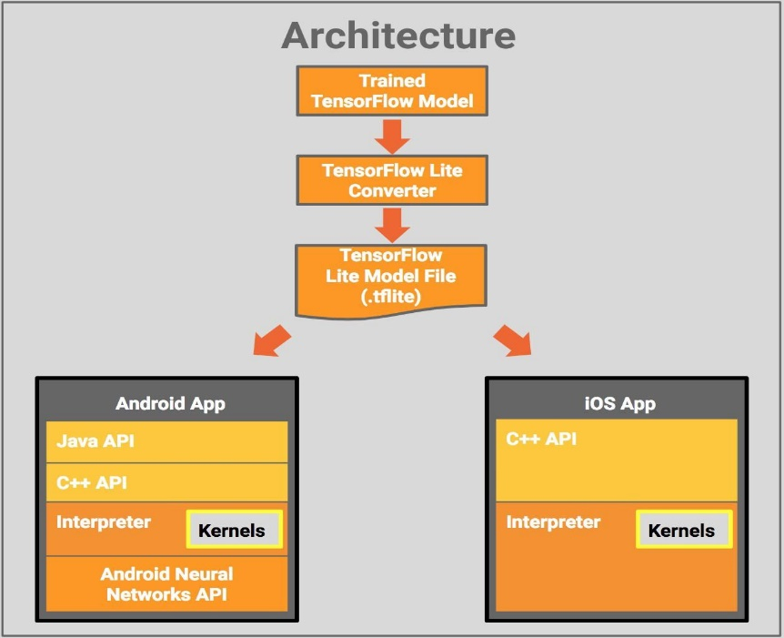

**Hadoop**

Hadoop was originally developed to improve search engine technology, but today can process enormous amounts of data on relatively inexpensive hardware — and of course, can store data on a distributed file system without needing to transform it in advance. That makes it a great tool to deploy deep neural networks.

# 

AI – Artificial Intelligence  
  
**Artificial intelligence**

## Definition:

Artificial intelligence (AI) makes it possible for machines to learn from experience, adjust to new inputs and perform human-like tasks.

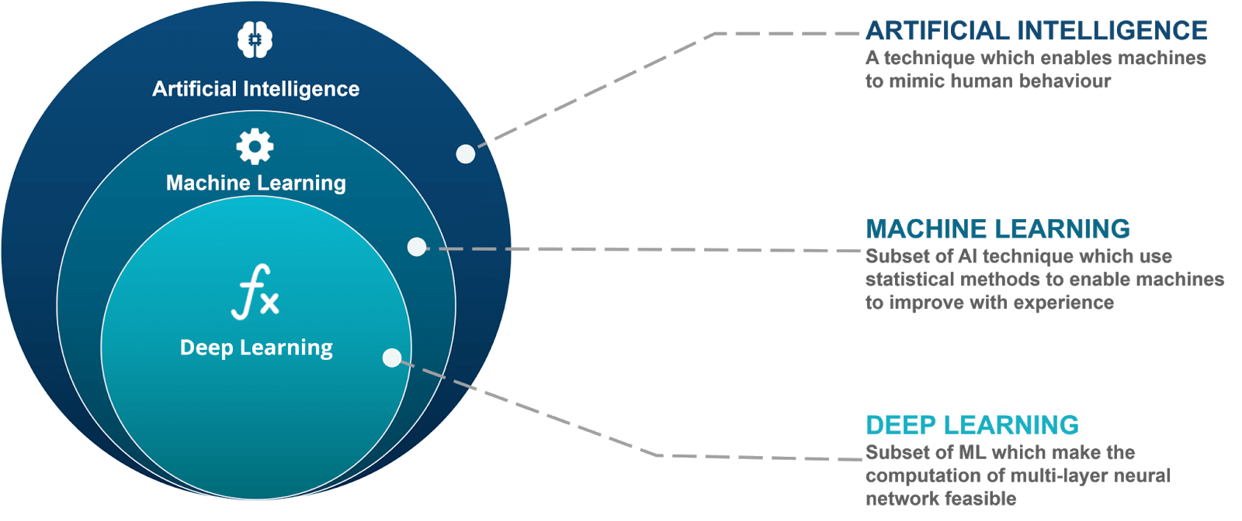

AI itself is the largest and outermost circle in a series of four concentric circles. The next circle nested within AI is ML, or Machine Learning. ML is, unsurprisingly, the learning part of AI, but ML is itself reliant on the next circle within it, or Deep Learning (DL). But it doesn’t stop there, the fourth and innermost circle, and the one that every other circle is counting on, is the idea of Neural Networks.

### Examples for an AI:

Snapchat is a good example of using machine learning to be able to recognize a human face for their face filters, they showed an AI pictures of faces so it could learn how to recognize faces.  
Another example would be modern day personal virtual assistants like Google Home, Alexa and Siri, based on the questions you ask they collect data and from that data they are able to continue to learn to be able to answer more difficult questions.

2 types of learning supervised and unsupervised learning, the difference is supervised data has been classified and labeled while unsupervised has not been classified allowing AI to find patterns and commonalities within data.  
  
How Artificial Intelligence Works

AI works by combining large amounts of data with fast, iterative processing and intelligent algorithms, allowing the software to learn automatically from patterns or features in the data. AI is a broad field of study that includes many theories, methods and technologies, as well as the following major subfields:

* [**Machine learning**](https://www.sas.com/cs_cz/insights/analytics/machine-learning.html)automates analytical model building. It uses methods from neural networks, statistics, operations research and physics to find hidden insights in data without explicitly being programmed for where to look or what to conclude.
* **A neural network** is a type of machine learning that is made up of interconnected units (like neurons) that processes information by responding to external inputs, relaying information between each unit. The process requires multiple passes at the data to find connections and derive meaning from undefined data.
* [**Deep learning**](https://www.sas.com/cs_cz/insights/analytics/deep-learning.html) uses huge neural networks with many layers of processing units, taking advantage of advances in computing power and improved training techniques to learn complex patterns in large amounts of data. Common applications include image and speech recognition.
* **Cognitive computing** is a subfield of AI that strives for a natural, human-like interaction with machines. Using AI and cognitive computing, the ultimate goal is for a machine to simulate human processes through the ability to interpret images and speech – and then speak coherently in response.
* [**Computer vision**](https://www.sas.com/cs_cz/insights/analytics/computer-vision.html) relies on pattern recognition and deep learning to recognize what’s in a picture or video. When machines can process, analyze and understand images, they can capture images or videos in real time and interpret their surroundings.
* [**Natural language processing**](https://www.sas.com/cs_cz/insights/analytics/what-is-natural-language-processing-nlp.html)(NLP) is the ability of computers to analyze, understand and generate human language, including speech. The next stage of NLP is natural language interaction, which allows humans to communicate with computers using normal, everyday language to perform tasks.

Machine learning models:  
  
Artificial neural networks are a framework for many different machine learning algorithms to work together and process complex data inputs. Such systems "learn" to perform tasks by considering examples, generally without being programmed with any task-specific rules.

Support vector machines are a set of related supervised learning methods used for classification and regression. Given a set of training examples, each marked as belonging to one of two categories, an SVM training algorithm builds a model that predicts whether a new example falls into one category or the other. This form of machine learning is very linear unlike ANNs.

Bayesian Networks are a probabilistic graphical model that represents a set of random variables and their conditional independence with a directed acyclic graph. For example, a Bayesian network could represent the probabilistic relationships between diseases and symptoms. Given symptoms, the network can be used to compute the probabilities of the presence of various diseases. (Useful for health chatbot).

Genetic Algorithms are a search algorithm and heuristic technique that mimics the process of natural selection, using methods such as mutation and crossover to generate new genotypes in the hope of finding good solutions to a given problem.

The most useful one seems to be the Artificial neural network as it has the most functionality and allows you to combine algorithms.

However, there are limitations to the uses of machine learning, machine learning programs can often fail to deliver expected results for reasons such as lack of data, lack of access or data bias.   
Data bias is when a machine learning program has learned everything from one type of data leading to it not being able to learn from a different type of data, an example of this would be: A machine learning system trained on current customers only may not be able to predict the needs of new customer groups that are not represented in the training data.

The Intel Movidius is a device plugged in by USB which allows you to learn AI programming much easier than most devices/programs.

Machine learning is needed for tasks that are too complex for humans to code directly. Some tasks are so complex that it is impractical, if not impossible, for humans to work out all the nuances and code for them explicitly. So instead, we provide a large amount of data to a machine learning algorithm and let the algorithm work it out by exploring that data and searching for a model that will achieve what the programmers have set it out to achieve.

In my opinion we should try to implement a neural network into our project as it’s intriguing, difficult and most importantly innovative and efficient.   
  
  
  
  
  
Implementation of an Artificial Intelligence

Artificial Intelligence is one of the most reputable technologies that are currently making waves in the mobile app industry. Just so you know, there are several app development companies that are committed to the task of creating intelligent mobile applications that can modify themselves to attend to users’ needs without requiring their permanent control.

With this technology, any mobile app development company can tailor its Android application to function based on the personal needs of its users. Unarguably, [app developers](https://www.hyperlinkinfosystem.com/android-app-development-india.htm) stand a better chance to attract more users and even build a stronger and more viable connection with existing ones by simply adding Artificial Intelligence (AI) to a mobile application.

While helping to significantly improve user experience, it is amazing to see how the adoption of Artificial Intelligence (AI) can efficiently help to solve a wide range of tasks. Here are some effective ways AI can be integrated to enhance Android app development.

Learning user habits

**AI is great for dealing with complex data like analyzing preferences.** Building products with user experience in mind is a priority for modern applications. Appealing visuals are not enough to keep your user base happy, but AI can help with that. While most people do not bother to customize or personalize their apps small things like choosing which screen appears first or discovering what color theme is the most popular, can make the user feel that the app is designed specifically for them. Apps where the user has to go through many steps to complete a task can also easily use AI to make it faster or reduce the cognitive load on the user.

**Create a friendly and intelligent digital assistant**. These days, many customers are no longer interested in writing long letters or making calls to access support from customer service. Since the whole process is done online, the customer does not expect “opening hours” in the traditional sense and therefore customer service should be able to answer questions around the clock. Interestingly, some [app development companies](https://topappdevelopmentcompanies.com/)have begun adopting AI integration as an alternative means to help customers get all the necessary information. One way to effectively do this is by creating an intelligent digital assistant such as a chatbot to support customers with the right customer service and assistance they need.

## Implementing AI into an App

Following a research I have found out that there are several ways we could implement an AI into an application. There are several deep learning based codes we can find on GitHub and use in our application. The most common programming language for AI I have found is Python. There are several tutorials on YouTube in which there is explained step by step how to use the codes and work with the algorithms. There are examples in which guys create applications and use the AI codes for image recognition.

One example is: <https://www.youtube.com/watch?v=vmdZ12NyXqQ&t=1243s>.

For Android Studio: <https://www.youtube.com/watch?v=kFWKdLOxykE>.

We could use Tensorflow for implementing the AI. The codes are on Github: <https://github.com/topics/image-recognition?l=python&o=asc&s=stars>.

There are already created source codes for an App similar to Tinder with the same features on GitHub:

<https://github.com/topics/tinder>

We could also use Gradle, due to the fact that there are a lot of tinder like applications already created: <https://github.com/yuyakaido/CardStackView>

This website explains in detail how to create an AI for image recognition in Python:

<https://towardsdatascience.com/train-image-recognition-ai-with-5-lines-of-code-8ed0bdd8d9ba>

There are many easy ways to implement an AI in the app, depending on the software we are going to use for creating the app. We can find already written codes for what we need on the internet and adapt them to our needs. There are also lots of tutorials which show how to implement the AI into the app, so we can just follow those tutorials step by step.

**Use data to your advantage**

Generally, technologies like AI require large amounts of data to effectively function. Basically, its efficiency depends solely on its ability to effectively analyze data such as the efficiency of an app, upcoming trends, market changes, behavioral patterns, client’s financial status, and so on. Therefore, this technology has been considered to be very valuable to the finance industry.

**Secure your app**

With the increasing rate of cyber crimes, any mobile app development company would want to consider the use of Artificial Intelligence (AI) for app security purposes. This is mainly because it offers a fast and secure authentication process. As a matter of fact, AI can be effectively incorporated in conjunction with a range of recognition types to pass user identification and authentication. This is a suitable decision for developing e-commerce apps and other personality apps.  
  
 **Mining big data**

It is expected for any mobile app development company looking to adopt Artificial Intelligence (AI) technology for app development to understand what mining big data is all about. Just so you know, this can go a long way in helping to improve the process of acquiring precise information by analyzing different kinds of data.

Additionally, several technologies enable and support AI:

* [**Graphical processing units**](http://www.allanalytics.com/author.asp?section_id=3314&doc_id=273820) are key to AI because they provide the heavy compute power that’s required for iterative processing. Training neural networks requires big data plus compute power.
* [**The Internet of Things**](https://www.sas.com/cs_cz/insights/big-data/internet-of-things.html)generates massive amounts of data from connected devices, most of it unanalyzed. Automating models with AI will allow us to use more of it.
* [**Advanced algorithms**](http://blogs.sas.com/content/subconsciousmusings/2017/04/12/machine-learning-algorithm-use/)are being developed and combined in new ways to analyze more data faster and at multiple levels. This intelligent processing is key to identifying and predicting rare events, understanding complex systems and optimizing unique scenarios.
* [**APIs, or application processing interfaces**](https://www.sas.com/cs_cz/insights/articles/analytics/apis-provide-analytics-for-masses.html)**,**are portable packages of code thatmake it possible to add AI functionality to existing products and software packages. They can add image recognition capabilities to home security systems and Q&A capabilities that describe data, create captions and headlines, or call out interesting patterns and insights in data.

In summary, the goal of AI is to provide software that can reason on input and explain on output. AI will provide human-like interactions with software and offer decision support for specific tasks, but it’s not a replacement for humans – and won’t be anytime soon.

# Sources

<https://espeo.eu/blog/implement-machine-learning-mobile-app/>

<https://chatbotnewsdaily.com/how-to-implement-artificial-intelligence-in-mobile-app-development-4cf6867bb1f6>

<https://www.quora.com/How-do-I-implement-machine-learning-in-an-Android-application>