Mobile Computing Progress

**Lecture-4: Introduction to IDE**

* **Step 01:** Open Android Studios and create a project by selecting Empty Activity.

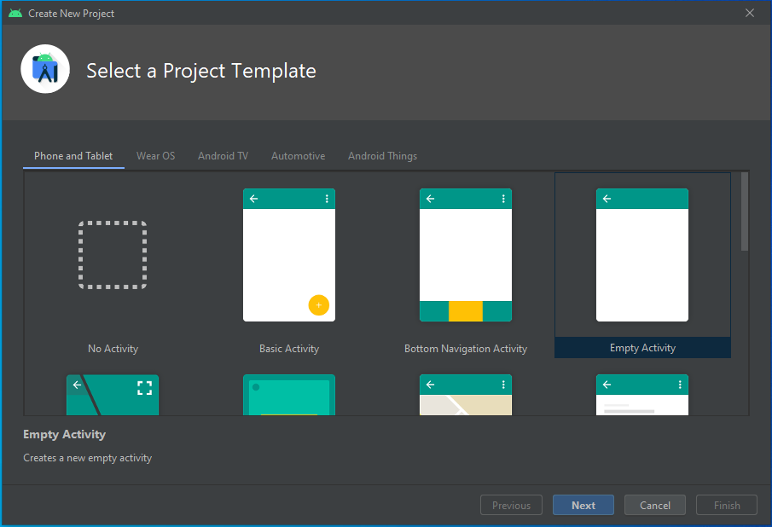

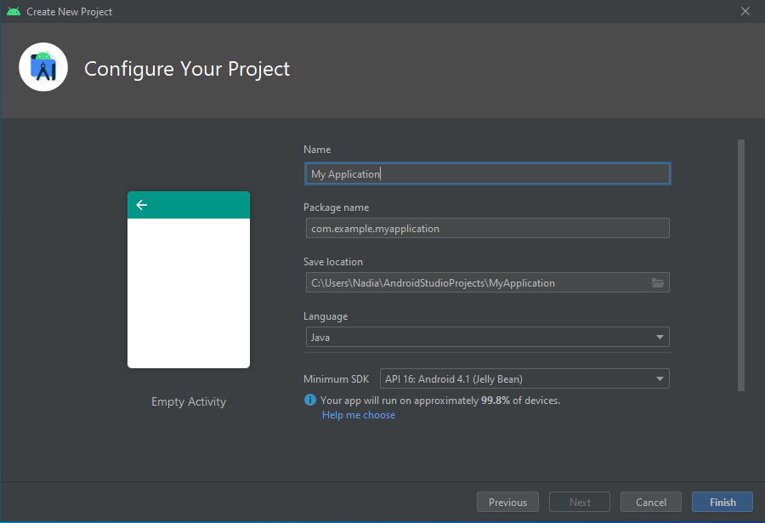

* **Step 02:** Open activity_main.xml in android view and add Text View, Password and Button from Pallet and set their constraints.

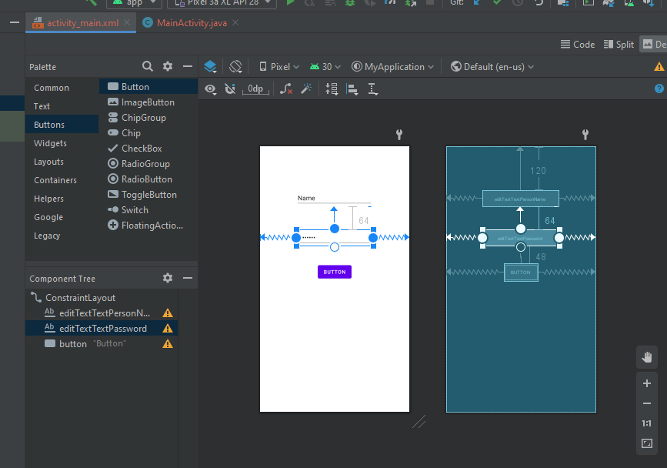

* **Step 03:** Run the application.

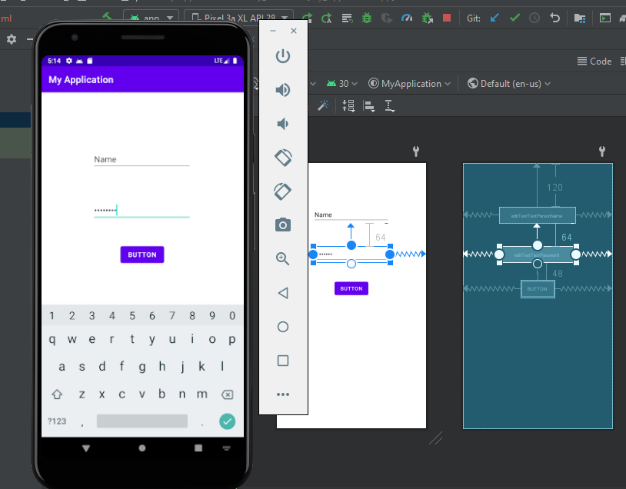

**Lecture-5: Layouts**

* **Step 01:** Open Android Studios and create a project by selecting Empty Activity.
* **Step 02:** Add Constraint Layout and then add Plain Text, Email and a Button in it and

set constraints.

.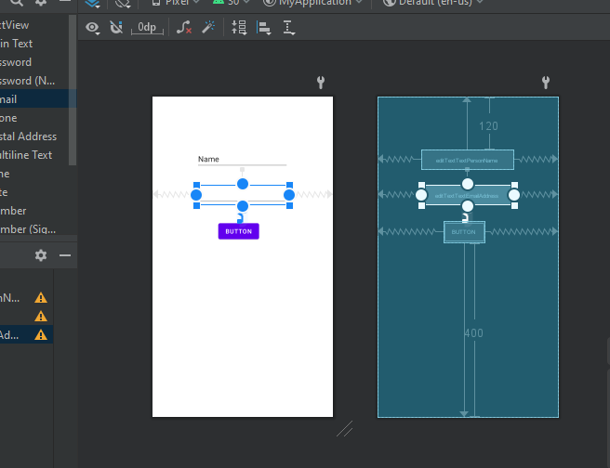

* **Step 03:** Run the application.

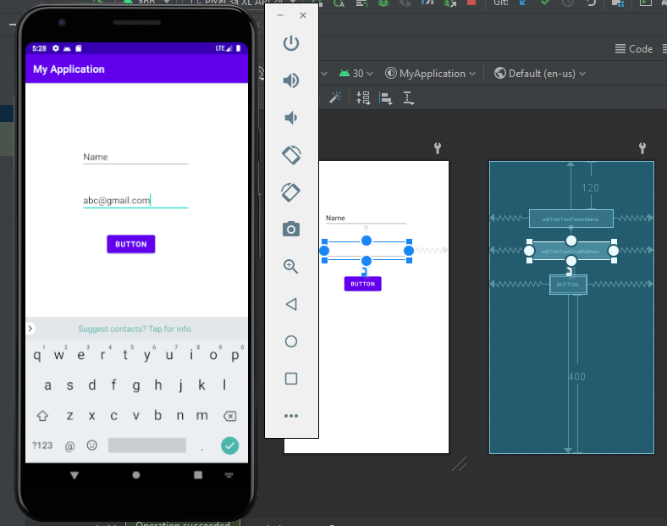

* **Step 04:** Add Linear Layout and then add Plain Text, Email and a Button in it.

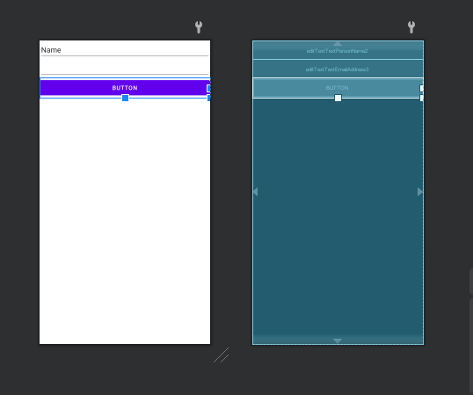

* **Step 05:** Run the application.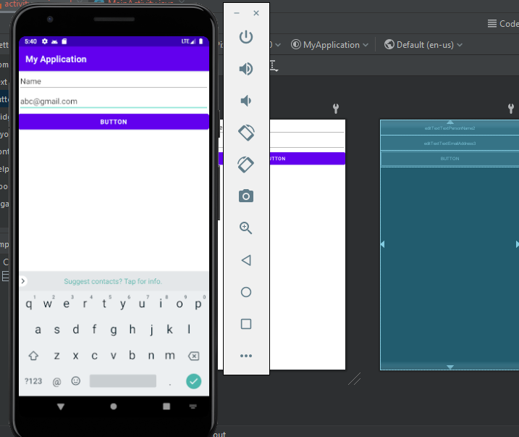

**Lecture-6: Intent and Activity**

* **Step 01:** Open Android Studios and create a project by selecting the Empty Activity.
* **Step 02:** Add Text View and Button in activity_main.xml and set constraints.

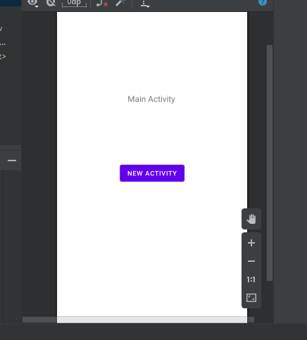

* **Step 03:** Add a new activity.
* **Step 04:** Add two buttons in this new activity and set constraints.

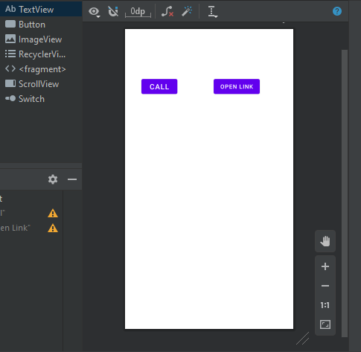

* **Step 05:** Add code in MainActivity.java to go to NewActivity.java on click event of button.

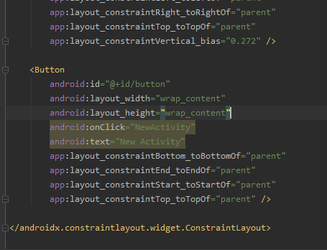

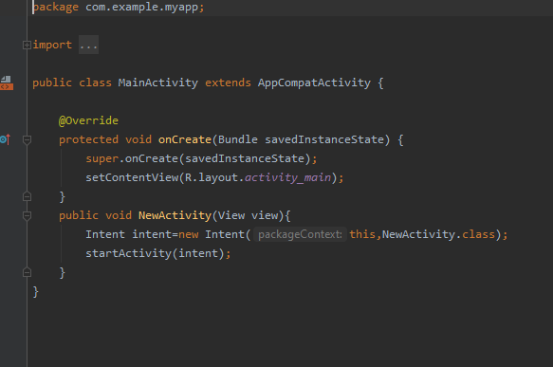

* **Step 06:** Add the code to call and open a website through the intent on click even of buttons.

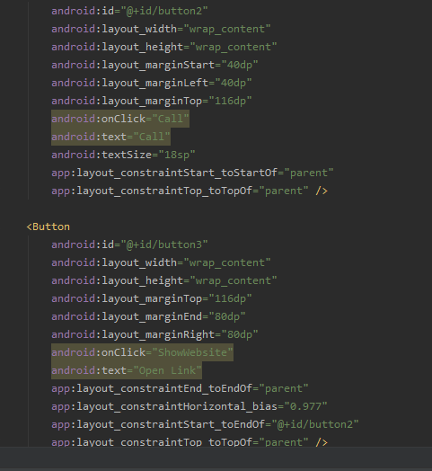

* **Step 07:** Run the application.

