Hat Racks for Understanding

Lecture 6

Nadia Noormohamed

[Year]

How to convey or represent the acquired information?

Informal Methods: Involve natural language. This could be forms, letters, memos and interviews. Requirements elicitation can be done by analyzing this language. Nouns and verbs represent actions and functionality. Identify constraints, targets, owners and actors.

User Stories

* Describes functionality that will be available to the users of the system.
* Can be of varying length
* Comprise of written description, conversations and details of the story.
* Stories should be independent.
* Can be altered or modified based on new information.
* Story should be estimable in terms of the time it should take to create the functionality.
* Should be testable

Use Cases

* More complex than user stories.
* Describes a system under various conditions
* Creates a unified language so that the UC can be understood by Software engineers, regardless of who created them.
* May take many different forms.
* Consists of:

1. The primary initiator, for example, the purchases, claimant or user.
2. Level of importance
3. List of stakeholders who may be interested

* In the case of the UX analyst UCs serve a perfectly adequate purpose for the necessity of specifying user-facing aspects of the system.
* Normally created as a series of steps or bullet points.

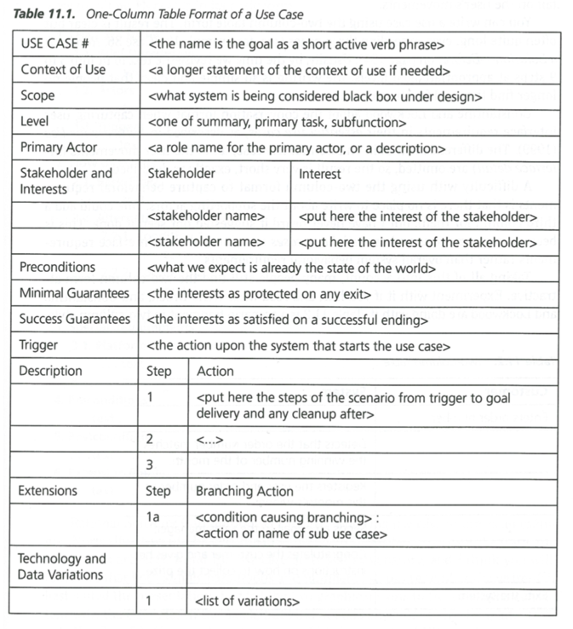

Personas

* It is ambiguous as to what a persona method encompasses.
* Common understanding: description of a fictitious person.
* Description based on assumption or data?
* What should the description cover?
* Related to scenarios and user stories.
* Can be very short.

Scenarios

* Detailed description of a user’s interaction with the computer.
* Larger than use cases
* Written in plain English as opposed to bullet points.
* Many actors and many interrelated stories crisscrossing throughout the scenario.
* Stories are not independent
* Detailed definition of a specific instance of interactivity.
* Easier to create than user stories and use cases.

Wireframes

* Hand drawn sketches of proposed UIs
* Can be created at the same time as requirements capture is happening.
* Can make fast and direct corrections and developments to the interface based on immediate feedback from the user.
* Fast to design
* Can design a computerized wireframe for better presentation.

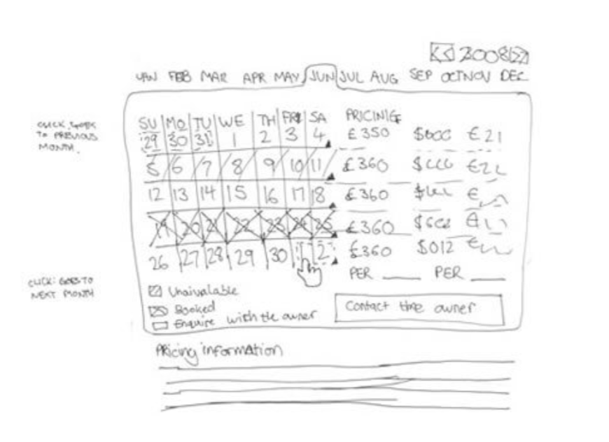

Mock-ups and Storyboards