**Group No:25**

Shahidul Islam Abir(2020331018)

Mahbub Islam Shamim(2020331032)

Md.Shahidur Rahaman(2020331049)

Nadia(2020331077)

Md.Asraf Ali(2020331090)

|  |
| --- |

Steps:

1. Firstly Simulate -> Enable Simulation  
   Simulate -> Ticks Enable

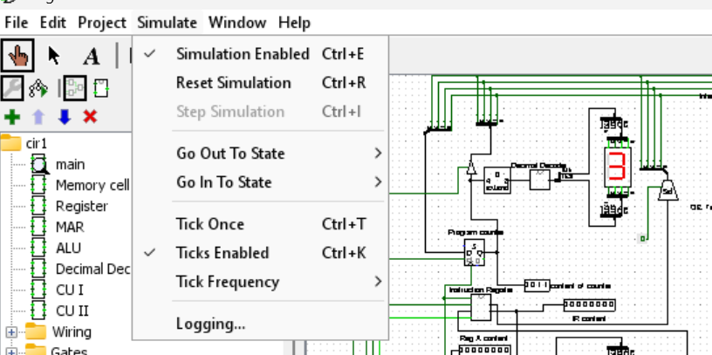

2.

Click on RAM

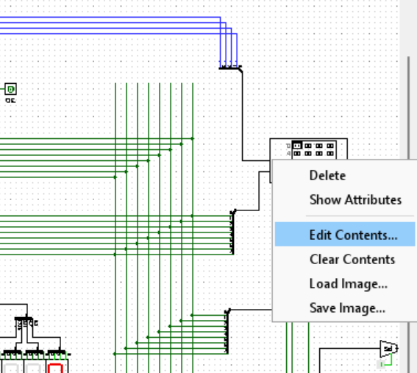

3.

Add the RAM file to RAM components from Architecture-cpu-design folder

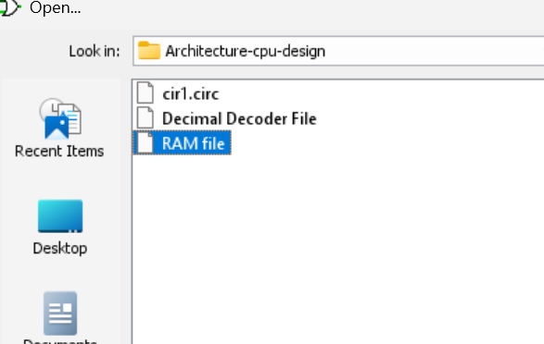

**N.B:This project requires Logisim-win-2.7.1.exe to run.**