**INSTRUCTIONS**

We present three excerpts from the work *Lamento* for tenor saxophone and tape by Jesús Villa Rojo.

|  |  |  |
| --- | --- | --- |
| **Phrase 1** | **Phrase 2** | **Phrase 3** |
| 18’’ – 48’’ | 3’30’’ – 3’48’’ | 7’30’’ – 7’45’’ |

For each Phrase, we ask that you **record:**

**1)  Original Phrase**

**2)**  3 versions of what you consider to be a **“parallel phrase”**;

**3)**  3 versions of what you consider to be a **“oblique phrase”**;

**4)**  3 versions of what you consider to be a **“contrary phrase”**.

We propose the following conceptual observations regarding the phrases to be generated:

* **“Parallel Phrase”**

In this case, we consider retaining a significant portion of the original phrase while modifying only one of the musical components: dynamics, pitch, interval direction, or tempo/movement.

* **“Oblique Phrase”**

We maintain one (or more) of the original phrase's elements, while making substantial, transformative changes to others.

* **“Contrary Phrase”**

The challenge is to create something that contrasts with the original phrase, developing a total contrast in dynamics, techniques, or intervals present in the original. The character of the phrase can also be altered, for example, by contrasting a long, low note with very fast and high notes.

**PHRASE 1**

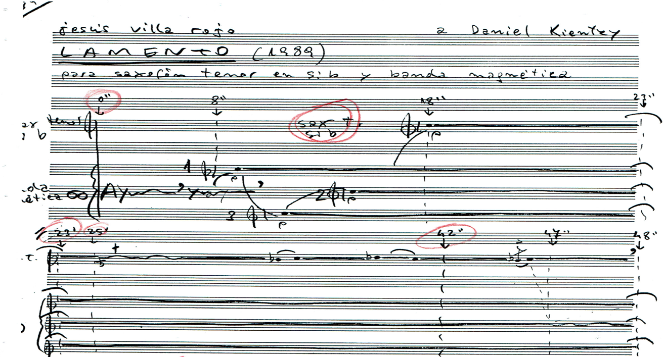

**- PH01_PARALLEL (1,2,3)**

**- PH01_OBLIQUE (1,2,3)**

**- PH01_CONTRARY (1,2,3)**

**PHRASE 2**

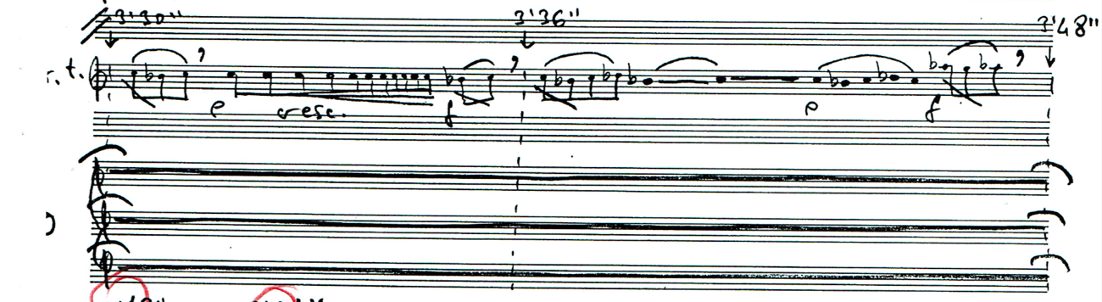

**- PH02_PARALLEL (1,2,3)**

**- PH02_OBLIQUE (1,2,3)**

**- PH02_CONTRARY (1,2,3)**

**PHRASE 3**

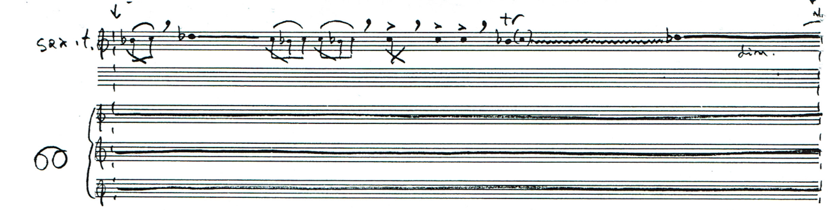

**- PH03_PARALLEL (1,2,3)**

**- PH03_OBLIQUE (1,2,3)**

**- PH03_CONTRARY (1,2,3)**