**Department of Computer Science and Engineering**

|  |  |
| --- | --- |
| **Course Code: CSE221** | **Credits: 1.5** |
| **Course Name: Algorithms** | **Semester: Spring’2019** |

**Lab 03  
Graph Traversals**

1. **Topic Overview:**

Graph traversal means visiting every vertex and edge exactly once in a well-defined order. While using certain graph algorithms, we must ensure that each vertex of the graph is visited exactly once. The order in which the vertices are visited are important and may depend upon the algorithm or question that we are solving.

There are many ways to traverse graphs. Breadth First Search (BFS) is the most commonly used approach. In this lab, we will discuss and implement BFS algorithm.

**Breadth First Search (BFS)**

1. **Overview:**

BFS is a traversing algorithm where you should start traversing from a selected node (source or starting node) and traverse the graph layer wise thus exploring the neighbor nodes (nodes which are directly connected to source node). You must then move towards the next-level neighbor nodes.

1. **Lesson Fit:**

There is prerequisite to this lab. Students must have completed Lab 01 and should have a basic idea on the following concepts:

* 1. Basic Graph Structures
  2. Graph Representation
  3. Recursion

1. **Learning Outcome:**

After this lecture, the students will be able to:

* 1. Learn about the complexity of the BFS algorithm.
  2. Implement the algorithm itself.
  3. Apply BFS to solve a scenario-based problem

1. **Anticipated Challenges and Possible Solutions**
   1. **Task 3:** Students might find it challenging to apply BFS in order to solve a problem.

**Solution:** The instructor will explain with a small example before starting the task.

1. **Acceptance and Evaluation**

Students will show their progress as they complete each problem. They will be marked according to their class performance. There may be students who might not be able to finish all the tasks, they will submit them later and give a viva to get their performance mark. The mark distribution for the lab will be as follows:

Code: 05

Viva: 05

1. **Activity Detail**
   1. **Hour 1:  
      Discussion:**Explain how BFS works and its various applications along with the time and space complexity of the traditional algorithm. **Problem Task:**
      1. Task 1
   2. **Hour 2:**

**Discussion:**

Explain Task 2, which is a soft implementation of the discussed algorithm. Check whether students have implemented it correctly.

**Problem Task:**

* + 1. Task 2
  1. **Hour 3:**

**Discussion:**

Check that individual students have completed at least tasks 1 and 2. Discuss any issues that the students have faced. Discuss Task 3.

**Problem Task:**

* + 1. Task 3

1. **Home tasks:** All unfinished tasks.

**Lab 3 Activity List**

**Task 1**

Simulate the algorithm below on a graph (sample graph in task 2), to ensure that you have understood the mechanism of BFS

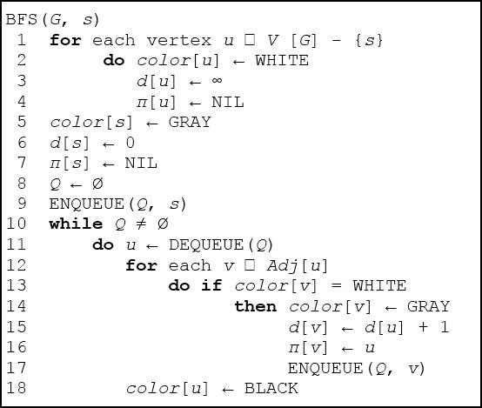 **Task 2**

Read the Graph.txt file to create an adjacency matrix **or** list. Reuse your code from Lab01. **Graph.txt represents an undirected graph.** After creating the matrix/list traverse the graph by implementing the BFS algorithm given above. You should print the distance (or hop) from the source and also the path from source. [Assume 1 is the root node]

### Sample Graph.txt File (Numbering starts from 1):

6 [# of nodes]   
[Edges]

1 2

1 3

2 1

2 4

2 5

3 1

3 5

4 2

4 5

4 6

5 2

5 3

5 4

5 6

6 4

6 5

**Sample graph (your graph.txt may represent a different graph, image for understanding):**

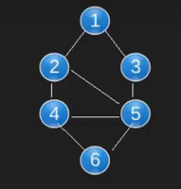

**Sample Output (Image for understanding):**

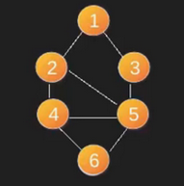

1 : distance from source - 0, path -> 1  
2 : distance from source – 1, path -> 1,2  
3 : distance from source – 1, path -> 1,3  
4 : distance from source – 2, path -> 1,2,4  
5 : distance from source – 2, path -> 1,2,5  
6 : distance from source – 3, path -> 1,2,4,6

**Task 3**

**Problem Description:**

Dalai Lama is visiting Maldives, the land of Thousand Islands. There are a total of N islands in Maldives numbered from 1 to N. Some pairs of islands are connected to each other by bidirectional bridges running over water.

Given Dalai Lama’s health condition, crossing these bridges require a lot of efforts. He is standing at Island #1 and wants to reach the Island #N, where he will attend a ceremony where leaders of all countries are gathered to celebrate his life and achievements. Find the number of bridges that Dalai Lama shall have to cross, assuming he takes the optimal route. Also print his route.

**Input:**

**maldives.txt**

First line contains T. T is the number of test cases.

First line of each test case contains two space-separated integers N, M. N is the total number of Islands and M is the total number of bridges.

Each of the next M lines contains two space-separated integers X and Y, denoting that there is a bridge between Island X and Island Y.

**Output:**

Print the answer to each test case in a new line.

**Constraints:**

1 ≤ T ≤ 10

1 ≤ N ≤ 104

1 ≤ M ≤ 105

1 ≤ X, Y ≤ N

**Sample Input:**

2

3 2

1 2

2 3

4 4

1 2

2 3

3 4

4 2

**Sample Output:**

Test Case 1

Total Bridges: 2

Path: 1🡪2🡪3

Test Case 2

Total Bridges: 2

Path: 1🡪2🡪4