Old layout

*Call Origin and Current Grade:*

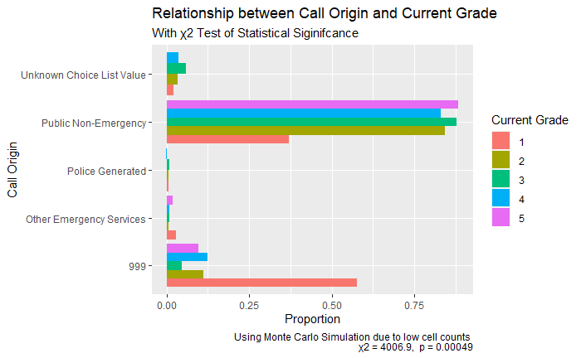

The bars for any grade sum to one across all categories of call origin. A large proportion of calls are within the PNE level, more specifically nearly 90% of the grade 3 and 5 calls are within the PNE category. However nearly 55% of grade 1 calls are within the 999 level. This would align with both police information regarding call handling as we expect to see emergency responses managed by 999. It is interesting to note that the calls handled by PNE receive roughly the same proportion of calls graded from 2-5

Adjusted standard residuals were used to access the association as we have a relationship that is not monotonic, differences greater in absolute value than 2 highlights significant difference between expected and observed frequency. The largest residuals for the PNE category are lower than -53.37 for the grade 1 categories. Representing an inverse relationship where those calls managed by 999 manage the more urgent calls, whereas calls managed by PNE deal with the second most urgent which accompany the majority of overall calls

Cranmer’s V is a method used to measure the strength of the association between two nominal variables; the statistic ranges from 0.00 to 1.00 with values closer to 0 indicating weak association. $v=√\frac{X2}{N.m}$. Cranmer V is a symmetric measure of association that takes treats the independent and dependent value as one; this was used because with the type of variables available grade also works as a dependent variable. The Cranmer’s V value between call origin and grade is 0.15, representing a week relationship

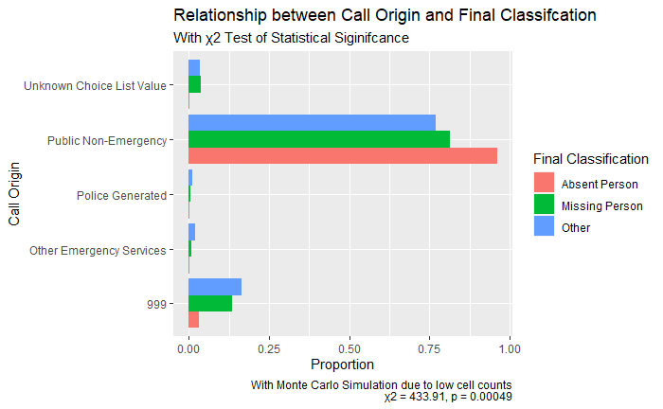*Call Origin and Final Classification*

Almost 95% of calls classed as absent are within the PNE level whereas roughly 77% of calls classed as missing are within this level. Compared to 999 calls where 17% of calls classed as other, 12% of calls are classed as missing and less than 5% as absent. With a significant statistical value, the adjusted standard residuals were then measured to test the strength of the relationship. The adjusted standard residual for Absent category is lower than -228.95 for the 999 categories, the expected count under the null hypothesis is far higher than the observed count. Using Cranmer V to measure the strength of association a value of 0.051 is obtained indicating a week association between the variables. Arguably this is not surprising as the ‘Absent Category’ were discontinued in 2017 hence the use of a time series becomes appropriate.

*Call Origin and attendance*

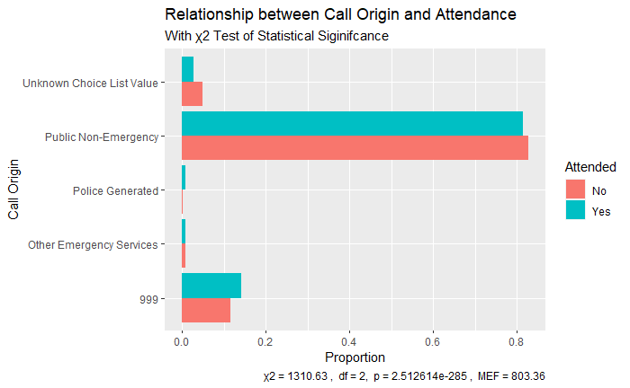

When examining the proportion of attendance rates across each level of call origin, almost 80% of calls attended and calls not attended are within the PNE level whereas 17% of calls are attended at the 999 level. Due to a monotonic relationship the residuals were examined to access the strength of the relationship. The adjusted standardised residuals are above 2 for those calls attended in 999 (249.169), other emergency service (13.561) and police generated (55.730) – these are the categories in the ‘Yes’ level of attendance that ate driving the results of the chi square to be significant.

*Final Classification and Current Grade:*

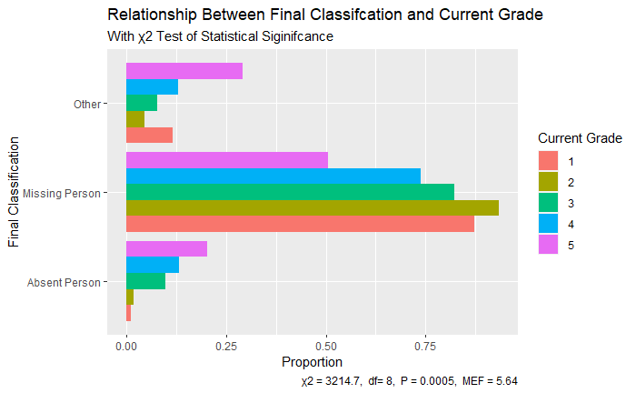

In the missing category, nearly 80% are graded at 2 compared to 50% graded at 5. In the absent category however, nearly 20% are graded at 5 and compared to less than 5% graded at 2. The adjusted standard residuals above the critical value of 2 in the absent are from grades 3 to 5, the other categories are from grades 1,2,3 and 4 and lastly in the missing persons are only in grade 2 – these relationships are driving the significant results of the chi square. Additionally, the largest residual for grade is at level 4; the residual is lower than -1440.32 for the Missing Person category. The expected count is much larger than the observed count. Using the Cramer V to understand the strength of this association a value of 0.19 is obtained, therefore highlighting a weak relationship

*What proportion of grades were re-graded?*

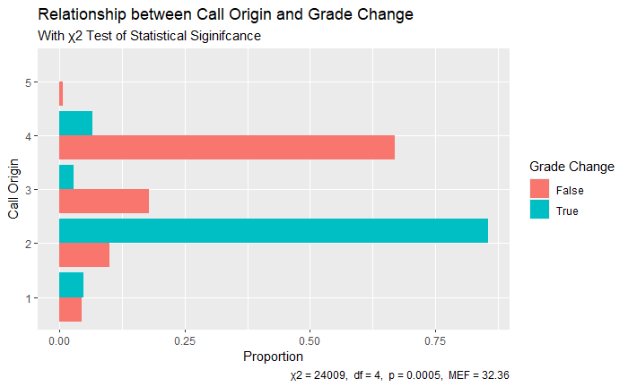

Almost 85% of those grades that changed from initial to current lie within the grade 2 category, whereas only 10% of grades didn’t change lie within this category. Compared to almost 65% of those grades that didn’t change lie within the grade 4 category compared to less than 10% that did change. Again, as the variables present a monotonic relationship, residuals were examined to access the strength of association. The adjusted standard residuals above the critical value of 2 in the those that changed are from grades 1 and 2 and from those that didn’t change are from grades 4 and 5. These are the relationships driving the significance in the chi square; grades 2 and 1 are more likely to change compared to grades 4 and 5 that are less likely. The expected count of grades that changes following the grade 4 level are also much higher than the observed count.

*Accessing the Temporal Trends*

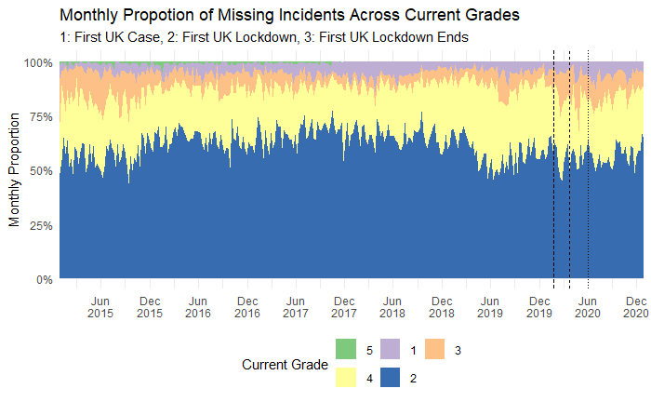In this section I highlight how police response to missing person calls have changed over time. there are two important dates to consider when examining the temporal trends; the first is following the change to the new call-handling system on the 03/06/2017 and the second is following changes in practise after HMIC call-handling report on the 15/05/2017. Figure x supports findings that from 2015 to 2020 roughly 60% to 90% of missing incidents are handled by public non-emergency whereas roughly 10-15% of incidents are handled by 999. This is different to what literature and police state about the handling of missing incidents. Less than 5% of incidents are handled by both Other Emergency Services and Police Generated which is what was expected to see as missing incidents are typically classed as ‘low-level societal crime’. From February 2018 there was an increase in unknown choice list values which were a result of changes to the new call-handling system 5 months prior

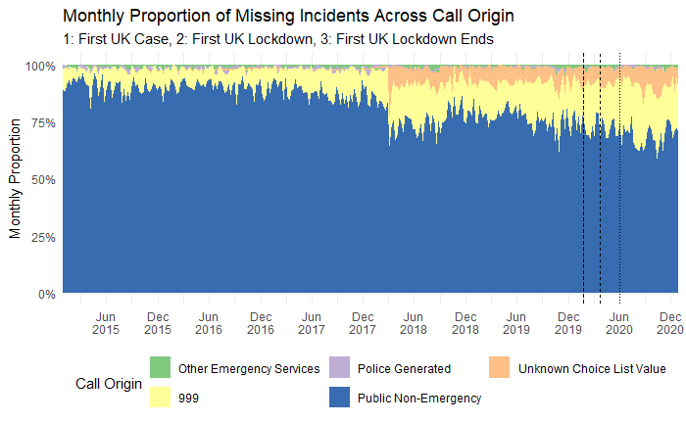Similarly figure x supports the univariate statistics where most incidents are graded at level 2, followed by level 4, 3 and 1. The graph also highlights a noticeable change following the first UK case

Figure x highlights the description of missing incidents at its final classification. The majority of missing incidents are indeed classed as ‘missing, but until March 2018 a portion of these were re-classified as ‘absent person’, this could be a result following the changes to the call handling system.

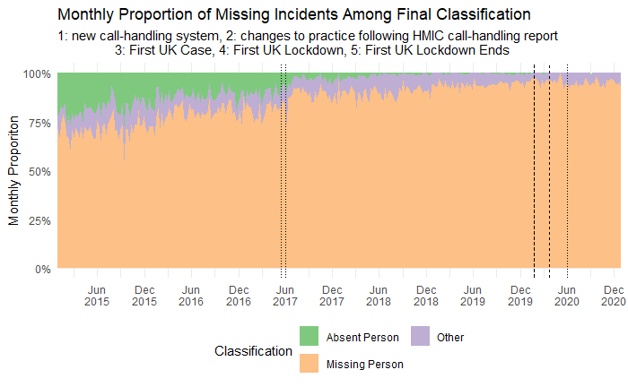

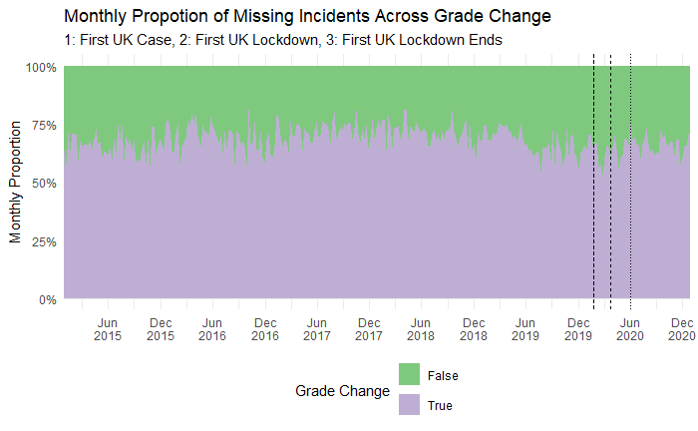Figure x shows what proportion of grades were re-graded (as in whether the grade changed following from the initial grade to the current grade). Roughly 70% of calls were re-graded; if initial grades indicate the immediate resource allocation and current grade indicates the urgency/risk of the call then we might argue there is seriousness gap in the communication within agency, policy and police

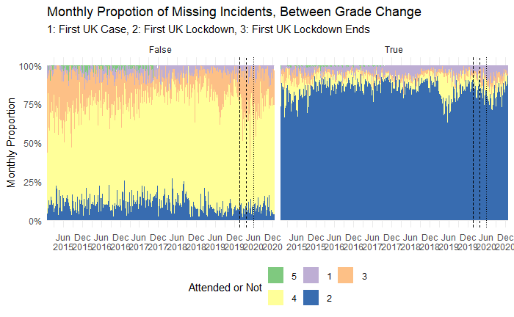For example, figure x shows that grade 2 are the most frequent grade to change whereas grade 4s are normally more consistent. Table x highlights the overall changes between each grade, for examples 69.5% calls remained at the same grade whereas 35% of calls had re-graded.

*Table 2: Ovaerall percentage changes between initial and current grade*

|  |  |  |  |  |  |
| --- | --- | --- | --- | --- | --- |
|  | **1** | **2** | **3** | **4** | **5** |
| 1 | 3.40 | 1.3 | 0 | 0.1 | 0 |
| 2 | 1.1 | 58.9 | 1 | 1.1 | 0.01 |
| 3 | 0.1 | 5 | 2.1 | 0.5 | 0.0004 |
| 4 | 0.4 | 19.2 | 1.4 | 5.1 | 0.01 |
| 5 | 0 | 0.19 | 0.014 | 0.014 | 0.08 |

Attendance rates and the graded response also have a relationship, following the GMP guidelines grade 1 calls should expect attendance in 15 minutes whereas grade 5 calls do not require attendance are typically resolved over the telephone. We can see this is true from figure x, where the highest attended calls are those graded at grade 2

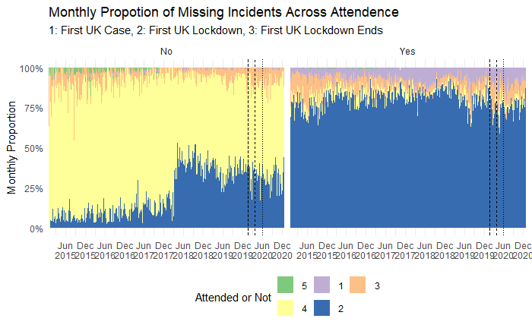

Out of the 42,019 calls 27472 (65.4%) were attended. The overall changes can be seen in figure x representing the median response in minutes from 2015-2020. The average median response time for services to attend a missing person incident is 32.63 minutes, when specifically examining this response time over the pandemic however, the average response time reduced to 29.63 minutes, the number of calls reduced resulting in less calls attended. Additionally, changes to people routine might have affect the response times for emergency service

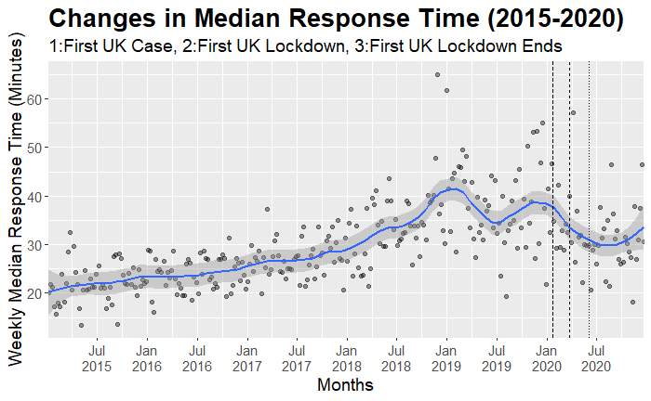

The median response time can also be disaggregated by grade, for this current grade was used. The median response time at each grade is 6.4, 30.6, 40.4, 23.3 and 15.4 all happen within the given time frames as stated in gmp incident response policy handbook

