**Project Identification**

|  |  |
| --- | --- |
| **Project:** | TopFit Fitness App |
| **Prepared By:** | Group 11 |
| **Document Version:** | Version 1.0 |
| **Published Date:** | 09/24/2019 |

**Contributors**

The following individuals contributed to this document:

| **Name** | **Title** |
| --- | --- |
| Vladyslav Bordiug | Developer |
| Parisa Khataei | Developer |
| Nadia Mokhireva | Developer |
| Muhammad Talha Sultan | Developer |
| Mahdi Esmaeelpour | Developer |

**Distribution**

This document is distributed to all the following people.

| **Name** | **Title** |
| --- | --- |
| Vladyslav Bordiug | Developer |
| Parisa Khataei | Developer |
| Nadia Mokhireva | Developer |
| Muhammad Talha Sultan | Developer |
| Mahdi Esmaeelpour | Developer |
| Anjana Shah | Instructor, Evaluator |

**Referenced Documents**

This document refers to the following materials

|  |  |  |  |  |
| --- | --- | --- | --- | --- |
| **Version number** | **Title** | **Author** | **Date** | **Source / Location** |
| V1.0 | T27_Project_Vision_Sample_Template.docx | Nadia Mokhireva | September 24, 2019 | https://github.com/NadiaMok/capstone |
| V1.0 | T27_Persona_And_Stories.docx | Mahdi Esmaeelpour | September 22, 2019 | https://github.com/NadiaMok/capstone |

**Revision History**

|  |  |  |  |
| --- | --- | --- | --- |
| **Version Number** | **Revision Date** | **Summary of Changes** | **Modified by** |
|  |  |  |  |
|  |  |  |  |
|  |  |  |  |

TABLE OF CONTENTS

1. Business Context Diagram 3

2. REquirements Scope Statements 4

3. High Level Business Requirements (HLR) Traceability 4

4. High Level Business Requirements Sign-Off 5

**Business Context Diagram**

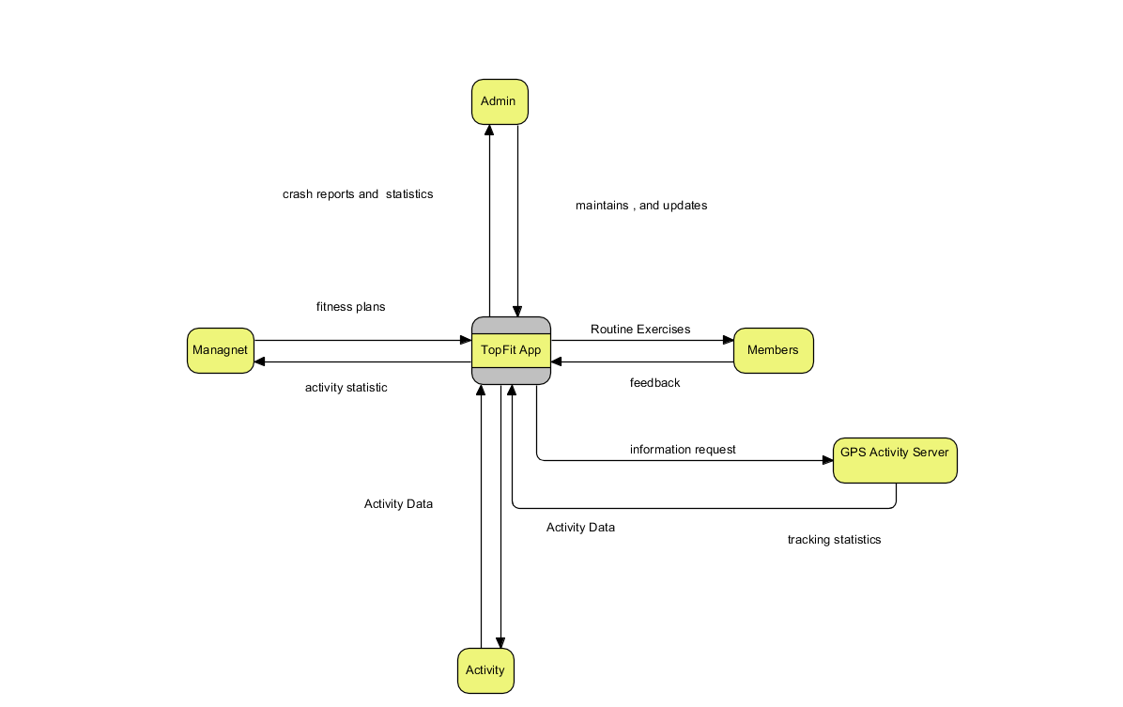

### Requirements Scope Statements

|  |  |
| --- | --- |
| **Requirement Scope Area** | **Description** |
| TopFit App | Area responsible for providing access to fitness app to members, management, admin, and services |

|  |  |
| --- | --- |
| **External Entity** | **Description** |
| Members | Clients of application that can access the application and its services after registrations |
| Management | Staff or shareholders who has access to Management accounts of application |
| Admin | Development team who provide maintains and updates of app |
| Activity | External are that provide access to all fitness exercises to members |
| GPS Server | External service that provides tracking statistics to members |

| **Information Flows** | **Description** |
| --- | --- |
| Tracking Statistics | Any running and walking statistics of member during exercises |
| Crash Repots | Crash reports send information to admins with logs of the problem |
| Feedback | Generated form from members to management about the app |
| Activity Data | Information about how often certain exercises is used by members |
| Maintains and Updates | Service provided by development team of keeping application running and providing updates of new features |
| Routine Exercises | Preset routine of exercise provided by fitness app to members |

High Level Business Requirements (HLR) Traceability

|  |  |  |
| --- | --- | --- |
| **HLR#** | **Description** | **Priority**  **(H, M, L)** |
| HLR01 | Member of TopFit must be able to create account | H |
| HLR02 | Member of TopFit must be able to set notification | H |
| HLR03 | Member of TopFit must be able to select Exercises that is best benefit him or her | H |
| HLR04 | Member of TopFit must be able to send feedback | H |
| HLR05 | Member of TopFit must be able to change language of application | M |
| HLR06 | Member of TopFit must be able to track performers of running and walking exercises with GPS module | H |
| HLR07 | Manager of TopFit must be able to access members accounts | H |
| HLR08 | Manager of TopFit must be able to delete accounts | H |
| HLR09 | Manager of TopFit must be able to create accounts | H |
| HLR10 | Member of TopFit must be able to rate application | H |
| HLR11 | Manager of TopFit must be able to rate application | L |

**High Level Business Requirements Sign-Off**

The undersigned acknowledge their agreement with the contents of Version 1.0 of the High-Level Requirements document for TopFit Fitness App.

Following approval of this document, requirements changes will be governed by the project’s change management process, including impact analysis and appropriate reviews and approvals, under the general control of the Project Plan and according to company policy. Approved Change Request Documents, if present, will be attached to this Requirements Document as updates.

|  |  |  |
| --- | --- | --- |
| **Name** | **Project Role and**  **Functional Area** | **Date Signed** |
| Vladyslav Bordiug | Front-End Developer, UI Designer | September 27, 2019 |
| Parisa Khataei | Developer, Tester | September 27, 2019 |
| Nadia Mokhireva | Back-End Developer | September 27, 2019 |
| Muhammad Talha Sultan | Developer, Tester | September 27, 2019 |
| Mahdi Esmaeelpour | Back-End Developer, Database Admin | September 27, 2019 |

* Note: physical signatures are not required. Email approvals are acceptable and should be appended to project documents.