**Rose Gilardoni**

**Age:** 44

**Occupation:** Software Developer

**Status:** Married

**Location:** Toronto, ON

**Role:** user

**Bio:** Rose is a full-time software developer who is also busy with freelance work. Apart from that, she is a mother to a 10-year-old girl and a 15-year-old boy. She has a very busy schedule and would like to devote some time to taking care of herself and working out to get back in shape.

**User Goal:** Rose is seeking an application that will allow her to organize her day more efficiently so she can fit her workout regime into daily basis. She wants the application to set regular reminders that encourage her to be more active.

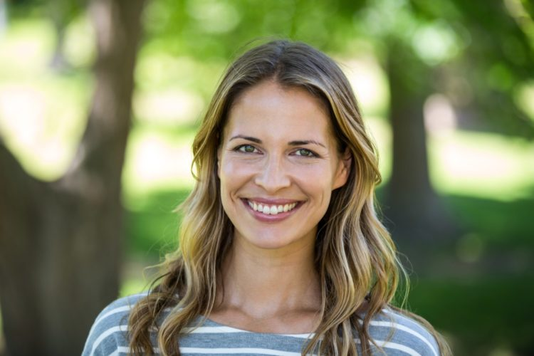

*I prefer to use online resources, because I need to be at home to look after my children.*

**User Stories:**

1. As a user, Rose must be able to select a workout length so that she can adjust it for availability.
2. As a user, Rose must be able to synchronize her exercise routines with her calendar so that activities don’t overlap.
3. As a user, Rose must be able to delete a workout from her calendar if her plans change.
4. As a user, Rose must be able to contact technical support should she discover a vulnerability so that the application still provides excellent service.
5. As a user, Rose should be able to receive notifications about an upcoming workout so that she doesn’t forget about it due to her busy schedule.

**Narina Shipton** 

*I am looking for a quick and effective workout that will assist me in managing my weight*

**Age:** 28

**Occupation:** Fashion Designer

**Status:** Single

**Location:** Toronto

**Role:** user

**Bio:** Narina is a fashionista who is truly passionate about the latest fashion trends, newest clothing lines, and fashion statements. In her free time, she enjoys shopping, getting her hair and nails done, and going out with her friends. She is a big of healthy lifestyle and enjoys being active.

**User Goal:** She wants to keep herself fit to find a partner and engage in life-long relationship. She is hoping that with the right guidance and proper exercise she will be able to feel more self-confident and stronger. Her primary goal is to pursue regular workout routines that will vary in length and intensity.

**User Stories:**

1. As a user, Narina must be able to track her progress so that she stays motivated.
2. As a user, Narina must be able to be reminded about a workout so that she can maintain a regular exercise schedule.
3. As a user, Narina should be able to choose different workouts for different times so that she can enjoy a wide variety of exercises.
4. As a user, Narina should be able to track her activity throughout the day so that she moves enough.

**Jack Forster**

**Age:** 21

**Occupation:** Student

**Status:** Single

**Location:** Toronto, ON

**Role:** developer intern, user

**Bio:** Jack is a full-time student, studying computer science. He needs to effectively manage his time between his personal time and school.Jack has no time to go to the gym so he wants an app which will make his life easier. He recently started an internship and is now helping to maintain the *TF* application.

**User Goal:** Jack’s goal is to have a balanced daily schedule. The app should allow him to meet his fitness goals by tracking his workout time and activities accurately. By taking on the internship, Jack is looking for some experience in maintaining mobile applications.



*I am looking for an application that can save my time for traveling and schedule my time for workouts.*

**User Stories:**

1. As a user, Jack must be able to schedule workout into his calendar so that he has a regular routine.
2. As a user, Jack must be able to change his workout preference any time so that he can try a different exercise.
3. As a developer, Jack must be able to add a new workout to the system, so that the customers can vary their routines.
4. As a developer, Jack should be able to remove a workout when it is not used much so that the system has only highly demanded content.

**Edmon McLoad**

**Age:** 37

**Occupation:** Architect, Entrepreneur

**Status:** Divorced

**Location:** Vancouver

**Role:** user

**Bio:** Edmon is a well-established architect with his own firm. With that comes a lot of responsibilities that take up a lot of his time. Along with that he is launching a new Home Designing company that will require to travel a lot, which will occupy a lot of his time. Consequently, he doesn’t have a lot of time to work out and is unable to attend a fitness facility.

**User Goal:** Edmon is seeking an app that will accommodate his busy schedule and provide him with exercise techniques that don’t require a gym or a trainer. Additionally, his goal is to be in shape and look fit by the time his new company will be launched.



*As an architect, I am too busy and need notifications to remind me It is time to work out.*

**User Stories:**

1. As a user, Edmon must be able to reschedule a workout so that he can still access it when his availability changes.
2. As a user, Edmon must be able to increase the worjout intensity so that he can get in shape faster.
3. As a user, Edmon should be able to track his daily activity so that he maintains a proper level of exercise.
4. As a user, Edmon should be able to receive notifications about an upcoming workout so that he doesn’t miss it.

**Maddy Hall**

**Age:** 57

**Occupation:** Medical Doctor

**Status:** Married

**Location:** Montreal

**Role:** user

**Bio:** Maddy is 57 years old. She is a doctor and has a big family: two children and 4 grandchildren. She worked for 30 years in different hospitals and clinics and is now retired, living in Montreal and enjoying her days. During her career she has seen the terrible consequences of not taking care of one’s health. This has encouraged her to pay attention to her lifestyle in order to stay healthy.

**User Goal:** Maddy seeks for the application to mentor her. She needs the activities that the app recommends to target her age group and be effective without tiring her out too much.



*I need to choose appropriate workouts for my age.*

**User Stories:**

1. As a user, Maddy must be able to receive suggested workouts based on her input data (age, gender, occupation) so that she can follow the routines that are best for her.
2. As a user, Maddy must be able to change the intensity of her workout so that she doesn’t over-exercise and thus harm herself.
3. As a user, Maddy should be able to contact technical support should she face an issue so that the problem is quickly fixed and she can continue using the application.

**Larry Hardage**



**Age:** 35

**Occupation:** Computer Technician

**Status:** Single

**Location:** Toronto

**Role:** user, technician

**Bio:** Larry is a certified technician who is in change of managing the TopFit application. He spends his free time learning new technical skills to keep himself up to date. He loves exploring new technology gadgets and is very fit because he uses TopFit daily.

**User Goal:** Larry wants the users of the gym application to be completely satisfied with the services provided. He collects feedbacks from the users and communicates the issues to the development team to make improvements.

**User Stories:**

*I am very passionate about maintaining excellent customer service.*

1. As a technician, Larry must be able to collect user feedback so that the development teams can make proper changes to the system.
2. As a technician, Larry must be able to change a workout content to keep users interested.
3. As a user, Larry must be able to communicate technical issues to the development team so that the service is not disrupted for long.
4. As a user, Larry must be able to modify personal data stored by the application so that the information is up to date.