An Interpretable Deep Learning System for Orbital Fracture Detection and Severe Globe Injury Prediction

Abstract
Background: Orbital fractures are frequently encountered in maxillofacial trauma and can be associated with severe globe injuries (SGI). Accurate and timely diagnosis is critical to prevent long-term complications, yet subtle fractures and soft tissue injuries may be overlooked. Recent advances in artificial intelligence offer promising tools to support clinical decision-making in such scenarios.
Methods: We collected CT images from 250 patients with orbital wall fractures treated at a single center between May 2020 and May 2023. From CT scans of 250 included subjects, a dataset of 18,000 annotated orbital CT scans (250 subjects) was used, with segmentation preprocessing based on a U-Net framework. Two supervised convolutional neural network (CNN) classifiers were trained on axial and coronal CT images of the orbit. The first model (FxDetectCNN) was trained to detect the presence of orbital fractures, while the second model (SGIDetectCNN) classifies the severity of injury into mild or severe categories. The models’ performance was compared with annotations by two experienced ophthalmologists.
Results: The fracture detection model achieved an overall accuracy of 81%, with 86% sensitivity and 76% specificity. The SGI estimation model achieved 64% accuracy, with a sensitivity of 80% and specificity of 48%, surpassing expert annotation, which reached a maximum accuracy of 59.5% for SGI estimation.
Conclusion: Our study demonstrates the feasibility of CNN models in detecting fractures and classifying the severity of ocular injuries from CT scans. These tools can assist non-specialist clinicians in triaging patients and may serve as valuable decision-support systems in emergency settings.
Keywords: Orbital fracture, Artificial intelligence, CT imaging, Deep learning, Ocular injury, Open globe injury, Closed globe injury

Introduction
Traffic collisions and sports-related injuries have led to a growing incidence of orbital fractures. Orbital fractures are one of the most frequently encountered facial fractures in maxillofacial surgery, accounting for up to 90% of such cases and approximately 3% of emergency room consultations [1, 2]. Accurate diagnosis of orbital fractures relies heavily on orbital tomography (CT) [3, 4]. While larger fractures are typically easy to identify using CT, more subtle fractures may be missed by non-experts. Moreover, orbital fractures may result in severe globe injuries (SGI), which can be sight-threatening and require urgent ophthalmic intervention [5].
Many studies have investigated clinical scoring systems that combine clinical and demographic data with radiologic findings to enhance the detection and assessment of ocular injuries in patients with orbital wall fractures [5-13]; however, none of these approaches have gained widespread use due to the challenges of applying them in real-world clinical settings. Recent advancements in deep learning methods resulted in the development of models that can improve the detection of orbital blowout fractures [14, 15]. For instance, Li et al. utilized convolutional neural networks (CNNs) combined with XgBoost to detect orbital blowout fractures, reporting a single-image accuracy of 92% and an area under the curve (AUC) of 0.9574 [16]. Umapathy et al. focused on volumetric analysis by using a modified U-Net model to quantify globe volumes, achieving a high F1 score of 0.95 [17]. In another AI-driven study, Bao et al. employed DenseNet-169 along with U-Net for the identification and segmentation of orbital fractures [18]. One of the limitations of these previous works is the lack of models trained and validated on complex, multi-wall orbital fractures.
Despite advances demonstrating the value of AI in orbital trauma diagnostics, AI-based prediction of severe globe injuries (SGI) in orbital fractures remains unexplored. Timely access to ophthalmologists in emergency settings remains limited, hindering the diagnosis and management of ocular injuries associated with orbital fractures. Severe ocular injuries are at risk of being overlooked by non-ophthalmologists, as specialized examination instruments, such as slit lamps and indirect ophthalmoscopes, are not always readily available in emergency departments and require specific training to use. Failure to promptly recognize ocular injuries may lead to serious long-term complications. To bridge this care gap, we introduce the development of two separate AI models: one for fracture detection and the second for predicting SGI in subjects with orbital wall fractures. This model aims to improve triage by non-ophthalmologists while serving as a decision-support system for ophthalmologists, enabling more precise and timely diagnosis [19].

Methods
This retrospective cohort study was conducted in accordance with the tenets of the Helsinki Declaration and was approved by the institutional ethics committee of Tehran University of Medical Sciences (IR.TUMS.FARABIH.REC.1401.026).
Dataset and annotations
Imaging from subjects diagnosed with orbital fractures at Farabi Eye Hospital between May 2020 and May 2023 were included in this study. Patients were eligible for inclusion if the interval from trauma to their first ophthalmologic examination was less than one week and if complete ophthalmologic evaluations, along with high-resolution fine-cut orbital CT scans (section thickness, 2 mm), were available. Subjects were excluded if visual acuity data were missing, whether due to patient non-cooperation (e.g., young age or inability to complete the Snellen chart) or incomplete documentation. Additionally, patients with a history of ocular surgery (e.g., corneoscleral repair, canthotomy, or cantholysis) were excluded.
Eyes with orbital fractures were labeled based on medical records documented by experienced oculoplastic surgeons (SMR, MTR). The severity of ocular injury was determined from clinical records using the modified Rossin classification [6] (Supplementary Table 1)[20]. In this system, ocular injuries associated with orbital fractures are categorized into four grades according to the urgency of ophthalmologic intervention. Injuries classified as grades 2 and 3 were considered severe globe injuries (SGI).
The dataset was randomly split into a training set (200 cases) and an internal validation set (50 cases). To establish a baseline for evaluating model performance against expert clinical judgment, two expert ophthalmologists (SMR and FS) independently annotated the validation dataset using CT imaging alone. Both experts reviewed 50 randomly selected samples and had access to all available imaging planes, including sagittal, coronal, and axial views.
Two experienced ophthalmologists were blinded to the clinical information and reviewed the CT scans independently. They evaluated for orbital fractures and recorded their locations.
Preprocessing
The dataset used in this study consists of high-resolution orbital CT images with corresponding annotations indicating whether a fracture is present and, for fractured cases, the severity (mild or severe). 18000 orbital CT slices were obtained from 250 included patients diagnosed with orbital fractures. All images were preprocessed to ensure uniform input sizes and consistent normalization for effective model training.
We extracted the axial dataset from DICOM files and standardized it by selecting 40 slices per case, since the number of slices varied across patients. To focus on the region of interest (ROI), specifically the eye globe and its surrounding orbital bones, we used the proposed U-Net network [1] to segment the mask. For each case, we began by defining an all-zero tensor. Next, we passed each axial slice through the model, added the output mask to the zero tensor, and repeated these steps for all slices. Finally, we applied a nonzero filter to identify the largest connected area, which was assumed to contain the eye globe. The processing area was then refined by applying dilation operations to the extracted mask. To enhance focus on relevant details, we applied a Hounsfield Unit (HU) window of -50 to 50 to the output. Finally, we extracted both eye globes, concatenated them into a single image, and normalized the resulting image to prepare it for further processing (Figure 1). At the next stage, each patient’s CT volume was processed to create two eye-specific samples (OS and OD). Rather than splitting the image by fixed pixel ranges, we isolated the orbital region by centering a crop on the midline of each axial or coronal slice. Specifically, the image was cropped around the middle and then symmetrically padded by 128 pixels on both the left and right sides to preserve the central field of view and ensure a consistent input size focused on the mid-orbital anatomy. This standardization step retained the mid portion of the scan where the orbits are best visualized while minimizing irrelevant peripheral content. Horizontal flipping was applied as needed to maintain anatomical consistency between left- and right-eye samples.
For patients with unilateral orbital fractures, each eye was treated as an independent sample, with the affected eye labeled as fracture (1) and the unaffected eye labeled as normal (0). Both samples were included in the dataset, using the contralateral eye as a within-patient control. For patients with bilateral orbital fractures, both eyes were included as separate positive samples, each labeled as fracture (1). Labels for OS and OD were extracted from the ground truth annotations and concatenated to form the final eye-level label set. This strategy increased the number of training instances while preserving the true fracture status of each eye and treating each orbit as an independent anatomical unit for classification.
Data augmentation techniques, including random rotations, flips, and zooms, were applied to increase the diversity of the training set and improve model robustness. Here, we aim to conduct two primary tasks: binary classification to detect the presence of a fracture (fracture vs. non-fracture) and binary classification to determine severity (severe vs. non-severe).

Model Architectures
We developed two convolutional neural network (CNN) architectures using 18,000 cropped CT images, focusing on the orbital region from the 250 included cases. The first, FxDetectCNN, integrates axial and coronal CT views via a dual-branch architecture to detect orbital fractures. The second, SGIDetectCNN, is a single-branch CNN that processes axial slices to classify fracture severity as severe or non-severe. This design allows the detection model to benefit from multi-view structural information, while the severity model emphasizes detailed axial features relevant to soft-tissue and optic nerve involvement.
The FxCNN_Model is designed to classify orbital CT images into fracture and non-fracture categories. It consists of two main branches, one processing the axial slice and the other the coronal slice. Both branches are equipped with convolutional layers, batch normalization, and max-pooling operations to extract spatial features from the input images. The two branches are then concatenated to create a joint representation, which is passed through a fully connected layer for final classification. The model structure is displayed in Figure 2. The SGIDetectCNN is intended to classify fractures as non-severe or severe. This model uses a similar structure to the fracture classification model (Figure 3).
The models were trained with a 75-25 train-test split, using the training set for optimization and the validation set for evaluation. Training employed Binary Cross Entropy Loss and Adam optimizer with an initial learning rate of 10⁻³, reduced by a factor of 10 every 5 epochs if validation loss did not improve. A batch size of 8 was chosen, with a maximum of 50 epochs and early stopping if validation loss did not improve for 10 consecutive epochs. L1 and L2 regularization, and dropout layers were applied to prevent overfitting. Model performance was tracked after each epoch, with the best model based on validation accuracy saved.
All experiments were conducted on a machine equipped with an NVIDIA GTX 1660 GPU, and total training time per model ranged from 5 to 10 minutes, depending on the number of epochs and model complexity.
Statistical Analysis
All statistical analyses were performed using the open-source software PyTorch (version 2.3.1) and Python 3.12.4. The data were presented as averages with standard deviations for continuous variables and as counts for categorical variables. Classification accuracy was evaluated using sensitivity, specificity, and F1 score (harmonic mean of recall and precision).

Results
250 subjects met the eligibility criteria, comprising 205 males (81.9%) and 45 females (18.1%), with a mean age of 32.9 ± 14.42 years (range: 5–79 years). Fracture laterality was recorded as left eye in 128 and right eye in 122 cases. Details of demographic and radiologic features of included subjects are summarized in Supplementary Table 2.
The dataset comprised 200 training and 50 internal validation volumetric orbital CT scans, each annotated with the affected eye's laterality. Each CT scan consisted of an axial volumetric series centered on the orbital region. Laterality information was used to standardize anatomical orientation during preprocessing, as described in the Methods section.
Fracture detection
The FxDetectCNN achieved an overall accuracy of 81% in detecting orbital bone fractures, with a sensitivity of 86% and specificity of 76%. In addition, the F1 score was 0.82, indicating substantial agreement between model predictions and ground-truth annotations. These results demonstrate that the model performs particularly well at detecting severe or positive injury cases, a critical capability in clinical applications where the cost of false negatives can lead to significant diagnostic and therapeutic delays and critical diagnostic oversights. Figure 4 presents the confusion matrix for orbital fracture detection, and Supplementary Figure 1 shows the training and validation performance across 20 epochs. For orbital fracture detection, the FxDetectCNN achieved an area under the ROC curve (AUC) of 0.83, indicating good discriminative ability (Figure 6).
SGI Estimation
A separate network, SGIDetectCNN, was trained to classify orbital injury severity as severe or non-severe. The model achieved an overall accuracy of 64%, with a sensitivity of 80%, a specificity of 48%, and an F1 score of 0.69. This indicates a strong ability to detect severe cases, although the model showed limitations in differentiating non-severe injuries. We compared the SGIDetectCNN model's performance with other classification models, demonstrating its superiority with an F1 score of 0.69. Supplementary Figure 2 shows the training and validation performance across 20 epochs. For severe globe injury (SGI) estimation, the SGIDetectCNN achieved an AUC of 0.75, demonstrating moderate discrimination between severe and non-severe injuries (Figure 7).

Table 1. Performance of the severity estimation model compared with prior studies (Table 1).
 | Accuracy | Sensitivity | Specificity | F1 score
SGIDetectCNN | 64% | 80% | 48% | 0.69
EfficientNet | 54% | 44% | 64% | 0.49
GoogLeNet | 58% | 64% | 52% | 0.60
VGG16 | 58% | 92% | 24% | 0.68

  - Expert performance
The first expert (FS) achieved 94.0% accuracy in binary injury detection and 56.5% in injury severity estimation. The second expert (SMR) demonstrated comparable accuracy for fracture detection (94.0%) and slightly higher accuracy for severity estimation (59.5%). Figures 4 and 5 illustrate the expert-annotated outcomes for injury severity estimation.
These findings highlight the importance of using interpretable models that capture clinically relevant patterns and emphasize key features for both injury detection and severity estimation. To clarify the model’s decision-making process, we applied Gradient-weighted Class Activation Mapping (Grad-CAM) to generate visual explanations of the predictions.
As shown in Figure 6, the model’s attention maps varied across injury classifications. In fracture cases, the focus was primarily on the bony structures of the orbit, whereas in mild, non-fracture cases, attention shifted to non-bony regions, reflecting sensitivity to subtle soft-tissue changes. Similarly, the Grad-CAM heatmaps in Figure 6 consistently highlighted anatomically meaningful areas that contributed to the model’s decisions. Several of these regions corresponded to subtle radiological features not readily identifiable to human experts, suggesting that the model may detect diagnostic cues that are often overlooked in standard evaluations.
In the severity estimation model, Grad-CAM revealed concentrated attention in clinically relevant areas when severe injuries were present (Figure 7). By contrast, in mild cases, the attention maps were more diffuse and extended into peripheral regions, which are less indicative of severity (Figure 7). This pattern suggests that while the model reliably localizes diagnostic features in severe injuries, its interpretability and confidence decrease when distinguishing more subtle presentations.
Discussion
Fine-cut orbital CT scans are the gold standard for diagnosing orbital wall fractures and for planning their management [21]. Although a comprehensive ophthalmic examination is the most reliable method for diagnosing severe ocular injuries associated with orbital wall fractures, factors such as decreased level of alertness or coexisting conditions, including severe periorbital edema, may limit emergency physicians' ability to accurately assess and manage ocular injuries [22]. Additionally, the intraconal and extraconal fatty pads around the globe provides excellent contrast, revealing details of eye structures Recent studies also provided clues that certain aspects of CT imaging can be used to predict SGIs, including the location of the fracture [6] and the muscle involvement [20].
The present study demonstrates the potential of an interpretable CNN framework for the dual tasks of orbital fracture detection and injury severity estimation from CT scans. Our model achieved 81% accuracy for fracture detection and 64% for severity estimation. The implementation of Grad-CAM provided crucial model interpretability, confirming that its diagnostic focus aligns with clinically relevant anatomical structures. Notably, the severity estimation model demonstrated greater consistency than the diagnostic agreement among human experts (56.5%–59.5%), suggesting that such AI systems can be used to reduce inter-observer variability and enhance diagnostic reliability in orbital trauma assessment.
Most applications of artificial intelligence in orbital fractures have focused on detecting and segmenting blowout fractures. Kim et al. (2025) achieved an accuracy of 99.47% for blowout fracture detection [23], while studies by Bao et al. (2023) and Li et al. (2020) also reported accuracies exceeding 92% using various deep learning architectures [16, 18]. The work by Li et al. (2024), which utilized a dual-network system (YOLOv7 for detection and an enhanced UNet for segmentation), achieved a detection F1-score of approximately 76.8% and a high segmentation Dice coefficient of 90.2% [24]. The hierarchical system developed by Oku et al. (2025) achieved excellent performance in classifying fracture morphology, with patient-level sensitivity of 94.7% for detection and 100% for differentiating clinically urgent trap-door fractures [25]. While these models demonstrated excellent performance, their scope was often confined to specific fracture subtypes. A significant contribution of this research is its departure from the current focus on isolated blowout fractures in the existing literature. By developing a model trained on an inclusive dataset encompassing all fracture morphologies, including complex multi-wall patterns, our framework possesses enhanced ecological validity. The FxDetectCNN model showed an acceptable performance for the detection of fractures in a dataset of 250 cases with mixed orbital wall fractures; however, further model adjustment on a larger dataset is required to improve the model’s accuracy.
To our knowledge, this study is the first to apply deep learning to improve SGI prediction in patients with orbital fractures. Estimating injury severity using only orbital CT scans has inherent limitations; for example, mild anterior segment hemorrhage or small full-thickness corneal lacerations cannot be detected with imaging alone. However, the widespread availability of CT in emergency departments and the difficulty in performing full ocular examinations by non-ophthalmologists in acute settings justifies efforts to enhance its utility by incorporating deep learning techniques. The SGIDetectCNN model achieved 64% accuracy on this complex task, surpassing the rates of expert clinicians. Although the specificity for severity estimation was moderate (48%), the model’s high sensitivity (80%) underscores its potential as a robust screening tool for the early identification of severe cases where timely intervention is paramount. Future studies are suggested to evaluate model performance in a prospective cohort to demonstrate its potential to improve clinical outcomes.
This study has several limitations. The model was developed using a modest sample size of 250 cases and 18000 CT slices from a single institution, which may limit the generalizability of our findings. The observed variability in expert annotations for severity grading highlights the intrinsic subjectivity of the SGI diagnostic task. Finally, the model input in this paper was only orbital CT scans, which have inherent li Future work could focus on building models that integrate optical imaging, such as fundus photography and optical coherence tomography, with CT scans.
Conclusion

This study introduces a novel deep learning framework that can detect the full spectrum of orbital fractures and estimate injury severity, with interpretable outputs. These models achieved clinically relevant performance, with the severity estimation model performing better than expert ophthalmologists. This work is a first step toward applying AI as a decision-support tool to standardize triage and reduce diagnostic variability in emergency settings where specialized expertise may not be immediately available.

Data Availability
The datasets used and analyzed during the current study are available from the corresponding author on reasonable request.

Code Availability
The full implementation and training scripts are publicly available at: https://github.com/Nadiam75/orbital-injury-detection/
References:

1. Scolozzi, P., Reflections on a patient-centered approach to treatment of blow-out fractures: Why the wisdom of the pastmust guide our decision-making. Journal of Plastic, Reconstructive & Aesthetic Surgery, 2022. 75(7): p. 2268-2276.
2. Bord, S.P. and J. Linden, Trauma to the Globe and Orbit. Emergency Medicine Clinics of North America, 2008. 26(1): p. 97-123.
3. Rhee, S.H., et al., Effectiveness of Computed Tomography for Blow-out Fracture. Maxillofac Plast Reconstr Surg, 2014. 36(6): p. 273-9.
4. Santos, D., et al., Computed tomography imaging strategies and perspectives in orbital fractures. Journal of applied oral science : revista FOB, 2007. 15: p. 135-9.
5. Zhong, E., et al., Orbital Fractures and Risk Factors for Ocular Injury. Clinical Ophthalmology, 2022: p. 4153-4161.
6. Rossin, E.J., et al., Factors Associated With Increased Risk of Serious Ocular Injury in the Setting of Orbital Fracture. JAMA Ophthalmol, 2021. 139(1): p. 77-83.
7. Andrews, B.T., et al., Orbit fractures: identifying patient factors indicating high risk for ocular and periocular injury. The Laryngoscope, 2016. 126: p. S5-S11.
8. Chow, J., et al., Primary assessment of the patient with orbital fractures should include pupillary response and visual acuity changes to detect occult major ocular injuries. Journal of oral and maxillofacial surgery, 2018. 76(11): p. 2370-2375.
9. Ho, T.Q., et al., The incidence of ocular injuries in isolated orbital fractures. Annals of plastic surgery, 2017. 78(1): p. 59-61.
10. Layton, C.J., Factors associated with significant ocular injury in conservatively treated orbital fractures. Journal of ophthalmology, 2014. 2014.
11. Richani, K., et al., Screening criteria for detecting severe ocular injuries in the setting of orbital fractures. Ophthalmic Plastic & Reconstructive Surgery, 2019. 35(6): p. 609-614.
12. Dutton, G., et al., Ophthalmic consequences of mid-facial trauma. Eye, 1992. 6(1): p. 86-89.
13. Lange, C., et al., Resolving the clinical acuity categories “hand motion” and “counting fingers” using the Freiburg Visual Acuity Test (FrACT). Graefe's Archive for Clinical and Experimental Ophthalmology, 2009. 247: p. 137-142.
14. Niño-Sandoval, T.C., F.S. Landim, and B.C. Vasconcelos, Deep Learning for Orbital Fracture Detection and Reconstruction: A Systematic Review on Diagnostic Accuracy and Surgical Planning. Journal of Cranio-Maxillofacial Surgery, 2025.
15. Ekman, T., A. Barakat, and E. Heiberg, Generalizable deep learning framework for 3D medical image segmentation using limited training data. 3D Printing in Medicine, 2025. 11(1): p. 1-18.
16. Li, L., et al., Deep Convolutional Neural Networks for Automatic Detection of Orbital Blowout Fractures. J Craniofac Surg, 2020. 31(2): p. 400-403.
17. Umapathy, L., et al., Fully Automated Segmentation of Globes for Volume Quantification in CT Images of Orbits using Deep Learning. AJNR Am J Neuroradiol, 2020. 41(6): p. 1061-1069.
18. Bao, X.L., et al., Automatic Identification and Segmentation of Orbital Blowout Fractures Based on Artificial Intelligence. Transl Vis Sci Technol, 2023. 12(4): p. 7.
19. Wawer Matos, P.A., et al., Artificial Intelligence in Ophthalmology - Status Quo and Future Perspectives. Semin Ophthalmol, 2023. 38(3): p. 226-237.
20. Salari, F., et al., Prediction of substantial closed-globe injuries in orbital wall fractures. Int Ophthalmol, 2024. 44(1): p. 219.
21. Boyette, J.R., J.D. Pemberton, and J. Bonilla-Velez, Management of orbital fractures: challenges and solutions. Clin Ophthalmol, 2015. 9: p. 2127-37.
22. Lee, H.J., et al., CT of orbital trauma. Emerg Radiol, 2004. 10(4): p. 168-72.
23. Kim, S., et al., Deep-Learning Method for the Diagnosis and Classification of Orbital Blowout Fracture Based on Computed Tomography. Journal of Oral and Maxillofacial Surgery.
24. Li, Y.-L., et al., Automatic detection of optic canal fractures and recognition and segmentation of anatomical structures in the orbital apex based on artificial intelligence. Frontiers in Cell and Developmental Biology, 2025. Volume 13 - 2025.
25. Oku, H., et al., Hierarchical deep learning system for orbital fracture detection and trap-door classification on CT images. Computers in Biology and Medicine, 2025. 196: p. 110732.

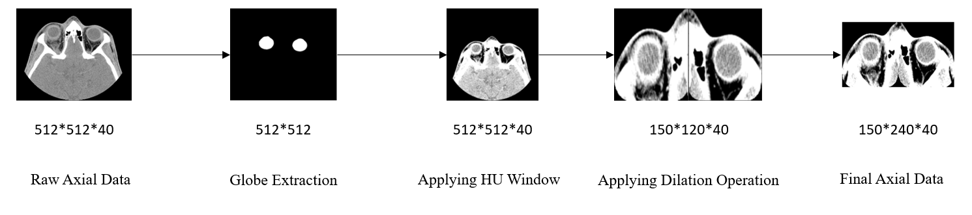
Figure 1. Preprocessing steps for axial CT images.
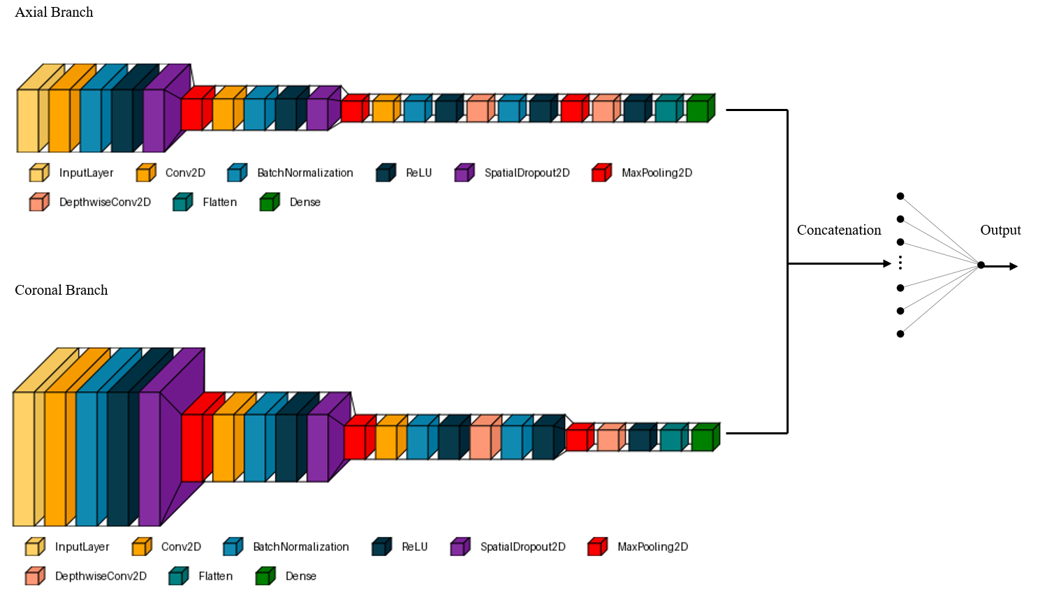

Axial Branch
Coronal Branch

Figure 2. Model structure for fracture detection (FxDetectCNN)
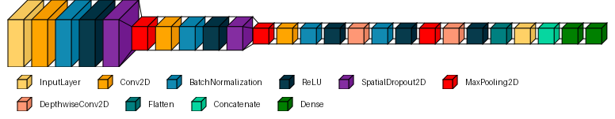
Severity Estimation

Figure 3. Model structure for detection of severe ocular injuries ( SGIDetectCNN).
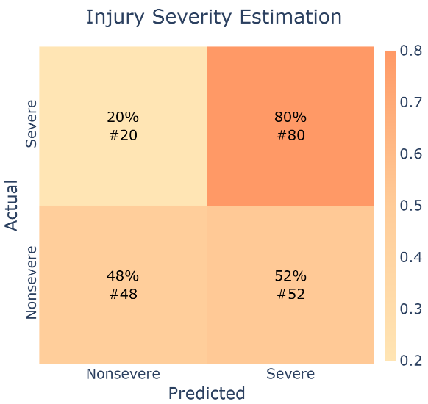
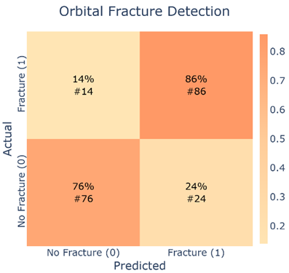
Figure 4. Confusion matrix for orbital fracture detection (left) and injury severity estimation (right).

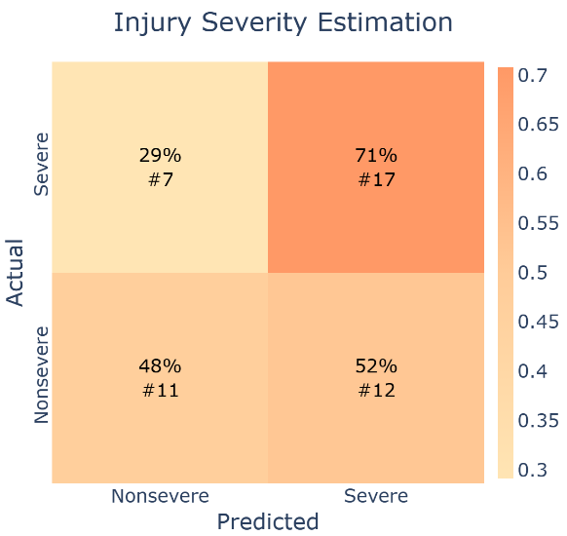
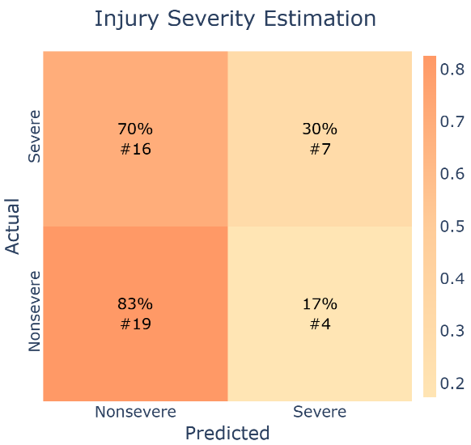
Figure 5. Expert annotations by (a): FS: 56.5% (b): SS: 59.5% for the task of injury severity estimation.
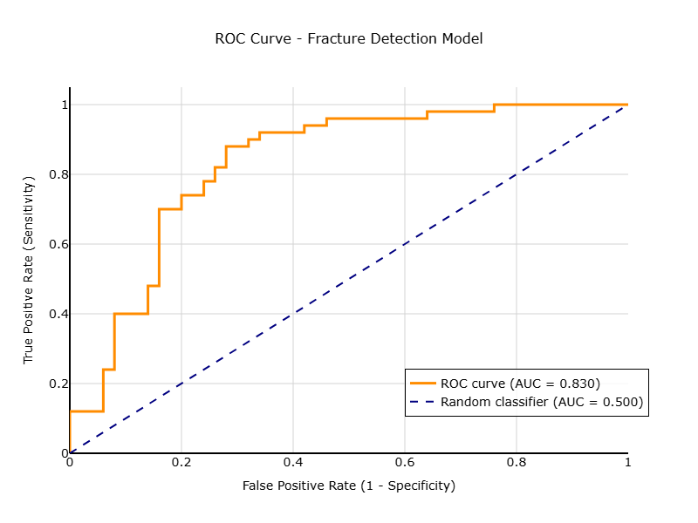
Figure 6. ROC curve for fracture detection (FxDetectCNN).
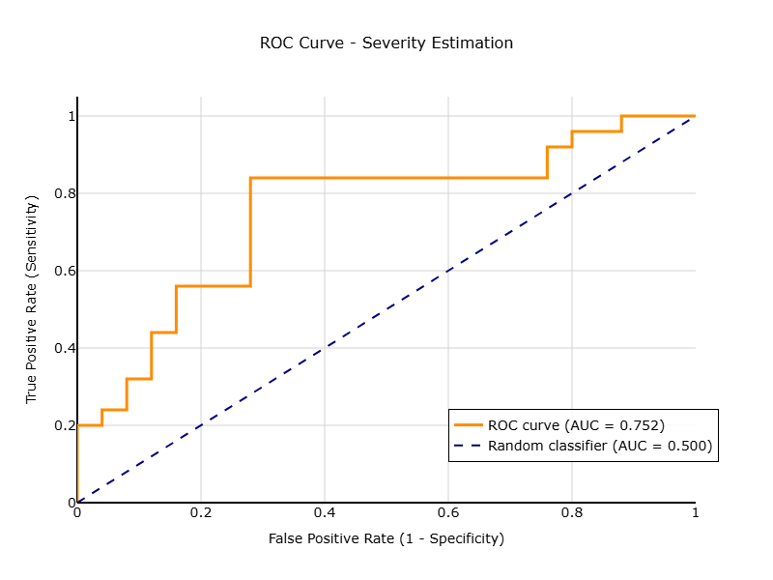
Figure 7. ROC curve for severity estimation (SGIDetectCNN).

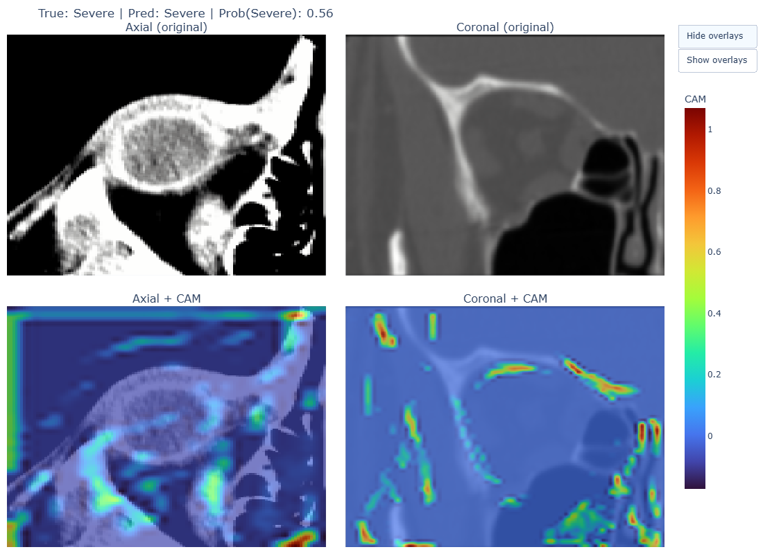

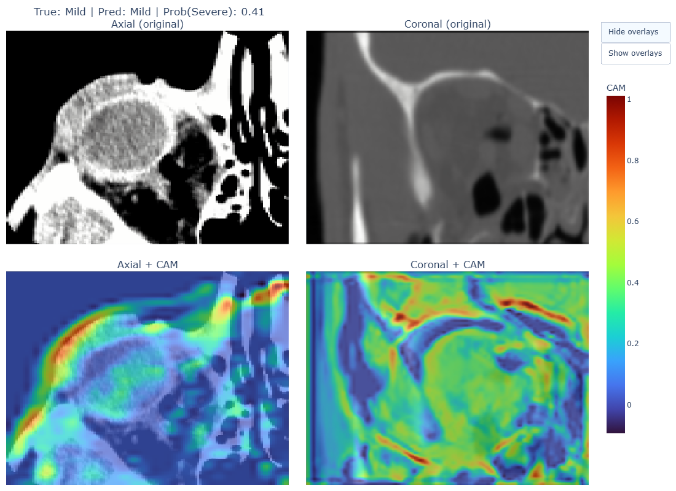
Figure 8. Grad-CAM Visualizations Highlighting Model Attention for Fracture Detection Model (Top) severe and (Down) mild.

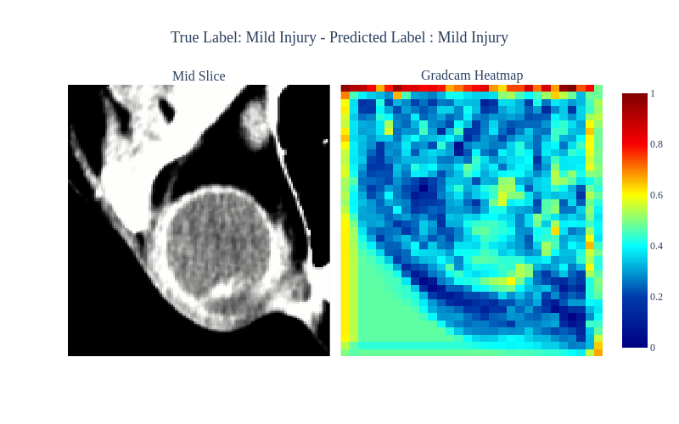
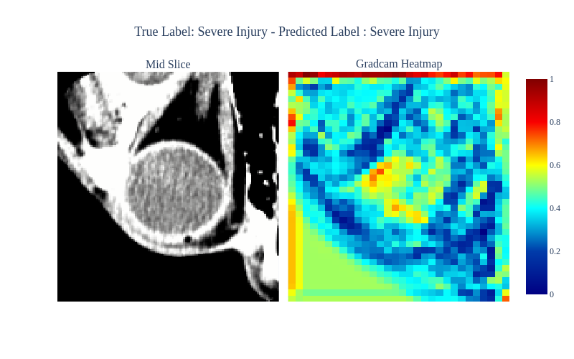
Figure 9. Grad-CAM Heatmaps for model predictions across injury severity levels

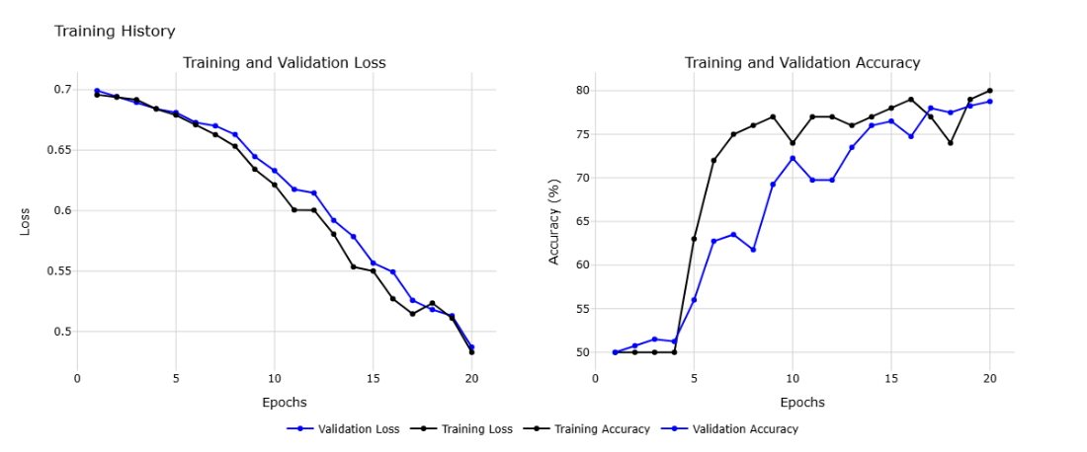
Supplementary Figure 1. Training and validation loss and accuracy over 20 Epochs for fracture detection network.
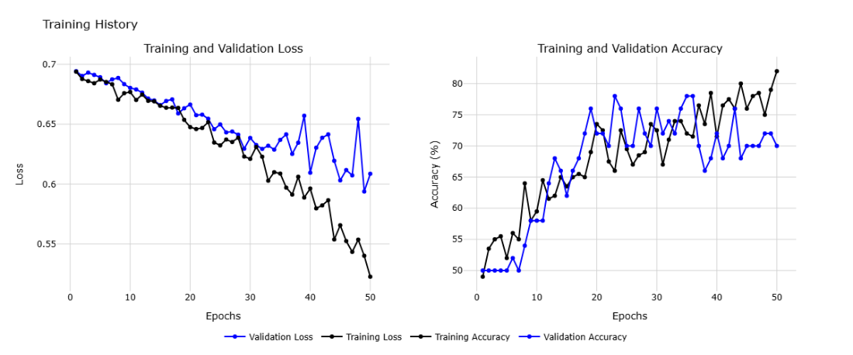
Supplementary Figure 2. Training and validation loss and accuracy over 50 Epochs for severe ocular injury detection.

Supplementary Table 1. Criteria used to define severe globe injuries (SGI)
Grade 0 (Not significant):
conjunctival injection, periorbital edema, or ecchymosis
lid laceration
Grade 1 (non-severe, no need for treatment):
subconjunctival hemorrhage, chemosis
punctate epithelial erosion, corneal abrasion less than 1mm
iritis trace or 1+, microscopic hyphema trace or 1+
Grade 2 (severe, outpatient follow-up)
conjunctival laceration
large corneal abrasion, corneal epithelial defect
microscopic hyphema 2+ and more, traumatic iritis (2+ and more), clot hyphema
Angle recession, High IOP (> 30), hypotony (< 10)
iridodonesis, sphincter rupture, traumatic cataract
vitreous hemorrhage, choroidal rupture, intraretinal hemorrhage, commotio retinae
Grade 3 (severe, urgent ophthalmic attention):
Intrastromal foreign body, corneoscleral laceration, globe rupture
Dislocated crystalline lens or intraocular lens, traumatic cataract with the open lens capsule
traumatic macular hole, retinal tear, traumatic retinal detachment

Supplementary Table 2: Clinical and imaging features of included subjects.
 |  | Training Dataset (n=200) | Validation Dataset (n=50) | P Value
Sex | Female | 40(20%) | 7(14%) | 0.33
Age |  | 31.75±13.8 | 30.18±11.81 | 0.46
Trauma setting, n (%) | Assault | 109(54.5%) | 22(44%) | 0.18
 | Explosion | 3(1.5%) | 0(0%) | <0.001
 | Fall | 11(5.5%) | 2(4%) | 0.90
 | Occupational | 19(9.5%) | 9(18%) | 0.09
 | Road traffic accidents | 37(18.5%) | 11(22%) | 0.57
 | Sport | 6(3%) | 2(4%) | 0.72
 | NS | 15(7.5%) | 4(8%) | 0.9
Low vision | Able to count fingers at 2 ft | 170(85%) | 43(86%) | 0.86
 | Unable to count fingers at ≥2 ft | 30(15%) | 7(14%) | 0.86
Number of fractured walls | 1 | 1.68±0.77 | 1.6±0.72 | 0.53
Trauma type, n (%) | Closed globe injury | 185(92.5%) | 46(92%) | 0.90
 | Open globe injury | 15(7.5%) | 4(8%) | 0.90
Zone | 1 | 92(46%) | 25(50%) | 0.61
 | 2 | 27(13.5%) | 7(14%) | 0.92
 | 3 | 81(40.5%) | 18(36%) | 0.56
Severity of globe injury | Non-severe | 100(50%) | 25(50%) | 1
 | Severe | 100(50%) | 25(50%) | 1
Severity score of globe injury (SGI) | 0 | 35(17.5%) | 10(20%) | 0.68
 | 1 | 65(32.5%) | 15(30%) | 0.73
 | 2 | 80(40%) | 20(40%) | 1
 | 3 | 20(10%) | 5(10%) | 1
Inferior wall fracture, n (%) | 1 | 166(83%) | 44(88%) | 0.39
Medial wall fracture, n (%) | 1 | 113(56.5%) | 23(46%) | 0.18
Lateral wall fracture, n (%) | 1 | 38(19%) | 8(16%) | 0.62
Superior wall fracture, n (%) | 1 | 17(8.5%) | 5(10%) | 0.73

