Supplementary Figure 1. Training and validation loss and accuracy over 20 Epochs for the fracture detection network.

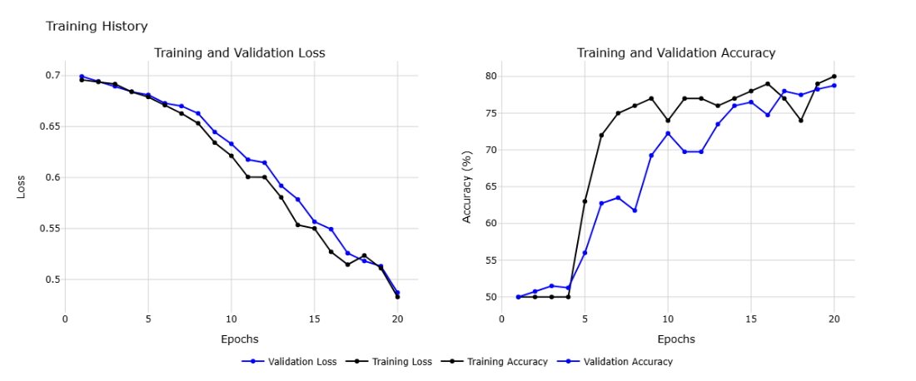

Supplementary Figure 2. Training and validation loss and accuracy over 50 Epochs for severe ocular injury detection.

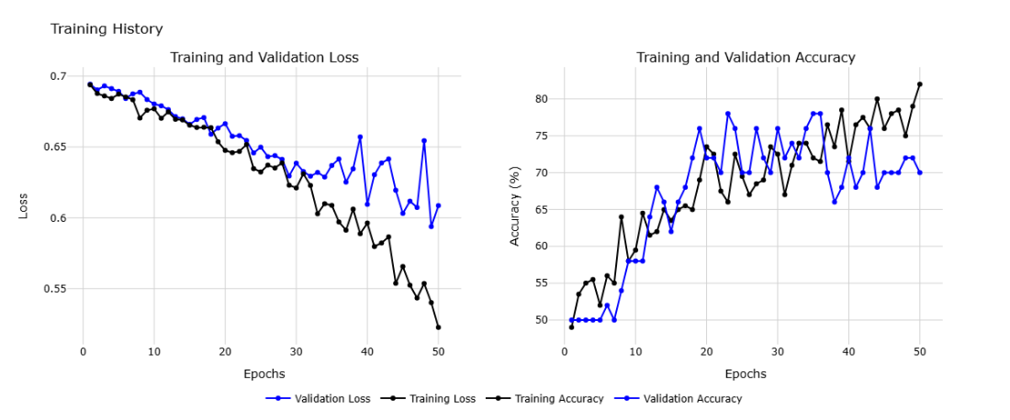

Supplementary Table 1. Criteria used to define severe globe injuries (SGI)
Grade 0 (Not significant):
conjunctival injection, periorbital edema, or ecchymosis
lid laceration
Grade 1 (non-severe, no need for treatment):
subconjunctival hemorrhage, chemosis
punctate epithelial erosion, corneal abrasion less than 1mm
iritis trace or 1+, microscopic hyphema trace or 1+
Grade 2 (severe, outpatient follow-up)
conjunctival laceration
large corneal abrasion, corneal epithelial defect
microscopic hyphema 2+ and more, traumatic iritis (2+ and more), clot hyphema
Angle recession, High IOP (> 30), hypotony (< 10)
iridodonesis, sphincter rupture, traumatic cataract
vitreous hemorrhage, choroidal rupture, intraretinal hemorrhage, commotio retinae
Grade 3 (severe, urgent ophthalmic attention):
Intrastromal foreign body, corneoscleral laceration, globe rupture
Dislocated crystalline lens or intraocular lens, traumatic cataract with the open lens capsule
traumatic macular hole, retinal tear, traumatic retinal detachment

Supplementary Table 2: Clinical and imaging features of included subjects.
 |  | Training Dataset (n=200) | Validation Dataset (n=50) | P Value
Sex | Female | 40 (20%) | 7(14%) | 0.33
Age |  | 31.75±13.8 | 30.18±11.81 | 0.46
Trauma setting, n (%) | Assault | 109 (54.5%) | 22 (44%) | 0.18
 | Explosion | 3 (1.5%) | 0 (0%) | <0.001
 | Fall | 11 (5.5%) | 2 (4%) | 0.90
 | Occupational | 19 (9.5%) | 9 (18%) | 0.09
 | Road traffic accidents | 37 (18.5%) | 11 (22%) | 0.57
 | Sport | 6 (3%) | 2 (4%) | 0.72
 | NS | 15 (7.5%) | 4 (8%) | 0.9
Low vision | Able to count fingers at 2 ft | 170 (85%) | 43 (86%) | 0.86
 | Unable to count fingers at ≥2 ft | 30 (15%) | 7 (14%) | 0.86
Number of fractured walls | 1 | 1.68±0.77 | 1.6±0.72 | 0.53
Trauma type, n (%) | Closed globe injury | 185 (92.5%) | 46 (92%) | 0.90
 | Open globe injury | 15 (7.5%) | 4 (8%) | 0.90
Zone | 1 | 92 (46%) | 25 (50%) | 0.61
 | 2 | 27 (13.5%) | 7 (14%) | 0.92
 | 3 | 81 (40.5%) | 18 (36%) | 0.56
Severity of globe injury | Non-severe | 100 (50%) | 25 (50%) | 1
 | Severe | 100 (50%) | 25 (50%) | 1
Severity score of globe injury (SGI) | 0 | 35 (17.5%) | 10 (20%) | 0.68
 | 1 | 65 (32.5%) | 15 (30%) | 0.73
 | 2 | 80 (40%) | 20 (40%) | 1
 | 3 | 20 (10%) | 5 (10%) | 1
Inferior wall fracture, n (%) | 1 | 166 (83%) | 44 (88%) | 0.39
Medial wall fracture, n (%) | 1 | 113 (56.5%) | 23 (46%) | 0.18
Lateral wall fracture, n (%) | 1 | 38 (19%) | 8 (16%) | 0.62
Superior wall fracture, n (%) | 1 | 17 (8.5%) | 5 (10%) | 0.73

