Deep learning-based detection of severe ocular injuries in orbital fractures
Abstract
Background: Orbital fractures are frequently encountered in maxillofacial trauma and can be associated with significant ocular injury. Accurate and timely diagnosis is critical to prevent long-term complications, yet subtle fractures and soft tissue injuries may be overlooked, especially in emergency settings lacking ophthalmology expertise. Recent advances in artificial intelligence (AI) offer promising tools to support clinical decision-making in such scenarios.
Methods: We developed and evaluated two supervised CNN classifiers trained on axial and coronal orbital CT images. The first model (AxCorCNN_Model) was trained to detect the presence of orbital fractures, while the second model (AxCNN_Model) classified injury severity into mild or severe categories. A dataset of 250 annotated orbital CT scans was used, with segmentation preprocessing based on a U-Net framework. Model performance was compared with annotations by two experienced ophthalmologists. Gradient-weighted Class Activation Mapping (Grad-CAM) was used to visualize decision regions.
Results: The fracture detection model achieved an overall accuracy of 81%, with 86% sensitivity and 76% specificity. The severity estimation model reached 64% accuracy, with a sensitivity of 80% and specificity of 48%. Expert annotation yielded 94% accuracy for injury detection, but lower accuracy for severity estimation (56.5%–59.5%). Grad-CAM analysis revealed that the models focused on clinically relevant orbital structures, with distinct patterns for mild versus severe injuries.
Conclusion: Our study demonstrates the feasibility of convolutional neural network (CNN) models with Grad-CAM–based interpretability in detecting and classifying orbital injuries from CT scans. These tools can assist non-specialist clinicians in triaging patients and may serve as valuable decision-support systems in emergency settings, especially where ophthalmology consultation is not immediately available.
Keywords: Orbital fracture, Artificial intelligence, CT imaging, Deep learning, Injury severity, Emergency diagnostics

Introduction
Traffic collisions and sports-related injuries have contributed to a growing incidence of orbital fractures. Orbital fractures are the most frequently encountered facial fractures in maxillofacial surgery, accounting for up to 90% of such cases and approximately 3% of emergency room consultations [1, 2]. Accurate diagnosis of orbital fractures relies heavily on orbital tomography (CT) [3, 4]. While larger fractures are typically easy to identify using CT, smaller or more subtle fractures may be missed during visual assessment.
Recent studies have investigated clinical scoring systems and artificial intelligence to enhance the detection and assessment of orbital and ocular injuries. Building on AI applications, Li et al. utilized convolutional neural networks (CNNs) combined with XGBoost to detect orbital blowout fractures, reporting a single-image accuracy of 92% and an area under the curve (AUC) of 0.9574 [5]. Umapathy et al. focused on volumetric analysis by using a modified U-Net model to quantify globe volumes, achieving a high F1 score of 0.95 [6]. Rossin et al. developed a practical bedside tool for ocular injury prediction, which demonstrated a sensitivity of 95% [7]. In another AI-driven study, Bao et al. employed DenseNet-169 along with U-Net for the identification and segmentation of orbital fractures [8]. These advancements highlight the growing role of AI and predictive tools in enhancing diagnostic accuracy and clinical decision-making for orbital trauma.
Timely access to ophthalmologists in emergency settings remains limited, creating challenges in diagnosing and managing ocular injuries linked to orbital fractures. Closed-globe injuries are especially at risk of being overlooked by non-ophthalmologists due to limited specialized training. Failure to promptly recognize ocular injuries may lead to serious long-term complications, highlighting the importance of early detection. Several scoring systems have been proposed to aid non-ophthalmologists in diagnosis of orbital fractures [9-11]. However, these tools have not been widely adopted in clinical practice due to their complexity and lack of validation.
To bridge this gap in care, we introduce the development of an AI model that evaluates the severity of intra-orbital injuries on CT scans. This model aims to improve triage by non-ophthalmologists while serving as a decision-support system for ophthalmologists, enabling more precise and timely diagnosis [12].

Methods
  - Patients and study design

Patients diagnosed with orbital fractures at Farabi Eye Hospital between [Month Year] and [Month Year] were included in this study. A total of N = 250 patients met the eligibility criteria, comprising 205 males (81.9%) and 45 females (18.1%), with a mean age of 32.9.X ± 14.42 years (range: 5–79 years). Fracture laterality was recorded as OS (left eye) in 128 and OD (right eye) in 122 cases.
Patients were eligible for inclusion if the interval from trauma to their first ophthalmologic examination was less than one week and if complete ophthalmologic evaluations along with high-resolution fine-cut orbital CT scans were available. Records were excluded if visual acuity data were missing, whether due to patient non-cooperation (e.g., young age or inability to complete the Snellen chart) or incomplete documentation. Additionally, patients with a prior history of corneoscleral repair, canthotomy, or cantholysis at another medical facility were excluded.
Medical records were reviewed to collect data on age, sex, time to presentation, trauma setting, trauma mechanism (foreign object vs. body part), and uncorrected visual acuity (UCVA), which was converted into LogMAR scores. UCVA values of counting fingers, hand motion, light perception, and no light perception were recorded as 2, 2.4, 2.7, and 3 LogMAR units, respectively .
Objective clinical signs, including eyelid lacerations, periorbital edema or ecchymosis, limitation in extraocular motility (EOM), and conjunctival hemorrhage, were documented. Due to the retrospective design of the study, subjective symptoms such as diplopia and pain with eye movement were excluded from model development due to >30% missing data.
All available slit-lamp and fundus examination findings were recorded. The severity of closed-globe ocular injury was graded using the modified Rossin classification system, which stratifies ocular injuries with concurrent orbital fractures into four categories based on the urgency of ophthalmic care. For this study, injuries categorized as grade 2 or 3—indicating conditions requiring ophthalmologic attention—were defined as severe ocular injury (SOI).
Ocular injuries were also classified according to the Birmingham Eye Trauma Terminology (BETT) system into closed-globe and open-globe injuries, and further stratified by injury zone. Additionally, the presence of optic nerve injuries (ONI), including traumatic optic neuropathy and retrobulbar compartment syndrome, was recorded.
  - Preprocessing
The dataset used in this study consists of high-resolution orbital CT images with corresponding annotations indicating whether a fracture is present or not, as well as the severity estimation (mild or severe) for fractured cases. All images were preprocessed to ensure uniformity in input size and normalization for effective model training.
We extracted the axial dataset from DICOM files and standardized it by selecting 40 slices per case, since the number of slices varied across patients. To focus on the region of interest (ROI), specifically the eye globe and its surrounding orbital bones, we used the proposed U-Net network [1] to segment the mask. For each case, we began by defining an all-zero tensor. Next, we passed each axial slice through the model, added the output mask to the zero tensor, and repeated these steps for all slices. Finally, we applied a nonzero filter to identify the largest connected area, which was assumed to contain the eye globe. The processing area was then refined by applying dilation operations to the extracted mask. To enhance the focus on relevant details, we applied a Hounsfield Unit (HU) window in the range of -50 to 50 to the output. Finally, we extracted both eye globes, concatenated them into a single image, and normalized the resulting image to prepare it for further processing.
Data augmentation techniques, including random rotations, flips, and zooming, were applied to increase the diversity of the training set and improve the robustness of the models. Here we aim to conduct two primary tasks: binary classification for detecting the presence of a fracture (fracture vs. non-fracture) and multi-class classification for severity determination (mild vs. severe fractures).
  - Model Architectures
We implemented two convolutional neural network (CNN) architectures tailored to distinct tasks. The first, AxCorCNN_Model, integrates both axial and coronal CT views through a dual-branch design to detect the presence of orbital fractures. The second, AxCNN_Model, is a single-branch CNN that processes axial slices to classify fracture severity as mild or severe. This design allows the detection model to benefit from multi-view structural information, while the severity model emphasizes detailed axial features relevant to soft-tissue and optic nerve involvement.
    - Fracture Classification Model (AxCorCNN_Model)
The AxCorCNN_Model is designed to classify orbital CT images into fracture and non-fracture categories. It consists of two main branches, one processing the axial slice and the other the coronal slice. Both branches are equipped with convolutional layers, batch normalization, and max-pooling operations to extract spatial features from the input images. The two branches are then concatenated to create a joint representation, which is passed through a fully connected layer for final classification. The model structure is displayed in Figure 1 (a).
1.3.2. Fracture Severity estimation Model (AxCNN_Model)
The AxCNN_Model is intended for classifying the severity of fractures as mild or severe. This model shares similarities with the fracture classification model but differs in the final classification layer to account for the multi-class nature of the severity estimation task. The model structure is displayed in Figure 1 (b).
The models were trained with a 75-25 train-validation split, using the training set for optimization and the validation set for evaluation. Training employed Binary Cross Entropy Loss and Adam optimizer with an initial learning rate of 10^-3, reduced by a factor of 10 every 5 epochs if validation loss did not improve. A batch size of 8 was chosen, with a maximum of 50 epochs and early stopping if validation loss did not improve for 10 consecutive epochs. L1, L2 regularization and dropout layers were applied to prevent overfitting. Model performance was tracked after each epoch, with the best model based on validation accuracy saved.
All experiments were conducted on a machine equipped with an NVIDIA GTX 1660 GPU, and total training time per model was approximately 5-10 minutes, depending on the number of epochs and model complexity.
Statistical Analysis
All statistical analyses were performed using the open-source software PyTorch (version 2.3.1) and Python 3.12.4. The data were expressed as averages with standard deviations for the continuous variables and as sample numbers for the categorical variables.

Data Availability
The datasets used and analyzed during the current study are available from the corresponding author on reasonable request.

Code Availability
The full implementation and training scripts are publicly available at: https://github.com/Nadiam75/orbital-injury-detection/

Results
In this section, we present the performance outcomes of the two convolutional neural networks trained for orbital fracture detection and injury severity estimation.
The dataset comprised 200 training and 50 test volumetric orbital CT scans, each annotated with the laterality of the affected eye—OS (oculus sinister, left eye) or OD (oculus dexter, right eye Each CT scan consisted of an axial volumetric series centered on the orbital region. Laterality information was used to standardize anatomical orientation during preprocessing, as described in the Methods section. Both axial and coronal image slices were utilized in the analysis. Figure 1 illustrates the mid index slices of axial orientation for 4 random cases with two positive and two negative labels
- Fracture Detection
The Fracture Network achieved an overall accuracy of 81% in detecting orbital bone fractures, with a sensitivity of 86% and specificity of 76%. In addition, the F1 score was 0.82, indicating substantial agreement between model predictions and ground-truth annotations. These results demonstrate that the model performs particularly well in detecting severe or positive injury instances, a critical capability in clinical applications where the cost of false negatives may lead to significant diagnostic and therapeutic delays and critical diagnostic oversights. Figure 2 presents the confusion matrix for orbital fracture detection, and Figure 3 shows the training and validation performance across 20 epochs.

- Severity Estimation
A separate network (AxCNN_Model) was trained to classify orbital injury severity as mild or severe. The model achieved an overall accuracy of 64%, with sensitivity of 80%, specificity of 48%, and a F1 score of 0.69This indicates a strong ability to detect severe cases, although the model showed limitations in differentiating mild injuries. The model achieved a F1 score of 0.69, reflecting its overall balance between precision and recall in identifying severe injuries.

Table 1. Performance of the severity estimation model compared with prior studies
 | Accuracy | Sensitivity | Specificity | Precision | F1 score
Severity Estimation | 64% | 80% | 48% | 39% | 0.69
EfficientNet | 54% | 44% | 64% | 55% | 0.49
GoogLeNet | 58% | 64% | 52% | 57% | 0.60
ResNet18 | 68% | 76% | 60% | 65% | 0.70
VGG16 | 58% | 92% | 24% | 55% | 0.68

- Surgeon Annotations
To establish a baseline for evaluating model performance against expert clinical judgment, two ophthalmic specialists independently annotated a subset of the dataset using CT imaging alone. Both experts reviewed 50 randomly selected samples and had access to all available imaging planes, including sagittal, coronal, and axial views.
The first expert (FS) achieved an accuracy of 94.0% for binary injury detection and 56.5% for injury severity estimation. The second expert (SS) demonstrated comparable accuracy for fracture detection (94.0%) and slightly higher accuracy for severity estimation (59.5%).
The results indicate that while experienced clinicians are highly reliable in detecting the presence of orbital injuries, determining the severity of such injuries is more challenging. This limitation may stem from the restricted visibility of critical anatomical structures—particularly the optic nerve—in standard CT imaging. These findings suggest that more accurate assessment of injury severity may require additional imaging modalities or enhanced visualization techniques focused on the optic nerve region.
Figure 4, 5 illustrate the annotation outcomes of the expert annotations for injury severity estimation.
These findings highlight the importance of using interpretable models that capture clinically relevant patterns and emphasize key features for both injury detection and severity estimation. To clarify the model’s decision-making process, we applied Gradient-weighted Class Activation Mapping (Grad-CAM) to generate visual explanations of the predictions.
As shown in Figure 5, the model’s attention maps varied according to injury classification. For fracture cases, the focus was primarily on the bony structures of the orbit, whereas in mild, non-fracture cases, attention shifted to non-bony regions, reflecting sensitivity to subtle soft tissue changes. Similarly, the Grad-CAM heatmaps in Figure 6 consistently highlighted anatomically meaningful areas that contributed to the model’s decisions. Several of these regions corresponded to subtle radiological features not readily identifiable to human experts, suggesting that the model may detect diagnostic cues that are often overlooked in standard evaluations.
In the severity estimation model, Grad-CAM revealed concentrated attention in clinically relevant areas—particularly the posterior orbit near the optic nerve—when severe injuries were present. By contrast, in mild cases, the attention maps were more diffuse and extended into peripheral regions, which are less indicative of severity. This pattern suggests that while the model reliably localizes diagnostic features in severe injuries, its interpretability and confidence decrease when distinguishing more subtle presentations.
- Discussion

Our study developed and evaluated two interpretable CNN-based frameworks for orbital CT analysis: one for fracture detection (81% accuracy) and another for severity estimation (64% accuracy). Gradient-weighted Class Activation Mapping (Grad-CAM) confirmed that both models focused on clinically relevant anatomical regions, supporting their use as decision-support tools for non-specialist clinicians in emergency settings. Compared with expert annotations (94% accuracy for detection, 56.5–59.5% for severity estimation), our severity estimation model achieved greater consistency, suggesting its ability to reduce variability in clinical assessments and improve diagnostic reliability.
Previous research has primarily addressed orbital fracture detection and segmentation. Kim et al. (2025) reported 99.47% accuracy for blowout fracture (BOF) detection, 97.36% for location classification, and 96.79% for distinguishing acute from old fractures in 1,264 CT images using automated deep learning software [16]. Their system outperformed established architectures including DenseNet (96.81%), ResNet (91.76%), AlexNet (93.52%), and VGGNet (90.45%). Bao et al. (2023) achieved 96.93% accuracy for BOF detection and 98.59% for medial/inferior fracture classification using DenseNet-169 with U-Net [8]. Li et al. (2020) combined Inception-V3 with XGBoost, reporting 92% accuracy for single-image BOF classification and 87% at the patient level (AUC = 0.9574) across 94 BOF and 94 control CT scans [5].
These studies highlight that ensemble approaches and fracture type–specific features may enhance detection robustness, but none addressed injury severity.
In contrast, our work focused on the clinically important but underexplored task of severity estimation, which directly informs triage. Although our fracture detection model achieved lower accuracy (81%) than those of Kim et al. and Li et al.—likely due to the smaller dataset (250 CT scans) and the inclusion of diverse fracture types beyond BOF—our severity estimation model reached 64% accuracy, outperforming expert annotations (56.5–59.5%). The lower specificity (48%) in severity estimation reflects the inherent difficulty of distinguishing mild injuries, a challenge also reported in Bao et al.’s infraorbital canal segmentation errors. These findings underscore both the complexity of severity assessment and the need for automated frameworks to standardize evaluations.
This study has several limitations. The dataset size was relatively small and lacked diverse injury types, which may limit generalizability. Reliance on expert annotations as ground truth introduces subjectivity, as reflected in inter-annotator variability. The lower specificity of the severity estimation model suggests that diffuse Grad-CAM attention patterns for mild injuries may not always capture clinically discriminative features.
Future research should prioritize larger, multi-institutional datasets to improve robustness. Emerging approaches such as federated learning (for privacy-preserving multi-institutional training) [18], semi-supervised and self-supervised learning (to leverage unannotated CT data), and active learning (to direct expert review toward ambiguous cases) may address data scarcity and annotation subjectivity. Reframing severity estimation as a regression or ordinal task could yield more granular severity scores, aligning better with the clinical spectrum of orbital injuries. Additionally, multimodal imaging (e.g., MRI) and advanced visualization techniques may enhance optic nerve assessment and overcome limitations noted in expert comparisons.
Finally, combining high-performance BOF detection systems (e.g., Li et al., Kim et al.) with our severity estimation framework could create a comprehensive diagnostic pipeline capable of both identifying fractures and prioritizing cases by urgency. Such integration would be particularly valuable in emergency departments without ophthalmology expertise, facilitating consistent, timely triage and referral.
- Conclusion
Our interpretable CNN-based diagnostic frameworks demonstrated strong performance in automated detection and severity estimation of orbital fractures in CT imaging, achieving 81% accuracy for fracture detection and 64% for severity estimation. Validated by Grad-CAM visualizations of clinically meaningful orbital regions, these CNN-based systems can enhance diagnostic accuracy and support clinical decision-making in emergency care. Although constrained by sample size and injury diversity, this study shows that interpretable CNN-based models can facilitate timely and standardized diagnosis of orbital injuries, offering a foundation for integration into routine clinical practice. All source code developed in this study is openly accessible at https://github.com/Nadiam75/orbital-injury-detection/ .

References:

1. Scolozzi, P., Reflections on a patient-centered approach to treatment of blow-out fractures: Why the wisdom of the past must guide our decision-making. Journal of Plastic, Reconstructive & Aesthetic Surgery, 2022. 75(7): p. 2268-2276.
2. Bord, S.P. and J. Linden, Trauma to the Globe and Orbit. Emergency Medicine Clinics of North America, 2008. 26(1): p. 97-123.
3. Rhee, S.H., et al., Effectiveness of Computed Tomography for Blow-out Fracture. Maxillofac Plast Reconstr Surg, 2014. 36(6): p. 273-9.
4. Santos, D., et al., Computed tomography imaging strategies and perspectives in orbital fractures. Journal of applied oral science : revista FOB, 2007. 15: p. 135-9.
5. Li, L., et al., Deep Convolutional Neural Networks for Automatic Detection of Orbital Blowout Fractures. J Craniofac Surg, 2020. 31(2): p. 400-403.
6. Umapathy, L., et al., Fully Automated Segmentation of Globes for Volume Quantification in CT Images of Orbits using Deep Learning. AJNR Am J Neuroradiol, 2020. 41(6): p. 1061-1069.
7. Rossin, E.J., et al., Factors Associated With Increased Risk of Serious Ocular Injury in the Setting of Orbital Fracture. JAMA Ophthalmol, 2021. 139(1): p. 77-83.
8. Bao, X.L., et al., Automatic Identification and Segmentation of Orbital Blowout Fractures Based on Artificial Intelligence. Transl Vis Sci Technol, 2023. 12(4): p. 7.
9. Galant, K., et al. The Orbital Destruction Intensity Classification—An Easy-to-Use, Numerical Scale for Assessing the Severity of Orbital Fractures. Journal of Clinical Medicine, 2025. 14, DOI: 10.3390/jcm14113826.
10. Timkovic, J., et al., Role of orthoptics and scoring system for orbital floor blowout fracture: surgical or conservative treatment. Int J Ophthalmol, 2021. 14(12): p. 1928-1934.
11. Ritschl, L.M., et al., Results of a Clinical Scoring System Regarding Symptoms and Surgical Treatment of Isolated Unilateral Zygomatico-Orbital Fractures: A Single-Centre Retrospective Analysis of 461 Cases. J Clin Med, 2022. 11(8).
12. Wawer Matos, P.A., et al., Artificial Intelligence in Ophthalmology - Status Quo and Future Perspectives. Semin Ophthalmol, 2023. 38(3): p. 226-237.
13. Hamwood, J., et al., A deep learning method for automatic segmentation of the bony orbit in MRI and CT images. Sci Rep, 2021. 11(1): p. 13693.
14. Morita, D., et al., Automatic orbital segmentation using deep learning-based 2D U-net and accuracy evaluation: A retrospective study. J Craniomaxillofac Surg, 2023. 51(10): p. 609-613.
15. Zhang, J., et al., Context-guided fully convolutional networks for joint craniomaxillofacial bone segmentation and landmark digitization. Med Image Anal, 2020. 60: p. 101621.
16. Kim, S., et al., Deep-Learning Method for the Diagnosis and Classification of Orbital Blowout Fracture Based on Computed Tomography. Journal of Oral and Maxillofacial Surgery.
17. Gernandt, S., R. Aymon, and P. Scolozzi, Assessing the accuracy of artificial intelligence in the diagnosis and management of orbital fractures: Is this the future of surgical decision-making? JPRAS Open, 2024. 42: p. 275-283.
18. Pham, T.D., S.B. Holmes, and P. Coulthard, A review on artificial intelligence for the diagnosis of fractures in facial trauma imaging. Front Artif Intell, 2023. 6: p. 1278529.

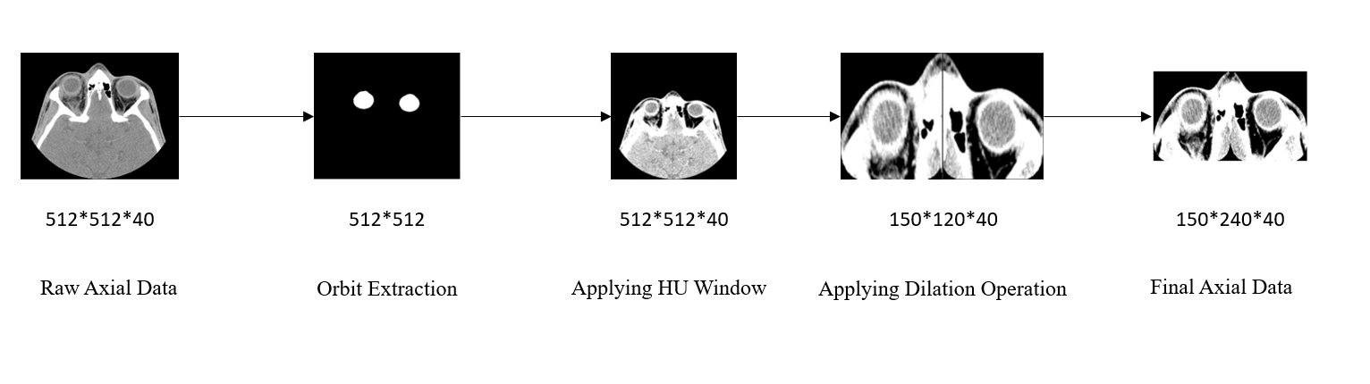Figure 1. Preprocessing Steps for Axial CT Images

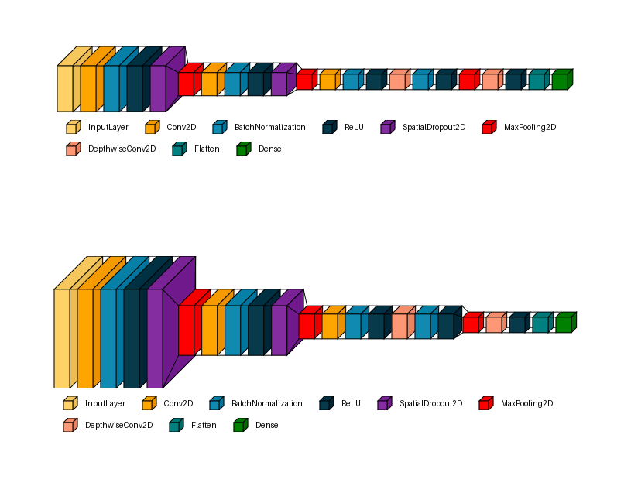
Fracture Detection
Axial Branch
Coronal Branch

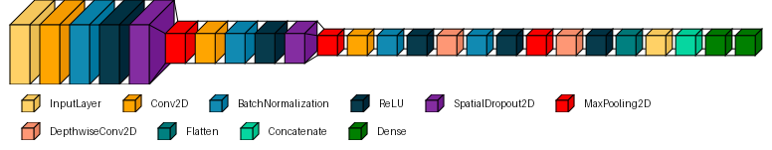
Severity Estimation

Figure 2. Model Structures. (up) AxCorCNN_Model for Fracture Detection. (down) AxCNN_Model for Severity Estimation.

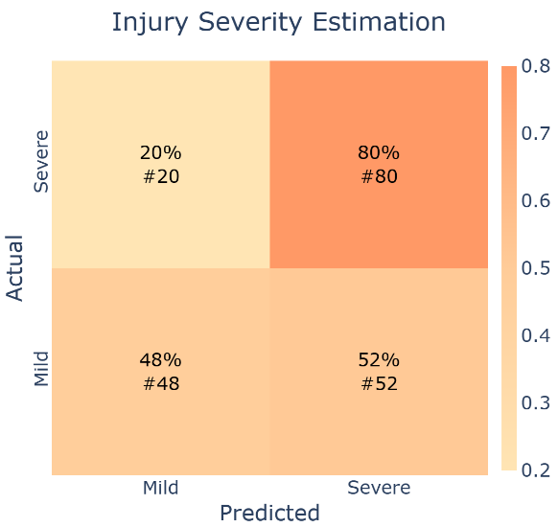
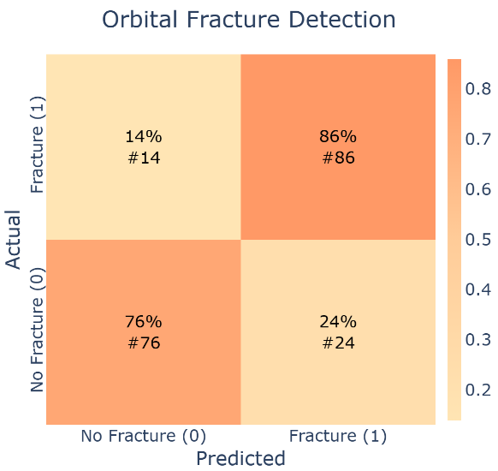
Figure 3. Confusion Matrix for orbital fracture detection (left) and injury severity estimation (right).
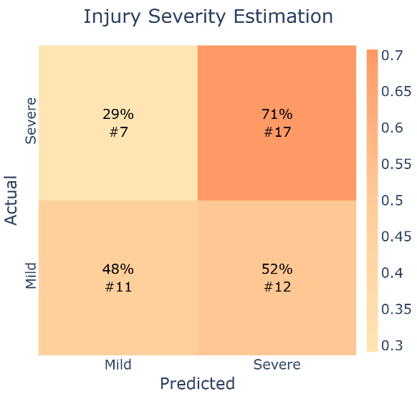
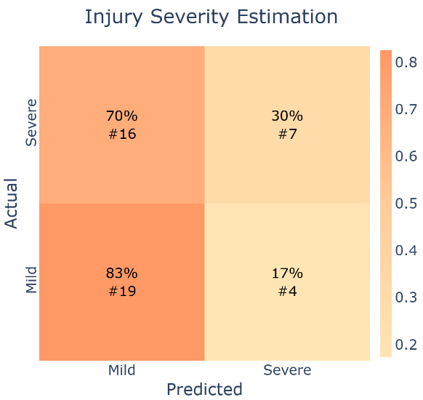
Figure 4. Expert annotations by (a): FS: 56.5% (b): SS: 59.5% for the task of injury severity estimation.
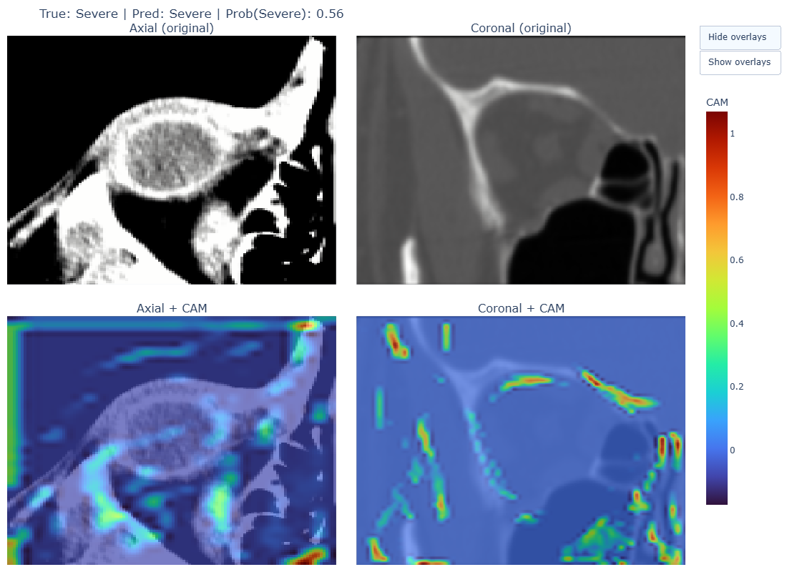

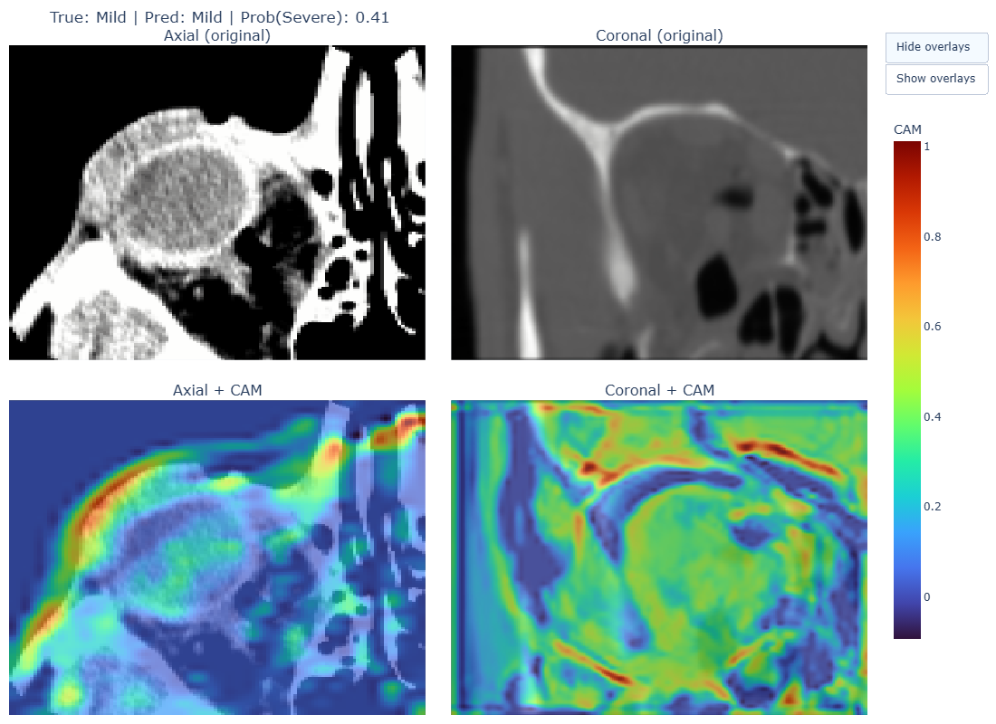
Figure 5. Grad-CAM Visualizations Highlighting Model Attention for Fracture Detection Model (Top) severe and (Down) mild.

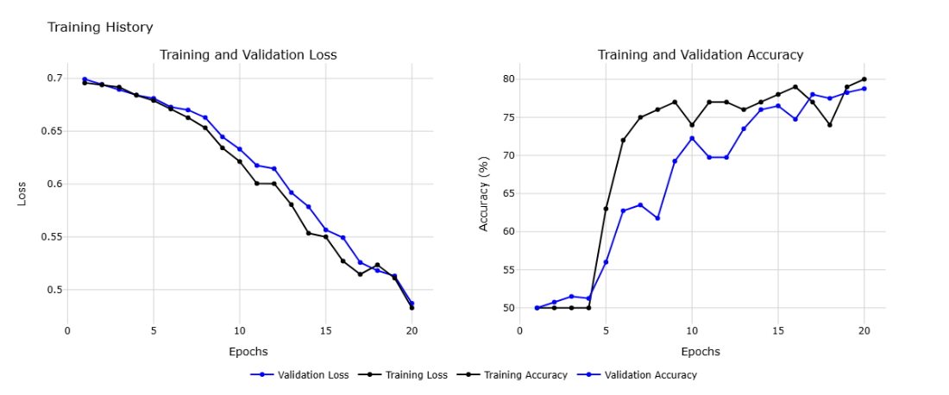
Supplementary Figure 1. Training and validation loss and accuracy over 20 Epochs for fracture detection network.
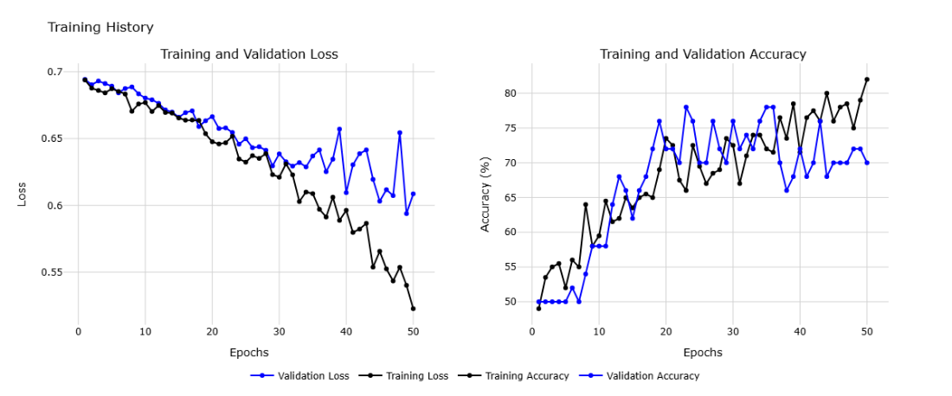
Supplementary Figure 2. Training and Validation Loss and Accuracy over 50 Epochs for Orbit Injury Severity Estimation Network.

