Department of Computer Systems Engineering
Mehran University of Engineering and Technology, Jamshoro

Course: Data Science and Analytics (CS-461)
Instructor | Engr. Faiz Nadeem | Assignment Type | Complex Engineering Problem
Semester | 7th | Year | 4th
Submission Deadline | 15-04-2026 | Assessment Score | 10

The semester project is designed to enable students to solve complex real-world problems using Data Science and Analytics techniques. Students will apply data preprocessing, analysis, visualization, and machine learning concepts to develop intelligent data-driven solutions.
Complex Engineering Problem – Characteristics
1 | Depth of knowledge Required
2 | Range of Conflicting Requirements
3 | Depth of Analysis Required
4 | Infrequently Encountered Issues Involved
5 | Beyond codes/standards of practice
6 | Diverse groups of stakeholders with widely varying needs involved
7 | Interdependence (high-level problems including many component parts/sub-problems)
8 | Have significant consequences in a range of contexts
9 | Judgment (Require judgment in decision-making)

Students are required to submit a data-driven predictive or analytical model developed using Data Science and Analytics techniques.
The scope of this CEP focuses on developing or presenting a comprehensive data-driven solution that demonstrates problem identification, data pre-processing, feature engineering, model development, performance evaluation, and interpretation of results. Students are encouraged to use a comprehensive analytical or predictive model that they have already developed or are currently developing as part of their academic or research work, provided that the model demonstrates sufficient complexity, originality, and engineering depth. The selected problem should reflect real-world challenges and must involve meaningful decision-making and analytical reasoning rather than simple or basic dataset implementation.

Equipment Allowed:
- Python
- Jupyter Notebook / Google Colab
- Excel
- Kaggle Datasets
- Pandas
- Numpy
- Matplotlib
- Seaborn

Project Deliverables:
- Model (Python/Colab/Jupyter/Code)
We are working the model of colab
- Dataset used
We are used kaggle dataset
- Model explanation
- If predicting marks (numbers) → Regression Problem
- If predicting pass/fail or grade (A, B, C) → Classification Problem
Example:
- Marks predict → Regression (Linear Regression, Random Forest Regressor)
- Pass/Fail → Classification (Logistic Regression, Decision Tree, Random Forest)

- Evaluation metrics (Accuracy / RMSE / F1-score / Precision-Recall/ Confusion matrix or evaluation graphs)
Accuracy / RMSE / F1-score / Precision-Recall:
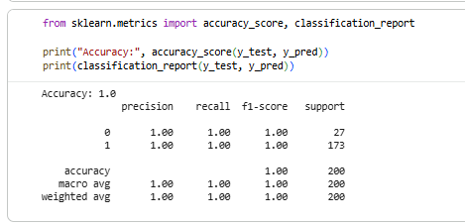
Confusion matrix:
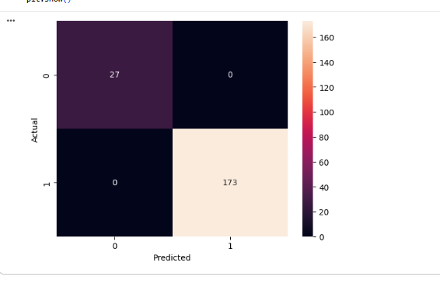
- Problem description
The objective of this project is to develop a machine learning-based system that can predict whether a student will pass or fail based on their academic and behavioral data. Traditional evaluation methods only focus on final exam results, which may not accurately reflect a student’s overall performance.
This system analyzes multiple factors such as:
- Study hours
- Attendance percentage
- Previous exam scores
- Assignment completion
- Class participation
- Dataset explanation
The dataset used in this project is Students Performance in Exams Kaggle dataset, which contains information about students' academic records.
- Methodology
The project follows a standard machine learning pipeline:
- Data Collection
Dataset was obtained from Kaggle.
- Data Preprocessing
  - Handling missing values
  - Converting categorical data into numerical form using encoding
- Feature Engineering
  - Created a new feature called average score
  - Combined math, reading, and writing scores
- Model Training
  - Split data into training and testing sets
  - Applied machine learning algorithm
- Evaluation
  - Used metrics like Accuracy, RMSE, and F1-score
- Model used (Regression, Classification, CNN, etc.)
This project uses a Regression Model:

Linear Regression
- Used to predict continuous values (average score)
- Simple and effective for beginner-level projects
Alternative models
- Decision Tree
- Random Forest
- Results and accuracy

- Conclusion
The Student Performance Prediction System successfully predicts student scores using machine learning techniques.
This system can help:
- Teachers identify weak students
- Improve academic performance
- Provide early intervention
Overall, the model performs efficiently and provides useful insights.

- Future improvement
The project can be improved in the following ways:
- Use advanced models like:
  - Random Forest
  - Neural Networks
- Add more features such as:
  - Attendance
  - Study hours
  - Socioeconomic factors
- Build a web application using:
  - Streamlit
- Use larger datasets for better accuracy

The CEP emphasizes complex engineering problem-solving; therefore, simple regression or basic classification models on small or trivial datasets will not be accepted. Students are expected to demonstrate practical implementation, analytical depth, and logical reasoning in their work. Existing analytical work may be refined, improved, or extended before submission to meet the required complexity and quality standards. Proper documentation, structured code, and clear explanation of results are essential components of the evaluation process.
RUBRICS
 | Unacceptable  0 | Poor  2 | Acceptable  5 | Adequate  7 | Proficient  10 | Score
R1 Problem/Requirement Identification | Problem not identified | Problem poorly identified | Problem is identified | Problem is defined adequately. | Problem is identified and analyzed in a well-defined manner.
R2 Engineering knowledge (standards) | Can not apply engineering knowledge to the solution. | Has difficulty  applying  mathematics to  the solution  of complex  engineering  problems | Correctly applies basic  sciences to the solution  of complex engineering  problems | Correctly applies engineering  fundamentals to the solution of complex  engineering problems | Correctly applies  engineering  specialization to the  solution of complex  engineering problems.
R3 Efficiency of the solution | Solution does not meet requirements. | A difficult and inefficient solution. | A logical solution that is easy to follow but it is not the most efficient. | Solution is adequately efficient. | Solution is efficient, easy to understand, and maintain.
R4 Technical Writing | The report is submitted but lacks solutions to major requirements. | The report submitted but not according to the requirements. | The requirements of report writing are not properly addressed. | Reports meets all prescribed requirements. | Reports meets all requirements, and it is prepared in original and corrective way to engage readers.
Total

Normalized Score = (Total /40)*10

