# TREND EPI SOP

**Please see the most updated version of this SOP** **here**

**In memoriam:**

* Christopher Bell
* Jayson Shurgold
* Wallis Rudnick
* Jennifer Macri
* Glenys Smith
* Maribeth Mitri
* Farzad Islam
* Harneet Aujla
* Michael Elten
* Michelle Chen

Contents

TREND EPI SOP 1

Introduction 4

What is our role? 4

Typical Hours 4

Deliverables 4

Trend Epi AM vs PM 5

Trend Epi AM 5

Trend Epi PM 5

Other Important Information 5

Useful File Paths Not Mentioned Below: 6

What you need: 6

R Set Up 6

Downloading Rstudio: 6

Installing packages: 6

SALT Activity Levels Table (Tuesdays AM) - Trend epi AM 7

Data Source 7

• SALT 7

Steps 7

Weekly report (Tuesday before 12pm) - Trend epi AM 8

Data sources for the weekly report: 8

Steps on Monday: (start the weekly report) 8

Steps on Tuesday: (finish the weekly report) 9

Cabinet Deck/Epi & Modelling (Wednesday AM) - Trend epi AM 13

Data sources: 13

Steps 13

The following products are done by the Trend Epi PM. 17

1. DISCOVER EXTRACTS (Sundays PM) – Trend Epi PM 17

2. Running the Trend Report and CPHO Table 17

Setting up GitHub: 17

Setting up OneDrive 17

Generating the Trend report 17

Formatting the Trend Report 18

Formatting/Sending the CPHO Table 18

Chief Science Report (Thursdays PM) – Trend Epi PM 18

Troubleshooting 19

Data sources 20

# Introduction

## What is our role?

* Providing analysis on COVID data over time.
* Primary areas of interest include:
  + Reported cases
  + Deaths
  + Hospitalizations
  + ICU admissions
  + Lab testing data
* Anything else that is significant, noteworthy, or interesting.
* A relevant quote that led to the creation of this position:
* “The OCPHO doesn’t just want to know what has happened to date, they want to know what is happening now and what direction we are heading in.”.
* As a result, many of the data provided by us are used for sound bites during the CPHO press briefings (i.e. “pressers”).
* We maintain the analysis of indicators they are interested in, but also have the liberty to develop new products that may be of interest to them. Lots of freedom to develop anything you like.

## Typical Hours

1. Trend epi AM: Monday – Fridays: 8am – 4pm
2. Trend epi PM: Mondays – Thursdays: 1pm – 9pm and Sundays: 4pm – 9pm

# Deliverables

Trend Epi products are used by many teams and are due at specific times Sunday - Thursday:

1. Trend Report (Sun – Thurs at 9:30pm)
   1. COVID_CaseDeath_7MA.csv file
   2. Hosp_icu_historical_data.csv file
2. Chief Science Report (Thurs at 9:30pm)
3. DISCOVER Extracts
4. Weekly Epidemiological Report (Due Tues before noon)
5. SALT Activity Levels Table (Due Tues AM)
6. Cabinet Deck (Weds before noon)
7. Epi & Modelling Deck (occurs every 3 weeks, Weds ASAP)
8. Ad Hoc Requests

|  |  |  |  |  |  |  |
| --- | --- | --- | --- | --- | --- | --- |
| **Product** | **Mon** | **Tues** | **Wed** | **Thurs** | **Fri/Sat** | **Sun** |
| **Weekly Epi Report** | Due on Tuesday before noon | |  |  |  |  |
| **Cabinet Deck** |  |  | Once requested, it’s due ASAP |  |  |  |
| **Epi & Modelling Deck** |  |  | Once requested, it’s due ASAP. Usually occurs every 3 weeks. |  |  |  |
| **Trend Report** | Due 9:30pm | Due 9:30pm | Due 9:30pm | Due 9:30pm |  | Due 9:30pm |
| **Chief Science Report** |  |  |  | Due 9:30pm |  |  |
| **SALT Activity Levels Table** |  | Due 9:00am |  |  |  |  |
| **DISCOVER Extracts** |  |  |  |  |  | Due before 6pm |

# Trend Epi AM vs PM

## Trend Epi AM

* Completes products 4 -8 from above.
* A quick handover is done after whenever possible. Please send a quick message to the Trend Epi (PM) to let him/her know of what’s outstanding, any important updates during any meetings you attended during the day, etc.
  + This is important as the Trend Epi AM is attending the meetings during the day. We need to make sure both epis are aware of any issues/updates.

## Trend Epi PM

* Completes products 1 -3 and 8 from above.
* Please send a quick message to the Trend Epi (AM) to let him/her know of what’s outstanding, any issues with code, etc.

# Other Important Information

1. All Trend Epi work can be completed at this location:

* Y:\PHAC\IDPCB\CIRID\VIPS-SAR\EMERGENCY PREPAREDNESS AND RESPONSE HC4\EMERGENCY EVENT\WUHAN UNKNOWN PNEU - 2020\EPI SUMMARY\Trend analysis
  + The current files are saved in: “_Current”
  + Source data are organised here: “\_Current\_Source Data”
    - Please see the bottom of this document for information on the Source Data used.

1. If you are having a quiet day, let the Epi Coordinator know that you are able to take on some data requests.

# Useful File Paths Not Mentioned Below:

1. Previous trend reports are located here:

Y:\PHAC\IDPCB\CIRID\VIPS-SAR\EMERGENCY PREPAREDNESS AND RESPONSE HC4\EMERGENCY EVENT\WUHAN UNKNOWN PNEU - 2020\EPI SUMMARY\Trend analysis\_Current\_Reporting\Daily Trend Report

1. Other SOPs in CIRID

Y:\PHAC\IDPCB\CIRID\VIPS-SAR\EMERGENCY PREPAREDNESS AND RESPONSE HC4\EMERGENCY EVENT\WUHAN UNKNOWN PNEU - 2020\HANDOVERS\CIRID Transition\Transition binder\SOPs\By Roles

# What you need:

* R studio
* GitHub account / GitHub desktop
* GitLab account
* Access to Metabase
* Access to Y: drive
* Access to SALT
* Access to OneDrive repository

# R Set Up

## Downloading Rstudio:

## Installing packages:

To install a package – run “install.packages(“package_name”).

Additionally, two other packages can’t be installed using “install.packages()”.

1. Metabaser: see here for more info on installing metabaser: <https://discover.hres.ca/wiki/index.php?title=Request_Metabase_or_GitLab_Access>
2. PHACTrendR: first install the devtools package “install.packages(“devtools”)”, then run the following command: devtools::install_github(“Michael-Elten/PHACTrendR”)

# SALT Activity Levels Table (Tuesdays AM) - Trend epi AM

* This table is made in R and is done first thing on Tuesday mornings.
* It’s a table that shows laboratory testing among all FPTs for the past 2 weeks.
* Code is located here: Y:\PHAC\IDPCB\CIRID\VIPS-SAR\EMERGENCY PREPAREDNESS AND RESPONSE HC4\EMERGENCY EVENT\WUHAN UNKNOWN PNEU - 2020\EPI SUMMARY\Trend analysis\_Current\SALT Activity Level Table

## Data Source

## SALT

## Steps

1. Open the “SALT Activity Levels.R” code in the path mentioned above.
2. Highlight the entire code and press the “Run” button.
3. An excel file named “Activity Levels Raw.xlsx” will be outputted in the working directory you have.
   1. Type in **getwd()** in R to see where your output is located if you are unsure where your working directory is.
4. Open the “check_before_export” data set in R. Make sure the dates are correct (should be the 2 most recent weeks for each FPT).
   1. The Canada days_reported total should both be 91. If it’s not 91, it means that a PT(s) didn’t report. Take note of which PT didn’t report (see Step 9). PTs that didn’t report will have days_reported less than 7.
5. Open the “SALT Activity Levels Template.xlsx” file in the path mentioned above.
   1. Change the dates of the weeks manually. It will be the 2 most recent weeks (Sun-Sat).
6. Copy/paste the appropriate columns of the “Activity Levels Raw.xlsx” file into the “SALT Activity Levels Template.xlsx” file.
7. NOTE: YK has not reported since May 6th. Just put **NA** in the “SALT Activity Levels Template.xlsx” file if YK continues to not report.
8. Save the file in this path and name it with today’s date (for example, “SALT Activity Levels Table May 6.xlsx”): \\Ncr-a_irbv2s\IRBV2\PHAC\IDPCB\CIRID\VIPS-SAR\PUBLIC HEALTH PROTECTION AND PROMOTION HC8\SURVEILLANCE\COVID\PLANNING\5-Activity Levels\Weekly assessments\SALT data
   1. Archive the file from last week.
9. Email Aashna Upppal (and cc [COVID19surveillance@Canada.ca](mailto:COVID19surveillance@Canada.ca)) to let her know the table has been uploaded in the usual path. Let her know which PTs haven’t reported in the current week.

# Weekly report (Tuesday before 12pm) - Trend epi AM

* Trend epis contribute to the Weekly Epi Summary Report by producing, analyzing, and intepreting certain plots.
* Data cut off is always Saturday.
* Must include both English and French plots.
* Some parts of the weekly report can be done on Mondays (hosp, icu, and international plots).
* The rest will have to be completed on Tuesday (usually before 12pm).
* Codes are currently written **mostly in SAS (one code is in R).**
* Codes for the weekly report are located here: Y:\PHAC\IDPCB\CIRID\VIPS-SAR\EMERGENCY PREPAREDNESS AND RESPONSE HC4\EMERGENCY EVENT\WUHAN UNKNOWN PNEU - 2020\EPI SUMMARY\Trend analysis\_Current\Weekly Epi Report

## Data sources for the weekly report:

* DISCOVER trend extract
* SALT
* COVID_CaseDeath_7MA.csv (webscraped data)
* Hosp_icu_historical_data.csv (webscraped data)
* OurWorldinData

## Steps on Monday: (start the weekly report)

1. Go to this file path and copy the most recent weekly report document onto your local computer: Y:\PHAC\IDPCB\CIRID\VIPS-SAR\EMERGENCY PREPAREDNESS AND RESPONSE HC4\EMERGENCY EVENT\WUHAN UNKNOWN PNEU - 2020\EPI SUMMARY\Trend analysis\_Current\_Reporting\Weekly Epi Summary
2. 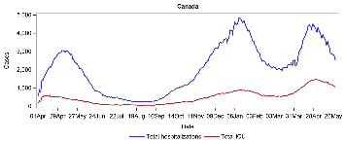
   1. Data source: Hosp_icu_historical_data.csv (webscraped data)
      1. Located here: Y:\PHAC\IDPCB\CIRID\VIPS-SAR\EMERGENCY PREPAREDNESS AND RESPONSE HC4\EMERGENCY EVENT\WUHAN UNKNOWN PNEU - 2020\EPI SUMMARY\Trend analysis\Case count data
   2. To get this plot, open the “FPT Hosp and ICU_weekly_v2.sas” file in the file path mentioned above using SAS.
   3. Once the code is opened in SAS, change the cut off date (on line 2) to the Saturday cut off date. Change the “Tomorrow” date to the Sunday date.
   4. Highlight the entire code and click on the “Run” icon.
   5. Look in the “Log” tab in SAS and make sure there are no red errors in the code.
   6. If everything ran correctly, the two plots (ENG and FR) will be outputted. Check the log to see where they are outputted.
   7. Copy and paste these plots into the weekly report doc and update the interpretation piece.
   8. Change the dates at the bottom of the SAS code to update the interpretation piece (see below).

**proc** **print** data=hosp_icu2;

where jurisdiction = "Canada" and date >= **'23may2021'd**;

**run**;

**proc** **print** data=hosp_icu2;

where jurisdiction = "Canada" and date >= **'01apr2020'd**;

var jurisdiction date icu icu7ma;

**run**;

**proc** **print** data=hosp_icu2;

where date = **'29may2021'd**;

**run**;

1. 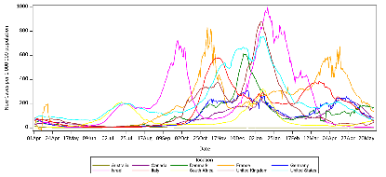
   1. Data source: OurWorldinData
   2. You must first download the data manually before running the SAS code. Copy the following link to Google Chrome and it will automatically download the latest data: <https://covid.ourworldindata.org/data/owid-covid-data.csv>
   3. Open the downloaded data and save it as “International.csv” in this path: Y:\PHAC\IDPCB\CIRID\VIPS-SAR\EMERGENCY PREPAREDNESS AND RESPONSE HC4\EMERGENCY EVENT\WUHAN UNKNOWN PNEU - 2020\EPI SUMMARY\Trend analysis\_Current\_Source Data\International
      1. You can overwrite the old file (or rename the old file before saving).
   4. Close the file before running the SAS code.
   5. Open the “09. International cases pop adjusted v1.sas” SAS code.
   6. Change the cut off dates in the first 3 lines of code.
   7. Highlight the entire code and press the “Run” button.
   8. Look in the “Log” tab in SAS and make sure there are no red errors in the code.
   9. If everything ran correctly, the two plots (ENG and FR) will be outputted. Check the log to see where they are outputted.
   10. Copy and paste these plots into the weekly report doc and update the interpretation piece.
   11. The “Results” tab in SAS will have some numbers to help you complete the interpretation piece.

## Steps on Tuesday: (finish the weekly report)

1. 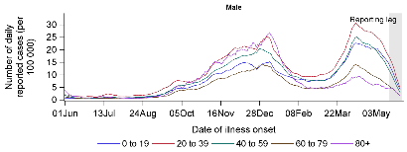
   1. Data source: DISCOVER trend extract
      1. Located here: Y:\PHAC\IDPCB\CIRID\VIPS-SAR\EMERGENCY PREPAREDNESS AND RESPONSE HC4\EMERGENCY EVENT\WUHAN UNKNOWN PNEU - 2020\EPI SUMMARY\Trend analysis\_Current\_Source Data\CaseReportForm
   2. You must first unzip the file called “trend_extract.csv.bz2” by right clicking this file, hover over “7 zip”, then click on “Extract here”.
   3. After the file’s been unzipped, open the “Reported cases by age and sexgender 7MA_v7.sas” code.
   4. Highlight the entire code and press the “Run” button.
   5. Look in the “Log” tab in SAS and make sure there are no red errors in the code.
   6. If everything ran correctly, the four plots (ENG and FR) will be outputted. Check the log to see where they are outputted.
   7. Copy and paste these plots into the weekly report doc and update the interpretation piece.
   8. Change the dates in the very bottom of the SAS code to help update the interpretation piece (see below). You’d want to look at the data from two weeks ago because there is a 2 week lag in data.

title 'male';

**proc** **print** data= Test_male;

by agegroup20;

where earliestdate>=**'09may2021'd** and earliestdate <= **'15may2021'd**;

var A earliestdate SMA_7_adj;

**run**;

title 'female';

**proc** **print** data= Test_female;

by agegroup20;

where earliestdate>=**'09may2021'd** and earliestdate <= **'15may2021'd**;

**run**;

1. 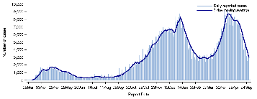
   1. Data source: COVID_CaseDeath_7MA.csv (webscraped data)
      1. Located here: Y:\PHAC\IDPCB\CIRID\VIPS-SAR\EMERGENCY PREPAREDNESS AND RESPONSE HC4\EMERGENCY EVENT\WUHAN UNKNOWN PNEU - 2020\EPI SUMMARY\Trend analysis\Case count data
   2. Open the “Historical_Canada daily cases figure (weekly epi report)_v2.sas” SAS code.
   3. Highlight the entire code and press the “Run” button.
   4. Look in the “Log” tab in SAS and make sure there are no red errors in the code.
   5. If everything ran correctly, the two plots (ENG and FR) will be outputted. Check the log to see where they are outputted.
   6. Copy and paste these plots into the weekly report doc and update the interpretation piece.
   7. Change these dates at the end of the SAS code to get data for the interpretation piece:

**proc** **print** data=covid19_trend;

Where Jurisdiction="Canada" and date>=**'23may2021'd** and date <= **'29may2021'd**;

**run**;

**proc** **print** data=covid19_trend;

Where Jurisdiction="Canada" and date>**'01jan2021'd**;

**run**;

**proc** **print** data=covid19_trend;

Where date = **'29may2021'd**;

**run**;

1. 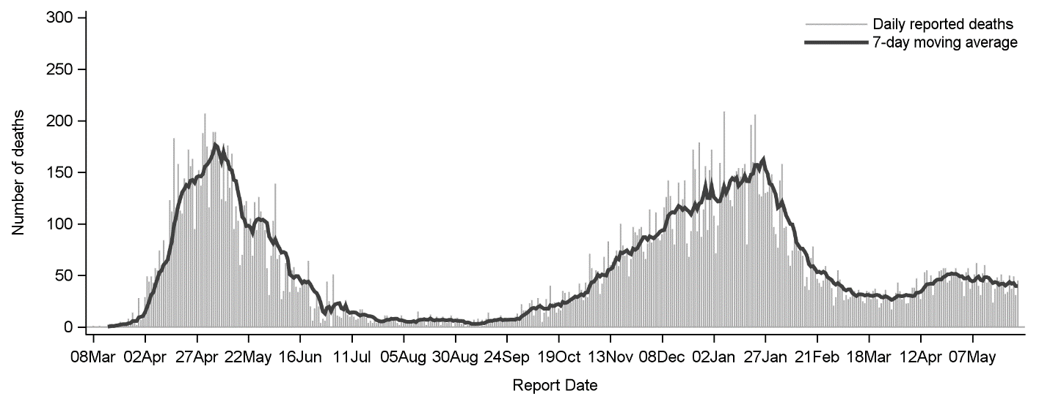
   1. Data source: COVID_CaseDeath_7MA.csv (webscraped data)
      1. Located here: Y:\PHAC\IDPCB\CIRID\VIPS-SAR\EMERGENCY PREPAREDNESS AND RESPONSE HC4\EMERGENCY EVENT\WUHAN UNKNOWN PNEU - 2020\EPI SUMMARY\Trend analysis\Case count data
   2. Open the “HistoricalFPT daily deaths with 7MA figure (weekly epi report)_v3.sas” SAS code.
   3. Highlight the entire code and press the “Run” button.
   4. Look in the “Log” tab in SAS and make sure there are no red errors in the code.
   5. If everything ran correctly, the two plots (ENG and FR) will be outputted. Check the log to see where they are outputted.
   6. Copy and paste these plots into the weekly report doc and update the interpretation piece.
   7. Change the dates at the end of the SAS code to get data for the interpretation piece:

**proc** **print** data=covid19_trend;

where jurisdiction = 'Canada' and date >= **'23may2021'd** and date <= **'29may2021'd**;

*var jurisdiction date deaths_daily deaths_Daily_7ma;

**run**;

**proc** **print** data=covid19_trend;

where date = **'29may2021'd**;

**run**;

**proc** **print** data=covid19_trend;

Where Jurisdiction="Canada" and date>=**'01apr2021'd**;

var jurisdiction date deaths_daily deaths_Daily_7ma;

**run**;

1. 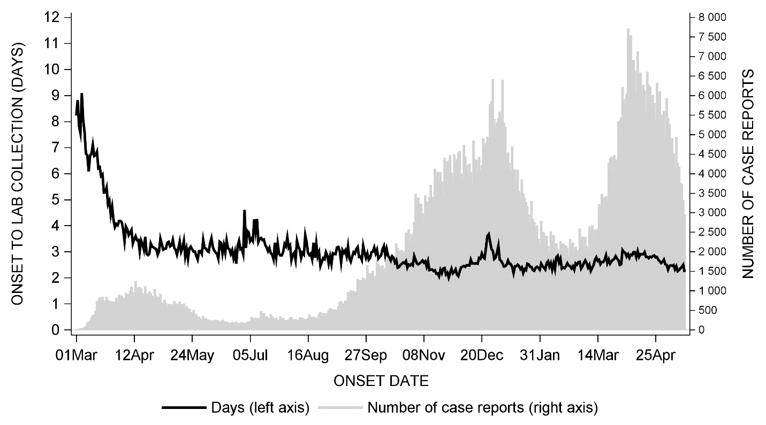
   1. Source: DISCOVER trend extract
      1. Located here: Y:\PHAC\IDPCB\CIRID\VIPS-SAR\EMERGENCY PREPAREDNESS AND RESPONSE HC4\EMERGENCY EVENT\WUHAN UNKNOWN PNEU - 2020\EPI SUMMARY\Trend analysis\_Current\_Source Data\CaseReportForm
   2. Ensure that the “trend_extract.csv” file is unzipped from step 1.
   3. Open the “Onset date to Lab Collection delay_v3.sas” SAS code.
   4. Highlight the entire code and press the “Run” button.
   5. Look in the “Log” tab in SAS and make sure there are no red errors in the code.
   6. If everything ran correctly, the two plots (ENG and FR) will be outputted. Check the log to see where they are outputted.
   7. Copy and paste these plots into the weekly report file and update the interpretation piece.
   8. 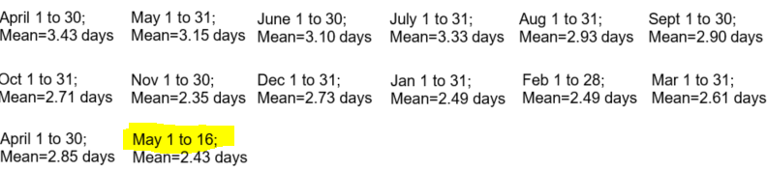 To fill in the mean values, look at the “Results” tab in SAS and you will see the mean values by month. Fill those values in the weekly report doc and make sure to change the latest date in the weekly report doc.
      1. You can check the latest date by running this code in SAS and then checking the “Results” tab in SAS:

**data** date;

x= &fifteendaysago;

format x date9.;

**run**;

**proc** **print**; **run**;

1. 
   1. Data source: Submitted+Reports.csv (SALT data)
      1. Located here: Y:\PHAC\IDPCB\CIRID\VIPS-SAR\EMERGENCY PREPAREDNESS AND RESPONSE HC4\EMERGENCY EVENT\WUHAN UNKNOWN PNEU - 2020\EPI SUMMARY\Trend analysis\_Current\_Source Data\SALT
   2. Open the “Lab_testing_table_v2.R” **R** code.
   3. Highlight the entire code and press the “Run” button.
   4. If everything ran correctly, the excel file will be outputted where your working directory is set to.
      1. Run this function in **R** if you are unsure of where the output is saved to: **getwd()**
   5. Copy the contents of the output into the file named “SALT_table_template.xlsx” and format the table so that it looks like the one in the weekly report doc.
   6. Copy the table into the weekly report doc and adjust the fit.
   7. Type “NA” in the table if an entry is blank.
      1. Yukon has not reported since May 6th, 2021. So you will need to put “NA” in the table if they continue with non-reporting.
2. Once you have completed everything, save the document. Then, notify the weekly epi (via email) that it is completed and save it in the correct path on the Y drive.
3. Save the new weekly report doc here as well and archive the one from last week: Y:\PHAC\IDPCB\CIRID\VIPS-SAR\EMERGENCY PREPAREDNESS AND RESPONSE HC4\EMERGENCY EVENT\WUHAN UNKNOWN PNEU - 2020\EPI SUMMARY\Trend analysis\_Current\_Reporting\Weekly Epi Summary

# Cabinet Deck/Epi & Modelling (Wednesday AM) - Trend epi AM

* The surveillance coordinator will let you know Wednesday morning that there is a Cabinet deck and/or Epi & Modeling deck (usually between 8am – 12pm). Once assigned, it is completed right away.
* Epi & Modelling deck usually occurs every 3 weeks.
* **R** is used to create the necessary data sets and Excel is used to create the plots (using the data sets produced in **R**). Both decks use the same **R** code.
* The formatting of these decks are very specific. Space separators are used in numbers (ex. 1 000), x-axis for dates are in the form “mmm yy” (ex. Apr 21), Arial font for all plots with size 16.
* Decks must be completed in both English and French.
* Codes for both decks are located here: Y:\PHAC\IDPCB\CIRID\VIPS-SAR\EMERGENCY PREPAREDNESS AND RESPONSE HC4\EMERGENCY EVENT\WUHAN UNKNOWN PNEU - 2020\EPI SUMMARY\Trend analysis\_Current\TESSA\Epi & Modelling

## Data sources:

* Infobase (webscraped cases and deaths)
* Webscraped hosp and ICU
* DISCOVER

## Steps

* + - 1. Open the “Trend Graphs.xlsx” file in the path mentioned above. This is where you will copy and paste the R data sets into to produce the plots.
      2. 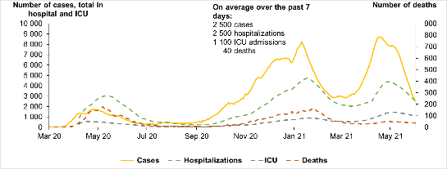
         1. Data source: Infobase (webscraped)
         2. When the Cabinet deck (or Epi & Mod) deck is requested, the coordinator will tell you the network path to the decks. Copy the English and French versions of the deck onto your local computer so that you can start working on it.

If a path isn’t given, find the most recent folder here: Y:\PHAC\IDPCB\CIRID\VIPS-SAR\EMERGENCY PREPAREDNESS AND RESPONSE HC4\EMERGENCY EVENT\WUHAN UNKNOWN PNEU - 2020\BRIEFINGS\Cabinet committee

* + - * 1. Open the “Cases_Hosp_ICU_Deaths.R” code in the path mentioned above using **R Studio**.
        2. Highlight the entire code and press the “Run” button.
        3. An excel file named “Raw_case_death_hosp_icu.xlsx” will be outputted in the working directory you have.

Type in **getwd()** in R to see where your output is located if you are unsure where your working directory is.

* + - * 1. Open the “Raw_case_death_hosp_icu.xlsx” output file.
        2. Filter the “Jurisdiction” column to only “Canada”.
        3. Open the “Trend Graphs.xlsx” file, go to the sheet named “CaseHospDeathICU”.
        4. Delete all the data from column A – P (highlight all cells between columns A-P and press delete).
        5. Copy each column, **one by one**, of the “Raw_case_death_hosp_icu.xlsx” output file to the CaseHospDeathICU tab.
        6. The plots will autogenerate. Check that the plots are pulling the correct columns and that the most recent dates are included in the plot.
        7. Open the ENG and FR decks up. Copy and paste these plots in their corresponding slides.

When pasting the plots into the decks, right click on the deck, choose the “**Keep Source Formatting & Link Data**” under Paste option.

Make sure you update the data cut-off date on the bottom left of each slide.

Update the title of the slide with a summary of the data and any presenter notes.

* + - 1. 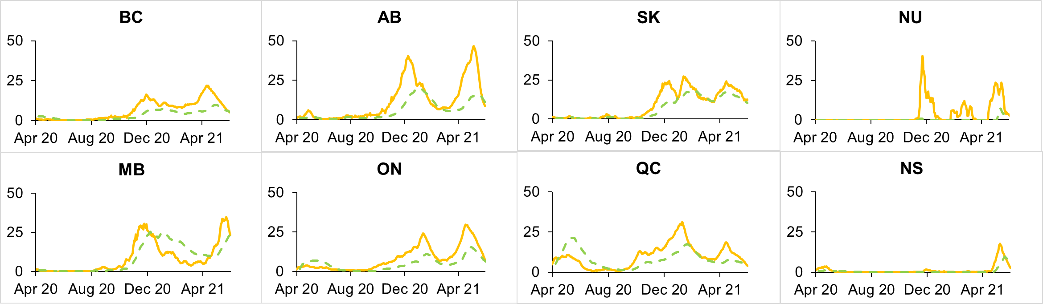
         1. Data source: webscraped data
         2. Open the “Cases hosp icu per 100k.R” code.
         3. Highlight the entire code and press the “Run” button.
         4. It should output 3 Excel files in your working directory:

cases_100k_7ma.xlsx

hosp_100k_7ma.xlsx

Icu_100k_7ma.xlsx

* + - * 1. Open the “Trend Graphs.xlsx” file; go to the sheet named “case and hosp per 100k”.
        2. In this sheet, **columns A - N** are using the “cases_100k_7ma.xlsx” output.

So delete the data in columns A-N in the “Trend Graphs.xlsx” file and then copy the data from the “cases_100k_7ma.xlsx” output into it.

* + - * 1. **Columns Q - AD** of the “Trend Graphs.xlsx” file uses the “hosp_100k_7ma.xlsx” output.

So delete the data in columns Q-AD in the “Trend Graphs.xlsx” file and then copy the data from the “hosp_100k_7ma.xlsx” output into it.

* + - * 1. The plots will autogenerate. Check that the plots are pulling the correct columns and that the most recent dates are included in the plot.
        2. Open the ENG and FR decks up. Copy and paste these plots in their corresponding slides **as pictures**.

Make sure you update the data cut-off date on the bottom left of each slide.

Update the title of the slide with a summary of the data and any presenter notes.

* + - 1. 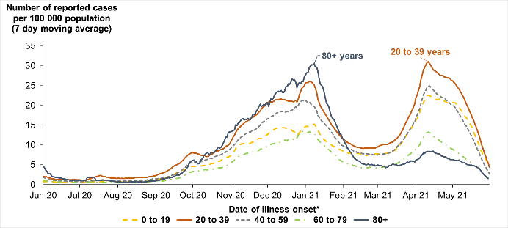
         1. Data source: DISCOVER data
         2. Open the “Cases_per_100k.R” code.
         3. Highlight the entire code and press the “Run” button.
         4. It should output a csv file named: “agegroup_cases_per_100k.csv” in your working directory.
         5. Open the “Trend Graphs.xlsx” file; go to the sheet named “Age group”.

Delete all data in **columns A - I.**

* + - * 1. Copy the data from the “agegroup_cases_per_100k.csv” output and paste it into the “Trend Graphs.xlsx” file.
        2. In the “Trend Graphs.xlsx” file, you need to update the pivot table (on **columns O - T**).

Click the pivot table.

Click on the “Analyze” tab.

Click on “Change data source”.

Highlight all the data in **columns A – I**.

* + - * 1. Copy all the data from the pivot table (excluding the headings) onto the **columns V – AA**.
        2. The plots will autogenerate. Check that the plots are pulling the correct columns and that the most recent dates are included in the plot.
        3. Open the ENG and FR decks up. Copy and paste these plots in their corresponding slides.

When pasting the plots into the decks, right click on the deck, choose the “**Keep Source Formatting & Link Data**” under Paste option.

Make sure you update the data cut-off date on the bottom left of each slide.

Update the title of the slide with a summary of the data and any presenter notes.

* + - 1. 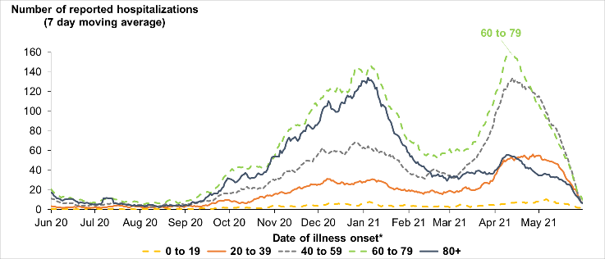
         1. Data source: DISCOVER data.
         2. Open the “hosp 100k and hosp 7ma by age.R” code.
         3. Highlight the entire code and press the “Run” button.
         4. It should output a csv file named: “7ma_hosp_agegroup.csv” in your working directory.
         5. Open the “Trend Graphs.xlsx” file; go to the sheet named “hosp_7ma”.

Delete all data in columns A – E.

* + - * 1. Copy the data from the “7ma_hosp_agegroup.csv” output and paste it into the “Trend Graphs.xlsx” file.
        2. In the “Trend Graphs.xlsx” file, you need to update the pivot table (on **columns G - L**).

Click the pivot table.

Click on the “Analyze” tab.

Click on “Change data source”.

Highlight all the data in **columns B – E**.

* + - * 1. Copy all the data from the pivot table (excluding the headings) onto the **columns O – T** and **columns V – AA**.
        2. The plots will autogenerate. Check that the plots are pulling the correct columns and that the most recent dates are included in the plot.
        3. Open the ENG and FR decks up. Copy and paste these plots in their corresponding slides.

When pasting the plots into the decks, right click on the deck, choose the “**Keep Source Formatting & Link Data**” under Paste option.

Make sure you update the data cut-off date on the bottom left of each slide.

Update the title of the slide with a summary of the data and any presenter notes.

* + - 1. Once all slides have been completed, go back to the network path and copy/paste the newly updates slides into the original decks.
      2. Let the coordinator know when you’re done.

# The following products are done by the Trend Epi PM.

# DISCOVER EXTRACTS (Sundays PM) – Trend Epi PM

* The Trend Epi PM is responsible for running the DISCOVER extracts on Sunday evenings. Please see the full SOP named “SOP Running DISCOVER Extracts.docx” here: Y:\PHAC\IDPCB\CIRID\VIPS-SAR\EMERGENCY PREPAREDNESS AND RESPONSE HC4\EMERGENCY EVENT\WUHAN UNKNOWN PNEU - 2020\HANDOVERS\CIRID Transition\Transition binder\SOPs\By Roles

# Running the Trend Report and CPHO Table

## Setting up GitHub:

If this is the first time you are doing the Trend Epi PM role, please do the following.

1. Download GitHub desktop here: <https://desktop.github.com/>
2. Make a GitHub account here: <https://github.com/>
3. In your File Explorer, go to your C drive and create a folder named “rmd”.
4. When the GitHub desktop has installed successfully onto your computer, ensure that you are logged into your account.
5. Click on “Clone repository”.
6. When the pop up appears, click on the “URL” tab and enter the following under “Repository URL”: <https://github.com/PHACDataHub/hpoc_daily_trend>
7. Set the “local path” to the “rmd” file you created in step 3.

## Setting up OneDrive

If this is the first time you are doing the Trend Epi PM role, please do the following.

1. Contact **Aashna Uppal**: tell her that you’re rotating in as the new Trend Epi PM and that you require access to OneDrive.
   1. She will grant you access to OneDrive and you will be responsible for uploading the Trend report and Chief Science report onto OneDrive **daily.**

## Correcting Infobase (cases/deaths) data

There are times when a PT bulk reports for various reasons. We use a googlesheet to correct the number of cases/deaths located here: <https://docs.google.com/spreadsheets/d/1lHTwMuZlGq8hXpiFMamy46jRkcBqetP16-1cYkfELJE/edit#gid=0>

* To edit the googlesheet, this is the login info:
  + Trend epi google account: PHAC.Trend.Epi@gmail.com / TrendEpi2021!
* BC tends to bulk report their deaths on Monday because they don’t report on weekends. We need to correct this using the googlesheet mentioned above. Watch the press release for BC on Mondays at 6pm (via CPAC) to see if they give a breakdown of deaths. If they don’t, divide the Monday total deaths by 3 and split it evenly among the three days (Sat, Sun, Mon).
* Sometimes a PT will bulk report (such as reporting cases/death from months ago). The current practice is to remove those extra cases/deaths out of today’s total (using the googlesheet) so that the trends will not inflate.

## Generating the Trend report

1. Open GitHub desktop and click on the “Fetch origin” button to retrieve the latest R codes.
2. Click on the “Pull origin” button if it appears in place of the “Fetch origin” button.
3. Open R studio by clicking on “Trend_Report.rmd” in your “rmd -> hpoc_daily_trend” file.
4. Ensure that your working directory is set to the “hpoc_daily_trend” folder and then run the following function in the R Studio console: PHACTrendR::generate_trend_report()
   1. This code will automatically generate the Trend report ppt and it will be located in the hpoc_daily_trend folder.
   2. This code will also generate the CPHO table and will be located in the “output” subfolder.
5. You will need to reformat certain slides in this report. Please see the next section below.
6. Attach this report into an email with the CPHO table (see below) and send it to hsfluepi.
7. Notify the evening coordinator that the reports are sent for review.
8. Wait until the evening coordinator says that there are no issues with the reports.
9. Once the evening coordinator says that the reports have no issues, upload the trend report to the following path: Y:\PHAC\IDPCB\CIRID\VIPS-SAR\EMERGENCY PREPAREDNESS AND RESPONSE HC4\EMERGENCY EVENT\WUHAN UNKNOWN PNEU - 2020\EPI SUMMARY\Trend analysis\_Current\_Reporting\Daily Trend Report
10. Upload the Trend report to OneDrive as well.

## Formatting the Trend Report

Currently, some touch-ups to the final trend report must be done:

1. Open the newly created trend report.
2. Move the summary bullets slide from the very end to slide 2.
   1. Fix the formatting of this slide by clicking on the “Line and Spacing” button , click on “Line spacing options”, under “Spacing: before”, click on the up arrow once and then the down arrow once. Then click on “OK. 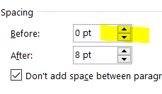
3. Centering the cases/deaths table.
4. Centering the hosp/ICU table.

## Formatting/Sending the CPHO Table

1. Open the newly created CPHO table in the Output subfolder.
2. Copy this table.
3. Paste this table in your email **as an image** (with the trend report attached)**.** – This was requested by CPHO to do it this way.

# 3. Chief Science Report (Thursdays PM) – Trend Epi PM

* The “Chief Science Report” is generated every Thursday evening and is sent to hsfluepi at the same time and same email as the Trend Report.
* This report is a subset of the trend report.

1. Open R studio by clicking on “Trend_Report.rmd” in your “rmd -> hpoc_daily_trend” file.
2. Ensure that your working directory is set to the “hpoc_daily_trend” folder and then run the following function in the R Studio console: PHACTrendR::generate_Nemer_report()
   1. This code will automatically generate the Chief Science Report ppt and it will be located in the hpoc_daily_trend folder.
3. Attach this report into the same email as the Trend Report (and CPHO table) and send it to hsfluepi.
4. Notify the evening coordinator that the reports are sent for review.
5. Once the evening coordinator says that the reports have no issues, upload the Chief Science report to the following path: Y:\PHAC\IDPCB\CIRID\VIPS-SAR\EMERGENCY PREPAREDNESS AND RESPONSE HC4\EMERGENCY EVENT\WUHAN UNKNOWN PNEU - 2020\EPI SUMMARY\Trend analysis\_Current\_Reporting\Daily Trend Report
6. Upload the Chief Science report to OneDrive as well.

# 

# Troubleshooting

It may happen that for whatever reason, the code does not work. Don’t panic! First thing that should be done is to verify the data sources infobase, hosp/icu google sheet, etc. to ensure that data is entered as expected.

1. Blanks in hosp/icu table
2. Error generating report (it is open locally)

# Data sources

**Case report form data (DISCOVER)**

[https://discover-metabase.hres.ca/auth/login?](https://discover-metabase.hres.ca/auth/login?redirect=%2F)

Y:\PHAC\IDPCB\CIRID\VIPS-SAR\EMERGENCY PREPAREDNESS AND RESPONSE HC4\EMERGENCY EVENT\WUHAN UNKNOWN PNEU - 2020\EPI SUMMARY\Trend analysis\_Current\_Source Data\CaseReportForm\trend_extract.rds

Maintained by the data synthesis team within SED – this database contains case report form information submitted by PTs to PHAC. The trend extract file is produced Sun-Thurs by the R coder, and contains a subset of variables needed in the trend report.

**Hosp/ICU data (GoogleSheets)**

<https://docs.google.com/spreadsheets/d/17KL40qJ8tpFalFeBv1XDopTXaFm7z3Q9J2dtqqsQaJg>

Maintained by the daily report epi – this sheet contains daily numbers of total hospitalizations and ICU for each province from their public facing websites. If a province does not provide an update, the previous day’s values are carried over. Note – for the trend report, we do retrospective corrections for AB, based on their dashboard.

**PT case and death data (Infobase)**

<https://health-infobase.canada.ca/src/data/covidLive/covid19.csv>

This dataset is maintained by the daily report epi. It contains many variables, but is mainly used for publically reported cases and deaths. It gets updated between 7-9pm daily. You can check the date on the [infobase page](https://health-infobase.canada.ca/covid-19/epidemiological-summary-covid-19-cases.html) to be sure that its been updated.

**Infobase corrections source (Googlesheets)**

<https://docs.google.com/spreadsheets/d/1lHTwMuZlGq8hXpiFMamy46jRkcBqetP16-1cYkfELJE>

This dataset is maintained by the trend epi. It contains information on the manual corrections made to the infobase dataset, in order to smooth data reporting irregularities caused by data dumps, and corrections by the provinces.

**Laboratory data (SALT)**

Y:\PHAC\IDPCB\CIRID\VIPS-SAR\EMERGENCY PREPAREDNESS AND RESPONSE HC4\EMERGENCY EVENT\WUHAN UNKNOWN PNEU - 2020\EPI SUMMARY\Trend analysis\_Current\_Source Data\SALT\submitted+reports.csv

This dataset is manually saved by the daily report epi, and a copy gets written to the above folder when they run their PCO bullets .R code (around 5-6pm). If any issues, can download the data directly from CNPHI via the following steps:

1. Log into **CNPHI** (<https://www.cnphi-rcrsp.ca/cnphi/index.jsp>) after 6pm
2. Navigate to SALT via the **Laboratory** drop-down menu
3. Navigate to the **Submitted Reports** section via the **Menu** drop-down menu
   * Set the start date at 01-01-2020
   * Ensure that “Incremental” is checked off
   * Select “Export to .**CSV**”
4. Save file (Submitted+Reports.**csv**) to **\_Current\_Source Data\SALT**

**International data (OWID)**

<https://covid.ourworldindata.org/data/owid-covid-data.csv>

<https://github.com/owid/covid-19-data/tree/master/public/data>

Maintained by “OurWorldInData”, this data source contains data on cases, deaths, vaccines, etc. for all countries.