
DESIGN THINKING LAB (CS237DL) REPORT
AI POWERED PLAGIARISM AND DATA INTEGRITY GUARDIAN FOR ACADEMIC SUBMISSIONS
Submitted by:
Sohan Sridhar
Syed Sameer
Srujan Nadig
Yadhu Vamshi P
II Year B.E – Computer Science and Engineering
Academic Year: 2025–2026
RV College of Engineering, Bengaluru

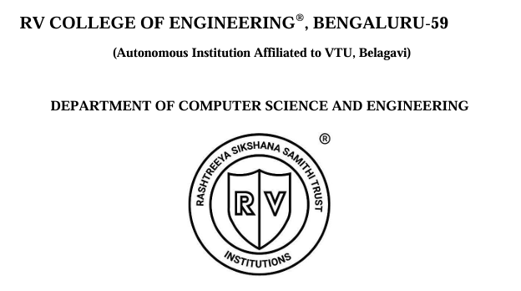CERTIFICATE
Certified that the Design thinking Laboratory work titled ‘AI Powered plagiarism and data integrity guardian from academic submissions’ is carried out by in partial fulfilment for the requirement of degree of Bachelor of Engineering in Computer Science and Engineering of the Visvesvaraya Technological University, Belagavi during the year 2025-2026. It is certified that all corrections/suggestions indicated for the Internal Assessment have been incorporated in the report.

Mentor Name: Dr. K Badari Nath
Designation: Associate Professor
Department of CSE
Name of Examiners
1
2

DECLARATION
This report has been prepared on the basis of our own work. Where other published and unpublished source materials have been used, those have been acknowledged.

Students Name:
Sohan Sridhar
Syed Sameer
Srujan Nadig
Yadhu Vamshi P

Date of submission:

Signatures:

ACKNOWLEDGEMENT
Any accomplishment, whether academic or personal, is the result of collective effort, guidance, and encouragement from many individuals. We would like to take this opportunity to express our sincere gratitude to all those who contributed to the successful completion of this Design Thinking Laboratory project.
We express our heartfelt thanks to our faculty mentors for their continuous guidance, valuable suggestions, and constructive feedback throughout the course of this project. Their insights and encouragement played a vital role in shaping our understanding of design thinking and its real-world applications.
We are grateful to the Head of the Department and the faculty members of the Department of Computer Science and Engineering for providing the necessary resources and an encouraging academic environment. Their support helped us explore innovative ideas and apply them effectively.
We would also like to thank all the students who participated in surveys, interviews, and testing sessions. Their honest feedback and cooperation were instrumental in understanding real user concerns and refining our solution.
Finally, we thank our peers and friends for their constant motivation and support during the execution of this project.

ABSTRACT
Academic integrity is a fundamental pillar of the education system, ensuring fairness, originality, and credibility in student assessments. With the growing adoption of AI-based plagiarism detection tools, concerns related to transparency, data privacy, and fairness have become increasingly prominent among students. Many existing systems function as opaque evaluation mechanisms, offering limited explanations for similarity scores and creating anxiety regarding false accusations and misuse of academic data.
This Design Thinking Laboratory project presents an AI Powered Plagiarism and Data Integrity Guardian for Academic Submissions, designed using a human-centered approach. The project emphasizes empathy-driven design to understand student pain points related to plagiarism detection, including fear of unfair evaluation, lack of explainability, and concerns over data ownership. Through surveys, interviews, and observation, key insights were gathered to inform the design of a supportive, transparent, and privacy-first solution.
The proposed system integrates explainable AI techniques, draft-check functionality, and privacy-preserving verification mechanisms to transform plagiarism detection from a punitive process into a learning-oriented experience. Prototyping and iterative testing validated the effectiveness of visual explanations, draft improvement tools, and user-controlled data handling in building trust and reducing anxiety among students. This project demonstrates that academic integrity systems can be both ethically responsible and technically robust, fostering originality while empowering students through transparency and trust.

CHAPTER 1: EMPATHY
1.1 Introduction to Empathy
The Design Thinking process begins with the Empathy phase, which focuses on understanding the users, their experiences, emotions, and challenges. Empathy allows designers to move beyond assumptions and view a problem from the user’s perspective. In the context of academic submissions, this phase is critical because issues related to plagiarism detection, data privacy, and fairness directly impact students’ academic confidence and mental well-being.
With the increasing use of AI-based plagiarism detection tools in educational institutions, students often experience anxiety, mistrust, and confusion regarding how their work is evaluated. Many existing tools operate as “black boxes,” providing only a similarity percentage without meaningful explanations. This lack of transparency creates fear of false accusations, misuse of data, and unfair evaluation. Recognizing these concerns, our team chose to focus on developing a student-centric, transparent, and privacy-first academic integrity platform.
The empathy phase helped us deeply understand the emotional and practical challenges faced by students while submitting academic work. By engaging directly with students through surveys, interviews, and observation, we gathered insights into their fears, expectations, and desired features. These insights formed the foundation for designing a solution that protects originality while empowering students rather than policing them.
1.2 Customer Persona and Environment
Primary Stakeholders
The primary stakeholders for this project are students, particularly undergraduate and postgraduate students who regularly submit assignments, reports, and projects for evaluation. Students are the producers of academic content and are directly affected by plagiarism detection systems.
Persona: “The Conscientious Student”
A representative persona identified during our empathy study is The Conscientious Student. This student is academically sincere, puts genuine effort into assignments, and values originality. However, they often feel anxious while using plagiarism detection tools due to fears of accidental plagiarism, data misuse, or incorrect flagging.
Goals:
Ensure their work is evaluated fairly
Understand why content is flagged, not just that it is flagged
Protect ownership and privacy of their academic submissions
Improve writing quality before final submission
Frustrations:
Opaque plagiarism scores with no explanation
Fear of false accusations due to AI errors
Concern over long-term storage and misuse of submitted data
Lack of tools that help improve drafts proactively
User Environment
Students interact with plagiarism tools in a digital academic environment, typically using laptops or desktops within college networks or personal systems. Submissions often occur under time pressure, especially during exams or deadlines, which amplifies stress. Emotionally, students oscillate between confidence in their work and anxiety about evaluation fairness. A trustworthy, transparent system is therefore essential to reduce stress and encourage ethical academic behavior.
1.3 Customer Journey Map
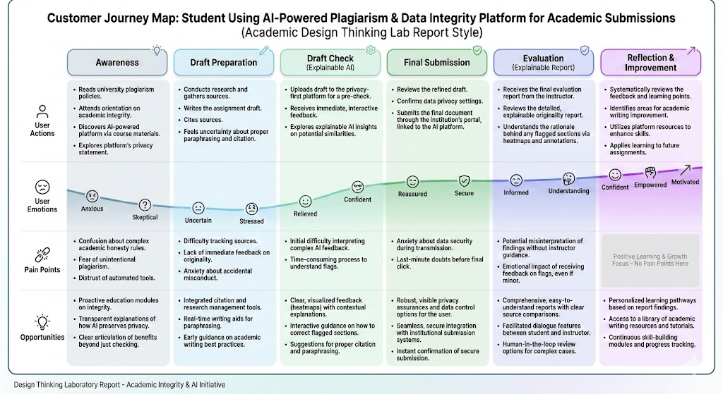
The student journey while interacting with academic integrity tools was mapped across multiple stages:
Awareness Phase
Students become aware of plagiarism detection tools through faculty instructions, institutional policies, or prior experiences.
Pain Point: Confusion about how tools work and fear of penalties.
Consideration Phase
Students decide whether to check drafts before submission.
Pain Point: Existing tools feel punitive rather than helpful.
Submission Phase
Students upload assignments for evaluation.
Pain Point: Anxiety about false positives and lack of explanation.
Verification Phase
Results are generated in the form of similarity scores.
Pain Point: No clarity on flagged sections or reasoning.
Reflection Phase
Students reflect on feedback and outcomes.
Opportunity: Provide actionable feedback that helps improve writing.
Mapping this journey helped us identify critical moments where transparency, feedback, and trust are essential.
1.4 Customer Empathy Maps
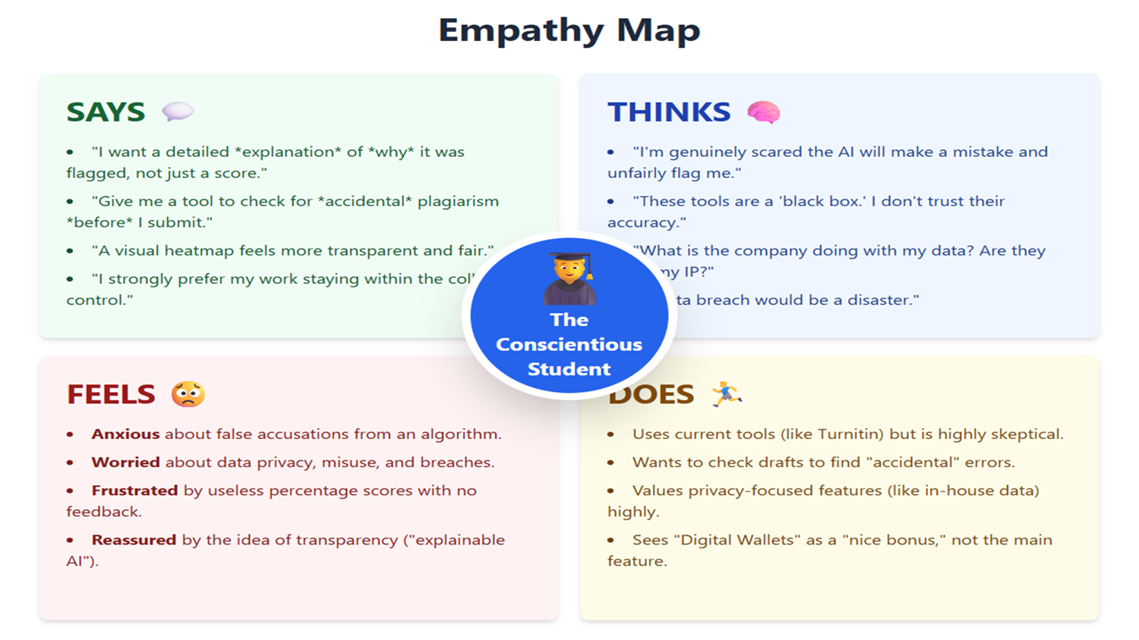
Based on survey responses and interviews, an empathy map was created to capture what students say, think, feel, and do.
Says:
“I want to know why my work was flagged.”
“I want to check my draft before final submission.”
Thinks:
“What happens to my data after I upload it?”
“Will the AI make a mistake and accuse me unfairly?”
Feels:
Anxious about false accusations
Frustrated by meaningless percentage scores
Reassured by transparency and explainable results
Does:
Uses tools like Turnitin cautiously
Avoids draft checks due to fear
Seeks alternative ways to validate originality
These insights clearly indicated a strong demand for Explainable AI, privacy-first design, and student empowerment.
1.5 Tools Used for Empathy
1.5.1 Student Survey and Analysis
A structured survey was conducted with over 200 student responses, focusing on:
Trust in current plagiarism tools
Fear of AI-related false accusations
Data ownership and privacy concerns
Preference for explainable feedback over raw scores
The results showed:
Low trust in existing tools
High anxiety regarding fairness and data misuse
Strong preference for detailed explanations and draft-check features
1.5.2 Interviews and Video Interactions
In-person and video interviews were conducted with students across different years. These interactions provided qualitative insights into emotional responses that numerical data alone could not capture.
1.5.3 Observation and Feedback Review
Students’ reactions to current plagiarism tools were observed, revealing hesitation, fear, and dissatisfaction with opaque systems. This reinforced the need for a transparent, supportive alternative.

1.6 Survey Design
To gain a deeper understanding of student perceptions, concerns, and expectations regarding plagiarism detection systems, a structured online survey was designed and conducted during the Empathy phase of the Design Thinking process. The primary objective of this survey was to capture both quantitative and qualitative insights related to trust, transparency, data privacy, and the emotional impact of AI-based academic integrity tools.
The survey was administered using Google Forms and received 213 valid responses from students across different academic years. The questions were carefully framed to avoid bias and to encourage honest feedback. Both closed-ended and open-ended questions were included to capture measurable trends as well as personal opinions and concerns.
The survey was structured into the following thematic sections:
- Trust and Fairness
Questions focused on how much students trust existing plagiarism detection tools to be fair and accurate.
- AI-Related Risks and Concerns
This section explored students’ fears related to AI errors, data misuse, intellectual property theft, and privacy breaches.
- Feedback Expectations
Questions assessed what type of feedback students find most useful when plagiarism is detected.
- Data Ownership and Privacy
Students were asked about their concerns regarding long-term data storage, ownership, and access to their submitted work.
- Transparency and Explainability
This section examined preferences for explainable AI outputs versus traditional similarity percentage scores.
- Future-Oriented Features
Questions explored student interest in features such as proof of originality, digital academic wallets, and blockchain-based verification.
The survey design ensured that the collected data would directly inform the problem definition and solution ideation phases, keeping the focus on real user needs rather than assumptions.

1.7 Survey Analysis
The survey responses revealed several important patterns and trends that strongly influenced the direction of the project.

1.7.1 Trust in Existing Plagiarism Detection Tools
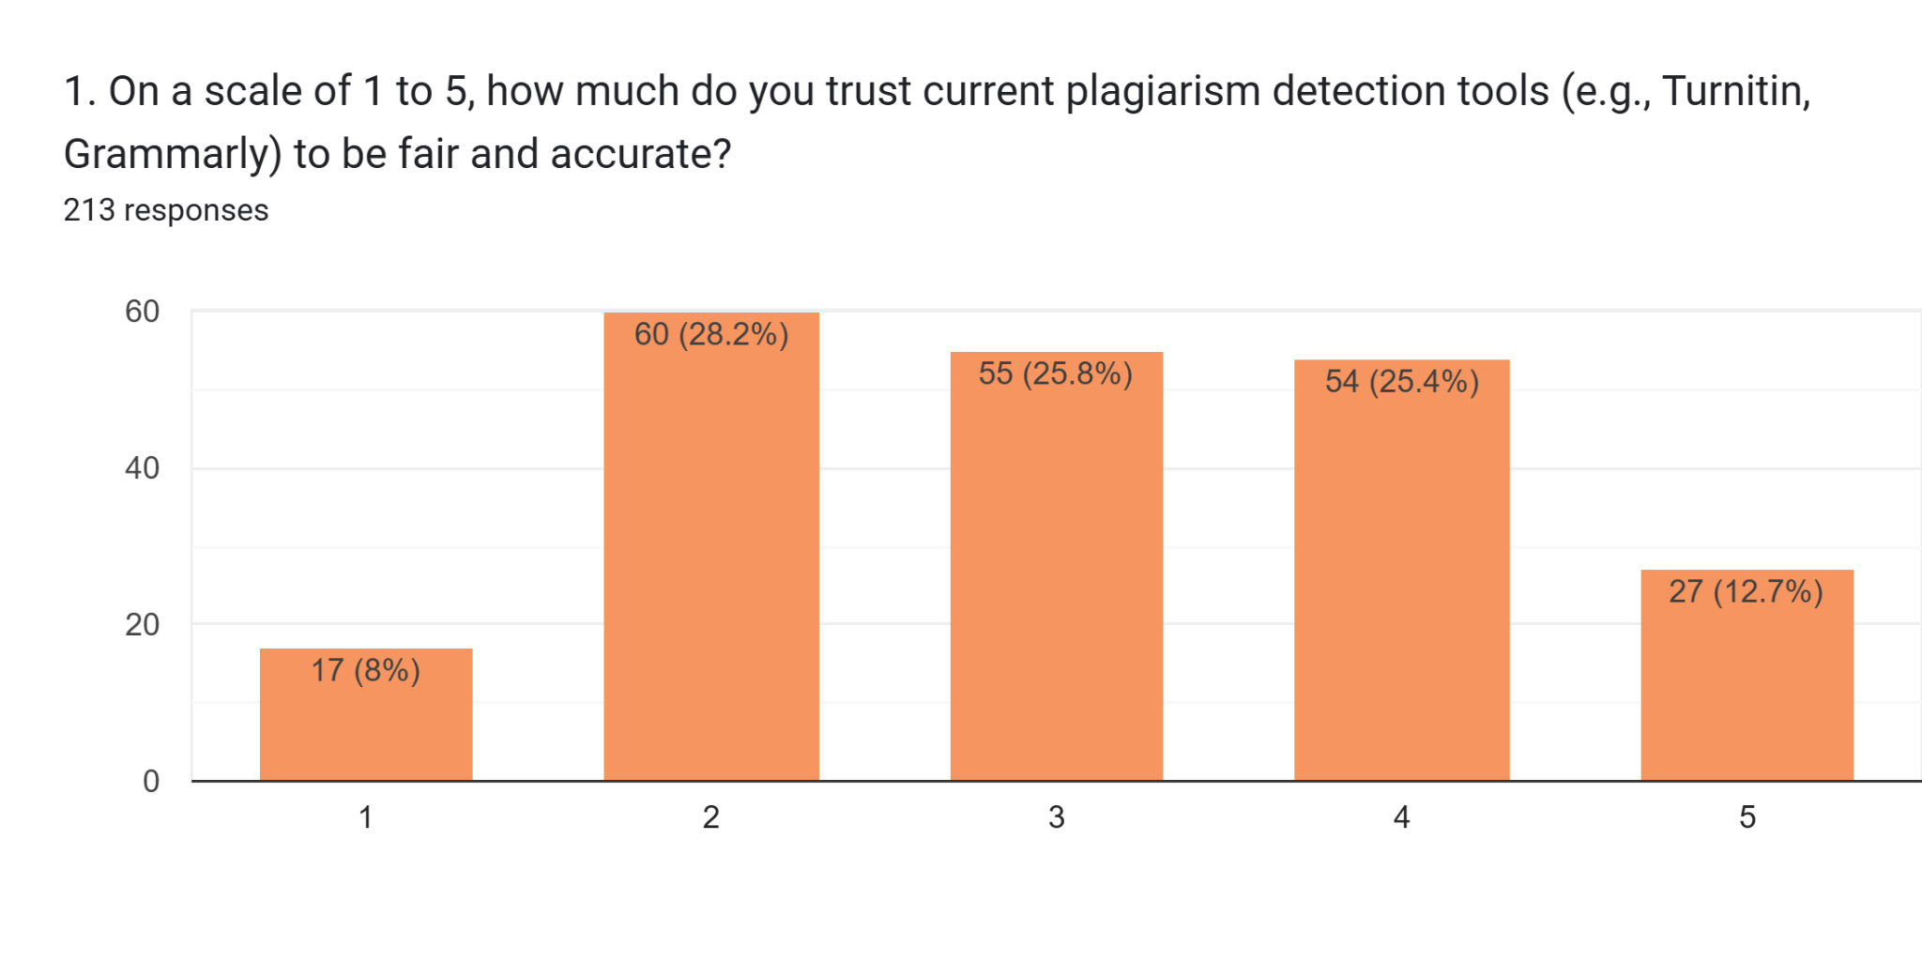
When asked to rate their trust in current plagiarism detection tools on a scale of 1 to 5, the majority of students selected values between 2 and 4, with relatively fewer students expressing complete trust.
This distribution indicates that:
- Students do not fully distrust existing tools, but
- There is significant skepticism regarding fairness and accuracy
A noticeable portion of respondents rated their trust as low (1 or 2), highlighting concerns about false positives and opaque evaluation mechanisms.
Interpretation:
Existing tools are seen as necessary but unreliable, creating anxiety rather than confidence among students.

1.7.2 Primary Concerns About AI-Based Evaluation

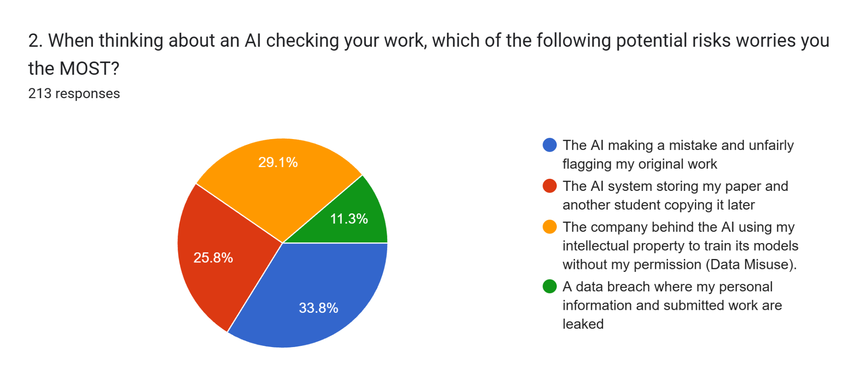
When asked about the biggest risk of AI checking their work, the most selected concern was:
- AI making mistakes and unfairly flagging original work
Other significant concerns included:
- Misuse of academic work for AI training without consent
- Unauthorized storage or sharing of submitted documents
- Data breaches and loss of personal information
Interpretation:
Students are more afraid of unfair consequences than plagiarism itself, emphasizing the emotional impact of AI decisions.

1.7.3 Preferred Feedback When Plagiarism Is Flagged
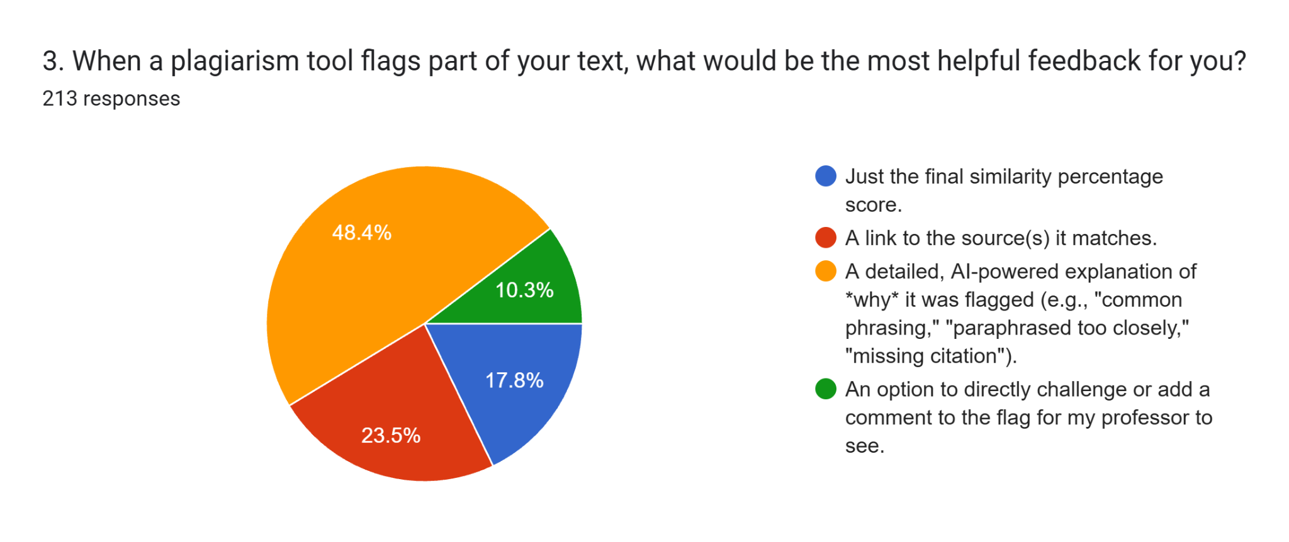
Responses clearly showed that students overwhelmingly prefer:
- Detailed, AI-powered explanations of why content was flagged
Far fewer students preferred:
- Just a final similarity percentage
- Minimal links without context
A smaller but notable group also wanted:
- An option to comment on or challenge flagged sections
Interpretation:
Students want explainability and reasoning, not just numerical judgments.

1.7.4 Concerns About Data Ownership and Long-Term Storage
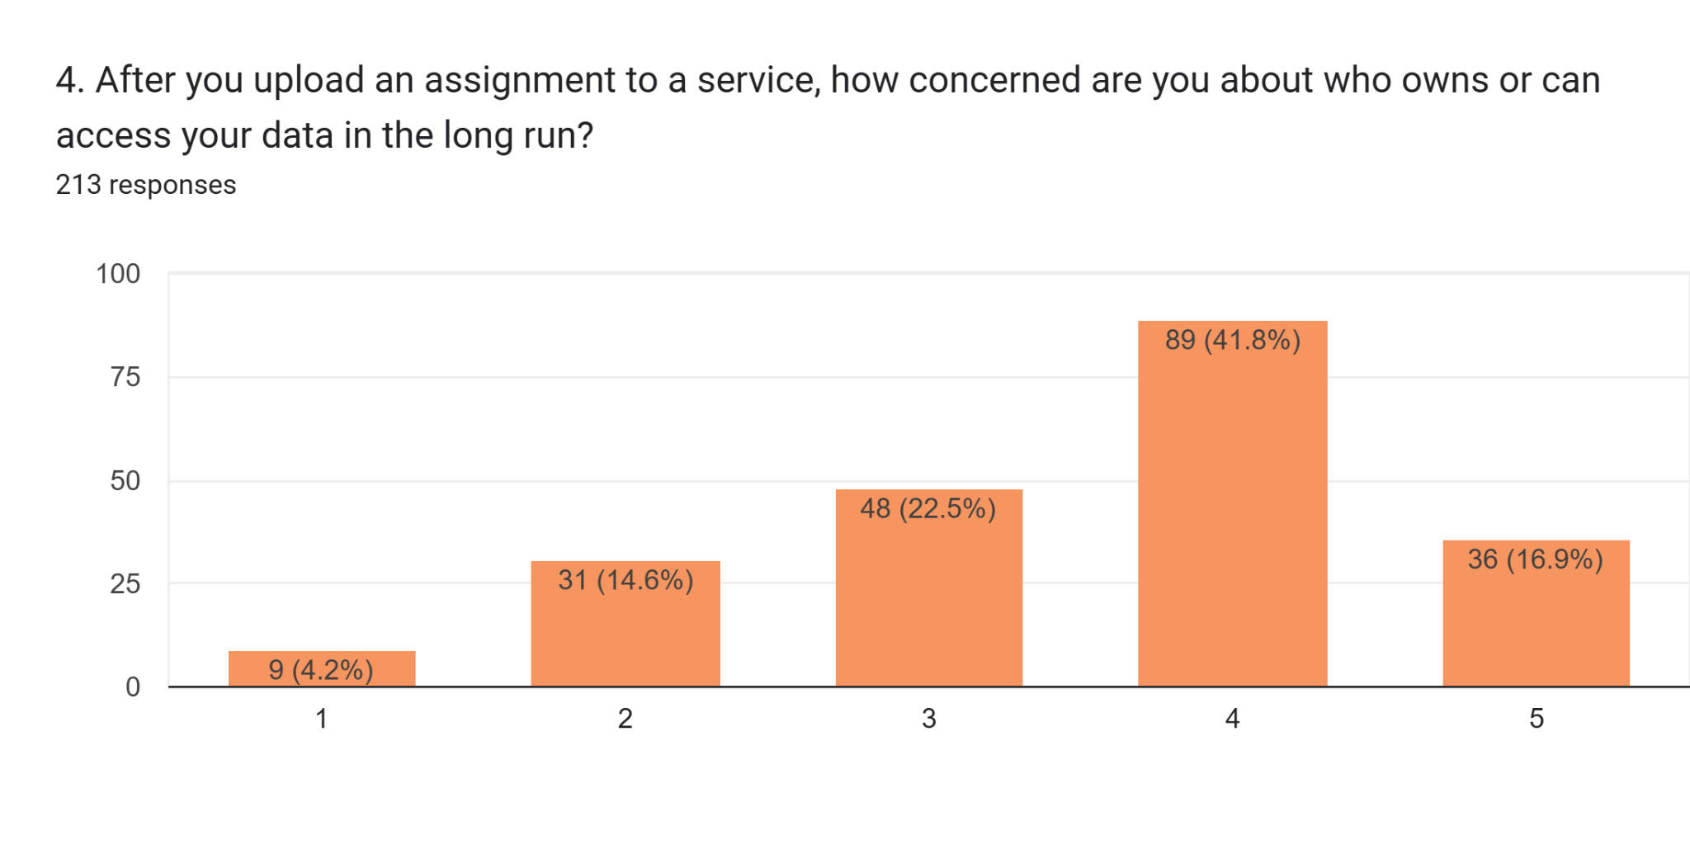
When asked how concerned they were about who owns or can access their data after submission:
- A large majority selected high concern levels (4 or 5)
This demonstrates widespread discomfort with:
- Indefinite data storage
- Lack of clarity on who controls submitted work
Interpretation:
Data ownership is a major trust barrier in existing academic platforms.

1.7.5 Control Over Academic Data
When asked what level of control they would want if privacy and transparency were guaranteed, students strongly favored:
- The ability to delete their work anytime
- Choosing whether their work trains AI models
- Viewing access logs of who interacted with their data
Interpretation:
Students want active control, not passive assurances.

1.7.6 Perceived Value of Proof of Originality
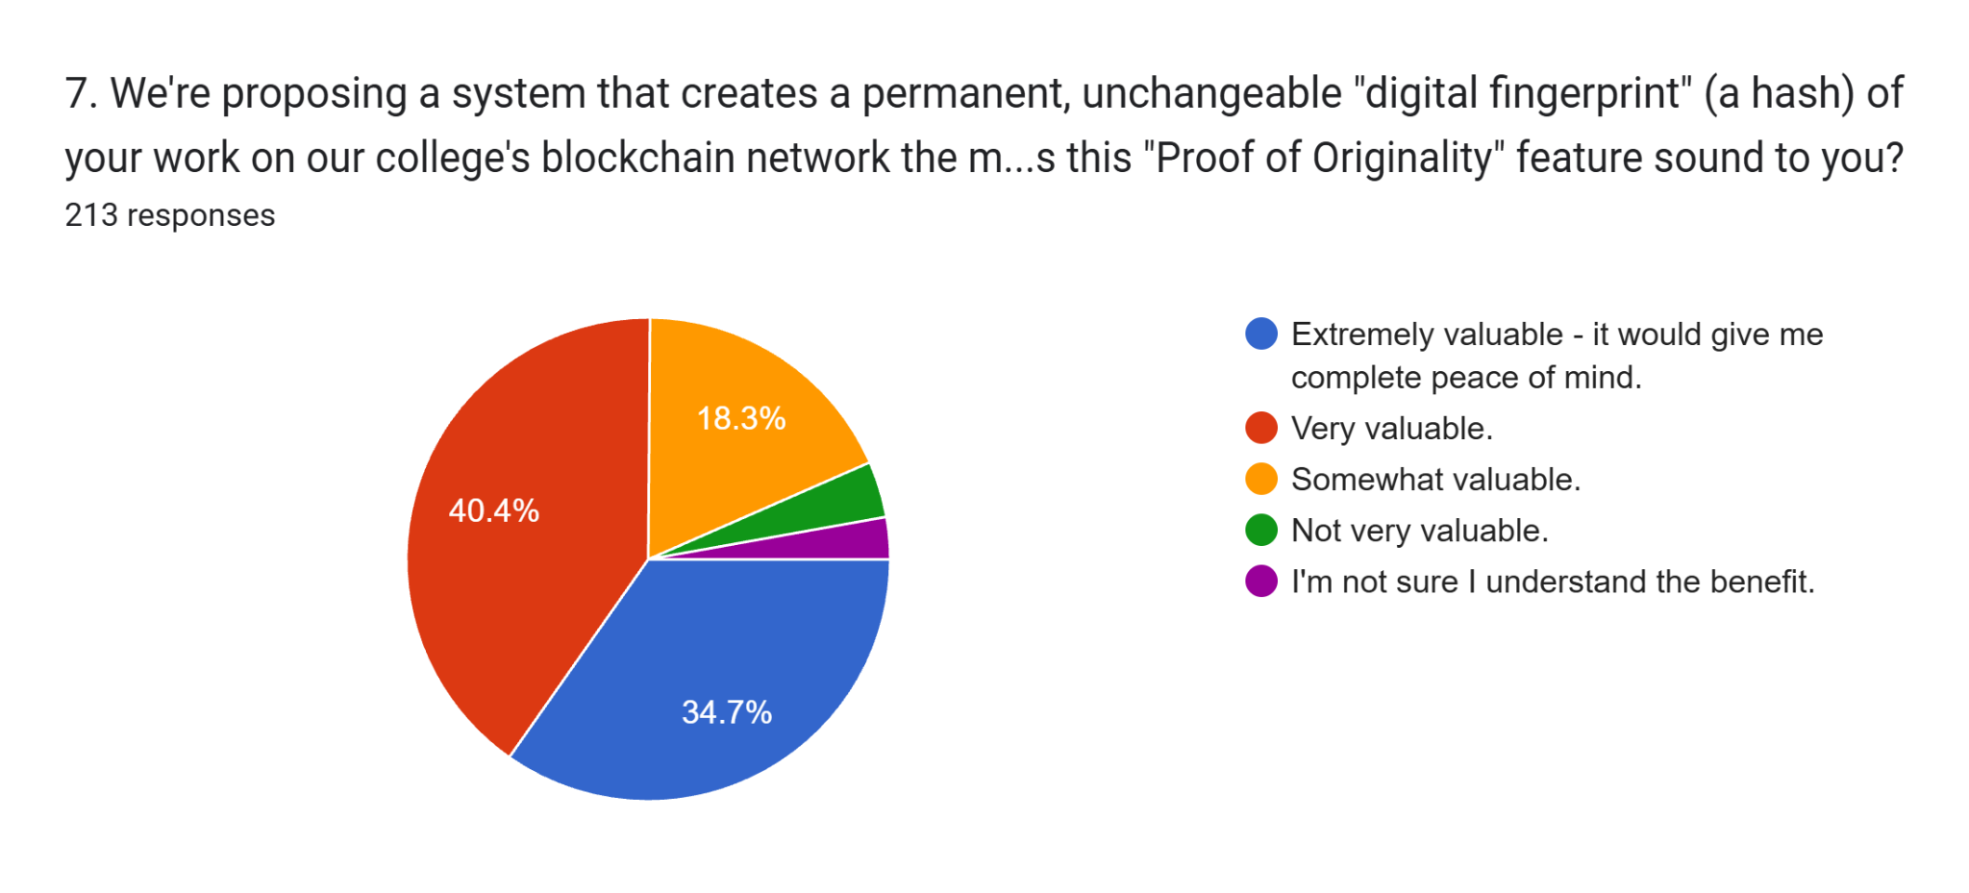
A significant majority of students rated a digital proof of originality feature as:
- Very valuable or extremely valuable
Students appreciated the idea of:
- Proving authorship without exposing the actual document
- Timestamped verification for future disputes
Interpretation:
There is strong acceptance of cryptographic and blockchain-inspired solutions when privacy is preserved.

1.7.7 Interest in a Digital Academic Wallet
Responses indicated high interest in a Digital Academic Wallet that stores verifiable certificates of originality. Most students rated their likelihood of using such a feature as 4 or 5 on the scale.
Interpretation:
Students see long-term academic value in owning verified proof of their original work.

1.7.8 Explainable AI vs Similarity Scores
When comparing explainable visual breakdowns (such as heatmaps) with traditional similarity percentages:
- A clear majority stated that explainable AI is significantly better or slightly better
Only a small fraction felt it was unnecessary or too complex.
Interpretation:
Explainability directly improves trust and perceived fairnes
1.8 Insights and Pain Points
Based on the survey analysis, the following key insights and pain points were identified:

Key Insights
- Students do not inherently oppose plagiarism detection, but oppose opaque evaluation
- Explainable AI significantly improves trust and acceptance
- Privacy and data ownership are as important as accuracy
- Students want plagiarism tools to support learning, not punish mistakes
- Proof of originality is seen as empowering rather than restrictive

Major Pain Points
- Fear of false accusations due to AI errors
- Lack of explanation behind similarity scores
- No control over stored academic work
- Anxiety during submission and evaluation
- Absence of draft-check and improvement-oriented tools
These insights directly shaped the problem definition and guided the ideation of a student-centric, transparent, and privacy-first academic integrity platform.

CHAPTER 2: DEFINE
2.1 Introduction to Problem Definition
The Define phase is a critical stage in the Design Thinking process where insights gathered during the Empathy phase are synthesized to clearly articulate the core problem. While empathy helps in understanding users and their emotions, the define phase focuses on narrowing down those insights into a structured, actionable problem statement. This phase ensures that the team does not attempt to solve superficial symptoms, but instead addresses the underlying issues faced by the users.
In the context of academic integrity tools, the problem initially appeared straightforward—detecting plagiarism accurately. However, findings from the empathy phase revealed that accuracy alone is not the primary concern for students. Instead, students expressed deep anxiety regarding fairness, lack of transparency, misuse of their academic data, and fear of false accusations caused by AI-based systems. These concerns highlighted that the real issue lies not merely in plagiarism detection, but in how plagiarism detection systems interact with students.
Many existing systems adopt a punitive and surveillance-oriented approach. They operate as opaque systems that generate similarity percentages without explaining the reasoning behind flagged content. This creates mistrust and positions students as suspects rather than learners. Therefore, defining the problem required reframing it from a technical challenge to a human-centered design challenge.
Through multiple iterations of discussion and analysis, the team recognized that the problem space must focus on trust, transparency, privacy, and student empowerment, rather than only on enforcement. The define phase allowed us to eliminate assumptions and align the project scope with what students genuinely need from an academic integrity platform.
2.2 Insights Derived from the Empathy Phase
The following key insights from Chapter 1 directly informed the problem definition:
Low Trust in Existing Tools
A majority of students expressed skepticism toward current plagiarism detection tools, citing unfair flagging and lack of clarity.
High Anxiety Related to AI Decisions
Students fear false accusations and feel helpless when they cannot challenge or understand AI-generated results.
Transparency is Non-Negotiable
Students consistently demanded explanations that show why content was flagged, not just similarity percentages.
Data Privacy and Ownership Concerns
Students are uncomfortable with their academic work being stored indefinitely or used for AI training without consent.
Preference for Improvement-Oriented Tools
Students want tools that help them correct mistakes before submission, rather than systems that only penalize them after submission.
These insights made it clear that the design challenge extends beyond plagiarism detection into the broader domain of ethical AI usage in education.
2.3 Problem Exploration and Scope Limitation
At the beginning of the define phase, several potential problem directions were considered, including:
Improving AI accuracy in plagiarism detection
Reducing false positives through better datasets
Automating disciplinary workflows for faculty
Enhancing institutional compliance mechanisms
However, many of these directions were intentionally excluded for the following reasons:
They prioritize institutional convenience over student experience
They fail to address emotional and psychological impacts on students
They are beyond the scope of a student-centric DTL project
The project scope was therefore refined to focus on designing a system that balances academic integrity with fairness, transparency, and data sovereignty, while remaining technically feasible and ethically responsible.
2.4 Final Problem Statement (Point of View)
After consolidating empathy insights and eliminating out-of-scope directions, the final problem statement was defined as:
“The academic ecosystem currently lacks a trustworthy and transparent system that verifies originality while protecting student data and empowering learners to understand and improve their work, rather than subjecting them to opaque and punitive evaluation.”
This problem statement reflects:
The user: students submitting academic work
The need: transparency, fairness, privacy, and guidance
The insight: trust cannot be achieved through surveillance alone
2.5 How Might We (HMW) Questions
“How Might We” questions were framed to convert the problem statement into actionable ideation prompts. These questions are intentionally open-ended to encourage creative exploration while remaining grounded in user needs.
Transparency & Explainability
How might we explain plagiarism results in a way students can clearly understand?
How might we show why specific sections were flagged instead of displaying only similarity percentages?
How might we visualize AI decisions to reduce fear and confusion?
Student Empowerment
How might we help students detect accidental plagiarism before final submission?
How might we transform plagiarism tools from policing systems into learning aids?
How might we allow students to improve their writing using AI-guided feedback?
Privacy & Data Ownership
How might we ensure student submissions are never misused or stored without consent?
How might we give students full control over their uploaded data?
How might we verify originality without permanently storing raw documents?
Trust & Fairness
How might we reduce anxiety around false accusations?
How might we make AI-based evaluation feel fair and accountable?
How might we help institutions maintain integrity without violating student trust?
These HMW questions directly guided the ideation techniques discussed in the next chapter.
2.6 Design Thinking Challenges Identified
From the problem definition, the following key design challenges were identified:
1. Transparency Gap
Challenge: Existing tools function as black boxes.
Need: Explainable AI that justifies decisions clearly.
2. Data Sovereignty Gap
Challenge: Students fear loss of ownership over their work.
Need: Privacy-first, local, and controlled data handling.
3. Utility Gap
Challenge: Tools focus only on detection, not improvement.
Need: Draft checking and formative feedback mechanisms.
4. Trust Deficit
Challenge: Low confidence in AI-driven academic systems.
Need: Accountability, explainability, and user control.
5. Emotional Impact
Challenge: Anxiety and fear dominate the submission process.
Need: A supportive system that reassures rather than intimidates.
2.7 Outcome of the Define Phase
The Define phase successfully reframed the project from a technical plagiarism detector into a student-centric academic integrity guardian. By clearly articulating the problem and its constraints, this phase ensured that all future design decisions remained aligned with user needs.
This clarity enabled the team to proceed into the Ideation phase with a strong foundation, ensuring that proposed solutions would be meaningful, ethical, and impactful rather than superficial or enforcement-driven.
CHAPTER 3: IDEATE
3.1 Introduction to Ideation
The Ideation phase represents the creative core of the Design Thinking process. After clearly defining the problem in the previous phase, ideation focuses on generating a wide range of possible solutions without immediate judgment or restriction. The goal of this phase is not to find the perfect solution instantly, but to explore diverse ideas that may later evolve into strong, user-centered designs.
For our project, ideation was especially important because the problem space involved emotions, trust, and ethics, not just technical accuracy. A narrow or purely technical ideation approach would have resulted in solutions similar to existing plagiarism tools, which students already distrust. Therefore, the team consciously adopted multiple ideation techniques to encourage creativity, challenge assumptions, and move away from punitive system designs.
During this phase, we created a safe, judgment-free environment where every idea—practical or impractical—was documented. This approach allowed the team to think expansively and later converge on ideas that best aligned with student needs identified during the empathy and define phases.
3.2 Ideation Objectives
The key objectives of the ideation phase were:
To generate student-centric solutions rather than institution-centric controls
To explore ways of making AI transparent and explainable
To identify privacy-preserving mechanisms for academic submissions
To shift plagiarism tools from a punitive role to a supportive role
To balance innovation with feasibility within an academic environment
These objectives guided the selection of ideation techniques and the evaluation of generated ideas.
3.3 Ideation Techniques Used
To ensure depth and diversity in idea generation, the following ideation techniques were employed:
3.3.1 Brainstorming
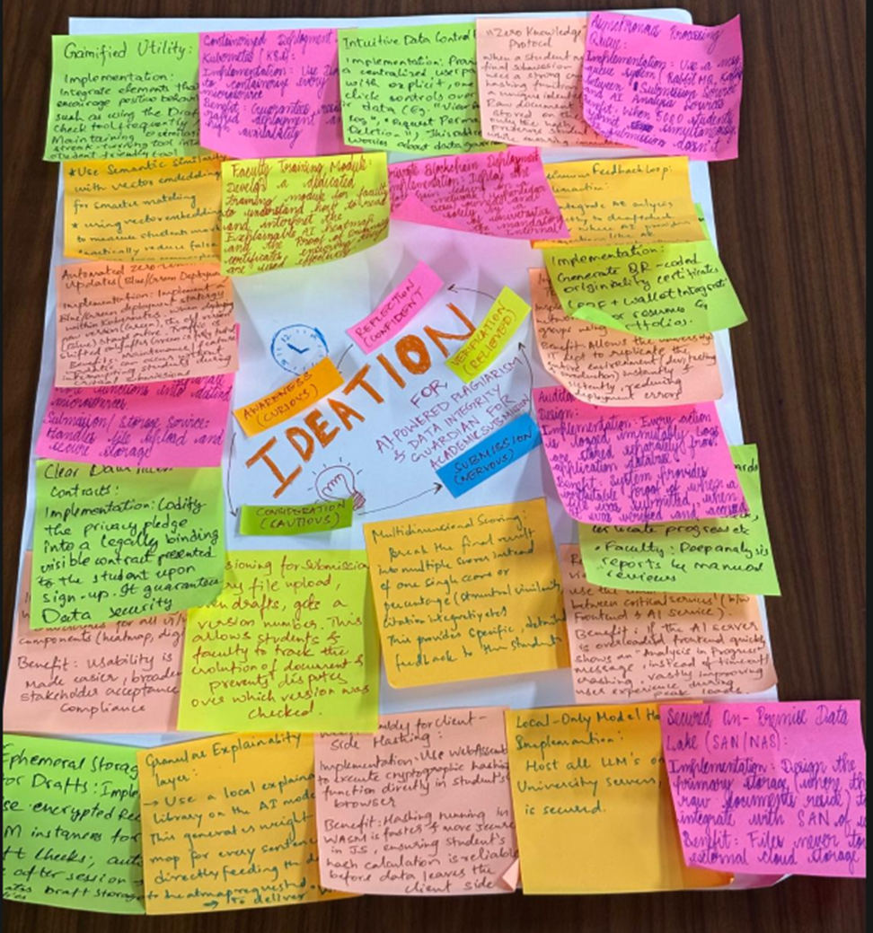
Brainstorming was the first technique used to generate ideas. All team members independently proposed ideas related to academic integrity, plagiarism detection, AI transparency, and student trust. These ideas were then collectively discussed and grouped.
Approach:
No idea was criticized during generation
Focus was placed on quantity rather than quality
Ideas were recorded visually for easy clustering
Sample Ideas Generated:
Explainable AI plagiarism reports
Draft-check tool before final submission
Visual heatmaps instead of numeric similarity scores
Student-controlled data deletion options
AI-based writing improvement suggestions
Insight Gained:
Brainstorming revealed that most ideas naturally leaned toward transparency and student empowerment, reinforcing insights from the empathy phase.
3.3.2 Mind Mapping
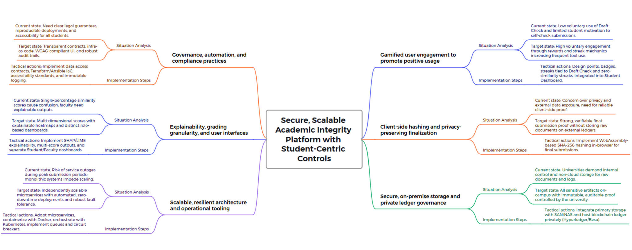
Mind mapping was used to organize the large number of brainstorming ideas into meaningful categories. A central node titled “Secure, Scalable Academic Integrity Platform with Student-Centric Control” was created, with branches extending into key domains.
Major Mind Map Branches:
Transparency & Explainability
Privacy & Data Sovereignty
Student Utility & Learning Support
System Scalability & Reliability
Institutional Compliance
Each branch was further divided into sub-ideas such as explainable heatmaps, local data storage, digital proof of originality, and role-based dashboards.
Insight Gained:
Mind mapping helped the team visualize how technical, ethical, and emotional aspects are interconnected, rather than isolated concerns.
3.3.3 How–Now–Wow Matrix
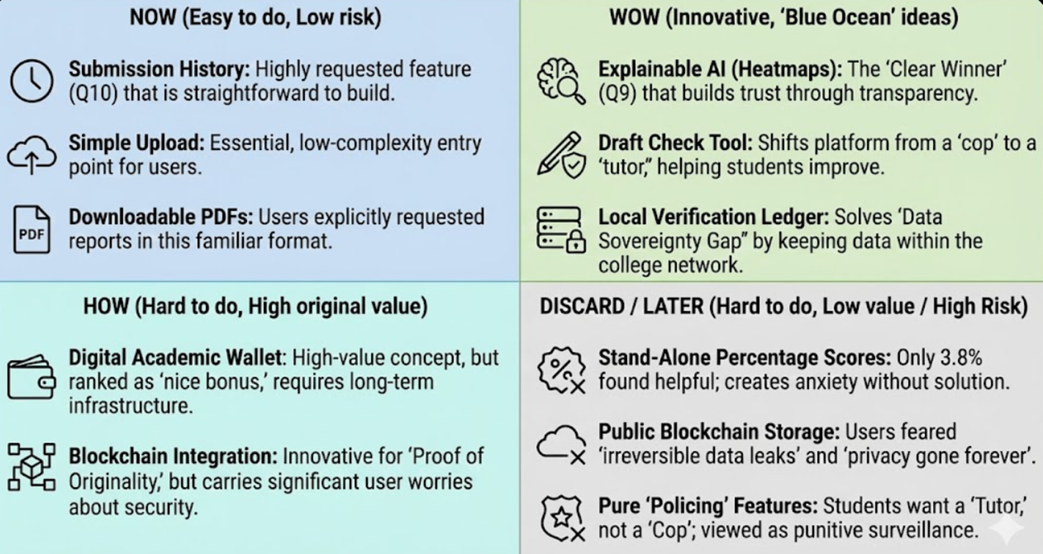
The How–Now–Wow matrix was used to evaluate ideas based on feasibility and impact.
Now (High Impact, High Feasibility)
Draft Check Tool
Downloadable Explainable Reports
Simple and secure submission interface
How (High Impact, Low Feasibility)
Digital Academic Wallet
Blockchain-based Proof of Originality
Local-only AI model hosting
Wow (Low Impact, High Feasibility)
Gamified zero-similarity streaks
UI feedback animations
Submission history timelines
Discard / Later
Standalone similarity percentages
Fully automated punishment workflows
Public blockchain storage of submissions
Insight Gained:
This matrix helped prioritize ideas that were both useful to students and realistic for implementation, while postponing high-risk concepts.
3.3.4 SCAMPER Technique
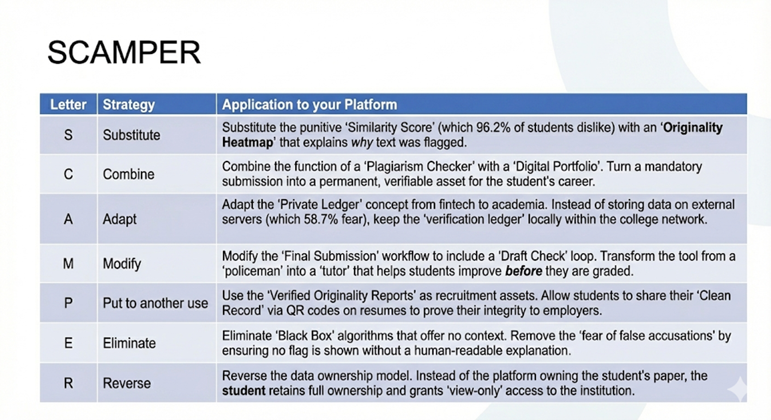
The SCAMPER technique was applied to reimagine traditional plagiarism tools.
Substitute: Replace similarity percentage with explainable AI feedback
Combine: Merge plagiarism detection with writing assistance
Adapt: Adapt blockchain concepts to store hashes instead of raw data
Modify: Change submission workflow to include draft validation
Put to Another Use: Use originality reports as academic credentials
Eliminate: Remove black-box scoring systems
Reverse: Shift ownership of data from platform to student
Insight Gained:
SCAMPER encouraged the team to question assumptions behind existing tools and redesign them from a student-first perspective.
3.3.5 Worst Possible Idea
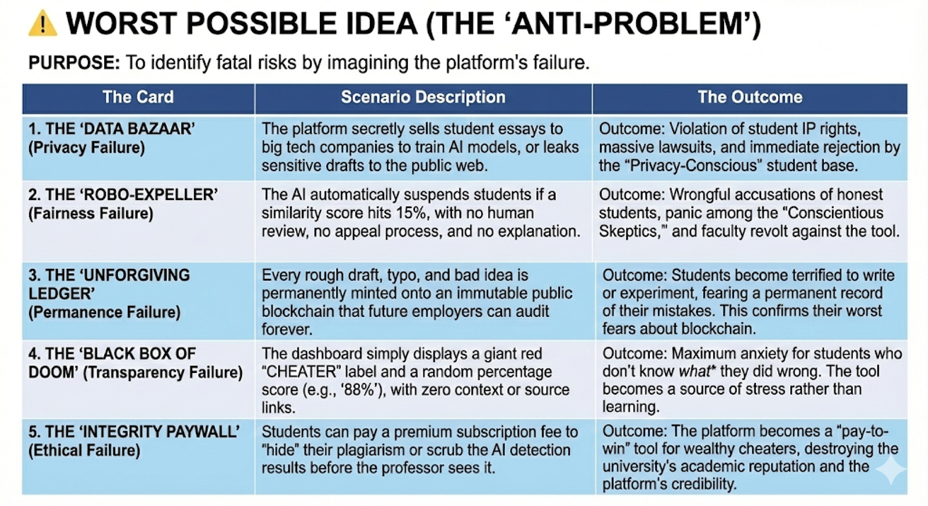
To challenge conventional thinking, the team intentionally designed the worst possible plagiarism system.
Examples:
Automatically failing students based on similarity scores
Permanently storing student submissions on public ledgers
No explanation or appeal mechanisms
Selling student data for AI training
Outcome:
By identifying these failure scenarios, the team gained clarity on what must be avoided, strengthening ethical boundaries for the final design.
3.4 Idea Consolidation and Filtering
After generating over 80 ideas, the team consolidated them using the following criteria:
Alignment with student needs
Ethical and privacy considerations
Transparency and explainability
Technical feasibility
Long-term academic value
Ideas that directly contradicted empathy findings—such as purely punitive systems—were eliminated.
3.5 Finalized Solution Concept
Based on ideation outcomes, the final concept was defined as:
An AI-powered, privacy-first academic integrity platform that verifies originality through explainable analysis, supports students through draft checks, and preserves ownership of academic work using secure verification mechanisms.
Core Features Selected:
Explainable AI similarity analysis with heatmaps
Draft Check tool for pre-submission improvement
Proof of originality through cryptographic hashes
Student-controlled data privacy and deletion
Transparent, downloadable reports
3.6 Learnings from the Ideation Phase
Creativity increases when judgment is deferred
Ethical constraints improve design quality rather than limiting it
Student trust is a stronger design driver than enforcement
Combining multiple ideation techniques leads to richer outcomes
3.7 Transition to Prototyping
The ideation phase concluded with a clear and validated direction for implementation. The next step was to bring these ideas to life through prototyping, allowing users to interact with the solution and provide feedback.

CHAPTER 4: PROTOTYPING

4.1 Introduction to Prototyping
Prototyping is a crucial phase in the Design Thinking process where ideas generated during ideation are transformed into tangible representations. This phase allows designers to explore how a solution would function in real-world scenarios before committing to full-scale development. Prototyping is not about building a final product, but about learning through making.
For our project, prototyping played a significant role because the solution involved sensitive aspects such as academic integrity, AI decision-making, and data privacy. These elements required careful validation with users to ensure that the system felt supportive rather than intimidating. Prototypes helped us test assumptions, identify usability gaps, and validate whether the design choices aligned with student expectations identified during the empathy phase.
We adopted an iterative prototyping approach, starting from low-fidelity conceptual models and gradually moving toward higher-fidelity interactive and technical prototypes.
4.2 Objectives of Prototyping
The key objectives of the prototyping phase were:
To visualize how students would interact with the system
To validate transparency and explainability of AI outputs
To test privacy-preserving workflows
To ensure the system feels supportive and not punitive
To gather early feedback before full implementation
These design choices directly address the concerns identified during the Empathy phase, particularly regarding fairness, transparency, and long-term data ownership.
4.3 Types of Prototypes Used
To achieve the above objectives, multiple forms of prototypes were developed.
4.3.1 Low-Fidelity Prototypes
Low-fidelity prototypes were created to represent the basic structure and workflow of the system.
Examples:
Hand-drawn UI layouts
Process flow diagrams
User journey sketches
Purpose:
Quickly test ideas without technical complexity
Identify logical gaps in user flow
Encourage open feedback from users
These prototypes helped validate core concepts such as draft checking, submission flow, and report visualization.
4.3.2 Mid-Fidelity Prototypes
Mid-fidelity prototypes were developed using digital tools to provide clearer visual structure.
Tools Used:
Figma for UI wireframes
Flowchart tools for system architecture
Features Represented:
Student dashboard
Draft check interface
Submission confirmation screens
Explainable report layouts
These prototypes allowed users to better imagine real interactions and provided more actionable feedback.
4.3.3 High-Fidelity Prototypes
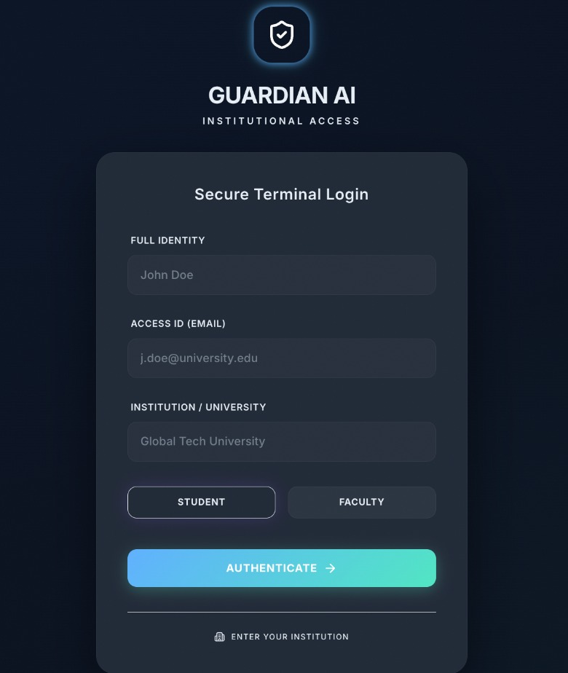
Fig: Integrity report generated during draft check
High-fidelity prototypes focused on interaction realism and technical feasibility.
Characteristics:
Near-real UI designs
Interactive navigation
Partial backend logic
Sample AI outputs
At this stage, prototypes were tested for usability, clarity, and emotional response.
4.4 Tools Used for Prototyping
The following tools were selected based on accessibility, collaboration support, and suitability for academic projects:
4.4.1 Figma
Used for UI/UX design and interactive prototyping
Enabled real-time collaboration among team members
Helped simulate navigation flows
4.4.2 Process Flow Diagrams
Used to represent system architecture
Helped visualize interactions between AI modules, storage, and users
4.4.3 Partial Code Implementation
Used to test feasibility of AI analysis and workflow logic
Validated integration between frontend and backend components
4.5 System Architecture Prototype
The system was prototyped as a modular and scalable architecture, ensuring separation of concerns and data safety.
4.5.1 Major Components
User Interface Layer
Student Dashboard
Faculty Dashboard
Draft Check Editor
AI Analysis Layer
Semantic similarity analysis
Explainable AI module
Visualization engine
Data Security Layer
Cryptographic hashing
Local storage management
Access control mechanisms
Verification Layer
Proof of originality generation
Submission timestamping
Audit logging
This modular design allows independent scaling and maintenance.
4.6 User Flow Prototype
4.6.1 Draft Check Flow
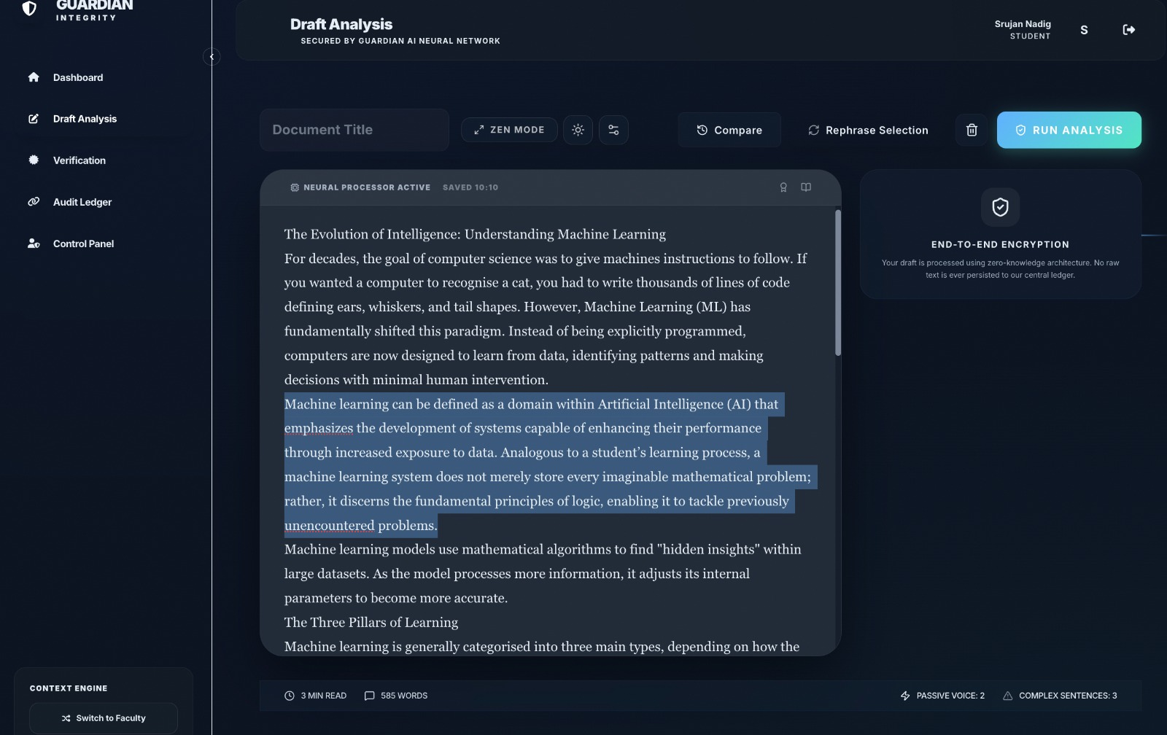
Fig: Draft analysis interface with explainable AI highlights
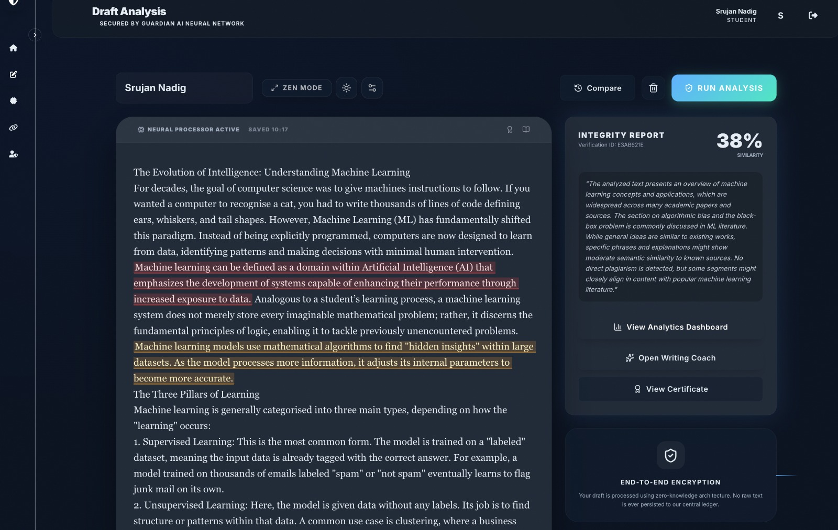
Fig: Integrity report generated during draft check
Student uploads a draft
AI analyzes content locally
Explainable feedback is generated
Student revises content
Draft data is automatically deleted
4.6.2 Final Submission Flow
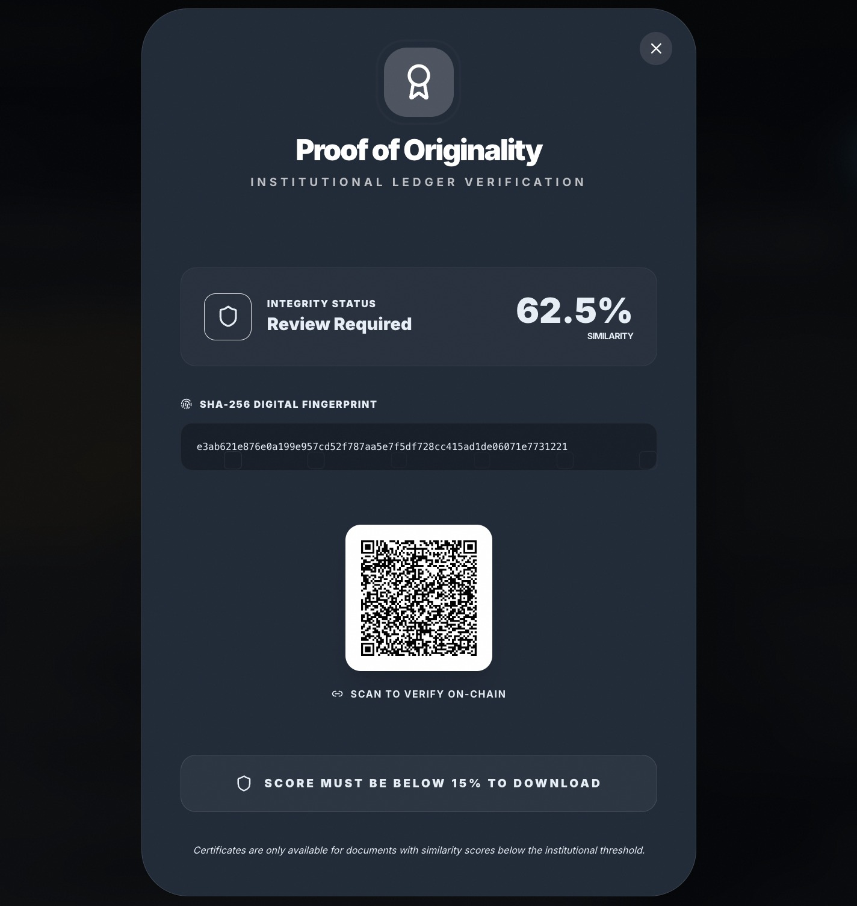
Fig. Proof of originality generated after final submission
Student submits final document
Cryptographic hash is generated
AI analysis is performed
Transparent report is generated
Proof of originality is issued
This flow reassured students that drafts would not be permanently stored.
4.7 UI Prototype Description
4.7.1 Student Dashboard
Clear submission status
Draft history (temporary)
Downloadable reports
Data deletion controls
4.7.2 Explainable Report View
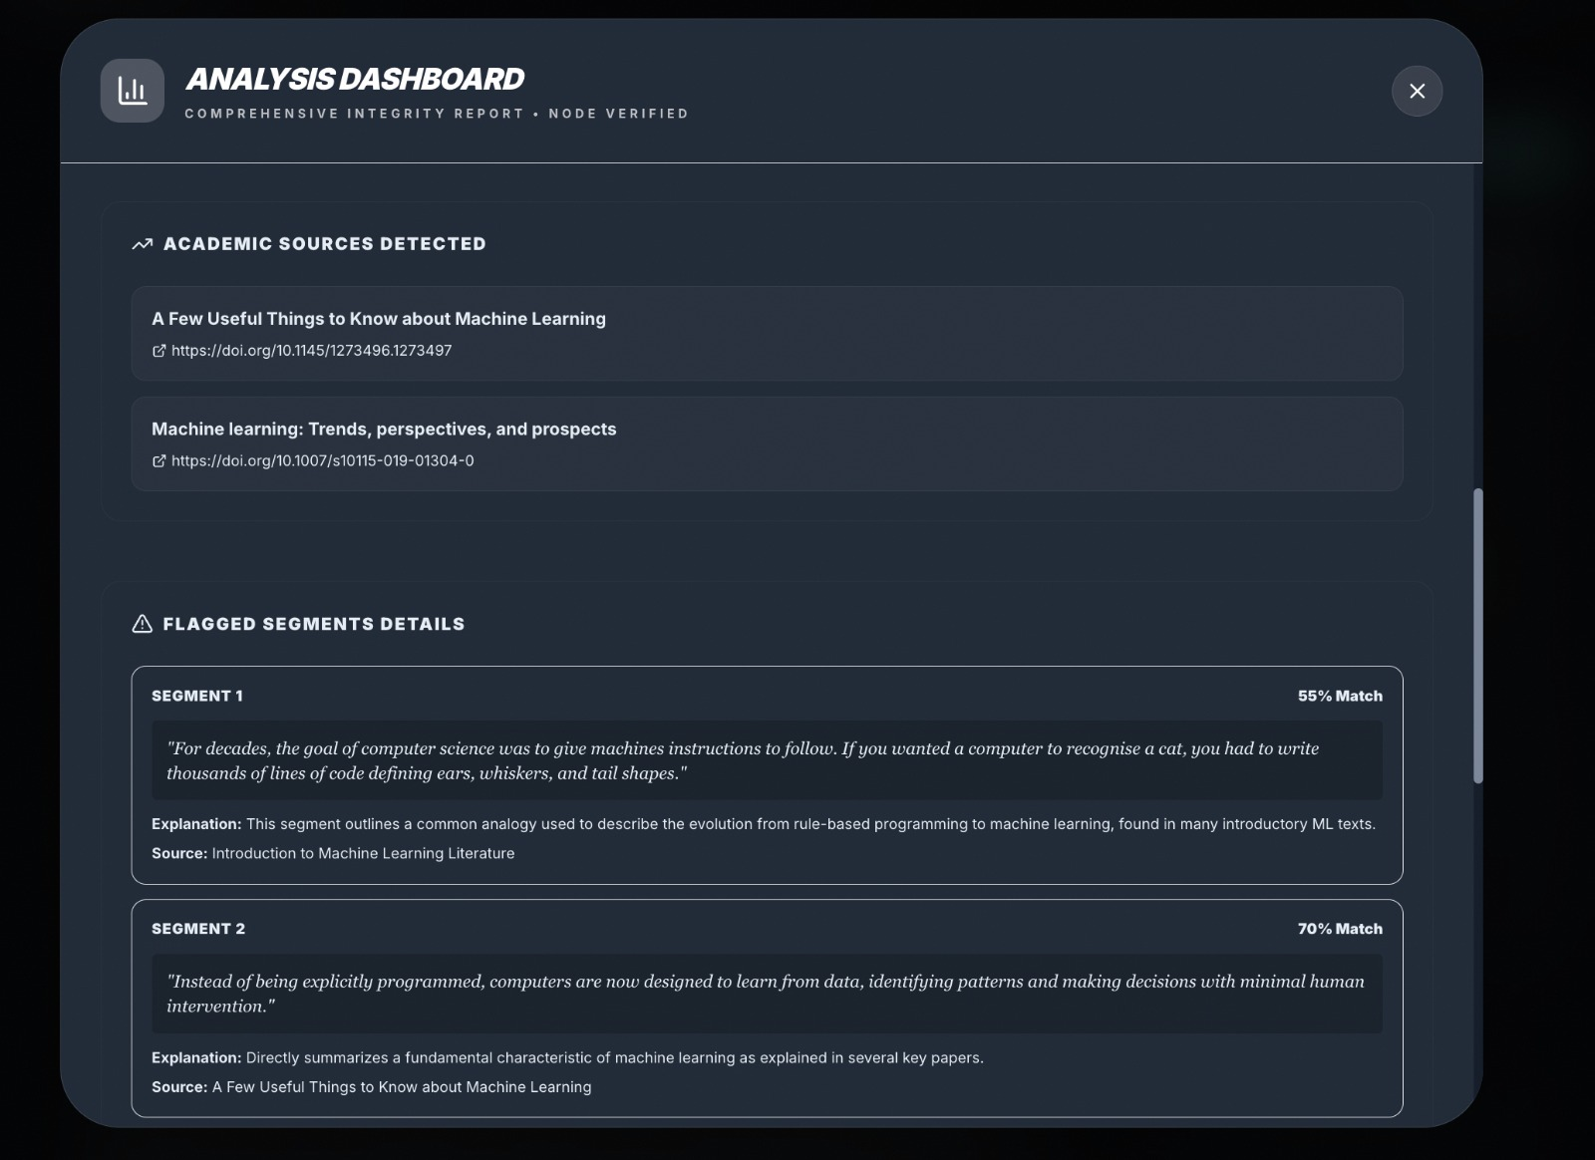
Fig: Segment-wise explainable similarity analysis
Highlighted sections with similarity context
Heatmap-based visual explanation
No single “punitive” score emphasis
4.7.3 Faculty View (Limited)
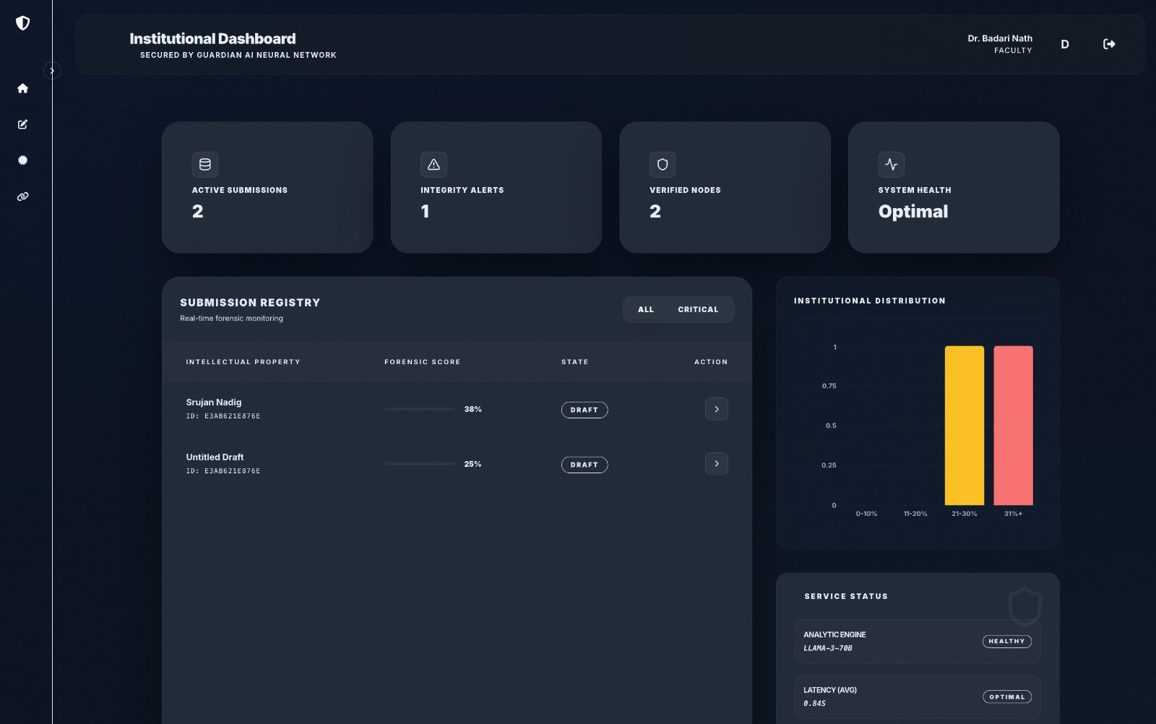
Fig: Faculty dashboard with limited visibility and audit monitoring
Access to reports only after submission
No access to draft history
Audit logs for transparency
4.8 Partial Technical Implementation (Proof of Feasibility)
A partial backend implementation was developed to validate the feasibility of the proposed system.
Key Functionalities Tested
Text ingestion and preprocessing
Semantic similarity computation
Explainable feedback generation
Report visualization logic
The implementation confirmed that explainable and privacy-first analysis is technically feasible within academic constraints.
4.9 Privacy-by-Design Implementation
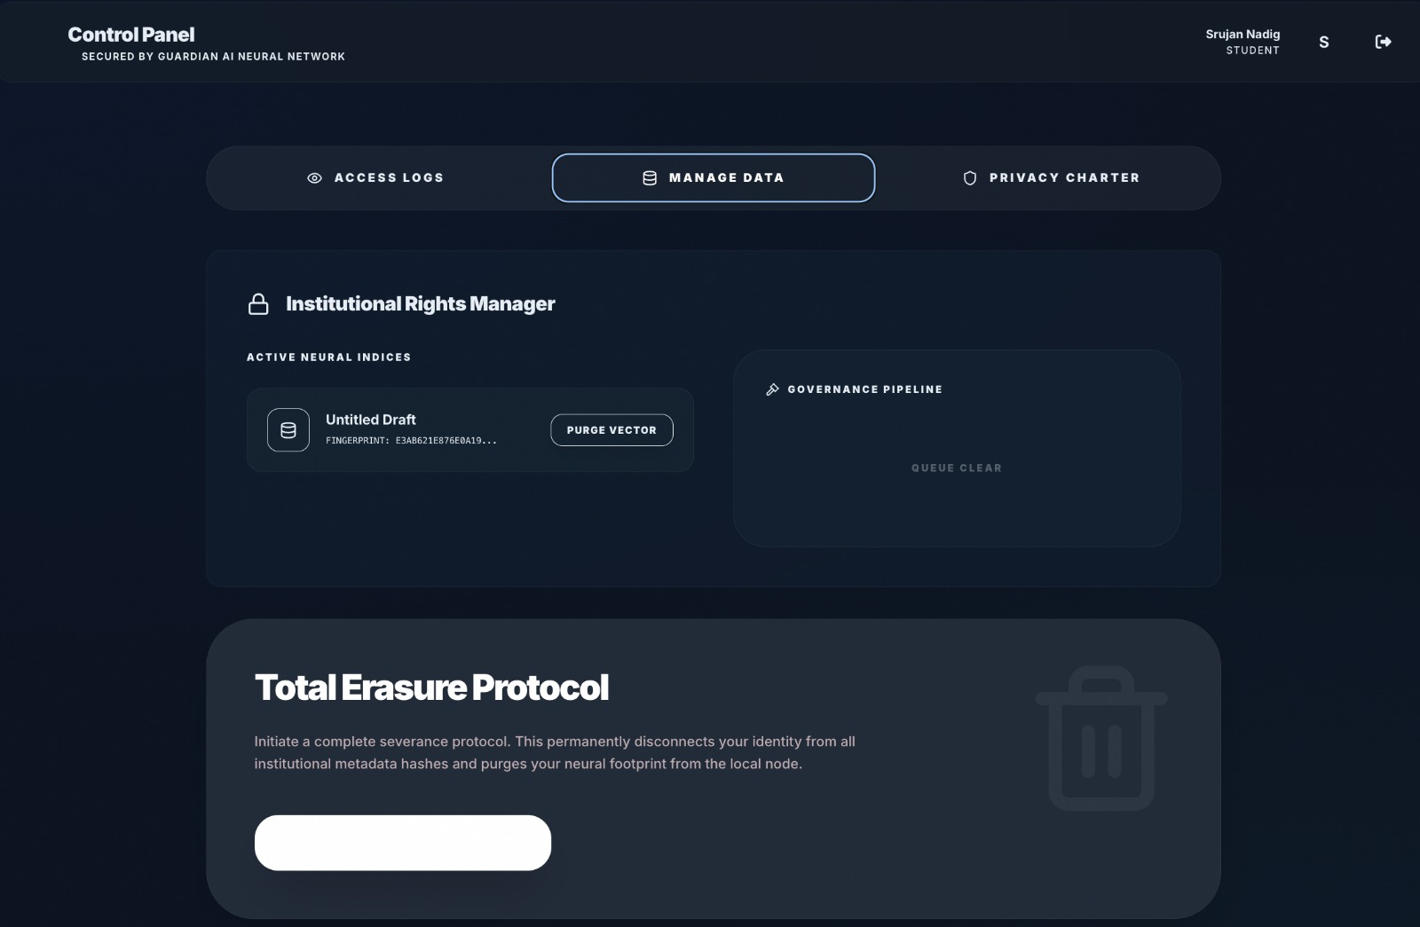
Fig: User-controlled data management and privacy enforcement interface
Privacy was treated as a design constraint, not an afterthought.
Key Privacy Measures
Draft submissions stored temporarily
Hash-based verification instead of raw storage
Student-controlled deletion options
Local processing of sensitive data
This approach directly addressed concerns raised during the empathy phase.
These design choices directly address the concerns identified during the Empathy phase, particularly regarding fairness, transparency, and long-term data ownership.
4.10 Iteration Based on Feedback
Feedback collected from users resulted in multiple refinements:
Reduced emphasis on numeric similarity scores
Improved explanation clarity
Simplified UI navigation
Added reassurance messages during submission
Each iteration brought the prototype closer to student expectations.
4.11 Limitations of the Prototype
While the prototype successfully demonstrated core concepts, certain limitations remained:
Full-scale AI model deployment was not implemented
Performance under extreme load was not tested
Institutional policy integration was simulated
These limitations were acknowledged and documented for future work.
User testing was conducted in a controlled academic context and may not fully represent large-scale institutional deployment scenarios.
4.12 Learnings from Prototyping
Early prototypes prevent costly design mistakes
Transparency must be visual, not textual
Students value reassurance as much as accuracy
Privacy improves trust and adoption
4.13 Transition to Testing
With a validated prototype in place, the project moved into the Testing phase, where user feedback and system behavior were evaluated systematically.

CHAPTER 5: TESTING & VALIDATION
5.1 Introduction to Testing
Testing is a vital phase in the Design Thinking process, as it evaluates how well the proposed solution meets user expectations and real-world requirements. Unlike traditional software testing, design thinking testing focuses heavily on user experience, emotional response, clarity, and usefulness, in addition to technical correctness. The primary objective of this phase is to validate assumptions made during ideation and prototyping by observing real users interacting with the solution.
In this project, testing was not treated as a final checkpoint but as an iterative learning process. Feedback gathered during testing was continuously used to refine the prototype, ensuring alignment with student needs identified in the empathy phase. Since the system deals with sensitive academic data and AI-driven decisions, user trust and comfort were considered key validation parameters.
5.2 Objectives of the Testing Phase
The testing phase aimed to:
Validate whether the system reduced student anxiety during submissions
Evaluate clarity and usefulness of explainable AI outputs
Test usability of the draft check feature
Assess trust in privacy and data control mechanisms
Identify usability gaps and improvement areas
5.3 Types of Testing Conducted
To comprehensively evaluate the prototype, multiple testing methods were employed.
5.3.1 User Testing
User testing was conducted with students from different academic years to ensure diverse perspectives. Participants were asked to interact with the prototype and complete predefined tasks.
Tasks Given:
Upload a draft and view explainable feedback
Make changes based on feedback
Submit a final document
Download the originality report
Observations:
Students felt reassured when explanations were shown visually
Draft check feature reduced fear of accidental plagiarism
Clear messaging about data deletion increased trust
Key Insight:
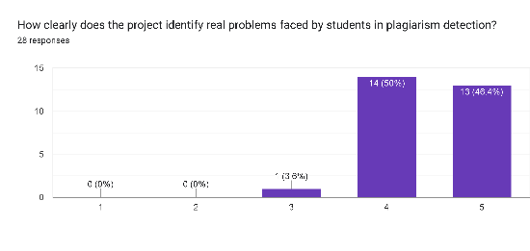
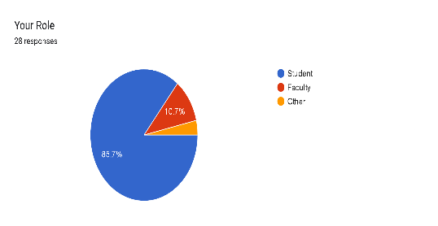
Students preferred guidance-oriented feedback over judgment-based outputs.
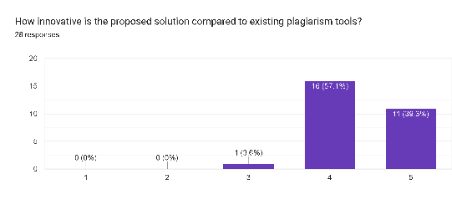
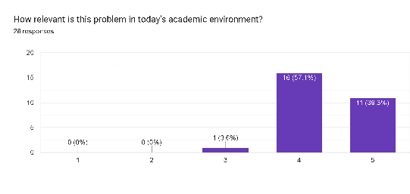
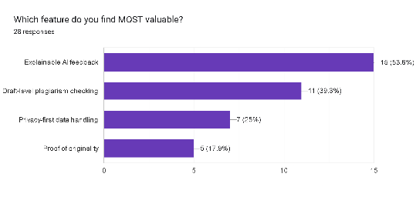
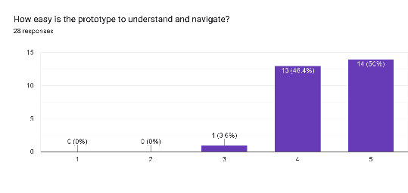
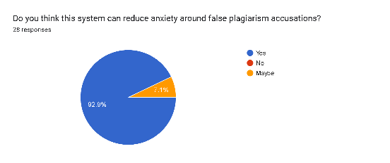
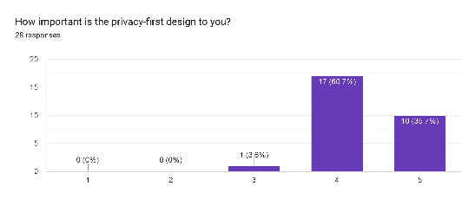

5.3.2 Usability Testing
Usability testing focused on interface clarity, navigation flow, and ease of use.
Parameters Evaluated:
Navigation intuitiveness
Time taken to complete tasks
Error frequency
Need for external guidance
Findings:
Minimal learning curve for first-time users
Clear labeling reduced confusion
Visual hierarchy improved readability
Minor improvements were made to button placement and instructional text based on this feedback.
5.3.3 Visualization Testing
Visualization testing ensured that AI outputs were accurate, interpretable, and meaningful.
Visual Elements Tested:
Heatmaps for similarity explanation
Highlighted text sections
Contextual explanation panels
Validation Steps:
Cross-checking highlighted regions with underlying text similarity
Verifying consistency across multiple documents
Ensuring color schemes were accessible
Result:
Visual explanations significantly improved user understanding compared to numeric scores alone.
5.3.4 Privacy and Trust Validation
Since privacy was a major concern identified during empathy, specific testing focused on user perception of data safety.
Validation Methods:
Asking users if they trusted the system with their drafts
Observing behavior related to draft uploads
Collecting qualitative feedback on privacy messaging
Outcome:
Students were more willing to upload drafts when assured that data was temporary and under their control.
5.4 Feedback Collection Methodology
Feedback was collected using:
Structured Google Forms
Open-ended questionnaire responses
Informal interviews after testing sessions
Sample Questions:
Did the explanation help you understand the results?
Did the system reduce your anxiety?
Would you use this tool voluntarily before submission?
Both quantitative and qualitative data were used to refine the prototype.
5.5 Iterative Improvements Based on Feedback
Testing led to multiple iterations of the prototype.
Iteration 1: Initial Feedback
Students wanted clearer explanations
Too much emphasis on similarity percentage
Iteration 2: Improved Transparency
Reduced visibility of raw scores
Added explanation tooltips
Improved heatmap contrast
Iteration 3: Trust Reinforcement
Added reassurance messages
Explicit data deletion confirmation
Simplified report language
Each iteration resulted in improved user confidence and satisfaction.
5.6 Validation of Design Goals
The testing phase validated the core design goals:
Design Goal
Validation Outcome
Transparency
Achieved through explainable visuals
Student Empowerment
Draft check widely appreciated
Privacy
Strong positive response
Trust
Increased willingness to use tool
Usability
Minimal learning curve
5.7 Limitations Observed During Testing
Despite positive results, certain limitations were identified:
Testing was conducted with a limited sample size
Long-term adoption behavior could not be measured
Institutional policy variations were not tested
These limitations highlight opportunities for future enhancement.
5.8 Transition to Validation and Results
Testing provided confidence that the solution meets student needs, while also revealing areas for refinement. The next section focuses on formal validation of outcomes and how the solution aligns with academic integrity objectives.
5.9 Validation Summary
Overall, testing confirmed that:
Explainable AI improves trust
Privacy-first design reduces anxiety
Supportive tools encourage ethical behavior
The solution successfully balances academic integrity with student well-being..

CHAPTER 6: CONCLUSION & REFLECTION

6.1 Conclusion
This Design Thinking Laboratory project set out to explore a critical challenge in modern academic ecosystems—the need for plagiarism detection systems that ensure academic integrity while also being fair, transparent, and respectful of student data. Through a structured and human-centered design approach, the project successfully moved beyond conventional plagiarism detection methods to propose a student-centric academic integrity guardian.
The project began with the Empathy phase, where direct interaction with students revealed strong emotional and practical concerns surrounding existing plagiarism tools. Students expressed anxiety, mistrust, and fear of false accusations, largely due to opaque AI systems and unclear data usage policies. These insights were crucial in reframing the problem from a purely technical challenge into a trust and transparency problem.
In the Define phase, the core issue was articulated as the absence of a system that balances originality verification with student empowerment. This clarity ensured that all subsequent design decisions aligned with genuine user needs rather than assumptions. The Ideation phase then enabled the team to explore a wide range of creative solutions using structured techniques such as brainstorming, mind mapping, SCAMPER, How–Now–Wow analysis, and worst-case scenario evaluation. These techniques allowed the team to challenge traditional, punitive system designs and instead focus on ethical and supportive alternatives.
The Prototyping phase brought these ideas to life through low-fidelity, mid-fidelity, and high-fidelity representations. By developing UI flows, system architectures, and partial technical implementations, the team demonstrated the feasibility of explainable AI, privacy-first workflows, and draft-based learning support. Iterative refinement ensured that the system evolved in response to real user feedback rather than static assumptions.
Finally, the Testing and Validation phase confirmed that the proposed solution effectively addressed the concerns raised during the empathy phase. Students reported reduced anxiety, increased trust, and a stronger willingness to engage proactively with the system. The explainable visual feedback, draft check functionality, and explicit privacy controls were particularly well received. Together, these outcomes validate the effectiveness of applying Design Thinking principles to complex, sensitive problems in educational technology.
Overall, this project demonstrates that academic integrity tools do not need to rely solely on surveillance and enforcement. By prioritizing empathy, transparency, and ethical AI usage, institutions can foster an environment that encourages originality while maintaining fairness and trust.
6.2 Reflection
Reflecting on this project, it is evident that the Design Thinking process significantly influenced both the outcome and the learning experience of the team. Initially, the problem appeared to be a straightforward technical challenge—detecting plagiarism more accurately. However, as the project progressed through each design thinking phase, the team’s understanding evolved into a deeper appreciation of the human impact of technological systems.
One of the most valuable lessons learned was the importance of empathy as a design driver. Engaging directly with students revealed emotional dimensions—fear, stress, and uncertainty—that would have been overlooked in a purely technical approach. This insight fundamentally changed how the team evaluated design decisions, prioritizing user comfort and trust alongside functionality.
The ideation phase reinforced the value of creative freedom and structured exploration. Techniques such as the worst possible idea and SCAMPER helped break conventional thinking patterns and exposed hidden assumptions in existing systems. The team learned that innovation often emerges not from adding complexity, but from reimagining purpose.
Prototyping and testing further emphasized the importance of iteration and feedback. Early prototypes exposed flaws that were not apparent in conceptual discussions, demonstrating that user interaction is essential for validating design assumptions. The iterative refinement process also highlighted the role of communication—how information is presented can significantly influence user perception, especially in AI-driven systems.
On a personal and professional level, this project strengthened the team’s skills in collaboration, critical thinking, ethical reasoning, and user-focused design. It also fostered an appreciation for responsible AI development, particularly in domains where decisions can have serious academic and emotional consequences.
In conclusion, this project reaffirmed that effective problem-solving requires more than technical expertise. By integrating empathy, creativity, and ethical considerations into the design process, the team developed a solution that not only addresses academic integrity but also respects and empowers its users. These learnings will serve as a strong foundation for future projects and professional endeavors.

BIBLIOGRAPHY

[1] R. F. Dam and T. Y. Siang, The Five Stages of Design Thinking, Interaction Design Foundation, 2020.
[2] R. F. Dam and T. Y. Siang, Design Thinking: Getting Started with Empathy, Interaction Design Foundation, 2019.
[3] D. H. Mortensen, Stage 1 in the Design Thinking Process: Empathize with Your Users, Interaction Design Foundation, 2018.
[4] R. F. Dam and T. Y. Siang, Stage 3 in the Design Thinking Process: Ideate, Interaction Design Foundation, 2019.
[5] R. F. Dam and T. Y. Siang, Stage 4 in the Design Thinking Process: Prototype, Interaction Design Foundation, 2019.
[6] Z. Singla, S. Randhawa, and S. Jain, “Sentiment Analysis of Customer Product Reviews Using Machine Learning,” International Journal of Computer Science Engineering, Thapar University, India.
[7] S. Yi and X. Liu, “Machine Learning-Based Customer Sentiment Analysis for Recommending Shoppers,” Journal of Intelligent Systems, 2021.
[8] O. Grljević and Z. Bošnjak, “Sentiment Analysis of Customer Data,” University of Novi Sad, Serbia.
[9] S. Russell and P. Norvig, Artificial Intelligence: A Modern Approach, 4th ed., Pearson Education, 2021.
[10] IEEE, Ethically Aligned Design: A Vision for Prioritizing Human Well-being with Autonomous and Intelligent Systems, IEEE Standards Association, 2020.

