

HIVE STUDIO

A CASE STUDY BY

Edita Etube-Muchová

Nadiia Goncharenko

Kornelia Kopf

**Content**

**1.** **Introduction and Goals** 4

**1.1.** **Use-case diagram** 4

**1.2.** **Requirements Overview** 5

**1.3.** **Quality Goals** 6

**1.4.** **Stakeholders** 7

**2.** **Architecture Constraints** 8

**2.1.** **Organizational Constraints** 8

**2.2.** **Technical Constraints** 9

**3.** **System Scope and Context** 10

**3.1.** **Business Context** 10

**3.2.** **Technical Context** 12

**4.** **Solution Strategy** 14

**5.** **Building Block View** 15

**5.1.** **Level 0** 15

**5.2.** **Level 1:** 16

**5.3.** **Level 2** 17

**5.4.** **Level 3** 18

**6.** **Runtime View** 19

**6.1.** **<Runtime Scenario “New vote”-Tweet >** 19

**6.2.** **<Runtime Scenario Created Tweet >** 19

**7.** **Deployment View** 20

**8.** **Cross-cutting Concepts** 21

**8.1.** **Entity Relationship Diagram** 21

**8.2.** **Safety** 22

**8.3.** **JavaScript and CSS optimization** 22

**8.4.** **User Interface** 22

**8.5.** **Exception/Error Handling** 22

**8.6.** **Internationalization** 23

**8.7.** **Usability** 23

**8.8.** **Testable** 23

**8.9.** **Build-Management** 23

**8.10.** **Usability** 23

**9.** **Design Decisions** 24

**9.1.** **Using temporary local file storage for video and track data** 24

Problem 24

Considered Alternatives: 24

Decision 24

**9.2.** **Using of program languages** 24

Problem 24

Considered Alternatives 24

Decision 24

**10.** **Quality Requirements** 25

**10.1.** **Quality Tree** 25

**10.2.** **Priority Table:** 25

**10.3.** **Quality Scenarios** 26

**11.** **Risks and Technical Debts** 28

**12.** **Glossary** 29

**Tables**

Table 1: Requirements Overview 5

Table 2: Quality Goals 6

Table 3: Stakeholders 7

Table 4: Organizational Constraints 8

Table 5: Technical Constraints 9

Table 6: Business Context Supplement 11

Table 7: Technical Context Supplement 13

Table 8: Solution Approaches 14

Table 9: Annex to Level 0 15

Table 10: Annex to Level 2 17

Table 11: Annex to Level 3 18

Table 12: Annex to Deployment View 20

Table 13: Entities to ER-Diagram 22

Table 14: Priority Table 26

Table 15: Quality Scenarios 27

Table 16: Technical Risks 28

Table 17: Glossary 29

**Figures**

Figure 1: Use-Case Diagram 5

Figure 2: Business Context 11

Figure 3: Technical Context 13

Figure 4: Level 0 16

Figure 5: Level 1 - HiveStudio::JavaModule 17

Figure 6: Level 2 - HiveStudio.PlayBox 18

Figure 7: Level 3 - Tweet 19

Figure 8: Runtime Scenario "New vote"-Tweet 20

Figure 9: Runtime Scenario Created Tweet 20

Figure 10: Deployment View 21

Figure 11: ER-Diagram 22

# **Introduction and Goals**

HiveStudio is an entertainment project to add, prioritise, play, and visually represent songs in playlists. The aim of this project is also to learn how to prepare the architecture concept on the hand of arc42.

The project result should be clear, easily understandable, and implementable for future developers. The main stakeholders of the project are user, developer, software architects and project leader.

## **Use-case diagram**

The functions of HiveStudio as described in document “CaseStudy-HiveStudio_English” are summarized in this use-case diagram:

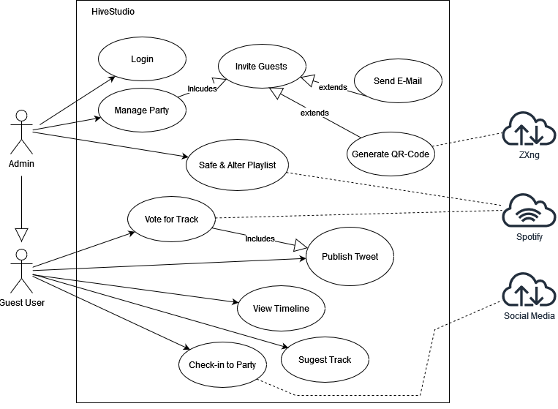

Figure 1: Use-Case Diagram

## **Requirements Overview**

|  |  |
| --- | --- |
| R1 | Operating system-independent: The HiveStudio website should run on all operating systems Windows, Linux and Mac, as well as all types of modern browsers. |
| R2 | Every user of HiveStudio can participate in creating a playlist, which contains music and videos. |
| R3 | Server component of the system manages playlists and different types of users in a centralized way. Part of this HiveStudio.Server is also user authentication. |
| R4 | There are two main types of clients, one manages playlist content, another one manages the visual representation and media management. |
| R5 | Web service is responsible to export the functionality of Hive Studio.Server and provides the communication between the Hive.Studio.Server and its clients - HiveStudio.Playbox, HiveStudio.WebVote and HiveStudio.SimpleVote. |
| R6 | HiveStudio.Playbox is used to manage user data, party data, invite users to parties, manage playlists and a party Twitter-like timeline, as well as play the item with the highest priority. |
| R7 | HiveStudio.WebVote - with the help of this client, party guests can suggest new music tracks or videos and vote on the priority of the suggested media. |
| R8 | HiveStudio.SimpleVote - the GUI client is necessary so the entire system can also be demonstrated without a web client. A subset of the functionality of the web client is to be implemented in this client. |

Table 1: Requirements Overview

## **Quality Goals**

|  |  |  |  |  |
| --- | --- | --- | --- | --- |
| # | Priority | Quality Goal | Important to | Scenario |
| QG1 | 1 | **Interoperability** | software architects | Final system should be able to work with and communicate easily with other systems, which will be responsible for playing songs and videos like computers, TVs. |
| QG2 | 1 | **Easy to use** | user | Final system should be intuitive, easy to use and administrate for users. |
| QG3 | 2 | **Performance** | user | Software architecture built according to the provided specification with attention to high performance. |
| QG4 | 3 | **Testable** | developer | Easy testing of all components of the software architecture. |
| QG5 | 2 | **Correctness** | project leader | Software architecture built according to the provided specification. |

Table 2: Quality Goals

## **Stakeholders**

|  |  |
| --- | --- |
| Role/Name | Expectations |
| User | Music fans who want to add, prioritize and play songs in playlists. The user is also able to manage the visual representation of the playlist. |
| Developer | developing HiveStudio website and application on the base of this arc42 |
| Software architects  (*Edita Etube Muchova, Nadiia Goncharenko, Kornelia Kopf*) | responsibly built and prepare arc42 according to the architecture concepts and technologies taught within SWA course |
| Project leader  (Marvin Kosmider) | project overview and supervision |

Table 3: Stakeholders

# **Architecture Constraints**

## **Organizational Constraints**

|  |  |  |
| --- | --- | --- |
| **#** | **Constraint** | **Background and / or motivation** |
| OC1 | Configuration and version control / management | Private GoogleDoc |
| OC2 | Architecture documentation | Structure-based on the English arc42-Template. |
| OC3 | Language | English |
| OC4 | Time schedule | Start in October and final results until 19.01. (presentation Date) |
| OC5 | Published under an Open Source license | The source, including documentation, should be published as Open Source |
| OC6 | Team | Edita Etube Muchova, Nadiia Goncharenko, Kornelia Kopf |

Table 4: Organizational Constraints

## **Technical Constraints**

|  |  |  |
| --- | --- | --- |
| **#** | **Constraint** | **Background and / or motivation** |
| TC1 | Operating system-independent | The HiveStudio website should run on all operating systems Windows, Linux and Mac, as well as all types of modern browsers |
| TC2 | Export of functionality | Entire functionality and interaction with the server is exported via HiveStudio.WebService |
| TC3 | Authentication | Authentication of all components runs through HiveStudio.Server |
| TC4 | Data management | Managing of all data should run via HiveStudio.PlayBox |
| TC5 | Third party media platforms and services must be available “under an compatible open source license “ | The interested developer or architect should be able to check out the sources, compile and run the application without problems compiling dependencies. All external dependencies should be available via the package manager of the App or at least through an installer. |
| TC6 | Memory friendly | Memory can be limited due to deployment to cloud based host |
| TC7 | Implementation in Java | Development with Java SE version 16. The engine should also run in newer Java versions, when available. |

Table 5: Technical Constraints

# **System Scope and Context**

This part explains the environment and context of HiveStudio.

## **Business Context**

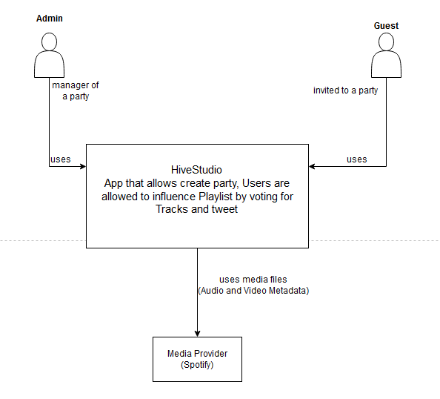

Figure 2: Business Context

|  |  |
| --- | --- |
| User/ System | Description |
| Admin | Via PlayBox Admin can:   * manage party/parties * manage playlist * manage timeline * invite guests to a party (via QR Code or Email) |
| Guest | Via WebVote Guest can:   * join the party via QR Code or Email with a access code * view the playlist * suggests tracks/videos * vote for tracks/ videos * view timeline with posted messages * post short messages to the timeline |
| Media Provider (Spotify) | HiveStudio and its Server component are able to fetch tracks, videos and metadata from Spotify |

Table 6: Business Context Supplement

## **Technical Context**

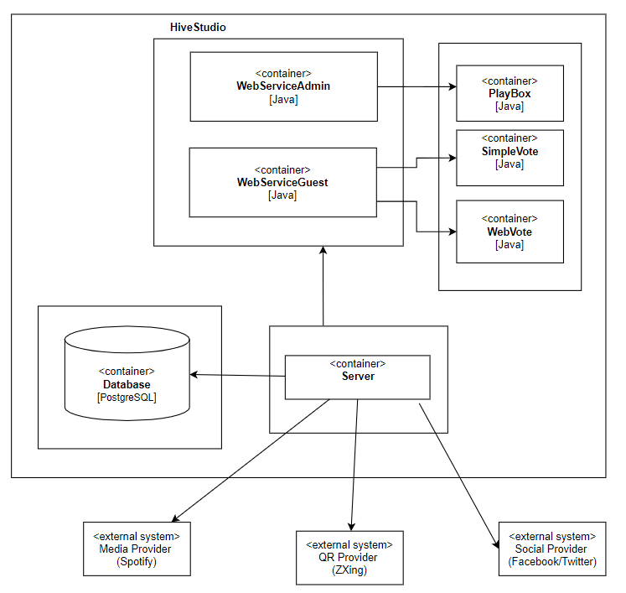

Figure 3: Technical Context

|  |  |
| --- | --- |
| **User/ System** | **Description** |
| **PlayBox** | This client allows the user group administrator to manage the user master data, create parties and invite users to parties.  PlayBox allows administrators to manage parties, tracks, timeline and interact with users. |
| **SimpleVote** | Basic client that supports only login, voting, suggesting and sending tweets for demonstration purpose without using WebClient at an early stage.  SimpleVote is a simple Client that allows Login, suggesting a track, sending tweets and viewing a playlist. |
| **WebVote** | With the help of the web interface, users get an overview of all parties. You can get to the playlist of a party by checking in using a QR code or party code. In the playlist, users can vote for individual titles or invited users can suggest new titles. Of course, you can also listen to or look at the music or video titles directly. Voting processes or user comments are displayed in the party twitter timeline. With HiveStudio.WebVote, particular attention should be paid to ease of use and a visually appealing implementation.  WebVote allows users viewing parties, tracks , timeline and interact with them. |
| **WebServiceAdmin** | Provides the functionality for Administrator interactions with the system via RESTful Interface. Exporting the required functionality for the SimpleVote and WebVote in the form of a web service, including all the Administrator funktionality. |
| **WebServiceGuest** | Provides the functionality for Guest interactions with the system via RESTful Interface. Exporting the required functionality for the PlayBox in the form of a web service, not including all the Administrator functionality. |
| **Server** | Main component of the system. Server handles data, user and party administration.  Server also fetches data from external MediaProvider (Spotify) and SocialMedia Provider. This component is responsible for all funktionality needed by its clients. |
| **Database** | MySQL Database. Stores user information, hashed authentication credentials, access logs, parties, etc. |

Table 7: Technical Context Supplement

# **Solution Strategy**

Solution strategies are built on the basis of quality goals. They also reflect the experience and education level of the software architects, which led to the main goal - make it as simple as possible. Solutions strategies are explained in following table:

|  |  |
| --- | --- |
| **Quality goal** | **Solution approach** |
| **QG1**  **Interoperability** | Implementing interface for video and music applications. The first version is planned to implement the Spotify API (application programming interface). |
| **QG2**  **Easy to use** | Start UX testing at the early stage, already at the stage of finishing SimpleVote. According to the results of the tests, the programming of WebVote will be modified. |
| **QG3**  **Performance** | Regular review of performance goals - provide voting (in 2 seconds), appear Tweets (in 3 seconds) |
| **QG4**  **Testable** | Creating test classes in Java. |
| **QG5**  **Correctness** | Programmed in Java SE, version 16. |

Table 8: Solution Approaches

# 

# **Building Block View**

## **Level 0**

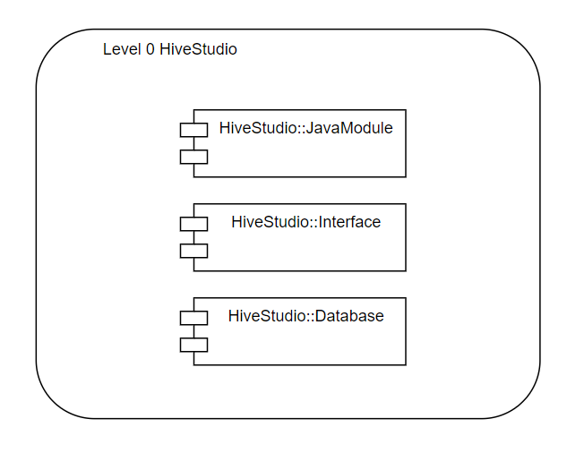

Figure 4: Level 0

| **Blackbox** | **Description** |
| --- | --- |
| HiveStudio::Java Modules | Backend application runs on the supported server. Application provides all the required functions |
| HiveStudio::Interfaces | Interface for all needed APIs (Application Programming Interface) like Spotify API, social media API. |
| HiveStudio:Database | Stores all relevant data. |

Table 9: Annex to Level 0

## **Level 1:**

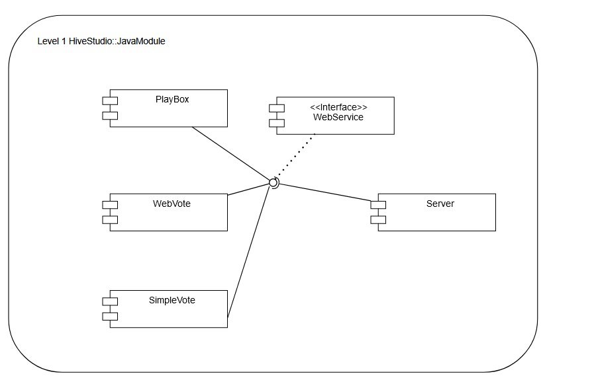

Figure 5: Level 1 - HiveStudio::JavaModule

## **Level 2**

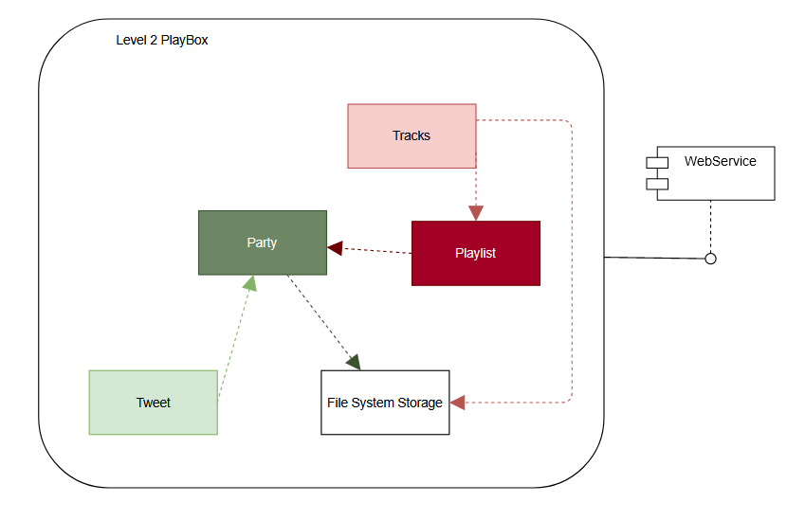

Figure 6: Level 2 - HiveStudio.PlayBox

|  |  |
| --- | --- |
| **BLACK BOX** | **DESCRIPTION** |
| Tweet | get information either from vote (like) or user (comment) and sends it to the party |
| Tracks | get information from vote (liked video/song) and stored the information to File System Storage, sends it to the Playlist |
| Party | Party gets the information from Tweet about all party likes or comments and about actual playlist.  PlayBox stores the current Playlist and tweets into the File System Storage. Administrator accesses the Party to manage it. PlayBox plays songs/videos from Music API. |
| Playlist | Playlist holds the current list of most liked tracks. As soon as the class Tracks gets a new vote, the list of tracks is rearranged. |
| File System Storage | In File System Storage are Tracks and Parties stored. |

Table 10: Annex to Level 2

## **Level 3**

This white box on level 3 explains the black box “Tweet”.

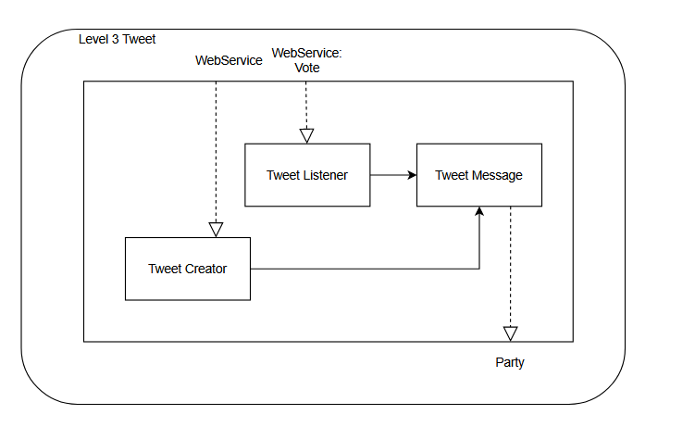

Figure 7: Level 3 - Tweet

|  |  |
| --- | --- |
| BLACK BOX | DESCRIPTION |
| Tweet Creator | contains all methods for writing and publishing an individual tweet |
| Tweet Listener | is triggered when a new vote is cast for a title |
| Tweet Message | contains methods to create and publish an automatic tweet |

Table 11: Annex to Level 3

# **Runtime View**

We have picked two examples to demonstrate the runtime view.

## **<Runtime Scenario “New vote”-Tweet >**

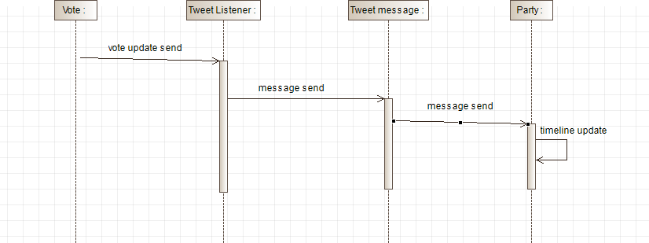

Figure 8: Runtime Scenario "New vote"-Tweet

## **<Runtime Scenario Created Tweet >**

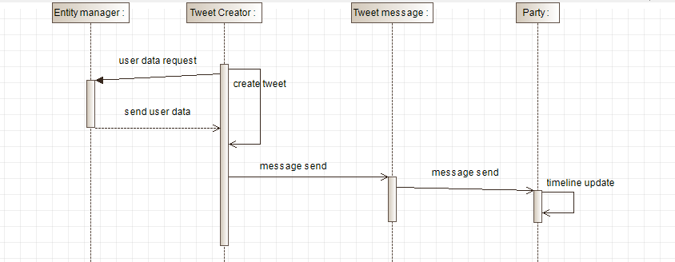

Figure 9: Runtime Scenario Created Tweet

# **Deployment View**

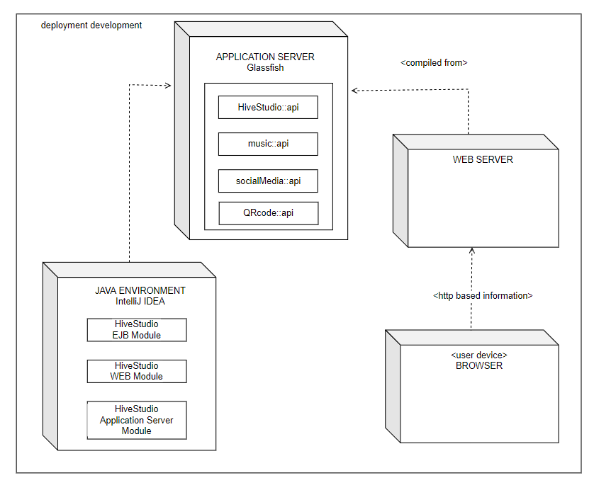

Figure 10: Deployment View

|  |  |
| --- | --- |
| **Node / Artifact** | **Description** |
| **Java Environment** | *HiveStudio* development takes place here with all Java Modules and Components. Modules are built as .jar and .war files. |
| **Application Server** | Server that hosts the application. They communicate with Java Environment through interfaces. |
| **Web Server** | Request from client server is stored here and forwarded through Web Server |
| **Browser** | A client browser to access the application. All major browsers (Chrome, Firefox, Safari, IE / Edge) should work. |

Table 12: Annex to Deployment View

# **Cross-cutting Concepts**

## **Entity Relationship Diagram**

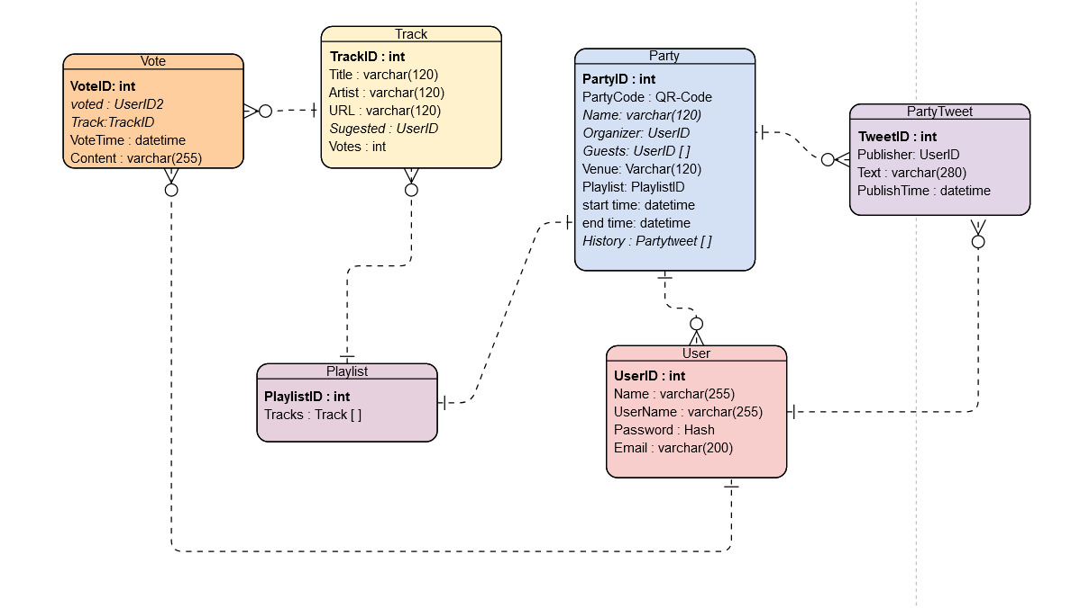

Figure 11: ER-Diagram

### 

|  |  |
| --- | --- |
| **Name** | **Description** |
| User | For each user, the access data and e-mail address are to be saved. A user can be assigned one of the following two roles:   * Administrator: Administrators can use the HiveStudio.PlayBox. Administrators authenticate themselves with their username and password. * Guest: Guests are authorized to perform all functions offered by the HiveStudio clients. Guests authenticate themselves with a party code, which only allows access to a specific party. |
| Party | This entity is used to manage the master data of a party: name, venue, start and end time, party code, etc. |
| Playlist | The playlist is the collection of all tracks suggested for a party. The playlist is assigned to a party. |
| Track | This entity is used to manage the metadata of music titles or videos: title, author/artist, URL, etc. A track clearly belongs to a playlist. For each track it is also necessary to save who suggested it. The media file itself is not stored permanently in the database or locally. Make sure to use an online media platform like YouTube, Vimeo, etc... If runtime efficiency requires it, media files can be temporarily stored (downloaded and deleted after usage). |
| Vote | This entity stores which user voted for which track and when. |
| Party tweet | A party tweet is a short message (280 signs) that is assigned to a user and a party inside the system (no integration to the actual twitter.com platform). |

Table 13: Entities to ER-Diagram

## **Safety**

No part of the system has life endangering aspects.

## **JavaScript and CSS optimization**

JavaScript and CSS dependencies are managed through Maven dependencies in the form of webjars wherever possible.

## **User Interface**

The default user interface for *HiveStudio* which is packaged within the final artifact is a Single Page Application written in JavaScript using *AngularJS* together with a very default *Bootstrap* template.

## **Exception/Error Handling**

Errors handling inconsistent data (regarding the data models constraint) as well as failures to validation are mapped to HTTP errors. Those errors are handled by the frontend’s controller code. Technical errors (hardware, database etc.) are not handled and may lead to application failure or lost data.

## **Internationalization**

HiveStudio's supported language is English.

## **Usability**

Ensuring the Quality Goals “Easy to use”, “Readable” and “Attractiveness”: To finish a milestone while developing, it is mandatory to prove that the usability was successfully tested.

## **Testable**

The project contains Unit tests in the standard location of a Maven project. At the time of writing those tests cover > 95% of the code written. Tests must be executed during build and should not be skipped.

## **Build-Management**

The application can be built with Maven without external dependencies outside Maven.

## **Usability**

Ensuring the Quality Goals “Easy to use”, “Readable” and “Attractiveness”: To finish a milestone while developing, it is mandatory to prove that the usability was successfully tested.

# **Design Decisions**

## **Using temporary local file storage for video and track data**

### Problem

HiveStudio needs optionally to store "large" objects for temporary use during the party: Mediafiles with its metadata.

### Considered Alternatives:

* use of cloud storage (for example S3)
* use of local file system

### Decision

Local file system was selected as it is expected to have enough storage. If HiveStudio should be runnable in cloud-based setup, one has to create an abstraction over the local file system currently used.

## **Using of program languages**

### Problem

The used programming language should be:

* easy to program
* functional, able to cover all requirements.

### Considered Alternatives

* C++
* Python
* Java

### Decision

Java was chosen because of its functionality and widespread use. A wide range of interfaces and off-the-shelf solutions is also a plus.

# **Quality Requirements**

## **Quality Tree**

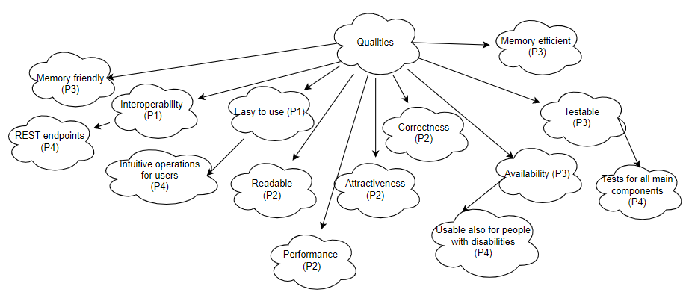

## **Priority Table:**

|  |  |  |  |
| --- | --- | --- | --- |
| **Priority 1 (P1)** | **Priority 2 (P2)** | **Priority 3 (P3)** | **Priority 4 (P4)** |
| Interoperability |  |  | REST endpoints |
| Easy to use |  |  | Intuitive operations for users |
|  | Readable |  |  |
|  | Performance |  |  |
|  | Attractiveness |  |  |
|  | Correctness |  |  |
|  | Performance |  |  |
|  |  | Availability | Usable also for people with disabilities |
|  |  | Testable | Tests for all main components |
|  |  | Memory friendly |  |
|  |  | Memory efficient |  |

Table 14: Priority Table

## **Quality Scenarios**

|  |  |
| --- | --- |
| **Scenario** | **Description** |
| Testable | Provide test files in Java. |
| Intuitive operations for users | Apply user friendly concept according to 10 Usability Heuristics for User Interface Design |
| Tests for all main components | Coverage of 90 % code with tests in the development phase. |
| Memory efficient | For a party of 50 guests 200 MB should be available. |
| Memory friendly | If Media were saved it should be deleted as soon as it was played in the playlist. Cash should be cleaned automatically every 2 hours during a party. |
| Performance | Voting should be provided in 2 seconds. |
| Performance | Tweets should appear in max. 3 seconds in a timeline after posting / voting for a track. |
| Readable | Defined operations should be easy to understand, follow and execute. |
| Interoperability | Check if different systems, devices, applications or products are able to connect and communicate in a coordinated way, without effort of the end user.  Provide Interoperability Testing with at least 20 test cases to prove:   1. Data access 2. Data transmission |
| REST endpoints | Provide at 2 test cases for each REST Endpoint java class. |
| Easy to use | 1. No broken links 2. Website search included for “lost” user 3. Use of short sentences - easier understandable for people with lower skill of language or with reading/understanding disabilities |
| Attractiveness | Ensure responsive design |
| Correctness | Coverage of at least 95 % of provided project specification. |
| Availability | Control if following features are part of the project, if not then adjust:   1. text alternatives for non-text content and time-based media are available 2. functionality is available from the keyboard 3. site’s appearance and behaviour is predictable 4. maximising compatibility with current and future hardware and software (including assistive technologies) |
| Usable also for people with disabilities | Control the website with an accessibility checker (webaccessibility.com, e.g.). When the score is less than 90%, improve accessibility. |

Table 15: Quality Scenarios

# **Risks and Technical Debts**

To minimise the risks and achieve the certainty, early proof of concept is planned. Though there can come to following risks:

|  |  |
| --- | --- |
| **Risk** | **Solution** |
| Damage of MySQL database | Regular backups |
| Low software quality due to lack of testing | At least one test environment should be made available to the team. In addition, the team should have direct access to the test server. |
| Server crash | Prepare BackUp Servers with regular updates and tests |
| Insufficient memory | Non-monolite structures are used. Prepare for adding new Servers if needed. |
| Insufficient memory | Preparing a support plan for the use of cloud storage and preparing the legal side |
| Slow data processing speed | Regular tests for encrypted connections and their optimization |
| Slow data processing speed | Checking on enough servers in System |

Table 16: Technical Risks

# **Glossary**

|  |  |
| --- | --- |
| **Term** | **Definition** |
| spa | Single Page Application:  Application which interacts with the user by dynamically rewriting the current web page with new data from the server, instead of the default method of a web browser loading entire new pages. |
| API | Application Programming Interface:  This is a type of software interface, connecting computers or computer programs, offering a service to other pieces of software. |
| REST | Representational state transfer |
| REST endpoint | A REST endpoint is a resource located on a server, which can be accessed with a RESTful URL. |
| WAR file | ***W****eb* ***AR****chive*:  the standard container file format for packaging Java EE applications as a single, deployable unit which can be deployed on Java EE-compliant application servers like Tomcat, JBoss, Glassfish. |
| EJB | Enterprise Java Bean: used to develop scalable, robust and secured enterprise applications in java. |

Table 17: Glossary