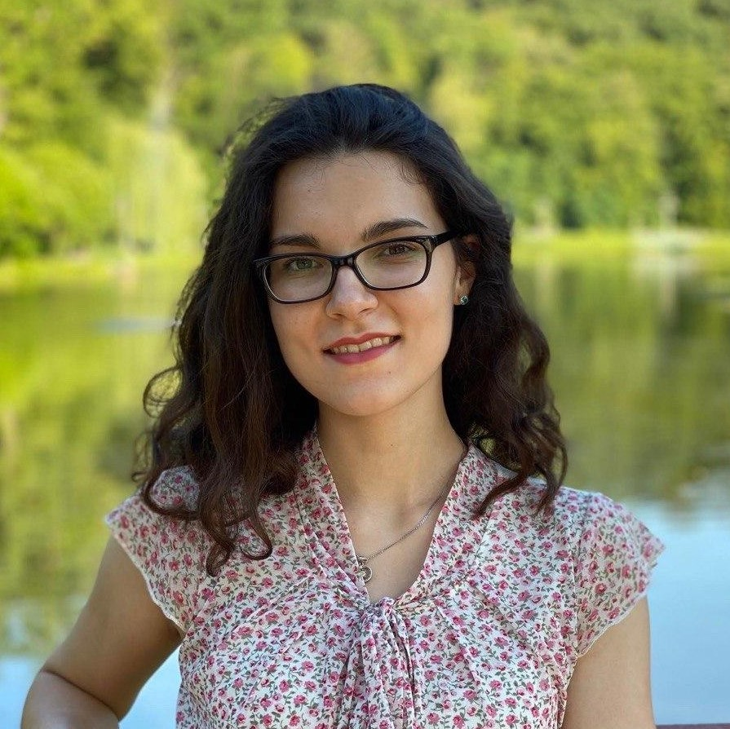

Contact information

|  |  |  |  |  |
| --- | --- | --- | --- | --- |
| Phone: 0672548529  Email: sandora65@gmail.com  Skype: sandora651  GitHub: <https://github.com/NadiiaSky>  LinkedIn: https://www.linkedin.com/in/nadiia-skyba-1371b81a3/ | | | Nadiia Skyba | |
|  | | Python Developer | | |
|  | | | | |
| Summary of Qualifications | Technical skills:  - languages/frameworks:  * python: Matplotlib, NumPy, Flask, Django  * js: Three.js  * computer network: HTTP, TCP, UDP  - databases:  * mysql, postgresql | | | |
|  | | | | |
| Skills | Other tech skills:  * OOP  * layout design [html, css]  * ubuntu: base level  * algorithms and data structures  * C/C++/Java/PHP (all based)  Soft skills:  * teamwork,  * ability to learn new skills and grow as a technical specialist. | | |  |
|  |  | | | |
| Experience / IT related educational practice | I have no experience. | | | |
|  |  | | | |
|  |  | | | |
|  |  | | | |
|  |  | | | |
| Languages | Ukrainian – fluently, | | | |
| Russian – fluently, | | | |
| English – Intermediate. | | | |
|  |  | | | |
| Education | NTUU “Igor Sikorsky Kyiv Polytechnic Institute” since 2017  Software engineering. Heat and Power Engineering Department, bachelor degree | | | |
|
|

|  |  |  |
| --- | --- | --- |
| Additional education (courses, trainings) | -books:  *Learning Python (reading Mark Lutz ‘Learning Python’, Python Crash Course by Eric Matthes)  *Web-design [Кириченко А.В, Хрусталев А.А. “HTML5+CSS3 Основы современного Web-дизайна”]  - courses on Coursera (Programming for Everybody(Getting Started with Python), Web Application Technologies and Django)  - OOP course on GeekBrains (Object Oriented Programming)  - articles [Medium]  - SoftServe certification [June 2020]  - pet project:  * http://nadiiasky.pythonanywhere.com/ - Messages System on Django.  * source code - <https://github.com/NadiiaSky/WebService_Django/tree/master> | |
|  | | |
| Hobbies | Sport, travelling, walking |  |