Git hook configuration:  
  
  
Git hook script file:

Node’s local variable configuration:

Robot Framework status and commit messages:

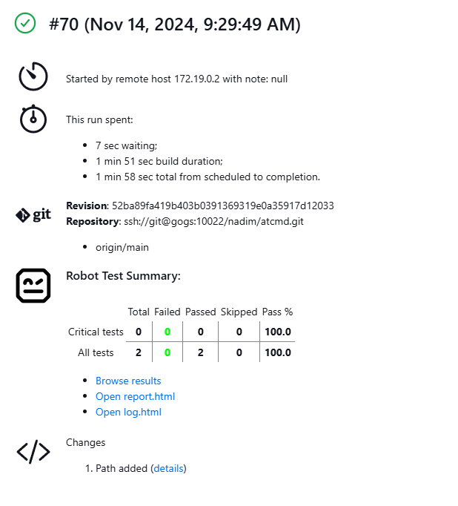

Pipeline scan interval:

