**Assignment -1**

1. Write a program to find the grade for a given mark according to the grading rule of your university.
2. Write a program to test a year if it is leap year or not.
3. Write a program to evaluate the following series 12+32+52+………………………. Up to n terms
4. Write a program to evaluate the following series 1-2+3-4+………………………. Up to n terms
5. Write a program to find the factorial of a number.
6. Write a program to find the power for a given base and exponent.
7. Write a program to find the Bangla season form a given month using if/switch.
8. Write a program to find the largest number in a list of Array.
9. Write a program to sort some number in ascending order.

**Assignment -2**

Write a program in Java that uses a class **Student**. Include the following members:

Data members

* Student identification number
* Student name
* Department name
* Course Number
* Marks obtained

Constructor

* Initialize all the variables

Methods

* Take input for all the variables
* Check if the student is passed or not (pass marks 40%)
* To display all the variables

**Assignment -3**

Design a class **Account** that represents a bank account. Include the following members:

Data members

* Account holders name
* Account number
* Type of account
* Balance amount in the account

Constructor

* To assign initial values( i.e., account holders name, account no, account type and initial deposit)

Methods

* To deposit an amount
* To withdraw an amount after checking balance
* To display the name and balance

**Assignment -4**

Write a program in Java that uses a class **Employees**. Include the following members:

Data members

* Id
* Name
* Basic Salary
* House rent

Constructor

* Initialize all the variables (use parameters as arguments)

Methods

* To Take input for an employee.
* Compute the house rent of the employee . House rent is 50% of the basic salary if the basic salary is more than 20000 otherwise 60%
* Display the employee information showing the total monthly salary

**Assignment -5**

An organization keeps the following information for customers.

* + - Data members

id, name, bill

* + - Constructor
      1. To assign initial values( i.e., id, name, bill)
    - Methods

1. Take input for a customer.
2. Compute the discount.

Customers get 10% discount if purchase Tk2000 or more.

1. Display the information showing the total bill after discount

Write a program in java using class.

**Assignment -6**

Implement the following UML Diagram using Java:

|  |
| --- |
| **Circle** |
| -radius: double |
| +Circle()  +Circle(radius: double)  +getRadius() double  +setRadius( radius: double) void  +getArea():double  +dispayArea(): void |

Implement the Circle UML diagram also write a main program **TestCircle** that uses the **Circle** class to create a circle object with the radius 5 and then modifies the radius to 10 using the *setRadius* method of the circle class. Call all the methods used on your written Java code. Display the area using *displayArea* method.

**Assignment -7**

|  |
| --- |
| Suppose you need to process course information. Each course has a name and has students enrolled. You should be able to add/drop a student to/from the course. You can use a class to  model the courses, as shown in the following UML Diagram:  E:\Desktop\222\Course_UML.PNG  Course object can be created using the constructor *Course(String name)* by passing a course *name*. You can add students to the course using the *addStudent(String student)* method, drop a student from the course using the *dropStudent(String student)* method, and return all the students for the course using the *getStudents()* method.  Write a Java program named *TestCourse.java* where the Course class is implemented and it shows the name of the course and enrolled students of that course from main *[i.e. public static void main (String []args)].* |

**Assignment -8**

|  |
| --- |
| Convert the following UML into JAVA code also explain why the constructor’s modifiers are protected?  E:\Desktop\Exam\CSE-222\Abstract_UML.PNG |

**Assignment -9**

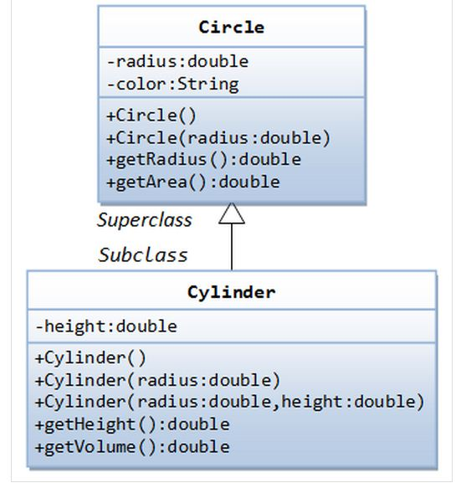Convert the following UML into Java code.

**Assignment -10**

Consider the following UML:

Emp

Id: String

name: String

dept: String

Emp()

Emp( String , String, String)

SalaryInfo

+Pos: String

+Salary: double

SalaryInfo ()

+SalaryInfo (String , String , String, String , double)

Calculate(): void

DisplayAll():void

Write a program for the UML above. Implement both the constructors. Calculate House rent from the salary in Calculate() method. Display all the information of the employee in DisplayAll() method. House rent(HR) is calculated as follows:

HR = 60% of the basic salary if the basic salary>=Tk20000

50% otherwise

**Assignment -11a**

Consider the following UML:

**Employee**

#Id: int

+name: String

+Dept: String

Employee ()

Employee ( int, String, String)

**Salaryinfo**

Month: String

Basic\_Salary: double

Salaryinfo ( int , String, String , String, double)

CalculateSalary(): void

+DisplaySalary()

**Pension**

-No\_of\_years: int

-Lastbasic: double

Pension( int , String, String. int , double)

DisplayPension()

Write a program in Java for the UML above. Implement all the constructors. Calculate House rent from the salary in CalculateSalary() method. Display all the information of the employee in DisplaySalary() method. House rent(HR) is calculated as follows:

HR = 60% of the basic salary if the basic salary>=Tk30000

50% otherwise

Pension is calculated as follows:

Total Pension = (length of service in years) **×** 10 **×** (70% of Last Basic salary)

**Assignment -11b**

Consider the following UML:

**Student**

#Id: int

name: String

**Student** ()

**Student** ( int, String)

**Payment**

-costpercredit: double

-credithour: double

Payment( int , String, double , double)

displayPayment()

**Grade**

-coursename: String

-marks: double

Grade ( int , String, String , double)

+displayGrade()

Write a program in Java for the UML above. Follow the grading system of your University.

**Assignment -11c**

Consider the following UML:

has

**Address**

Road\_No: String

House\_No: String

City: String

**Employee**

#Id: int

+name: String

+Dept: String

Employee ()

Employee ( int, String, String)

**Salaryinfo**

Month: String

Basic\_Salary: double

Salaryinfo ( int , String, String , String, double)

CalculateSalary(): void

+DisplaySalary()

**Pension**

-No\_of\_years: int

-Lastbasic: double

Pension( int , String, String. int , double)

DisplayPension()

Write a program in Java for the UML above. Implement all the constructors. Calculate House rent from the salary in CalculateSalary() method. Display all the information of the employee in DisplaySalary() method. House rent(HR) is calculated as follows:

HR = 60% of the basic salary if the basic salary>=Tk30000

50% otherwise

Pension is calculated as follows:

Total Pension = (length of service in years) **×** 10 **×** (70% of Last Basic salary)

Display the pension information in DisplayPension() method.

**Assignment -11d**

Consider the following UML:

has

**Address**

Road\_No: String

House\_No: String

City: String

**Student**

#Id: int

name: String

**Student** ()

**Student** ( int, String)

**Payment**

-costpercredit: double

-credithour: double

Payment( int , String, double , double)

displayPayment()

**Grade**

-coursename: String

-marks: double

Grade ( int , String, String , double)

+displayGrade()

Write a program in Java for the UML above. Follow the grading system of your University.

**Assignment -12**

|  |
| --- |
| Implement the following UML object model using Java:  Interface |

**Assignment -13**

Implement the following UML object model using Java:

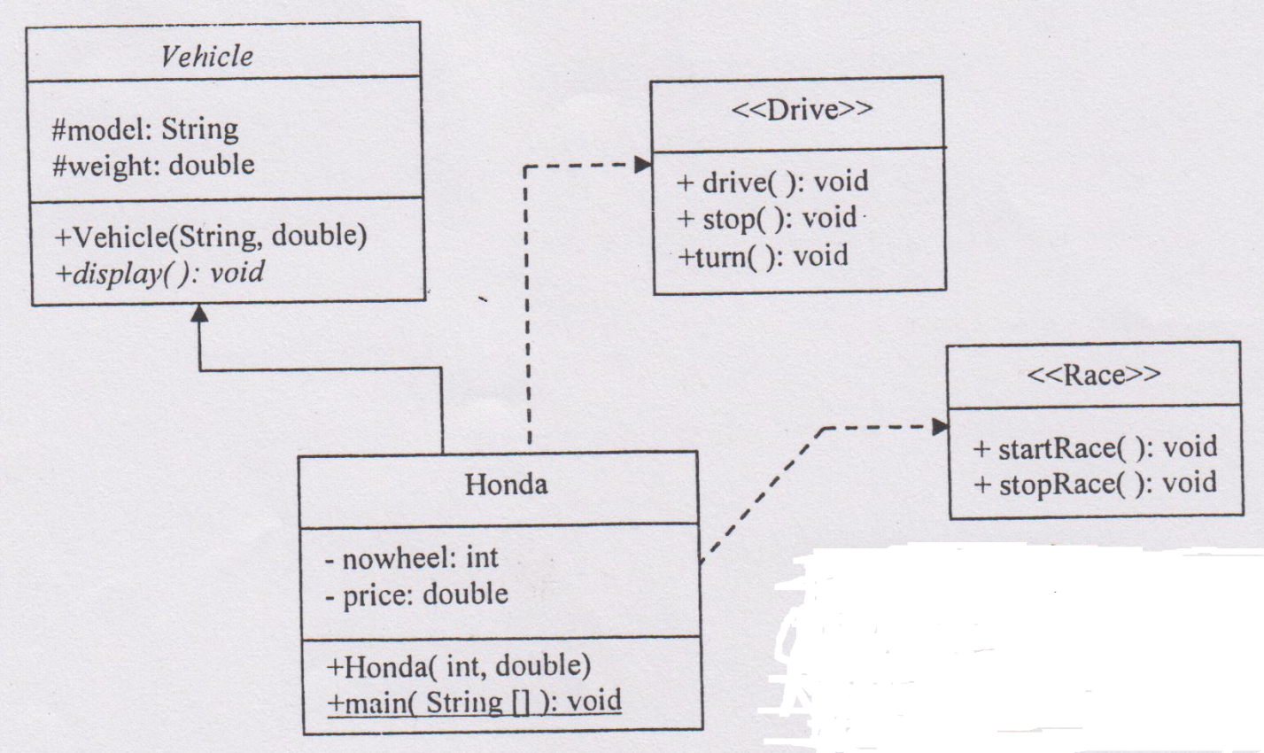

**Assignment -14**

Implement the UML in Java. There is course and its marks in each department. Take all the inputs from the keyboard in getValue() method. Show the grades with all the information in displayAll() method.

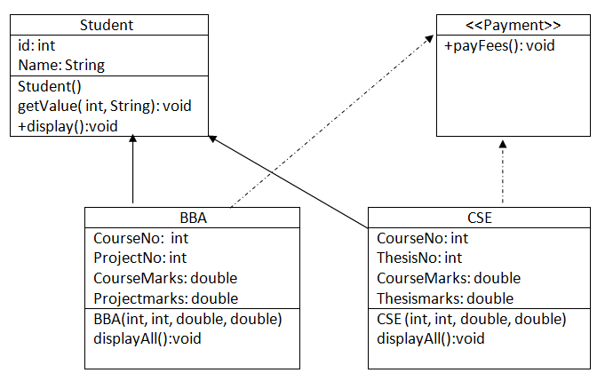

**Assignment -15**

We have a "MS Access" database "STUDENT" which contains a table called "***RESULT***", with 4 columns, as shown below:

Id: int

Name: varchar(30)

Dept: varchar(20)

Marks: float

Write a Java program with necessary code that connect with this database and show all the information from the ***RESULT*** table. Also find the Grade from marks. Assume any grading system.