HTML & CSS

**What is HTML** 🡪 Hypertext Markup language

**Hypertext**: it is the link between two web pages, like Wikipedia has multiple links it the content they show

**Markup language**: text between tags which defines structures

HTML defines the structure of the webpage

Html files should be saved in the extension of .**html** htmlis a **case insensitive** language.

<!DOCTYPE HTML> 🡪 it tells the browser that we written in the particular version… like it says to the browser the code is written in the html version 5.

<html> 🡪 these angular are called as tags opening tags

</html> 🡪 these are called as closing tags.

Every tag opening should be closed. No should left open and <!DOCTYPE HTML> doesn’t have a closing tag .

We should write a <html> tag. Consider oru human body having head and body in html we should need to give head and body

<html>

<head>

</head>

<body>

</body>

</html>

***Title:***

it 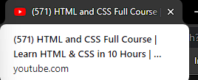 is the title

<html>

    <head>

        <title> I am NADIN </title>

    </head>

    <body>

    </body>

</html>

***Paragraph:***

The format token to write the paragraph is <p>

<!DOCTYPE html>

<html>

    <head>

        <title> I am NADIN </title>

    </head>

    <body>

        <p>Hello guys I am NADIN from bit</p>

    </body>

</html>

In visual studio put --- ! ---- symbol we get a default head body section. Not need to type every time. Easier to save time.

**HTML skeleton:**

**<!doctype html>**

Instruction to the browser about the html version.

**<html>**

Acts as a container to hold all the code. Browser should know that this is a html document. One head tag followed by one body tag.

**<head>**

The things written in the head tag will not be shown on the browser it contains the information about the document.

**<body>**

Everything written here will be displayed on the browser, text, images links through tags.

**How to add link of another page 🡪** we need to use -- <a --- tag which is **anchor tag** --- <a href ---- hyperlink reference...

<!DOCTYPE html>

<html>

    <head>

        <title> I am NADIN </title>

    </head>

    <body>

        <p>Hello guys I am NADIN from bit</p>

        <a href="https://www.youtube.com/"> click here to open your youtube </a>

    </body>

</html>

Note: here the link youtube.com is not shown directly it present inside the statement “click here to open your youtube”. When touches it redirects me to youtube

The tag **<br>** which breaks the present line and gives us statement what ever written next to this on a new line.

The tag **<hr>** which gives us the horizontal line in the page.

***Comments:***

It helps to understand our code better.

Single line comments

Multiline comments

To make comments use <!-- statement -->

**Tags 🡪 <**head**>** which is knows as tags

<br> <hr> tags are called as empty tags they do not have any content.

**Element 🡪** head is known as an element < the hole sentence present inside the angular arrow are known as element>.

**Attribute 🡪** extra features added to the tag…. As in above example <a hperf 🡪 here the hperf is an attribute.

<!DOCTYPE html>

<html>

    <head>

        <title> I am NADIN </title>

    </head>

    <body>

        <p style="color: lightblue; background-color: black;">Hello guys I am NADIN from bit</p>

        <a href="https://www.youtube.com/"> click here to open your youtube </a>

        <hr>

    </body>

</html>

Here this **color** is used to change the font color. And **background-color**  is used to change the background of the particular line.

What if we give style in the body tag? 🡪 it changes the background of the entire page.

Consider the code:

   <body>

        <div style="background-color: black;color: whitesmoke;">hi hello it is div 1</div>

        <div style="background-color: blue;color: :white;">form div 2</div>

        <p style="color: black;">Hello guys I am NADIN from bit</p>

        <a  href="https://www.youtube.com/"> click here to open your youtube </a>

        <hr>

    </body>

**Block level:** Here as we can see div1 and div2 are very next, close to each other and paragraph takes a small gap. One full block will be taken to paragraph, div tag.

**Inline level: <span>** used to change the color of word in the sentence **<strong>** used to bold the word or sentence in that line

        <p> <strong>NADIN</strong> having more <span style="color: green">GREEN </span>color shirts </p>

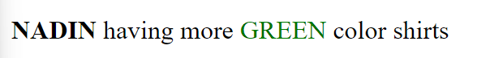

**FILES AND FOLDER:**

HTML files are present simply in the root folder. Css-files will be in css-folder. Images are in image folder. And js-files are in js-folder

**Anatomy of html tags:**

Which is known as elements

<a  href="https://www.youtube.com/"> click here to open your youtube </a>

opening tag content tag closing tag

attribute name Attribute tag attribute value

**Attributes:**

Properties associated with each tag.

Basic structure is <tag name =”value”></tag>

What is global attribute? Consider the attribute **style** is can able to used in **<p>** tag, **<h1>** tag, **<div>** tag..

 <div style="background-color: blue;">form div 2</div>

        <p style="color: black;">Hello guys I am NADIN from bit</p>

        <h1 style="color: palevioletred;">hi hello</h1>

But the hyperlinks **hrpef** can only be given in the **<a>** tag.

<img src =”url” width=”100”>

Here src is the attribute used in image tag to define path.

Width is attribute used to define width in pixels.

Alt i.e alternate text if image isn’t loaded.

***Heading:***

Headings are important there are 6 kinds of heading tags <h1> to <h6>

Search engine use the headings to index the structure and content of your web page.

<h1> should be used for the main heading, followed by <h2> for sub-heading and so on.

***Paragraph.***

<p> if I accidentally give more space or given enter in the paraph in the end there will be no change in the statement it prints the word in the line with single space the more space and the entre we given won’t be considered. It is because the html program it considers as a paragraph. If I use <pre> tag it give the text as the way I want in the output.

*Without <pre> tag.*

    <body>

        <h1>HELLO WELCOME</h1>

        <p>hi     HELLO

            IM FROM

                            NAMAKKAL

            ILL disturb you forever......

        </p>

    </body>

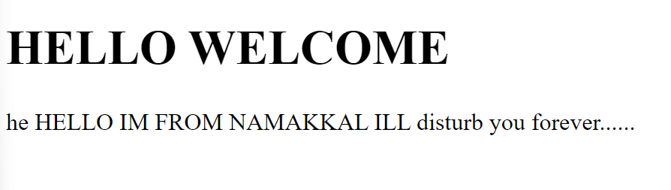

*With <pre> tag:*

 <body>

        <h1>HELLO WELCOME</h1>

        <p><pre>hi     HELLO

            IM FROM

                            NAMAKKAL

            ILL disturb you forever......</pre>

        </p>

    </body>

<pre> tag defines preformatted text. The text style will be changed when we use a <pre> tag…

1. *<****blockquote>***

To define along quotation or block quotation, <blockquote> tags are used

This tag indents the quotation in the browser.

<blockquote>"now i am studying eee at bannari amman institute of

                technology sathyamangalam"-Nadin</blockquote><hr>

output for the line it give some space indentation and print in a neat manner



1. ***<q>***

The html <q> tag defines a short quotation.

Browser normally insert quotation marks around the quotation.

            <q>welcome to my college</q>



1. ***<abbr>***

This tag defines an abbreviation tag or an acronyms, like “HTML”, “CSS”, “Mr.”, “ASAP”.

If I place a cursor above “HTML” it shows the full form of the HTML.

Marking abbreviation can give useful information to browsers, transition system and search engine.

            <p>I'm gonna to take money in <abbr title="Automatic Teller Machine">ATM</abbr>at <abbr title="Bannari Amman Institute of Technology"> BIT</abbr></p><hr>

 when I place a cursor in the ATM or on BIT I’ll get the full-form of it

1. ***<address>***

The address tag defines the contact information for the author/owner of a document or an article.

The contact information can be email, URL, physical address, phone number, social media account, etc.,

 <address>

                Made by: NADIN.<br>

                contact number: 9345633643 <br>

                address: bit sathyamangalam. <br>

            </address>

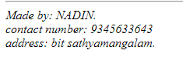

Here in address tag the fonts in italic manner If I had not given the line break then it will be like a paragraph written in italic.

1. ***<cite>***

This tag defines the title of the creative work (example. A book, a poem, a movie, etc).

            <p>"Knowledge is wealth" - <cite>By NADIN</cite> </p>

Which is also like a address tag the words “By NADIN ” will be italized..



1. ***<I>***

This tag is used to make the statement in the italic manner

            <i> I tag gives us the italic manner</i> <hr>

1. ***<bdo>***

This tag stands for bidirectional override.

Tag us used to override the current text direction.

            <bdo dir="rtl">Namakkal is famous for Kolli hills</bdo>



It shifts the direction of the sentence. Rtl 🡪 right to left. Ltr 🡪 left to right.

1. ***<b> <i> <small> <u> <em> <del> <ins> <sub> <sup> <dfn>:***

<b> tag is for bold the sentence.

<i> tag is for italic.

<small> tag is to make the font size of the sentence small.

<u> tag is for underline the sentence.

<em> tag is for bolding the text in an italic manner.

<del> tag strikes out the chosen word like 🡪 ~~this~~

<ins> tag is also line a underline the text.

<sub> subscript tag. Makes the statement slightly slower.

<sup> superscript tag. Make the statement slightly higher.

            <pre><b>Against</b> an <i>international backdrop of European war</i> and Asian high diplomacy,

                <u>political events</u> in my country look <em>more absurd</em> <small>than ever after the publication

                of an MPs’report condemning Boris Johnson</small> for <del>misleading Parliament</del> <ins> MISLEADING PARLIMENT</ins> when he

                was prime minister <sub>(as he was less than a year ago)</sub>. Mr Johnson quit as an MP

                in a fit of <sup>pique before the report came out</sup>. Our Bagehot columnist

                reckons.</pre>.

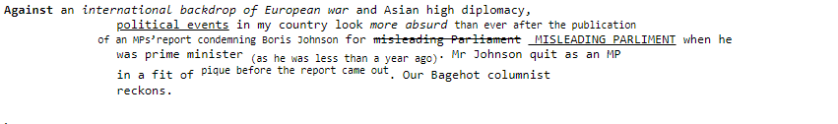

1. ***<dfn>:***

This tag is known as definition tag, which is also makes the statement looks in a italic manner.

Input: HTML - <dfn> Hypertext markup language is used to design or structure your webpage.</dfn>

Output 🡪 HTML – *Hypertext markup language is used to design or structure your webpage.*

1. ***<hr>***

Stands for horizontal line

Divide the webpage.

1. ***<br>***

Stands for breaking the line

Moving to the next line.

1. ***<img>***

To add images in the webpage.

            <img src="ME.jpeg" alt=" source not found" width="50%"> <br> <hr>

Here the Image should be present in the folder.

If image not found “source no found will be displayed”.

Width helps to change the size of the picture.

Note: if image is not in the folder, then u should copy the path of the picture where the image is present. After pasting the path change the “\” 🡪 “/”.

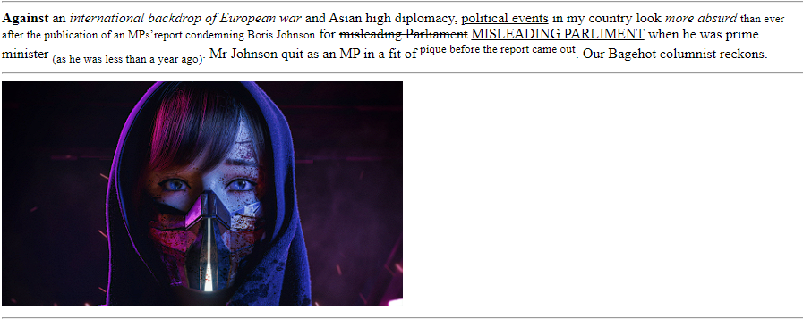

1. ***<center> tag:***

<center> tag is for making the sentence to look in a center position of the page

**List tags:**

1. <ol> tag:

Stands for ordered list.

To define series of events takes place in some order.

Making a tea like flow chat [1st step 2nd step …]

<ol> …… </ol>

Note. In ol tag we have 1,2,3… upper alpha, lower alpha, lower roman, upper roman.

1. <ul> tag

Stands for unorder list

To define series of events takes place where order is not important.

Example our hobbies

<ul> …. </ul>

Note. Default [disc], square, circle.

1. <li> tag:

Defines the list item.

Used inside both ul and ol tag to define the events.

<li></li>

 <ol style="list-style-type: lower-greek;">

                <li >nadin</li>

                <li>chandru</li>

                <li>pavin</li>

                <li>jaswanth</li> <hr>

            </ol>

  <ul style="list-style-type: square;">

                <li>Madhaneesh</li>

                <li>Sathiesh</li>

                <li>Tharun</li>

Otherwise:

<ol type="i">

                <li >nadin</li>

                <li>chandru</li>

                <li>pavin</li>

                <li>jaswanth</li> <hr>

            </ol>

            <ul style="list-style-type: square;">

                <li>Madhaneesh</li>

                <li>Sathiesh</li>

                <li>Tharun</li>

Note: type is note used inside the ul tag..

**Definition list:**

<dl> definition list. <dt> definition term, <dd> definition data/ description.

<dl>

                <dt>HTML</dt>

                <dd>Hyper text markup language</dd>

                <dt>ATM</dt>

                <dd>Automatic teller machine</dd>

            </dl>

Output:

HTML

Hyper text markup language

ATM

Automatic teller machine

**Nested list:**

 <ul>

                <li>American breakfast</li>

                <ul>

                    <li>Take away dishes</li>

                    <ul>

                        <li>American Sausage</li>

                        <li>American Hotdog</li>

                        <ul>

                            <li>Dark sause</li>

                            <li>Country special sause</li>

                        </ul>

                        <li>American tost</li>

                    </ul>

                    <li>Dining dishes</li>

                    <ul>

                        <li>bacan and fries</li>

                        <li>fishesh and chips</li>

                        <li>Amaerican Vacado beverage</li>

                    </ul>

                </ul>

            </ul>

Output will be:

* American breakfast
  + Take away dishes
    - American Sausage
    - American Hotdog
      * Dark sause
      * Country special sause
    - American tost
  + Dining dishes
    - bacan and fries
    - fishesh and chips
    - Amaerican Vacado beverage

            <ol type="i">

                <li>History</li>

                <ul>

                    <li>Mughal Empire</li>

                    <li>British Empire</li>

                    <ol type="a">

                        <li>Mongol Empire</li>

                        <li>Russian Empire</li>

                    </ol>

                </ul>

                <li>Mathematics</li>

                <ol type="1">

                    <li>Number System</li>

                    <ul>

                        <li>Ratio and proportion</li>

                        <li>Probability</li>

                    </ul>

                    <li>Differentiation</li>

                </ol>

                <li>Science</li>

            </ol> <br> <hr>

Output will be

1. History
   * Mughal Empire
   * British Empire
     1. Mongol Empire
     2. Russian Empire
2. Mathematics
   * Number System
     1. Ratio and proportion
     2. Probability
   * Differentiation
3. Science

**TABLE TAGS:**

|  |  |  |  |  |  |
| --- | --- | --- | --- | --- | --- |
| <th> | <th> | <th> | <th> | <th> | <th> |
| <td> | <td> | <td> | <td> | <td> | <td> |
| <td> | <td> | <td> | <td> | <td> | <td> |
| <td> | <td> | <td> | <td> | <td> | <td> |
| <td> | <td> | <td> | <td> | <td> | <td> |

heading

cells

<table> it’s the tag for table

<tr> this tag represents table row

<th> table head which is like <li> in list… 🡪 it gives the rows in a heading manner

<td> table data, here the datas will be written

            <table border="3" cellpadding ="10" cellspacing ="10" style="border-collapse: collapse;">

                <tr>

                    <th>Sno</th>

                    <th>Name</th>

                    <th>Age</th>

                    <th>Gender</th>

                    <th>Marks</th>

                </tr>

                <tr>

                    <td>1.</td>

                    <td>Nadin</td>

                    <td>20</td>

                    <td>Male</td>

                    <td>416</td>

                </tr>

                <tr>

                    <td>2.</td>

                    <td>Chandru</td>

                    <td>20</td>

                    <td>Male</td>

                    <td>510</td>

                </tr>

Cellpadding is to give space inside the cell. Cell spacing is used to give space between the cells… border-collapse is used to make a table with single line not in double line.

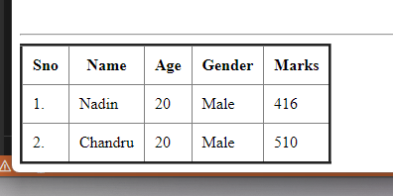

**Table tags – colspan:**

Colspan is an attribute.

|  |  |  |  |  |  |  |
| --- | --- | --- | --- | --- | --- | --- |
| Name | | age | marks | | | |
| fn | ln |  | Maths | Eng | Sci | Soc |
|  |  |  |  |  |  |  |
|  |  |  |  |  |  |  |
|  |  |  |  |  |  |  |

            <table border="3">

                <tr>

                    <th colspan="2" >Name</th>

                    <th>age</th>

                    <th colspan="4">Marks</th>

                </tr>

                <tr>

                    <th>First Name</th>

                    <th>Last Name</th>

                    <th> </th>

                    <th>Maths</th>

                    <th>English</th>

                    <th>Science</th>

                    <th>Social</th>

                </tr>

                <tr>

                    <td>Chandru</td>

                    <td>Sakthivel</td>

                    <td>21</td>

                    <td>90</td>

                    <td>90</td>

                    <td>90</td>

                    <td>95</td>

                </tr>

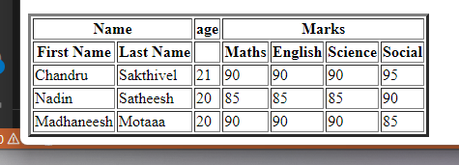

**Table tags Rowspan**

|  |  |  |  |  |
| --- | --- | --- | --- | --- |
|  |  |  |  |  |
|  |  |  |  |
|  |  |  |  |  |
|  |  |  |  |  |
|  |  |  |  |
|  |  |  |  |
|  |  |  |  |

            <table border="3">

                <tr>

                    <th rowspan="2">Name</th>

                    <th>First Name</th>

                    <td>Krishna</td>

                    <td>Mohan</td>

                    <td>Shubam</td>

                </tr>

                <tr>

                    <th>Last Name</th>

                    <td>Raj</td>

                    <td>Kumar</td>

                    <td>Garg</td>

                </tr>

                <tr>

                    <th>Age</th>

                    <th></th>

                    <td>20</td>

                    <td>21</td>

                    <td>22</td>

                </tr>

                <tr>

                    <th rowspan="4">Marks</th>

                    <th>Maths</th>

                    <td>85</td>

                    <td>88</td>

                    <td>92</td>

                </tr>

                <tr>

                    <th>English</th>

                    <td>81</td>

                    <td>86</td>

                    <td>91</td>

                </tr>

                <tr>

                    <th>Science</th>

                    <td>89</td>

                    <td>86</td>

                    <td>81</td>

                </tr>

                <tr>

                    <th>Social</th>

                    <td>91</td>

                    <td>95</td>

                    <td>93</td>

                </tr>

            </table>

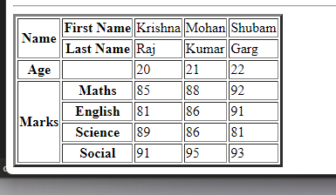

**Table tags – rowspan & colspan:**

|  |  |  |  |  |  |  |
| --- | --- | --- | --- | --- | --- | --- |
|  | | | | | | |
|  |  |  |  |  |  |  |
|  |  |  |  |  |  |
|  |  |  |  |  |  |
|  | | | | |  |
|  |  |  |  |  |
|  |  |  |  |

            <table border="3">

                <tr>

                    <th colspan="7">Time Table</th>

                </tr>

                <tr>

                    <th rowspan="6">Hours</th>

                    <th>Mon</th>

                    <th>Tue</th>

                    <th>Wed</th>

                    <th>Thu</th>

                    <th>Fri</th>

                    <th>Sat</th>

                </tr>

                <tr>

                    <td>Social Science</td>

                    <td>Maths</td>

                    <td>Physics</td>

                    <td>Biology</td>

                    <td>Arts</td>

                    <td>P.Ed</td>

                </tr>

                <tr>

                    <td>Chemistry</td>

                    <td>History</td>

                    <td>English</td>

                    <td>Maths</td>

                    <td>Sports</td>

                    <td>Env.sc.</td>

                </tr>

                <tr>

                    <th colspan="5"> Lunch</th>

                    <td rowspan="3">Half Day</td>

                </tr>

                <tr>

                    <td>Maths</td>

                    <td>Biology</td>

                    <td>Physics</td>

                    <td>Social Science</td>

                    <td rowspan="2">Project</td>

                </tr>

                <tr>

                    <td>Chemistry</td>

                    <td>Maths</td>

                    <td>Sports</td>

                    <td>Physics</td>

                </tr>

            </table>

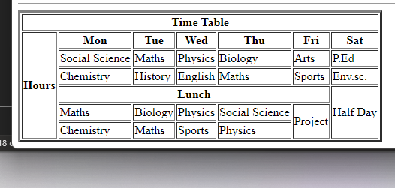

***Html forms***

The very main important is <form> tag.

<form>

<label for =”fname”> First name: </label><br>

<input type =”text” id = “fname” name=”fname” value=”ritwik”><br>

<label for =”lname”> Last name: </lable><br>

<input type = “text” id=”lname” name=”lname” value=”raj”>

</form>

<label> is to label something it’s like marking up things. If I write first name without label also there will be no mistake or error the reason for which we used label here is for “for” attribute

<input> tag is for providing the text box. The size of the box can be manipulated by us 🡪 type =”text” means we can write any text inside it

* <input type =”text”> 🡪 displays a single line text input field.
* <input type =” radio”> 🡪 displays a radio button [for selecting one of many choices]
* <input type =” checkbox”> 🡪 displays a checkbox [for selecting zero or more of many choices]
* <input type =” submit”> 🡪 displays a submit button [for submitting the form]
* <input type =”button”> 🡪 displays a clickable button.

Note: “for’ of the label tag and “id” of the input tag should be same. Helps to browser to understand the code easily [descriptive manner].

Action attribute:

<form action =” ”> is used to save or submit the form inside double quotes we need to give the file name where the form should get submitted.

“radio”🡪 button is like getting circle. Consider the person choosing his gender male/female.

“checkbox”🡪 is like getting a checkbox.

“submit”🡪 we can write anything in the submit position. Its just a normal button.

***Radio:***

                    <form>

                        <input type="radio" name="gender" value="Male">

                        <label >Male</label><br>

                        <input type="radio" name="gender" value="Female">

                        <label>Female</label><br>

                        <input type="radio" name="gender" value="Other">

                        <label >Other</label><br><hr>

                    </form>

While writing radio checkbox name and value should must include if I didn’t included name and value it wont work correctly like instead of choosing any one we can able to choose all of the genders😂

            <form>

                getting input from user <br>

                <label *for* ="fname"> First name: </label><br>

                <input *type* ="text" *id* = "fname" *name*="fname" *value*="Nadin "><br>

                <label *for* ="lname"> Last name: </label><br>

                <input *type* = "text" *id*="lname" *name*="lname" *value*="Maddy "><br><hr>

                <form>

                    choosing options <br>

                    <input *type*="radio" *name*="gender" *value*="Male">

                    <label >Male</label><br>

                    <input *type*="radio" *name*="gender" *value*="Female">

                    <label>Female</label><br>

                    <input *type*="radio" *name*="gender" *value*="Other">

                    <label >Other</label><br><hr>

                </form>

                <form>

                    personal information <br>

                    <input *type*="radio" *name*="gender" *value*="Male">

                    <label >Male</label><br>

                    <input *type*="radio" *name*="gender" *value*="Female">

                    <label >Female</label><br>

                    <input *type*="radio" *name*="gender" *value*="other">

                    <label >other</label><br>

                    <input *type*="checkbox" *name*="age" *value*="">

                    <label>above 20</label><br>

                    <form >

                        select your city <br>

                    <input *type*="radio" *name*="city" *value*="">

                    <label >chennai</label><br>

                    <input *type*="radio" *name* ="city" *value*="">

                    <label >other</label>

                    <input *type*="text" *name*="" *id*="" *value*="">

                    </form>

                </form>

        </form><hr><br>

                    <input *type*="submit">

                    <input *type*="button" *value*="try it bitch">

Write <input type="submit” > to get a submit button

<input type =”button” value =”try it”> to get a button with own name.

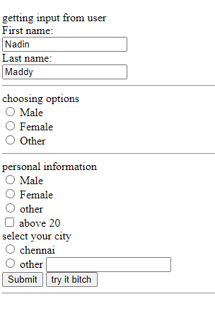

***Tags inside forms:***

<input> <label> <select> <textarea> <button> <fieldset> <legend> <detalist> <option> If I give selected attribute inside the opition then it will show on 1st

Note inside every option we need to give value.

                    <select>

                        <option *value*="audi">audi</option>

                        <option *value*="bmw">bmw</option>

                        <option *value*="benz" *selected*>benz</option>

                        <option *value*="lambo">lambo</option>

                    </select>

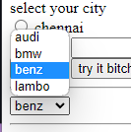

If I gave <select size=”2”> then in the selection page it will show only 2 option then scroll to get the other option 2 options will be shown at 1 scroll

If I want to select multiple item on the option then give multiple inside select <select size=”2” multiple>

**<textarea>**

<textarea name=”” id =”” cols =”30” rows = “10”></textarea>

By this we will get a text box to write.

                    <textarea *name*="" *id*="" *cols*="30" *rows*="10"></textarea>

Which is for entering a text in the webpage which is dragable 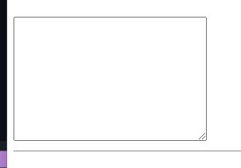

**<button> tag**

Instead of typing

                    <input *type*="button" *value*="try it bitch"><br><hr>

We can write it also as

                    <button>hi hello</button><br>



**<fieldset> <legend>**

                    <fieldset>

                        <legend>Personal information</legend>

                        <label *for* ="fname"> First name: </label><br>

                        <input *type* ="text"  *id* = "fname" *name*="fname" *value*="Nadin "><br>

                        <label *for* ="lname"> Last name: </label><br>

                        <input *type* = "text" *id*="lname" *name*="lname" *value*="Maddy "><br><hr>

                    </fieldset>

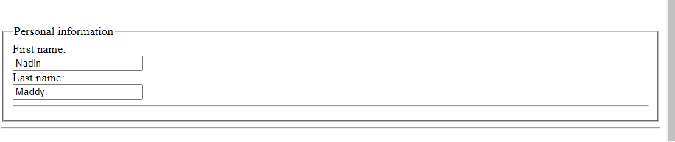

***<datalist>***

<input *list*="carstype">

                    <datalist *id*="carstype">

                        <option *value*="Audi">Audi</option>

                        <option *value*="Benz">Benz</option>

                        <option *value*="Ferrari">Ferrari</option>

                        <option *value*="Aston martin" *selected*>Aston martin</option>

                    </datalist><hr><br>

<input list> 🡪 refers to the datalist we are going to write it is mandatory.

When we are using data list we should nee to use input list. And the id should be mentioned in the data list which it refers to

***Placeholder attribute, required attribute:***

<label> firstname: </label>

            <input *type*="text" *name*="Firstname" *placeholder*="your Firstname" *size*="10" *required*>

<input type =”text” name = “firstname” placeholder = ”firstname” size 10 required /> 🡪 as we can see placeholder attribute gives the grey color text inside the text box and we can able to overwrite it. And the requited attribute is for the compulsory



***Label to get a mobile number:***

<input type = “tel” name = “phone” size =”25” pattern= “[0-9]{4}-[0-9]{6}” placeholder =”1234-567890” required>

Here tel means telephone number which is for getting a mobile number and patten 🡪pattern= “[0-9]{4}-[0-9]{6}” which is for the way the mobile number should be given.

***Label to upload a file:***

<label for =”myfile”>drop your file:</label>

<input type = “file”

**Mobile number:**

            <label *for*="">Phone number</label>

            <input *type*="text"*name*= "country code" *value*="+91" *size*="1">

            <input *type*="tel" *name*="tele number" *size*="15" *pattern*="[0-9]{4}-[0-9]{6} "*placeholder* ="1234-123456">

**File uploading:**

            <label *for*="myfile">drop your file</label>

            <input *type*="file" *id*="myfile" *name*="myfile"><br><hr>



To get email-id as input:

<label *for*="email"><b>Email</b></label>

<input *type*="email"*placeholder*="Entre your email"*,name*="email"><br>

To get Password as your input:

<label *for*="psw"><b>Password</b></label>

<input *type*="password"*placeholder*="Enter password"*name*="psw"*required*> <br>

<label *for*="psw-repeat"><b>Re-type password</b></label>

<input *type*="password"*placeholder*="retype password"*name*="psw-repeat"*required*> <br><br>

NOTE: I didn’t get EYE-option to view my password like it shown in the video I can only able to fill the password box cant able to view the thing I’d entered

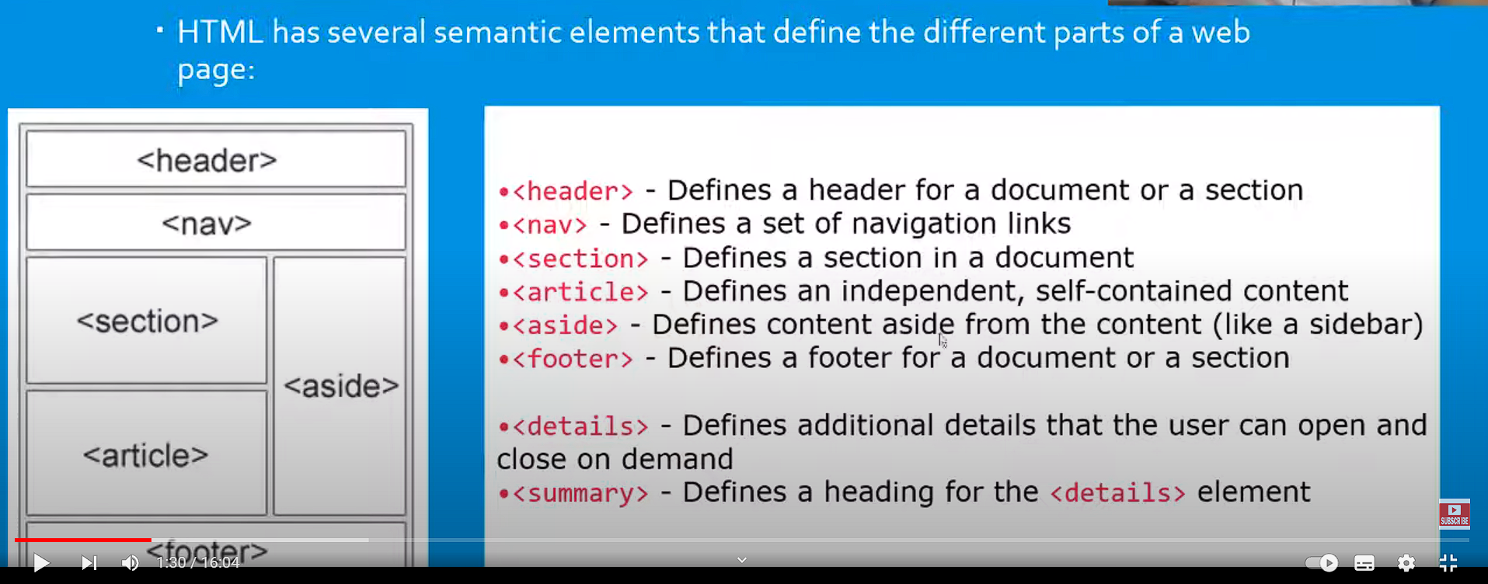

CSS – Cascading Style Sheet.

It’s the language that makes our web pages presentable

Designed to make style sheet for web

Cascading 🡪 falling of styles

Style 🡪 Adding design/ style our HTML tags

Sheets 🡪 writing oru style in different documents.

History of CSS:

1994: first proposed by Hakon Wiium Lie on 10th October

1996: CSS was published on 17th November with influencer Bert Bos later he become co-author of css

1996: Css became official with CSS was published in December

1997: Created level 2 CSS in 4th November

1998: Published on 12th may

CSS basic structure:

Selector {

Property 1: value;

Property 2: value;

Property 3: value;

}

Selector: which selects the element you want to target. Few basic selectors like id’s & classes.

code written in HTML:

<h1> Welcome </h1>

It the code written on the HTML sheet we can able to make the different HTML & CSS sheet to develop a web page we can able to create more then one CSS sheets

Code going to wite in CSS

H1{

Color : red;

Text-alignment: centre;

}

Which is property, Which is value

Here h1 is known as selector because it’s the teg we are going to give styling

Property & value are called as Key-value Pair.

Always remains same whether we apply internal or external styling.

*Explanation for above line:*

*Inline CSS* is called writing the CSS in the same line where I want it

<h1 style = “ color: green”> Welcome to my webpage </h1>

*Internal CSS* writing CSS separately on the head position.

<head>

<title> Web page </title>

<style>

Address{

Color : red;

}

</style>

</head>

*External CSS:*

CSS COMMENTS:

Css comment 🡪 /* statement */ for internal CSS

<!-- Statement --!> for inline css

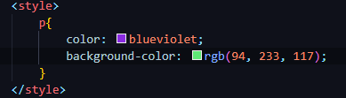 when I give styling for p it changes color for all the line where p is present.

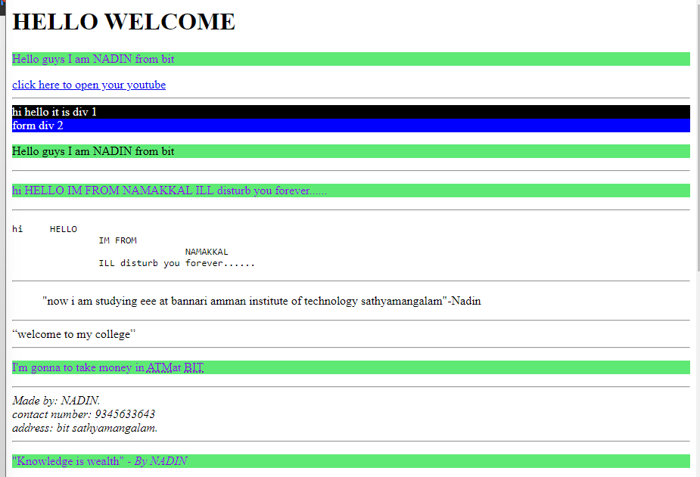

Priority CSS:

Inline > Internal > External

External CSS: while writing external CSS we should not use any tag

Normal HTML code written:

<!DOCTYPE *html*>

<head>

    <title>Learning CSS</title>

    <link *rel*="stylesheet" *href*="learningexternal.css">

</head>

<body>

    <h1 *style*="text-align: center;color: white;background-color: black;">Hi Hello Learning CSS basics</h1>

    <h2 >Im Nadin from Namakkal Learning Css basics</h2>

    <p>I've studies in SRV boys Higher secondary school Rasipuram and then joined my engineering on Bannari Amman Institute of Technology

    </p>

</body>

</html>

External CSS written:

Link for adding the external CSS and in href part we need to give the name of the file. Which is saved in the **same folder.**

h2{

    color: red;

    background-color: azure;

    text-align: center;

    size: 200px;

}

p{

    font-style: italic;

    color: rgba(33, 155, 226, 0.884);

*/* size: 5000px; */*

    font-size: 30px;

}

Output:

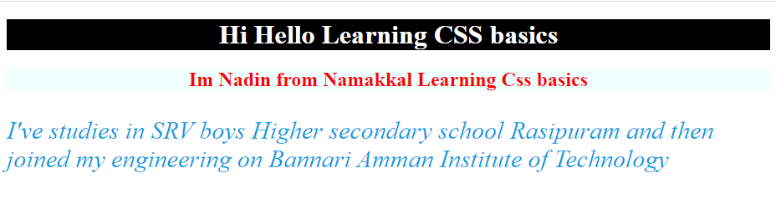

*Inline CSS*

* + Before CSS this was the only way to apply styles
  + Not an efficient way to write as it has lot of redundancy
  + Self-contained
  + Need to uniquely apply on each element
  + Idea of separation of concerns was lot

Examples:

<h2 style =” color: red”> have a great day </h2>

<p style =” color =” green”> I am nadin, from Namakkal </p>

*Internal CSS:*

* + With the help of style tag, we can apply styles with in HTML file
  + Redundancy is removed
  + But idea of separation of concerns still lost
  + Uniquely applied on single document

Example:

<style>

H1{

Color: red;

}

</style>  
*External CSS:*

* + With the help of the <link> tag in head tag we can apply the styles
  + Reference is added
  + File must be saved with .css extension
  + Redundancy is removed.
  + Idea of separation of concerns is maintained
  + Uniquely applied on each document

Example:

<link rel =” stylesheet” type =”text/css” href =” *mention your file name here*”>

H1{

Color: red; //.css file

}

Note if I’m am working with a huge project, it contains multiple HTML files by using external CSS I can able to style the multiple HTML files using a single external CSS style sheet. One external style sheet is needed to style the multiple HTML files.

**Types of Selectors in CSS**

Selectors are used as target elements and apply CSS

Five simple selectors:

* Element selector – (type)
  + Id selector – (#)
  + Class selector – (.)
  + Group selector – (,)
  + Universal selector – (*)

Priority selector:

Id > class > element

*Element Selector (type):*

It is also called as type selector.

Used to select the HTML elements by its name

How do we do it?

H1 p

{ {

Color: red; color: bule;

} }

We select the heading tag and then change the color property text, color, now whatever is written in this tag(content) will have the text color as red.

Element selector is like Internal selector.

*ID Selector (#):*

Id attribute is used to select HTML element.

Used to target specific or unique element.

We work with similar tag.

How we do it?

Inside head

#unique

{

Color: red;

}

Inside body:

<h1 id= “unique”> Hi hello </p>

We select the id and then change the color property i.e text color to red now whatever written in this tag (content) will have the text color as red

Note: id we can only cheese for a same tags, not for different.

Class selector (.)

Class attribute is used to select the HTML element

Used to target specific class of element.

We work with different tags.

How we do it

.group

{

Color: red;

}

<h1 class= “group”> hello </h1>

We select class and then changed the color priority i.e text color to red. Now whatever is written in this tag (content) will have the text color as red.

Inside head:

*.nadin*{

            color: rgba(149, 7, 243, 0.865);

            text-align: center;

            font-size: 20px;

        }

Inside body:

    <h3 *class*="nadin">hello im nadin</h3>

    <p *class*="nadin">hello im maddy</p>

    <h4 *class*="nadin">hello im chandru</h4>

Group selector (,):

Here by using group selector we can able to choose the tags without specifying their class or id,

Inside head:

H1, h2, p, h3{

Color: green;

}

Inside body

<h1> hello im nadin </h1>

<h2> hello im chandru </h2>

<h3> hello im Maddy </h3>

<p> hello im jeslyn </p>

Universal selector (*):

If I need a same kind of styling for all the tags in the HTML sheet, we can use the universal selector. It can apply to all the tags present in the HTML sheet.

Inside head:

*{

Color: red;

Background color: blue;

Text align: centre;

}

Inside body

<h1> hello im nadin </h1>

<h2> hello im chandru </h2>

<h3> hello im Maddy </h3>

<p> hello im jeslyn </p>

CSS COLORS:

There are different colouring schemes in CSS.

2 widely used techniques are as follows:

RGB:

* + This starts with rgb and takes 3 parameters.
  + 3 parameters basically correspond to red green and blue.
  + Value of each parameter may vary from 0 to 255.
  + Eg. Rgb (255,0,0) means color red

HEX:

* + Hex code starts with # and comprises of 6 numbers which is further divided into 3 sets.
  + Sets basically corresponds to red, green, blue.
  + A single set value can vary from 00 o ff
  + Eg: #ff0000; means color red.

CSS BACKGROUND:

* Background image:
  + The background image property is used to set the image as a background of an element, by default the image covers the entire element.
* Background repeat:
  + By default, the background-image property repeats the background image horizontally and vertically some images are repeated only horizontally or vertically.
* Background-position:
  + The background position property is used to define the initial position of the background image, by default, the background image is placed top-left of the webpage
* <head>
* <title>background learning</title>
* <style>
* body{
* background: url(Images/wallpaper.jpg);
* background-repeat:no-repeat;
* background-attachment:fixed;
* background-size:cover;
* }
* </style>
* </head>

CSS TEXT & FONTS

Text color:

The property is used to set the color of the text

Text alignment:

Text alignment property is used to set the horizontal alignment of the text.

A text can be left or right aligned or centre or justified.

Text decoration:

Th text_decoration property is used to set or remove the decorations from the text.

The value text-decoration: none; is often used to remove the underlines from the links.

3 basic things: underline, overline, line-through.

Text transform:

The text-transfrom property is used to specify the uppercase and lowercase letters in a text.

CSS Font:

CSS font color: this property is used to change the color of the text.

CSS font family; this property is used to change the face if the font.

CSS font size: this property is used to decrease or increase the font size.

CSS font style: this property is used to make the font bold, italic, oblique.

CSS font variant: this property creates a small caps effect.

CSS font weight: This property is used to increase or decrease the boldness and lightness of the font.

Font Family:

Serif: Serif font include small lines at the end of character. Example of serif: time new roman, Georgia etc.

San-serif: a San-serif doesn’t include the small lines at the end of the characters. Example of San-serif is, arial, verdana etc,.

Font style:

The font style property is mostly used to specify the italic text.

This property has three values.

Normal – the text is shown normally.

Italic – the text is shown in italic.

Oblique – the text is “learning” (“oblique is similar to italic, but less supported)

Font size:

The font size property sets the size of the text pixel/16 = 1 em.