**Practical Software Engineering I.**

**Exercise for the 2nd assignment**

**Student Name: Nadeen Hussein**

**Neptun Code: ZZKUIL**

**Task:**

Tricky five-in-a-row Create a game, which is a variant of the well-known five-in-a-row game. The two players can play on a board consists of n x n fields. Players put their signs alternately (X and O) on the board. A sign can be put only onto a free field. The game ends, when the board is full, or a player won by having five adjacent signs in a row, column or diagonal. The program should show during the game who turns. The trick in this variant is that if a player makes 3 adjacent signs (in a row, column or diagonal), then one of his signs is removed randomly (not necessary from this 3 signs). Similar happens, when the player makes 4 adjacent signs, but in this case two of his signs are removed. Implement this game, and let the board size be selectable (6x6, 10x10, 14x14). The game should recognize if it is ended, and it has to show in a message box which player won (if the game is not ended with draw), and automatically begin a new game.

1. **UML:**

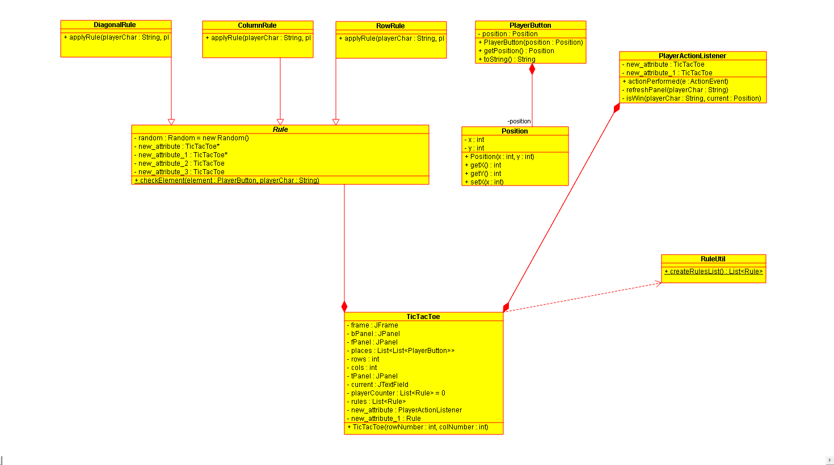

**Methods:**

1. **TicTacToe: initializes the frame and the game**
2. **actionPerformed: switches between player X and player O and updates the positions**
3. **refreshPanel: refreshes the panel when a player wins or no one wins**
4. **isWin: Checks if the table is full to clear it or checks if actually a player wins through a row, column or a diagonal**
5. **checkElement: Checks if the element given (x or o) is equal to the player's char**
6. **retrivePositions: Get the position of the player to later check if they are equal through checkElement**
7. **removeRandomly: Removing elements randomly from the boxes**
8. **removeElements: Removes elements from the list according to the 4 or 3 rule**
9. **applyRule: applies rule according to the position**

# Testing plan

1.X wins by row

2. O wins by row

3.X wins by column

4. O wins by column

5. Winner is set on the diagonal from left

6. Winner is set on the diagonal from right

7.No one Wins