
МIНIСТЕРСТВО ОСВIТИ І НАУКИ УКРАЇНИ
НАЦІОНАЛЬНИЙ ТЕХНІЧНИЙ УНІВЕРСИТЕТ УКРАЇНИ
“КИЇВСЬКИЙ ПОЛІТЕХНІЧНИЙ ІНСТИТУТ ІМЕНІ ІГОРЯ СІКОРСЬКОГО”

Факультет прикладної математики
Кафедра програмного забезпечення комп’ютерних систем

Лабораторна робота №2
з дисципліни “Основи web-програмування”
тема “Створення та стилізація статичних веб-документів”

Виконала  студентка II курсу  групи КП-52  Ісаєва Надія Михайлівна |  | Перевірив  “____”“____________”2016р.  викладач  Гадиняк Руслан Анатолійович

Штрафні бали: | Нараховані бали: | Сумарний бал:
  Термін здачі | Оформлення звіту
  Корект. Програм (2 бала) | Відп. на теор. Питання (1 бал) | Відп. на прогр. Питання (2 бала)

Київ 2016
Мета роботи

Познайомитись із поняттям веб-документів та технологіями їх створення та стилізацїі.
Постановка завдання
- Обрати просту тему для веб-сайту, що міститиме список об’єктів, описаних у ЛР№1. У даній лабораторній роботі потрібно описати HTML документи із окремими CSS стилями, які будуть доступними тільки локально на комп’ютері без використання веб-сервера.
- Описати веб-документи:
- Головна сторінка із вказанням назви сайту і додаткової інформації про сайт і його призначення.
- Сторінка зі списком об’єктів. Кожен запис повинен містити основну (коротку) інформацію про об’єкт і зображення об’єкта. (створити близько 5 записів).
- Сторінка окремого об’єкта із розширеною інформацією про об’єкт.
- Зв’язати сторінки за допомогою гіперпосилань в обидві сторони.
- Створити зовнішній CSS-стиль та підключити його до всіх сторінок. (Використання CSS препроцесора буде плюсом)

Лістинги програм
index.html
<!doctype html>

<html lang="en">
<head>
<meta charset="utf-8">

<title>Lab_2</title>
<meta name="description" content="The second lab">
<meta name="author" content="Nadya Isaeva">

<link rel="stylesheet" href="static/css/main.css">
</head>

<body>
<div class="header">
<div class="brand">
<img id='logo' class="grow" src="http://sleepwalker.github.io/kottans-js-2014/03-css-1/images/logo.png" />
<h1>Lab_2</h1>
</div>
</div>
<div class="main">
<ul id="sections">
<li class="grow"><a href="cats.html">Check Cats</a></li>
</ul>
<p><img id='animated' src="http://zoopark-shop.ru/images/product_images/info_images/z405117.jpg" /></p>
</div>
</body>
</html>

cats.html
<!doctype html>
<html lang="en">
<head>
<meta charset="utf-8">
<title>Cats</title>
<meta name="description" content="The page with cats list">
<meta name="author" content="Nadya Isaeva">

<link rel="stylesheet" href="static/css/main.css">
</head>

<body>
<div class="">
<h1>Cats</h1>
<ul id="sections">
<a class="grow" href="white.html">White cat</a>
<li>
<img class="small" src="http://hitgid.com/images/%D0%B1%D0%B5%D0%BB%D1%8B%D0%B9-%D0%BA%D0%BE%D1%82-1.jpg">
<p align="left">One beautiful cream-point male birman kitten for sale. I'm looking for a loving new pet home for this gorgeous, playful yet affectionate boy. He is from a litter of three of which two have been reserved. They have been raised in a family hom....
</p>
</li>
<a class="grow" href="black.html">Black cat</a>
<li>
<img class="small" src="http://xproggn.net/images/data/a/8/big.a8ecc67fa23546ce061983ff208a58d2.jpg">
<p align="left">Due to totally time wasters again this amazing girl is still for sale !!!Very fluffy girl in beautifull rare smoky colour with amber eyes ,looking for caring owner now !!! If yo....</p>
</li>
<a class="grow" href="red.html">Red cat</a>
<li>
<img class="small" src="http://wpapers.ru/wallpapers/animals/Cats/1905/1400x1050_%D0%A0%D1%8B%D0%B6%D0%B8%D0%B9-%D0%BA%D0%BE%D1%82.jpg">
<p align="left">One Pretty colourpoint female. Now sold but more available just after Christmas, 28th Dec at 8 weeks old. Boys and girls.
Birman Mummy, Angora Daddy,
Lovely friendly kitten, loves to jump and play,
cuddly and cute! Ready now for kind loving home...</p>
</li>
<a class="grow" href="brown.html">Brown cat</a>
<li>
<img class="small" src="http://cs5.pikabu.ru/post_img/2015/07/26/11/1437933708_1220052471.jpg">
<p align="left">Reluctant sale of cinnamon tortie and white female kitten. We were going to keep her as part of our breeding program but have her full sister and mum so have decided to let Seraphina go to a very special new home. She is fully registered, vac....</p>
</li>
<a class="grow" href="gray.html">Gray cat</a>
<li>
<img class="small" src="http://enigma-project.ru/wp-content/uploads/2014/02/kot-1.jpg">
<p align="left">Solid Lilac British Shorthair Male . GCCF reg .Active - pkd tested. - vet chect - microchiped - vaccination up to the date. - his register with GCCF as a Stud ) but can go as a pet . -BLOOD GR B</p>
</li>
<li class="grow"><a href="index.html">Home</a></li>
</ul>
</div>
</body>
</html>

brown.html
<!doctype html>
<html lang="en">
<head>
<meta charset="utf-8">
<title>Brown Cat</title>
<meta name="description" content="The white cat's params">
<meta name="author" content="Nadya Isaeva">

<link rel="stylesheet" href="static/css/main.css">
</head>

<body>
<div class="other">
<h1>Brown cat</h1>
<ul>

<li class="grow"><a href="cats.html">Back</a></li>
<li class="grow"><a href="index.html">Home</a></li>
</ul>
<img align="left" src="http://cs5.pikabu.ru/post_img/2015/07/26/11/1437933708_1220052471.jpg">
<p class="desc">One Pretty colourpoint female. Now sold but more available just after Christmas, 28th Dec at 8 weeks old. Boys and girls.
Birman Mummy, Angora Daddy,
Lovely friendly kitten, loves to jump and play,
cuddly and cute! Ready now for kind loving home.
Wormed, Flea prevention and litter trained.
Seen with Mum Dad if not out hunting!
comes with kitten biscuits and meat.</p>
</div>
</body>
</html>

black.html
<!doctype html>
<html lang="en">
<head>
<meta charset="utf-8">
<title>Black Cat</title>
<meta name="description" content="The white cat's params">
<meta name="author" content="Nadya Isaeva">

<link rel="stylesheet" href="static/css/main.css">
</head>

<body>
<div class="other">
<h1>Black cat</h1>
<ul>

<li class="grow"><a href="cats.html">Back</a></li>
<li class="grow"><a href="index.html">Home</a></li>
</ul>
<img align="left" src="http://xproggn.net/images/data/a/8/big.a8ecc67fa23546ce061983ff208a58d2.jpg">
<p class="desc">Due to totally time wasters again this amazing girl is still for sale !!!Very fluffy girl in beautifull rare smoky colour with amber eyes ,looking for caring owner now !!!

If you love longhair cats but you haven't a lot of time to brushing them these type of cat is for you !

Dam was stunning black dad huge silver tabby longhair stud both own very rich pedigrees .

Fizzy POP will be registered in GCCF as a pets only !

All our kittens from beginning reside around the kids ,dog and other cats .

All our cats are strictly indoor only ,so we are looking also indoor homes for our kittens !

We put a lot of work to keep them happy and healthy every day .

-full set of vaccinations including FeLV
- Two vet checks
-microchip
-4 weeks free insurance
-Rc kitten pack
-wet food and toys

Kitten are scratching post and litter tray trained and full socialised.

Ready for collection any time from 10.12.16

Deposit secured (no refundable) 100£

Any questions please don't hesitate to ask, but also NO TIME WASTERS AND NO OFFERS !

Thanks</p>
</div>
</body>
</html>

grey.html
<!doctype html>
<html lang="en">
<head>
<meta charset="utf-8">
<title>Gray Cat</title>
<meta name="description" content="The white cat's params">
<meta name="author" content="Nadya Isaeva">

<link rel="stylesheet" href="static/css/main.css">
</head>

<body>
<div class="other">
<h1>Gray cat</h1>
<ul>

<li class="grow"><a href="cats.html">Back</a></li>
<li class="grow"><a href="index.html">Home</a></li>
</ul>
<img align="left" src="http://enigma-project.ru/wp-content/uploads/2014/02/kot-1.jpg">
<p class="desc">We have available a lovely British Shorthair Blue Girl.
She is GCCF ACTIVE registered and has had a fabulous litter of kittens for us earlier this year.
Sadly we are having to sell our cats due to buying a house abroad.

We bred her and kept her back as she was so pretty, she has a superb pedigree.
She is an indoor cat, and has always been indoors.
She is very pretty, she is a beautiful Blue, and has a lovely temperament.

She is only 18 months old, so has plenty of potential as a breeding queen.
If you think she could be for you get in touch.
Please email first as phone reception here is very poor.</p>
</div>
</body>
</html>

white.html
<!doctype html>
<html lang="en">
<head>
<meta charset="utf-8">
<title>White Cat</title>
<meta name="description" content="The white cat's params">
<meta name="author" content="Nadya Isaeva">

<link rel="stylesheet" href="static/css/main.css">
</head>

<body>
<div class="other">
<h1>White cat</h1>
<ul>
<li class="grow"><a href="cats.html">Back</a></li>
<li class="grow"><a href="index.html">Home</a></li>
</ul>
<img align="left" src="http://hitgid.com/images/%D0%B1%D0%B5%D0%BB%D1%8B%D0%B9-%D0%BA%D0%BE%D1%82-1.jpg">
<p class="desc">One beautiful cream-point male birman kitten for sale. I'm looking for a loving new pet home for this gorgeous, playful yet affectionate boy. He is from a litter of three of which two have been reserved. They have been raised in a family home around children, other cats and a dog. Their mum is our family pet and is available to see also. They will go to their new homes fully vaccinated, micro-chipped, wormed, flea treated and with four weeks free pet insurance. They will also have a four generation pedigree and be gccf registered.</p>
</div>
</body>
</html>

red.html
<!doctype html>
<html lang="en">
<head>
<meta charset="utf-8">
<title>Red Cat</title>
<meta name="description" content="The white cat's params">
<meta name="author" content="Nadya Isaeva">

<link rel="stylesheet" href="static/css/main.css">
</head>

<body>
<div class="other">
<h1>Red cat</h1>
<ul>

<li class="grow"><a href="cats.html">Back</a></li>
<li class="grow"><a href="index.html">Home</a></li>
</ul>
<img align="left" src="http://wpapers.ru/wallpapers/animals/Cats/1905/1400x1050_%D0%A0%D1%8B%D0%B6%D0%B8%D0%B9-%D0%BA%D0%BE%D1%82.jpg">
<p class="desc">Hi all
we have currently an amazing litter of British Shorthair kittens born 03/11/2016 from the best of European lines
dad is imported and mother is daughter of my imported female
we have all colours available from :

black male - available
lilac male - available
cream male - available
ginger male - available
ginger female - available
ginger female - available

These babies are loving and very affectionate, friendly with great personalities. They love attention and would make amazing new additions to a loving family

Ready to leave from 13/14 weeks old
I do not allow viewings before the first vaccination
these wonderful babaies will come with :

fully vaccinated
Free 4 week's immediate Pet plan insurance
Medical card/record
Microchiped
Receipt of purchase
wormed
Advice sheet
Kitten starter pack with lots of toys
and life long support

Non-refundable £100 deposit will secure your chosen kitten.
we only want the best homes for our kittens

for more info you can give us a ring
price as a pet only
Please do not waste my and your time, no offers and photo collectors

I try to update the photos on my website ;)
Thank you</p>
</div>
</body>
</html>

main.css
body {
font-family: arial;
}
#logo {
width: 100px;
padding:6px;
}
.small {
max-width:200px;
max-height:200px;
}
h1 {
color: grey;
}
li {
font-size: 100%;
}
.header {
text-align: left;
}
.main {
text-align: center;
}
.other {
float: left;
position: absolute;
}
#sections {
padding: 0px;
margin-bottom: 40px;
}
ul {
list-style: none;
}
#sections > li {
list-style: none;
padding: 0px;
color: darkblue;
}
a {
font-size: 250%;
text-decoration: none;
color: black;
}
img {
max-width:500px;
max-height:400px
}
.bordered {
border: 3px solid lightsteelblue;
}
#animated {
margin: 20px;
width: 100px;
height: 100px;

-webkit-animation-name: spin;
-webkit-animation-duration: 4000ms;
-webkit-animation-iteration-count: infinite;
-webkit-animation-timing-function: linear;

-moz-animation-name: spin;
-moz-animation-duration: 4000ms;
-moz-animation-iteration-count: infinite;
-moz-animation-timing-function: linear;

-ms-animation-name: spin;
-ms-animation-duration: 4000ms;
-ms-animation-iteration-count: infinite;
-ms-animation-timing-function: linear;

animation-name: spin;
animation-duration: 4000ms;
animation-iteration-count: infinite;
animation-timing-function: linear;
}
@-ms-keyframes spin {
from { -ms-transform: rotate(0deg); }
to { -ms-transform: rotate(360deg); }
}
@-moz-keyframes spin {
from { -moz-transform: rotate(0deg); }
to { -moz-transform: rotate(360deg); }
}
@-webkit-keyframes spin {
from { -webkit-transform: rotate(0deg); }
to { -webkit-transform: rotate(360deg); }
}
@keyframes spin {
from {
transform:rotate(0deg);
}
to {
transform:rotate(360deg);
}
}
.grow { transition: all .2s ease-in-out; }
.grow:hover { transform: scale(1.1); }

Скріншоти веб-сторінок

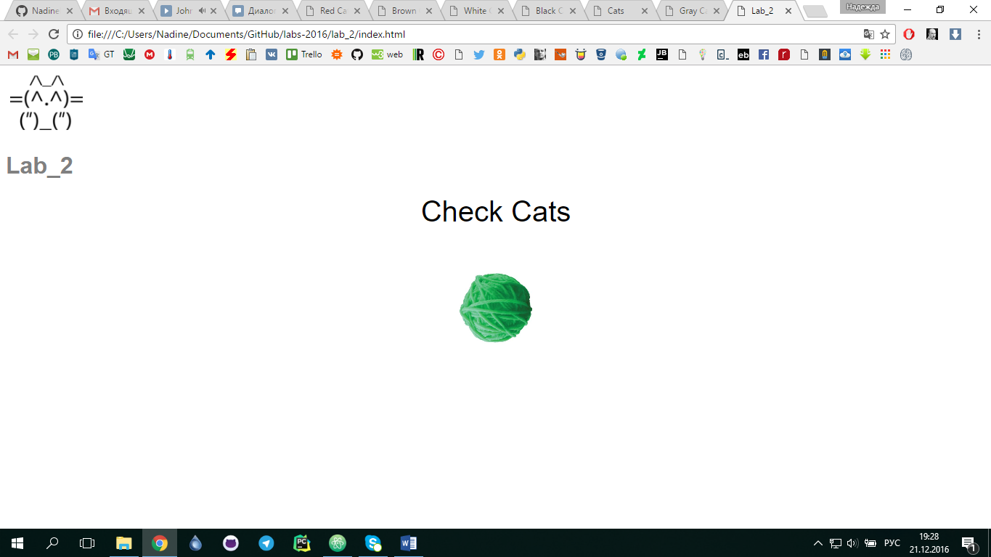

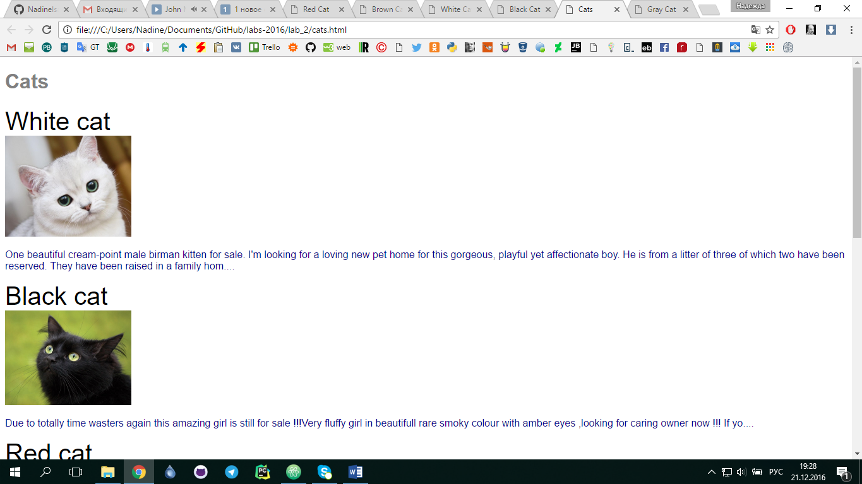

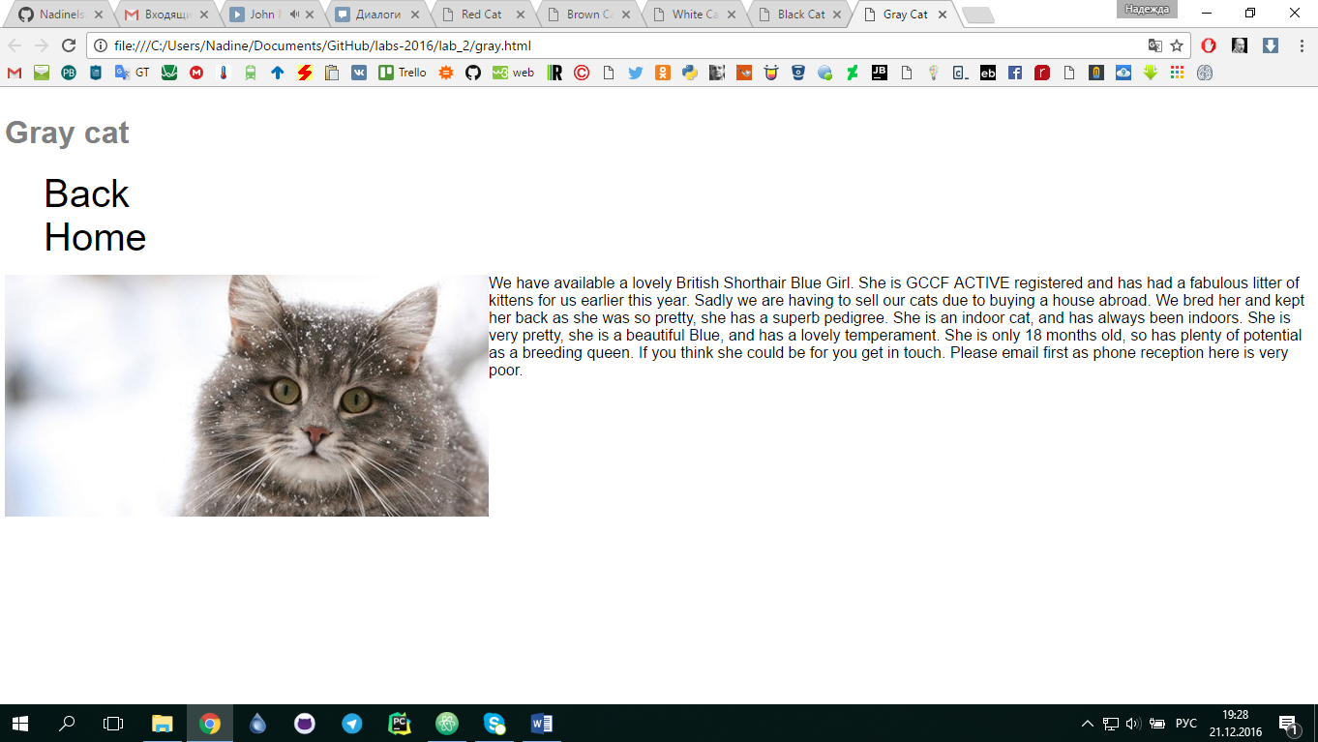

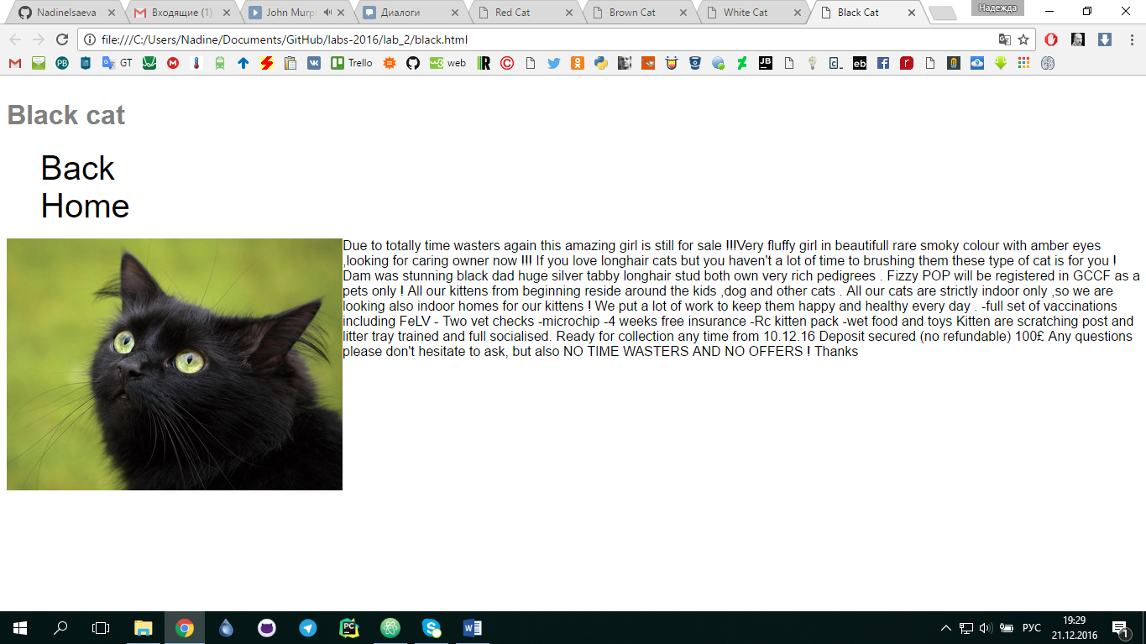

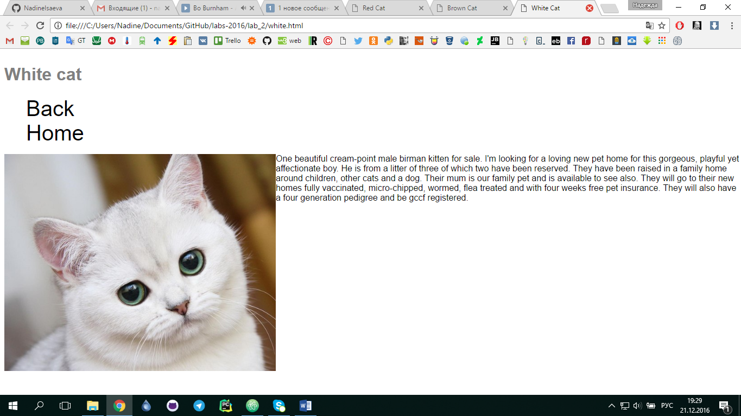

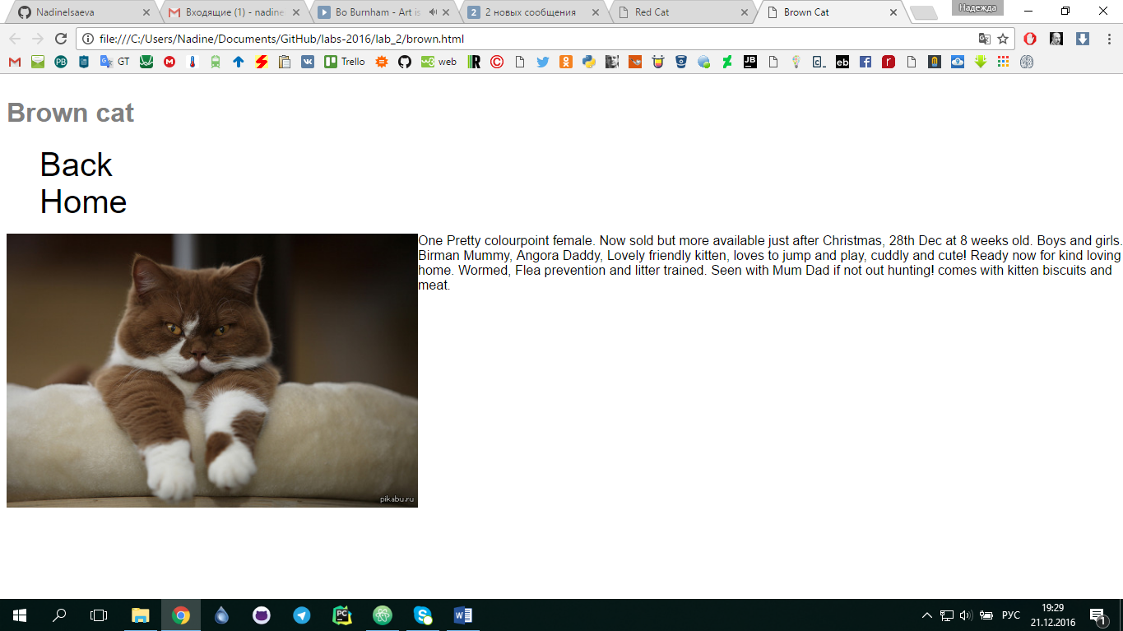

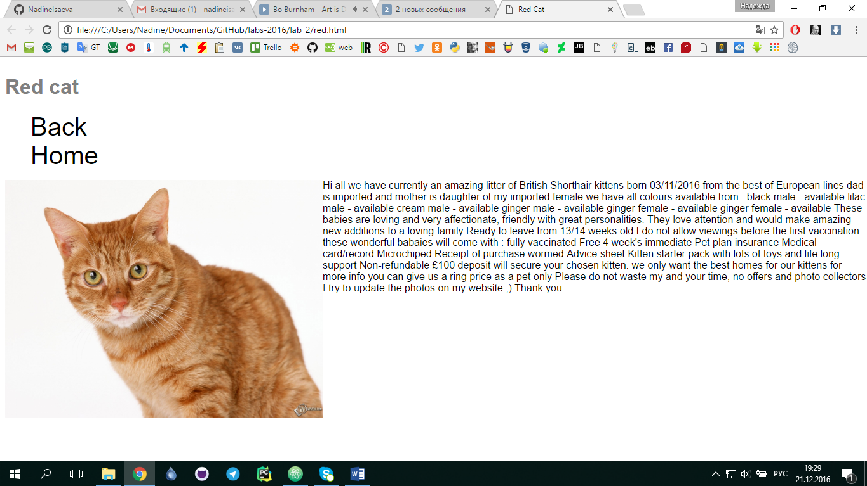

Висновки
Виконавши дану лабораторну роботу, я познайомилася із поняттям веб-документів та технологіями їх створення та стилізації.

