Lab no:02
Name of the lab: basic Linux command.
Name:Nadira Islam
Id:It-17051
objectives:Understand basic Linux command.

Q1: What is Linux command?
Ans:Linux is a Unix-like operating system.All the Linux commands are run in the terminal provided by linux system.This terminal is just like command prompt of windows OS.

Q2:Write 15 commands in Linux operating system.
Ans:
1.alias
2.cat
3.cd
4.chmod
5.chown
6.curl
7.df
8.diff
9.echo
10.exit
11.find
12.finger
13.free
14.grep
15.gzip

Q3:Describe the basic operation of linux basic command.

Ans:
) pwd command
‘pwd’ command prints the absolute path to current working directory.
$ pwd
/home/raghu
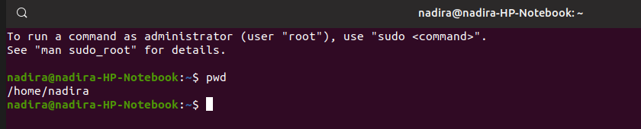
2. ls — Use the "ls" command to know what files are in the directory you are in. You can see all the hidden files by using the command “ls -a”.

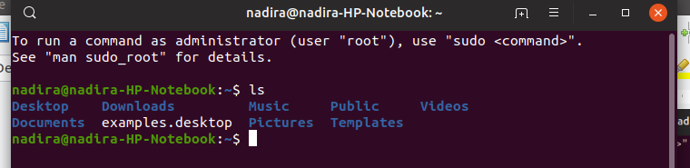
3. cd — Use the "cd" command to go to a directory. For example, if you are in the home folder, and you want to go to the downloads folder, then you can type in “cd Downloads”.

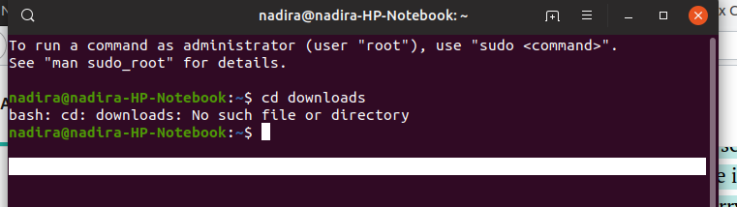
4.cat — Use the cat command to display the contents of a file. It is usually used to easily view programs.

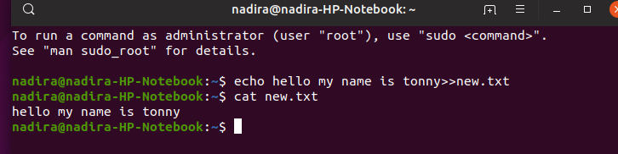
5.echo — The "echo" command helps us move some data, usually text into a file. For example, if you want to create a new text file or add to an already made text file,

6.df — Use the df command to see the available disk space in each of the partitions in your system. You can just type in df in the command line and you can see each mounted partition and their used/available space in % and in KBs. If you want it shown in megabytes, you can use the command “df -m”.

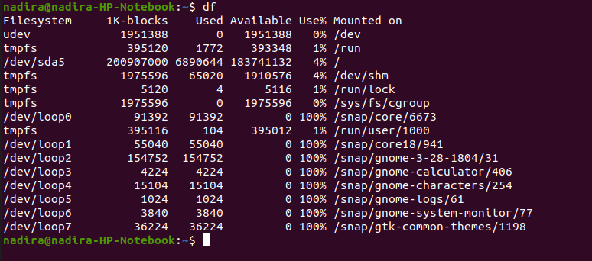
7.du — Use du to know the disk usage of a file in your system. If you want to know the disk usage for a particular folder or file in Linux, you can type in the command df and the name of the folder or file. For example, if you want to know the disk space used by the documents folder in Linux, you can use the command “du Documents”. You can also use the command “ls -lah” to view the file sizes of all the files in a folder.

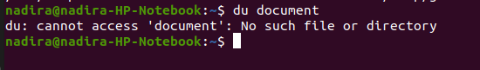
9. uname — Use uname to show the information about the system your Linux distro is running. Using the command “uname -a” prints most of the information about the system. This prints the kernel release date, version, processor type, etc.

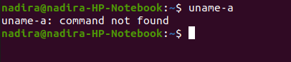

10.hostname — Use hostname to know your name in your host or network. Basically, it displays your hostname and IP address. Just typing “hostname” gives the output. Typing in “hostname -I” gives you your IP address in your network.

