**Name:Nadira Islam ID: IT-17051**

**Exercise 4.1.1 :** Create a python project, click in File > New > PyDev Project. Provide a name for the project (LAB_1 for lab), then select the version of python to be used and select to add the project to working set as shown below:

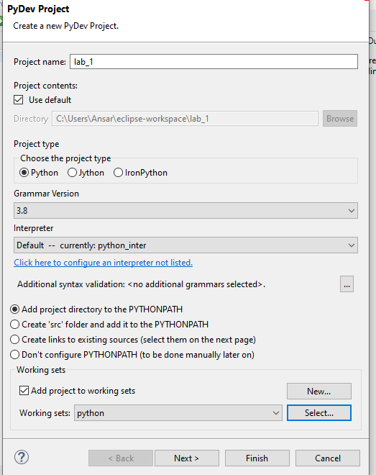

**Exercise 4.1.2 : Write a Hello World program.**

**Ans:**

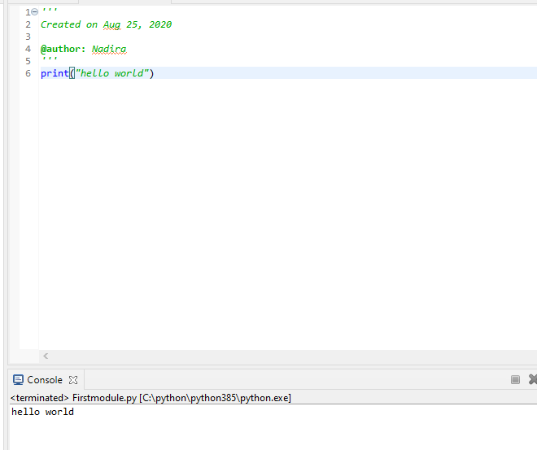

**Exercise 4.1.3: Compute 1+1**

**Ans:**

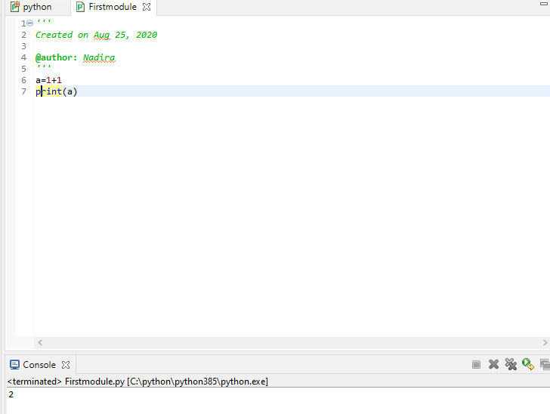

**Exercise 4.1.4: Type in program text**

**Ans:**

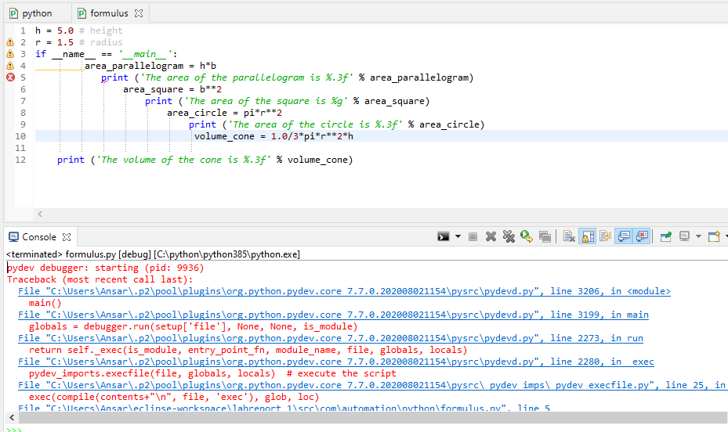

**Exercise 4.2.1: Verify the use of the following operator. Execute the example code in python script and provide the output.**

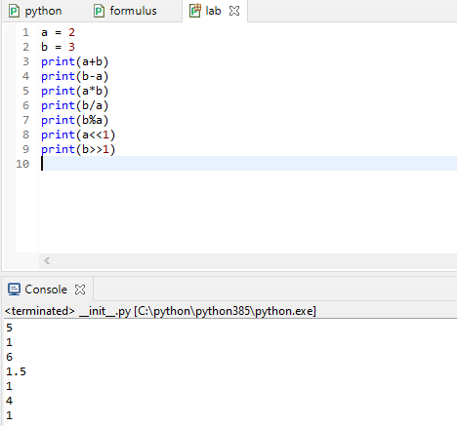

**Exercise 4.2.2: The if statement:**

**Create a program for taking a number from the user and check if it is the number that you have saved in the code (TIP: use input command). Save the file as if.py**

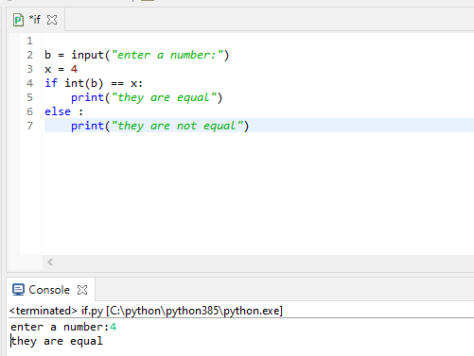

**Exercise 4.2.3: The while Statement Create a program for taking a number from the user and check if it is the number that you have saved in the code. The program run until the user will guess the number. Save the file as while.py**

**Ans:**

**Exercise 4.2.4: The for Statement Create a program for printing a sequence of numbers. Save the file as for.py**

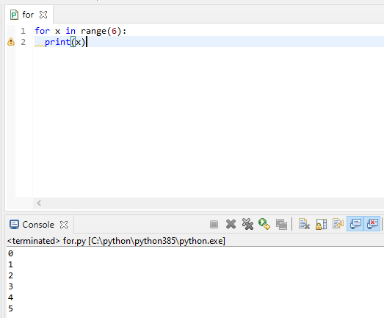

**Question 5.1: Explain what is eclipse? And why we use it for programing on python?**

**Ans:**

**Eclipse** is an integrated development environment (IDE) used in computer **programming**. It contains a base workspace and an extensible plug-in system for customizing the environment. ... It was one of the first IDEs to run under GNU Classpath and it runs without problems under IcedTea.

In fact, once **we** start **using Eclipse** for real **programming**, whenever **it** starts **it** ... in **Eclipse** is the PyDev perspective, which **we use** to develop **Python** modules ..

**Question 5.2: Explain three main characteristics of python that you test in the lab?**

There are many features in Python, some of which are discussed below –

**1. Easy to code:**  
Python is a high-level programming language. Python is very easy to learn the language as compared to other languages like C, C#, Javascript, Java, etc. It is very easy to code in python language and anybody can learn python basics in a few hours or days. It is also a developer-friendly language.

**2. Free and Open Source:**  
Python language is freely available at the official website and you can download it from the given download link below click on the **Download Python** keyword.  
[Download Python](https://www.python.org/downloads/)  
Since it is open-source, this means that source code is also available to the public. So you can download it as, use it as well as share it.

**3. Object-Oriented Language:**  
One of the key features of python is Object-Oriented programming. Python supports object-oriented language and concepts of classes, objects encapsulation, etc.

**• Question 5.3: Which is the difference between empty module and main module when creating a python script?**

**Ans:** A package is a collection of Python modules: while a module is a single Python file, a package is a directory of Python modules containing an additional __init__.py file, to distinguish a package from a directory that just happens to contain a bunch of Python scripts.

**Question 5.4: Find error(s) in a program Suppose somebody has written a simple one-line program for computing sin(1):**

**x=1; print ’sin(%g)=%g’ % (x, sin(x))**

**Ans:** In this code print() is incomplete.so there is an error.

**Question 5.5: Create a python program that combines at least 4 operators and one statement (if, while or for)**

