Importing Project files into Eclipse Oxygen

1. Download Eclipse Oxygen and install it.
2. Download the zip file that contains project files.

<https://www.eclipse.org/downloads/download.php?file=/oomph/epp/oxygen/R/eclipse-inst-win64.exe>

1. Open Eclipse Oxygen

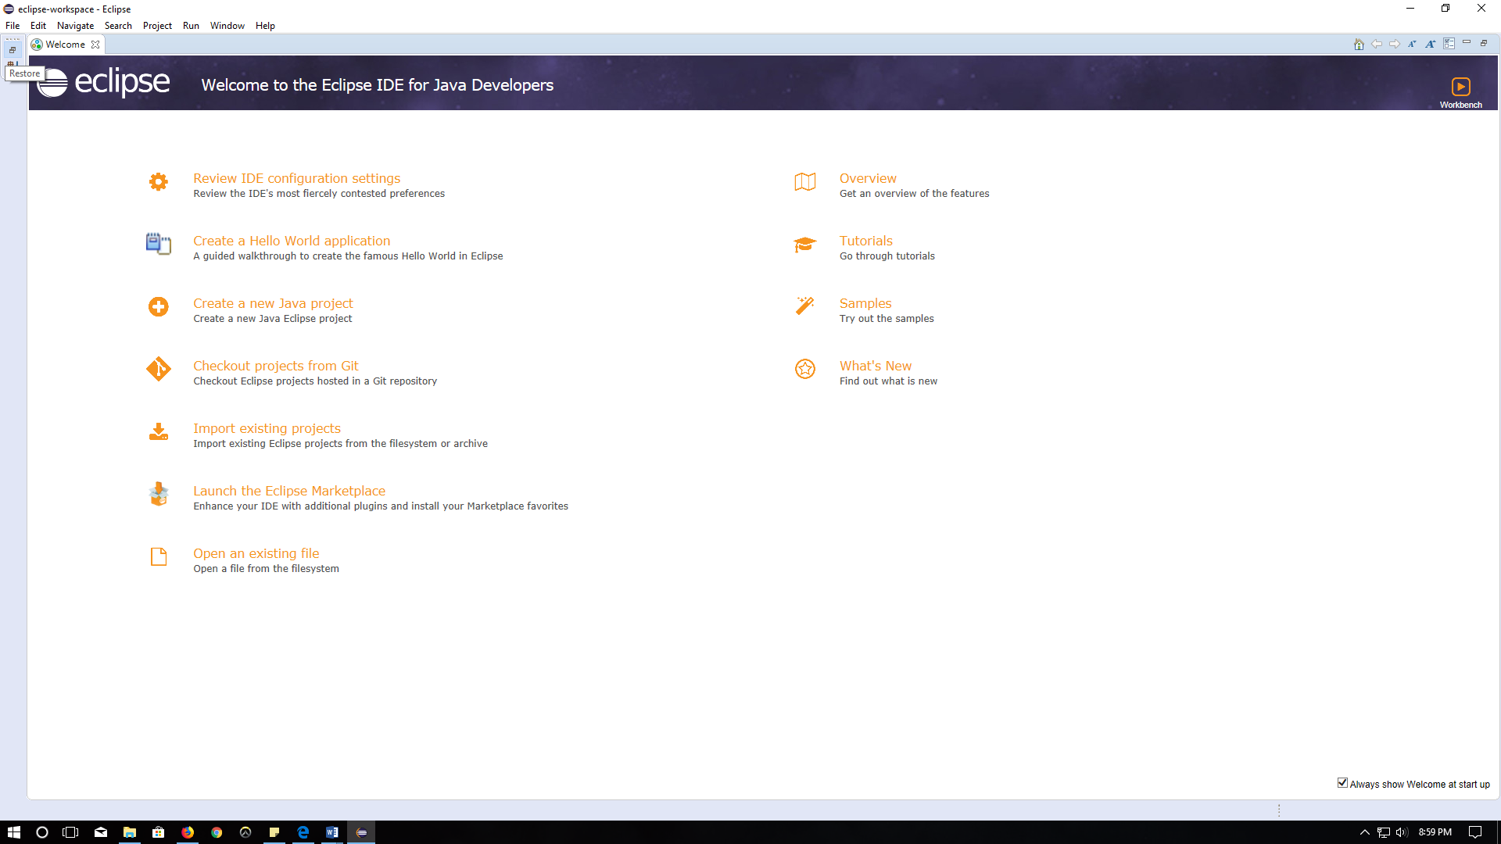

1. Click on the restore button (top left corner)  to restore the project explorer.

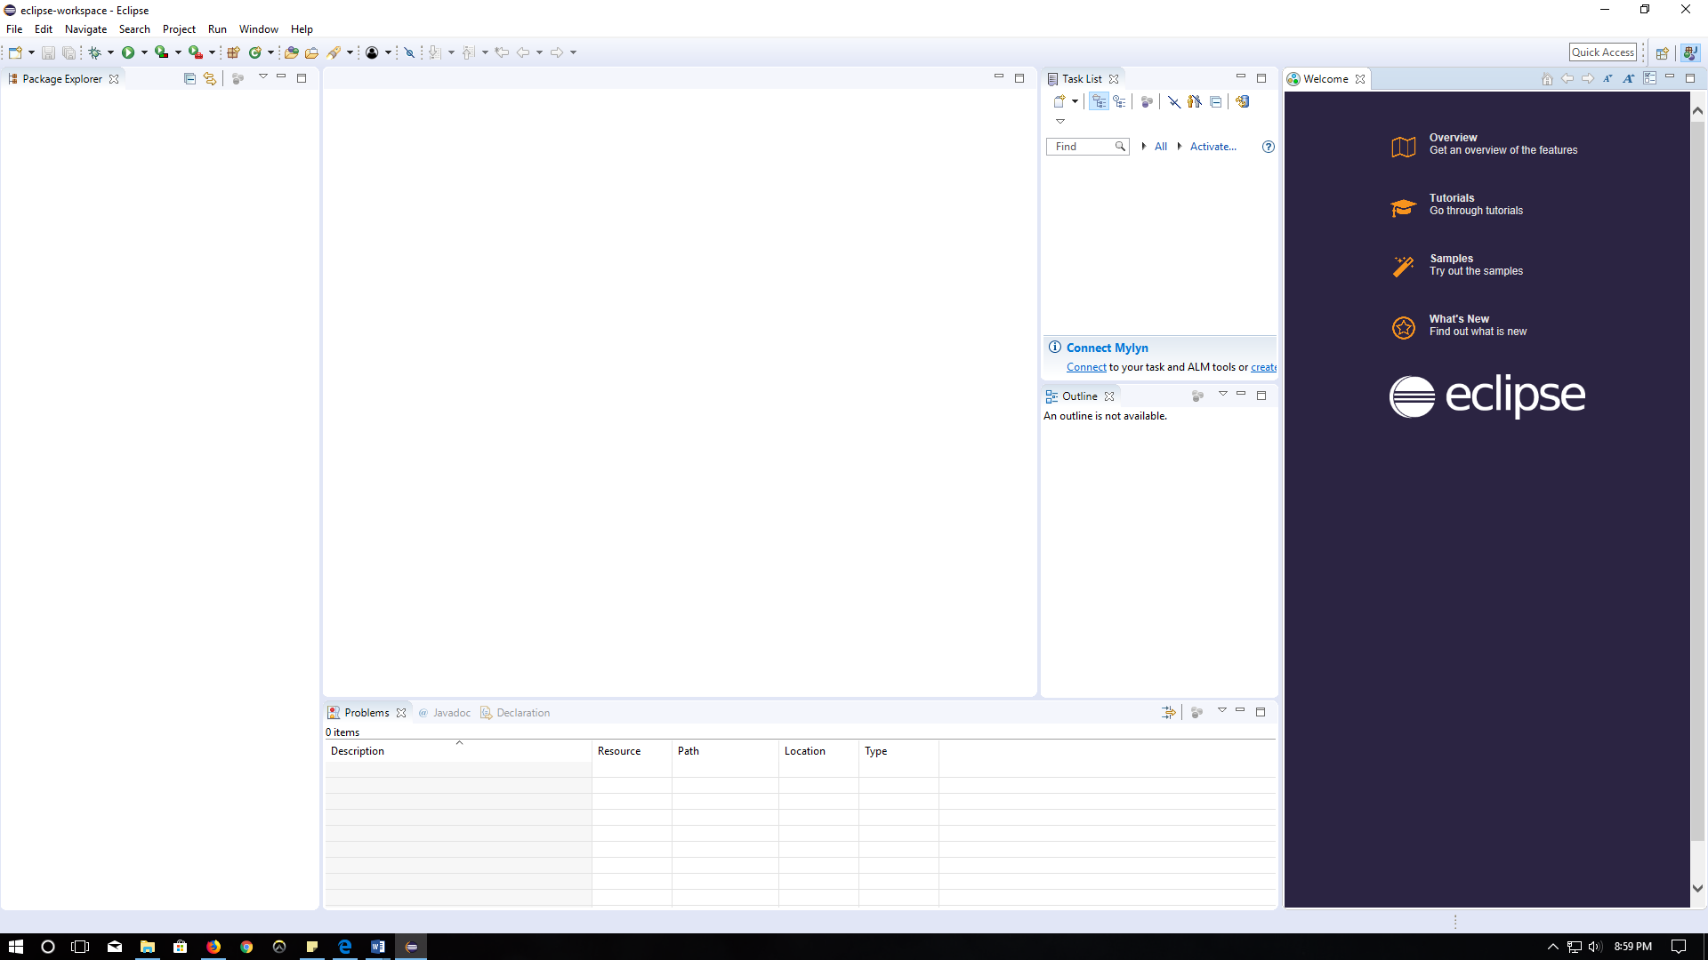

1. Right click inside the project explorer to import the project files

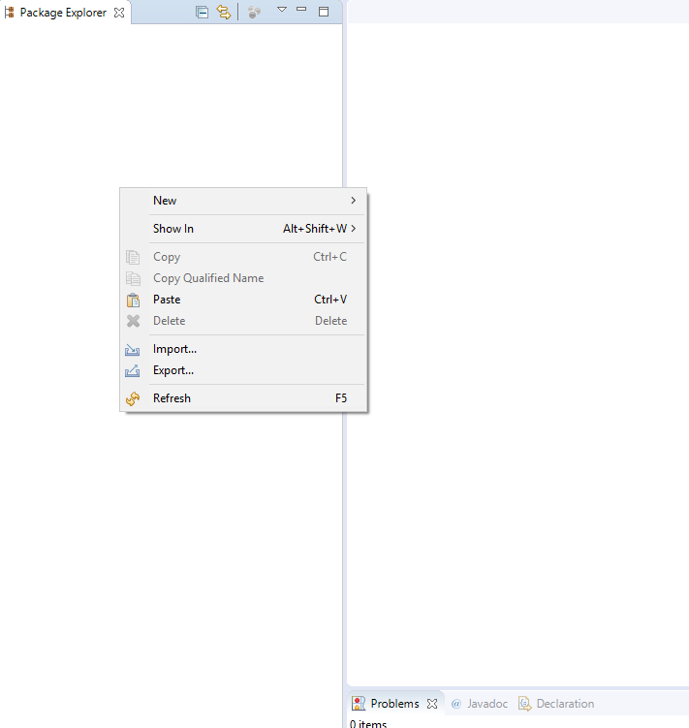

1. Click Import

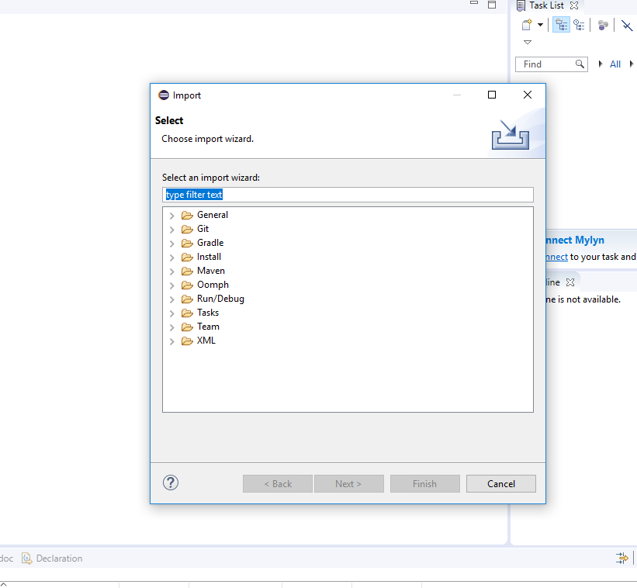

1. Expand the **General** tab and select **Existing Projects into Workspace**. Then click **next.**

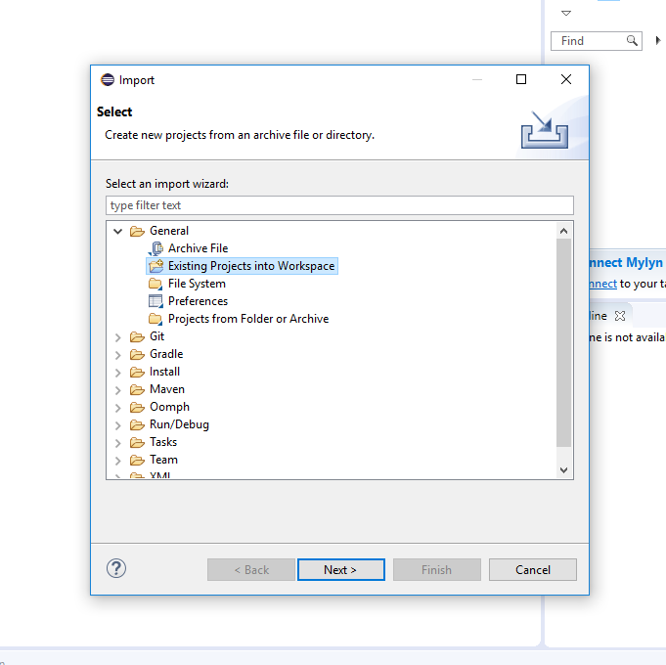

1. Under the **Select root directory**, click **Browse** button to locate the project file that we included in the zip file.

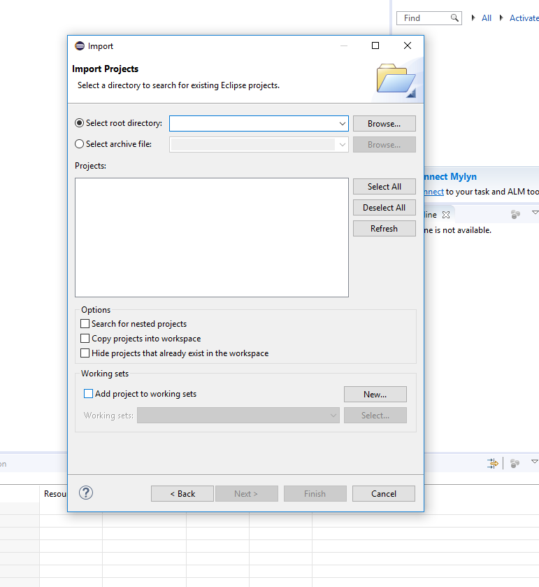

1. Locate the folder and click **Next.**  It will load all the projects files into Project Explorer

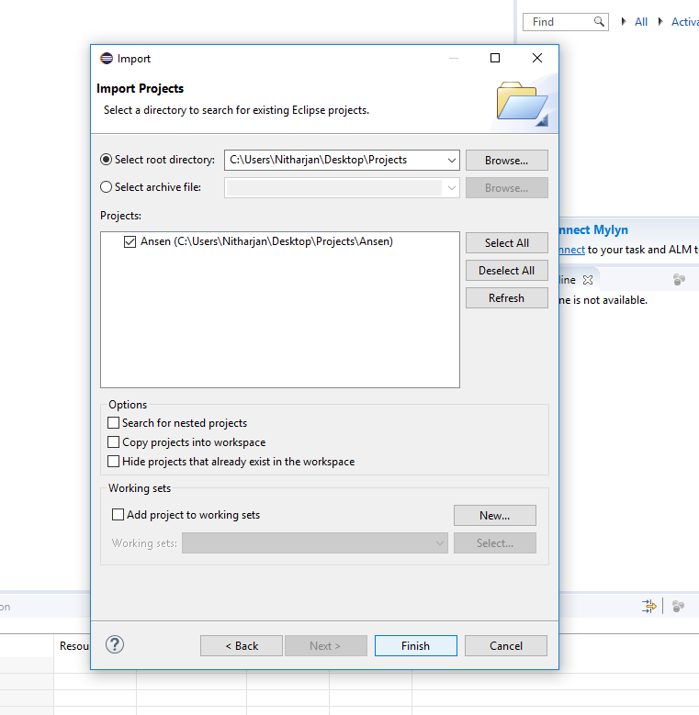 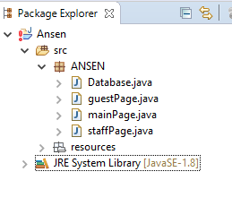

1. Right click on **JRE System Library 🡪 Build Path 🡪 Configure Build Path**

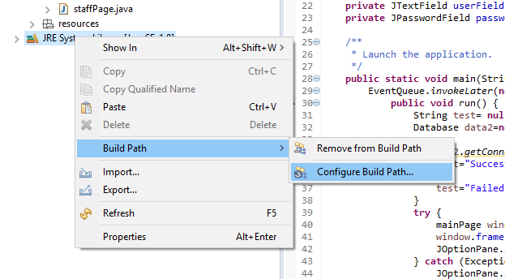

1. A window will pop up. Click on **Add External JARs**  on the top right corner.

Locate the **mysql-connector-java-5.1.44-bin.jar** file and click **open.**

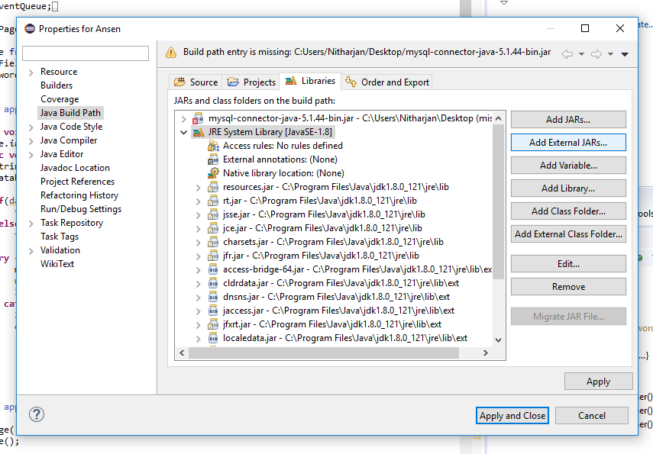

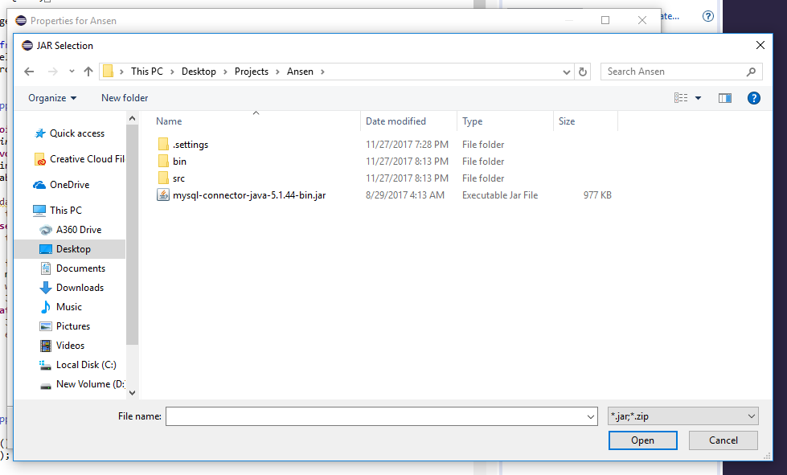

1. Click **Apply and Close**

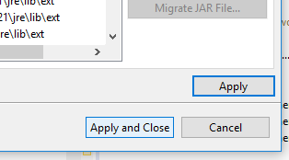

1. Click **Help** in the menu bar and click **Install New Software.**

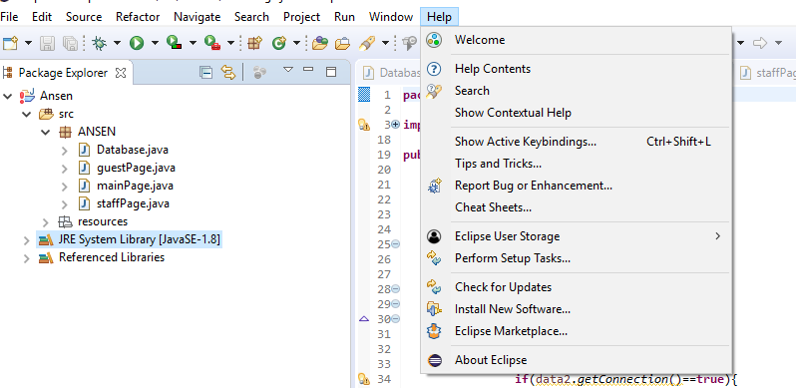

1. Expand the work with tap using the arrow  and click **Oxyge – http://download.eclipse.org/releases/oxygen**

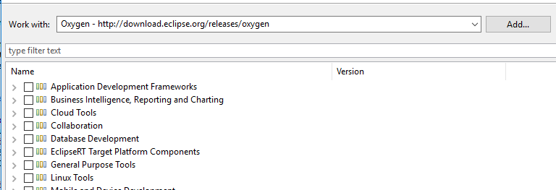

1. Expand the **General Purpose Tools**

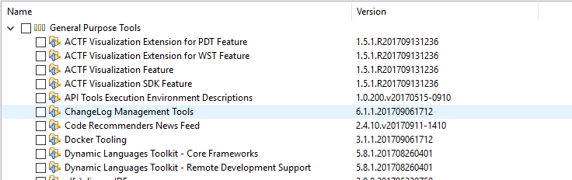

1. Select everything from **Swing Designer** to **Xtext Complete SDK**

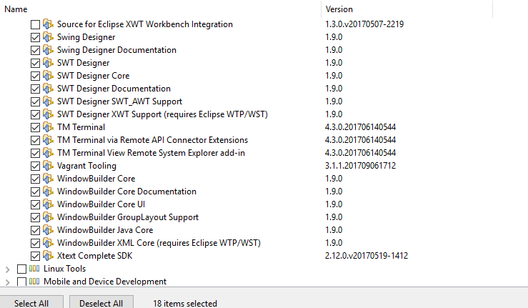

1. Click **Next**



1. Click **Next** again



1. Accept the license agreement and click **next.**  It will install all the plugins and you can monitor the process in bottom right corner.

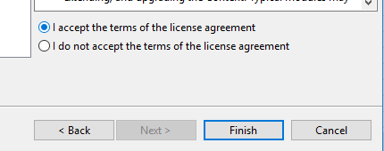 

1. It will ask you to restart Eclipse. So, click **Restart Now.**

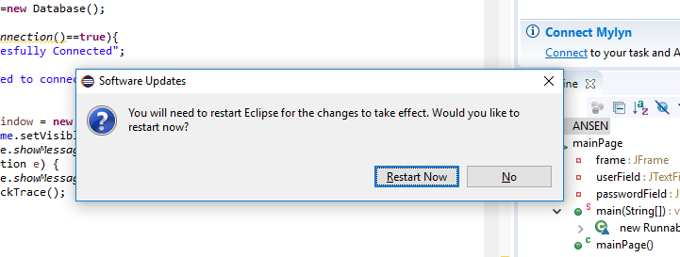

1. Once the program restarted, open all the java classes and run the **mainPage.java** to run the project.

