Volodymyr Nadolskyi | 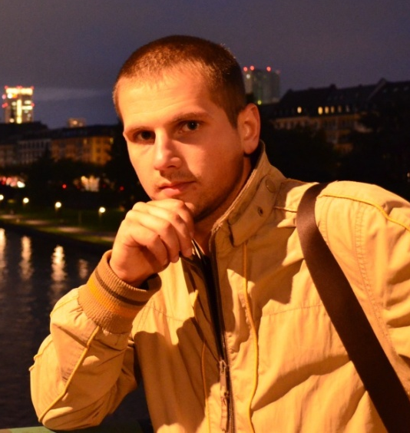
DOB: 15/07/1991
POB: Yavoriv village, Dolyna district, Ivano-Frankivsk region
Live: 27, Karpyntsia Str, Lviv
Nadolskyy@i.ua
0667258420

Academic qualifications:
2014 – till now: PhD studies at National University “Lvivska Polytechnika”, Department of Building Materials and Items
The Theme of PhD work: Composite binders from modify gypsum, and using them in building construction.
The main idea of my research work is modifying gypsum binders with chemical and activated mineral additives. Mineral additives are activated by viber mill. Chemical additives have superplasticity properties, and water-resistance effect is achieved.
2013 – 2014: Master studies of Building Construction at University “Lvivska Polytechnika”
The Theme of Master work: Construction of a house with gypsum products
2009 – 2013: Bachelor studies of Building Construction at University “Lvivska Polytechnika”
The Theme of Bachelor work: Add floor of residential building with strengthening the foundation
Working experience:
summer-Fall 2013: engineer at BALKO design company, Lviv
Duties: monitoring of building, making reports on technical state, giving recommendations on further exploitation
summer 2012: carpenter assistant at “Deck Helmet” Washington DC, USA
Duties: cleaning of wooden surfaces by using Power Wash, replacing of damaged items, protection against decay, painting, driver.

Voluntary experience:
2014-till now: volunteer at Foster Care Center in Lviv, active participant and organizer of volunteering group.
2013-till now: active participant at international voluntary organization “Community of Sant'Egidio” that deals with the poor and homeless.

Key skills: expert in gypsum products

make exact estimates of costs,

work in drafting program AutoCAD,

work with data documents and scientific literature,

understand and make technical drafts.

Personal qualities: able to get along with work colleagues and managers

highly motivated and organized

hardworking, easy-going, open-minded

Languages: Ukrainian – native;
Russian, Polish – fluent;
English - Upper-Intermediate.

