
MACHINE LEARNING COURSEWORK, PHASE 2:
TECHNICAL APPLICATION (BASELINE IMPLEMENTATION)
Reproducing and testing “Extremely randomized trees machine learning model for electricity theft detection” (Appiah et al., 2023)
Name: W. M. N. M. Wasala
Student Registration Number: KIC-BSCCSAI-251P-045
Programme: BSc (Hons) in Computer Science with Artificial Intelligence
Module: Machine Learning and Related Applications
Kandy Innovation Centre
National Institute of Business Management
1095, Kandy – Colombo Rd, Getambe.
Date of Submission: 15/10/2026
Table of Contents
1. Why I chose Option A 1
2. Experimental setup 1
2.1 Data 1
2.2 Environment and reproducibility 1
2.3 Metrics 2
2.4 How each experiment is set up 2
2.5 Code structure and components 3
2.6 How I tested the code 4
3. E1: reproducing the paper 5
4. E2: splitting the data first 6
5. E3: the corrected pipeline and baselines 7
5.1 Key parts of the code 7
5.2 Results 8
6. Comparison with the paper's claims 10
7. Updates to Phase 1 10
8. Limitations 11
9. Conclusion 11
References 12
Appendix A: Code repository 12

Table of Figures
Figure 1: The three experiments. E1 and E2 use the same steps in a different order. 1
Figure 2: Code: choosing the decision threshold from training predictions only 2
Figure 3: Components of the code and how they connect 3
Figure 4: Run output: the Phase 1 calculation repeated in code 4
Figure 5: Run log: nested cross-validation of Extra Trees, with the time stamp and chosen settings for each outer fold 5
Figure 6: Code: E1 follows the paper's order, so scaling and SMOTETomek see all the data before the split 5
Figure 7: Code: E2 splits first, then fits the scaler and SMOTETomek on the training part only 6
Figure 8: Confusion matrices. E1's test set is resampled and mostly synthetic; E2 and E3 use the same real test customers. 7
Figure 9: Code: rule-based cleaning in E3 7
Figure 10: Code: nested cross-validation 8
Figure 11: E3 models: nested cross-validation (mean ± SD) against the held-out test set 9
Figure 12: Left: MCC on each experiment's test set. Right: precision-recall curves on the same real-ratio test set. 10

1. Why I chose Option A
The brief provides two possible directions. For option B, the authors' code would be required, which is not provided in the paper. The only publicly available source is SGCC dataset repository created by Zheng et al. (2018). It contains only data files; therefore, option B could not be fulfilled. On the other hand, option A (baseline implementation) is appropriate for this paper, as I have access to the publicly available dataset to be able to reproduce the authors' pipeline and check whether their results were correct.
I have three research questions for the three experiments, each (Figure 1):
- E1: Is it possible to reproduce results of this paper using their pipeline?
- E2: How will these results change if the data would be split first, ensuring that there is no test set contamination during training?
- E3: How well will simple models perform when trained and tested using the fixed pipeline in phase 1?
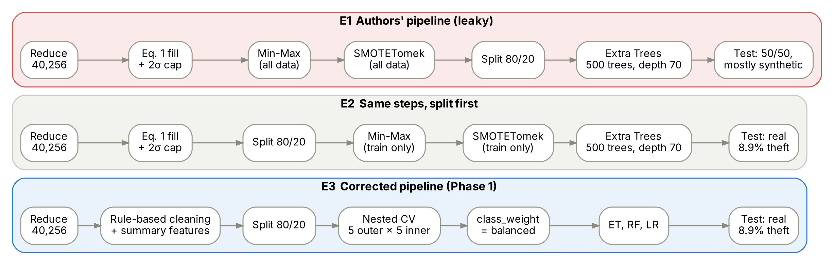
Figure 1: The three experiments. E1 and E2 use the same steps in a different order.

2. Experimental setup

2.1 Data
In my experiments, I use SGCC dataset from GitHub repository of Zheng et al. (2018), which contains 42,372 customers and 1,035 days (from 1 January 2014 to 31 October 2016). First of all, the notebook sorts the day columns by dates and adds 18 September 2016 as an additional empty column as it was suggested in Phase 1. After that, the notebook excludes the customers without any reading and duplicate rows. In total, 2,080 normal and 36 theft customers were excluded, and 40,256 customers are left – 36,677 normal and 3,579 theft (8.9%) – that corresponds to the numbers of the customers mentioned in the paper after the data reduction step, so the experiments start with the same dataset as the authors.
For E2 and E3, the dataset is divided only once into 80%/20% (training/test) – 32,204/8,052 customers (2,863/716 thieves) in each part, but with the same theft rate (8.9%) in both parts and with the fixed seed.

2.2 Environment and reproducibility
Python version 3.13, scikit-learn version 1.9.1 (Pedregosa et al., 2011), imbalanced-learn version 0.14.2 (Lemaître et al., 2017), NumPy version 2.5.3 and pandas version 3.0.5 are used in this notebook. All random processes (split, SMOTETomek, CV folds, hyperparameter grid search and models) are done with SEED = 42 so re-running the notebook will produce the same results. Execution of the complete notebook took approximately 5.8 hours on a two core machine, most of this time being spent on nested CV.

2.3 Metrics
I provide the performance metrics used in the paper (MCC, ROC-AUC, precision, recall, F1, false positive rate and accuracy) to make my results comparable with the paper. I include the two additional metrics found by Phase 1 to be lacking:
- PR-AUC (average precision). This metric equals theft rate of 0.089 for a random model, thus showing how much better than random is a certain model (Saito & Rehmsmeier, 2015).
- Precision at 5%. If only 5% of customers are suspicious enough to have an inspection, this metric tells what percentage of inspections will discover a true thief.
The models E1 and E2 have a cutoff point of 0.5 because that is what is used in the paper. However, the E3 models have class weights. Therefore, a cutoff point of 0.5 is arbitrary. In the case of the E3 models, I pick the cutoff point that produces the highest MCC in the out-of-fold predictions in the training set and then apply it to the test set.
Figure 2: Code: choosing the decision threshold from training predictions only
The function tests 300 cutoff points between the median and 99.9th percentiles of the predicted probabilities to find the point with the highest MCC. It is only used for the out-of-fold training predictions, never for the test set.

2.4 How each experiment is set up
 | E1: authors' pipeline | E2: split first | E3: corrected pipeline
Missing values | Equation 1 (neighbour average, otherwise 0) | Equation 1 | Interpolate intervals up to 3 days long but ignore longer intervals
Outliers | Cap at mean + 2σ per customer | Cap at mean + 2σ | Readings above 10,000 kWh set to missing; log(1 + x); clip at median + 3 × 1.4826 × MAD
Scaling | Min-Max, fitted on all data | Min-Max, fitted on training data | RobustScaler within the folds for Logistic Regression
Imbalance | SMOTETomek on all data | SMOTETomek on training data | class_weight = "balanced"
Split | 80/20 after resampling | 80/20 before anything is learned | 80/20 before anything is learned
Tuning | Values chosen by the paper's grid search | Same as E1 | Nested cross-validation, 5 outer × 5 inner folds
Test set | Resampled, 50% theft | Real, 8.9% theft | Real, 8.9% theft

I chose the parameter configuration selected by the paper's grid search for E1 and E2, namely 500 trees with a maximum depth of 70. E3 uses the design given in Section 5.5 of my Phase 1 report. For Extra Trees and Random Forest, the same search space applies: max_features ∈ {√p, 0.05p, 0.1p}, min_samples_leaf ∈ {1, 5, 20} and max_depth ∈ {10, 20, none}. These two models consider the same 8 out of the possible 27 parameter configurations, selected randomly, with the same seed. Logistic Regression searches through 8 different values of the regularization strength C, meaning that all the models have the same tuning budget of 8 configurations evaluated with respect to PR-AUC. The search uses only 100 trees for computational efficiency, while all winning configurations are retrained with 500 trees.
The E3 model uses 1,046 features for each customer: the 1,035 daily usage values cleaned and log(1 + x), along with 11 summary statistics. They are the percent of days missing, maximum number of days missing, first observation day, percentage of days missing in 2016, percentage of zero days, median and MAD of log use, coefficient of variation, recent usage relative to total usage, and the number of outlier flags. The Extra Trees and Random Forest models in scikit-learn handle missing data, so large gaps remain missing rather than being filled in with zeroes.

2.5 Code structure and components
There are eight components in the notebook that operate in sequence from top to bottom. Figure 3 illustrates how these components interconnect, while the table below highlights the problem solved by each component. Since both pipelines (the authors' pipeline – red and the modified pipeline – blue) use the same data loader and the same evaluation utilities, the differences arise from the pipeline alone.
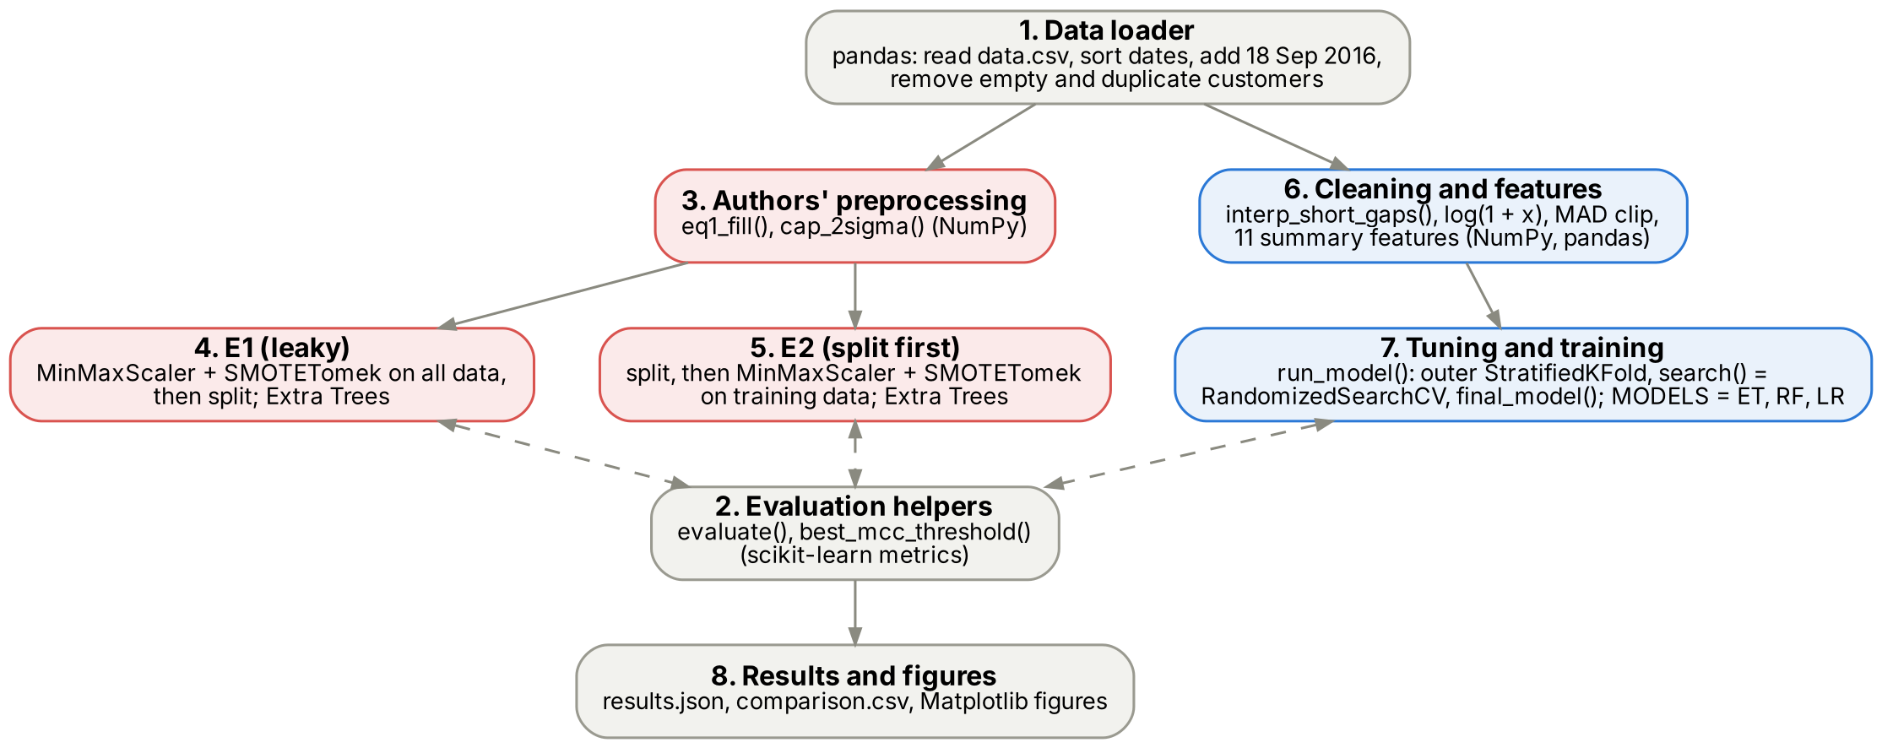
Figure 3: Components of the code and how they connect
Component | Notebook section | Problem it solves | Main library
1. Data loader | 1 | Corrects file problems in Phase 1 (disorganized dates, missing date field) and re-performs the paper's data reductions | pandas
2. Evaluation helpers | 2 | Calculates identical metrics for all experiments, such as PR-AUC and top 5% precision, and selects the threshold | scikit-learn
3. Authors' preprocessing | 3 | Rebuilds Equation 1 and the mean + 2σ cap as the paper describes them | NumPy
4. E1 | 4 | Reproduces the paper's results in the paper's (leaky) order | scikit-learn, imbalanced-learn
5. E2 | 5 | Measures the leakage by splitting first | scikit-learn, imbalanced-learn
6. Cleaning and features | 6 | Applies the Phase 1 corrections and builds the 11 summary features | NumPy, pandas
7. Tuning and training | 6.1 | Nested cross-validation with the same tuning budget for every model | scikit-learn
8. Results and figures | 6.3, 7 | Save results.json, comparison.csv, and the figures for this document | Matplotlib, json

Each library has one sole purpose:
- pandas 3.0.5 loads data.csv, interprets the column names as dates, sets the index to full calendar dates, and creates the feature summary table.
- NumPy 2.5.3 is in charge of array operations such as mask of the missing values, gaps, log(1+x), median, and MAD of each customer.
- scikit-learn 1.9.1 gives us the splitting and folding methods (train_test_split, StratifiedKFold), the random search (RandomizedSearchCV), the three models, scalers, and imputer, as well as the pipeline method and all the metrics.
- imbalanced-learn 0.14.2 has SMOTETomek, which is used by E1 and E2 only.
- Matplotlib plots the graphs based on the saved results.
The connections between the libraries are via a common interface. While pandas is used initially to set up features, thereafter everything is processed using NumPy arrays. scikit-learn and imbalanced-learn libraries both employ fit(), transform(), and fit_resample(), and therefore, ordering of the functions determines if data leak happens or not. There is only one distinction between E1 and E2, and that is where train_test_split() is used. In E3, the make_pipeline() function groups the imputer, scaler, and the logistic regression into a single model, and therefore, cross-validation recreates all three within each fold using clone().

2.6 How I tested the code
Before relying on the findings, I ensured that each element of the code performs its intended function:
- Data check. Loader correctly reproduces the numbers from the paper after data reduction (36,677 normal customers and 3,579 theft customers).
- Hand calculation check. First calculation cell correctly reproduces my Phase 1 hand calculation of code and yields the same 0.75 precision at real class ratio (see Figure 4).
- Reproduction check. E1 reproduces the numbers from the paper within 0.02 MCC, which means that the procedure described by the authors is indeed implemented in code.
- Reproducibility check. I executed the full notebook twice on two separate computers. As every random step uses SEED = 42, both executions have exactly the same train/test split and exactly the same settings for each model in every fold. The differences between the numbers produced by the execution on different computers are minor (< 0.01 MCC), since tree building and SMOTE's nearest neighbours search lead to small numerical differences due to different hardware and library builds. The numbers in this report were generated in my computer run.
- No-leak check. Test indices are calculated once and saved to split_test_idx.npy; used only once at the end of training. There are 716 thieves (8.89%) in the test set, which is the expected ratio.
- Progress log. The log() function records a timestamp for each step in progress.txt. Figure 5 illustrates the log file for the nested cross-validation of Extra Trees using the parameters selected in each outer loop iteration.
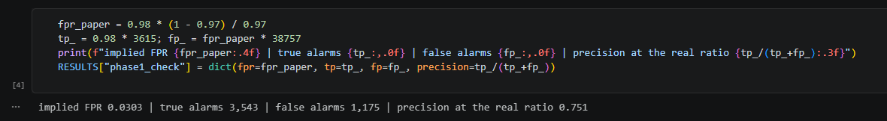
Figure 4: Run output: the Phase 1 calculation repeated in code
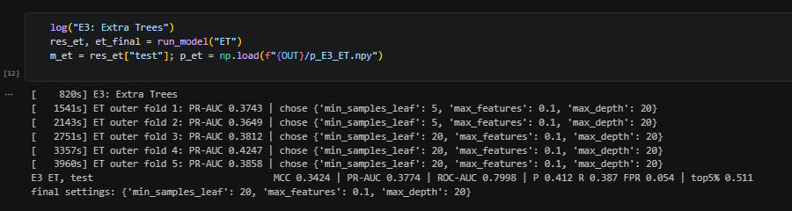
Figure 5: Run log: nested cross-validation of Extra Trees, with the time stamp and chosen settings for each outer fold

3. E1: reproducing the paper
According to the paper's pipeline, using SMOTETomek algorithm, the number of customers is increased to 73,336 rows, where 50% of cases are theft, which is very close to 73,352 of the paper. Out of these rows, 33,089 (45.1%) are synthetic thefts.
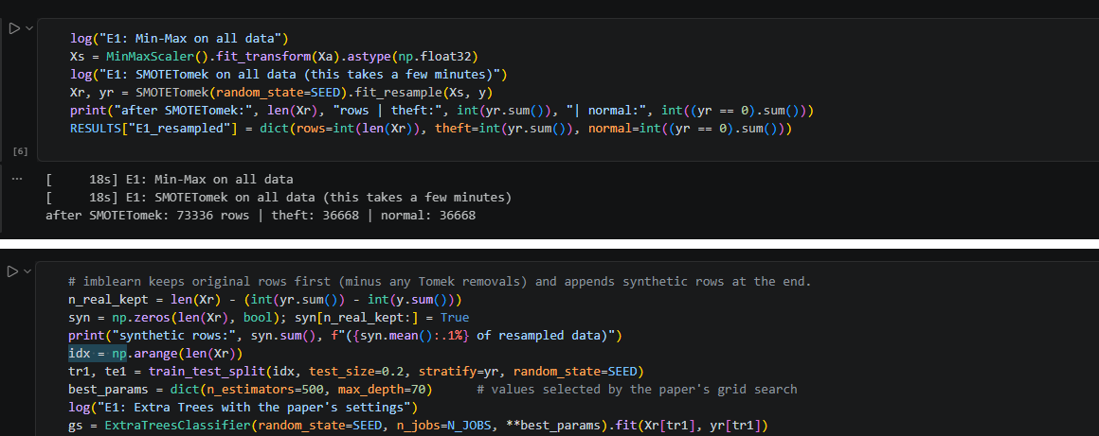
Figure 6: Code: E1 follows the paper's order, so scaling and SMOTETomek see all the data before the split
Min-Max Scaling and SMOTETomek are applied to all 40,256 customers (Xa), after which the resampled dataset is then divided into a training and test set. This is the leakage: the test set consists of artificial thieves based on the training customers and real test thieves that have their own copies in the training set.
Metric | Paper (reported) | E1 (my reproduction) | E1, real test customers only
MCC | 0.9506 | 0.9312 | 0.8344
ROC-AUC | 0.9965 | 0.9915 | 0.9925
Precision | 0.97 | 0.969 | 0.739
Recall (detection rate) | 0.98 | 0.962 | 0.976
False positive rate | 0.030 (implied) | 0.031 | 0.031
Theft rate in the test set | 50% (resampled) | 50% | 8.3%

My replication is nearly identical to the paper in all aspects (MCC = 0.93 versus 0.95, Precision = 0.97 versus 0.97). Hence, the pipeline used in the paper yields the results found in the paper. But only 9.1% of the cases for thefts in my sample are real. If I filter out only the real customers from my test set (last column), then Precision drops to 0.74 and MCC to 0.83. As predicted in Phase 1, Precision in this case should have been about 0.75.
I also computed the 4-fold cross-validation that would be used by the grid search in the paper using the resampled dataset in file order (using 100 trees to reduce computational burden). In the original file, the thieves occur first and SMOTE creates its rows at the bottom. Consequently, all 3,579 actual thieves are in fold 1 while folds 2 to 4 have only synthetic thieves. However, the 4 folds have nearly identical MCCs, and hence the grid search could not differentiate between real and synthetic customer detection.

Fold | Real thieves | Synthetic thieves | MCC
1 | 3,579 | 5,588 | 0.921
2 | 0 | 9,167 | 0.927
3 | 0 | 9,167 | 0.918
4 | 0 | 9,167 | 0.931

4. E2: splitting the data first
E2 executes the same process using the same model, although the partitioning takes place at the beginning. Scaling and SMOTETomek use the training dataset alone, and the testing set retains the true proportion of thefts. The performance degrades dramatically: MCC 0.295, PR-AUC 0.341, and ROC-AUC 0.779. The number of thieves identified by the model becomes 164 out of 716 (Figure 8).
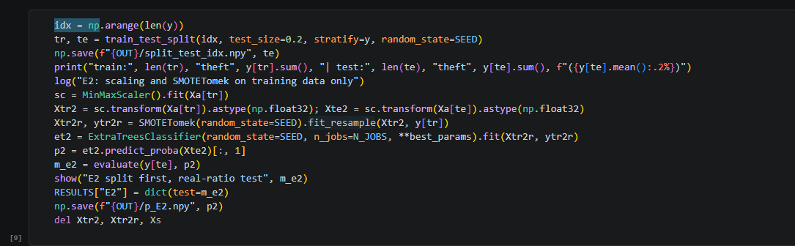
Figure 7: Code: E2 splits first, then fits the scaler and SMOTETomek on the training part only
Just the order is altered. The scaler calculates its maximum and minimum based on the training customers (fit on Xa[tr]) and is applied to the test customers, and SMOTETomek never sees anything other than the training data. The test set still has its actual 8.9% theft rate with no artificial customers.
The comparison of E2 with the last column in the E1 table is the crucial finding in this stage. The model is tested on actual customers at an actual theft rate in both cases. The only difference is that there are artificial copies of the test thieves in the training data for one of the cases. Recall is 0.98 with the copies and 0.23 without them. This is proof positive of the leak I talked about in Section 6.5 of Phase 1.
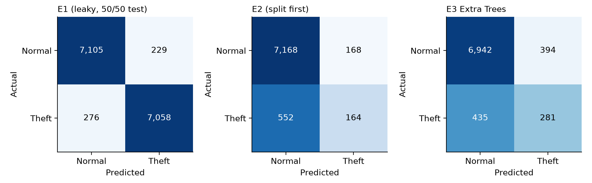
Figure 8: Confusion matrices. E1's test set is resampled and mostly synthetic; E2 and E3 use the same real test customers.

5. E3: the corrected pipeline and baselines

5.1 Key parts of the code
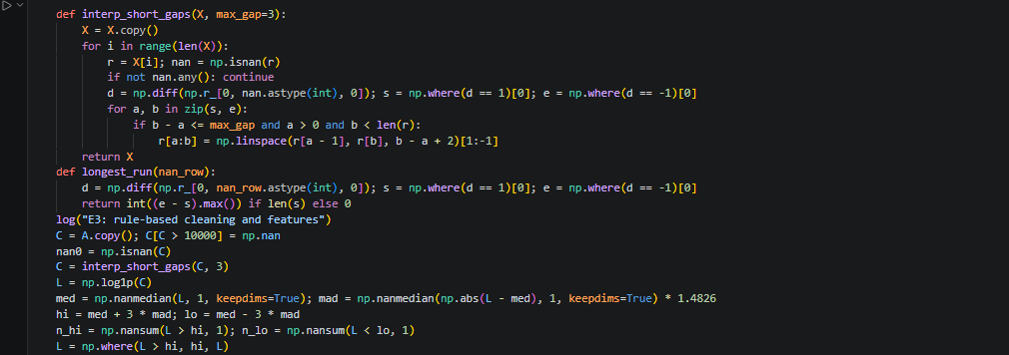
Figure 9: Code: rule-based cleaning in E3
For data greater than 10,000 kWh, they are missing. The interp_short_gaps function takes care of only 3-day gaps, making use of the values present on both sides, while longer gaps are left missing. After taking log(1+x), the median and MAD for each customer are calculated (1.4826 * MAD is made equivalent to σ). All values exceeding median + 3 * MAD are capped. The high and low flags are also included as features. Every transformation is done using only one customer's data at a time.

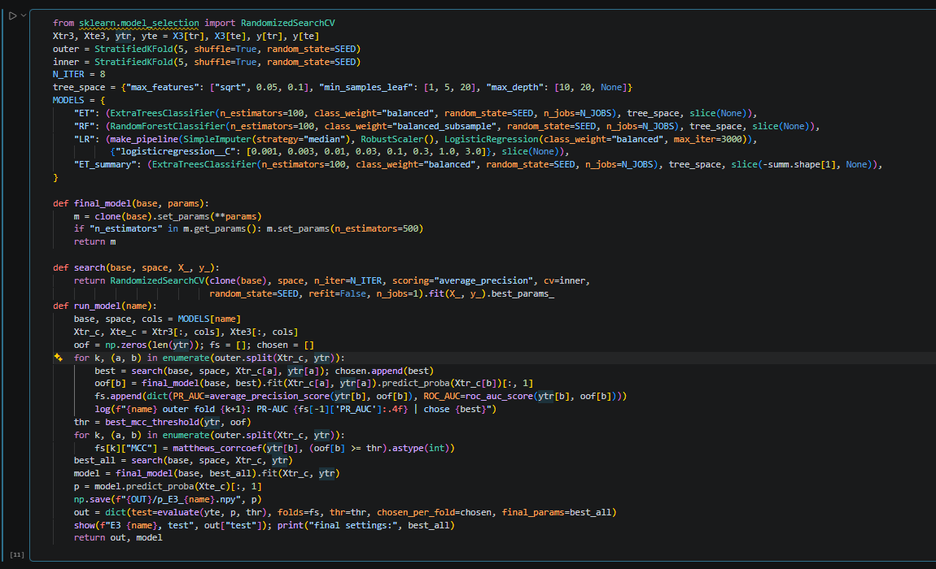
Figure 10: Code: nested cross-validation
According to the MODELS dictionary, Extra Trees and Random Forest have the same search space, while all models have the same budget, which is 8 candidates. The outer loop divides the training dataset into 5 parts and is employed just for measuring performance. In every outer training part, the search function performs 5-fold cross-validation on 8 randomly selected configurations, evaluated using the PR-AUC metric, in such a way that the outer holdout fold is not exposed during tuning. The selected configuration is refitted with 500 trees and predicts the holdout fold, resulting in out-of-fold prediction for every customer in the training set. The threshold is determined using these predictions.

5.2 Results
Table 6 presents the results of nested cross-validation (mean ± standard deviation from 5 outer folds) and the test set evaluation results.
Model | CV PR-AUC | CV MCC | Test PR-AUC | Test MCC | Test ROC-AUC | Top 5% precision
Extra Trees | 0.387 ± 0.020 | 0.337 ± 0.029 | 0.378 | 0.348 | 0.800 | 0.516
Random Forest | 0.390 ± 0.018 | 0.345 ± 0.020 | 0.391 | 0.342 | 0.800 | 0.526
Logistic Regression | 0.306 ± 0.018 | 0.295 ± 0.021 | 0.279 | 0.271 | 0.754 | 0.395
Extra Trees, 11 summary features only | 0.351 ± 0.024 | 0.324 ± 0.022 | 0.340 | 0.317 | 0.782 | 0.442

Random Forest and Extra Trees behave very similarly. Random Forest has the best PR-AUC test result (0.391 compared to 0.378), but both algorithms get approximately 0.35 MCC (0.348 and 0.342) and ROC-AUC 0.80 on test data. Compared to E2 that utilizes Extra Trees combined with authors' preprocessing, improved Extra Trees detects more offenders (281 compared to 164) and increases its PR-AUC from 0.341 to 0.378. 51.6% out of the most suspicious 5% customers on test data turn out to be real offenders, which is about 5.8 times more than the 8.9% from a random choice. The logistic regression algorithm performs much worse (test PR-AUC 0.279).
This stage will also allow me to verify the authors' claim of Extra Trees being fast, which was stated in Phase 1 and never proven yet. For the same amount of searches, folds, and dataset, complete cross-validation took 66 minutes for Extra Trees and 202 minutes for Random Forest; hence, Extra Trees proved to be three times faster. This is consistent with theoretical assumptions provided in Section 5.3 of Phase 1, since Extra Trees makes only one random cut-point for each feature and does not sort the features. Thus, Extra Trees identifies the criminals as well as Random Forest for one-third of the cost.
The tuning procedure was also consistent. Both forests selected max_features = 0.1p and max_depth = 20 in all 5 outer folds; the other hyperparameter value of importance is min_samples_leaf = 20 in most folds (3 out of 5 for Extra Trees, 4 out of 5 for Random Forest). In the final step, when I tuned models on the whole training set, I used max_depth = 20, max_features = 0.1p, min_samples_leaf = 20. Two observations seem to be important. Firstly, in all cases, the search procedure selected max_depth = 20, which was not even included in the grid of the paper (50 to 80). Secondly, max_features = 0.1p is the biggest value in my search space, therefore a bigger search may produce slightly better results. Logistic Regression selected C = 0.003 in all folds. Figure 11 illustrates that the test score for each tree model lies within one standard deviation from its cross-validation mean, but the scores for Logistic Regression are somewhat lower on the test set. This is how a good evaluation procedure should work, as opposed to E1, where both tuning and test scores were obtained using leakages.
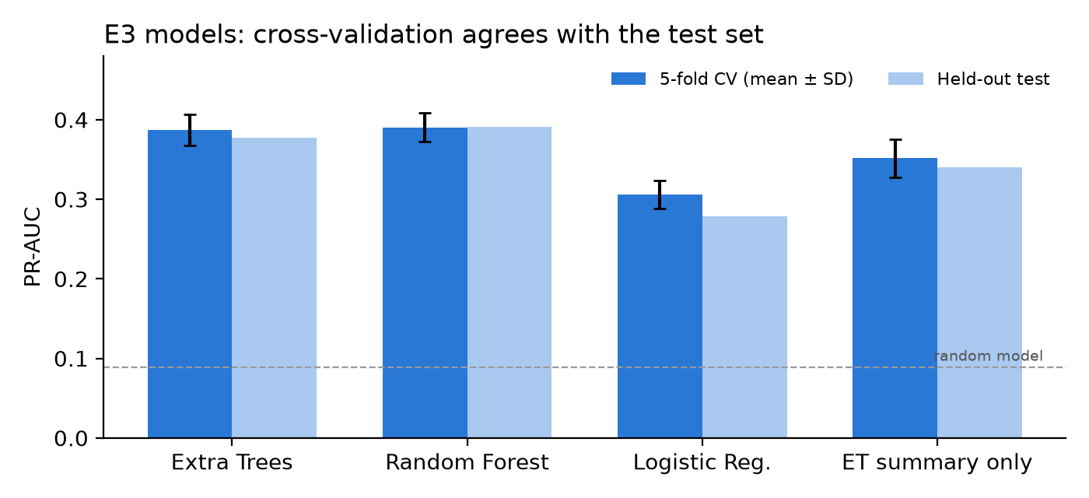
Figure 11: E3 models: nested cross-validation (mean ± SD) against the held-out test set
Two other findings help to clarify the task. First, the model that considers only the 11 summary features gets the test PR-AUC of 0.340, which is almost equal to the full model with 1,046 features. Most of the information contained in the features is related to usage level and amount of missing data, as expected based on my EDA analysis in Phase 1. Second, the few days that the Extra Trees algorithm considers most important are 15 to 21 September 2016. Between 15 to 17 September, 20% of thieves and just 6% of the regular customers do not have readings. This seems like an event during the process of collecting data that may be associated with some kind of inspection rather than theft behavior. If so, at least partially, the models are learning from SGCC when the utility examined the customer, not the customer's behavior itself. I will test this in Phase 3.
Once again, accuracy demonstrates its uselessness as a metric in this case. The accuracy of the Extra Trees algorithm is 0.897, which is lower than 0.911 of a model that classifies all the customers as normal.

6. Comparison with the paper's claims
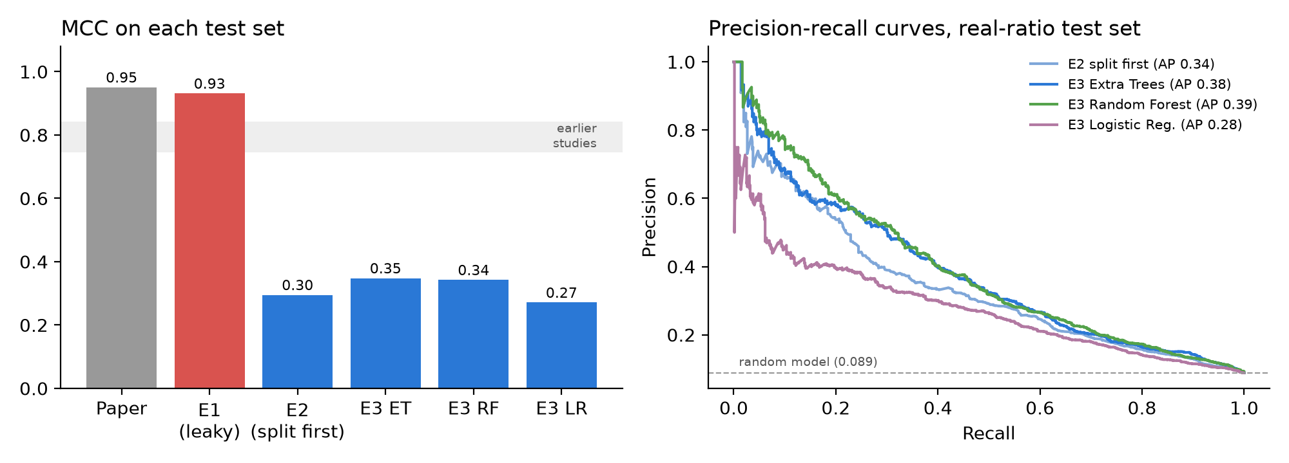
Figure 12: Left: MCC on each experiment's test set. Right: precision-recall curves on the same real-ratio test set.
Experiment | MCC | PR-AUC | ROC-AUC | Precision | Recall | Theft in test
Paper (reported) | 0.9506 | – | 0.9965 | 0.97 | 0.98 | 50%
E1: authors' pipeline | 0.931 | 0.993 | 0.991 | 0.969 | 0.962 | 50%
E1: real customers only | 0.834 | 0.967 | 0.992 | 0.739 | 0.976 | 8.3%
E2: split first | 0.295 | 0.341 | 0.779 | 0.494 | 0.229 | 8.9%
E3: Extra Trees | 0.348 | 0.378 | 0.800 | 0.416 | 0.392 | 8.9%
E3: Random Forest | 0.342 | 0.391 | 0.800 | 0.407 | 0.392 | 8.9%
E3: Logistic Regression | 0.271 | 0.279 | 0.754 | 0.319 | 0.362 | 8.9%

Conclusions drawn from all three experiments regarding the statements made in the paper are as follows:
- These scores are reproducible, but only in case of leakage. In accordance with the steps described in the paper, MCC is obtained 0.93, which is quite close to the reported 0.95. Using the same model with the same parameters, one will obtain score of 0.30 if splitting occurs first.
- The claimed superiority over previous papers is unsubstantiated. The author contrasts his 0.95 with 0.75-0.84 of previous studies. But testing his model on the genuine customers in his test set brings MCC to 0.83, which lies in the above range, even with leakage.
- The true performance on SGCC dataset is much worse. The best my model scored when evaluated without leakage was ROC-AUC 0.80. It correlates with the ROC-AUC of approximately 0.79 for Wide and Deep CNN of Zheng et al. (2018) and is inferior to 0.93 for the attention-based model of Finardi et al. (2020). Evaluation was performed using stratified folds with the true class ratio. Extratreess seem to be a decent and fast enough baseline, but there is no proof it is superior to previous deep models.
- Preprocessing is important. Missing values being kept as such, inclusion of missingness indicators, as well as class weights rather than SMOTE increased the PR-AUC value of Extra Trees from 0.341 (E2) to 0.378 (E3). This confirms my suggestions made in Phase 1.

7. Updates to Phase 1
When running the code, it was found that there were four statements that needed to be fixed in my Phase 1 report. They are listed below:
- Data reduction. In Phase 1, I said that the paper incorrectly performs this step because it doesn’t test for duplicate rows. Removing the 2,114 customers without any meter readings and then removing the two duplicate rows produces exactly the numbers that the paper claims to have deleted (2,080 normal and 36 theft customers). This means that the authors indeed eliminated duplicates and the step can be replicated.
- Alerting on empty meters. In Phase 1, I advised the authors to use a simple warning for empty meters rather than deleting those rows. It becomes clear from the data that it makes no sense, as there are only 36 thefts among 2,114 empty meters (1.7%). This number is lower than the one that random choice would produce (8.5%), which means that removal of such rows (which the authors did) is justified.
- False Positive Rate. In Phase 1, I applied an FPR = 0.031 and 1,201 false positives. The paper doesn’t state FPR directly. Its claimed recall = 0.98 and precision = 0.97 mean that its FPR = 0.030, which gives 1,175 false positives based on the actual class sizes. This way, the precision of the inspector remains 0.75.
- The count for SMOTETomek is also off. While I have 36,668 in my replication, which is 36,676 in the paper, due to the pairs eliminated in Tomek links. It makes less than 0.1% of the entire dataset and may be caused by using a different library version.

8. Limitations
- Since the code is not available from the authors, E1 adheres to the paper. In case of any ambiguity, I took the decision closest to that of Zheng et al. (2018): customer-level mean and σ for the cap on outliers and sort-by-date columns for equation 1. The high similarity with the paper's results shows that the decisions were correct.
- The hyperparameters used by E1 and E2 models were those used in the paper (500 trees with depth 70), without having to carry out their own grid search.
- A hyper-parameter search is carried out using 8 of the 27 combinations in the parameter space, while 100 trees are used. A complete search might lead to better results.
- There is only one train/test split. The distribution across the outer folds provides some indication about the uncertainty, although more splits would have provided more reliable results.
- It’s random, not temporal, as in the paper. The deployed model would have been trained on the past but used on the future, and that is generally more difficult.
- The 10,000 kWh threshold to detect impossible data points is personal. It impacts just 260 data points.
- The labels apply to the consumers and not days; hence, there will always be noise in all outcomes.

9. Conclusion
The primary conclusion drawn in Phase 1 is validated by the code developed in Phase 2. The MCC of 0.95 stated in the paper can be replicated with the code, but only if SMOTETomek is done before the split. This means that most of the thieves in the test set are synthetic, while the real thieves have synthetic duplicates in the training set. When the split is done before SMOTETomek, the same Extra Trees Classifier reaches an MCC of 0.30. However, with the corrected pipeline of Phase 1, this value becomes 0.35 MCC and 0.38 PR-AUC with stable cross-validation results. About half of the customers ranked highest by Extra Trees prove to be real thieves. Random Forest classifier performs just as well, but Extra Trees' advantage is in its training speed, which is three times faster than that of Random Forest. In Phase 3, I plan to employ the developed models as baselines for stress-testing, along with September 2016 missing data patterns, added noise and higher dimensionality.

References
Appiah, S. Y., Akowuah, E. K., Ikpo, V. C., & Dede, A. (2023). Extremely randomised trees machine learning model for electricity theft detection. Machine Learning with Applications, 12, 100458. https://doi.org/10.1016/j.mlwa.2023.100458
Batista, G. E. A. P. A., Prati, R. C., & Monard, M. C. (2004). A study of the behavior of several methods for balancing machine learning training data. ACM SIGKDD Explorations Newsletter, 6(1), 20–29. https://doi.org/10.1145/1007730.1007735
Breiman, L. (2001). Random forests. Machine Learning, 45(1), 5–32. https://doi.org/10.1023/A:1010933404324
Cawley, G. C., & Talbot, N. L. C. (2010). On over-fitting in model selection and subsequent selection bias in performance evaluation. Journal of Machine Learning Research, 11, 2079–2107.
Chawla, N. V., Bowyer, K. W., Hall, L. O., & Kegelmeyer, W. P. (2002). SMOTE: Synthetic minority over-sampling technique. Journal of Artificial Intelligence Research, 16, 321–357. https://doi.org/10.1613/jair.953
Finardi, P., Campiotti, I., Plensack, G., de Souza, R. D., Nogueira, R., Pinheiro, G., & Lotufo, R. (2020). Electricity theft detection with self-attention. arXiv preprint arXiv:2002.06219. https://arxiv.org/abs/2002.06219
Geurts, P., Ernst, D., & Wehenkel, L. (2006). Extremely randomized trees. Machine Learning, 63(1), 3–42. https://doi.org/10.1007/s10994-006-6226-1
Kaufman, S., Rosset, S., Perlich, C., & Stitelman, O. (2012). Leakage in data mining: Formulation, detection, and avoidance. ACM Transactions on Knowledge Discovery from Data, 6(4), 15. https://doi.org/10.1145/2382577.2382579
Lemaître, G., Nogueira, F., & Aridas, C. K. (2017). Imbalanced-learn: A Python toolbox to tackle the curse of imbalanced datasets in machine learning. Journal of Machine Learning Research, 18(17), 1–5.
Pedregosa, F., et al. (2011). Scikit-learn: Machine learning in Python. Journal of Machine Learning Research, 12, 2825–2830.
Saito, T., & Rehmsmeier, M. (2015). The precision-recall plot is more informative than the ROC plot when evaluating binary classifiers on imbalanced datasets. PLOS ONE, 10(3), e0118432. https://doi.org/10.1371/journal.pone.0118432
Zheng, Z., Yang, Y., Niu, X., Dai, H.-N., & Zhou, Y. (2018). Wide and deep convolutional neural networks for electricity-theft detection to secure smart grids. IEEE Transactions on Industrial Informatics, 14(4), 1606–1615. https://doi.org/10.1109/TII.2017.2785963
Dataset: State Grid Corporation of China (SGCC) electricity theft dataset. https://github.com/henryRDlab/ElectricityTheftDetection

Appendix A: Code repository
The code is on GitHub at https://github.com/Nadun24617/electricity-theft-extratrees-review. The repository contains:
- Phase2_Baseline.ipynb: the notebook with all outputs saved.
- requirements.txt: the library versions used.
- README.md: what the project does and how to run it.
- results/: results.json, comparison.csv and the figures used in this report.
The SGCC data is not in the repository because of its size. Download it from https://github.com/henryRDlab/ElectricityTheftDetection.

